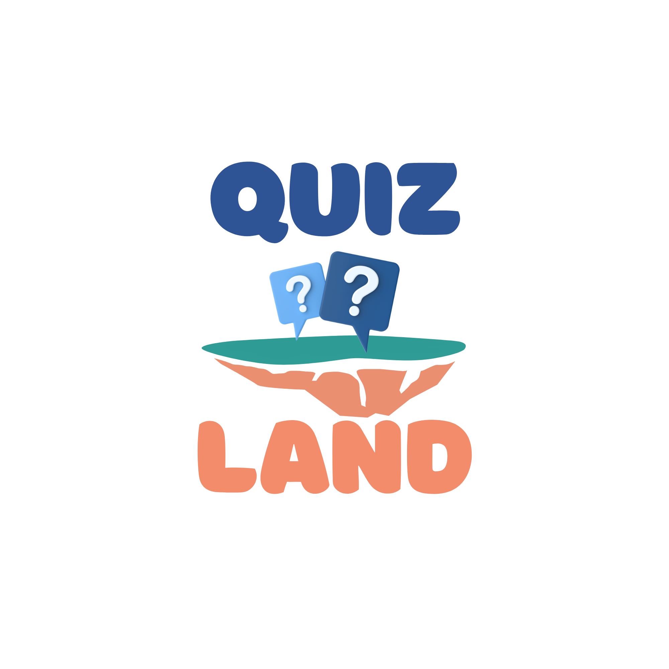
Quiz Land
UI Brand Guideline Book
Source of truth: the latest uploaded landing page archive and screenshot
Think fast! Survive in Quiz Land!
This version deliberately uses only the visual language visible in the current landing page screenshot and the CSS from the latest uploaded archive. No older Quiz Land components or independently invented UI specimens are used.

1. Visual source of truth
Use this landing page screenshot as the primary visual reference for UI styling, component proportions, pills, cards, forms, imagery, spacing, and color mood.
Do not substitute these components with the older blue-outline app screens or previous generated card specimens.
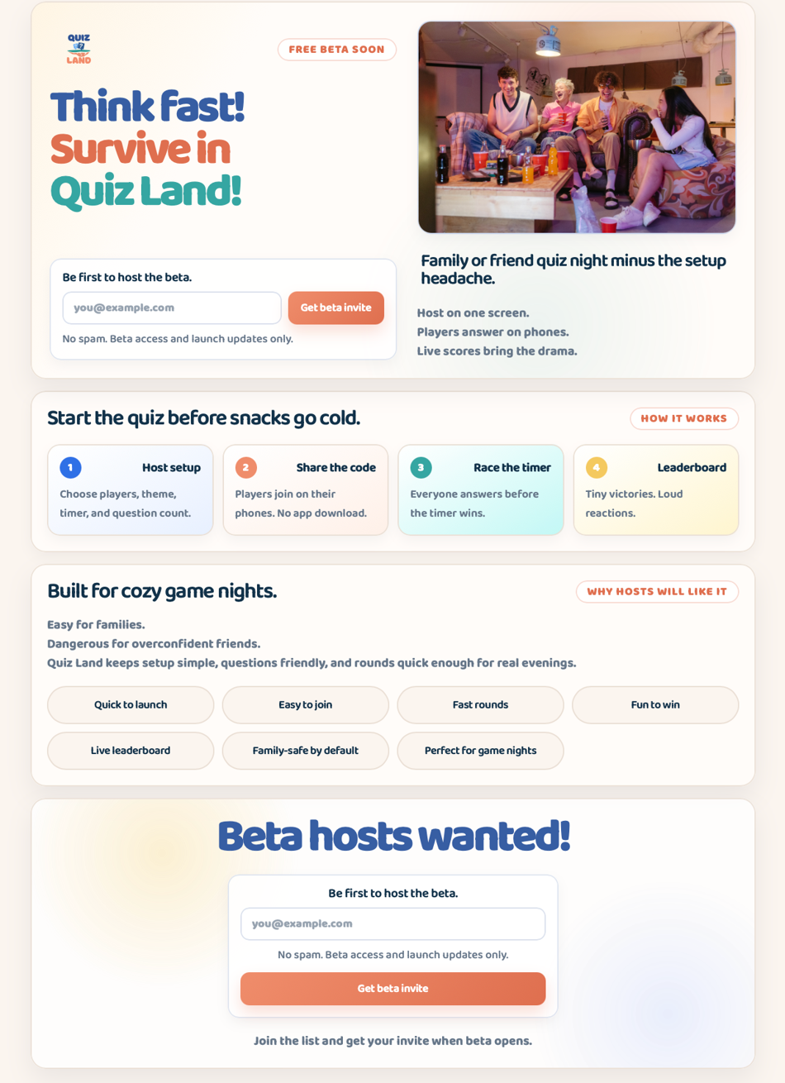

2. Brand direction
Quiz Land is playful, cozy, fast, and slightly chaotic in a friendly way. The UI should feel like an easy family or friend game night, not a corporate quiz dashboard.
Token / class | Definition from current landing CSS
Brand promise | Make group evenings more fun with fast browser quizzes.
Core slogan | Think fast! Survive in Quiz Land!
Tone | Short, punchy, warm, playful, and direct.
UI mood | Soft cream background, round cards, friendly pills, vivid logo colors, gentle shadows.
Avoid | Dense admin-like layouts, sharp rectangles, heavy borders, cold gray UI, and old component styles.

3. Color system
Use the CSS custom properties below as the source of truth. Do not introduce new primary colors unless the CSS tokens are updated first.
Token / class | Definition from current landing CSS
--bg | #fbf5ef
--panel | #fffdf9
--ink | #12324a
--muted | #667689
--line | #eadfd5
--blue | #375ea3
--blue-action | #2f70e6
--blue-soft | #e8f0ff
--coral | #ef8d6b
--coral-dark | #df6f4f
--coral-soft | #fff0e8
--yellow | #f4c95f
--yellow-soft | #fff5cf
--teal | #35a6a2
--teal-soft | #c3f8f5

Shape and depth tokens
Token / class | Definition from current landing CSS
--shadow | 0 18px 40px rgba(31, 44, 58, 0.08)
--shadow-soft | 0 8px 20px rgba(31, 44, 58, 0.05)
--radius | 24px
--radius-sm | 14px

4. Typography
The latest uploaded CSS imports Inter, Nunito Sans, and Baloo 2, but the active body font is Baloo 2. This gives the landing page its rounded, playful personality.
@import url("https://fonts.googleapis.com/css2?family=Inter:wght@400;500;600;700;800&family=Nunito+Sans:wght@400;500;600;700;800&family=Baloo+2:wght@400;500;600;700;800&display=swap");
body {
font-family: "Baloo 2", ui-sans-serif, system-ui, -apple-system, BlinkMacSystemFont, "Segoe UI", sans-serif;
}
Token / class | Definition from current landing CSS
Hero H1 | clamp(42px, 5.2vw, 72px), line-height 0.94, weight 800, letter-spacing -0.06em.
H2 | clamp(24px, 2.8vw, 34px), line-height 1.05, weight 600, letter-spacing -0.04em.
H3 | 20px desktop / 20px mobile, line-height 1.08, weight 700.
Body/support text | Muted color, rounded Baloo voice, short lines. Avoid long paragraphs.
Hero title colors | .title-blue, .title-coral, .title-teal should be used exactly as in the screenshot.

5. Page layout and spacing
Token / class | Definition from current landing CSS
.page | width: min(1140px, calc(100% - 28px)); margin auto; padding 24px 0 38px.
.hero-panel | Two-column grid on desktop; gap 32px; padding 28px; radius 24px; cream panel.
.section | Reusable content panel; display grid; gap 22px; margin-top 18px; padding 24px.
.final-cta | Centered call-to-action block with radial background accents and 24px internal gap.
Mobile breakpoint | At max-width 640px: panels use 18px padding, 20px radius, forms/buttons stack, grids become one column.

6. Component examples from current screenshot
The following examples are cropped directly from the provided screenshot. They are not recreated UI specimens.

Hero panel
Logo, free-beta pill, multicolor hero title, email form, image card, and subtitle stack.
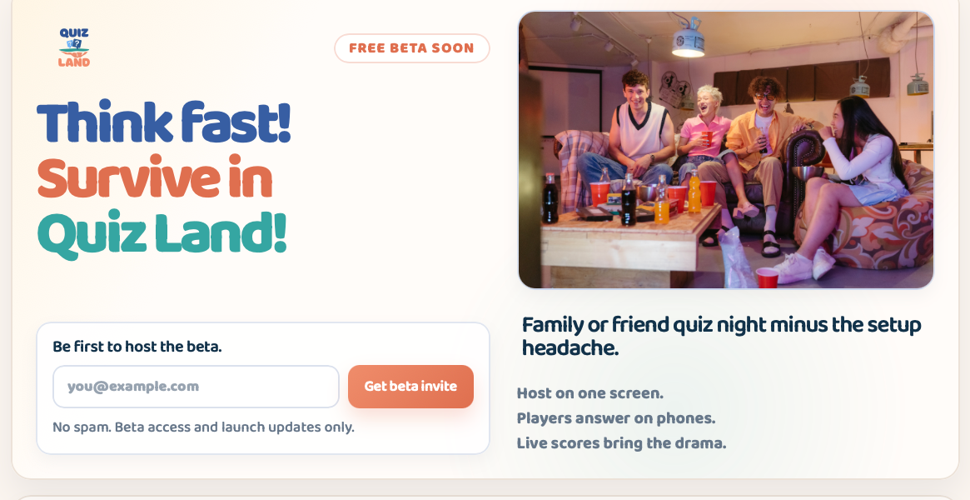

How-it-works cards
Small step cards use soft variant backgrounds, rounded corners, and compact copy.
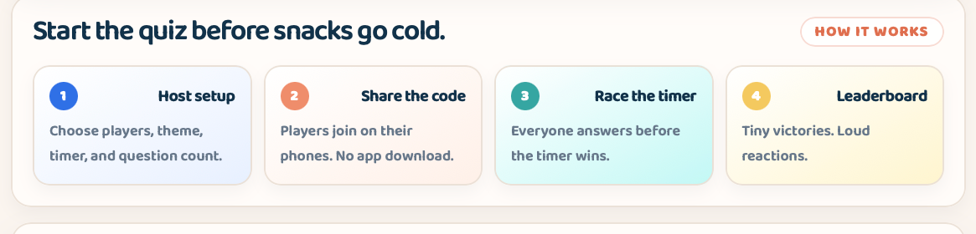

Benefit pills
Benefit labels use large rounded pill shapes with centered text and soft beige treatment.
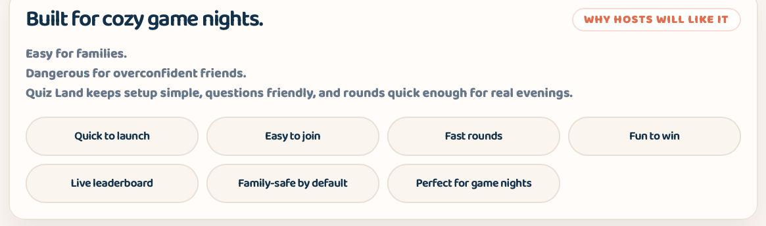

Final CTA
CTA reuses the same form style, centered composition, and large blue headline.
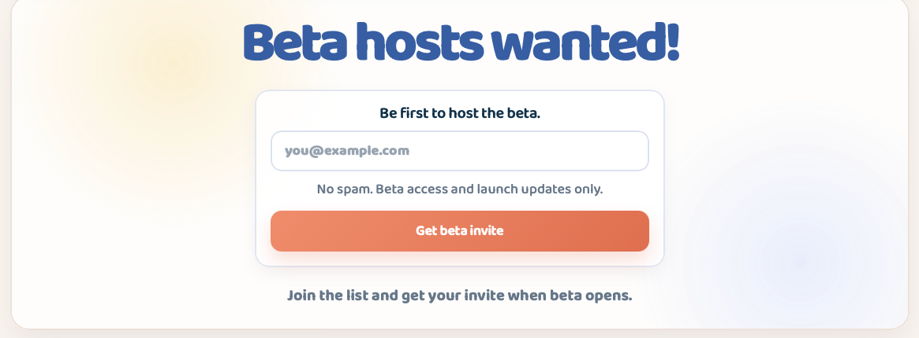

7. UI component specifications
When building new screens, reuse these component classes and values. If a new class is needed, derive it from the closest class below rather than inventing a new style.

7.1 Panels
.hero-panel,
.section,
.final-cta {
border: 1px solid rgba(234, 223, 213, 0.92);
border-radius: var(--radius);
background: rgba(255, 253, 249, 0.92);
box-shadow: var(--shadow);
}

7.2 Eyebrow pill
Used for section labels such as FREE BETA SOON, HOW IT WORKS, and WHY HOSTS WILL LIKE IT. It is a compact pill with coral text and a white translucent background.
.eyebrow {
width: fit-content;
min-height: 36px;
display: inline-flex;
align-items: center;
padding: 0 16px;
border-radius: 999px;
border: 1px solid rgba(223, 111, 79, 0.25);
background: rgba(255, 255, 255, 0.86);
color: var(--coral-dark);
font-size: 12px;
font-weight: 950;
text-transform: uppercase;
letter-spacing: 0.06em;
}

7.3 Benefit pills / labels
Benefit pills are represented by .proof-list div and .eyebrow-label in the current page. Use centered text, rounded 32px pills, soft page background, and line-colored border. Do not use the older blue-outlined pill style here.
.proof-list {
display: grid;
grid-template-columns: repeat(4, 1fr);
gap: 12px;
align-items: center;
}
.proof-list div {
min-height: 60px;
display: flex;
align-items: center;
justify-content: center;
text-align: center;
padding: 14px;
border: 1px solid var(--line);
border-radius: 32px;
background: var(--bg);
color: var(--ink);
}

7.4 How-it-works cards
Cards use compact padding, rounded corners, soft shadow, a numbered circular badge, and variant background tints.
.info-card {
display: grid;
gap: 10px;
padding: 18px;
border: 1px solid rgba(234, 223, 213, 0.95);
border-radius: 20px;
background: #ffffff;
box-shadow: var(--shadow-soft);
}
.card-blue { background: linear-gradient(150deg, #ffffff, var(--blue-soft)); }
.card-coral { background: linear-gradient(150deg, #ffffff, var(--coral-soft)); }
.card-teal { background: linear-gradient(150deg, #ffffff, var(--teal-soft)); }
.card-yellow { background: linear-gradient(150deg, #ffffff, var(--yellow-soft)); }

7.5 Step number badge
.step-number {
display: grid;
width: 34px;
height: 34px;
place-items: center;
border-radius: 999px;
background: var(--blue-action);
color: #ffffff;
font-size: 14px;
font-weight: 950;
}

7.6 Forms and CTA button
The form is a soft white card with pale blue border and subtle shadow. The primary CTA is coral gradient, rounded, and should not be replaced with blue unless a new CSS token is approved.
.hero-form {
display: grid;
gap: 10px;
width: 100%;
padding: 18px;
border: 1px solid rgba(49, 91, 156, 0.15);
border-radius: 18px;
background: rgba(255, 255, 255, 0.86);
box-shadow: var(--shadow-soft);
}
.primary-button {
min-height: 52px;
border-radius: var(--radius-sm);
padding: 0 20px;
background: linear-gradient(135deg, var(--coral), var(--coral-dark));
color: #ffffff;
}

8. Imagery and logo usage
Use the latest logo from the archive and the real friends-night photograph style for landing and marketing pages. Avoid invented placeholder cards when a real app/product image or lifestyle image is expected.
Token / class | Definition from current landing CSS
Logo | Use assets/logo.png from the latest archive. Default hero width is 92px, 84px below 980px, 72px below 640px.
Hero image | Use a real family/friend quiz-night image inside .family-image-card. Rounded 22px card, pale blue border, soft shadow.
Mood | Warm indoor, friends/family, laughter, phones, casual game night. Avoid corporate stock photos and cold device-only mockups.
Alt text | Describe the social scene and quiz context clearly.
.hero-logo { width: 92px; }
.family-image-card {
overflow: hidden;
border: 1px solid rgba(49, 91, 156, 0.18);
border-radius: 22px;
background: linear-gradient(180deg, rgba(232, 240, 255, 0.78), rgba(255, 255, 255, 0.92));
box-shadow: var(--shadow-soft);
}

9. Responsive behavior
Token / class | Definition from current landing CSS
<= 980px | Hero switches from two columns to one column. Steps grid becomes 2 columns. Logo becomes 84px.
<= 640px | Panels use 18px padding and 20px radius. Steps and proof-list become 1 column. CTA button becomes full width.
Mobile typography | H1 fixed at 42px, H2 at 26px, H3 at 20px. Keep copy short to prevent awkward wrapping.
@media (max-width: 640px) {
.hero-panel,
.section,
.final-cta {
padding: 18px;
border-radius: 20px;
}
.steps-grid,
.proof-list {
grid-template-columns: 1fr;
}
}

10. Designer and developer QA checklist
- Use only CSS tokens and class behavior from the latest landing archive unless the brand system is intentionally updated.
- Benefit pills must match the screenshot: centered text, soft beige fill, subtle line border, rounded pill shape.
- How-it-works cards must use .info-card plus one of the four card color modifiers.
- Primary CTAs must use the coral gradient button style.
- Hero typography must keep the three-color title treatment: blue, coral, teal.
- Do not reuse old in-game/admin page cards as marketing landing components.
- Check mobile at 640px and below: one-column stacks, full-width buttons, no horizontal overflow.
- Use short, punchy copy. Avoid explanatory paragraphs where labels or one-liners work.

