|  |  |  |  |  |  |  |  |  |  |  |  |  |
| --- | --- | --- | --- | --- | --- | --- | --- | --- | --- | --- | --- | --- |
|  | 0 | 1 | 2 | 3 | 4 | 5 | 6 | 7 | 8 | 9 | 10 | 11 |
| 2 | T | F | T | F | F | F | F | F | F | F | F | F |
| 3 | T | F | T | T | F | T | F | F | F | F | F | F |
| 7 | T | F | T | T | F | T | F | T | F | T | T | F |
| 8 | T | F | T | T | F | T | F | T | T | T | T | T |
| 10 | T | F | T | T | F | T | F | T | T | T | T | T |

子集和問題

給一個整數集合，判斷是否存在某個非空子集，使子集內的"數字和"為某個特定數值。

譬如，給個定集合{2,3,7,8,10}，是否存在子集和為11的集合? **sum**

答案是，有

因為子集{3,8}的數字和是11。

The **subset sum problem** is a [decision problem](https://en.wikipedia.org/wiki/Decision_problem) in [computer science](https://en.wikipedia.org/wiki/Computer_science). There are several equivalent formulations of the problem. One of them is: given a [multiset](https://en.wikipedia.org/wiki/Multiset) of integers, is there a non-empty subset whose sum is 11? For example, given the set{2,3,7,8,10}{\displaystyle \{-7,-3,-2,9000,5,8\}}, the answer is *yes* because the subset {\displaystyle \{-3,-2,5\}}{3,8} sums to 11. Another equivalent formulation is: given a multiset of *positive* integers and a target sum *T*, does any subset of the numbers sum to precisely *T*?[[1]](https://en.wikipedia.org/wiki/Subset_sum_problem#cite_note-kleinberg2006p491-1) Subset sum can also be regarded as an [optimization problem](https://en.wikipedia.org/wiki/Optimization_problem): find a subset whose sum is as close as possible to *T*.

----------------------------------------------------------------------------------------------------------------

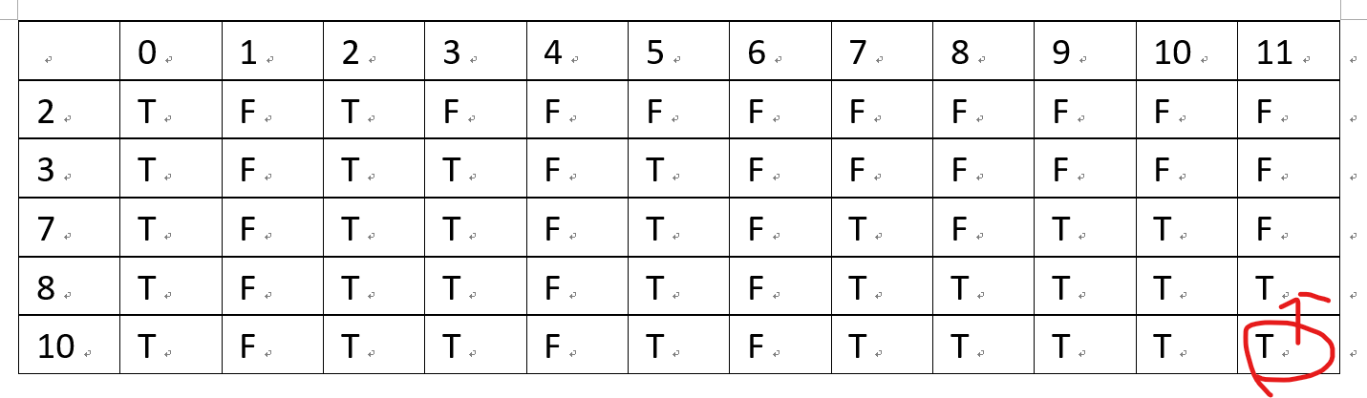

[10,11]的True可以知道是來自於[8,11]的TRUE

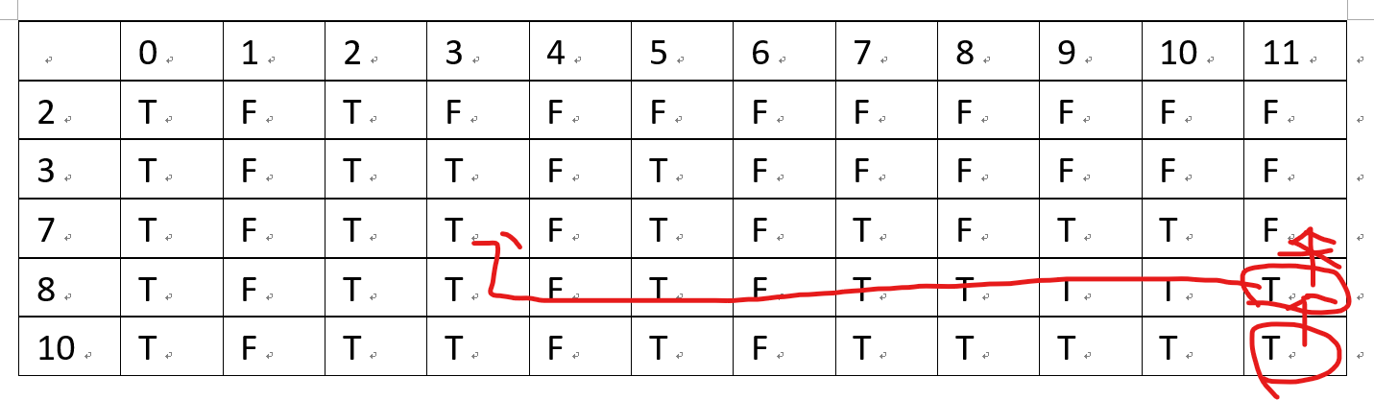

[8,11]的TRUE可以知道不是來自於[7,11]的TRUE，因為[7,11]時是FALSE

所以可以知道答案的子集有8，接下來只要找到是11-8的子集和，也就是3

再來檢查前面，可以發現[7,3]是TRUE

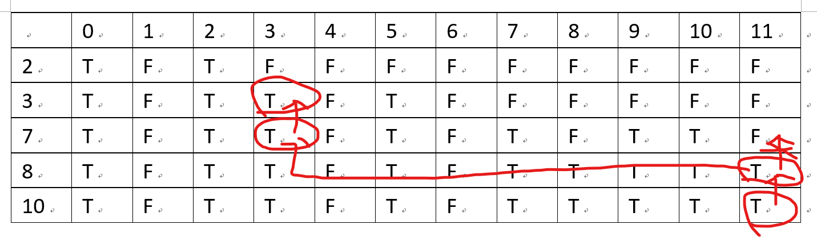

[7,3]的True可以知道是來自於[3,3]的TRUE

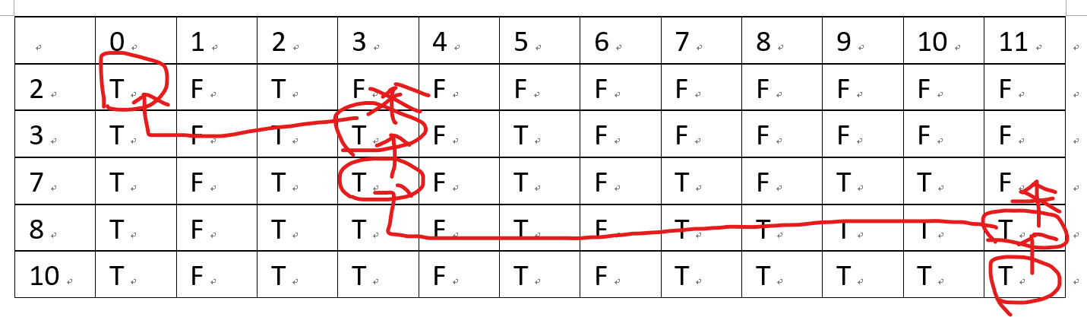

[3,3]的TRUE可以知道不是來自於[2,3]的TRUE，因為[2,3]時是FALSE

所以可以知道3要放進答案的子集

之前是{8}

放進3之後，現在子集就是{3,8}，

再來檢查前面的可以發現[3,0]是TRUE，並且能知道是來自於[2,0]的TRUE

流程結束

所以答案子集就是{3,8}

判斷式

R={1 3 5 7 9 11}

sum=10

r={1,9} || {3,7}

R{11}>sum

當子集中沒有input[i]

If ( sum < input[i] ) ︿

T[i][j] = T[i-1][j] T[i][j] 換成 T[8-1,11-8]=T[7,3]

else(sum >= input[i]) or ︿

T[i][j] = T[i-1][j] || T[i-1][j-input[i]]

﹀

[8,11]換掉[10,11]

-----------------------------------------------------------------------------------------------------------------

https://en.wikipedia.org/wiki/Subset_sum_problem

https://www.youtube.com/watch?v=s6FhG--P7z0

https://github.com/mission-peace/interview/blob/mas

ter/src/com/interview/dynamic/SubsetSum.java