|  |  |  |  |  |  |
| --- | --- | --- | --- | --- | --- |
|  | A | B | C | D | E |
| A | 0 | 1 | 0 | 1 | 0 |
| B | 1 | 0 | 1 | 1 | 0 |
| C | 0 | 1 | 0 | 0 | 1 |
| D | 1 | 1 | 0 | 0 | 1 |
| E | 0 | 0 | 1 | 1 | 0 |

無向圖

相鄰矩陣

有向圖

相鄰矩陣

|  |  |  |  |  |  |
| --- | --- | --- | --- | --- | --- |
|  | A | B | C | D | E |
| A | 0 | 1 | 0 | 0 | 0 |
| B | 0 | 0 | 1 | 1 | 0 |
| C | 0 | 0 | 0 | 0 | 1 |
| D | 1 | 0 | 0 | 0 | 0 |
| E | 0 | 0 | 0 | 1 | 0 |

算分支

無向圖:

A: degree=2

B: degree=3

C: degree=2

D: degree=3

E: degree=2

有向圖:

A: Indegree=1 outdegree=1 degree=2

B: Indegree=1 outdegree=2 degree=3

C: Indegree=1 outdegree=1 degree=2

D: Indegree=2 outdegree=1 degree=3

E: Indegree=1 outdegree=1 degree=2

有向圖

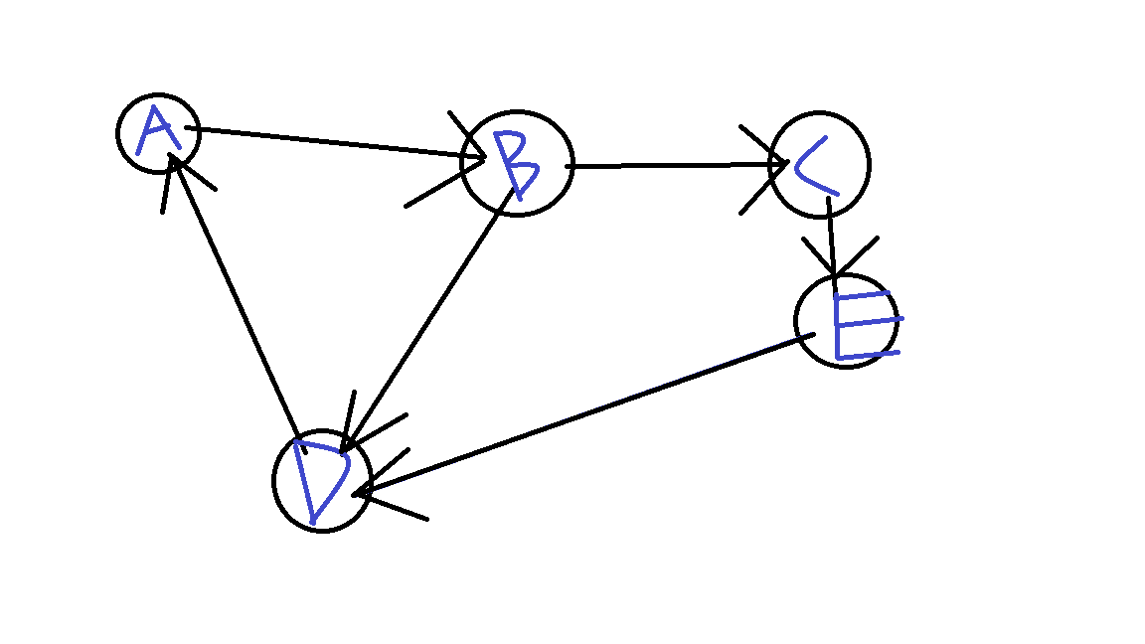

的相鄰串列

