**Exercise 4**

*Using Docker*

**Prior Knowledge**

Unix command-line  
Apt-get package manager  
Amazon AWS / EC2 Console

**Learning Objectives**

Be able to instantiate docker containers  
Be able to modify docker containers and save them

Interacting with the docker hub  
Creating a dockerfile

Running a docker container on EC2

**Software Requirements**

* AWS
* Docker
* Docker-Machine
* Ubuntu
* Nano text editor

**PART A – understanding the Docker model**

**Introduction**

This lab consists of three parts. The first part is just playing around with Docker to understand how stuff works. The things we are going to do are not typical docker usage as we are investigating the way the system works

The second part involves creating a dockerfile which is a sort of build file. This is the more usual usage of Docker and will stand you in good stead for many projects.

Finally we will load your newly created docker image up in EC2.

1. Let’s start by running a CentOs image inside our Ubuntu VM.
2. From the Ubuntu command-line, type:  
   docker pull centos  
     
   (You may need to enter the oxclo password which is **oxclo**)
3. You should see something like:

latest: Pulling from centos

47d44cb6f252: Pull complete

168a69b62202: Pull complete

812e9d9d677f: Pull complete

4234bfdd88f8: Pull complete

ce20c473cd8a: Pull complete

centos:latest: The image you are pulling has been verified. Important: image verification is a tech preview feature and should not be relied on to provide security.

Digest: sha256:c96eeb93f2590858b9e1396e808d817fa0ba4076c68b59395445cb957b524408

Status: Downloaded newer image for centos:latest

1. We will take a look at what this means shortly, but first lets try it out.  
   docker run -ti centos /bin/bash  
     
   You should see:  
   [root@c22c9c908236 /]#  
     
   Did you notice how fast it started?! This is not your usual VM.  
     
     
   Let’s refer to this window as the *docker window.*

***Hint:*** *-ti basically means run this container in interactive mode. For more explanation see:* [*https://docs.docker.com/engine/reference/run/*](https://docs.docker.com/engine/reference/run/)

1. Now type   
   ls /home/oxclo  
     
   This will fail, because we are now in a mini virtual machine. Now try   
     
   apt-get  
     
   Again it fails. But what about yum?  
   Why does yum succeed? Because yum is the package manager for CentOS and now we are in a CentOS world. (Actually we won’t use yum or apt-get *within* the docker… we’ll come to how that works shortly).
2. Start a separate window. Let’s refer to this as the *control window.* Now type  
     
   docker ps
3. You will see something like:

CONTAINER ID IMAGE COMMAND CREATED STATUS PORTS NAMES

c22c9c908236 centos:latest "/bin/bash" 10 minutes ago Up 10 minutes drunk_engelbart

1. Docker has given your container instance a random name (in my case drunk_engelbart). You can now see how this instance is doing:  
     
   docker stats drunk_engelbart  
     
   Obviously change *drunk_engelbart* to the name of your container!
2. Notice how little memory each container takes.
3. Now **Ctrl-C** to exit that command.
4. Now go onto <http://hub.docker.com> and signup. You need a valid email address to complete signup. I think you might want to do this in your own name because it’s a useful system.
5. Once you have signed up, then do a docker login:  
   docker login -u *yourdockerhubuserid*
6. Back in the control window, type   
     
   docker commit <your_container_name> <yr_dock_id>/mycentos  
   e.g.  
     
   docker commit drunk_engelbart pizak/mycentos
7. Now list the images you have locally  
     
   docker images
8. You will see something like:  
   REPOSITORY TAG IMAGE ID CREATED VIRTUAL SIZE  
   pizak/mycentos latest 9f154062124f 21 minutes ago 172.3 MB  
   centos latest ce20c473cd8a 5 weeks ago 172.3 MB
9. Actually it would be useful to give that image a version name:  
     
   docker tag pizak/mycentos pizak/mycentos:1
10. Repeat the sudo docker images command.
11. Now let’s push that image up to the docker hub:

docker push pizak/mycentos:1  
  
*Enter your docker hub credentials when prompted.*

1. The system will whirr away and upload some stuff. Eventually you will see something like:

The push refers to a repository [pizak/mycentos] (len: 1)

9f154062124f: Image already exists

ce20c473cd8a: Image successfully pushed

4234bfdd88f8: Image already exists

812e9d9d677f: Image already exists

168a69b62202: Image successfully pushed

47d44cb6f252: Image already exists

Digest: sha256:f751347496258e359fdc065b468ff7d72302cbb6f2310adee802b6c5ff92615d

1. Now let’s go back to the original docker window, where your image is still running. Make a new file in home like this:

[root@482fe4e23a8b /]# cd home

[root@482fe4e23a8b home]# echo hi > hi

[root@482fe4e23a8b home]# ls

hi

1. Now in your control terminal you can commit this change:  
     
   docker commit drunk_engelbart pizak/mycentos:2
2. Let’s push that image you’ve just made up to the Docker hub:  
     
   docker push pizak/mycentos:2
3. Notice how this time only a few bytes were uploaded. This is because of the layered file-system that docker uses to only save incremental changes. It is one of the major benefits of the docker system.
4. 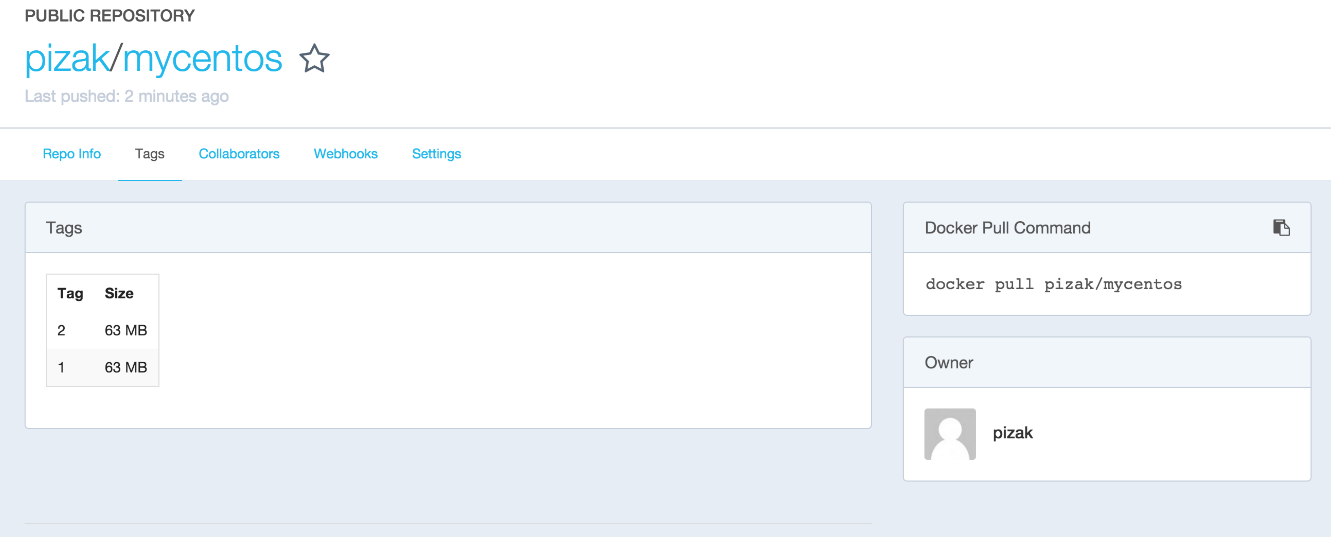Go to the docker website <http://hub.docker.com> and view your repositories. In particular look at the tags tab:
5. You can now pull this docker image and create a container anywhere you like. Let’s try some stuff out. From your *docker window* first exit the container by typing exit or Ctrl-D.
6. Now let’s start v1 of your container:  
     
   docker run -ti pizak/mycentos:1 /bin/bash

Try looking at the home directory:  
ls /home

Now exit and load version 2  
  
docker run -ti pizak/mycentos:2 /bin/bash  
ls /home

1. To prove that this is saved in the docker repo, do the following:  
     
   First delete all the images locally that were tagged with your userid:  
   *(Replace pizak with your userid)*   
   docker rmi -f $(docker images -q pizak/*)
2. Now try to start v2 again. You will see that docker automatically re-downloads this and then runs it. Check that your file exists in the /home directory.
3. The one thing we haven’t yet seen is how to get a docker image to do something vaguely useful.
4. First check you have nothing running locally on port 80. Browse to <http://localhost:80> It should fail.
5. Now in your docker window, type:  
     
   docker run –p 80:80 httpd
6. You should see a bunch of stuff like this:

Unable to find image 'httpd:latest' locally

latest: Pulling from httpd

ef2704e74ecc: Pull complete

1d6f63d023f5: Pull complete   
…

781a5fd1cabf: Pull complete

bbd8adcb3ad5: Pull complete

6f953eead92f: Pull complete

afa235ca0577: Pull complete

f6d0a9cc3857: Pull complete

3fdd2b382f43: Pull complete

httpd:latest: The image you are pulling has been verified. Important: image verification is a tech preview feature and should not be relied on to provide security.

Digest: sha256:fe40d6cb973ad7acbbc5fa99867efc03474649250a54da002fddaa88c6a5ff2f

Status: Downloaded newer image for httpd:latest

AH00558: httpd: Could not reliably determine the server's fully qualified domain name, using 172.17.0.11. Set the 'ServerName' directive globally to suppress this message

AH00558: httpd: Could not reliably determine the server's fully qualified domain name, using 172.17.0.11. Set the 'ServerName' directive globally to suppress this message

[Fri Nov 20 14:08:08.239803 2015] [mpm_event:notice] [pid 1:tid 140576655767424] AH00489: Apache/2.4.17 (Unix) configured -- resuming normal operations

[Fri Nov 20 14:08:08.239940 2015] [core:notice] [pid 1:tid 140576655767424] AH00094: Command line: 'httpd -D FOREGROUND'

1. Now browse <http://localhost:80> again and you should see. 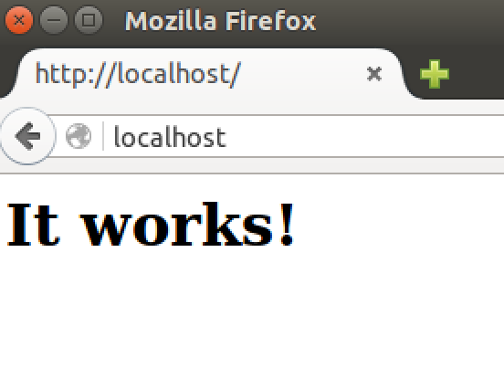
2. *Are you wondering what –p 80:80 means?*It means expose port 80 from within the container as port 80 in the host system.
3. Now kill that container (Ctrl-C) and start it again in detached mode.   
   This is how you would normally run a docker workload.  
     
   docker run –d –p 80:80 httpd
4. To find your docker runtime try   
     
   docker ps  
     
   CONTAINER ID IMAGE COMMAND CREATED STATUS PORTS NAMES

f9ed00d6c251 httpd:latest "httpd-foreground" 5 seconds ago Up 4 seconds 0.0.0.0:80->80/tcp reverent_lalande

and finally to stop it  
  
docker kill reverent_lalande

**Recap:**  
In this section we have learnt basic docker commands including run, ps, image, commit, push and pull. We have learnt about the layered file system, and also about the docker repository.

We have looked at exposing network ports, how to start detached workloads and how to kill them.

In particular, notice how the docker containers seem like processes, but with the complete configuration neatly packaged and contained within a single packaged system that can be versioned, pushed and pulled. This model is ideal for creating and managing *microservices.*

**PART B – creating a Dockerfile**

1. While I can imagine it might be possible to create docker images by modifying them like we have and then saving them, this is not a repeatable easy to use approach. Instead we want to build a dockerfile in a repeatable way.
2. Make a new directory (e.g. ~/dockerbuild)  
   Change to that directory and edit a file there called Dockerfile
3. Copy and paste the contents of this Dockerfile into it:  
   <http://freo.me/oxclo-dockerfile>
4. Save it.
5. Build it:  
     
   From the command line (in the correct directory) execute:  
     
   docker build -t *<your_docker_id>*/nodeapp:1 .
6. While it is building, take a look at the docker file and also the reference guide:  
   <https://docs.docker.com/engine/reference/builder/>
7. Once it has built, try running it:  
     
   docker run -d -p 80:8080 <yrdockerid>/nodeapp:1
8. Browse http://localhost:80 and you should see:  
   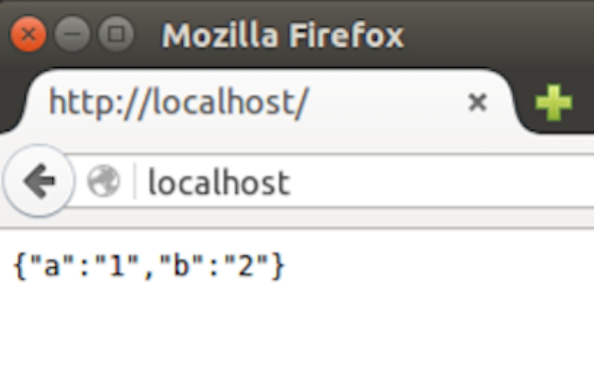
9. Finally, push your newly created docker image into the cloud:  
     
   docker push <yrdockerid>/nodeapp:1

Congratulations, you have completed part B.

**PART C – Running your docker in the cloud**

1. There is an Amazon Elastic Container Service for running containers. This provides their own container orchestration model, alternative to Docker Swarm and Kubernetes. However, we are going to use Docker Machine and Docker to start our systems instead, giving us a portable approach.
2. If you already did Exercise 1, then your AWS credentials should be stored in ~/.aws/credentials. Docker Machine uses those so you don’t need to set any environment variables.
3. Type:  
   docker-machine create \   
    -d amazonec2 \  
    --amazonec2-region eu-west-1 \  
    --engine-install-url=https://freo.me/getdocker \  
    --amazonec2-security-group web-server-sg \  
    oxcloXX-docker

This ensures our server will run in Ireland, and use our security group. The instance will be called oxcloXX-docker.   
  
*There is currently a bug in using the latest docker with AWS which is fixed by the engine-install-url.*

You should see:  
  
Running pre-create checks...

Creating machine...

(oxclo01-docker) Launching instance...

Waiting for machine to be running, this may take a few minutes...

Detecting operating system of created instance...

Waiting for SSH to be available...

Detecting the provisioner...

Provisioning with ubuntu(systemd)...

Installing Docker...

Copying certs to the local machine directory...

Copying certs to the remote machine...

Setting Docker configuration on the remote daemon...

Checking connection to Docker...

Docker is up and running!

To see how to connect your Docker Client to the Docker Engine running on this virtual machine, run: docker-machine env oxclo01-docker

1. Go to the AWS Console and you should see an EC2 instance now running.
2. Follow that last suggested command:  
     
   docker-machine env oxcloXX-docker

You should see:

export DOCKER_TLS_VERIFY="1"

export DOCKER_HOST="tcp://54.246.240.90:2376"

export DOCKER_CERT_PATH="/home/oxclo/.docker/machine/machines/oxclo01-docker"

export DOCKER_MACHINE_NAME="oxclo01-docker"

# Run this command to configure your shell:

# eval $(docker-machine env oxclo01-docker)

1. Once again, do as asked:

eval $(docker-machine env oxcloXX-docker)

1. Now when you run docker commands, they will no longer act locally on your Ubuntu VM, but instead on the AWS instance you’ve just started.
2. Now run the docker container again:  
   docker run -d -p 80:8080 <yrdockerid>/nodeapp:1
3. You can find the address of the AWS instance using:  
   docker-machine ip oxcloXX-docker  
     
   or by looking in the AWS console
4. Open a browser window and check you can access the app (running on port 80)
5. You can also SSH into the server using:  
   docker-machine ssh oxcloXX-docker
6. Try that. When you are finished type   
   logout
7. To terminate the instance, type:  
   docker-machine rm -f oxcloXX-docker
8. Check that the instance is now terminating in the AWS console.
9. Docker Machine will have automatically created a new key pair for this server (which is not ideal…. ). To tidy up, lets remove that:  
     
   aws ec2 delete-key-pair --key-name oxcloXX-docker

*Recap: What we have done is to take the container-ised application we built on our local machine and then deploy it automatically to EC2. While this looks a bit similar to using userdata (which we did in a previous exercise), in fact this is much more replicable because we can test and deploy our docker image on many different systems. For example, if you sign up to the Github Student deal, you get free credit on DigitalOcean, and with a very similar model you could run the same docker code on there.***Extension**

If you have a github or bitbucket account, you can put the Dockerfile into the repository and automatically build it. Have a go.   
  
Some rough hints:

Create a new public repository and place the Dockerfile in the root directory.

In <http://hub.docker.com> go to Settings (click on your username)  
Choose Linked Accounts and Services  
Link to your Github account. Choose the “Public and Private”

Now click on Create (next to search) and Create Automated Build.

Select your github repository.

Enter a description. Click Create.  
Now check the build status in the Build details tab. It takes about 3 minutes to build. If its not building you can manually trigger it from the build settings.  
Try doing an update to your dockerfile (maybe a spare comment) and then git push.