Phone Store

@ by Tran, Phu Hoa

# Description

## Overview

ABC phone shops need a commodity management software. This software is an information management list of each commodity. For each item you want to manage your name, manufacturer, specifications...

## Functions

### Display phone store

* When the user opens the software, it will display a list of products as shown below:

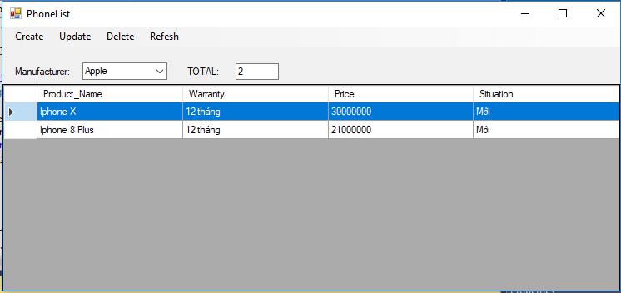

### Manage your product list

* Users can add a product to the software by providing the following information

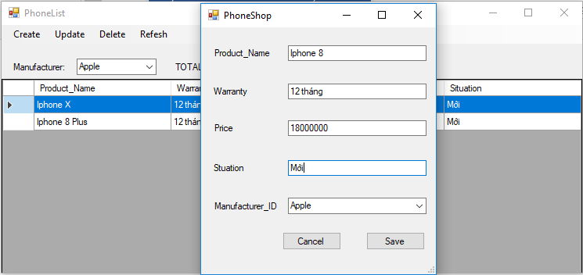

* Users can easily edit a product information or remove a product from the software

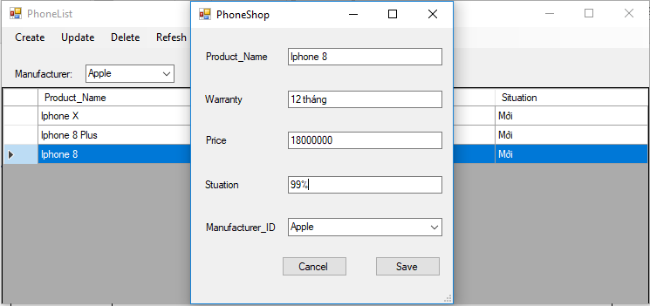

# Use cases diagram

### Display phone store use case

|  |  |
| --- | --- |
| Title | Display phone store |
| Description | Users enter some products in their store. Then, the software displays a list of each row as a product. |
| Actor | User |
| Precondition | User input information of the store products on the store |
| Postcondition |  |
| Main | 1. The user selects "Display Products" from the menu 2. The system displays a list of products where each row corresponds to a product (*see Fig. 1*) |
| Extensions |  |
| Mockup screens | Fig. 1 Display Products |

### List Product Information use case

|  |  |
| --- | --- |
| Title | List all product information |
| Description | User want to show all product that they inputted into the system. Then the software show a list of all product with their detail information |
| Actor | User |
| Precondition | User starts running the system |
| Postcondition |  |
| Main | 1. User selects “Manage product Info” from the menu 2. System displays a list of all products existing in the system. Each product has the following information: Name... . See Fig. 2 |
| Extensions |  |
| Mockup screens | Fig. 2 List of all product information |

### Create New Prodct use case

|  |  |
| --- | --- |
| Title | Create new product with information |
| Description | User want to add a new product into system. Then the software allows user to input all information related to that product |
| Actor | User |
| Precondition | User is showing a list of all system product |
| Postcondition |  |
| Main | 1. User selects “Add New product” from the menu 2. System displays a form for user to input the following information related to the new product: Name... . See Fig. 3 3. User inputs all information into the form and click “Submit” button 4. System displays a list of all product including the new product |
| Extensions | 1. a. If user inputs wrong information format (e.g. name…) then go to step 2. |
| Mockup screens | Fig. 3 Input information for new Product |

### Edit Product Info use case

|  |  |
| --- | --- |
| Title | Updating information for existing product |
| Description | User want change information of one product existing in system. Then the software allows user to input new information related to that product |
| Actor | User |
| Precondition | User is showing a list of all system product |
| Postcondition |  |
| Main | 1. User selects a product from the list and select “Edit information” from the menu bar 2. System displays a form that contains current information of that product and allows user to input or change the data, consist of: Name... . See Fig. 4 3. User inputs all information into the form and click “Submit” button 4. System displays a list of all products including the product with new information |
| Extensions | 1. a. If user inputs wrong information format (e.g. name…) then go to step 2. |
| Mockup screens | Fig. 4 Update information for existing product |

### Delete Existing Product use case

|  |  |
| --- | --- |
| Title | Delete existing product from database |
| Description | User want to remove one product information from the system database. Then the software allows user to select the one and then remove it from the database |
| Actor | User |
| Precondition | User is showing a list of all system products |
| Postcondition |  |
| Main | 1. User selects a product from the list and select “Remove product” from the menu bar 2. System displays a confirmation dialog for confirming the action 3. User confirms the action by selecting Yes button 4. System displays a list of all products excluding the product that user want to remove |
| Extensions | 1. a. If user select No button from confirming dialog, then system displays a list of all products again |

### Search Existing Products use case

|  |  |
| --- | --- |
| Title | Search existing products in the system |
| Description | User want to search some products with some criteria. Then the system filters and display all products that satisfy the inputted criteria |
| Actor | User |
| Precondition | User is showing a list of all system products |
| Postcondition |  |
| Main | 1. User enter information into the search box and press Enter key 2. System displays a list of all products that having the information that user entered. See Fig. 2 for the list in details. |
| Extensions |  |

1. Database
2. Table manufacturers

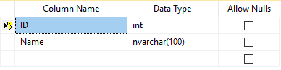

1. Table of products

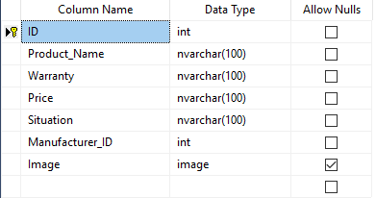

1. Database diagrams

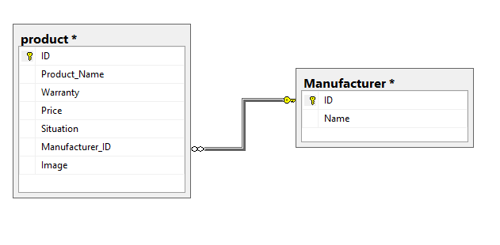

1. Source code path

Link github: https://github.com/tranphuhoa/T150112_TranPhuHoa_PhoneShopApp