A_B_C Tạo CSDL và nhập dữ liệu

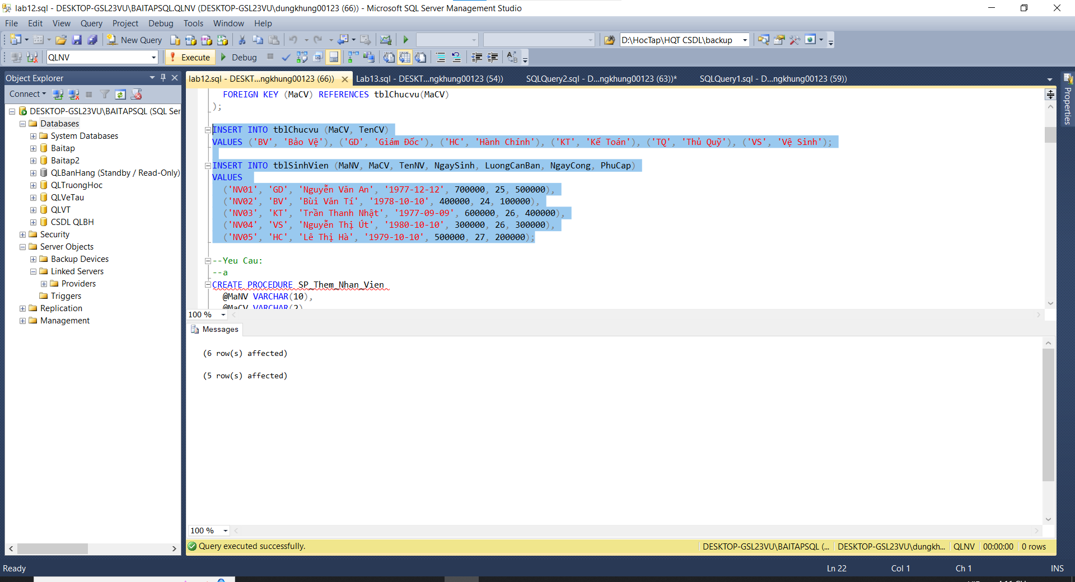

D)Yêu cầu

a)

b)

c)

d)

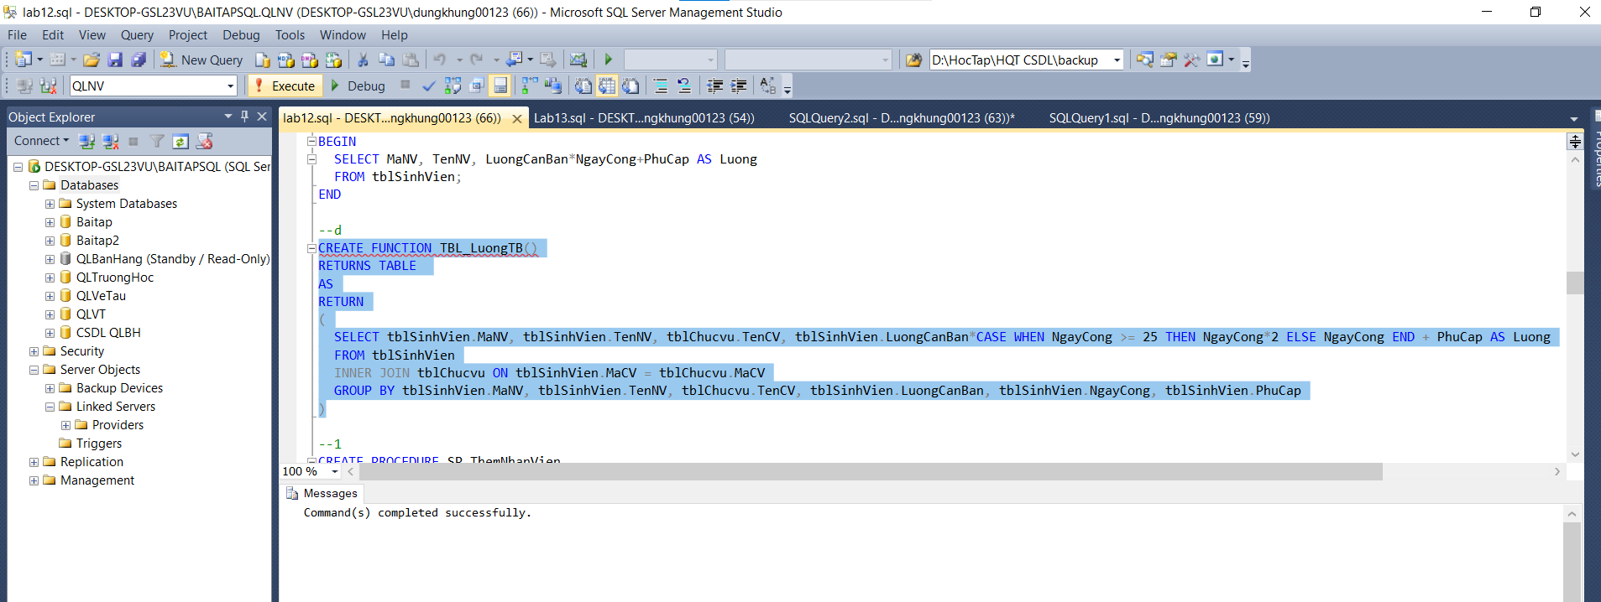

1)

2)

3)

4)

5)

