Câu 1:

Câu 2

Câu 3

a)

b)

c)

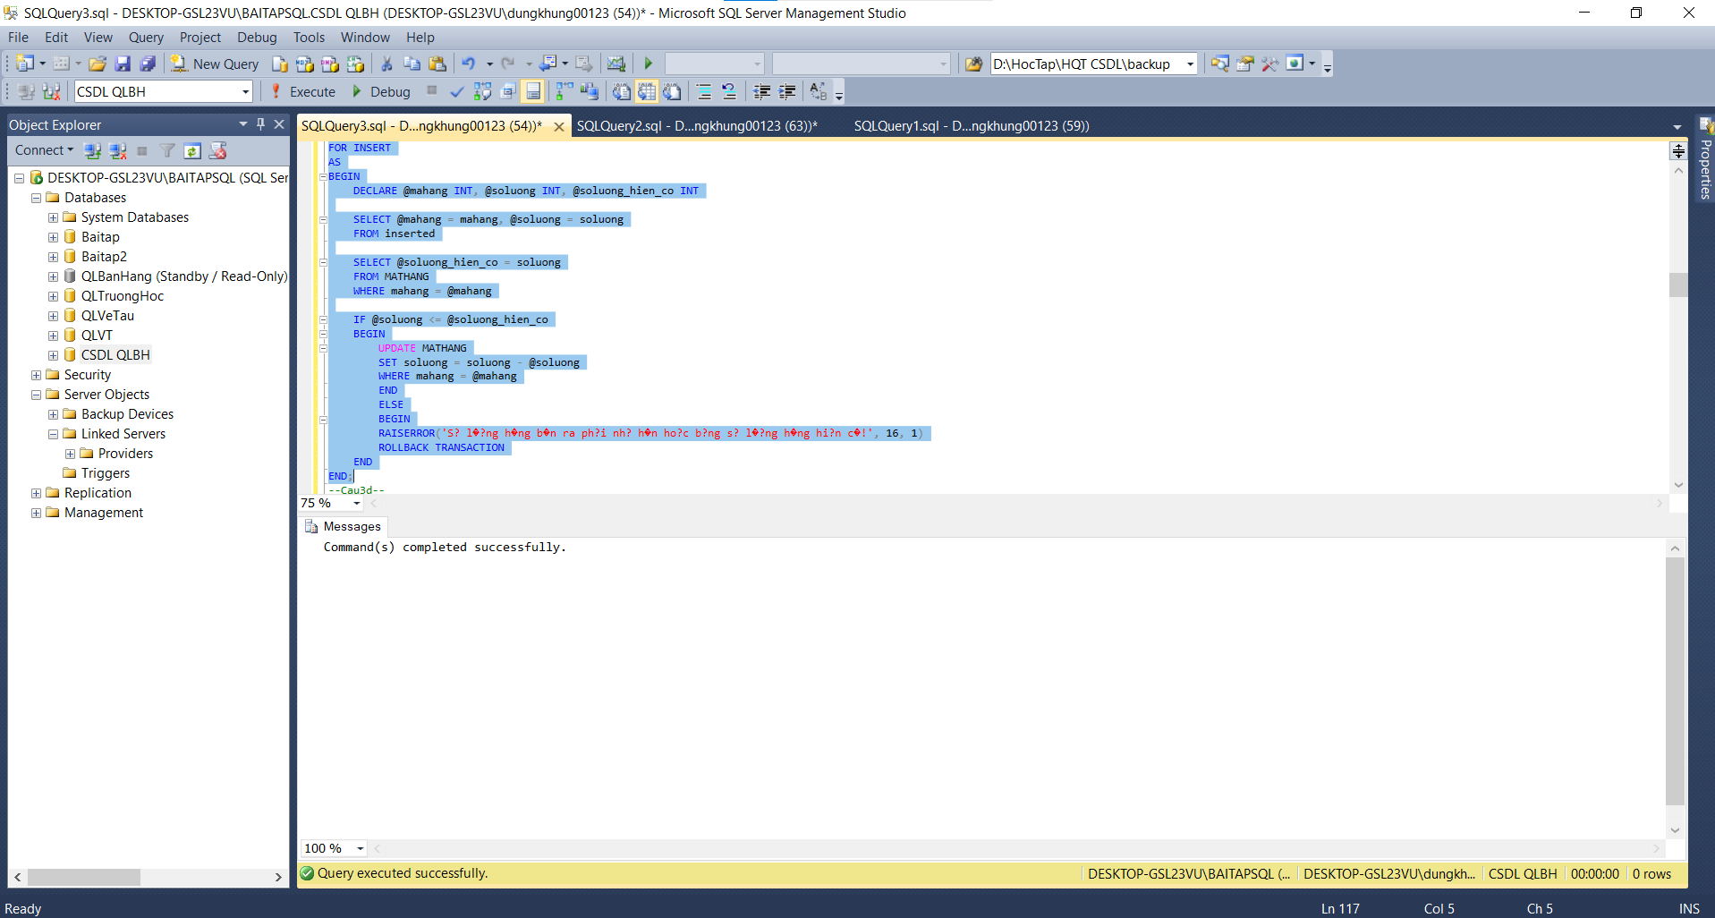

d)

e)

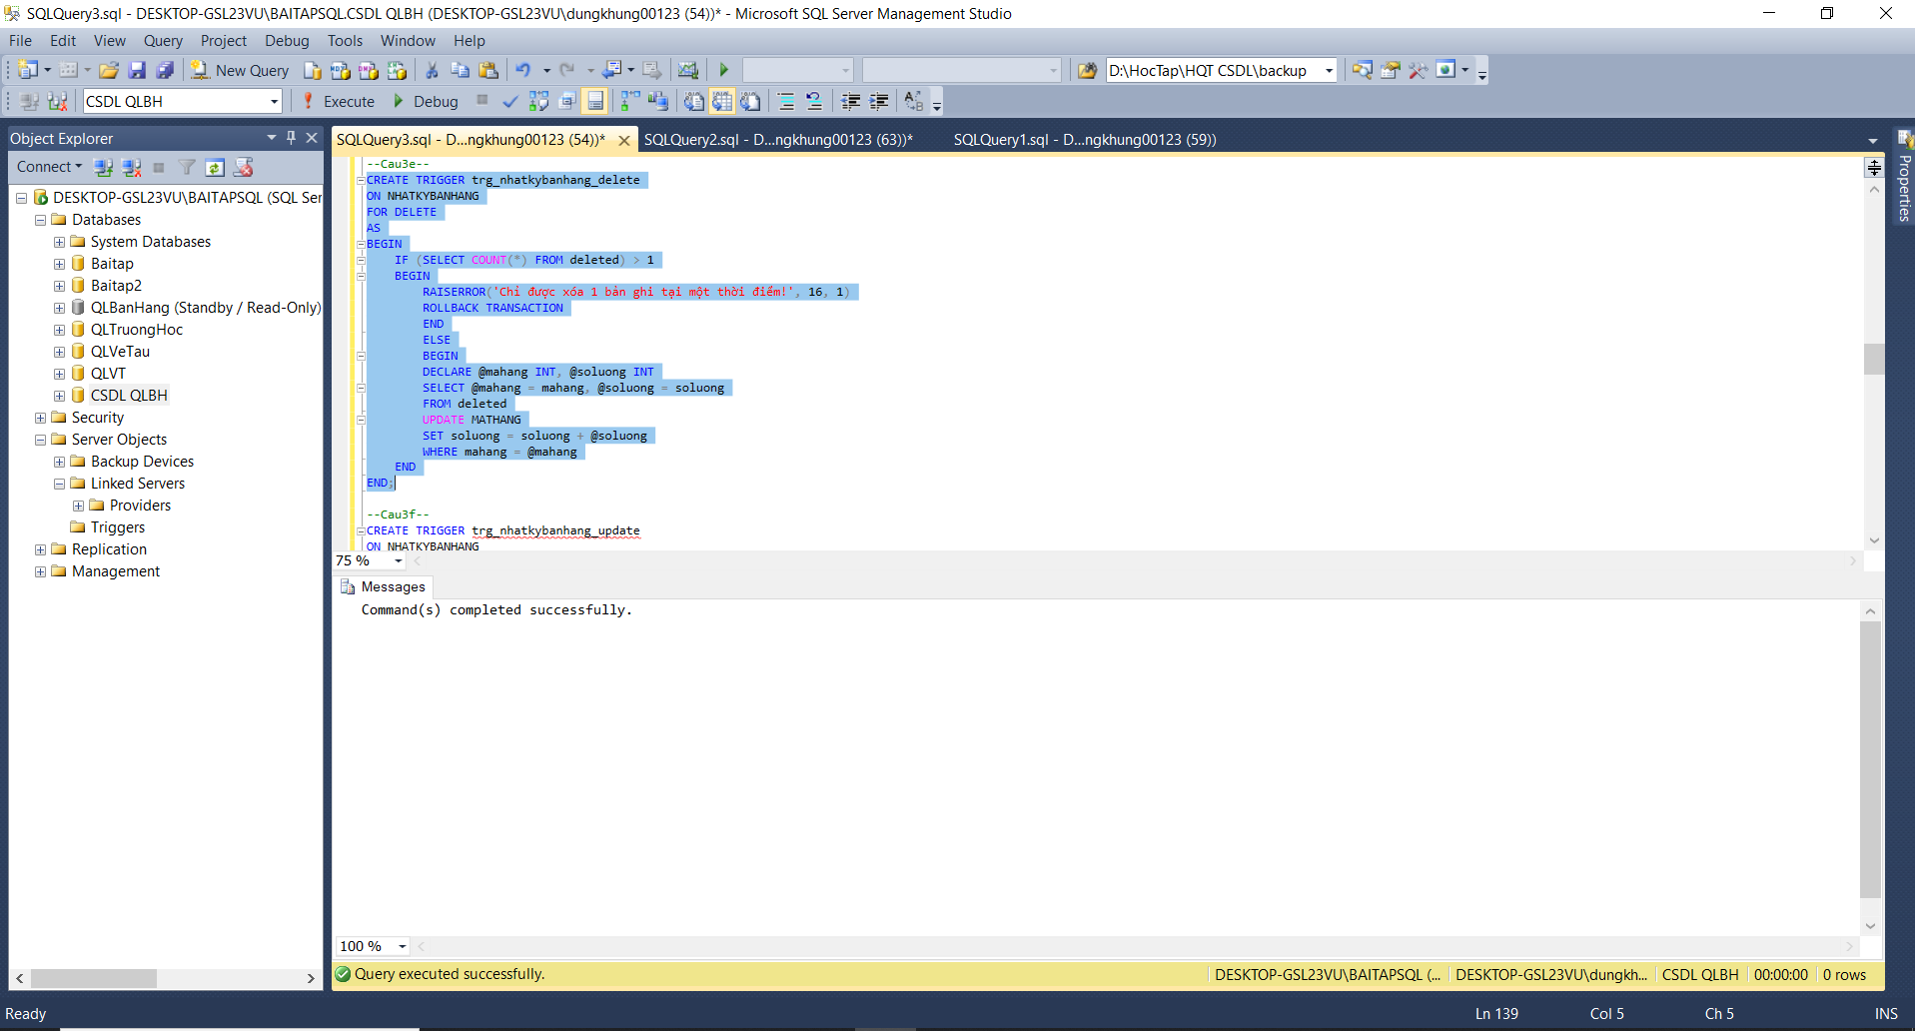

f)

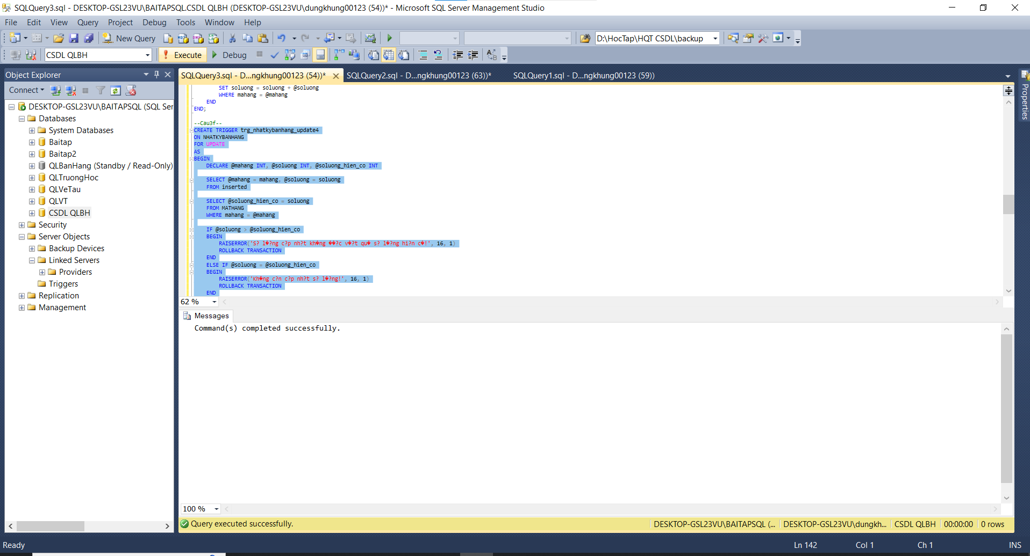

g)

h)

i)

Test câu 2

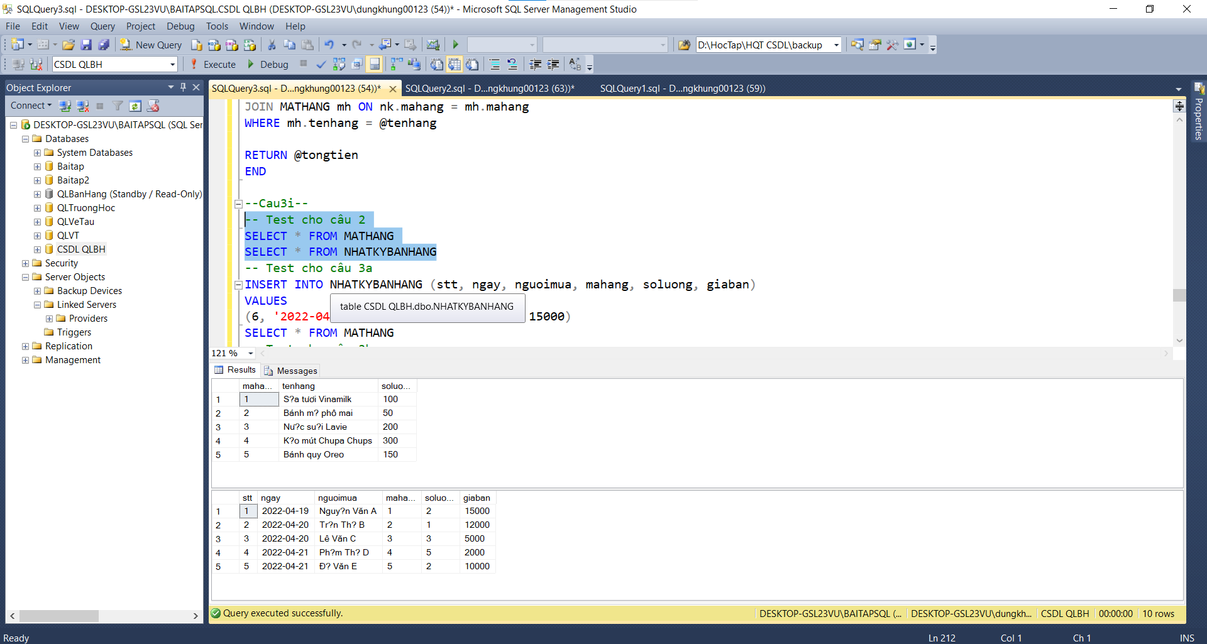

Test câu 3a)

Test câu 3b)

Test câu 3c)

Test câu 3d)

Test câu 3e)

Test câu 3f)

Test câu 3g)

Test câu 3h

