**Link source : https://github.com/QuocDuong-282003/test_technical_backend.git**

e) Write API specifications, API according to RESTful standards to:

i) Fetches a list of all product categories available in the e-commerce

platform.

|  |  |
| --- | --- |
|  |  |

|  |  |
| --- | --- |
|  |  |

iii) Allows users to search (full-text search) for products using various filters and

search terms.

|  |  |
| --- | --- |
|  |  |

iv) Creates a new order and processes payment.

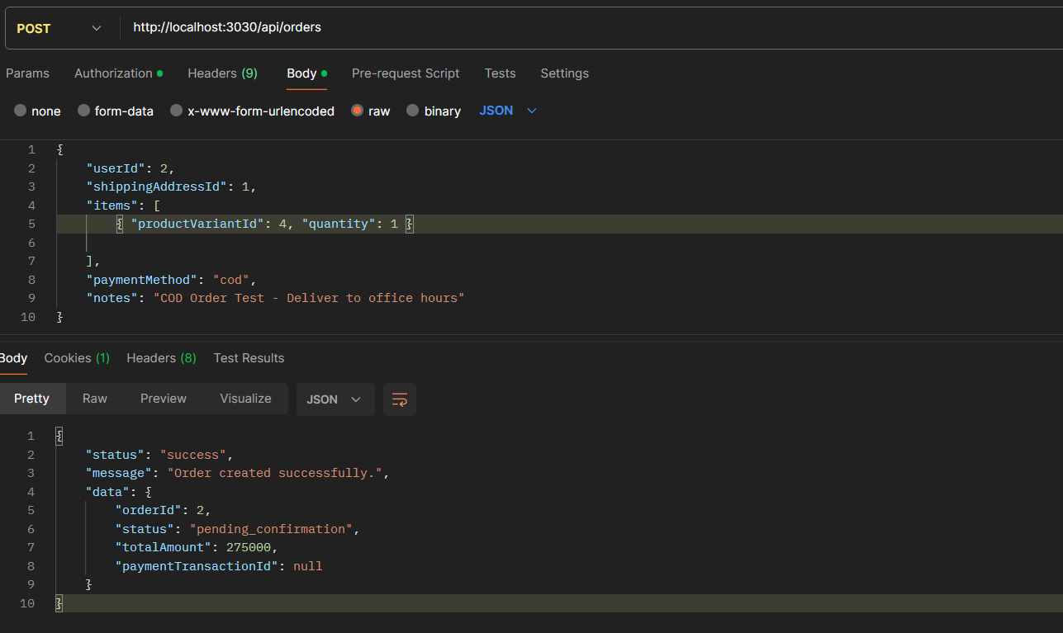

v) Send order confirmation email to user (processed asynchronously with order

creation flow).

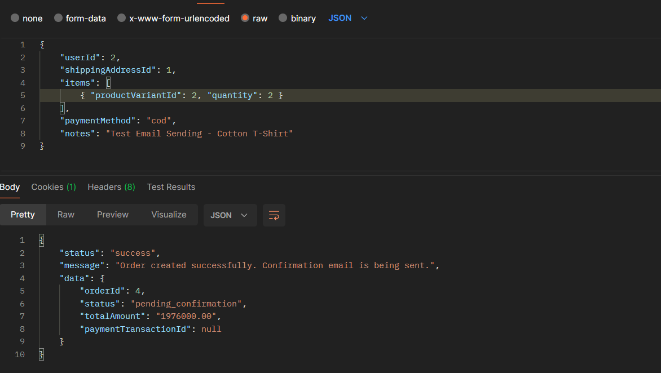

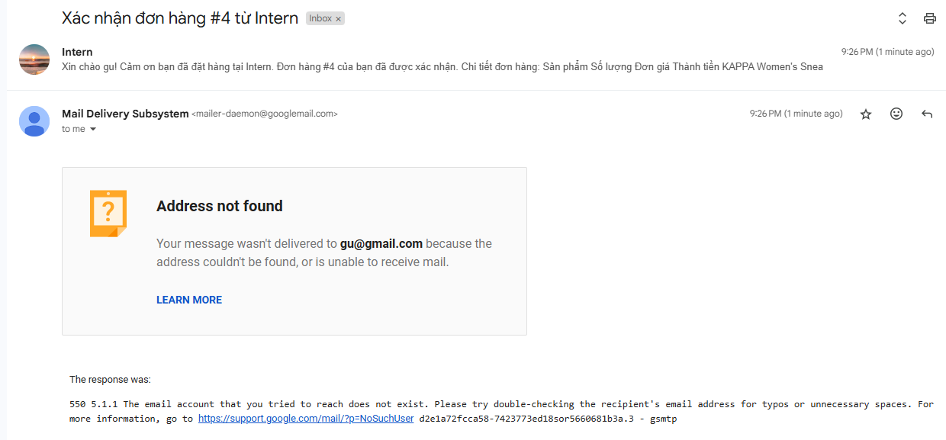

f) Implement the above APIs with the language/framework you choose.