Replica of League of Legends’s Health Bar

|  |
| --- |
| **If you’re satisfied with this product, please consider** [**donation**](https://www.paypal.me/piratas10)**.**  **It is not mandatory, but it will help me making other FREE product for your game development process.**  **Those money may not be much, but they are highly appreciated !** |

This tutorial will aid you in the implementation of the product to your own project.

Create the health bar as the example below:

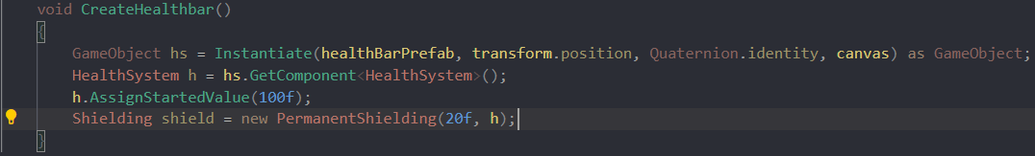

You can also check an example in **TestClass.cs**

**Health Bar Method:**

|  |  |
| --- | --- |
| **AssignStartedValue**(float **maxHealth**) | Initialize the given health and the max health |
| **AssignNewMaxHealth**(float **maxHealth**) | Changing the max health |
| **AssignNewValue**(float **currentHealth**, float **maxHealth**) | Changing both the max health and the current health |
| **TakeDamage**(float **damage**) | Decrease the health by an amount |
| **GainHealth**(float **health**) | Increase the health by an amount |

**Shielding-Derived Class**

|  |  |
| --- | --- |
| **Permanent Shielding**(float **amount**, HealthSystem **healthSystem**) | Create a shield staying permanently until all its health points is lost |
| **Temporary Shielding**(float **shieldAmount**, float **timeAmount**, HealthSystem **healthSystem**) | Create a shield for an amount of time |
| **Fading Shielding**(float **shieldAmount**, float **timeAmount**, HealthSystem **healthSystem**) | Create a shield that decay for an amount of time |

**NOTE:**

+ If you want to alter the size of the health bar, change the scale value of Rect Transform Component instead of dragging the health bar.

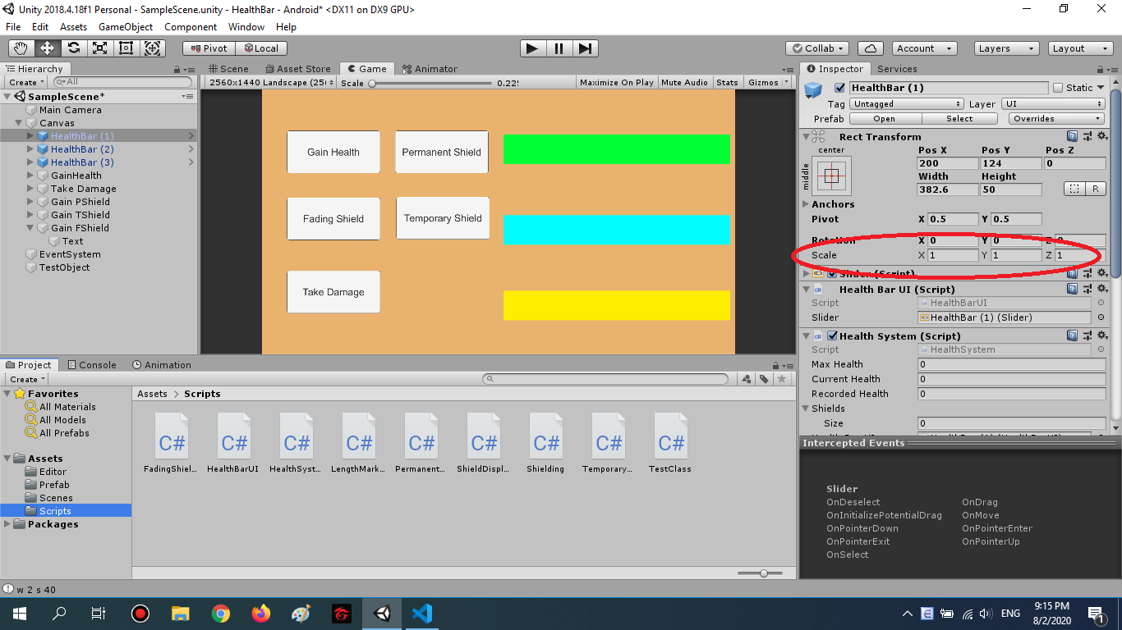

*Changing the size like this*

+ Fading Shielding experienced some bugs, it is not recommended for using.

----------------------------------------------------------------------------------------------------------

If you have any question, want to report bugs, or give me some feedbacks, just text me on any social media account I have posted this product and please give a thumbs-up on my [Facebook Page](https://www.facebook.com/Piratas-101162171458744/) for new free assets:

If you come up with solutions for some problems, bugs or any kind of naming convention, any ideas will be appreciated.

I will answer it as soon as possible.