THỰC HÀNH BUỔI 4 (Máy 17)
Nguyễn Dương Quốc Huy
1150070017
LAB 10 – 11
TRUYỆN CƯỜI
Khai báo manifest:
<?xml version="1.0" encoding="utf-8"?>
<manifest xmlns:android="http://schemas.android.com/apk/res/android"
package="com.example.nguyenduongquochuylab">
<application
android:allowBackup="true"
android:label="Truyện Cười"
android:icon="@mipmap/ic_launcher"
android:roundIcon="@mipmap/ic_launcher_round"
android:supportsRtl="true"
android:theme="@style/Theme.AppCompat.Light.NoActionBar">
<activity
android:name=".MainActivity"
android:exported="true">
<intent-filter>
<action android:name="android.intent.action.MAIN" />
<category android:name="android.intent.category.LAUNCHER" />
</intent-filter>
</activity>
<activity
android:name=".CategoryActivity"
android:exported="false" />
<activity
android:name=".StoryDetailActivity"
android:exported="false" />
</application>
</manifest>
MainActivity.java - Màn hình Splash:
package com.example.nguyenduongquochuylab;
import androidx.appcompat.app.AppCompatActivity;
import android.content.Intent;
import android.os.Bundle;
import android.os.Handler;
public class MainActivity extends AppCompatActivity {
@Override
protected void onCreate(Bundle savedInstanceState) {
super.onCreate(savedInstanceState);
setContentView(R.layout.activity_main);
new Handler().postDelayed(() -> {
startActivity(new Intent(MainActivity.this, CategoryActivity.class));
finish();
}, 2000);
}
}
CategoryActivity.java - Danh sách chủ đề:
package com.example.nguyenduongquochuylab;
import androidx.appcompat.app.AppCompatActivity;
import androidx.recyclerview.widget.LinearLayoutManager;
import androidx.recyclerview.widget.RecyclerView;
import android.content.res.AssetManager;
import android.os.Bundle;
import android.util.Log;
import com.example.nguyenduongquochuylab.adapter.CategoryAdapter;
import java.io.IOException;
import java.util.ArrayList;
public class CategoryActivity extends AppCompatActivity {
RecyclerView rcv;
ArrayList<Category> list = new ArrayList<>();
@Override
protected void onCreate(Bundle savedInstanceState) {
super.onCreate(savedInstanceState);
setContentView(R.layout.activity_category);
rcv = findViewById(R.id.rcvCategory);
loadCategories();
CategoryAdapter adapter = new CategoryAdapter(this, list);
rcv.setLayoutManager(new LinearLayoutManager(this));
rcv.setAdapter(adapter);
}
private void loadCategories() {
try {
AssetManager am = getAssets();
String[] imgs = am.list("photo");
String[] stories = am.list("story");
if (imgs == null || stories == null) {
Log.e("HUY_DEBUG", "⚠ Assets folder NOT FOUND!");
return;
}
for (String img : imgs) {
String base = img.substring(0, img.lastIndexOf("."));
String txt = base + ".txt";
boolean exists = false;
for (String s : stories) {
if (s.equals(txt)) {
exists = true;
break;
}
}
if (exists) {
String vietnameseName = convertToVietnamese(base);
list.add(new Category(vietnameseName, img));
}
}
} catch (IOException e) {
e.printStackTrace();
}
}
private String convertToVietnamese(String base) {
switch (base) {
case "BaiGiangVeTinhYeu": return "Bài giảng về tình yêu";
case "BaiHocVeThucVat": return "Bài học về thực vật";
case "BaiKiemTraDacBiet": return "Bài kiểm tra đặc biệt";
case "ChauLucVaBanDo": return "Châu lục và bản đồ";
case "ChuaBaiChoDung": return "Chữa bài cho đúng";
case "DoDoanTenConVat": return "Đố đoán tên con vật";
case "GiaiPhapDacBiet": return "Giải pháp đặc biệt";
case "KetQuaKhongNgo": return "Kết quả không ngờ";
case "LyThuyetVeBaiKiemTra": return "Lý thuyết về bài kiểm tra";
case "ThayGiaoBatNgo": return "Thầy giáo bất ngờ";
}
return base;
}
}
Category.java - Model dữ liệu:
package com.example.nguyenduongquochuylab;
public class Category {
public String title;
public String photo;
public Category(String title, String photo) {
this.title = title;
this.photo = photo;
}
}
StoryDetailActivity.java - Màn đọc truyện:
package com.example.nguyenduongquochuylab;
import androidx.appcompat.app.AppCompatActivity;
import android.content.res.AssetManager;
import android.os.Bundle;
import android.util.Log;
import android.widget.TextView;
import java.io.BufferedReader;
import java.io.IOException;
import java.io.InputStream;
import java.io.InputStreamReader;
public class StoryDetailActivity extends AppCompatActivity {
TextView txtStory;
String fileName;
@Override
protected void onCreate(Bundle savedInstanceState) {
super.onCreate(savedInstanceState);
setContentView(R.layout.activity_story_detail);
txtStory = findViewById(R.id.txtStory);
fileName = getIntent().getStringExtra("storyFile");
Log.d("HUY_DEBUG", "File nhận được = " + fileName);
if (fileName != null) {
loadStory(fileName);
} else {
txtStory.setText("Không tìm thấy file truyện!");
}
}
private void loadStory(String fileName) {
try {
AssetManager am = getAssets();
InputStream is = am.open("story/" + fileName);
BufferedReader br = new BufferedReader(new InputStreamReader(is));
StringBuilder sb = new StringBuilder();
String line;
while ((line = br.readLine()) != null) {
sb.append(line).append("\n");
}
txtStory.setText(sb.toString());
} catch (IOException e) {
txtStory.setText("Lỗi đọc file truyện: " + e.getMessage());
}
}
}
OnSwipeTouchListener.java - Bắt gesture vuốt:
package com.example.nguyenduongquochuylab;
import android.content.Context;
import android.view.GestureDetector;
import android.view.MotionEvent;
import android.view.View;
public class OnSwipeTouchListener implements View.OnTouchListener {
private final GestureDetector gestureDetector;
public OnSwipeTouchListener(Context context) {
gestureDetector = new GestureDetector(context, new GestureListener());
}
@Override
public boolean onTouch(View v, MotionEvent event) {
return gestureDetector.onTouchEvent(event);
}
private final class GestureListener extends GestureDetector.SimpleOnGestureListener {
private static final int SWIPE_THRESHOLD = 100;
private static final int SWIPE_VELOCITY = 100;
@Override
public boolean onDown(MotionEvent e) {
return true;
}
@Override
public boolean onFling(MotionEvent e1, MotionEvent e2, float velocityX, float velocityY) {
float diffX = e2.getX() - e1.getX();
if (Math.abs(diffX) > SWIPE_THRESHOLD && Math.abs(velocityX) > SWIPE_VELOCITY) {
if (diffX > 0) {
onSwipeRight();
} else {
onSwipeLeft();
}
return true;
}
return false;
}
}
public void onSwipeLeft() {}
public void onSwipeRight() {}
}
Layout
activity_main.xml
<?xml version="1.0" encoding="utf-8"?>
<LinearLayout xmlns:android="http://schemas.android.com/apk/res/android"
android:layout_width="match_parent"
android:layout_height="match_parent"
android:orientation="vertical"
android:gravity="center"
android:background="#4CAF50">
<LinearLayout
android:layout_width="wrap_content"
android:layout_height="wrap_content"
android:orientation="horizontal"
android:gravity="center"
android:padding="8dp">
<TextView
android:id="@+id/txtTitle"
android:layout_width="wrap_content"
android:layout_height="wrap_content"
android:text="TRUYỆN CƯỜI"
android:textColor="@android:color/white"
android:textSize="34sp"
android:fontFamily="sans-serif-medium" />
<ImageView
android:id="@+id/imgLogo"
android:layout_width="36dp"
android:layout_height="36dp"
android:layout_marginStart="6dp"
android:src="@drawable/ic_splash" />
</LinearLayout>
</LinearLayout>
activity_category.xml:
<?xml version="1.0" encoding="utf-8"?>
<LinearLayout xmlns:android="http://schemas.android.com/apk/res/android"
android:layout_width="match_parent"
android:layout_height="match_parent"
android:orientation="vertical">
<include
android:id="@+id/topbar"
layout="@layout/toolbar_top" />
<androidx.recyclerview.widget.RecyclerView
android:id="@+id/rcvCategory"
android:layout_width="match_parent"
android:layout_height="match_parent" />
</LinearLayout>
item_category.xml:
<?xml version="1.0" encoding="utf-8"?>
<androidx.cardview.widget.CardView xmlns:android="http://schemas.android.com/apk/res/android"
xmlns:card_view="http://schemas.android.com/apk/res-auto"
android:layout_width="match_parent"
android:layout_height="100dp"
android:layout_margin="8dp"
card_view:cardCornerRadius="8dp"
card_view:cardElevation="4dp">
<LinearLayout
android:layout_width="match_parent"
android:layout_height="match_parent"
android:orientation="horizontal"
android:padding="8dp">
<ImageView
android:id="@+id/imgCategory"
android:layout_width="90dp"
android:layout_height="match_parent"
android:scaleType="centerCrop"
android:rotation="-12"
android:translationX="-8dp"
android:translationY="-4dp" />
<TextView
android:id="@+id/txtCategory"
android:layout_width="0dp"
android:layout_height="match_parent"
android:layout_weight="1"
android:gravity="center_vertical"
android:text="Tên chủ đề"
android:textSize="18sp"
android:textColor="#2E7D32"
android:paddingStart="12dp" />
</LinearLayout>
</androidx.cardview.widget.CardView>
activity_story_detail.xml:
<?xml version="1.0" encoding="utf-8"?>
<LinearLayout xmlns:android="http://schemas.android.com/apk/res/android"
android:orientation="vertical"
android:layout_width="match_parent"
android:layout_height="match_parent">
<include layout="@layout/toolbar_top"/>
<ScrollView
android:layout_width="match_parent"
android:layout_height="match_parent"
android:padding="16dp">
<TextView
android:id="@+id/txtStory"
android:layout_width="match_parent"
android:layout_height="wrap_content"
android:textSize="18sp"
android:lineSpacingExtra="6dp"
android:textColor="#000000"/>
</ScrollView>
</LinearLayout>
toolbar_top.xml:
<?xml version="1.0" encoding="utf-8"?>
<androidx.appcompat.widget.Toolbar xmlns:android="http://schemas.android.com/apk/res/android"
android:id="@+id/myToolbar"
android:layout_width="match_parent"
android:layout_height="56dp"
android:background="#4CAF50"
android:paddingStart="12dp"
android:paddingEnd="12dp"
android:gravity="center_vertical">
<LinearLayout
android:layout_width="wrap_content"
android:layout_height="match_parent"
android:orientation="horizontal"
android:gravity="center_vertical">
<TextView
android:id="@+id/txtTitle"
android:layout_width="wrap_content"
android:layout_height="wrap_content"
android:text="Truyện cười "
android:textColor="@android:color/white"
android:textSize="22sp"
android:fontFamily="sans-serif-medium" />
<ImageView
android:id="@+id/icon1"
android:layout_width="26dp"
android:layout_height="26dp"
android:src="@drawable/ic_icon1"
android:layout_marginStart="4dp" />
<ImageView
android:id="@+id/icon2"
android:layout_width="26dp"
android:layout_height="26dp"
android:src="@drawable/ic_icon2"
android:layout_marginStart="2dp" />
<ImageView
android:id="@+id/icon3"
android:layout_width="26dp"
android:layout_height="26dp"
android:src="@drawable/ic_icon3"
android:layout_marginStart="2dp" />
</LinearLayout>
</androidx.appcompat.widget.Toolbar>
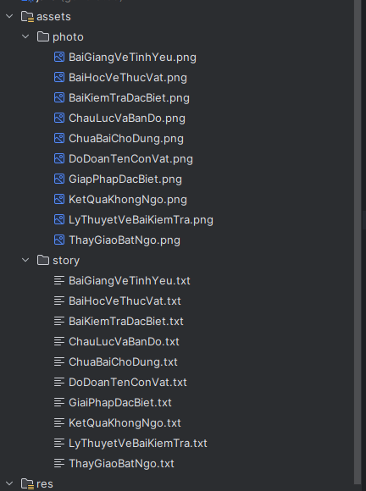
Trong assets (lưu trữ ảnh và truyện)

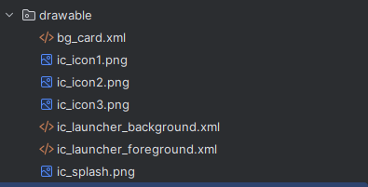
Trong drawable (lưu trữ icon)

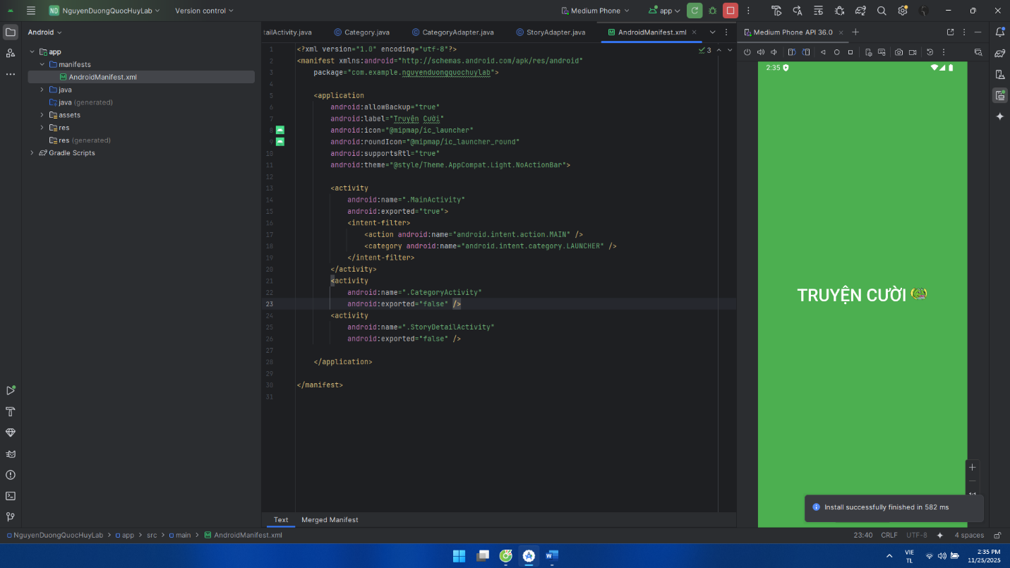
Giao diện:
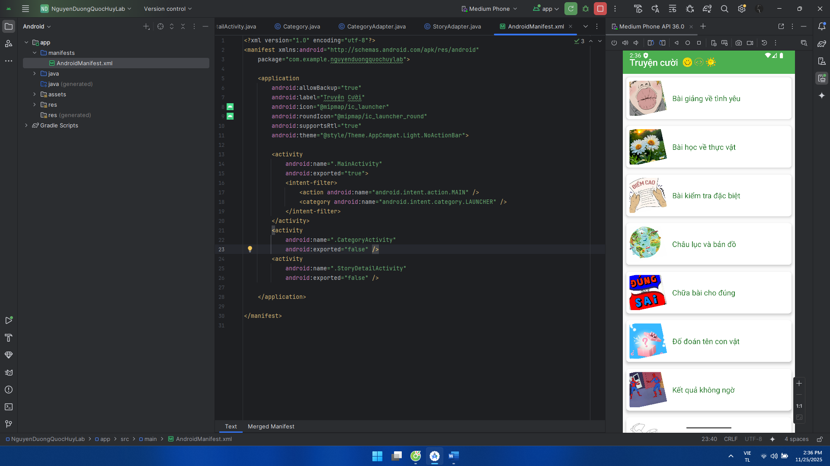
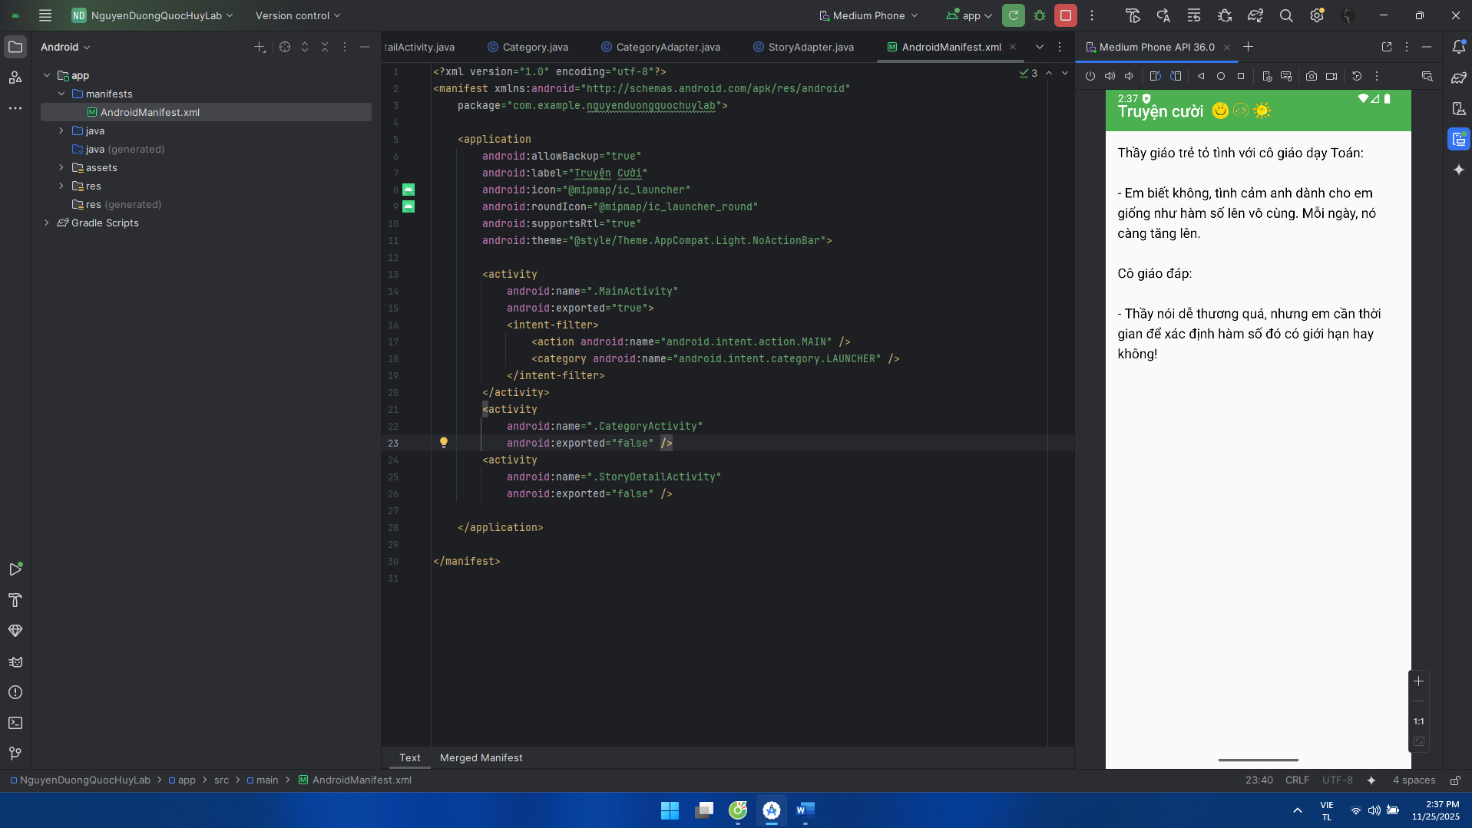
12 CUNG HOÀNG ĐẠO
Khai báo manifest:
<?xml version="1.0" encoding="utf-8"?>
<manifest xmlns:android="http://schemas.android.com/apk/res/android"
package="com.example.nguyenduongquochuylab">
<application
android:allowBackup="true"
android:icon="@mipmap/ic_launcher"
android:label="Cung Hoàng Đạo"
android:roundIcon="@mipmap/ic_launcher_round"
android:supportsRtl="true"
android:theme="@style/Theme.AppCompat.Light.NoActionBar">
<activity
android:name=".M001MenuActivity"
android:exported="true"
android:theme="@style/Theme.AppCompat.Light.NoActionBar">
<intent-filter>
<action android:name="android.intent.action.MAIN"/>
<category android:name="android.intent.category.LAUNCHER"/>
</intent-filter>
</activity>
<activity
android:name=".M002DetailActivity"
android:exported="false"
android:theme="@style/Theme.AppCompat.Light.NoActionBar"/>
</application>
</manifest>
M001MenuActivity.java - hiển thị menu các cung hoàng đạo.
package com.example.nguyenduongquochuylab;
import android.content.Intent;
import android.os.Bundle;
import android.view.View;
import android.widget.Button;
import android.widget.FrameLayout;
import android.widget.ImageView;
import androidx.appcompat.app.AppCompatActivity;
public class M001MenuActivity extends AppCompatActivity {
FrameLayout circleContainer;
Button btnXemThem;
int[] images = {
R.drawable.aries, R.drawable.taurus, R.drawable.gemini,
R.drawable.cancer, R.drawable.leo, R.drawable.virgo,
R.drawable.libra, R.drawable.scorpio, R.drawable.sagittarius,
R.drawable.capricorn, R.drawable.aquarius, R.drawable.pisces
};
String[] names = {
"Bạch Dương","Kim Ngưu","Song Tử","Cự Giải",
"Sư Tử","Xử Nữ","Thiên Bình","Bọ Cạp",
"Nhân Mã","Ma Kết","Bảo Bình","Song Ngư"
};
String[] descs = {
"Mô tả Bạch Dương...","Mô tả Kim Ngưu...","Mô tả Song Tử...",
"Mô tả Cự Giải...","Mô tả Sư Tử...","Mô tả Xử Nữ...",
"Mô tả Thiên Bình...","Mô tả Bọ Cạp...","Mô tả Nhân Mã...",
"Mô tả Ma Kết...","Mô tả Bảo Bình...","Mô tả Song Ngư..."
};
@Override
protected void onCreate(Bundle savedInstanceState) {
super.onCreate(savedInstanceState);
setContentView(R.layout.m001_act_menu);
circleContainer = findViewById(R.id.circleContainer);
btnXemThem = findViewById(R.id.btnXemThem);
int centerX = 540;
int centerY = 800;
int radius = 300;
for (int i = 0; i < 12; i++) {
ImageView img = new ImageView(this);
img.setImageResource(images[i]);
int size = 200;
FrameLayout.LayoutParams params = new FrameLayout.LayoutParams(size, size);
double angle = Math.toRadians(i * 30);
int x = (int)(centerX + radius * Math.cos(angle) - size/2);
int y = (int)(centerY + radius * Math.sin(angle) - size/2);
params.leftMargin = x;
params.topMargin = y;
img.setLayoutParams(params);
int finalI = i;
img.setOnClickListener(v -> {
findViewById(R.id.txtCungTitle).setTag(names[finalI]);
((android.widget.TextView)findViewById(R.id.txtCungTitle)).setText(names[finalI]);
((android.widget.TextView)findViewById(R.id.txtCungDesc)).setText(descs[finalI]);
});
circleContainer.addView(img);
}
btnXemThem.setOnClickListener(v -> {
String name = ((android.widget.TextView)findViewById(R.id.txtCungTitle)).getText().toString();
int idx = 0;
for (int i = 0; i < names.length; i++) if (names[i].equals(name)) idx = i;
Intent intent = new Intent(M001MenuActivity.this, M002DetailActivity.class);
intent.putExtra("imgRes", images[idx]);
intent.putExtra("name", names[idx]);
intent.putExtra("desc", descs[idx]);
startActivity(intent);
});
}
}
M002DetailActivity.java - hiển thị chi tiết thông tin cung hoàng đạo:
package com.example.nguyenduongquochuylab;
import androidx.appcompat.app.AppCompatActivity;
import android.os.Bundle;
import android.widget.Button;
import android.widget.ImageView;
import android.widget.TextView;
public class M002DetailActivity extends AppCompatActivity {
ImageView imgDetail;
TextView txtName, txtContent;
Button btnBack;
@Override
protected void onCreate(Bundle savedInstanceState) {
super.onCreate(savedInstanceState);
setContentView(R.layout.m002_act_detail);
imgDetail = findViewById(R.id.imgDetail);
txtName = findViewById(R.id.txtName);
txtContent = findViewById(R.id.txtContent);
btnBack = findViewById(R.id.btnBack);
Bundle b = getIntent().getExtras();
if(b != null){
txtName.setText(b.getString("name"));
imgDetail.setImageResource(b.getInt("img"));
txtContent.setText(b.getString("desc"));
}
btnBack.setOnClickListener(v -> finish());
}
}
Trong Layout
m001_act_menu.xml:
<?xml version="1.0" encoding="utf-8"?>
<FrameLayout xmlns:android="http://schemas.android.com/apk/res/android"
android:layout_width="match_parent"
android:layout_height="match_parent"
android:background="@color/blue_dark">
<FrameLayout
android:id="@+id/circleContainer"
android:layout_width="match_parent"
android:layout_height="match_parent"
android:layout_marginTop="60dp"
android:layout_marginBottom="220dp">
</FrameLayout>
<LinearLayout
android:orientation="vertical"
android:layout_width="match_parent"
android:layout_height="220dp"
android:layout_gravity="bottom|center_horizontal"
android:gravity="center">
<TextView
android:id="@+id/txtCungTitle"
android:layout_width="wrap_content"
android:layout_height="wrap_content"
android:text="Tên Cung"
android:textSize="50sp"
android:textColor="@android:color/white"
android:gravity="center"/>
<TextView
android:id="@+id/txtCungDesc"
android:layout_width="wrap_content"
android:layout_height="wrap_content"
android:text="Mô tả cung hoàng đạo..."
android:textSize="25sp"
android:textColor="@android:color/white"
android:gravity="center"
android:layout_marginTop="8dp"
android:padding="4dp"/>
<Button
android:id="@+id/btnXemThem"
android:layout_width="wrap_content"
android:layout_height="wrap_content"
android:text="XEM THÊM"
android:layout_marginTop="12dp"/>
</LinearLayout>
</FrameLayout>
m002_act_detail.xml:
<?xml version="1.0" encoding="utf-8"?>
<ScrollView xmlns:android="http://schemas.android.com/apk/res/android"
android:layout_width="match_parent"
android:layout_height="match_parent"
android:background="#1E1E50"
android:padding="16dp">
<LinearLayout
android:layout_width="match_parent"
android:layout_height="wrap_content"
android:orientation="vertical"
android:gravity="center">
<ImageView
android:id="@+id/imgDetail"
android:layout_width="200dp"
android:layout_height="200dp"
android:scaleType="centerInside"/>
<TextView
android:id="@+id/txtName"
android:layout_width="wrap_content"
android:layout_height="wrap_content"
android:textColor="#FFFFFF"
android:textSize="22sp"
android:textStyle="bold"
android:layout_marginTop="8dp"
android:text="Tên Cung"/>
<TextView
android:id="@+id/txtContent"
android:layout_width="match_parent"
android:layout_height="wrap_content"
android:textColor="#FFFFFF"
android:textSize="16sp"
android:layout_marginTop="8dp"
android:text="Mô tả cung hoàng đạo dài..."/>
<Button
android:id="@+id/btnBack"
android:layout_width="wrap_content"
android:layout_height="wrap_content"
android:text="QUAY LẠI"
android:layout_marginTop="16dp"/>
</LinearLayout>
</ScrollView>
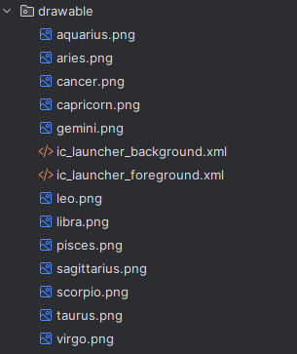
Trong drawable lưu trữ 12 cung hoàng đạo

Giao diện:
