THỰC HÀNH BUỔI 5 (Máy 17)
Nguyễn Dương Quốc Huy
1150070017
LAB 13 – 14
MainActivity
package com.example.nguyenduongquochuylab;
import android.content.Intent;
import android.os.Bundle;
import android.view.Gravity;
import android.view.LayoutInflater;
import android.view.View;
import android.widget.Button;
import android.widget.EditText;
import android.widget.TextView;
import android.widget.Toast;
import androidx.appcompat.app.AppCompatActivity;
public class MainActivity extends AppCompatActivity {
EditText edtEmail, edtPassword;
Button btnLogin;
TextView tvForgot, tvRegister;
@Override
protected void onCreate(Bundle savedInstanceState) {
super.onCreate(savedInstanceState);
setContentView(R.layout.activity_main);
edtEmail = findViewById(R.id.edtEmail);
edtPassword= findViewById(R.id.edtPassword);
btnLogin = findViewById(R.id.btnLogin);
tvForgot = findViewById(R.id.tvForgot);
tvRegister = findViewById(R.id.tvRegister);
btnLogin.setOnClickListener(v -> {
String email = edtEmail.getText().toString().trim();
String pass = edtPassword.getText().toString();
if (email.isEmpty() || pass.isEmpty()) {
showCustomToast("Vui lòng nhập đầy đủ email và mật khẩu");
return;
}
String msg = "Bạn đã đăng nhập thành công với email: " + email
+ " và mật khẩu " + pass;
showCustomToast(msg);
});
tvForgot.setOnClickListener(v -> {
showCustomToast("Chức năng quên mật khẩu đang phát triển...");
});
tvRegister.setOnClickListener(v -> {
Intent i = new Intent(MainActivity.this, RegisterActivity.class);
startActivity(i);
});
}
private void showCustomToast(String message) {
LayoutInflater inflater = getLayoutInflater();
View layout = inflater.inflate(R.layout.view_toast, findViewById(R.id.toastRoot));
TextView tv = layout.findViewById(R.id.tvToast);
tv.setText(message);
Toast t = new Toast(getApplicationContext());
t.setGravity(Gravity.TOP | Gravity.CENTER_HORIZONTAL, 0, 140);
t.setDuration(Toast.LENGTH_LONG);
t.setView(layout);
t.show();
}
}
RegisterActivity
package com.example.nguyenduongquochuylab;
import android.content.Intent;
import android.os.Bundle;
import android.widget.Button;
import android.widget.EditText;
import android.widget.TextView;
import android.widget.Toast;
import androidx.appcompat.app.AppCompatActivity;
public class RegisterActivity extends AppCompatActivity {
private EditText edtFullName, edtEmail, edtPassword, edtConfirm;
private Button btnRegister;
private TextView tvLoginInstead;
@Override
protected void onCreate(Bundle savedInstanceState) {
super.onCreate(savedInstanceState);
setContentView(R.layout.activity_register);
initViews();
setEvents();
}
private void initViews() {
edtFullName = findViewById(R.id.edtFullName);
edtEmail = findViewById(R.id.edtEmail);
edtPassword = findViewById(R.id.edtPassword);
edtConfirm = findViewById(R.id.edtConfirm);
btnRegister = findViewById(R.id.btnRegister);
tvLoginInstead = findViewById(R.id.tvLoginInstead);
}
private void setEvents() {
btnRegister.setOnClickListener(view -> {
String fullName = edtFullName.getText().toString().trim();
String email = edtEmail.getText().toString().trim();
String pass = edtPassword.getText().toString().trim();
String confirm = edtConfirm.getText().toString().trim();
if (fullName.isEmpty()) {
show("Vui lòng nhập Họ tên");
return;
}
if (email.isEmpty()) {
show("Vui lòng nhập Email");
return;
}
if (pass.isEmpty()) {
show("Vui lòng nhập mật khẩu");
return;
}
if (!pass.equals(confirm)) {
show("Mật khẩu xác nhận không trùng khớp");
return;
}
show("Đăng ký thành công!");
Intent i = new Intent(RegisterActivity.this, MainActivity.class);
startActivity(i);
finish();
});
tvLoginInstead.setOnClickListener(view -> {
startActivity(new Intent(RegisterActivity.this, MainActivity.class));
finish();
});
}
private void show(String msg) {
Toast.makeText(this, msg, Toast.LENGTH_SHORT).show();
}
}
activity_main.xml:
<?xml version="1.0" encoding="utf-8"?>
<RelativeLayout xmlns:android="http://schemas.android.com/apk/res/android"
android:layout_width="match_parent" android:layout_height="match_parent"
android:background="@color/bg_screen">
<FrameLayout
android:id="@+id/header"
android:layout_width="match_parent" android:layout_height="220dp"
android:background="@drawable/bg_header">
<TextView
android:id="@+id/tvTitle"
android:layout_width="wrap_content" android:layout_height="wrap_content"
android:text="@string/login_title" android:textSize="20sp"
android:textColor="@color/white" android:layout_margin="20dp"
android:layout_gravity="end|bottom"/>
</FrameLayout>
<LinearLayout
android:layout_below="@id/header"
android:layout_width="match_parent" android:layout_height="wrap_content"
android:orientation="vertical" android:padding="24dp">
<LinearLayout
android:layout_width="match_parent" android:layout_height="wrap_content"
android:background="@drawable/bg_input" android:padding="6dp"
android:gravity="center_vertical">
<ImageView
android:layout_width="22dp" android:layout_height="22dp"
android:src="@drawable/ic_email" android:layout_marginLeft="8dp"
android:layout_marginRight="8dp"/>
<EditText
android:id="@+id/edtEmail"
android:layout_width="0dp" android:layout_height="wrap_content"
android:layout_weight="1"
android:background="@android:color/transparent"
android:hint="@string/email" android:textColorHint="@color/hint"
android:textColor="@color/text_dark" android:inputType="textEmailAddress"
android:padding="8dp"/>
</LinearLayout>
<LinearLayout
android:layout_width="match_parent" android:layout_height="wrap_content"
android:layout_marginTop="12dp"
android:background="@drawable/bg_input" android:padding="6dp"
android:gravity="center_vertical">
<ImageView
android:layout_width="22dp" android:layout_height="22dp"
android:src="@drawable/ic_key" android:layout_marginLeft="8dp"
android:layout_marginRight="8dp"/>
<EditText
android:id="@+id/edtPassword"
android:layout_width="0dp" android:layout_height="wrap_content"
android:layout_weight="1"
android:background="@android:color/transparent"
android:hint="@string/password" android:textColorHint="@color/hint"
android:textColor="@color/text_dark" android:inputType="textPassword"
android:padding="8dp"/>
</LinearLayout>
<TextView
android:id="@+id/tvForgot"
android:layout_width="wrap_content" android:layout_height="wrap_content"
android:text="@string/forgot" android:textColor="@color/text_dark"
android:layout_gravity="end" android:layout_marginTop="10dp"/>
<Button
android:id="@+id/btnLogin"
android:layout_width="match_parent" android:layout_height="48dp"
android:layout_marginTop="18dp"
android:text="@string/btn_login" android:textColor="@color/white"
android:background="@drawable/bg_btn_login"/>
<LinearLayout
android:layout_width="match_parent" android:layout_height="wrap_content"
android:orientation="horizontal" android:gravity="center"
android:layout_marginTop="18dp">
<TextView
android:layout_width="wrap_content" android:layout_height="wrap_content"
android:text="@string/no_acc" android:textColor="@color/text_dark"/>
<TextView
android:id="@+id/tvRegister"
android:layout_width="wrap_content" android:layout_height="wrap_content"
android:text=" @string/register" android:textColor="@color/link"/>
</LinearLayout>
</LinearLayout>
</RelativeLayout>

activity_register.xml
<?xml version="1.0" encoding="utf-8"?>
<RelativeLayout xmlns:android="http://schemas.android.com/apk/res/android"
android:layout_width="match_parent"
android:layout_height="match_parent"
android:background="@color/bg_screen">
<FrameLayout
android:id="@+id/header"
android:layout_width="match_parent"
android:layout_height="220dp"
android:background="@drawable/bg_header">
<TextView
android:id="@+id/tvTitle"
android:layout_width="wrap_content"
android:layout_height="wrap_content"
android:text="@string/register_title"
android:textSize="20sp"
android:textColor="@color/white"
android:layout_margin="20dp"
android:layout_gravity="end|bottom" />
</FrameLayout>
<ScrollView
android:layout_below="@id/header"
android:layout_width="match_parent"
android:layout_height="wrap_content">
<LinearLayout
android:layout_width="match_parent"
android:layout_height="wrap_content"
android:orientation="vertical"
android:padding="24dp">
<LinearLayout
android:layout_width="match_parent"
android:layout_height="wrap_content"
android:background="@drawable/bg_input"
android:padding="6dp"
android:gravity="center_vertical">
<ImageView
android:layout_width="22dp"
android:layout_height="22dp"
android:src="@drawable/ic_user"
android:layout_marginLeft="8dp"
android:layout_marginRight="8dp"/>
<EditText
android:id="@+id/edtFullName"
android:layout_width="0dp"
android:layout_height="wrap_content"
android:layout_weight="1"
android:background="@android:color/transparent"
android:hint="@string/fullname"
android:textColorHint="@color/hint"
android:textColor="@color/text_dark"
android:padding="8dp"/>
</LinearLayout>
<LinearLayout
android:layout_width="match_parent"
android:layout_height="wrap_content"
android:layout_marginTop="12dp"
android:background="@drawable/bg_input"
android:padding="6dp"
android:gravity="center_vertical">
<ImageView
android:layout_width="22dp"
android:layout_height="22dp"
android:src="@drawable/ic_email"
android:layout_marginLeft="8dp"
android:layout_marginRight="8dp"/>
<EditText
android:id="@+id/edtEmail"
android:layout_width="0dp"
android:layout_height="wrap_content"
android:layout_weight="1"
android:background="@android:color/transparent"
android:hint="@string/email"
android:textColorHint="@color/hint"
android:textColor="@color/text_dark"
android:inputType="textEmailAddress"
android:padding="8dp"/>
</LinearLayout>
<LinearLayout
android:layout_width="match_parent"
android:layout_height="wrap_content"
android:layout_marginTop="12dp"
android:background="@drawable/bg_input"
android:padding="6dp"
android:gravity="center_vertical">
<ImageView
android:layout_width="22dp"
android:layout_height="22dp"
android:src="@drawable/ic_key"
android:layout_marginLeft="8dp"
android:layout_marginRight="8dp"/>
<EditText
android:id="@+id/edtPassword"
android:layout_width="0dp"
android:layout_height="wrap_content"
android:layout_weight="1"
android:background="@android:color/transparent"
android:hint="@string/password"
android:textColorHint="@color/hint"
android:textColor="@color/text_dark"
android:inputType="textPassword"
android:padding="8dp"/>
</LinearLayout>
<LinearLayout
android:layout_width="match_parent"
android:layout_height="wrap_content"
android:layout_marginTop="12dp"
android:background="@drawable/bg_input"
android:padding="6dp"
android:gravity="center_vertical">
<ImageView
android:layout_width="22dp"
android:layout_height="22dp"
android:src="@drawable/ic_key"
android:layout_marginLeft="8dp"
android:layout_marginRight="8dp"/>
<EditText
android:id="@+id/edtConfirm"
android:layout_width="0dp"
android:layout_height="wrap_content"
android:layout_weight="1"
android:background="@android:color/transparent"
android:hint="@string/confirm_password"
android:textColorHint="@color/hint"
android:textColor="@color/text_dark"
android:inputType="textPassword"
android:padding="8dp"/>
</LinearLayout>
<Button
android:id="@+id/btnRegister"
android:layout_width="match_parent"
android:layout_height="48dp"
android:layout_marginTop="18dp"
android:text="@string/btn_register"
android:textColor="@color/white"
android:background="@drawable/bg_btn_login"/>
<LinearLayout
android:layout_width="match_parent"
android:layout_height="wrap_content"
android:orientation="horizontal"
android:gravity="center"
android:layout_marginTop="18dp">
<TextView
android:layout_width="wrap_content"
android:layout_height="wrap_content"
android:text="@string/have_acc"
android:textColor="@color/text_dark"/>
<TextView
android:id="@+id/tvLoginInstead"
android:layout_width="wrap_content"
android:layout_height="wrap_content"
android:text=" @string/login"
android:textColor="@color/link"/>
</LinearLayout>
</LinearLayout>
</ScrollView>
</RelativeLayout>

Bên trong drawable
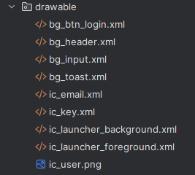
Giao diện:
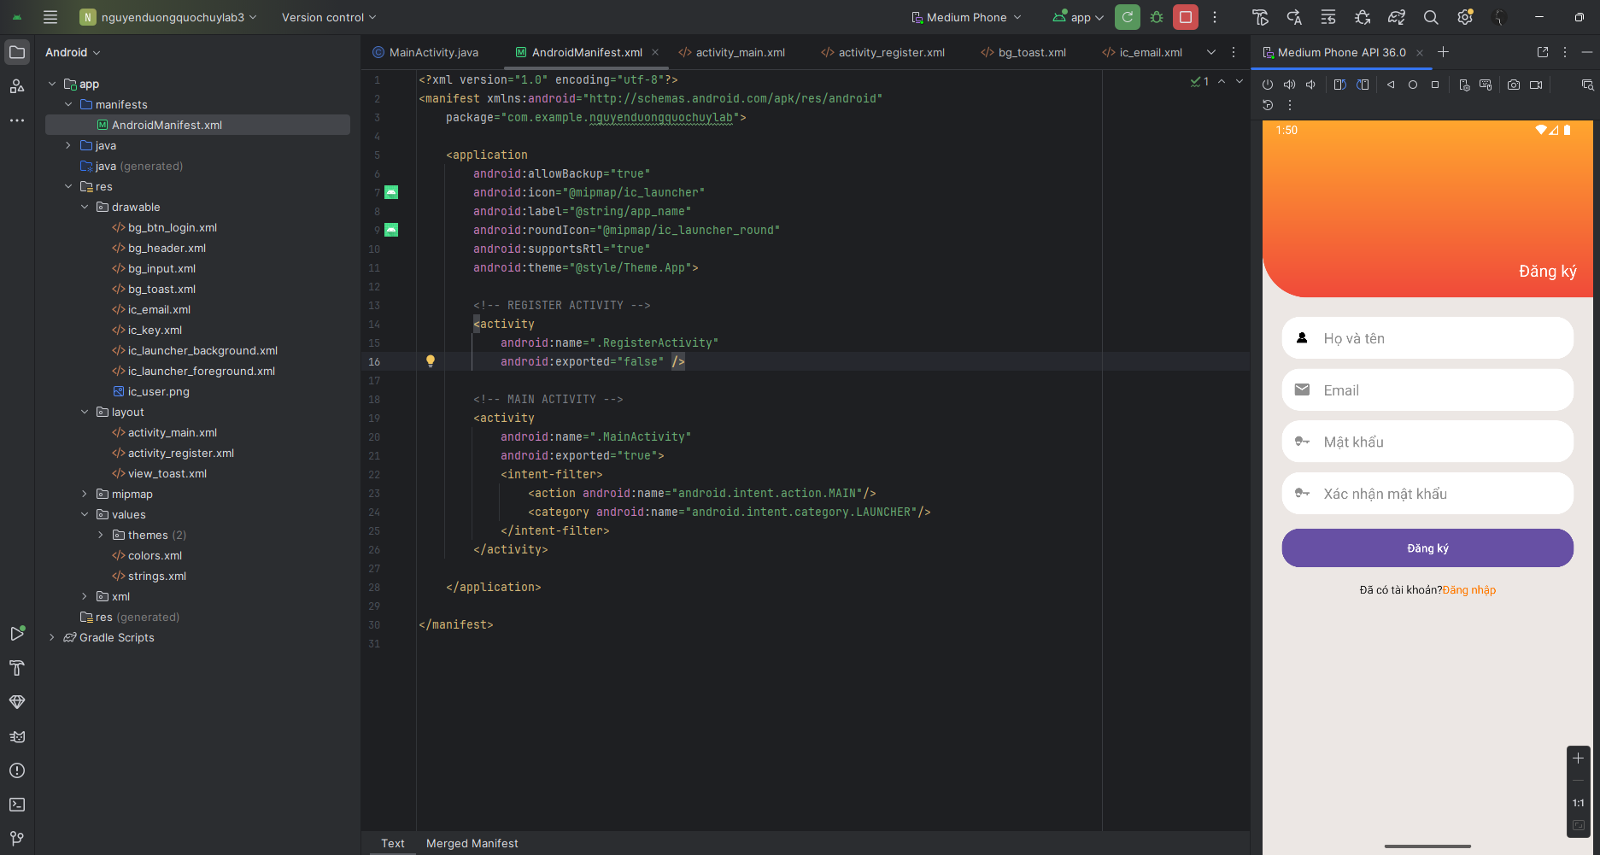
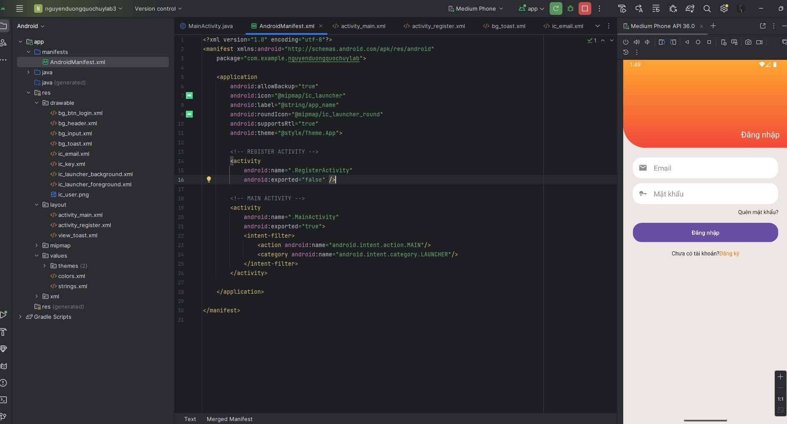
Kết nối sql:
Đầu tiên tạo 1 database đơn giản trong sql sever
CREATE DATABASE LabLoginDB;
GO

USE LabLoginDB;
GO

CREATE TABLE Users (
id INT IDENTITY(1,1) PRIMARY KEY,
fullname NVARCHAR(100) NOT NULL,
email NVARCHAR(100) UNIQUE NOT NULL,
password NVARCHAR(100) NOT NULL,
role NVARCHAR(20) DEFAULT 'user',
created_at DATETIME DEFAULT GETDATE()
);
GO

INSERT INTO Users (fullname, email, password, role)
VALUES
(N'Nguyễn Văn A', 'a@gmail.com', '123456', 'user'),
(N'Huỳnh Thị B', 'b@gmail.com', '123456', 'user'),
(N'Admin', 'admin@gmail.com', 'admin', 'admin');
GO

CREATE PROCEDURE sp_login
@email NVARCHAR(100),
@password NVARCHAR(100)
AS
BEGIN
SET NOCOUNT ON;

SELECT id, fullname, email, role
FROM Users
WHERE email = @email AND password = @password;
END
GO

SELECT * FROM Users;
Sau đó ta tạo nodejs để làm backend
1. tạo cấu trúc thư mục
mkdir api-login
cd api-login
npm init -y
npm install express mssql cors dotenv
mkdir controllers
mkdir routes
type nul > index.js
type nul > db.js
type nul > .env
Ta sẽ được như sau:
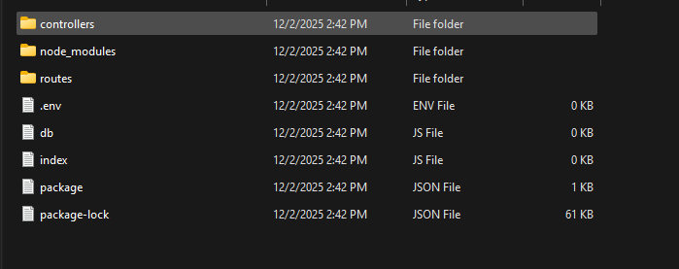
Cấu hình .env
PORT=3000
DB_USER=sa
DB_PASS=123
DB_NAME=LabLoginDB
DB_SERVER=localhost
DB_PORT=1433
Cấu hình index.js
require("dotenv").config();
const express = require("express");
const cors = require("cors");
const sql = require("mssql");
const dbConfig = require("./db");

const app = express();
app.use(cors());
app.use(express.json());

app.get("/", (req, res) => {
res.send("API Login đang chạy...");
});

app.post("/api/auth/login", async (req, res) => {
const { email, password } = req.body;

if (!email || !password) {
return res.json({ success: false, message: "Thiếu email hoặc mật khẩu" });
}

try {
let pool = await sql.connect(dbConfig);

const query = `
SELECT id, fullname, email, role
FROM Users
WHERE email = @email AND password = @password
`;

let result = await pool.request()
.input("email", sql.NVarChar, email)
.input("password", sql.NVarChar, password)
.query(query);

if (result.recordset.length > 0) {
return res.json({
success: true,
message: "Đăng nhập thành công",
user: result.recordset[0]
});
}

res.json({ success: false, message: "Email hoặc mật khẩu sai" });

} catch (err) {
res.json({ success: false, error: err });
}
});

app.listen(process.env.PORT, () =>
console.log(`API đang chạy tại http://localhost:${process.env.PORT}`)
);
Cấu hình db
require("dotenv").config();
const sql = require("mssql");

const config = {
user: process.env.DB_USER,
password: process.env.DB_PASS,
server: process.env.DB_SERVER,
port: Number(process.env.DB_PORT),
database: process.env.DB_NAME,
options: {
encrypt: false,
trustServerCertificate: true
}
};

module.exports = config;
Trong android tạo cấu trúc như sau:
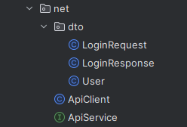

LoginRequest
package com.example.nguyenduongquochuylab.net.dto;
public class LoginRequest {
public String email;
public String password;
public LoginRequest(String email, String password) {
this.email = email;
this.password = password;
}
}
LoginResponse
package com.example.nguyenduongquochuylab.net.dto;
public class LoginResponse {
public boolean success;
public String message;
public User user;
}
User
package com.example.nguyenduongquochuylab.net.dto;
public class User {
public int id;
public String fullname;
public String email;
public String role;
}
ApiClient
package com.example.nguyenduongquochuylab.net;
import android.content.Context;
import java.util.concurrent.TimeUnit;
import okhttp3.OkHttpClient;
import okhttp3.logging.HttpLoggingInterceptor;
import retrofit2.Retrofit;
import retrofit2.converter.gson.GsonConverterFactory;
public class ApiClient {
private static Retrofit retrofit;
private static final String BASE_URL = "http://10.0.2.2:3000/api/";
public static Retrofit getClient() {
if (retrofit == null) {
HttpLoggingInterceptor logging = new HttpLoggingInterceptor();
logging.setLevel(HttpLoggingInterceptor.Level.BODY);
OkHttpClient client = new OkHttpClient.Builder()
.addInterceptor(logging)
.connectTimeout(20, TimeUnit.SECONDS)
.readTimeout(20, TimeUnit.SECONDS)
.writeTimeout(20, TimeUnit.SECONDS)
.build();
retrofit = new Retrofit.Builder()
.baseUrl(BASE_URL)
.addConverterFactory(GsonConverterFactory.create())
.client(client)
.build();
}
return retrofit;
}
}
ApiService
package com.example.nguyenduongquochuylab.net;
import com.example.nguyenduongquochuylab.net.dto.LoginRequest;
import com.example.nguyenduongquochuylab.net.dto.LoginResponse;
import retrofit2.Call;
import retrofit2.http.Body;
import retrofit2.http.POST;
public interface ApiService {
@POST("auth/login")
Call<LoginResponse> login(@Body LoginRequest body);
}
và thêm String API_URL = "http://10.0.2.2:3000/api/auth/login"; vào mainactivity
kết quả:
