**LAB 1**

Nguyễn Dương Quốc Huy 1150070017

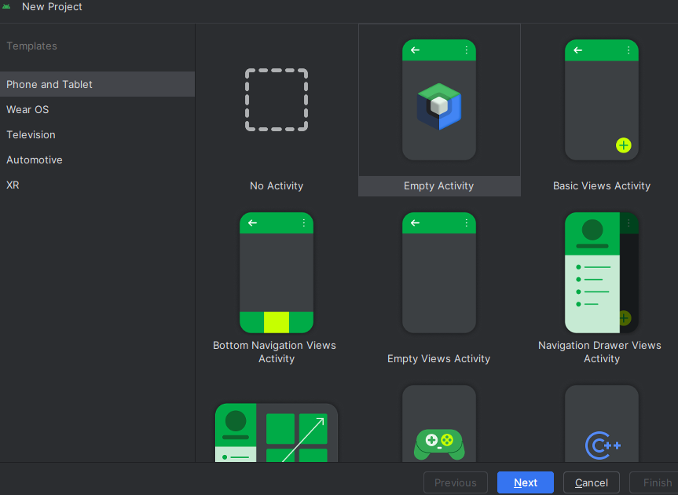Bước 1: Tạo NewProject

Bước 2: Đặt tên project

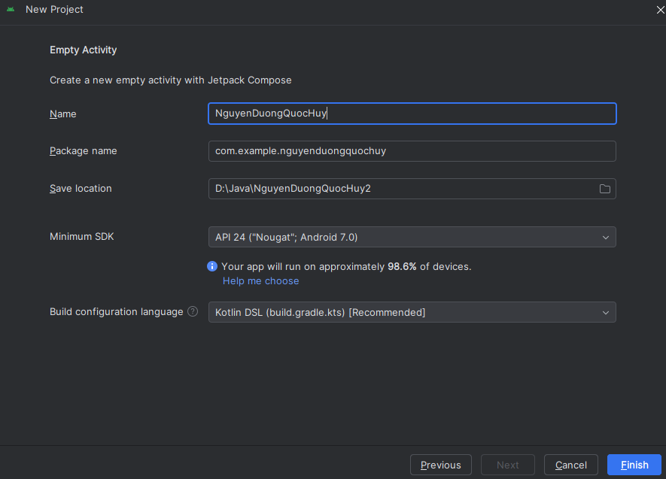

­­Bước 3: Nội dung của tập tin AndroidMainfest.xml

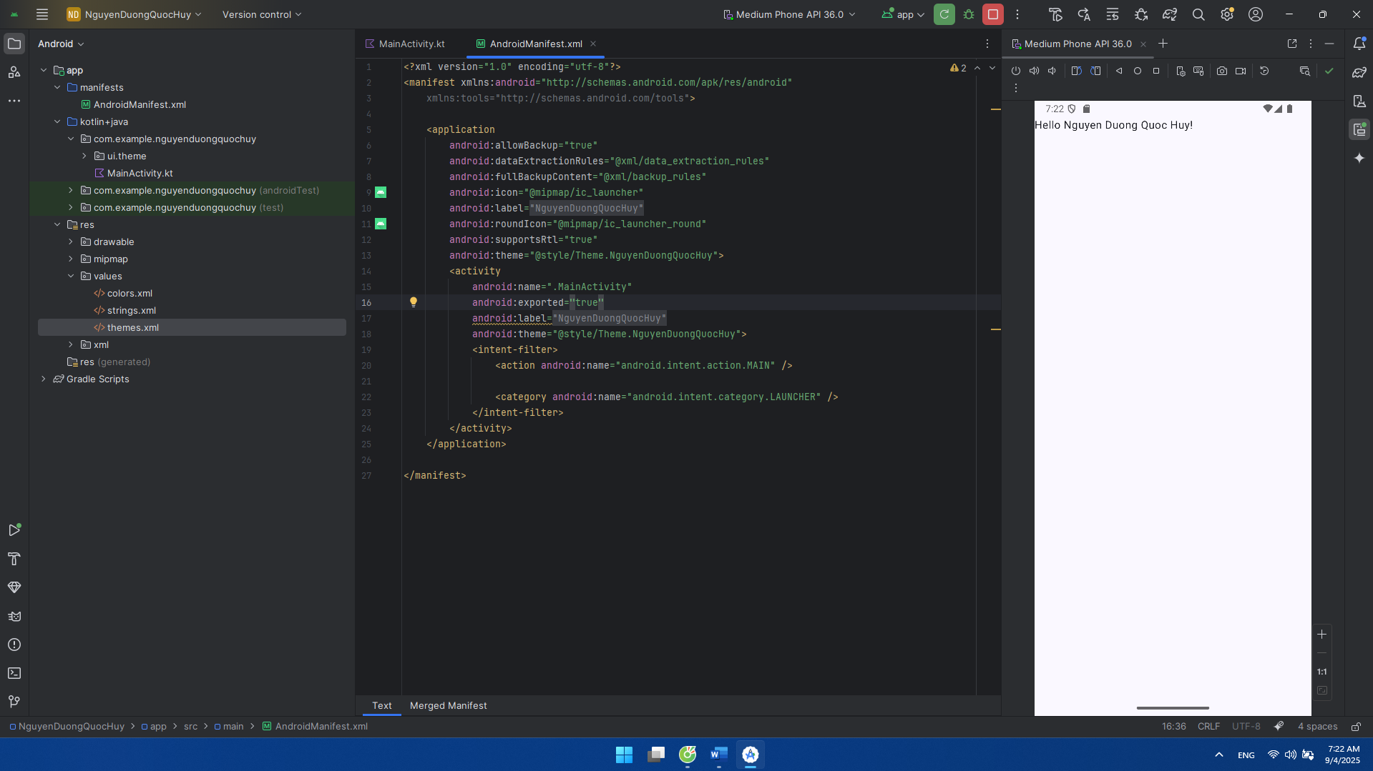

<?xml version="1.0" encoding="utf-8"?>  
<manifest xmlns:android="http://schemas.android.com/apk/res/android"  
 xmlns:tools="http://schemas.android.com/tools">  
  
 <application  
 android:allowBackup="true"  
 android:dataExtractionRules="@xml/data_extraction_rules"  
 android:fullBackupContent="@xml/backup_rules"  
 android:icon="@mipmap/ic_launcher"  
 android:label="@string/app_name"  
 android:roundIcon="@mipmap/ic_launcher_round"  
 android:supportsRtl="true"  
 android:theme="@style/Theme.NguyenDuongQuocHuy">  
 <activity  
 android:name=".MainActivity"  
 android:exported="true"  
 android:label="@string/app_name"  
 android:theme="@style/Theme.NguyenDuongQuocHuy">  
 <intent-filter>  
 <action android:name="android.intent.action.MAIN" />  
  
 <category android:name="android.intent.category.LAUNCHER" />  
 </intent-filter>  
 </activity>  
 </application>  
  
</manifest>

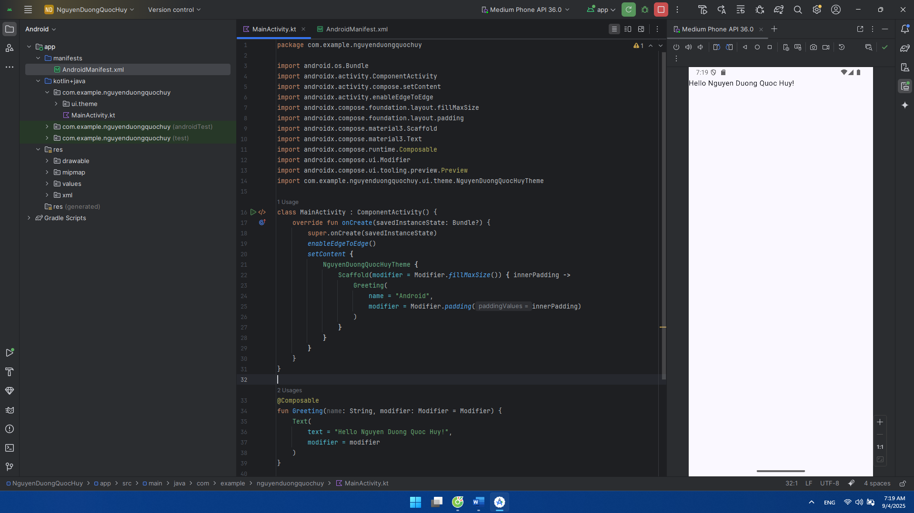Bước 4: Xử lý luồng đơn giản trong MainActivity.kt

package com.example.nguyenduongquochuy  
  
import android.os.Bundle  
import androidx.activity.ComponentActivity  
import androidx.activity.compose.setContent  
import androidx.activity.enableEdgeToEdge  
import androidx.compose.foundation.layout.fillMaxSize  
import androidx.compose.foundation.layout.padding  
import androidx.compose.material3.Scaffold  
import androidx.compose.material3.Text  
import androidx.compose.runtime.Composable  
import androidx.compose.ui.Modifier  
import androidx.compose.ui.tooling.preview.Preview  
import com.example.nguyenduongquochuy.ui.theme.NguyenDuongQuocHuyTheme  
  
  
class MainActivity : ComponentActivity() {  
 override fun onCreate(savedInstanceState: Bundle?) {  
 super.onCreate(savedInstanceState)  
 *enableEdgeToEdge*()  
 *setContent* **{** NguyenDuongQuocHuyTheme **{** Scaffold(modifier = Modifier.*fillMaxSize*()) **{** innerPadding **->** Greeting(  
 name = "Android",  
 modifier = Modifier.*padding*(innerPadding)  
 )  
 **}  
 }  
 }** }  
}  
  
@Composable  
fun Greeting(name: String, modifier: Modifier = Modifier) {  
 Text(  
 text = "Hello Nguyen Duong Quoc Huy!",  
 modifier = modifier  
 )  
}  
  
@Preview(showBackground = true)  
@Composable  
fun GreetingPreview() {  
 NguyenDuongQuocHuyTheme **{** Greeting("Android")  
 **}**}