**LAB 2**

Nguyễn Dương Quốc Huy 1150070017

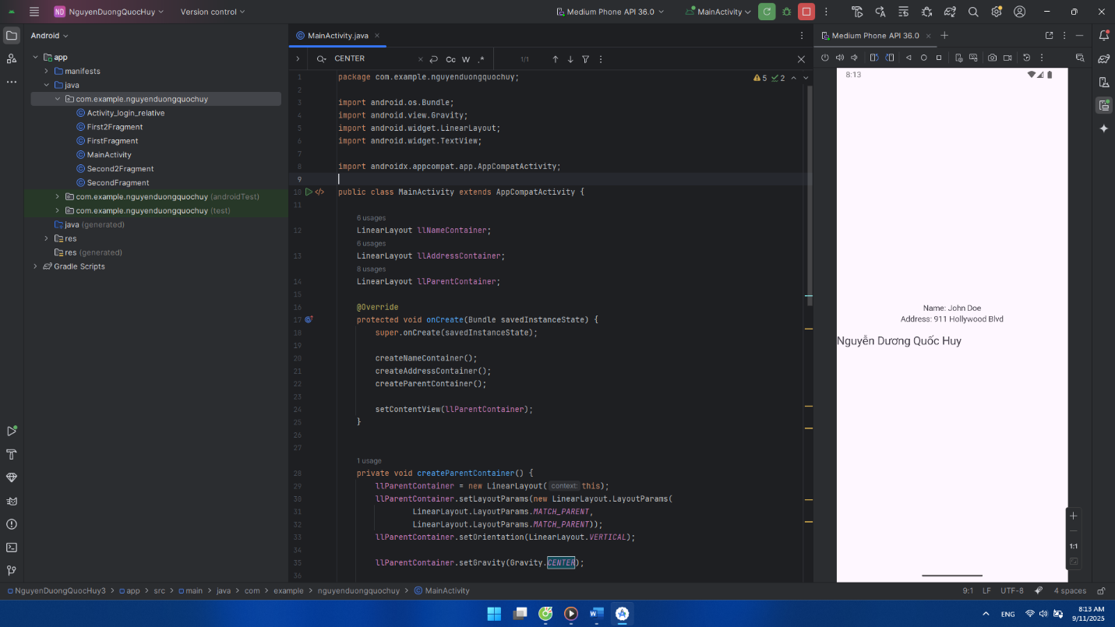**Khai Báo Biến :**

package com.example.nguyenduongquochuy;  
  
import android.os.Bundle;  
import android.view.Gravity;  
import android.widget.LinearLayout;  
import android.widget.TextView;  
  
import androidx.appcompat.app.AppCompatActivity;  
  
public class MainActivity extends AppCompatActivity {  
  
 LinearLayout llNameContainer;  
 LinearLayout llAddressContainer;  
 LinearLayout llParentContainer;  
  
 @Override  
 protected void onCreate(Bundle savedInstanceState) {  
 super.onCreate(savedInstanceState);  
  
 createNameContainer();  
 createAddressContainer();  
 createParentContainer();  
  
 setContentView(llParentContainer);  
 }  
  
  
 private void createParentContainer() {  
 llParentContainer = new LinearLayout(this);  
 llParentContainer.setLayoutParams(new LinearLayout.LayoutParams(  
 LinearLayout.LayoutParams.*MATCH_PARENT*,  
 LinearLayout.LayoutParams.*MATCH_PARENT*));  
 llParentContainer.setOrientation(LinearLayout.*VERTICAL*);  
  
 llParentContainer.setGravity(Gravity.*CENTER*);  
  
 llParentContainer.addView(llNameContainer);  
 llParentContainer.addView(llAddressContainer);  
  
 TextView tvAuthor = new TextView(this);  
 tvAuthor.setText("Nguyễn Dương Quốc Huy");  
 tvAuthor.setTextSize(20); // chữ to hơn  
 tvAuthor.setPadding(0, 40, 0, 0); // cách 40dp so với Address  
 llParentContainer.addView(tvAuthor);  
 }  
 private void createNameContainer() {  
 llNameContainer = new LinearLayout(this);  
 llNameContainer.setLayoutParams(new LinearLayout.LayoutParams(  
 LinearLayout.LayoutParams.*WRAP_CONTENT*,  
 LinearLayout.LayoutParams.*WRAP_CONTENT*));  
 llNameContainer.setOrientation(LinearLayout.*HORIZONTAL*);  
  
 TextView tvName = new TextView(this);  
 tvName.setText("Name: ");  
 llNameContainer.addView(tvName);  
  
 TextView tvNameValue = new TextView(this);  
 tvNameValue.setText("John Doe");  
 llNameContainer.addView(tvNameValue);  
 }  
  
 private void createAddressContainer() {  
 llAddressContainer = new LinearLayout(this);  
 llAddressContainer.setLayoutParams(new LinearLayout.LayoutParams(  
 LinearLayout.LayoutParams.*WRAP_CONTENT*,  
 LinearLayout.LayoutParams.*WRAP_CONTENT*));  
 llAddressContainer.setOrientation(LinearLayout.*HORIZONTAL*);  
  
 TextView tvAddress = new TextView(this);  
 tvAddress.setText("Address: ");  
 llAddressContainer.addView(tvAddress);  
  
 TextView tvAddressValue = new TextView(this);  
 tvAddressValue.setText("911 Hollywood Blvd");  
 llAddressContainer.addView(tvAddressValue);  
 }  
  
}

**Sử dụng LinearLayout trong file xml:**

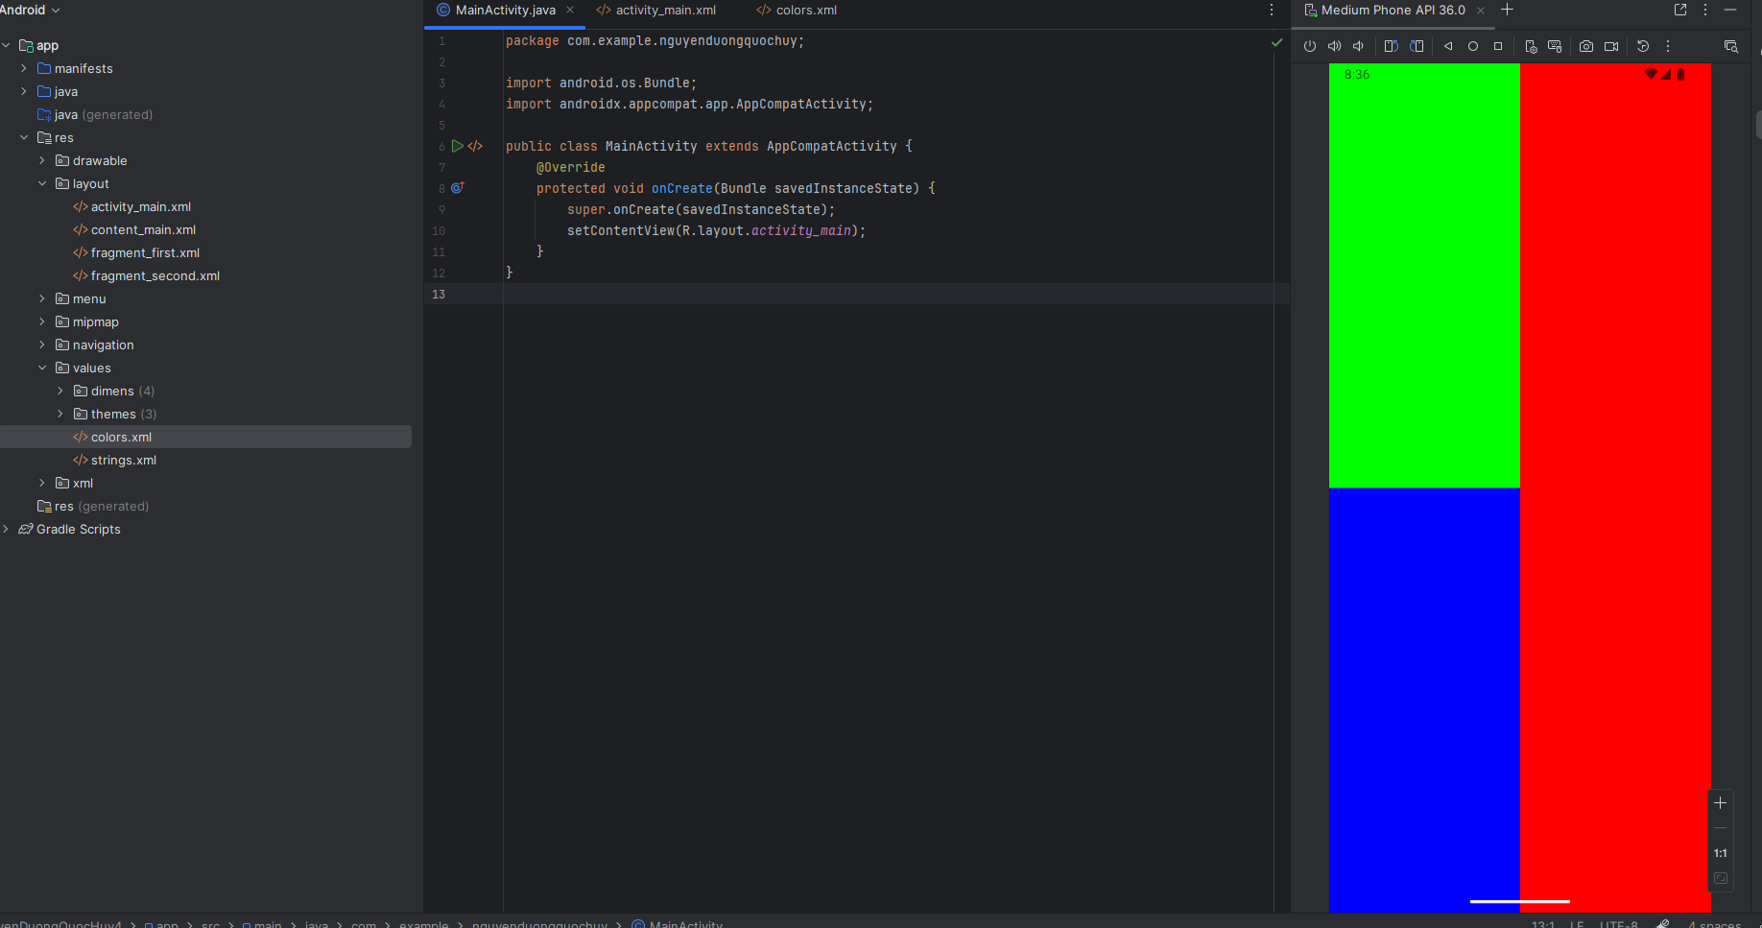

**File res/values/colors.xml:**

<resources>

<color name="green_box">#00FF00</color>

<color name="red_box">#FF0000</color>

<color name="blue_box">#0000FF</color>

<color name="black_box">#000000</color>

</resources>

**File res/layout/activity_main.xml:**

<?xml version="1.0" encoding="utf-8"?>

<LinearLayout xmlns:android="http://schemas.android.com/apk/res/android"

android:layout_width="match_parent"

android:layout_height="match_parent"

android:orientation="vertical">

<!-- Hàng trên -->

<LinearLayout

android:layout_width="match_parent"

android:layout_height="0dp"

android:layout_weight="1"

android:orientation="horizontal">

<!-- Ô màu xanh lá -->

<View

android:layout_width="0dp"

android:layout_height="match_parent"

android:layout_weight="1"

android:background="@color/green_box" />

<!-- Ô màu đỏ -->

<View

android:layout_width="0dp"

android:layout_height="match_parent"

android:layout_weight="1"

android:background="@color/red_box" />

</LinearLayout>

<!-- Hàng dưới -->

<LinearLayout

android:layout_width="match_parent"

android:layout_height="0dp"

android:layout_weight="1"

android:orientation="horizontal">

<!-- Ô màu xanh dương -->

<View

android:layout_width="0dp"

android:layout_height="match_parent"

android:layout_weight="1"

android:background="@color/blue_box" />

<!-- Ô màu đỏ -->

<View

android:layout_width="0dp"

android:layout_height="match_parent"

android:layout_weight="1"

android:background="@color/red_box" />

</LinearLayout>

</LinearLayout>

**File MainActivity.java:**

package com.example.nguyenduongquochuy;

import android.os.Bundle;

import androidx.appcompat.app.AppCompatActivity;

public class MainActivity extends AppCompatActivity {

@Override

protected void onCreate(Bundle savedInstanceState) {

super.onCreate(savedInstanceState);

setContentView(R.layout.activity_main);

}

}

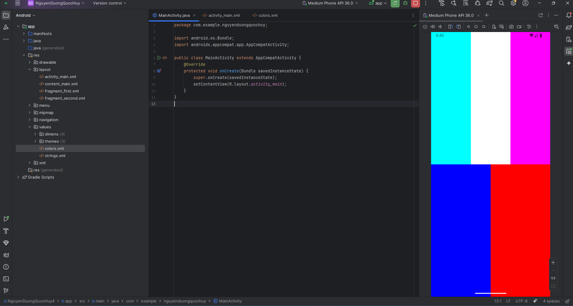

**File res/values/colors.xml:**

<resources>

<color name="cyan_box">#00FFFF</color>

<color name="white_box">#FFFFFF</color>

<color name="pink_box">#FF00FF</color>

<color name="blue_box">#0000FF</color>

<color name="red_box">#FF0000</color>

</resources>

**File res/layout/activity_main.xml:**

<?xml version="1.0" encoding="utf-8"?>

<LinearLayout xmlns:android="http://schemas.android.com/apk/res/android"

android:layout_width="match_parent"

android:layout_height="match_parent"

android:orientation="vertical">

<!-- Hàng trên: 3 ô -->

<LinearLayout

android:layout_width="match_parent"

android:layout_height="0dp"

android:layout_weight="1"

android:orientation="horizontal">

<View

android:layout_width="0dp"

android:layout_height="match_parent"

android:layout_weight="1"

android:background="@color/cyan_box" />

<View

android:layout_width="0dp"

android:layout_height="match_parent"

android:layout_weight="1"

android:background="@color/white_box" />

<View

android:layout_width="0dp"

android:layout_height="match_parent"

android:layout_weight="1"

android:background="@color/pink_box" />

</LinearLayout>

<!-- Hàng dưới: 2 ô -->

<LinearLayout

android:layout_width="match_parent"

android:layout_height="0dp"

android:layout_weight="1"

android:orientation="horizontal">

<View

android:layout_width="0dp"

android:layout_height="match_parent"

android:layout_weight="1"

android:background="@color/blue_box" />

<View

android:layout_width="0dp"

android:layout_height="match_parent"

android:layout_weight="1"

android:background="@color/red_box" />

</LinearLayout>

</LinearLayout>

**File MainActivity.java:**

package com.example.nguyenduongquochuy;

import android.os.Bundle;

import androidx.appcompat.app.AppCompatActivity;

public class MainActivity extends AppCompatActivity {

@Override

protected void onCreate(Bundle savedInstanceState) {

super.onCreate(savedInstanceState);

setContentView(R.layout.activity_main);

}

}

**RelativeLayout:**

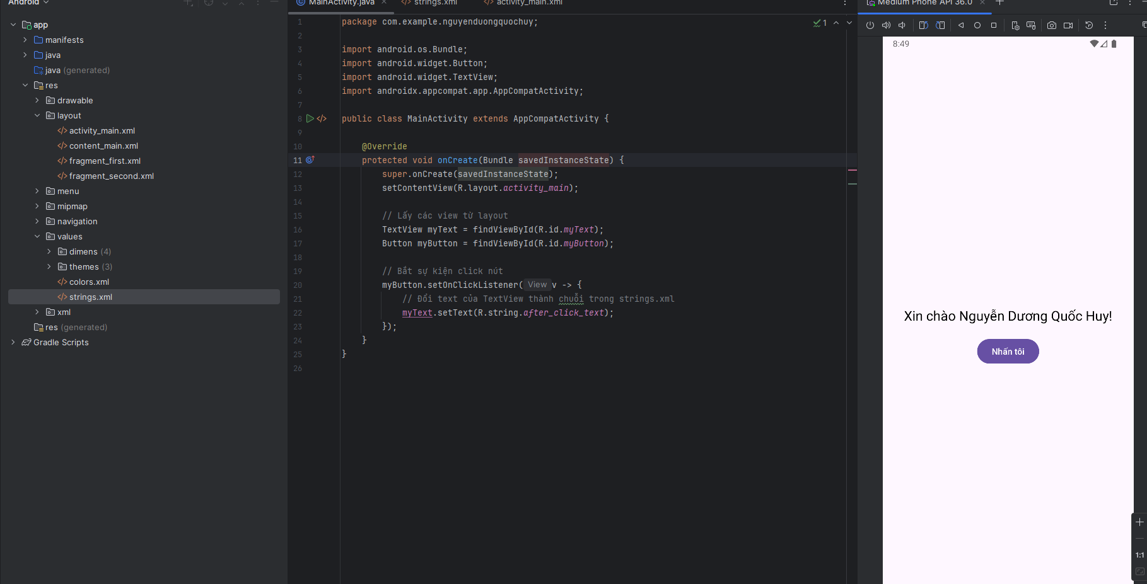

**File res/values/strings.xml:**

<resources>  
 <!-- Tên app -->  
 <string name="app_name">MyApp</string>  
  
 <!-- Chuỗi cho activity_main.xml -->  
 <string name="hello_text">Xin chào Nguyễn Dương Quốc Huy!</string>  
 <string name="button_text">Nhấn tôi</string>  
 <string name="after_click_text">Bạn vừa nhấn nút</string>  
  
 <!-- Chuỗi cho fragment_first.xml -->  
 <string name="next">Next</string>  
 <string name="lorem_ipsum">Lorem ipsum dolor sit amet, consectetur adipiscing elit.</string>  
  
 <!-- Chuỗi cho fragment_second.xml -->  
 <string name="previous">Previous</string>  
  
 <!-- Chuỗi cho menu_main.xml -->  
 <string name="action_settings">Settings</string>  
  
 <!-- Chuỗi cho nav_graph.xml -->  
 <string name="first_fragment_label">First Fragment</string>  
 <string name="second_fragment_label">Second Fragment</string>  
</resources>

**File res/layout/activity_main.xml**

<?xml version="1.0" encoding="utf-8"?>  
<RelativeLayout xmlns:android="http://schemas.android.com/apk/res/android"  
 android:layout_width="match_parent"  
 android:layout_height="match_parent"  
 android:padding="20dp">  
  
 <!-- TextView nằm ở giữa màn hình -->  
 <TextView  
 android:id="@+id/myText"  
 android:layout_width="wrap_content"  
 android:layout_height="wrap_content"  
 android:text="@string/hello_text"  
 android:layout_centerInParent="true"  
 android:textSize="22sp"  
 android:textColor="@android:color/black" />  
  
 <!-- Button nằm dưới TextView -->  
 <Button  
 android:id="@+id/myButton"  
 android:layout_width="wrap_content"  
 android:layout_height="wrap_content"  
 android:text="@string/button_text"  
 android:layout_below="@id/myText"  
 android:layout_centerHorizontal="true"  
 android:layout_marginTop="20dp"/>  
</RelativeLayout>

**File MainActivity.java:**

package com.example.nguyenduongquochuy;  
  
import android.os.Bundle;  
import android.widget.Button;  
import android.widget.TextView;  
import androidx.appcompat.app.AppCompatActivity;  
  
public class MainActivity extends AppCompatActivity {  
  
 @Override  
 protected void onCreate(Bundle savedInstanceState) {  
 super.onCreate(savedInstanceState);  
 setContentView(R.layout.*activity_main*);  
  
 // Lấy các view từ layout  
 TextView myText = findViewById(R.id.*myText*);  
 Button myButton = findViewById(R.id.*myButton*);  
  
 // Bắt sự kiện click nút  
 myButton.setOnClickListener(v -> {  
 // Đổi text của TextView thành chuỗi trong strings.xml  
 myText.setText(R.string.*after_click_text*);  
 });  
 }  
}