**Lab 4**

Nguyễn Dương Quốc Huy

1150070017

**ACTIVITY VÀ INTENT**

**1. Sửa file Manifest**

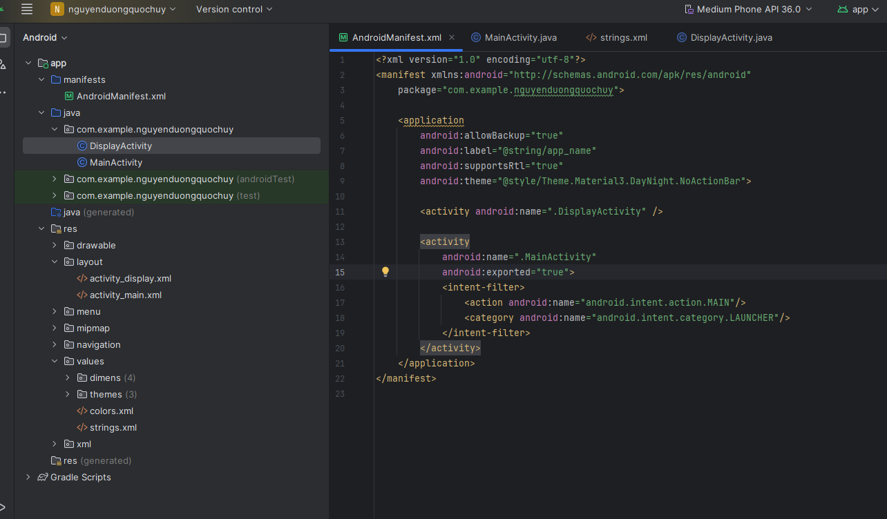Mở app/src/main/AndroidManifest.xml, chỉnh lại như sau

<manifest xmlns:android="http://schemas.android.com/apk/res/android"

package="com.example.nguyenduongquochuy">

<application

android:allowBackup="true"

android:label="@string/app_name"

android:supportsRtl="true"

android:theme="@style/Theme.Material3.DayNight.NoActionBar">

<activity android:name=".DisplayActivity" />

<activity

android:name=".MainActivity"

android:exported="true">

<intent-filter>

<action android:name="android.intent.action.MAIN"/>

<category android:name="android.intent.category.LAUNCHER"/>

</intent-filter>

</activity>

</application>

</manifest>

**2. Tạo layout cho MainActivity**

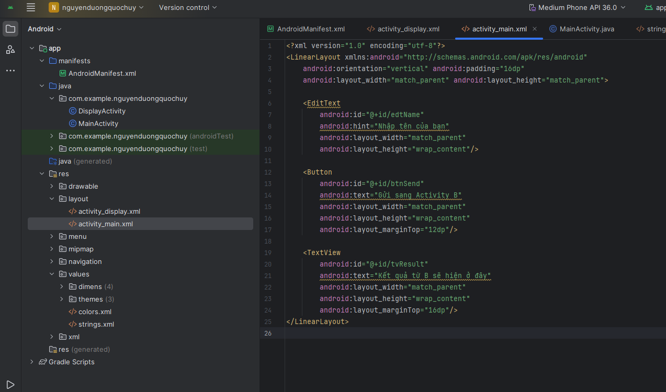**File:** res/layout/activity_main.xml

<LinearLayout xmlns:android="http://schemas.android.com/apk/res/android"

android:orientation="vertical" android:padding="16dp"

android:layout_width="match_parent" android:layout_height="match_parent">

<EditText

android:id="@+id/edtName"

android:hint="Nhập tên của bạn"

android:layout_width="match_parent"

android:layout_height="wrap_content"/>

<Button

android:id="@+id/btnSend"

android:text="Gửi sang Activity B"

android:layout_width="match_parent"

android:layout_height="wrap_content"

android:layout_marginTop="12dp"/>

<TextView

android:id="@+id/tvResult"

android:text="Kết quả từ B sẽ hiện ở đây"

android:layout_width="match_parent"

android:layout_height="wrap_content"

android:layout_marginTop="16dp"/>

</LinearLayout>

**3. Tạo layout cho DisplayActivity**

**File:** res/layout/activity_display.xml

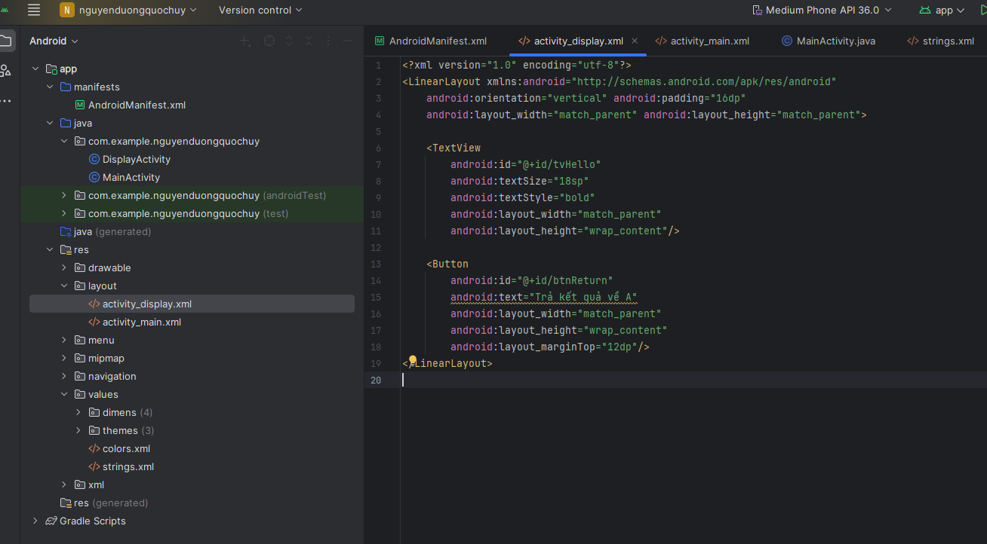

<LinearLayout xmlns:android="http://schemas.android.com/apk/res/android"

android:orientation="vertical" android:padding="16dp"

android:layout_width="match_parent" android:layout_height="match_parent">

<TextView

android:id="@+id/tvHello"

android:textSize="18sp"

android:textStyle="bold"

android:layout_width="match_parent"

android:layout_height="wrap_content"/>

<Button

android:id="@+id/btnReturn"

android:text="Trả kết quả về A"

android:layout_width="match_parent"

android:layout_height="wrap_content"

android:layout_marginTop="12dp"/>

</LinearLayout>

**4. Thêm chuỗi vào strings.xml**

**File:** res/values/strings.xml

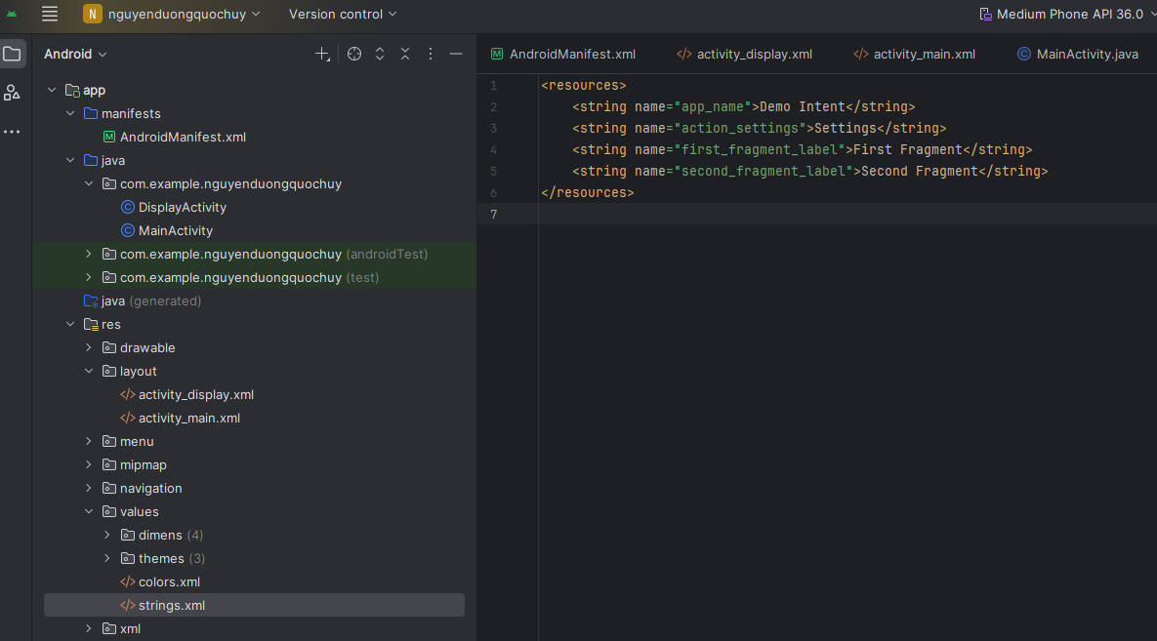

<resources>

<string name="app_name">Demo Intent</string>

<string name="action_settings">Settings</string>

<string name="first_fragment_label">First Fragment</string>

<string name="second_fragment_label">Second Fragment</string>

</resources>

**5. Code MainActivity**

**File:** java/com/example/nguyenduongquochuy/MainActivity.java

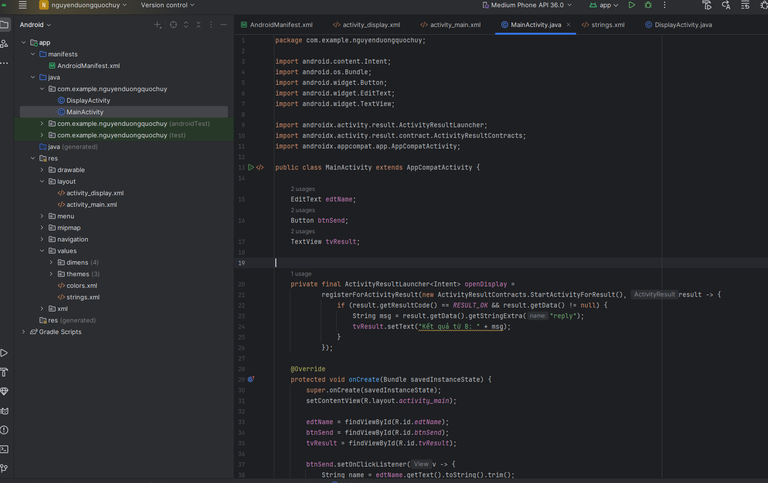

package com.example.nguyenduongquochuy;

import android.content.Intent;

import android.os.Bundle;

import android.widget.Button;

import android.widget.EditText;

import android.widget.TextView;

import androidx.activity.result.ActivityResultLauncher;

import androidx.activity.result.contract.ActivityResultContracts;

import androidx.appcompat.app.AppCompatActivity;

public class MainActivity extends AppCompatActivity {

EditText edtName;

Button btnSend;

TextView tvResult;

private final ActivityResultLauncher<Intent> openDisplay =

registerForActivityResult(new ActivityResultContracts.StartActivityForResult(), result -> {

if (result.getResultCode() == RESULT_OK && result.getData() != null) {

String msg = result.getData().getStringExtra("reply");

tvResult.setText("Kết quả từ B: " + msg);

}

});

@Override

protected void onCreate(Bundle savedInstanceState) {

super.onCreate(savedInstanceState);

setContentView(R.layout.activity_main);

edtName = findViewById(R.id.edtName);

btnSend = findViewById(R.id.btnSend);

tvResult = findViewById(R.id.tvResult);

btnSend.setOnClickListener(v -> {

String name = edtName.getText().toString().trim();

Intent intent = new Intent(MainActivity.this, DisplayActivity.class);

intent.putExtra("name", name);

openDisplay.launch(intent);

});

}

}

**6. Code DisplayActivity**

**File:** java/com/example/nguyenduongquochuy/DisplayActivity.java

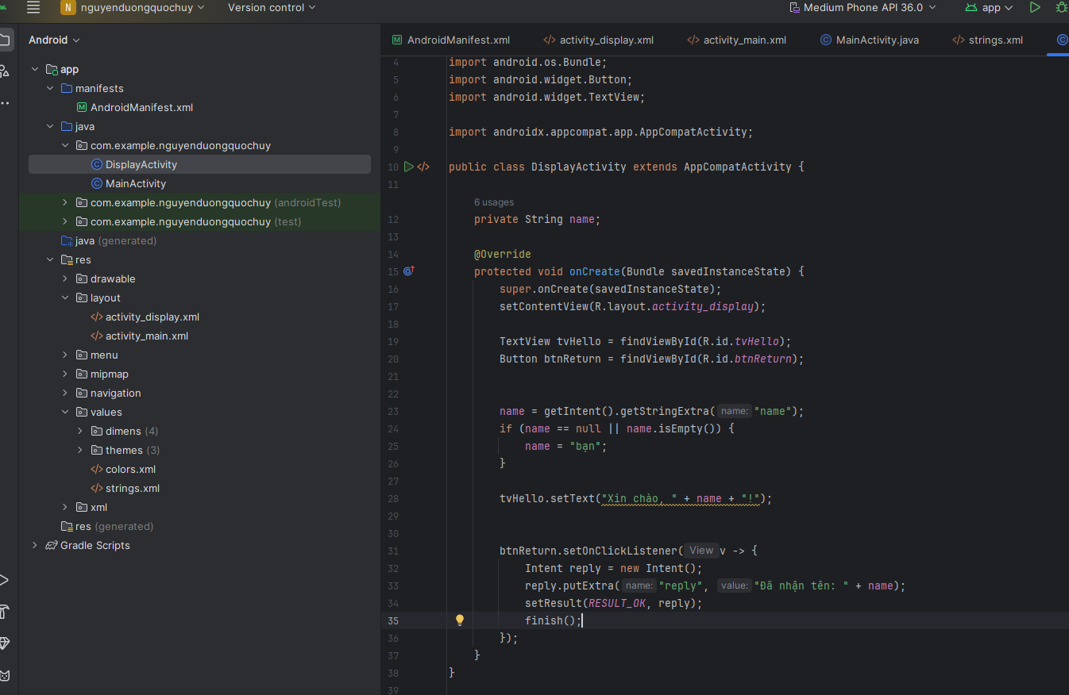

package com.example.nguyenduongquochuy;

import android.content.Intent;

import android.os.Bundle;

import android.widget.Button;

import android.widget.TextView;

import androidx.appcompat.app.AppCompatActivity;

public class DisplayActivity extends AppCompatActivity {

private String name;

@Override

protected void onCreate(Bundle savedInstanceState) {

super.onCreate(savedInstanceState);

setContentView(R.layout.activity_display);

TextView tvHello = findViewById(R.id.tvHello);

Button btnReturn = findViewById(R.id.btnReturn);

name = getIntent().getStringExtra("name");

if (name == null || name.isEmpty()) {

name = "bạn";

}

tvHello.setText("Xin chào, " + name + "! ");

btnReturn.setOnClickListener(v -> {

Intent reply = new Intent();

reply.putExtra("reply", "Đã nhận tên: " + name);

setResult(RESULT_OK, reply);

finish();

});

}

}

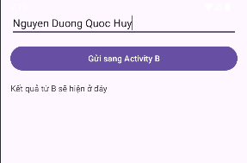**Kết quả:**

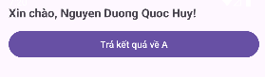

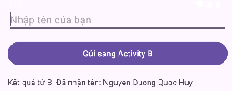

**BROADCASTRECEIVER**

**1. Layout MainActivity**

**File:** res/layout/activity_main.xml

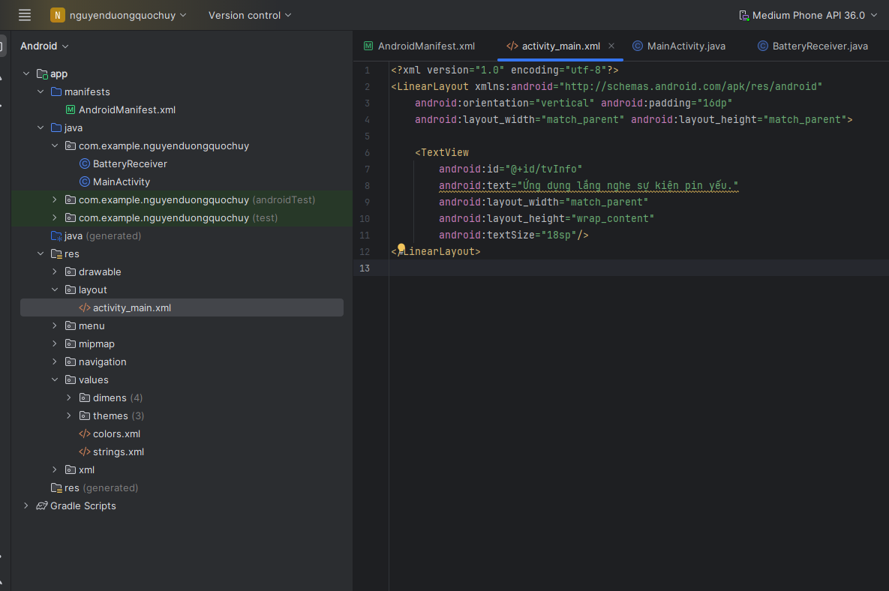

<?xml version="1.0" encoding="utf-8"?>

<LinearLayout xmlns:android="http://schemas.android.com/apk/res/android"

android:orientation="vertical" android:padding="16dp"

android:layout_width="match_parent" android:layout_height="match_parent">

<TextView

android:id="@+id/tvInfo"

android:text="Ứng dụng lắng nghe sự kiện pin yếu."

android:layout_width="match_parent"

android:layout_height="wrap_content"

android:textSize="18sp"/>

</LinearLayout>

**2. MainActivity.java**

**File:** java/com/example/nguyenduongquochuy/MainActivity.java

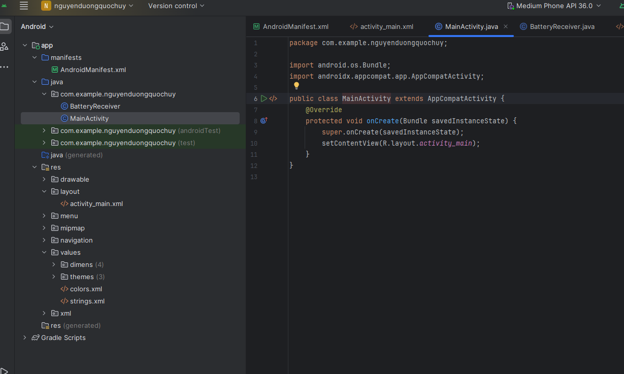

package com.example.nguyenduongquochuy;

import android.os.Bundle;

import androidx.appcompat.app.AppCompatActivity;

public class MainActivity extends AppCompatActivity {

@Override

protected void onCreate(Bundle savedInstanceState) {

super.onCreate(savedInstanceState);

setContentView(R.layout.activity_main);

}

}

**3. BatteryReceiver.java**

**File:** java/com/example/nguyenduongquochuy/BatteryReceiver.java

package com.example.nguyenduongquochuy;

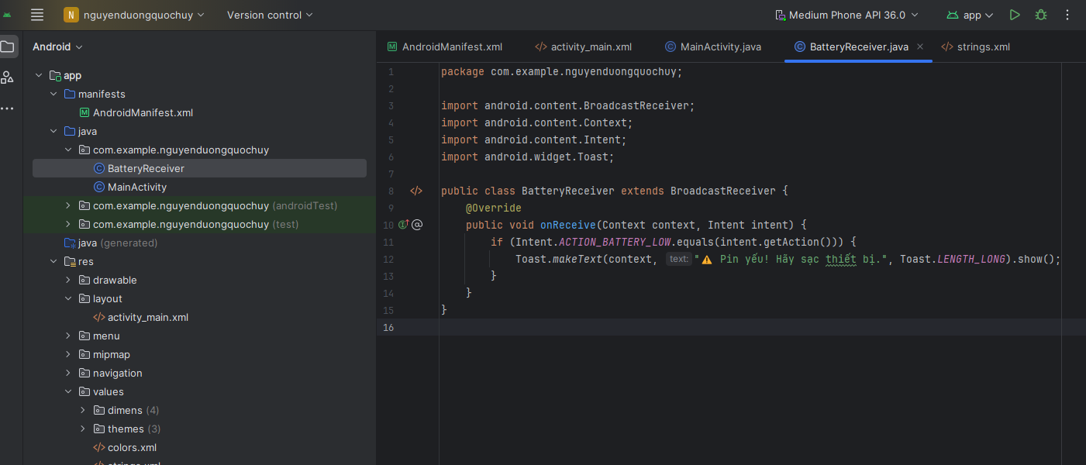

import android.content.BroadcastReceiver;

import android.content.Context;

import android.content.Intent;

import android.widget.Toast;

public class BatteryReceiver extends BroadcastReceiver {

@Override

public void onReceive(Context context, Intent intent) {

if (Intent.ACTION_BATTERY_LOW.equals(intent.getAction())) {

Toast.makeText(context, "⚠️ Pin yếu! Hãy sạc thiết bị.", Toast.LENGTH_LONG).show();

}

}

}

**4. AndroidManifest.xml**

**File:** app/src/main/AndroidManifest.xml

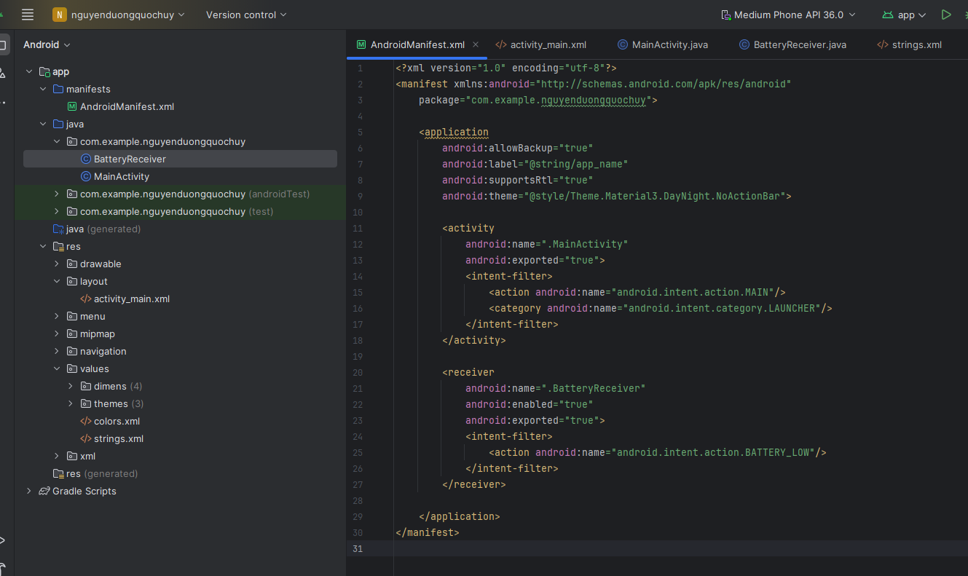

<?xml version="1.0" encoding="utf-8"?>

<manifest xmlns:android="http://schemas.android.com/apk/res/android"

package="com.example.nguyenduongquochuy">

<application

android:allowBackup="true"

android:label="@string/app_name"

android:supportsRtl="true"

android:theme="@style/Theme.Material3.DayNight.NoActionBar">

<activity

android:name=".MainActivity"

android:exported="true">

<intent-filter>

<action android:name="android.intent.action.MAIN"/>

<category android:name="android.intent.category.LAUNCHER"/>

</intent-filter>

</activity>

<receiver

android:name=".BatteryReceiver"

android:enabled="true"

android:exported="true">

<intent-filter>

<action android:name="android.intent.action.BATTERY_LOW"/>

</intent-filter>

</receiver>

</application>

</manifest>

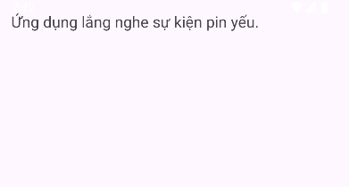**Kết quả:**