LAB 3
Nguyễn Dương Quốc Huy 1150070017

SQL lite
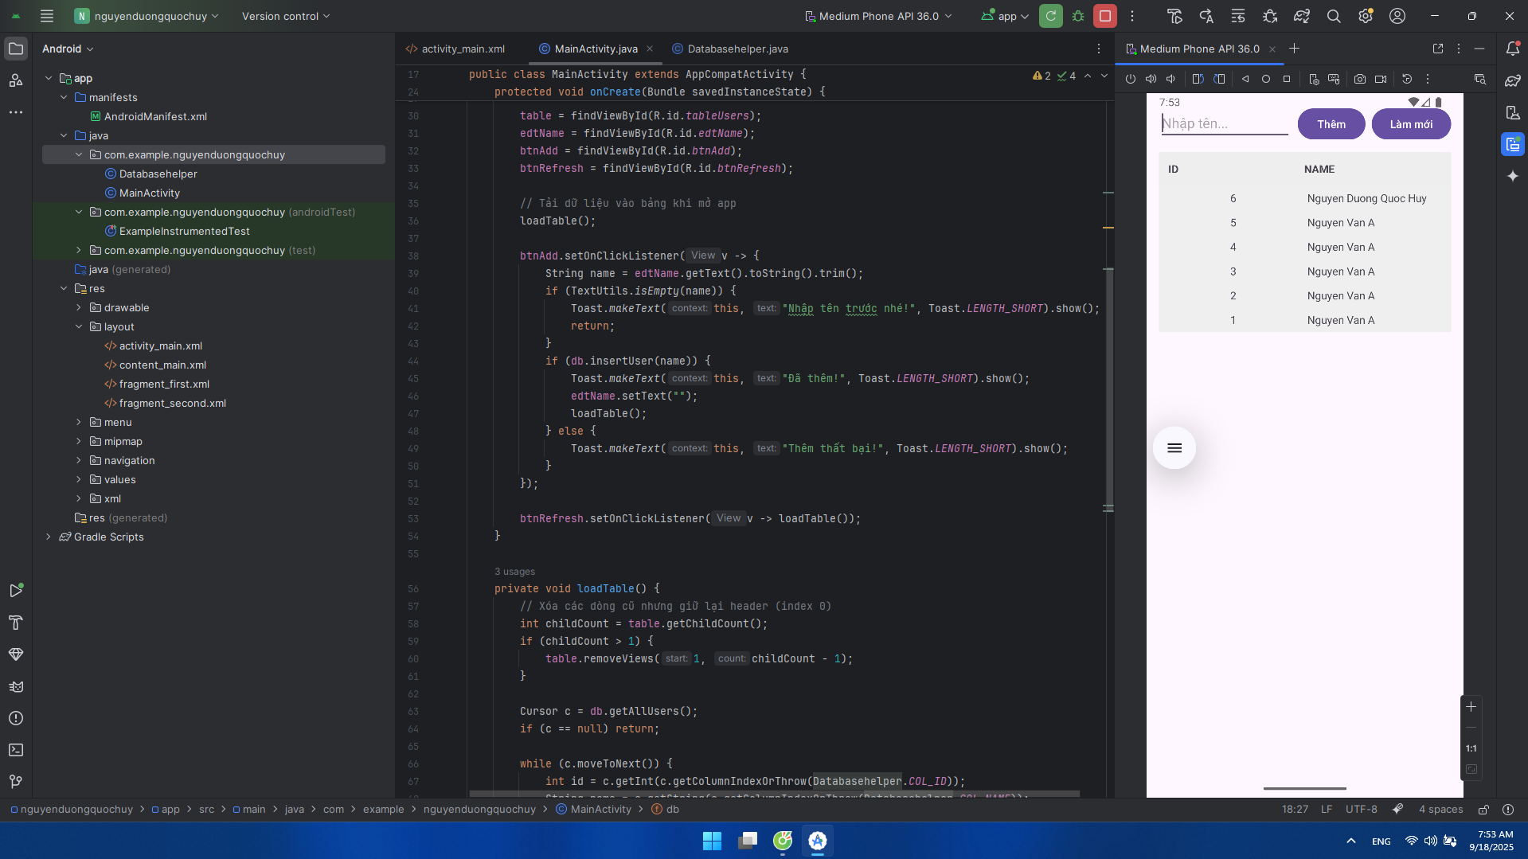
Tạo file Databasehelper
Trong file Databasehelper
package com.example.nguyenduongquochuy;
import android.content.ContentValues;
import android.content.Context;
import android.database.Cursor;
import android.database.sqlite.SQLiteDatabase;
import android.database.sqlite.SQLiteOpenHelper;
public class Databasehelper extends SQLiteOpenHelper {
private static final String DB_NAME = "mydb.db";
private static final int DB_VERSION = 1;
public static final String TBL_USERS = "users";
public static final String COL_ID = "ID";
public static final String COL_NAME = "NAME";
public Databasehelper(Context context) {
super(context, DB_NAME, null, DB_VERSION);
}
@Override
public void onCreate(SQLiteDatabase db) {
db.execSQL(
"CREATE TABLE IF NOT EXISTS " + TBL_USERS + " (" +
COL_ID + " INTEGER PRIMARY KEY AUTOINCREMENT, " +
COL_NAME + " TEXT NOT NULL)"
);
}
@Override
public void onUpgrade(SQLiteDatabase db, int oldV, int newV) {
db.execSQL("DROP TABLE IF EXISTS " + TBL_USERS);
onCreate(db);
}
public boolean insertUser(String name) {
SQLiteDatabase db = getWritableDatabase();
ContentValues cv = new ContentValues();
cv.put(COL_NAME, name);
return db.insert(TBL_USERS, null, cv) != -1;
}
public Cursor getAllUsers() {
SQLiteDatabase db = getReadableDatabase();
return db.rawQuery("SELECT * FROM " + TBL_USERS + " ORDER BY " + COL_ID + " DESC", null);
}
}
Trong file Main
package com.example.nguyenduongquochuy;
import androidx.appcompat.app.AppCompatActivity;
import android.database.Cursor;
import android.os.Bundle;
import android.text.TextUtils;
import android.view.Gravity;
import android.view.ViewGroup;
import android.widget.Button;
import android.widget.EditText;
import android.widget.TableLayout;
import android.widget.TableRow;
import android.widget.TextView;
import android.widget.Toast;
public class MainActivity extends AppCompatActivity {
private Databasehelper db;
private TableLayout table;
private EditText edtName;
private Button btnAdd, btnRefresh;
@Override
protected void onCreate(Bundle savedInstanceState) {
super.onCreate(savedInstanceState);
setContentView(R.layout.activity_main);
db = new Databasehelper(this);
table = findViewById(R.id.tableUsers);
edtName = findViewById(R.id.edtName);
btnAdd = findViewById(R.id.btnAdd);
btnRefresh = findViewById(R.id.btnRefresh);
// Tải dữ liệu vào bảng khi mở app
loadTable();
btnAdd.setOnClickListener(v -> {
String name = edtName.getText().toString().trim();
if (TextUtils.isEmpty(name)) {
Toast.makeText(this, "Nhập tên trước nhé!", Toast.LENGTH_SHORT).show();
return;
}
if (db.insertUser(name)) {
Toast.makeText(this, "Đã thêm!", Toast.LENGTH_SHORT).show();
edtName.setText("");
loadTable();
} else {
Toast.makeText(this, "Thêm thất bại!", Toast.LENGTH_SHORT).show();
}
});
btnRefresh.setOnClickListener(v -> loadTable());
}
private void loadTable() {
// Xóa các dòng cũ nhưng giữ lại header (index 0)
int childCount = table.getChildCount();
if (childCount > 1) {
table.removeViews(1, childCount - 1);
}
Cursor c = db.getAllUsers();
if (c == null) return;
while (c.moveToNext()) {
int id = c.getInt(c.getColumnIndexOrThrow(Databasehelper.COL_ID));
String name = c.getString(c.getColumnIndexOrThrow(Databasehelper.COL_NAME));
addRow(String.valueOf(id), name);
}
c.close();
}
private void addRow(String id, String name) {
TableRow row = new TableRow(this);
row.setLayoutParams(new TableRow.LayoutParams(
ViewGroup.LayoutParams.MATCH_PARENT,
ViewGroup.LayoutParams.WRAP_CONTENT));
row.setPadding(8, 8, 8, 8);
TextView tvId = makeCell(id, true);
TextView tvName = makeCell(name, false);
row.addView(tvId);
row.addView(tvName);
// viền mỏng mỗi hàng (tuỳ thích)
row.setBackgroundColor(0xFFEFEFEF);
TableRow spacer = new TableRow(this);
spacer.setLayoutParams(new TableRow.LayoutParams(
ViewGroup.LayoutParams.MATCH_PARENT, 1));
spacer.setBackgroundColor(0xFFCCCCCC);
table.addView(row);
table.addView(spacer);
}
private TextView makeCell(String text, boolean center) {
TextView tv = new TextView(this);
tv.setText(text);
tv.setPadding(8, 8, 8, 8);
tv.setLayoutParams(new TableRow.LayoutParams(
0, ViewGroup.LayoutParams.WRAP_CONTENT, 1f));
tv.setGravity(center ? Gravity.CENTER : Gravity.START);
return tv;
}
}

Trong file activity_main.xml
<?xml version="1.0" encoding="utf-8"?>
<LinearLayout xmlns:android="http://schemas.android.com/apk/res/android"
android:orientation="vertical"
android:padding="16dp"
android:layout_width="match_parent"
android:layout_height="match_parent">
<!-- Nhập tên và nút thêm/refresh -->
<LinearLayout
android:orientation="horizontal"
android:layout_width="match_parent"
android:layout_height="wrap_content">
<EditText
android:id="@+id/edtName"
android:hint="Nhập tên..."
android:layout_weight="1"
android:layout_width="0dp"
android:layout_height="wrap_content"/>
<Button
android:id="@+id/btnAdd"
android:text="Thêm"
android:layout_marginStart="8dp"
android:layout_width="wrap_content"
android:layout_height="wrap_content"/>
<Button
android:id="@+id/btnRefresh"
android:text="Làm mới"
android:layout_marginStart="8dp"
android:layout_width="wrap_content"
android:layout_height="wrap_content"/>
</LinearLayout>
<!-- Bảng dữ liệu: đặt trong ScrollView để cuộn -->
<ScrollView
android:layout_width="match_parent"
android:layout_height="0dp"
android:layout_weight="1"
android:fillViewport="true"
android:layout_marginTop="12dp">
<TableLayout
android:id="@+id/tableUsers"
android:stretchColumns="0,1"
android:layout_width="match_parent"
android:layout_height="wrap_content">
<!-- Header -->
<TableRow
android:background="#EEEEEE"
android:padding="8dp">
<TextView
android:text="ID"
android:textStyle="bold"
android:padding="4dp"
android:layout_width="wrap_content"
android:layout_height="wrap_content"/>
<TextView
android:text="NAME"
android:textStyle="bold"
android:padding="4dp"
android:layout_width="wrap_content"
android:layout_height="wrap_content"/>
</TableRow>
<!-- Dòng dữ liệu sẽ được thêm bằng code -->
</TableLayout>
</ScrollView>
</LinearLayout>

