Lab 5
Nguyễn Dương Quốc Huy
1150070017
SỬ DỤNG ANIMATION TỪ FILE XML
Scale → Translate → Rotate → Alpha
Code trong file mainfest
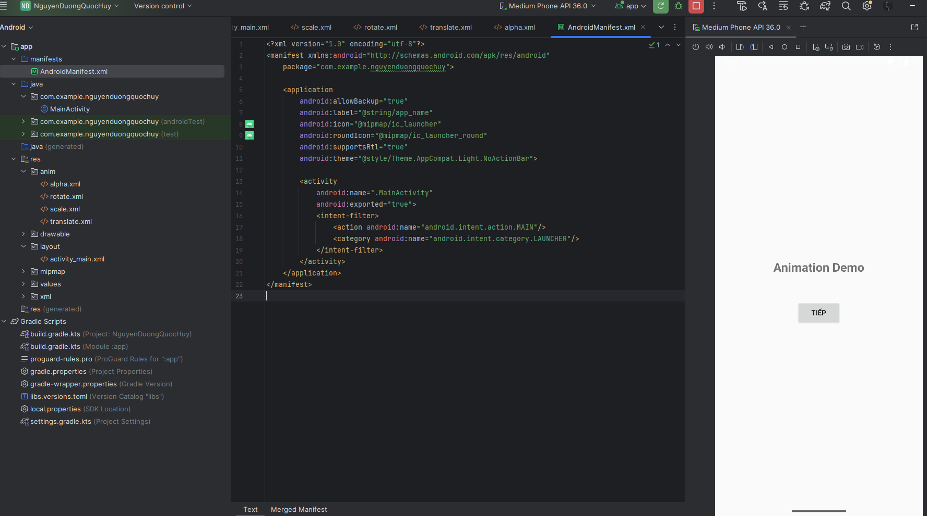
<?xml version="1.0" encoding="utf-8"?>
<manifest xmlns:android="http://schemas.android.com/apk/res/android"
package="com.example.nguyenduongquochuy">
<application
android:allowBackup="true"
android:label="@string/app_name"
android:icon="@mipmap/ic_launcher"
android:roundIcon="@mipmap/ic_launcher_round"
android:supportsRtl="true"
android:theme="@style/Theme.AppCompat.Light.NoActionBar">
<activity
android:name=".MainActivity"
android:exported="true">
<intent-filter>
<action android:name="android.intent.action.MAIN"/>
<category android:name="android.intent.category.LAUNCHER"/>
</intent-filter>
</activity>
</application>
</manifest>
Code trong file activity_main
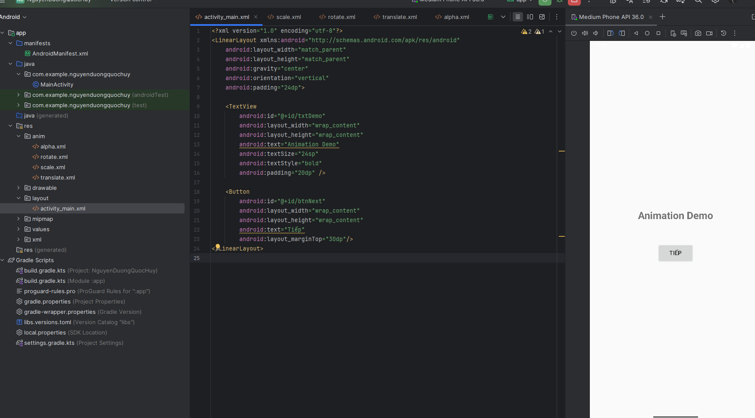
<?xml version="1.0" encoding="utf-8"?>
<LinearLayout xmlns:android="http://schemas.android.com/apk/res/android"
android:layout_width="match_parent"
android:layout_height="match_parent"
android:gravity="center"
android:orientation="vertical"
android:padding="24dp">
<TextView
android:id="@+id/txtDemo"
android:layout_width="wrap_content"
android:layout_height="wrap_content"
android:text="Animation Demo"
android:textSize="24sp"
android:textStyle="bold"
android:padding="20dp" />
<Button
android:id="@+id/btnNext"
android:layout_width="wrap_content"
android:layout_height="wrap_content"
android:text="Tiếp"
android:layout_marginTop="30dp"/>
</LinearLayout>
Code trong file scale
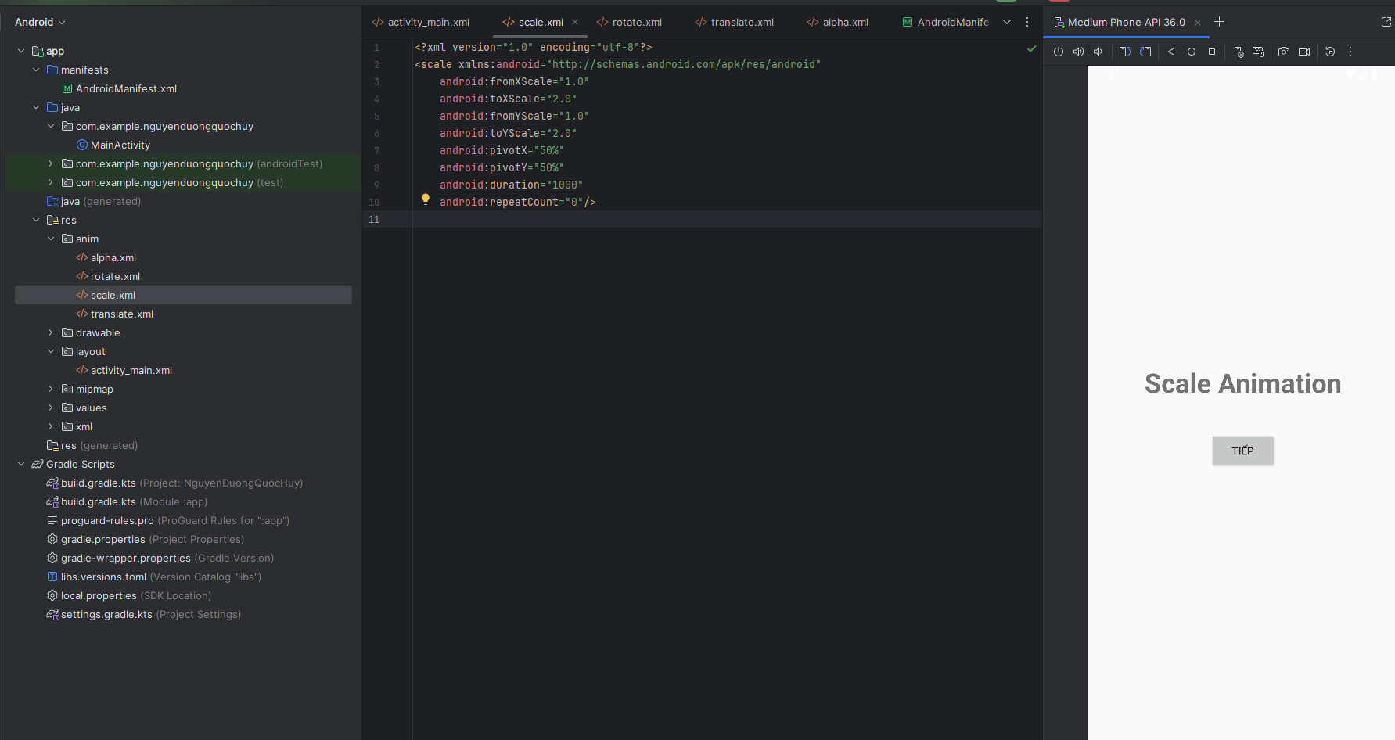
<?xml version="1.0" encoding="utf-8"?>
<scale xmlns:android="http://schemas.android.com/apk/res/android"
android:fromXScale="1.0"
android:toXScale="2.0"
android:fromYScale="1.0"
android:toYScale="2.0"
android:pivotX="50%"
android:pivotY="50%"
android:duration="1000"
android:repeatCount="0"/>

Code trong file translate
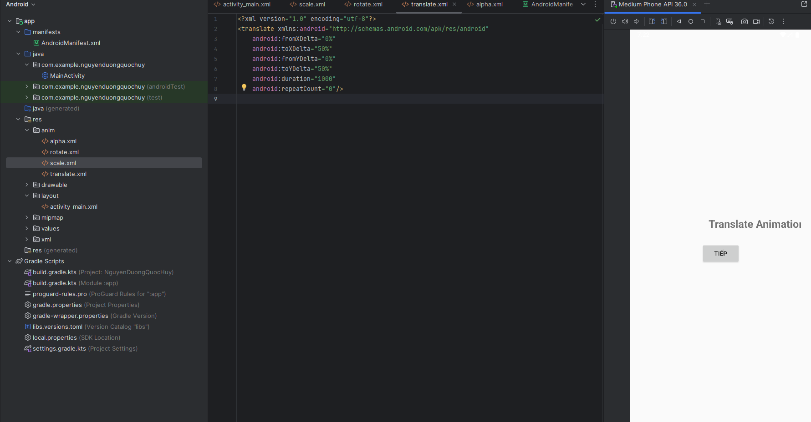
<?xml version="1.0" encoding="utf-8"?>
<translate xmlns:android="http://schemas.android.com/apk/res/android"
android:fromXDelta="0%"
android:toXDelta="50%"
android:fromYDelta="0%"
android:toYDelta="50%"
android:duration="1000"
android:repeatCount="0"/>
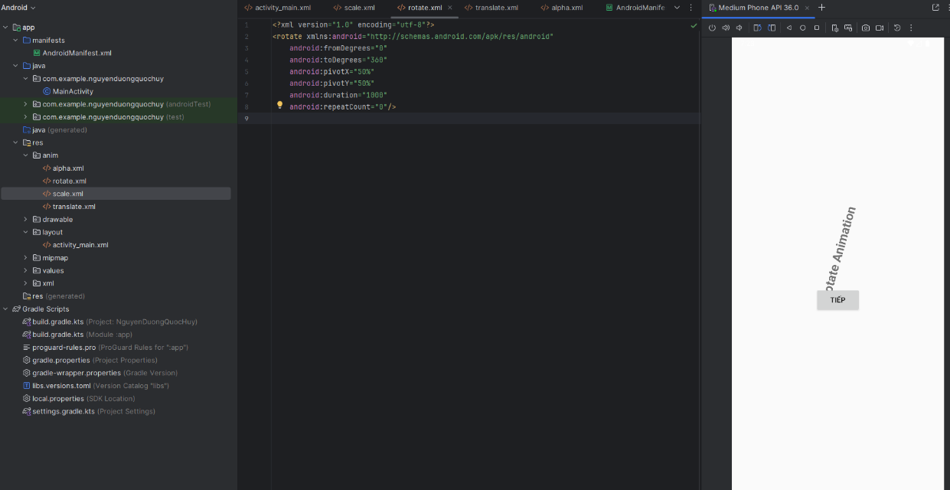
Code trong file Rotate

<?xml version="1.0" encoding="utf-8"?>
<rotate xmlns:android="http://schemas.android.com/apk/res/android"
android:fromDegrees="0"
android:toDegrees="360"
android:pivotX="50%"
android:pivotY="50%"
android:duration="1000"
android:repeatCount="0"/>
Code trong file Alpha
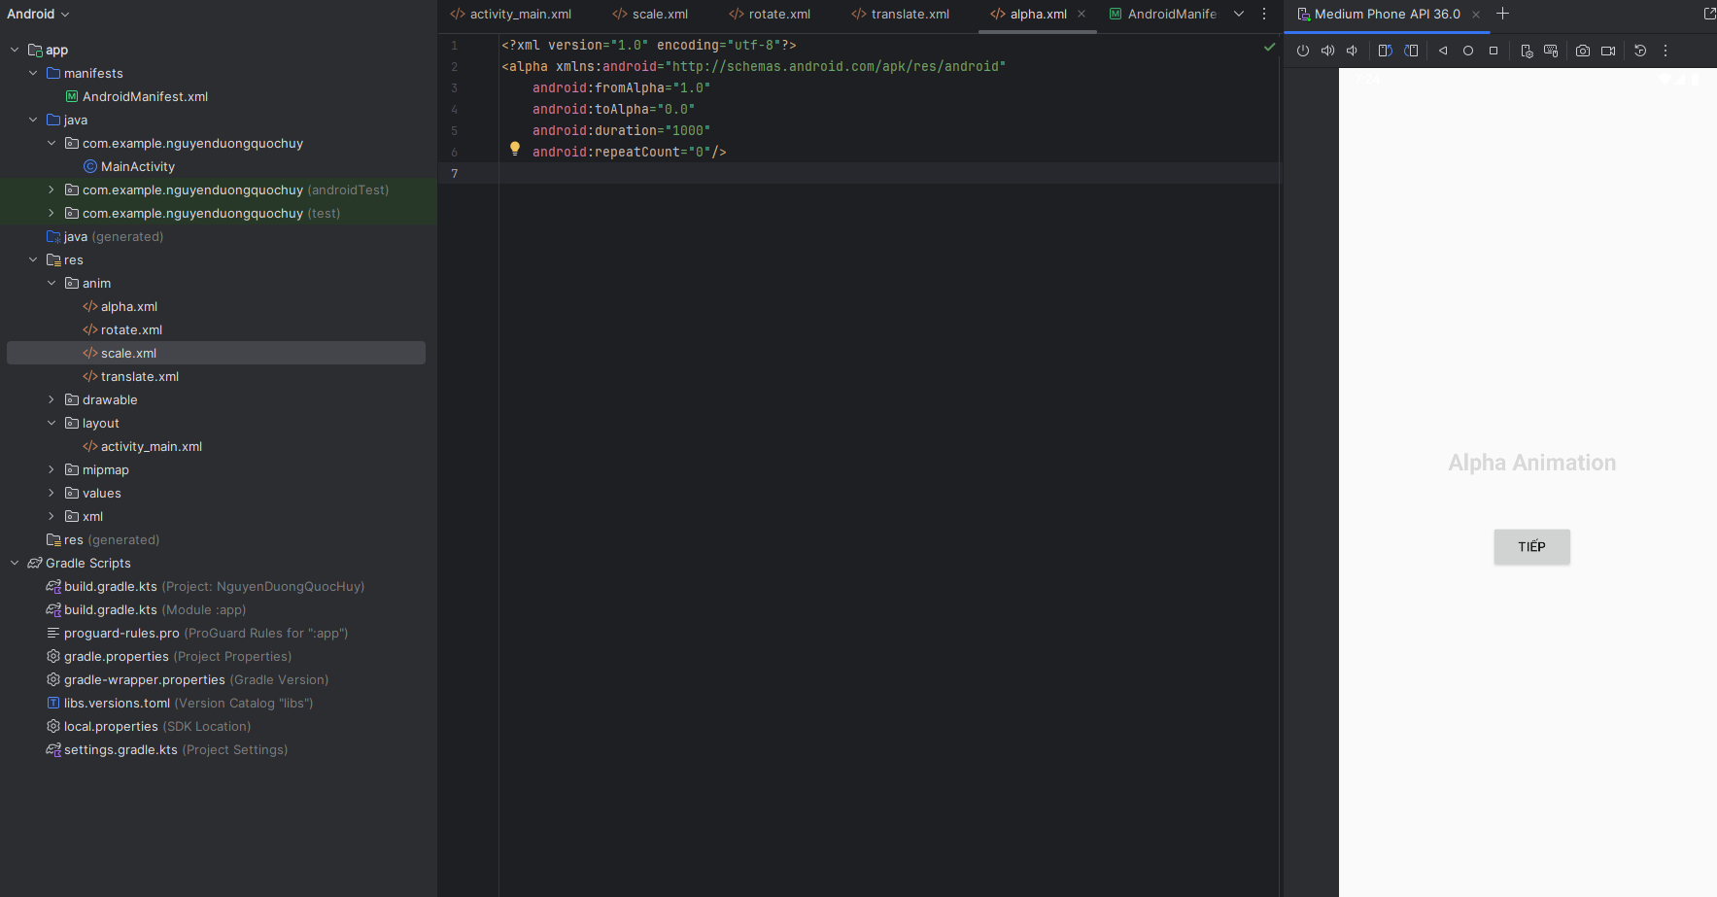
<?xml version="1.0" encoding="utf-8"?>
<alpha xmlns:android="http://schemas.android.com/apk/res/android"
android:fromAlpha="1.0"
android:toAlpha="0.0"
android:duration="1000"
android:repeatCount="0"/>
Code trong file MainActivity
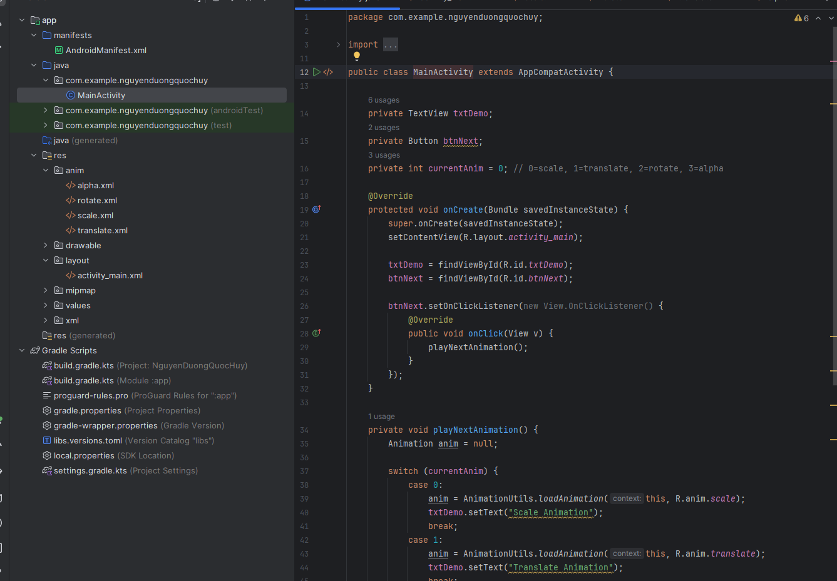
package com.example.nguyenduongquochuy;
import androidx.appcompat.app.AppCompatActivity;
import android.os.Bundle;
import android.view.View;
import android.view.animation.Animation;
import android.view.animation.AnimationUtils;
import android.widget.Button;
import android.widget.TextView;
public class MainActivity extends AppCompatActivity {
private TextView txtDemo;
private Button btnNext;
private int currentAnim = 0;
@Override
protected void onCreate(Bundle savedInstanceState) {
super.onCreate(savedInstanceState);
setContentView(R.layout.activity_main);
txtDemo = findViewById(R.id.txtDemo);
btnNext = findViewById(R.id.btnNext);
btnNext.setOnClickListener(new View.OnClickListener() {
@Override
public void onClick(View v) {
playNextAnimation();
}
});
}
private void playNextAnimation() {
Animation anim = null;
switch (currentAnim) {
case 0:
anim = AnimationUtils.loadAnimation(this, R.anim.scale);
txtDemo.setText("Scale Animation");
break;
case 1:
anim = AnimationUtils.loadAnimation(this, R.anim.translate);
txtDemo.setText("Translate Animation");
break;
case 2:
anim = AnimationUtils.loadAnimation(this, R.anim.rotate);
txtDemo.setText("Rotate Animation");
break;
case 3:
anim = AnimationUtils.loadAnimation(this, R.anim.alpha);
txtDemo.setText("Alpha Animation");
break;
}
if (anim != null) {
txtDemo.startAnimation(anim);
}
currentAnim = (currentAnim + 1) % 4;
}
}

SỬ DỤNG ANIMATION TỪ CODE
Scale → Translate → Rotate → Alpha
Code trong file mainfest
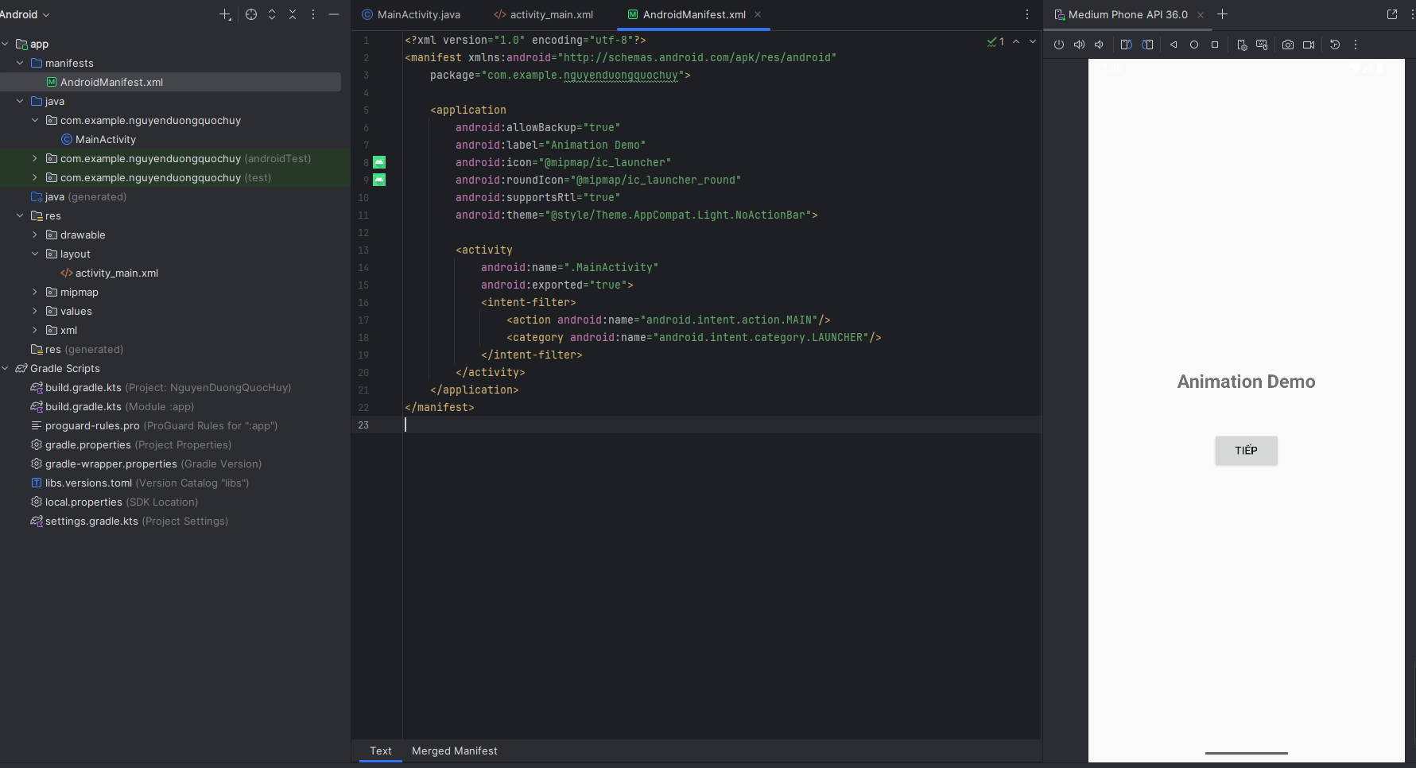
<?xml version="1.0" encoding="utf-8"?>
<manifest xmlns:android="http://schemas.android.com/apk/res/android"
package="com.example.nguyenduongquochuy">
<application
android:allowBackup="true"
android:label="Animation Demo"
android:icon="@mipmap/ic_launcher"
android:roundIcon="@mipmap/ic_launcher_round"
android:supportsRtl="true"
android:theme="@style/Theme.AppCompat.Light.NoActionBar">
<activity
android:name=".MainActivity"
android:exported="true">
<intent-filter>
<action android:name="android.intent.action.MAIN"/>
<category android:name="android.intent.category.LAUNCHER"/>
</intent-filter>
</activity>
</application>
</manifest>
Code trong file activity_main
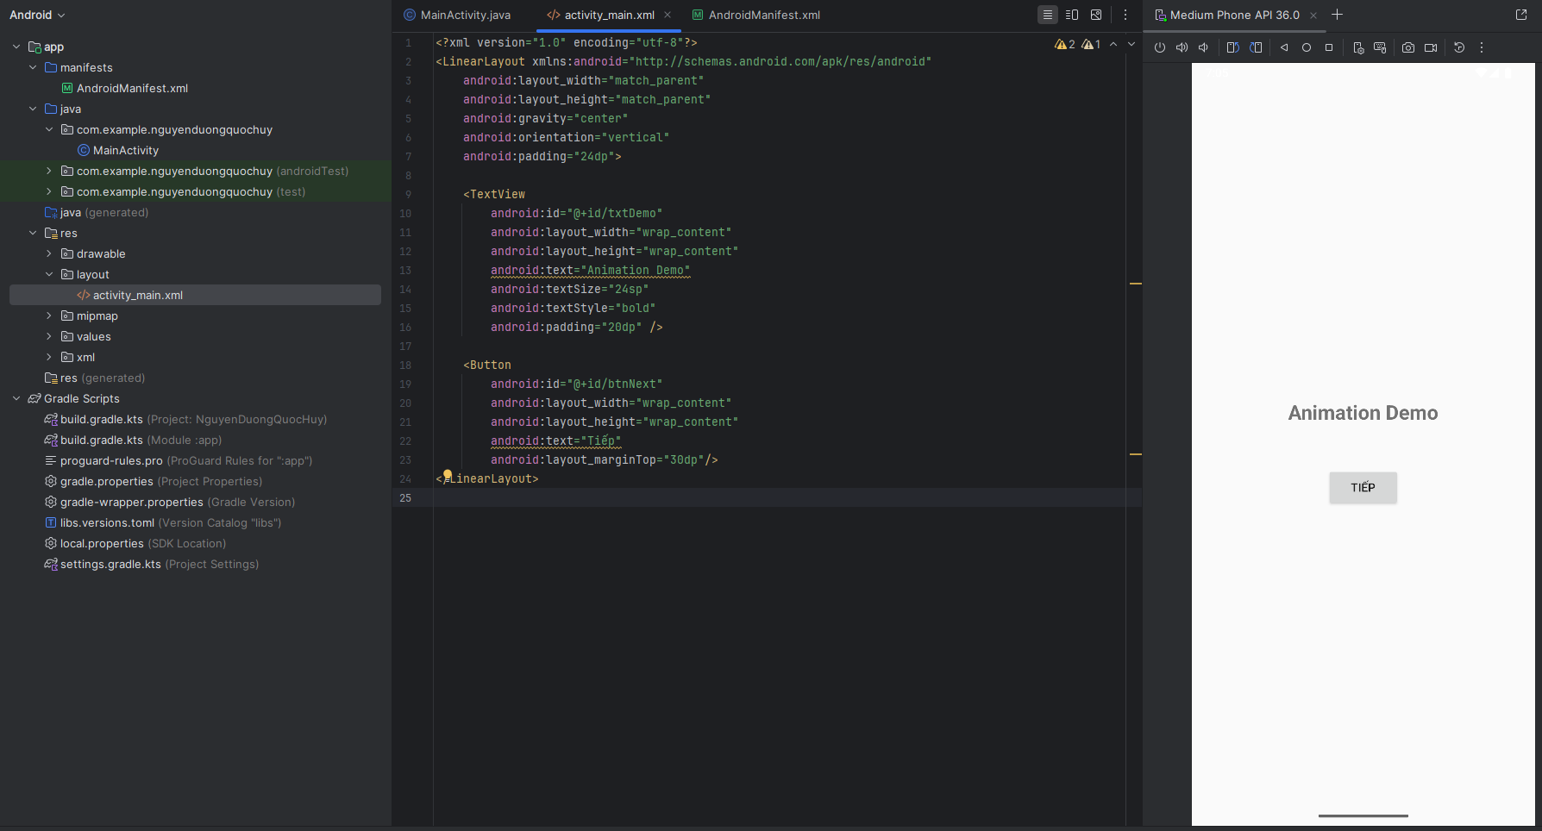
<?xml version="1.0" encoding="utf-8"?>
<LinearLayout xmlns:android="http://schemas.android.com/apk/res/android"
android:layout_width="match_parent"
android:layout_height="match_parent"
android:gravity="center"
android:orientation="vertical"
android:padding="24dp">
<TextView
android:id="@+id/txtDemo"
android:layout_width="wrap_content"
android:layout_height="wrap_content"
android:text="Animation Demo"
android:textSize="24sp"
android:textStyle="bold"
android:padding="20dp" />
<Button
android:id="@+id/btnNext"
android:layout_width="wrap_content"
android:layout_height="wrap_content"
android:text="Tiếp"
android:layout_marginTop="30dp"/>
</LinearLayout>
Code trong file MainActivity
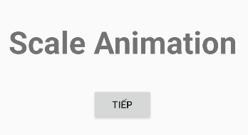
package com.example.nguyenduongquochuy;
import androidx.appcompat.app.AppCompatActivity;
import android.os.Bundle;
import android.view.View;
import android.view.animation.AlphaAnimation;
import android.view.animation.Animation;
import android.view.animation.RotateAnimation;
import android.view.animation.ScaleAnimation;
import android.view.animation.TranslateAnimation;
import android.widget.Button;
import android.widget.TextView;
public class MainActivity extends AppCompatActivity {
private TextView txtDemo;
private Button btnNext;
private int currentAnim = 0;
@Override
protected void onCreate(Bundle savedInstanceState) {
super.onCreate(savedInstanceState);
setContentView(R.layout.activity_main);
txtDemo = findViewById(R.id.txtDemo);
btnNext = findViewById(R.id.btnNext);
btnNext.setOnClickListener(new View.OnClickListener() {
@Override
public void onClick(View v) {
playNextAnimation();
}
});
}
private void playNextAnimation() {
Animation anim = null;
switch (currentAnim) {
case 0: // Scale
anim = new ScaleAnimation(
1f, 2f,
1f, 2f,
Animation.RELATIVE_TO_SELF, 0.5f,
Animation.RELATIVE_TO_SELF, 0.5f
);
anim.setDuration(1000);
txtDemo.setText("Scale Animation");
break;
case 1: // Translate
anim = new TranslateAnimation(
Animation.RELATIVE_TO_PARENT, 0f,
Animation.RELATIVE_TO_PARENT, 0.5f,
Animation.RELATIVE_TO_PARENT, 0f,
Animation.RELATIVE_TO_PARENT, 0.5f
);
anim.setDuration(1000);
txtDemo.setText("Translate Animation");
break;
case 2: // Rotate
anim = new RotateAnimation(
0, 360,
Animation.RELATIVE_TO_SELF, 0.5f,
Animation.RELATIVE_TO_SELF, 0.5f
);
anim.setDuration(1000);
txtDemo.setText("Rotate Animation");
break;
case 3: // Alpha
anim = new AlphaAnimation(1f, 0f);
anim.setDuration(1000);
txtDemo.setText("Alpha Animation");
break;
}
if (anim != null) {
txtDemo.startAnimation(anim);
}
currentAnim = (currentAnim + 1) % 4;
}
}

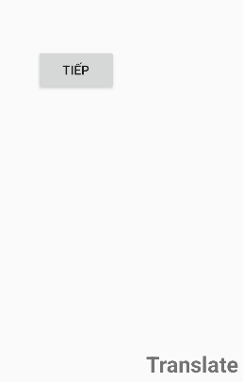

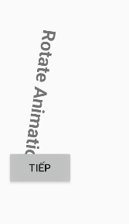

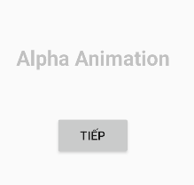

Tạo animation khi start Activity mới
Code trong secondActivity
package com.example.nguyenduongquochuy;
import androidx.appcompat.app.AppCompatActivity;
import android.os.Bundle;
public class SecondActivity extends AppCompatActivity {
@Override
protected void onCreate(Bundle savedInstanceState) {
super.onCreate(savedInstanceState);
setContentView(R.layout.activity_second);
}
@Override
public void finish() {
super.finish();
// khi back thì chạy animation ngược lại
overridePendingTransition(R.anim.slide_in_left, R.anim.slide_out_right);
}
}
Code trong slide_in_right
<?xml version="1.0" encoding="utf-8"?>
<translate xmlns:android="http://schemas.android.com/apk/res/android"
android:duration="500"
android:fromXDelta="100%"
android:toXDelta="0%"
android:fromYDelta="0%"
android:toYDelta="0%"/>
Code trong slide_in_right
<?xml version="1.0" encoding="utf-8"?>
<translate xmlns:android="http://schemas.android.com/apk/res/android"
android:duration="500"
android:fromXDelta="0%"
android:toXDelta="100%"
android:fromYDelta="0%"
android:toYDelta="0%"/>
Code trong slide_in_left
<?xml version="1.0" encoding="utf-8"?>
<translate xmlns:android="http://schemas.android.com/apk/res/android"
android:duration="500"
android:fromXDelta="-100%"
android:toXDelta="0%"
android:fromYDelta="0%"
android:toYDelta="0%"/>
Code trong slide_out_left
<?xml version="1.0" encoding="utf-8"?>
<translate xmlns:android="http://schemas.android.com/apk/res/android"
android:duration="500"
android:fromXDelta="0%"
android:toXDelta="-100%"
android:fromYDelta="0%"
android:toYDelta="0%"/>

