


FPT ACADEMY INTERNATIONAL

FPT – APTECH COMPUTER EDUCATION

Ryana Calendar Shop

Center Name |  | FPT – Aptech – HCM2  Address: 590 Cach Mang Thang Tam, District 3, Ho Chi Minh City
Instructor |  | Ms. Le Mong Thuy
Class |  | T1.2109.M1
Group |  | 3
Group members |  | Name | Student ID
 |  | Đặng Quốc Thái | Student1339031
 |  | Từ Bái Kỳ | Student1339036
 |  | Võ Duy Lễ | Student1339030
Duration | Start date | 9th Dec 2021
Duration | End date | 9th Jan 2022

This is to certify that

Mr.:

Đặng Quốc Thái

Từ Bái Kỳ

Võ Duy Lễ

has successfully designed & developed

eProject: Ryana Calender Shop

Submitted by:

Đặng Quốc Thái

Date of issue:
9th Dec 2021

Authorized Signature:


TABLE OF CONTENTS
FPT-APTECH COMPUTER EDUCATION 1
ACKNOWLEGMENT 4
PROBLEM DEFINITION
CUSTOMER’S REQUIREMENTS SPECIFICATION (CRS) 4
Business/project Objective 4
Hardware/software Requirements 5
SCOPE OF THE WORK (IN BRIEF) 6
Architecture and design of the system 7
Diagram of website 8
TASK SHEET REVIEW 1 9
SITE MAP 10
MOCK OF THE WESITE 11
1. Home page 11
2. Item menu 1 12
3. Item menu 2 13
4. Item menu 3 14
5. Prices lists 15
6. Contact us 17
TASK SHEET REVIEW 2 19
WEBSITE DISCRIPTION 20
1. Home page 20
2. Item menu 21
3. Prices list 21
4. Contact us 25
JAVASCRIPT DISCRIPTION 27
1. Product data json and javascript 27
2. Filter javascript 30
3. Comparison javascript 31
4. Add to cart javascript 34
5. Contact us javascript 35
TASK SHEET REVIEW 3 36

ACKNOWLEGMENT
On behalf of all members of group3, I would like to thank all of you for your hard work and support to make this eProject a success. Especially, Ms. Le Mong Thuy, our teacher, she has helped us a lot since the early days of FPT Aptech. With this eProject she guided us with enthusiasm and seriousness, because of her guidance we will be able to complete this project. In addition, I would like to thank all of the team members of Team 3, each of whom has worked continuously in order to complete this project.

SYNOSIS

In this assignment, we were assigned to design and develop a business website that fulfills every request from the client for calendar and diary products. The business is selling items such as calendars, diaries, magazines, etc. The customer's goal for the website is to make it convenient for customers to be able to easily View details of their products and what products are currently available. Besides, the business also offers some outstanding products for customers.

PROBLEM DEFINITION

Ryana Calendars is selling various Calendars and Diary products. The company
advertises by distributing the pamphlets, advertising on television and so on. Due to
rapid development in internet field, the company decides to launch a website where
people will get all the information about the various products available with them
easily..
The website is to be developed for the Windows Platform using HTML5, JavaScript and Geolocation. The site should work well in all leading browsers including Chrome, IE, Firefox etc.

CUSTOMER'S REQUIREMENTS SPECIFICATIONS (CRS)

Client: Ryana Calendars

Business/Project Objective:

Ryana Calendars is selling various Calendars and Diary products. The company
advertises by distributing the pamphlets, advertising on television and so on. Due to
rapid development in internet field, the company decides to launch a website where
people will get all the information about the various products available with them
easily.
The website is to be developed for the Windows Platform using HTML5, JavaScript and Geolocation. The site should work well in all leading browsers including Chrome, IE, Firefox etc.

Input to the system:

- Searching for products, calendars, journal articles.

Output from the system:

- A menu will categorize all the functions of the website.
- Display the list of product type
- Display the list of available product categories appropriately.
- Provide product information.
- Location of the store in the Contact page.
- In the Shop page, users can use filters to categorize products.

Expected delivery date: 9th-Jan-2022.

List of deliverables:

      - Document Word.
      - Source code.

Hardware/ Software Requirements:

- For developer
Hardware
  - Intel Pentium 4 processor or higher
  - 1 Gigabytes of RAM or higher
Software
  - Windows 7 OS or higher
  - Adobe Dreamweaver
  - Web browsers such as IE, Chrome or Firefox are supporting HTML5, CSS3 and Javascript.

- For web users
Hardware
  - Intel Pentium 4 processor or higher
  - 512 Megabytes of RAM or higher
Software
  - Windows XP OS or higher
  - Web browsers such as IE, Chrome or Firefox are supporting HTML5, CSS3 and Javascript.

SCOPE OF THE WORK (IN BRIEF)

SCOPE OF THE WORK (IN BRIEF)

After a long and detailed discussion, our group has decided to create a website contain the following webpages:
1. Home page: We divide this section into 2 sections:
- Part 1: Display part in the carousel / slide: new products / best selling products / branded products.
- Part 2: , product: images, prices, ....
2. Item Menu: Show all item type, filter to sort items by specific category.
3. Price List: display a downloadable document about product’s price.
4. Contact Us: Displays business contacts (address, phone, email, map).

Architecture and design of the system

CLIENT





Webpage request
Requested Page
RENDERING
ENGINE
CSS CODE
HTML CODE
WEB SERVER
WEB BROWSER
SERVER

Diagram of the website

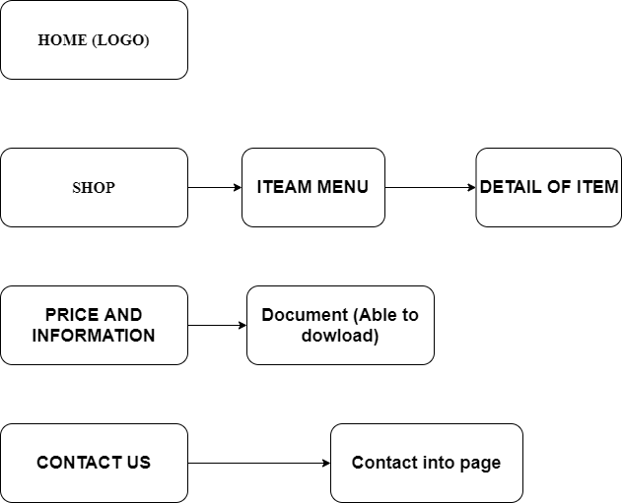






TASK SHEET REVIEW 1

Project Ref. No.:  eP/Advertisement Portal Management  System/01 |  | Project Title: | Activity Plan Prepared By: | Date of Preparation of Activity Plan:
Sr.  No. | Task | Project Title: | Activity Plan Prepared By: | Actual  Start Date | Actual Days | Team Mate Names | Status
1 | Problem Statement | Sattionary | Đặng Quốc Thái | 9-Dec-2021 | 1 | Đ.Q.Thái | Completed
2 | Analysis of Stationary shop requirements about the website | Sattionary | Đặng Quốc Thái | 9-Dec-2021 | 1 | T.B.Kỳ | Completed
3 | The scope of the work (in brief) | Sattionary | Đặng Quốc Thái | 9-Dec-2021 | 1 | V.D.Lễ | Completed
4 | Architecture and design of the system | Sattionary | Đặng Quốc Thái | 9-Dec-2021 | 1 | T.B.Kỳ | Completed
5 | Diagram of the website | Sattionary | Đặng Quốc Thái | 9-Dec-2021 | 1 | D.Q.Thái | Completed
6 | Task Sheet | Sattionary | Đặng Quốc Thái | 9-Dec-2021 | 1 | V.D.Lễ | Completed

Date: 9th Jan 2021
Signature of Instructor:  Ms. Le Mong Thuy | Signature of Team Leader:  Dang Quoc Thai

SITE MAP

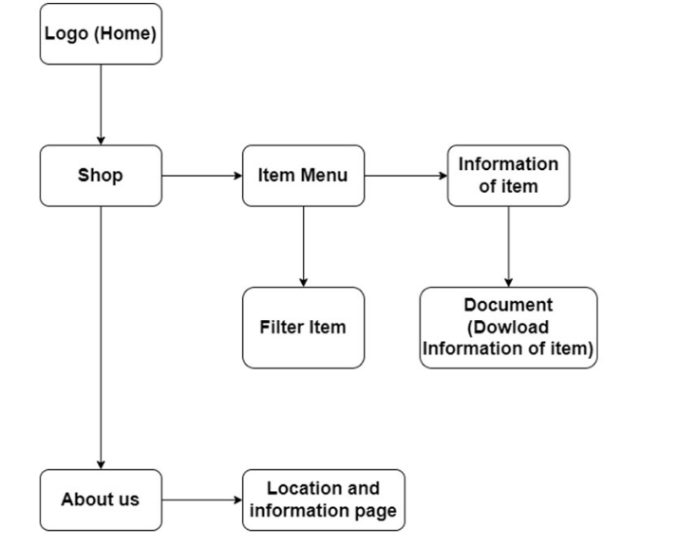

MOCK OF THE WEBSITE

- Homepage

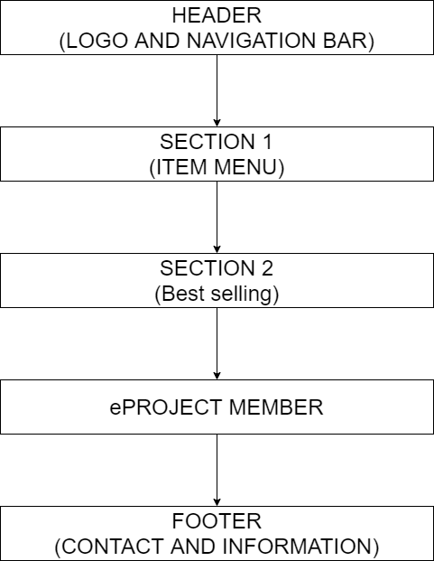

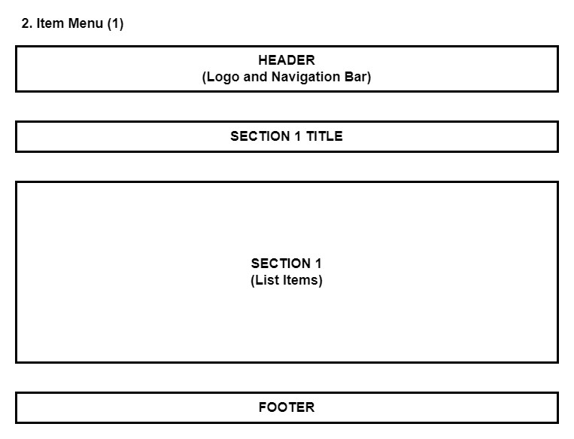

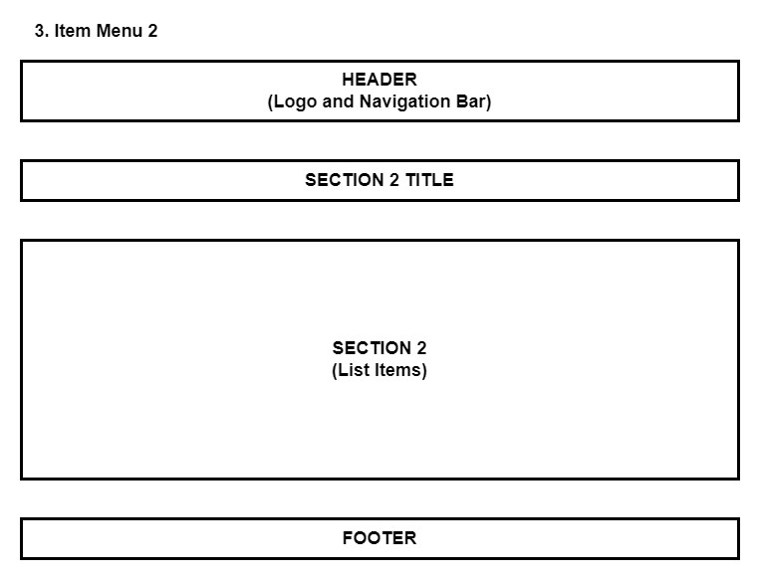

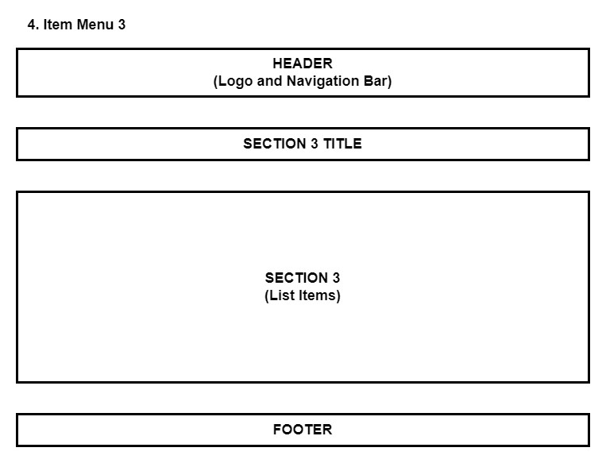

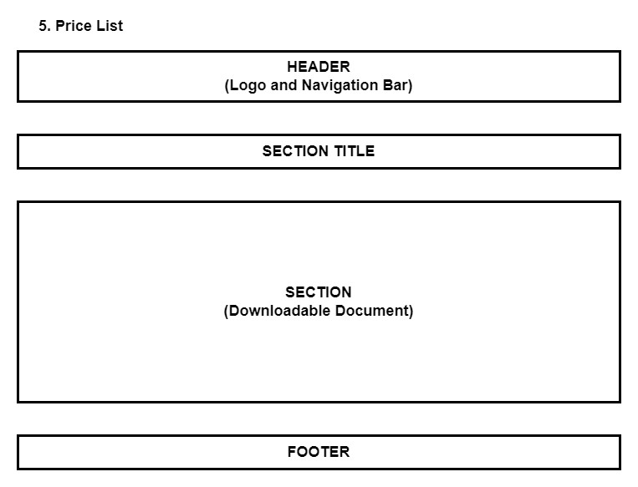

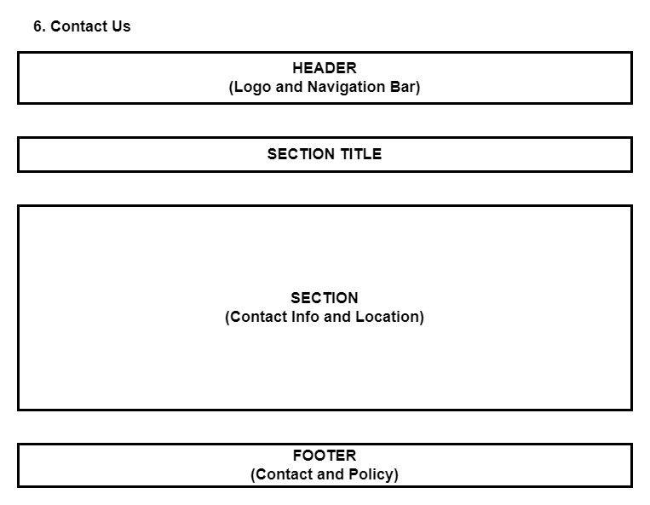

Logo

This logos designed by Võ Duy Lễ-Student1339030

HEADER LOGO


TASK SHEET REVIEW 2

Project Ref. No.:  eP/Advertisement  Portal Management System/01 |  | Project Title: | Activity Plan Prepared By: | Date of Preparation of Activity Plan:
Sr.  No. | Task | Project Title: | Activity Plan Prepared By: | Actual Start Date | Actual Days | Team Mate Names | Status
1 | Site map | Stationary Shop | Đ.Q.Thái | 9th-Dec-2021 | 1 | T.B.Kỳ | Completed
2 | Mock of the website | Stationary Shop | Đ.Q.Thái | 9th-Dec-2021 | 2 | V.D.Lễ | Completed
3 | Task sheet | Stationary Shop | Đ.Q.Thái | 9th-Dec-2021 | 2 | Đ.Q.Thái | Completed

Date: 19th Dec 2021
Signature of Instructor:  Ms. Le Mong Thuy | Signature of Team Leader:  Dang Quoc Thai

WEBSITE DESCRIPTION

- Home page
- Description
Home page displays following infomation
    - Events
    - Best Seller
  - Screenshot

- Item menu 1
  - Description
The menu item page has the following information
- Display calendar products at Shop page.
- Show all products of this category:
+ Desktop calendar.
+ Wall calendar
+ Calendar bloc
+ Exclusive calendar
+ …….
  - Screenshot

- Item menu 2
  - Description
The log product catalog shows the following information
- Show all products of the category.
+Personal diary
+ Diary of public service
+ Management diary
  - Screenshot

- Item menu 3
  - Description
This page shows some of the other products the store is selling
+Magazines
+........
  - Screenshot

- Price lists
  - Description
This page will display information about the prices of products in the shop
  - Screenshot

- About us
  - Description
This page will displays information about the history of Ryana Calendar shop, our service that we provide and our team member.
  - Screenshot

- Contact us
  - Description
This page displays contact information: location, telephone number, email and a quick contact form for customer.
  - Screenshot

JAVASCRIPT DESCRIPTION
- Product data json and javascript.
  - Description
This script used for adding product detail.
  - Screenshot

b-1 Product data json

b-2 Javascript

b-3 Modal show item’s detail

- Filter javascript
  - Description

This script used for filtering items in the shop page based on categories and brands
  - Screenshot

- Comparison javascript
  - Description

This script used for comparing items in the shop page based on categories and brands
  - Screenshot

- Add to Cart javascript
  - Description

This script used for adding items to cart and show how many item added.
  - Screenshot

- Contact us javascript
  - Description

This script used for contacting to our customer service.
  - Screenshot

TASK SHEET REVIEW 3

Project Ref. No.:  eP/Advertisement  Portal Management System/01 |  | Project Title: | Activity Plan Prepared By: | Date of Preparation of Activity Plan:
Sr.  No. | Task | Project Title: | Activity Plan Prepared By: | Actual Start Date | Actual Days | Team Mate Names | Status
1 | Website layout | GIFT  SHOP | Đỗ Thành Ân | 20th-July-2021 | 5 | N.H.Tuấn | Completed
2 | Edit CSS | GIFT  SHOP | Đỗ Thành Ân | 20th-July-2021 | 5 | N.H.Tuấn | Completed
3 | Modal javascript | GIFT  SHOP | Đỗ Thành Ân | 23th-July-2021 | 5 | P.Q.N.Thạch | Completed
4 | Filter & comparison javascript | GIFT  SHOP | Đỗ Thành Ân | 23th-July-2021 | 5 | P.Q.N.Thạch | Completed
5 | Product detail and data json | GIFT  SHOP | Đỗ Thành Ân | 20th-July-2021 | 3 | Đ.T.Ân | Completed
6 | Task sheet review | GIFT  SHOP | Đỗ Thành Ân | 06th-Aug-2021 | 3 | Đ.T.Ân | Completed

Date: 06th August 2021
Signature of Instructor:  Ms. Le Mong Thuy | Signature of Team Leader:  Do Thanh An

