|  |  |
| --- | --- |
|  | ISE 0801- Meeting minutes  September 25, 2016 |

# Attendees

Supervisor: Mr.ChienBD

Student: QuyetNH, HuyKH, TungNX, ToanMQ, GiangPV

# 

# Scriber

QuyetNH

# 

# Agenda

* Create and discuss about User cases.
* Design out general picture of system.
* Analyze the best solution for every single issue.
* Discuss and analyze what are the final goals of a successful project.
* Assign task for next week.

# 

# Detail Business

* **Create and discuss about User cases:** After analyze demands of application, team divided out 3 actors for the system are: Visitor (end user) – Museum (customer) - Administrator. Each actor had specific actions and interactions with system.

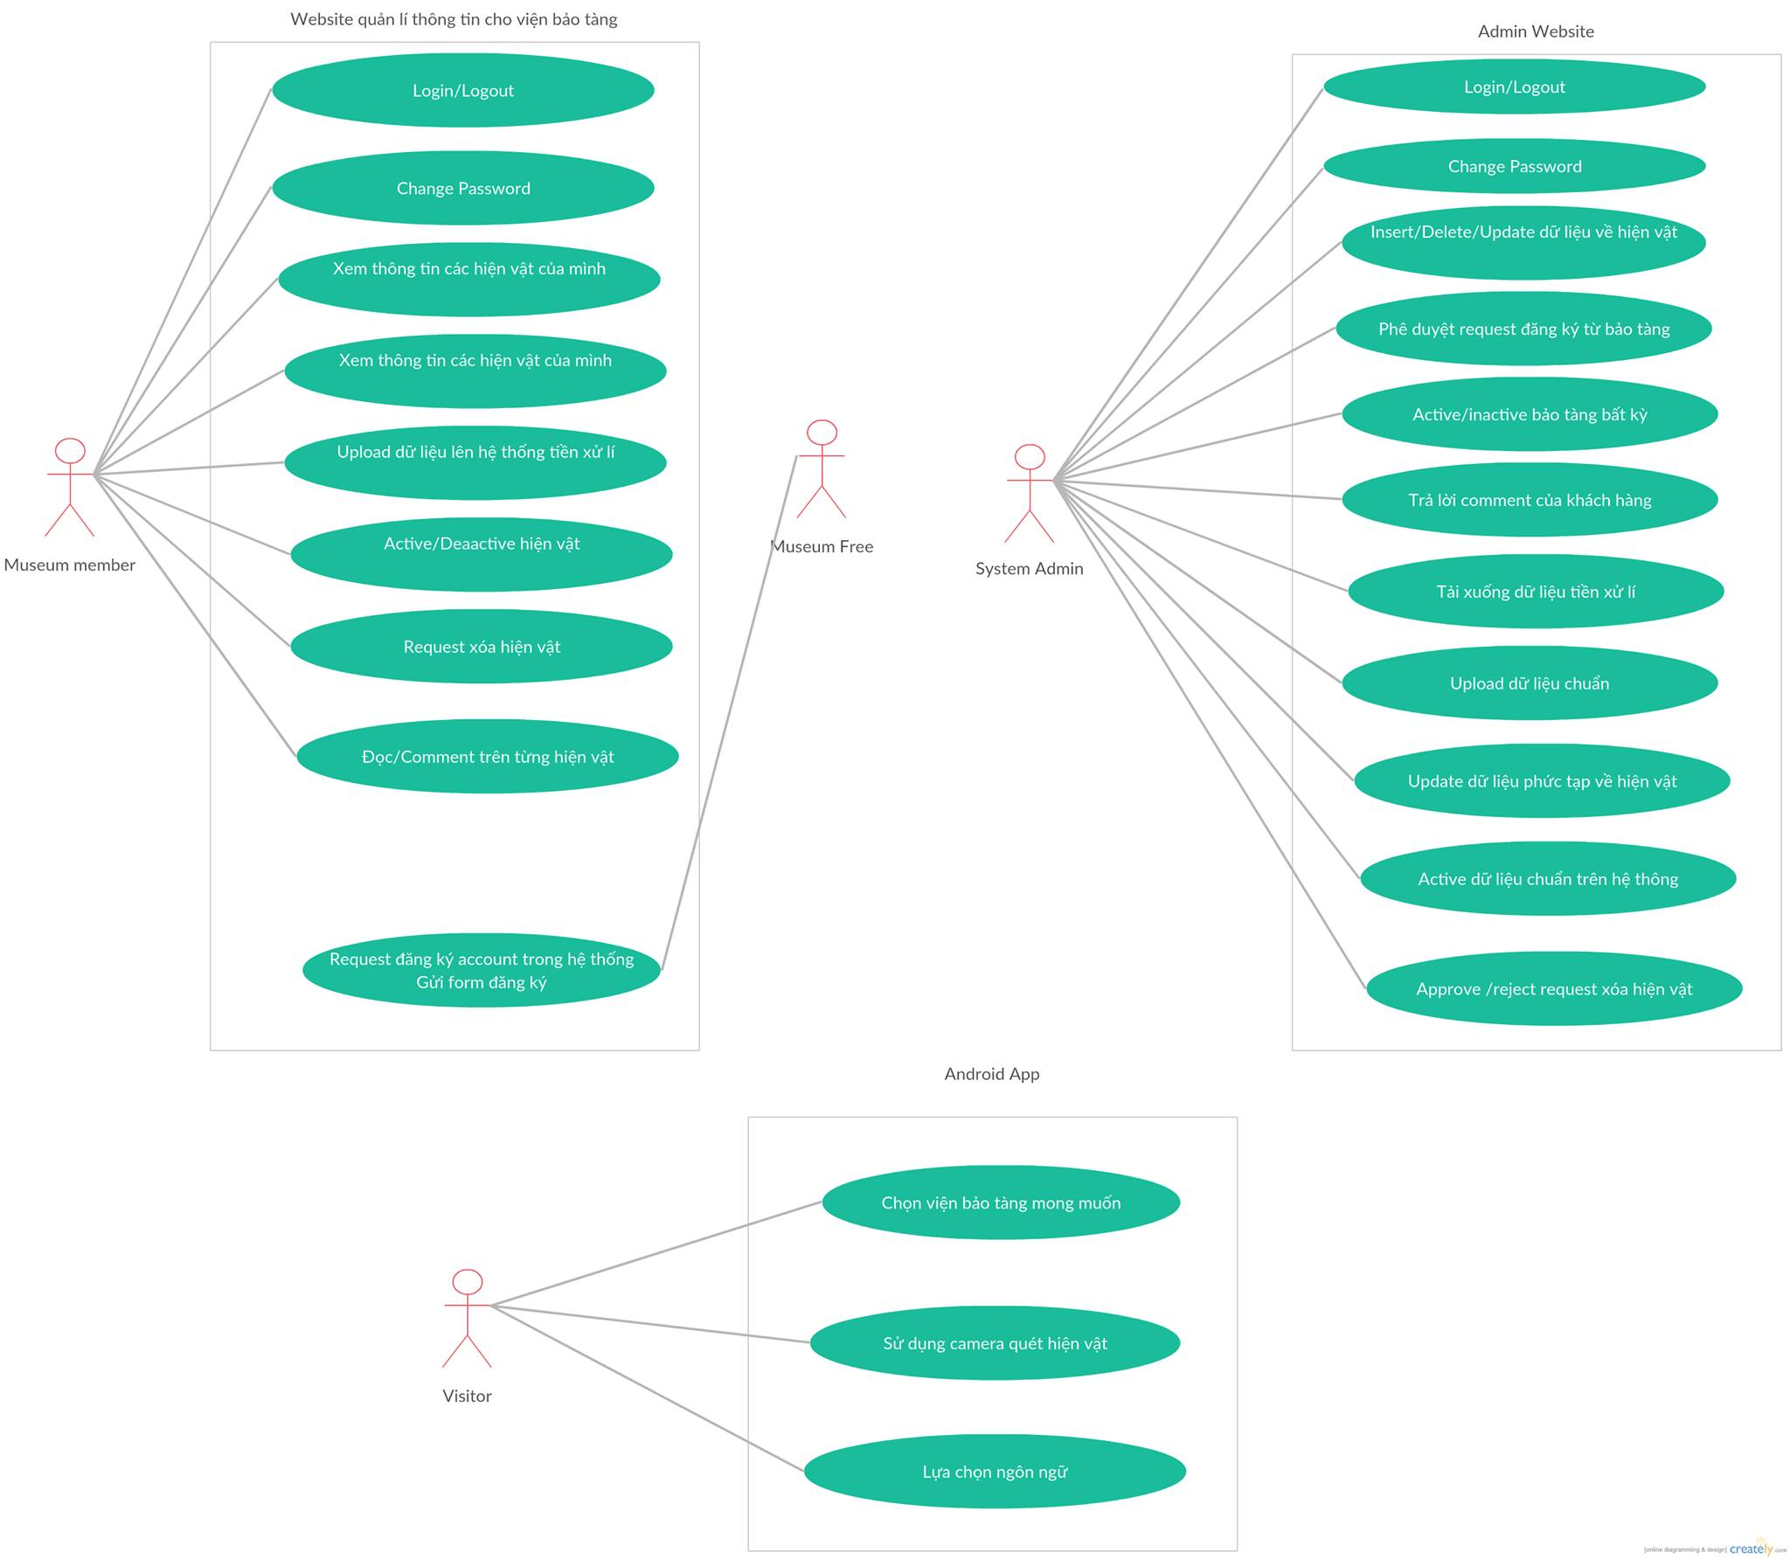

* **Design out general picture of system:**

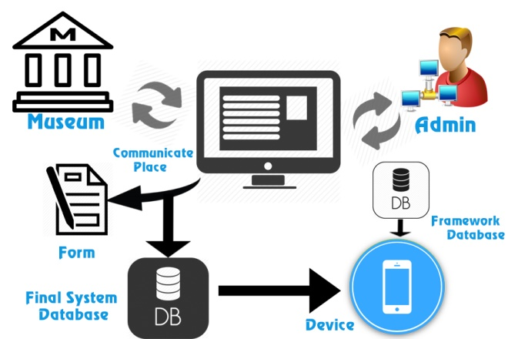

Now, like the picture above, our system includes a place to help Museum actor and Admin can discuss and exchange information of artifacts before they are released on the final database. This place can be a website and have form contain detail information of every single artifact (name, image target, content, 3D model,…). Information then can be converted into JSON or some kind of text format to warehouse in final DB. Base on that DB, application get what it need and use Vuforia API to run its functions and serves end users.

* **Analyze the best solution for every single issue:**
* We having 2 kind of structures:
* Client collects Image via camera and communicates to Vuforia server to get Target ID. After that Client continuously communicates to Back end server to get corresponding contents.
* Vuforia Server and Back end Server communicate each other and then return Target ID and Content to Client with corresponding collected Image of Client.

The lesson here is team had to analyze all advantages and disadvantages of each kind of structure and the draw decision. No matter which structure is chosen, the point is how we find method to analyze a problem.

* Project folder configuration: Team had tried to build several main functions and apply suitable Framework. Base on that, we organize folders for main case study, document, and source code.
* **Discuss and analyze what are the final goals of a successful project:**
* After project, the key is every team members got something, learn and improve their technic and ability.
* Now, worker with full stack skill is appreciated. Therefore, team member should try to learn and do as more as possible during capstone project.
* **Assign task for next week:** See table below.

# Task & Deadline

|  |  |  |
| --- | --- | --- |
| Task Name | Division | Deadline |
| Detail SRS: divide user cases and write description under end user’s point of view as clear as possible | * QuyetNH, ToanMQ | 1/10/2016 |
| Begin to code several main functions: login, register and account manager,… | TungNX (lead), HuyKH, GiangPV | 1/10/2016 |
| Build folder system on GitHub | ToanMQ | 1/10/2016 |

# Next Meeting

Time: October 1st, 2016

Place: Mydinh, Hanoi.