|  |  |
| --- | --- |
|  | ISE 0801- Meeting minutes  October 1, 2016 |

# Attendees

Supervisor: Mr.ChienBD

Student: QuyetNH, HuyKH, TungNX, ToanMQ, GiangPV

# 

# Scriber

QuyetNH

# 

# Agenda

* Describe and discuss about User cases.
* Discuss about Functional/ Non- Functional Requirements.
* Discuss and analyze issues/ risks and how to deal with them.
* Assign task for next week.

# 

# Detail Business

* **Describe and discuss about User cases:**

At the beginning, team defined out about fundamental 30 user cases for actors take part in system.

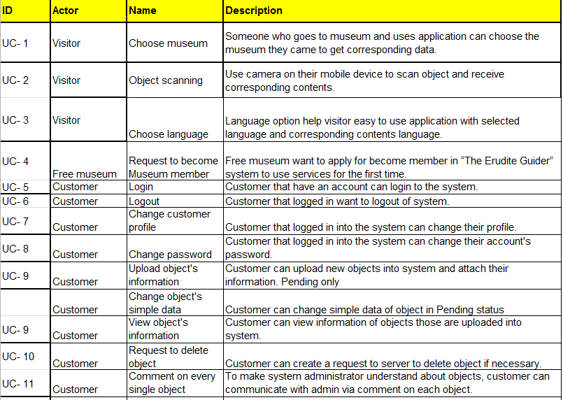

*Figure 1- System User cases*

Each user case have corresponding actor and was described detail in point of view of end user (as in figure above).

During create user cases, project team also defined 3 statuses of data from uploaded by museum actor to the time approached by system. Those are: Pending- Available- Active. Detail description about statuses will be described in State diagram.

* **Discuss about Functional/ Non- Functional Requirements:**

In systems engineering and requirements engineering, a non-functional requirement is a requirement that specifies criteria that can be used to judge the operation of a system, rather than specific behaviors. They are contrasted with functional requirements that define specific behavior or functions. The plan for implementing functional requirements is detailed in the system design. The plan for implementing non-functional requirements is detailed in the system architecture, because they are usually Architecturally Significant Requirements.

Broadly, functional requirements define what a system is supposed to do and non-functional requirements define how a system is supposed to be.

Functional requirements are usually in the form of "system shall do requirement", an individual action of part of the system, perhaps explicitly in the sense of a mathematical function, a black box description input, output, process and control functional model. In contrast, non-functional requirements are in the form of "system shall be requirement", an overall property of the system as a whole or of a particular aspect and not a specific function.

In the scope of capstone project, non-functional must be carefully considered and project team should define which non-functional project involve only.

* **Discuss and analyze issues/ risks and how to deal with them:**
* Try to base on framework that matching with our system and build a specific structure before start coding.
* Focus on fundamental function first to imagine system’s backbone.
* Persuade Museum (customer) to provide their devices. That can solve a lot of problem such as: application’s performance, system does not depend on transmission speeds so much, keep museum information in private,…
* **Assign task for next week:** See the table below.

# Task & Deadline

|  |  |  |
| --- | --- | --- |
| Task Name | Division | Deadline |
| Using Project Management tool (Microsoft project 2013) | * QuyetNH | 6/10/2016 |
| Begin to code several main functions: login, register and account manager,…  (from previous task and not complete yet) | TungNX (lead), HuyKH, GiangPV | 6/10/2016 |
| Create CM plan: rules to numbered version, file name, folder name,… | ToanMQ | 5/10/2016 |
| Draw state diagram for 3 statuses. | ToanMQ | 6/10/2016 |
| Draw EDM diagram to build DB. | GiangPV, TungNX, ToanMQ, QuyetNH, HuyKH | 7/10/2016 |
| Checklist to review every product before submit. | QuyetNH | 4/10/2014 |

# Next Meeting

Time: October 8th, 2016

Place: Mydinh, Hanoi.