|  |  |
| --- | --- |
|  |  |

The Erudite Guider

Software Project Management Plan

**Project Code: TEG**

**Document Code: TEG_PMP – <v0.1>**

**Hanoi, September 19th 2016**

Record of Change

*A - Added M - Modified D - Deleted

|  |  |  |  |  |
| --- | --- | --- | --- | --- |
| Effective Date | Changed Items | A* M, D | Change Description | New Version |
| 19/09/2016 | Create new | A | Create document | 0.1 |
|  |  |  |  |  |
|  |  |  |  |  |
|  |  |  |  |  |
|  |  |  |  |  |
|  |  |  |  |  |
|  |  |  |  |  |
|  |  |  |  |  |
|  |  |  |  |  |
|  |  |  |  |  |
|  |  |  |  |  |
|  |  |  |  |  |
|  |  |  |  |  |
|  |  |  |  |  |
|  |  |  |  |  |
|  |  |  |  |  |
|  |  |  |  |  |
|  |  |  |  |  |
|  |  |  |  |  |

Signature Page

**AUTHOR:** Nguyen Huu Quyet Date: 2016/09/7

Project manager

**REVIEWERS:** Mong Quoc Toan Date: 2016/09/18

Member

**APPROVAL:** Bui Đinh Chien Date: 2016/09/19

Supervisor

Table of Contents

Record of Change 2

Signature Page 3

1 INTRODUCTION 5

1.1 Purpose 5

1.2 Definition and Acronyms 5

1.3 References 5

2 PROJECT OVERVIEW 5

2.1 Project Description 5

2.2 Scope 6

2.3 Standard Objectives 6

2.4 Milestone and Deliverables 6

3 PROJECT ORGANIZATION 8

3.1 Software Process Model 8

3.2 Project lifecycle 8

3.3 Roles and Responsibilities 9

4 TOOLS AND INFRASTRUCTURES 10

4.1 Hardwares 10

4.2 Softwares 10

5 SCHEDULE 11

5.1 Detailed Schedule 11

5.2 Meeting Schedule 11

5.3 Effort Estimation 11

6 COMMUNICATION MANAGEMENT 11

7 RISK MANAGEMENT 11

8 QUALITY MANAGEMENT 11

8.1 Quality Objectives 12

8.2 Quality Strategies/Activities 12

9 CONFIGURATION MANAGEMENT 12

10 CODING CONVENTION 12

# INTRODUCTION

## Purpose

This document includes information about (The Erudite Guider) project team, work schedule from start to the end of project, project risk management plan and communication plan. This will be used by project manager to manage and control work of all team. The supervisor can use this to track progress of the project team.

## Definition and Acronyms

|  |  |  |
| --- | --- | --- |
| **Acronym & Abbreviation** | **Definition** | **Note** |
| TEG | The Erudite Guider |  |
| PMP | Project Management Plan |  |
| No | Number |  |
| RUP | Rational Unified Process |  |
| PM | Project Manager |  |

Table 1-1: Definitions and Acronyms

## References

Capstone project final report of Japanese Translator (Winter 2015): <http://cms.fpt.edu.vn/elearning/pluginfile.php/129874/mod_resource/content/1/JT_ProjectManagementPlan_ver1.0.pdf>

<https://en.wikipedia.org/wiki/Rational_Unified_Process>

<http://www.ambysoft.com/downloads/managersIntroToRUP.pdf>

*TEG_ProjectManagementPlan.mpp*

# PROJECT OVERVIEW

## Project Description

|  |  |  |  |
| --- | --- | --- | --- |
| **Project name:** | The Erudite Guider | | |
| **Project code:** | TEG | | |
| **Project instructor** | Mr. Bui Dinh Chien | | |
| **Project manager** | Nguyen Huu Quyet | | |
| **Project category** | 🗹New development | 🞏Maintenance | 🞏Other |
| **Business domain:** | Tourist assistance tools | | |

Table 2-1: Project description

In this project, we will develop an Android application that supports Visitors who go to museum in  
getting information of museum’s artifacts. User can use this application to scan artifact (object) in exhibition room of museum, then play video or audio to see information corresponding to each artifact. Using “The Erudite Guide” application could help visitors completely understand the meaning of artifacts for not only the moment they are in the exhibition room. Artifact’s information can be present under text, video or even 3D model are displayed on user’s smartphone to bring multiple perspectives and lively approach to visitors.

## Scope

The scope of this project includes these stages:

* Develop user requirement and software requirement specification.
* Develop architecture and detailed design documents.
* Coding and unit test.
* Develop test case and execute combination test.

This application has these main functions:

* Select corresponding museum.
* Scan artifacts/ objects.
* Detect artifacts/ objects are scanned by visitor.
* Display corresponding information (videos/ audios) on smartphone screen.

We also develop a Web service to manage museum, request and object’s information as database of the application.

## Standard Objectives

* This project must be finished no later than 14/12/2016.
* The 5 of team members give best effort to complete the project.
* The final application covers 100% of requirements.
* Precision rate of object detection from user’s camera should be 90% or more.
* All requests from museum to system in term of object management must be approved within 24 hour.

## Milestone and Deliverables

|  |  |  |  |  |
| --- | --- | --- | --- | --- |
| **No** | **Milestones** | **Delivery Date** | **Delivery Location** | **Delivery Type** |
| 1 | Project registration | 13/08/2016 | University | Hard and soft  copy |
| 2 | Kick off project | 5/09/2016 | Supervisor | Soft copy |
| 3 | Report No.1: Introduction | 12/09/2016 | Supervisor | Soft copy |
| 4 | Report No.2: Software Project Management Plan (SPMP) | 19/09/2016 | Supervisor | Soft copy |
| 5 | Report No.3: Software Requirements Specifications (SRS) | 30/09/2016 | Supervisor | Soft copy |
| 6 | Report No.4: Software Design Description (SDD) | 14/10/2016 | Supervisor | Soft copy |
| 7 | Report No.5: Software Test Documentation (STD) | 11/11/2016 | Supervisor | Soft copy |
| 8 | Report No.6: Software User’s Manual (SUM) | 5/12/2016 | Supervisor | Soft copy |
| 9 | Final Report | 14/12/2014 | Supervisor | Soft copy |
| 10 | All project resource | 14/12/2014 | University | Hard and soft  copy |
| 11 | Project defense | 22/12/2016 | University | Hard and soft  copy |

Table 2-2: Project milestones and deliverables

# PROJECT ORGANIZATION

## Software Process Model

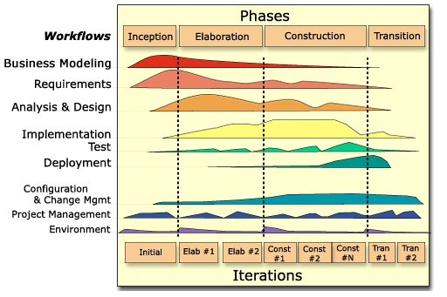

*Figure 1- The Rational Unified Process*

In this project, we apply Rational Unified Process (RUP) model as development process model.

The RUP has determined a project life-cycle consisting of four phases. These phases allow the process to be presented at a high level in a similar way to how a 'waterfall'-styled project might be presented, although in essence the key to the process lies in the iterations of development that lie within all of the phases. Also, each phase has one key objective and milestone at the end that denotes the objective being accomplished. The visualization of RUP phases and disciplines over time is referred to as the RUP hump chart.

## Project lifecycle

Base on RUP model above, this project is divided into 4 phases: Inception, Elaboration, Construction, Transition. Each phase goes through requirements, analysis and design, implementation and testing. Every phase has a specific set of goals, which are addressed within the iterations of the phase, so that the phase milestone may be met.

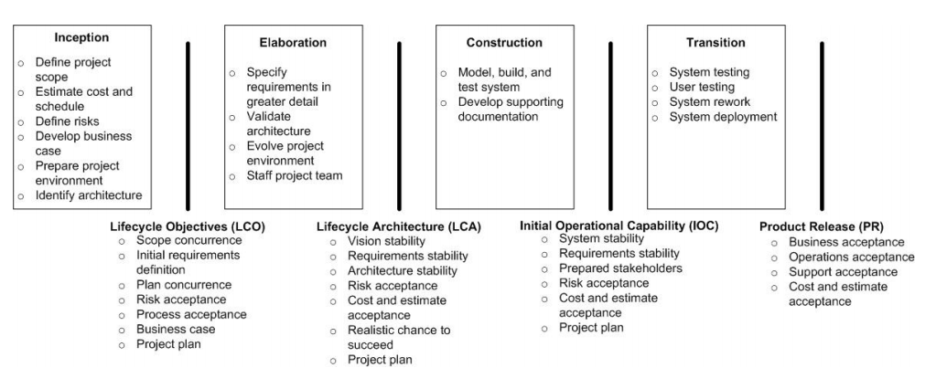

*Figure 2- The RUP phases and their milestone*

*.*

## Roles and Responsibilities

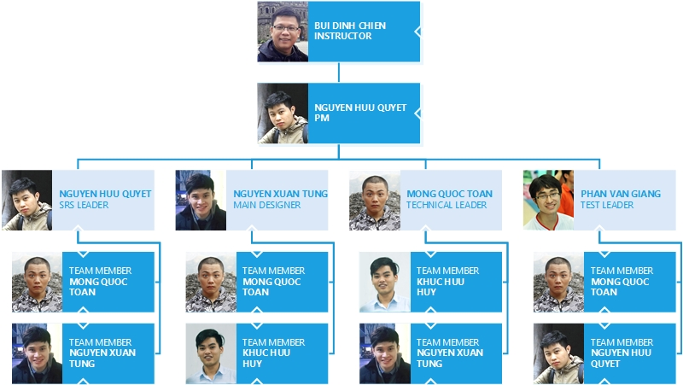

*Figure 3- Organization structure*

|  |  |  |
| --- | --- | --- |
| **Role** | **Full name** | **Responsibilities** |
| Instructor | Mr. Bui Dinh Chien | * Give instruction for project team * Resolve escalated issues * Supervise project team’s status * Verify deliverables |
| PM | Nguyen Huu Quyet | Have overall responsibility of the project:   * Create project plan * Create software requirements specification * Assign task to team members * Manage project stakeholders, project team and resolve conflicts. * Tracking team member’s work * Report work status to the instructor * Communication with members and instructor, include weekly plan, weekly status report, hold meetings and assure to submit reports and work status to the instructor on schedule |
| Requirement analysis team | | |
| SRS leader | Nguyen Huu Quyet | Complete SRS document and submit to instructor |
| Member #1 | Mong Quoc Toan | Create user case and review document |
| Member #2 | Nguyen Xuan Tung | Create database requirements |
| Design team | | |
| Main designer | Nguyen Xuan Tung | Design interface for web application |
| Designer #1 | Mong Quoc Toan | Design for mobile application |
| Designer #2 | Khuc Huu Huy | Support in design for web application |
| Development team | | |
| Technical leader | Mong Quoc Toan | * Decide technique and tools to be used * Develop and coding for mobile application |
| Developer #1 | Nguyen Xuan Tung | * Train other member of web development * Create coding convention * Develop web application   Coding for web service |
| Developer #2 | Khuc Huu Huy | Coding for web service |
| Test team | | |
| Test leader | Phan Van Giang | * Create test plan * Create test case * Report test result |
| Tester #1 | Mong Quoc Toan | Implement test case |
| Tester #2 | Nguyen Huu Quyet | Implement test case |

Table 3-1: Project roles and member’s responsibilities

# TOOLS AND INFRASTRUCTURES

## Hardwares

* Personal computer for developing and testing with the minimum configuration: 4GB RAM, 500GB of hard disk, Intel Core i3.
* Internet network connection.
* Smart phone run on Android operating system.

## Softwares

|  |  |  |
| --- | --- | --- |
| **Category** | **Software name** | **Version** |
| **Operating system** | Microsoft Windows 7 | Professional |
| **Office tools** | Microsoft Word | 2010 |
| Microsoft Excel | 2010 |
| Microsoft Power point | 2010 |
| **Management tool** | Microsoft Project | 2016 |
| Google Driver |  |
| **Design tool** | Astah Professional | 7.1.0 |
| [www.draw.io](http://www.draw.io) |  |
| Adobe Photoshop | CS6 |
| Microsoft Power point | 2010 |
| **Development tool** | Android Studio | 2.2.2 |
| Sublime Text | 3.0 |
| phpStrom | 2016.3 |
| **Database tool** | phpMySQL |  |
| Navicat |  |
| Xampp | 7.0.9.1 |
| **Source code**  **management tool** | GitHub Desktop | 3.3.3 |
| github.com |  |
| **Communication tools** | Google Mail Group |  |

Table 4-1: Software is used in project

# SCHEDULE

## Detailed Schedule

Below are the images of work schedule for this project. Refer to *TEG_Project_Plan.mpp* for detail.

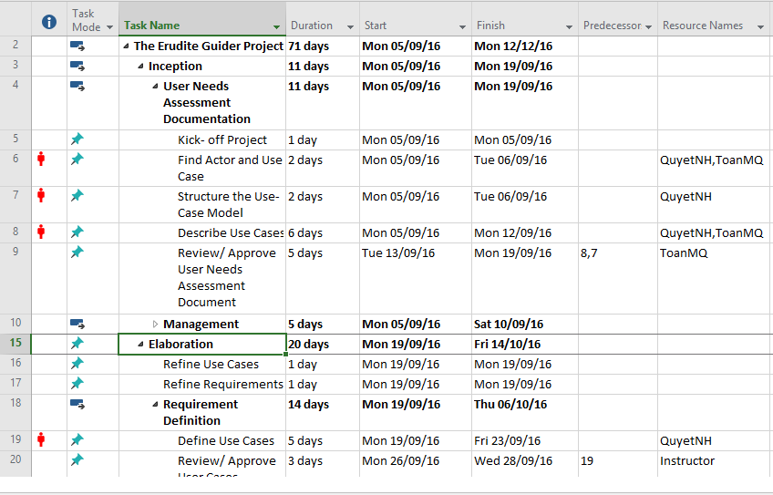

*Figure 4- Task list*

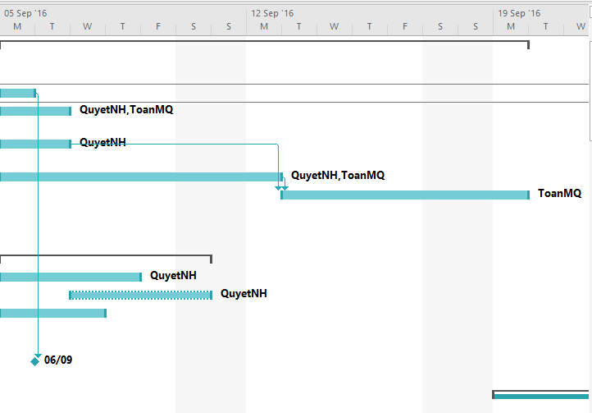

*Figure 5- Grantt chart*

## Meeting Schedule

Within 15 weeks from 9/5/2016 to 12/12/2016, project team had meeting with Instructor on every Monday. Moreover, in the implementation process if get any issue need instructor ‘consultation, we will proactively arrange meetings.

With team member, we arrange 3 days and all night of the week to discuss and work together.

# COMMUNICATION MANAGEMENT

For each meeting with Instructor, documents and meeting minutes will be kept under internal server directory of Github and email group.

All document is stored in server directory of Github in folder that corresponding with member who is assigned. Those are public for all team members. For each delivery milestone in this project, those reports required stored in document directory and we try to limit to modify them.

|  |  |  |  |
| --- | --- | --- | --- |
| **No** | **Name** | **Responsibilities** | **Telephone, Address, Email** |
| 1 | Mr. Bui Dinh Chien | Instructor | My Dinh, Ha Noi  Tel: +84 904232472  Email: [chienbd@fpt.edu.vn](mailto:chienbd@fpt.edu.vn) |
| 2 | Nguyen Huu Quyet | Project Manager | Hoa Lac, Thach That, Ha Noi  Tel: +84 1646093888  Email: [quyetnhse03119@fpt.edu.vn](mailto:quyetnhse03119@fpt.edu.vn) |
| 3 | Nguyen Xuan Tung | Main Designer | Hoa Lac, Thach That, Ha Noi  Tel: +84 974800599  Email: [tungnxse03325@fpt.edu.vn](mailto:tungnxse03325@fpt.edu.vn) |
| 4 | Phan Van Giang | Test Leader | Hoa Lac, Thach That, Ha Noi  Tel: +84 1692685219  Email: [giangpvse03422@fpt.edu.vn](mailto:giangpvse03422@fpt.edu.vn) |
| 5 | Mong Quoc Toan | Technical Leader | Hoa Lac, Thach That, Ha Noi  Tel: +84 947595595  Email: [toanmq03369@fpt.edu.vn](mailto:toanmq03369@fpt.edu.vn) |
| 6 | Khuc Huu Huy | Member | Hoa Lac, Thach That, Ha Noi  Tel: +84 868448682  Email:  [huykhse03064@fpt.edu.vn](mailto:toanmq03369@fpt.edu.vn) |

Table 6-1: Project team member’s contact

|  |  |  |
| --- | --- | --- |
| **Technologies or access method** | **Tool Name** | **Purpose** |
| Email and message | Gmail | Contact with Instructor or Customer |
| Skype/ Facebook | Contact with team member |
| Mobile phone call | Cellphone | Contact directly with other stakeholders in an emergency situation |
| Video call | Skype/ Facebook | Online meeting |
| Collaboration tool | Github Desktop | Managing source code and document |

Table 6-2: Technologies or access method use for communications

# RISK MANAGEMENT

## Risk Categories

|  |  |  |
| --- | --- | --- |
| **Category** | **Sub-category** | **Acronym & Abbreviation** |
| **Technical** | Requirement Definition | T-RD |
| Technology | T-T |
| Complexity and Interfaces | T-CI |
| Performance and Reliability | T-PR |
| Quality | T-Q |
| **Management** | Estimating | M-E |
| Human Resources | M-HR |
| Communication | M-Cm |
| Source | M-S |
| Controlling | M-Cl |
| **External** | Weather | E-W |

Table 7-1: Risk categories

## Risk Register

|  |  |  |  |  |  |  |  |
| --- | --- | --- | --- | --- | --- | --- | --- |
| **ID** | **Description**  **of risk** | **Cat** | **Impact** | **Root Cause** | **Avoidance Plan** | **Contingency Plan** | **Fallback Plan** |
| 1 | The processes does not meet their deadline | M-Cl | Delay task and negative affect the attitude of team member | Poor control and estimation | Research carefully about how to control team and assign task clearly | Increase work performance | Operate more work and task at the same time |
| Low technical skills of team members | Stepping up training and learning technique |
| 2 | A team member’s absence | M-HR | Bad affect to project schedule and project quality | Health reason | Motivate member and create positive work environment | Other members replace that  member’s work |  |
| 3 | Low team member’s motivation | M-Cm | Delay task and negative affect the attitude of team member | Personal morale | Organize team building so that team member can get well to each other | Conduct a meeting so that the team members can express their opinions and find out solutions | Take responsibility in front of the team/ apply team punishment rules |
| 4 | Training process is not effective | M-HR | Bad affect to project schedule and project quality | Each member needs to do research by themselves and consult experts (active to learn) | Create more team meeting to training and share resource and knowledge as well |  | Contact someone to help with technical training |
| 5 | Poor unit test and test case | T-Q | Bad affect to project schedule and project quality | Team member does not clearly understand about system | Each member needs to do research and work carefully | Increase work performance | Ask for other people’s help to test |
| 6 | Low processing speed | T-T | Bad affect to project quality | Third-party service package selection is poor | Select high service from third-party by pay money | Decrease redundant data on transmission line |  |

Table 7-2: Risk register

## Risk probability and impact

The probability and impact of occurrence for each identified risk will be assessed by the project manager, with input from the project team using the following approach:

* **Probability**
* High – Greater than <70%> probability of occurrence
* Medium – Between <30%> and <70%> probability of occurrence
* Low – Below <30%> probability of occurrence
* **Impact**
* High – Risk that has the potential to greatly impact project cost, project schedule or performance
* Medium – Risk that has the potential to slightly impact project cost, project schedule or performance
* Low – Risk that has relatively little impact on cost, schedule or performance

|  |  |  |  |  |
| --- | --- | --- | --- | --- |
| **Probability** | High |  | Risk 5 | Risk 1 |
| Medium |  | Risk 3  Risk 6 | Risk 4  Risk 2 |
| Low |  |  |  |
|  | Low | Medium | High |
|  | **Impact** | | | |

Table 7-3: Probability/Impact matrix

## Closing a Risk

A risk will be considered closed when it meets the following criteria:

* Risk is no longer valid.
* Risk Event has occurred.
* Risk is no longer considered a risk.
* Risk closure at the direction of the Project Manager.

# CONFIGURATION MANAGEMENT

## CI Identification and Naming Convention

|  |  |  |
| --- | --- | --- |
| **No** | **Configuration items** | **Naming convention** |
| Project Management | | |
| 1 | Project plan | TEG_SoftwareProjectManagementPlan(SPMP)_v[version number]  For example: TEG_SoftwareProjectManagementPlan(SPMP)_v0.1 |
| Requirement | | |
| 2 | Software requirement  specification | TEG_SoftwareRequirementSpecification(SRS__v[version number] |
| Design | | |
| 3 | Architecture design | TEG_Software Design Description (SDD)_v[version number] |
| 4 | Database design | TEG_DatabaseDesign_v[version number] |
| 5 | Interface design | TEG_ InterfaceDesign_v[version number] |
| Report | | |
| 6 | Meeting minutes | MeetingMinute_Num[meeting minutes number]_Date[yyyymmdd]  For example: MeetingMinute_Num1_20160917 |
| File type | | |
| 7 | MS Word | *.doc, *.docx |
| 8 | MS Excel | *.xls |
| 9 | MS Power Point | *.ptt |
| 10 | MS Project Plan | *.mpp |
| 11 | Astah | *.asta |
| 12 | Images | *.png, *.jpg, *.jpeg, *.bmp, *.gif |

Table 9-1: CI Identification and Naming Convention

## Directory structure

A folder for storing all project documents is created on GitHub server. This folder includes of some main folders as viewed following table.

|  |  |  |
| --- | --- | --- |
| **Main folder** | **Sub-folder** | **Purpose** |
| Capstone_ISE0801 |  | Root folder store all document and materials of project |
| 01_SourceCode | API_Service_Source | Store source code of Vuforia API |
| Mobile_App_Source | Store source code of mobile application in android |
| Web_Application_Source | Store source code of web application in html, css, javascript... |
| 02_Document | Meeting minutes | Store project meeting minutes |
|  | Reports | Store all required reports of project |
|  | Usecase | Store all use case description |
|  | WireFrame_Web | Store all screen design of web application |
| 03_User |  | Store all document about project tasks those are assigned for corresponding member |

Table 9-2: Directory structure

# CODING CONVENTION

## Coding convention

Coding convention for this project will follow the “Code Style for Contributors” for Android developer.

For more details, visit the following link: <https://source.android.com/source/code-style.html>

## Comment convention

* Write comment for all functions and important logic.