

**MOBILE SHOPPING APP**

Link download Project: https://drive.google.com/file/d/1WA2lhfPOoDKl0oM5KiDoDzG-hiCPI61l/view?usp=sharing

|  |  |
| --- | --- |
| **Group 1** | |
| **Group Members** | Trần Quốc Bảo - CE160365  Nguyễn Tiến Đạt - **Project Leader** - CE150672  Đoàn Minh Hiếu - CE160738  Nguyễn Thanh Phong - CE160482  Nguyễn Văn Hiếu - CE150343  Trương Minh Khang - CE160989 |
| **Supervisor** | Phạm Tiến Phúc |
| **Ext Supervisor** |  |

# **Introduction**

Modern ordering solutions are now gradually replacing manual purchasing processes. Eposh's Store was created to give customers the best possible experience when ordering online from our store. To make use as simple as possible for users, this system has undergone many updates, improvements and feature optimizations. Eposh's Shop offers consumers the ability to track their deliveries in addition to more basic activities like placing orders to let them know how their items are progressing.

# **ERD DESIGN**

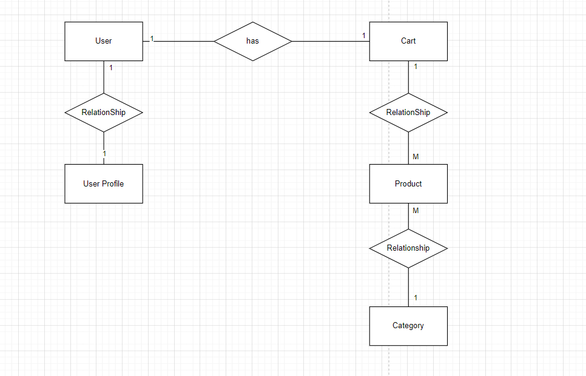

# **USE CASE DIAGRAM**

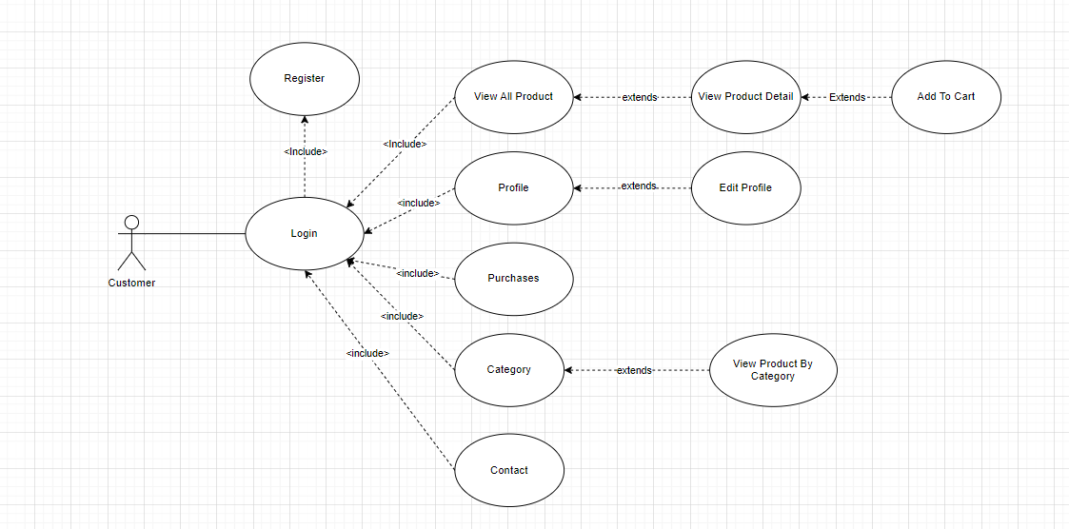

# **UI DESIGN**

4.1 Splash Screen:



4.2 Login:

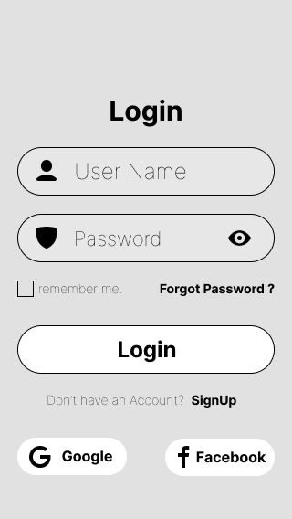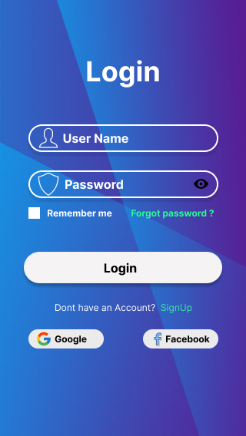

4.3 Register:

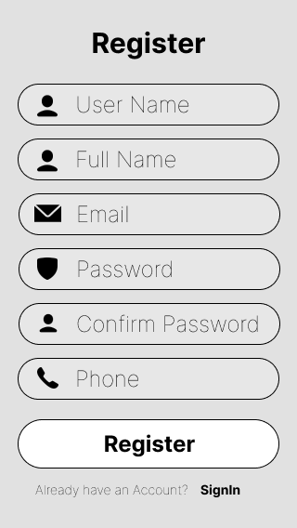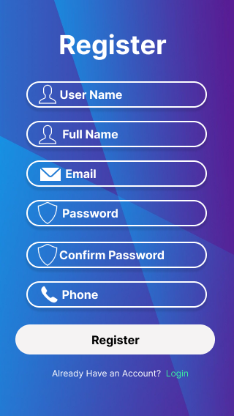

4.4 Home:

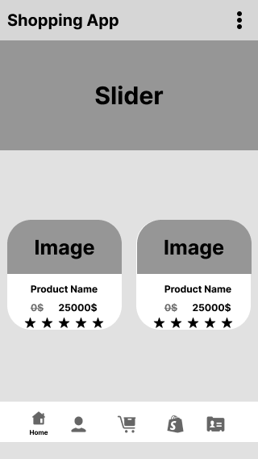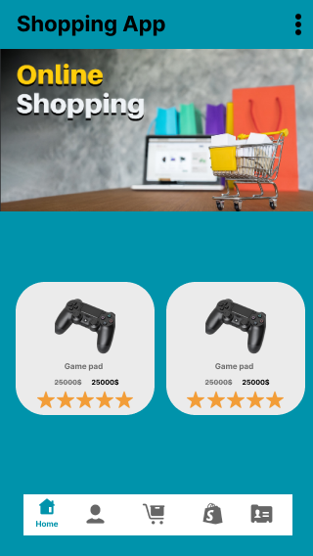

4.5 Profile:

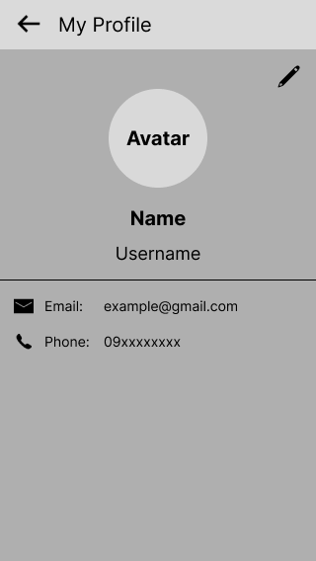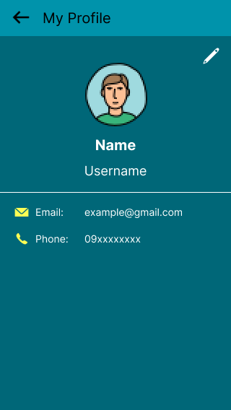

4.6 Categories:

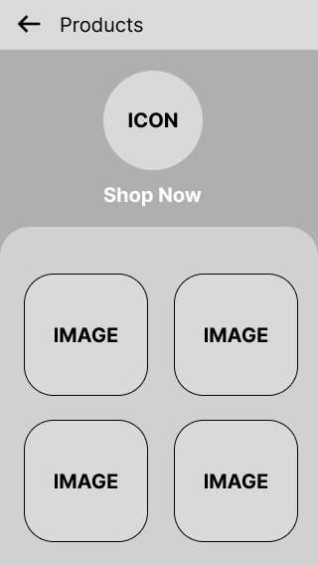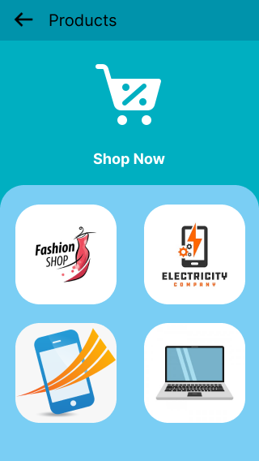

4.7 Product in each Category:

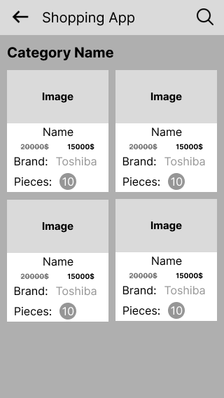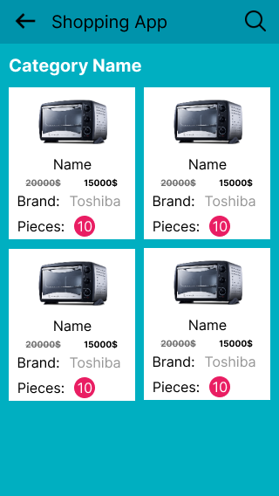

4.8 Product Details:

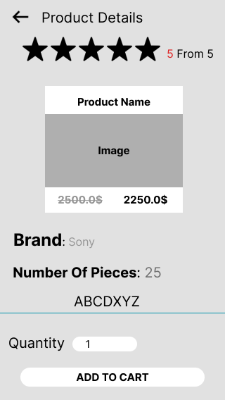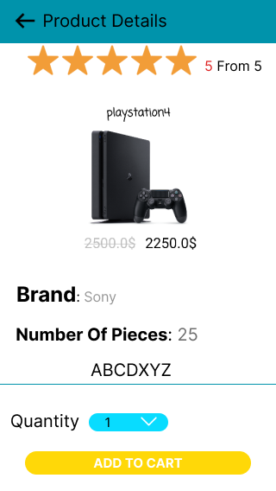

4.9 Purchases:

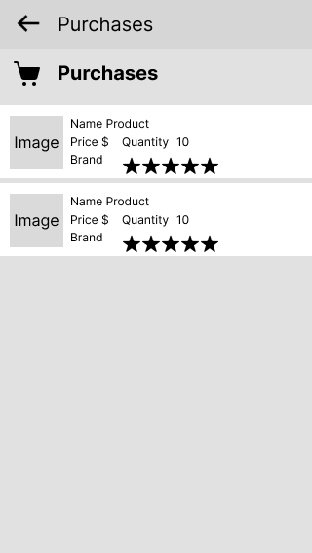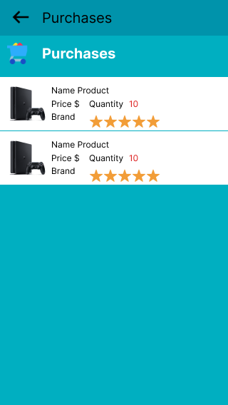

4.10 Setting:

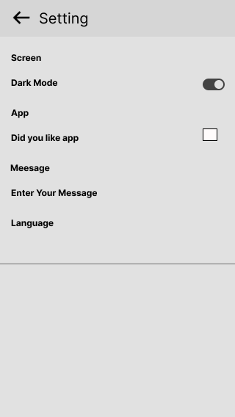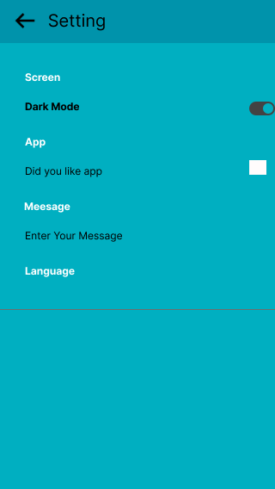

4.11 Contact:

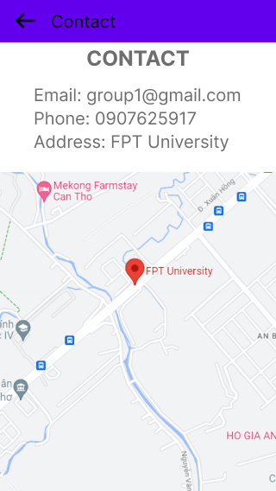

# **SEQUENCE DIAGRAM**

**5.1 Login**

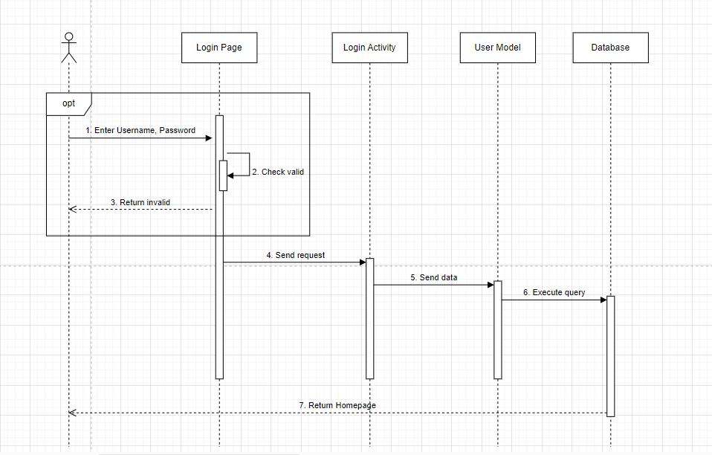

**5.2 Register**

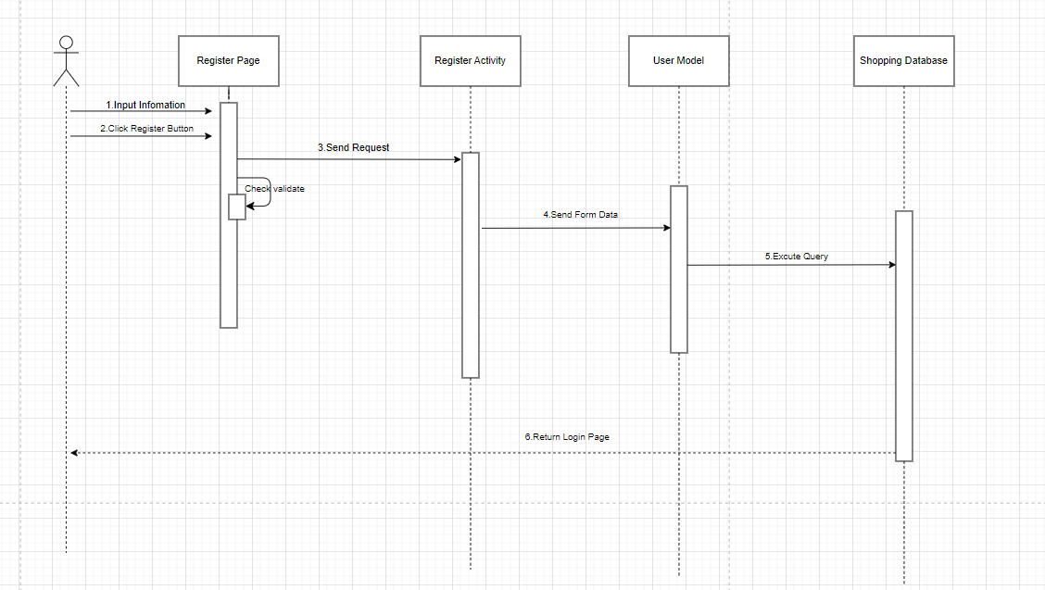

**5.3 View List Product**

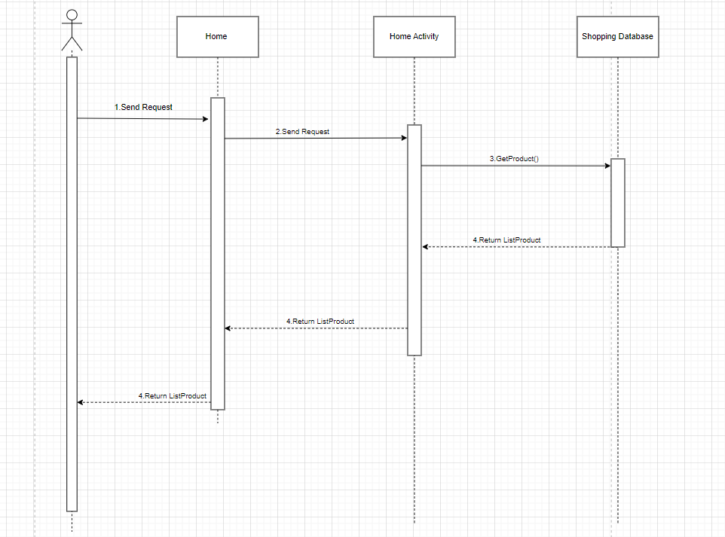

**5.4 View Product Details**

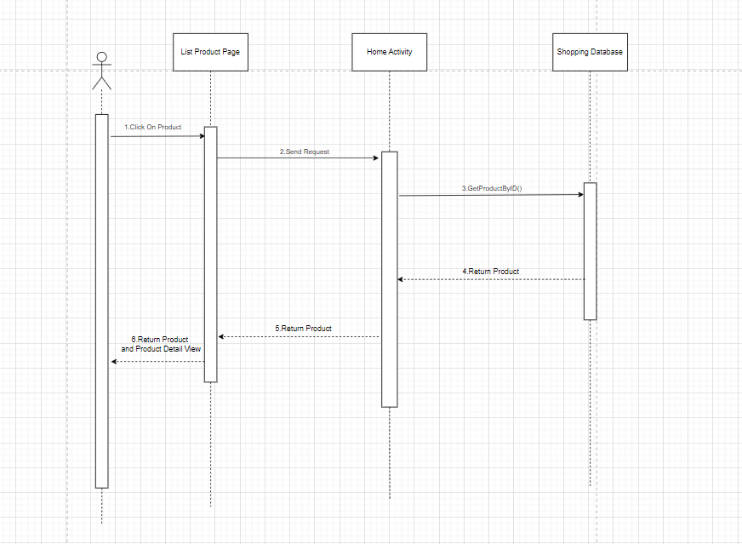

**5.5 Add To Cart  
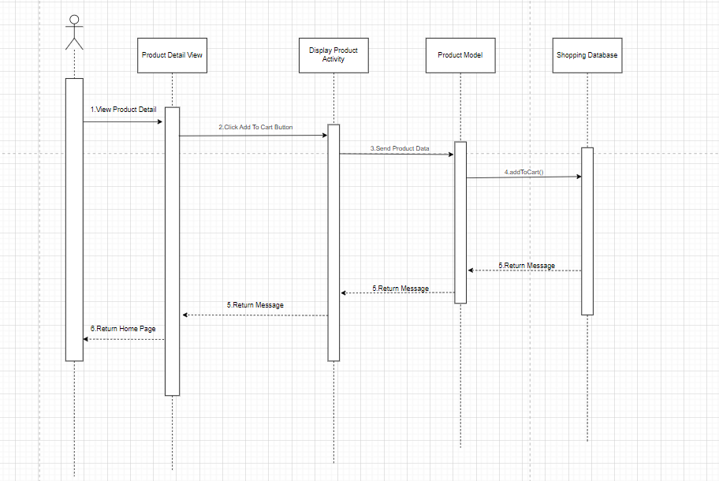**

**5.6 View Profile**

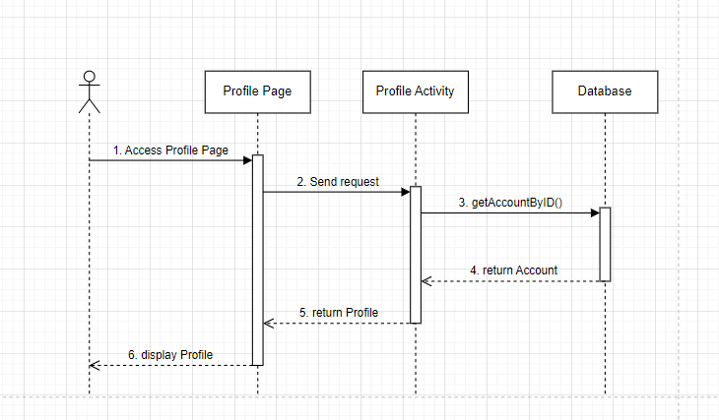

**5.7 Edit Profile**

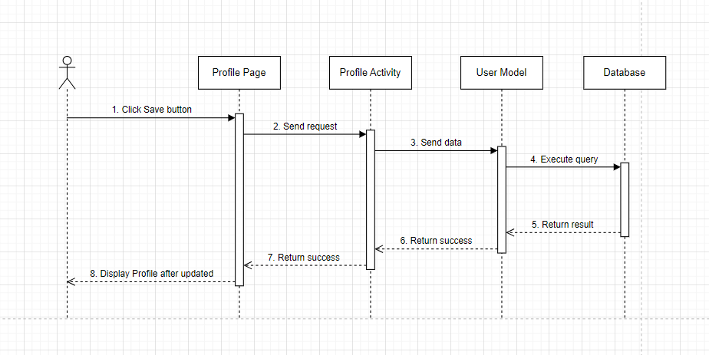

**5.8 Display Product In Purchases**

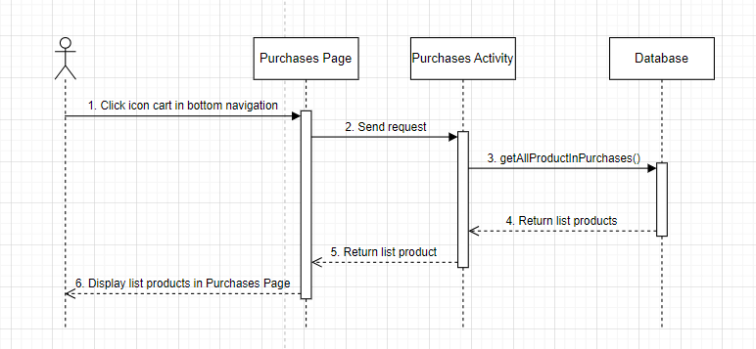

**5.9 View Contact**

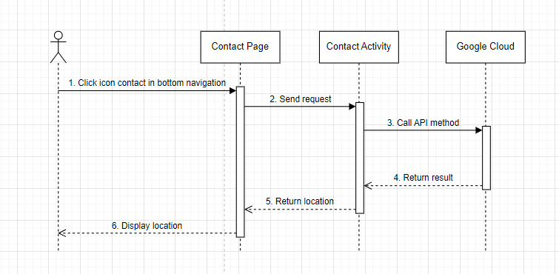

**5.10 View All Category**

