

Course Project Report
Subject: SWD391
Digital Legacy Management & Digital Asset Handover

– Ho Chi Minh City, October 2026 –

Table of Contents
Record of Changes 3
I. Overview 3
I.1 Project Information 3
I.2 Project Team 3
II. Requirement Specification 3
II.1 Problem description 3
II.2 Major Features 4
II.3 Context Diagram 5
II.4 Nonfunctional requirements 6
II.5 Functional requirements 7
II.5.1 Actors 7
II.5.2 Use Cases 8
II.5.2.1 Diagram(s) 8
II.5.2.2 Use case descriptions 9
II.5.3 Activity diagram 18
II.6 Entity Relationship Diagram 20
III. Analysis models 21
III.1 Interaction diagrams 21
III.1.1 Sequence Diagram 21
III.1.2 Communication Diagram 22
III.2 State diagram 23
IV. Design specification 25
IV.1 Integrated Communication Diagrams 25
IV.2 Component and Package Diagram 25
IV.2.1 Component Diagram 25
IV.2.2 Package Diagram 27
IV.3 Class diagram 29
IV.3.1 Domain Class Diagram 29
IV.3.2 Service and Repository Layers 30
IV.4 Database Design 31
IV.4.1 Conceptual Diagram 31
IV.4.2 Logical Diagram 32

Record of Changes
Date | A*  M, D | In charge | Change Description
21/10/2026 | A | Quoc Huy | Initial draft: requirement, analysis and design sections written from the team diagrams.
*A - Added M - Modified D - Deleted

I. Overview

I.1 Project Information
- Project name: LegacyVault – Digital Legacy Management & Digital Asset Handover
- Project code: [to be confirmed]
- Group name: [to be confirmed]
- Software type: Web application

I.2 Project Team
Full Name | Role | Student ID
Chung Quốc Huy | Leader | SE194569
Trịnh Nhật Quang | Member | SE192966
Lương Gia Luân | Member | SE192603
Lê Hoàng Huy | Member | SE192981
Vũ Nguyễn Đức Huy | Member | SE194089

II. Requirement Specification

II.1 Problem description
Digital assets such as online banking accounts, cryptocurrency wallets, social-media accounts, cloud documents and important legal papers are scattered across many providers and protected by personal credentials. When the owner dies or becomes incapacitated, the family often cannot find, access or legally claim these assets, and sensitive data may be lost or exposed. A traditional will does not cover credentials or encrypted data, and handing passwords to relatives in advance is a security risk.
LegacyVault is a web-based system for digital legacy management and digital asset handover. A Vault Owner stores digital asset profiles and legal documents in an end-to-end encrypted vault, assigns beneficiaries and a digital executor, and configures a Dead Man's Switch (DMS). The DMS periodically asks the owner to confirm that he or she is still alive. If the owner does not respond within the configured waiting period, the handover is triggered: the executor is notified and submits a death certificate, a Legal Verifier checks the documents and the digital signature and e-signs an unlock authorization, and only then is the vault unlocked. Each beneficiary then verifies his or her identity by OTP / eKYC, receives the assigned assets and confirms the receipt. Every state change is recorded in an audit log.
The system works with three external services: an OTP / eKYC service for identity verification, a Digital Signature / e-Notary service for signature validation and e-signing, and an Email / SMS / Push provider for notifications.

II.2 Major Features
The major features of LegacyVault are listed below.
FE-01: Digital assets and legal documents: create and encrypt digital asset profiles; upload and end-to-end encrypt legal documents (will, ownership proof).
FE-02: Beneficiaries and executor: assign one beneficiary to each asset or asset group; appoint, update or revoke the digital executor of a vault.
FE-03: Dead Man's Switch: configure the check-in cycle and the waiting period; respond to periodic check-ins; trigger the handover automatically when the owner does not respond.
FE-04: Activity log and monitoring: the owner views the activity log and access history; the administrator monitors audit logs and abnormal access alerts.
FE-05: Handover trigger and tracking: the executor receives the trigger notice, views the authorized assets (metadata only) and handover guidelines, and tracks the handover progress per asset.
FE-06: Legal verification and vault unlock: the executor submits a verification request with the death certificate; documents are exchanged through the integrated channel; the verifier validates the signature, approves or rejects the request and e-signs the unlock authorization; verified records are kept in a history.
FE-07: Asset receipt: the beneficiary is notified, verifies his or her identity (OTP / eKYC), views the inherited assets, downloads the decrypted documents or access keys and acknowledges the receipt.
FE-08: Administration: manage users, roles and permissions (RBAC); configure encryption, backup and default DMS policies; manage third-party integrations (eKYC, e-signature, e-notary).

II.3 Context Diagram
Figure 1 shows the context of LegacyVault: the five human actors and the three external services that exchange data with the system.
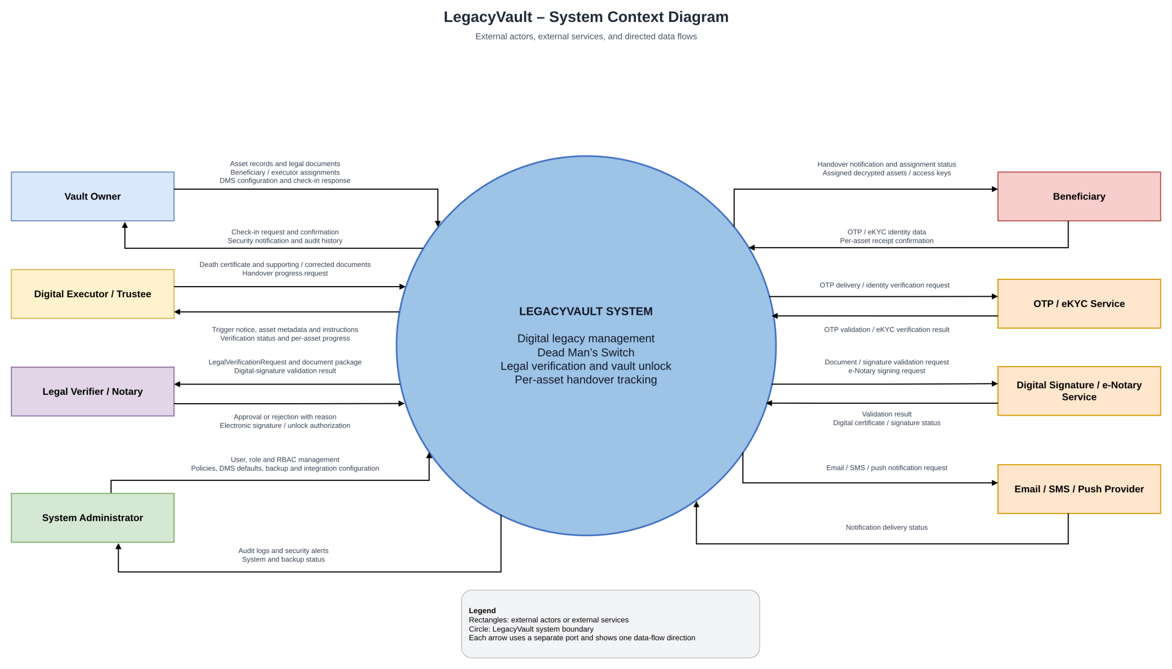
Figure 1. Context Diagram of LegacyVault

The main data flows between the system and each external entity are:
- Vault Owner: sends asset records, legal documents, beneficiary / executor assignments, DMS configuration and check-in responses; receives check-in requests, security notifications and the audit history.
- Digital Executor / Trustee: sends the death certificate and supporting or corrected documents; receives the trigger notice, asset metadata, handover instructions, verification status and per-asset progress.
- Legal Verifier / Notary: receives the verification request and document package; sends the approval or rejection (with reason) and the electronic signature that authorizes the unlock.
- Beneficiary: receives the handover notification and the assigned decrypted assets; sends OTP / eKYC identity data and the per-asset receipt confirmation.
- System Administrator: manages users, roles, policies, backup and integrations; receives audit logs, security alerts and system status.
- OTP / eKYC Service, Digital Signature / e-Notary Service and Email / SMS / Push Provider: receive requests from the system (identity verification, signature validation or signing, message delivery) and return the corresponding results.

II.4 Nonfunctional requirements
Functions without a user interface (performed by the system itself):
# | Feature | System Function | Description
1 | FE-03 | Scheduled check-in and trigger | The scheduler sends the periodic check-in, moves the DMS to Waiting when the owner does not respond and to Triggered when the waiting period expires.
2 | FE-01 | End-to-end encryption | Asset profiles and legal documents are encrypted before they are stored and decrypted only after the vault is unlocked and the beneficiary is verified.
3 | FE-06 | Vault unlock and case creation | When a verification request is approved, the system unlocks the vault and creates the Handover Case and one assignment for each asset.
4 | FE-03, 05, 07 | Notification delivery | The system sends Email / SMS / Push messages for check-ins, handover triggers, verification results and asset handover.
5 | FE-04 | Audit logging | Every state change and every access to the vault is written to the audit log.
6 | FE-08 | Periodic backup | System data is backed up periodically according to the backup policy configured by the administrator.

Nonfunctional requirements (draft, to be reviewed by the team):
# | Category | Requirement | Description
NF-01 | Security | End-to-end encryption | Assets and legal documents are encrypted at rest and in transit. Content is decrypted only after an approved unlock and only for the assigned beneficiary.
NF-02 | Access control | Role-based access (RBAC) | Each actor only sees what its role allows: the executor sees metadata only before the unlock (BR-06) and the beneficiary only sees his or her own assets (BR-09).
NF-03 | Auditability | Complete audit trail | All state changes and accesses are recorded and cannot be altered by normal users (BR-11).
NF-04 | Availability and recovery | Backup and restore | Data is backed up periodically and can be restored; the backup frequency is defined in the system policy.
NF-05 | Reliability | Dependable scheduling | Check-ins and triggers must run on schedule; a missed run must not skip or delay the handover trigger.
NF-06 | Usability | Simple check-in | The owner can confirm the check-in from the link in the Email / SMS / Push message with one main action.
NF-07 | Interoperability | Replaceable integrations | eKYC / OTP, e-signature / e-notary and notification providers are configured by the administrator and can be replaced without changing the core system.
NF-08 | Privacy | Minimal data exposure | Death certificates and personal data are used only for the verification and handover process.

II.5 Functional requirements

II.5.1 Actors
LegacyVault has five human actors, one time-based actor and three external systems.
# | Actor | Description
1 | Vault Owner | Owner of the vault. Creates and encrypts asset profiles and legal documents, assigns beneficiaries and the executor, configures the Dead Man's Switch and responds to check-ins.
2 | Digital Executor / Trustee | Person appointed by the owner to carry out the handover. Views authorized asset metadata and instructions, submits the legal verification request and tracks the handover progress.
3 | Beneficiary | Person who inherits one or more assets. Verifies identity, views and downloads the assigned decrypted assets and acknowledges the receipt.
4 | Legal Verifier / Notary | Legal professional who reviews verification requests, validates the digital signature and documents, approves or rejects the request and e-signs the unlock authorization.
5 | System Administrator | Manages users, roles and permissions, monitors audit logs and abnormal access, and configures policies and third-party integrations.
6 | System Scheduler (time actor) | Time-based actor that sends the periodic check-in and triggers the handover when the waiting period expires.
7 | eKYC / OTP Service (external) | External system that verifies the identity of users by OTP or eKYC.
8 | Digital Signature / e-Notary Service (external) | External system that validates digital signatures and documents and issues the e-signature for the unlock authorization.
9 | Email / SMS / Push Provider (external) | External system that delivers notifications to owners, executors and beneficiaries.

II.5.2 Use Cases

II.5.2.1 Diagram(s)
Figure 2 shows the use cases of every actor. «include» and «extend» relationships: View Inherited Assets and Download Decrypted Documents include Verify Identity (OTP / eKYC); Approve / Reject Verification Request includes Verify Digital Signature & Document Validity; e-Sign Vault Unlock Authorization extends Approve / Reject Verification Request when the request is approved.
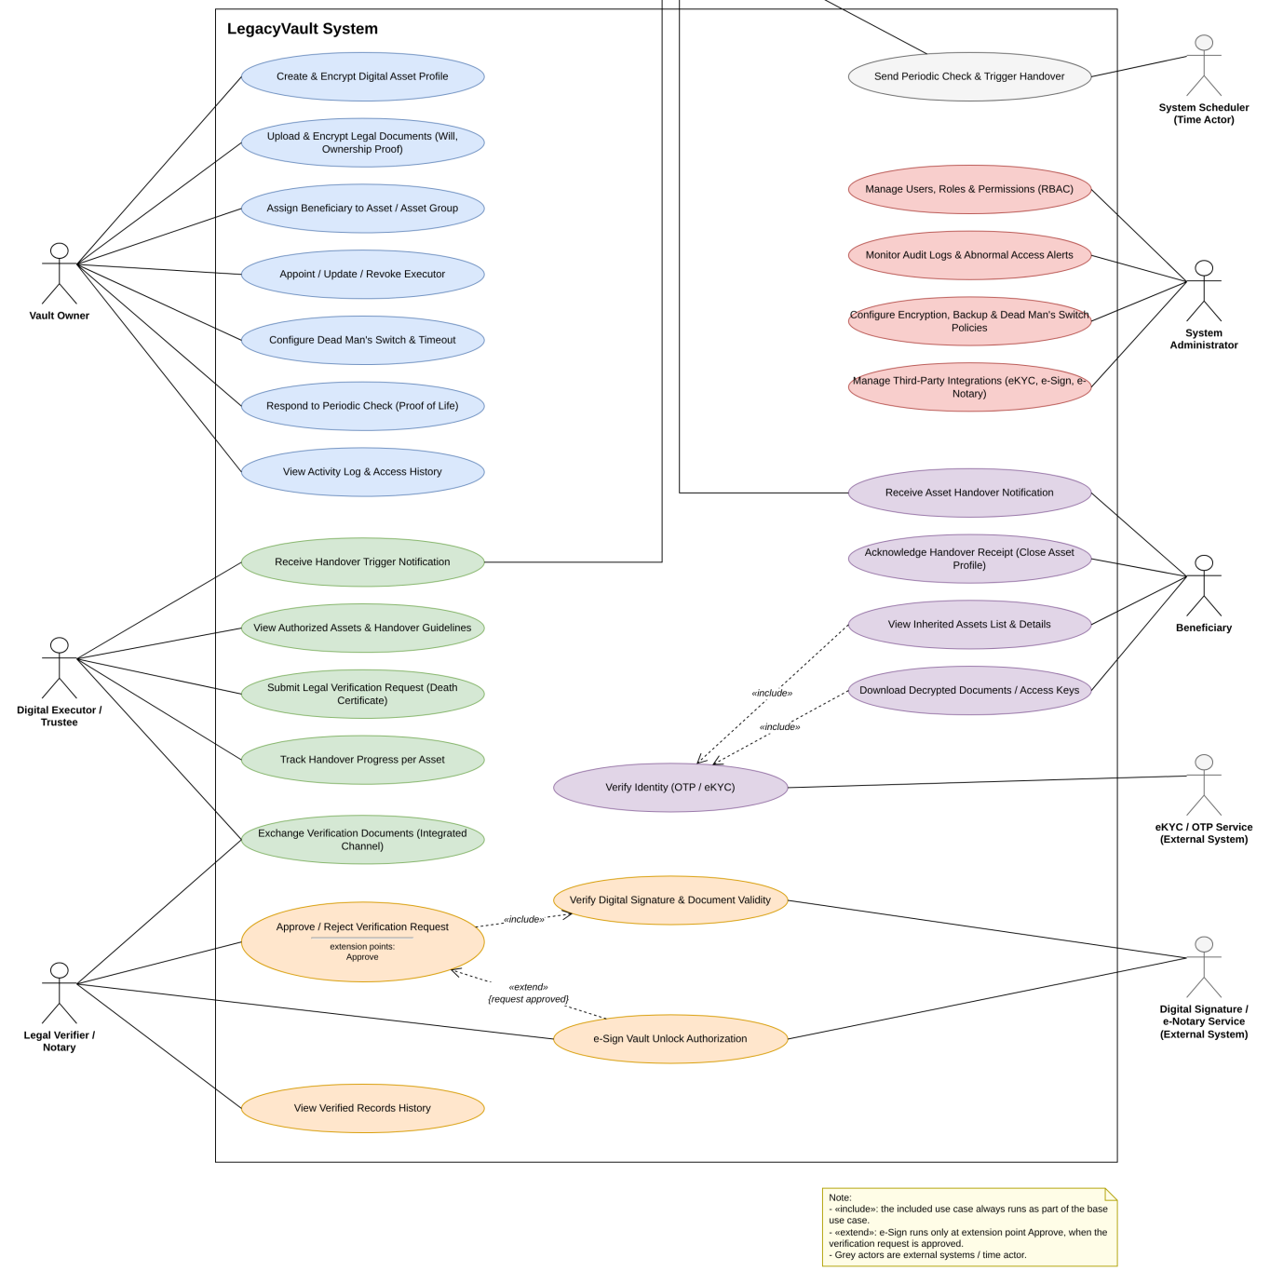
Figure 2. Use Case Diagram of LegacyVault

II.5.2.2 Use case descriptions

a. Use case list
ID | Use Case | Actors | Use Case Description
UC-01 | Create & Encrypt Digital Asset Profile | Vault Owner | Create a digital asset profile (bank, crypto, social, documents); the system encrypts it before storing.
UC-02 | Upload & Encrypt Legal Documents | Vault Owner | Upload will and ownership documents; they are end-to-end encrypted.
UC-03 | Assign Beneficiary to Asset / Asset Group | Vault Owner | Assign exactly one beneficiary to an asset or to an asset group.
UC-04 | Appoint / Update / Revoke Executor | Vault Owner | Appoint the active executor with handover instructions, or update / revoke the appointment.
UC-05 | Configure Dead Man's Switch & Timeout | Vault Owner | Set the check-in cycle and the waiting period of the vault.
UC-06 | Respond to Periodic Check (Proof of Life) | Vault Owner | Confirm "I am safe" to keep the DMS Active.
UC-07 | View Activity Log & Access History | Vault Owner | View who accessed what and when.
UC-08 | Send Periodic Check & Trigger Handover | System Scheduler; Email / SMS / Push Provider | Send check-ins, move the DMS to Waiting and trigger the handover when the waiting period expires.
UC-09 | Receive Handover Trigger Notification | Digital Executor; Email / SMS / Push Provider | Executor is notified that the handover has been triggered.
UC-10 | View Authorized Assets & Handover Guidelines | Digital Executor | View asset metadata (name, type, recipient) and the owner's instructions; content stays locked.
UC-11 | Submit Legal Verification Request (Death Certificate) | Digital Executor | Upload the death certificate and supporting documents to start the verification.
UC-12 | Exchange Verification Documents (Integrated Channel) | Digital Executor; Legal Verifier | Exchange messages and additional documents inside the system.
UC-13 | Track Handover Progress per Asset | Digital Executor | View the status of every asset assignment and the overall progress.
UC-14 | Approve / Reject Verification Request | Legal Verifier | Review the request and approve it, or reject it with a mandatory reason.
UC-15 | Verify Digital Signature & Document Validity | Legal Verifier; Digital Signature / e-Notary Service | Validate the signature and the validity of the submitted documents (included in UC-14).
UC-16 | e-Sign Vault Unlock Authorization | Legal Verifier; Digital Signature / e-Notary Service | Sign electronically to authorize the vault unlock (extends UC-14 when approved).
UC-17 | View Verified Records History | Legal Verifier | View the history of verified requests and their status.
UC-18 | Receive Asset Handover Notification | Beneficiary; Email / SMS / Push Provider | Beneficiary is notified that an asset has been handed over.
UC-19 | Verify Identity (OTP / eKYC) | eKYC / OTP Service | Verify the identity of the beneficiary (included in UC-20 and UC-21).
UC-20 | View Inherited Assets List & Details | Beneficiary | View the list and details of the assets assigned to the beneficiary.
UC-21 | Download Decrypted Documents / Access Keys | Beneficiary | Download the decrypted documents or access keys of an assigned asset.
UC-22 | Acknowledge Handover Receipt (Close Asset Profile) | Beneficiary | Confirm the receipt; the assignment of that asset is closed.
UC-23 | Manage Users, Roles & Permissions (RBAC) | System Administrator | Add, lock and change users, roles and permissions.
UC-24 | Monitor Audit Logs & Abnormal Access Alerts | System Administrator | Monitor security logs and alerts about abnormal access.
UC-25 | Configure Encryption, Backup & Dead Man's Switch Policies | System Administrator | Configure encryption, backup and default DMS rules.
UC-26 | Manage Third-Party Integrations (eKYC, e-Sign, e-Notary) | System Administrator | Enable, disable and configure external services.

b. Detailed use case descriptions
The detailed descriptions below cover the main use cases of the handover flow. Descriptions of the other use cases follow the same template and are to be completed by the team.
UC-04 – Appoint / Update / Revoke Executor
UC ID and Name: | UC-04 – Appoint / Update / Revoke Executor
Created By: | LegacyVault Team | Date Created: | 21/10/2026
Primary Actor: | Vault Owner | Secondary Actors: | Digital Executor (notified)
Trigger: | The owner opens the Executor tab of the vault.
Description: | The owner appoints one digital executor with handover instructions, or updates or revokes the existing appointment.
Preconditions: | 1. The owner is logged in (password + OTP).  2. The vault exists.
Postconditions: | 1. An ExecutorAppointment is created, updated or revoked.  2. The executor is notified.  3. The change is written to the audit log.
Normal Flow: | 1. The owner opens the Executor tab.  2. The system shows the current appointment (none).  3. The owner enters the executor's identity (email) and the handover instructions.  4. The owner submits.  5. The system checks that the vault has no active executor.  6. The system creates an ExecutorAppointment with status Active.  7. The system notifies the executor.  8. The system writes the audit log.
Alternative Flows: | A1 – Update: the owner changes the instructions or replaces the executor; the system closes the old appointment and creates the new one.  A2 – Revoke: the owner selects Revoke and confirms; the appointment is revoked and the executor loses access.
Exceptions: | E1 – The executor identity is invalid: the system shows an error.  E2 – The vault already has an active executor: the system rejects the second appointment (BR-04).
Priority: | High (Must have)
Frequency of Use: | Low: at setup and when the owner changes the executor.
Business Rules: | BR-04, BR-11
Other Information: | The executor only learns about the vault content after the unlock (BR-06).
Assumptions: | The executor is registered or invited by email.

UC-05 – Configure Dead Man's Switch & Timeout
UC ID and Name: | UC-05 – Configure Dead Man's Switch & Timeout
Created By: | LegacyVault Team | Date Created: | 21/10/2026
Primary Actor: | Vault Owner | Secondary Actors: | System Administrator (defines the default policy)
Trigger: | The owner opens the Dead Man's Switch tab.
Description: | The owner sets the check-in cycle (for example 30 days) and the waiting period (for example 14 days) of the vault.
Preconditions: | 1. The owner is logged in.  2. The vault exists.
Postconditions: | 1. The DMS configuration is saved and the DMS is Active.  2. The next check-in is scheduled.  3. The change is written to the audit log.
Normal Flow: | 1. The owner opens the Dead Man's Switch tab.  2. The system shows the current values, or the defaults from the system policy.  3. The owner chooses the check-in cycle and the waiting period.  4. The owner saves.  5. The system validates the values against the policy limits.  6. The system stores the configuration, sets the DMS to Active and schedules the next check-in.  7. The system writes the audit log.
Alternative Flows: | A1 – The owner keeps the default values and saves.
Exceptions: | E1 – A value is outside the limits of the policy: the system shows an error and does not save.
Priority: | High (Must have)
Frequency of Use: | Low: at setup and when the owner changes the configuration.
Business Rules: | BR-01, BR-11
Other Information: | There is one DMS per vault.
Assumptions: | The allowed ranges are defined by the administrator in the system policy.

UC-08 – Send Periodic Check & Trigger Handover
UC ID and Name: | UC-08 – Send Periodic Check & Trigger Handover
Created By: | LegacyVault Team | Date Created: | 21/10/2026
Primary Actor: | System Scheduler | Secondary Actors: | Email / SMS / Push Provider, Vault Owner, Digital Executor
Trigger: | The next check-in date of a vault is reached.
Description: | The scheduler sends the periodic check-in to the owner. If the owner does not respond, the DMS goes to Waiting and, when the waiting period expires, the handover is triggered and the executor is notified.
Preconditions: | 1. The DMS of the vault is Active and scheduled.  2. The contact information of the owner is valid.
Postconditions: | 1. The DMS is Active (owner responded) or Triggered (executor notified).  2. All state changes are written to the audit log.
Normal Flow: | 1. The check-in date is reached.  2. The system sends the check-in through the notification provider.  3. The owner confirms "I am safe" before the deadline (UC-06).  4. The system keeps the DMS Active and schedules the next cycle.
Alternative Flows: | A1 – The owner does not respond by the deadline: the DMS becomes Waiting and reminders are sent. If the owner responds during the waiting period, the DMS returns to Active (BR-02).  A2 – The waiting period expires without a response: the DMS becomes Triggered and the executor is notified (BR-03).
Exceptions: | E1 – The notification provider fails: the system retries and logs the failure.
Priority: | High (Must have)
Frequency of Use: | Every check-in cycle of every vault (for example monthly).
Business Rules: | BR-02, BR-03, BR-11
Other Information: | Only one waiting stage is used between Active and Triggered.
Assumptions: | The retry policy for failed notifications is defined by the team.

UC-11 – Submit Legal Verification Request (Death Certificate)
UC ID and Name: | UC-11 – Submit Legal Verification Request (Death Certificate)
Created By: | LegacyVault Team | Date Created: | 21/10/2026
Primary Actor: | Digital Executor | Secondary Actors: | Legal Verifier, Email / SMS / Push Provider
Trigger: | The executor opens a triggered case and chooses to submit the verification request.
Description: | The executor uploads the death certificate and supporting documents to start the legal verification of the vault.
Preconditions: | 1. The DMS of the vault is Triggered.  2. The executor has an active appointment and is logged in.
Postconditions: | 1. A LegalVerificationRequest is created with status Pending Verification.  2. The verifier is notified.  3. The submission is written to the audit log.
Normal Flow: | 1. The executor opens the case screen (status Triggered).  2. The executor reviews the asset metadata and the handover instructions (UC-10).  3. The executor uploads the death certificate and the supporting documents.  4. The executor submits.  5. The system checks that the executor is active.  6. The system creates the request with status Pending Verification.  7. The system notifies the verifier.  8. The system shows the status Pending Verification.
Alternative Flows: | A1 – After a rejection, the executor adds documents through the integrated channel (UC-12) and resubmits; the request returns to Pending Verification (BR-08).
Exceptions: | E1 – The executor is not active: the system shows "No permission".  E2 – The uploaded file is missing or invalid: the system shows an error.
Priority: | High (Must have)
Frequency of Use: | Once per case, more if the request is rejected.
Business Rules: | BR-06, BR-08, BR-11
Other Information: | The executor never sees the asset content at this stage.
Assumptions: | The accepted file types and sizes are defined in the implementation.

UC-14 – Approve / Reject Verification Request
UC ID and Name: | UC-14 – Approve / Reject Verification Request
Created By: | LegacyVault Team | Date Created: | 21/10/2026
Primary Actor: | Legal Verifier | Secondary Actors: | Digital Signature / e-Notary Service, Digital Executor
Trigger: | The verifier opens a request from the request inbox.
Description: | The verifier reviews the documents and the validation result, then approves the request or rejects it with a reason.
Preconditions: | 1. The request is Pending Verification.  2. The verifier is logged in.
Postconditions: | 1. The request is Approved (continues with UC-16) or Rejected with a reason.  2. The executor is notified.  3. The decision is written to the audit log.
Normal Flow: | 1. The verifier opens the inbox and selects a request.  2. The system validates the digital signature and the documents (UC-15) and shows the result.  3. The verifier reviews the death certificate and the documents.  4. The verifier chooses Approve.  5. The system continues with the e-sign step (UC-16).
Alternative Flows: | A1 – Reject: the verifier enters a mandatory reason; the system sets the request to Rejected and notifies the executor. The verifier can open the integrated channel to ask for more documents (UC-12).
Exceptions: | E1 – The signature validation fails: the system warns the verifier, who can reject the request.  E2 – The verifier rejects without a reason: the system blocks the action (BR-08).
Priority: | High (Must have)
Frequency of Use: | Once per request.
Business Rules: | BR-07, BR-08, BR-11
Other Information: | UC-15 is included and UC-16 extends this use case when the request is approved.
Assumptions: | None.

UC-16 – e-Sign Vault Unlock Authorization
UC ID and Name: | UC-16 – e-Sign Vault Unlock Authorization
Created By: | LegacyVault Team | Date Created: | 21/10/2026
Primary Actor: | Legal Verifier | Secondary Actors: | Digital Signature / e-Notary Service, Digital Executor, Beneficiary
Trigger: | The verifier approves a verification request (extension point of UC-14).
Description: | The verifier electronically signs the authorization to unlock the vault; the system then unlocks the vault and starts the per-asset handover.
Preconditions: | 1. The request is under review and the signature validation has been done.  2. The verifier selected Approve.
Postconditions: | 1. The request is Approved and stores the digital signature.  2. The vault is Unlocked.  3. A Handover Case and one assignment per asset are created.  4. The beneficiaries and the executor are notified.  5. The actions are written to the audit log.
Normal Flow: | 1. The verifier confirms the approval.  2. The system sends a signing request to the Digital Signature / e-Notary Service.  3. The service returns the signature or certificate.  4. The system stores the signature and sets the request to Approved.  5. The system unlocks the vault (BR-07).  6. The system creates the Handover Case and one assignment for each asset.  7. The system notifies every beneficiary and the executor.  8. The system writes the audit log.
Alternative Flows: | None.
Exceptions: | E1 – The e-sign service is unavailable or signing fails: the request stays Pending Verification, the vault stays locked and the verifier can retry.
Priority: | High (Must have)
Frequency of Use: | Once per case.
Business Rules: | BR-07, BR-11
Other Information: | The assets are not decrypted at this step; each beneficiary decrypts after OTP / eKYC verification.
Assumptions: | None.

UC-21 – Download Decrypted Documents / Access Keys
UC ID and Name: | UC-21 – Download Decrypted Documents / Access Keys
Created By: | LegacyVault Team | Date Created: | 21/10/2026
Primary Actor: | Beneficiary | Secondary Actors: | eKYC / OTP Service (through UC-19)
Trigger: | The beneficiary selects an assigned asset to download.
Description: | The beneficiary downloads the decrypted documents or the access keys of an asset that is assigned to him or her.
Preconditions: | 1. The vault is Unlocked.  2. The asset is assigned to this beneficiary.  3. The beneficiary identity is verified (UC-19).
Postconditions: | 1. The decrypted content is delivered to the beneficiary.  2. The access is written to the audit log.
Normal Flow: | 1. The beneficiary opens the asset detail (UC-20).  2. The system requires the identity verification (UC-19) if it has not been done in this session.  3. The beneficiary selects Download.  4. The system checks that the asset is assigned to this beneficiary.  5. The system decrypts the asset and delivers the documents or keys.  6. The system writes the audit log.
Alternative Flows: | A1 – The identity verification fails: the system shows an error and lets the beneficiary retry.
Exceptions: | E1 – The asset is not assigned to this beneficiary: the access is denied (BR-09).  E2 – The decryption fails: the system shows an error and logs it.
Priority: | High (Must have)
Frequency of Use: | Once per assigned asset.
Business Rules: | BR-09, BR-11
Other Information: | UC-19 is included.
Assumptions: | The number of identity verification retries is limited (for example 3 attempts).

UC-22 – Acknowledge Handover Receipt (Close Asset Profile)
UC ID and Name: | UC-22 – Acknowledge Handover Receipt (Close Asset Profile)
Created By: | LegacyVault Team | Date Created: | 21/10/2026
Primary Actor: | Beneficiary | Secondary Actors: | Digital Executor (sees the progress)
Trigger: | The beneficiary selects "I have received it" on an asset.
Description: | The beneficiary confirms that the asset has been received. The assignment of that asset is closed and the case progress is updated.
Preconditions: | 1. The beneficiary has viewed or downloaded the asset.  2. The assignment of the asset is open.
Postconditions: | 1. The assignment is confirmed and closed.  2. The progress of the Handover Case is updated (for example 2/5).  3. When all assets are closed, the case is Completed.  4. The change is written to the audit log.
Normal Flow: | 1. The beneficiary opens the asset.  2. The beneficiary selects "I have received it".  3. The system asks for confirmation.  4. The beneficiary confirms.  5. The system closes the assignment of the asset.  6. The system updates the progress counters.  7. If all assignments are closed, the system sets the Handover Case to Completed.  8. The system writes the audit log.  9. The executor sees the updated progress (UC-13).
Alternative Flows: | A1 – The beneficiary never confirms: the executor or the administrator can close the assignment after a number of days with a note (assumption).
Exceptions: | E1 – The session has expired: the beneficiary logs in again and repeats the step.
Priority: | High (Must have)
Frequency of Use: | Once per asset.
Business Rules: | BR-10, BR-11
Other Information: | The case is closed per asset, not for the whole vault at once.
Assumptions: | The timeout for a beneficiary who never confirms is not defined in the specification.

c. Business Rules
Business rules that apply to the use cases of LegacyVault:
ID | Business Rule | Business Rule Description
BR-01 | One DMS per vault | Each vault has exactly one Dead Man's Switch. The administrator sets the default rules and the owner configures them for his or her vault.
BR-02 | Owner response resets the DMS | If the owner responds to the check-in, even while the DMS is Waiting, the DMS returns to Active and the next cycle is scheduled.
BR-03 | Waiting period expiry | If the owner does not respond before the waiting period expires, the DMS becomes Triggered.
BR-04 | One active executor | Each vault has at most one active executor. The owner can update or revoke the appointment while it is active.
BR-05 | One beneficiary per asset | Each asset has exactly one beneficiary, assigned directly or through an asset group.
BR-06 | Executor sees metadata only | Before the unlock, the executor only sees asset metadata and the handover instructions, never the content.
BR-07 | Approved request required | Only a verification request in the Approved state, with the verifier's electronic signature, can unlock the vault.
BR-08 | Rejection needs a reason | A rejection must contain a reason. The executor adds documents through the integrated channel and resubmits.
BR-09 | Beneficiary access | A beneficiary can only see and download his or her own assets, after OTP / eKYC verification.
BR-10 | Per-asset closing | Confirming the receipt closes the assignment of that asset. The Handover Case is Completed when all assets are closed.
BR-11 | Audit all state changes | Every state change is written to the audit log.

II.5.3 Activity diagram
The activity diagram describes the end-to-end handover process across the five lanes: check-in cycle of the owner, waiting period and trigger, legal verification by the verifier (with resubmission through the integrated channel), vault unlock, and the per-asset receipt by each beneficiary until the Handover Case is completed.
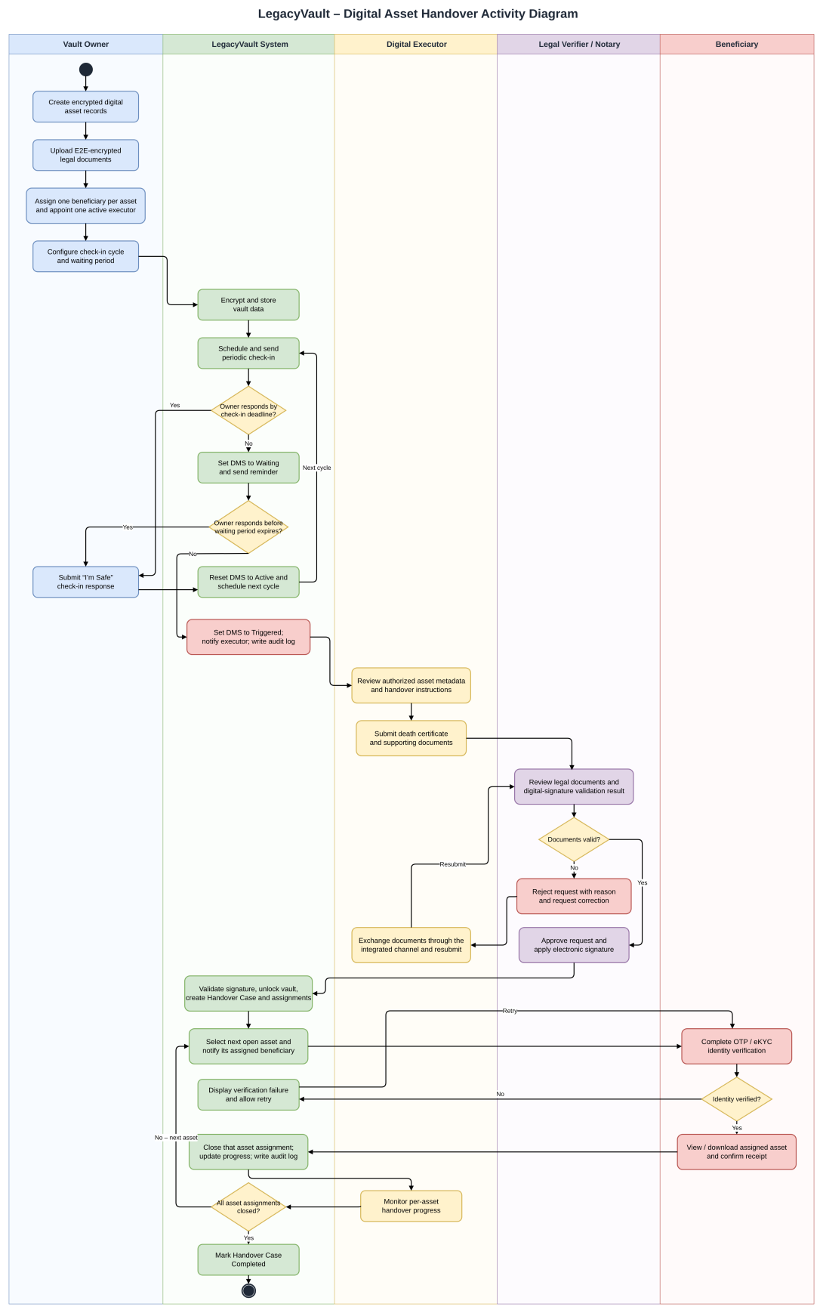
Figure 3. Activity Diagram – Digital Asset Handover

II.6 Entity Relationship Diagram
The entity relationship diagram is presented as the Conceptual Diagram of LegacyVault. It contains 19 entities; each arrow between entities corresponds to one of the 23 requirements of the specification.
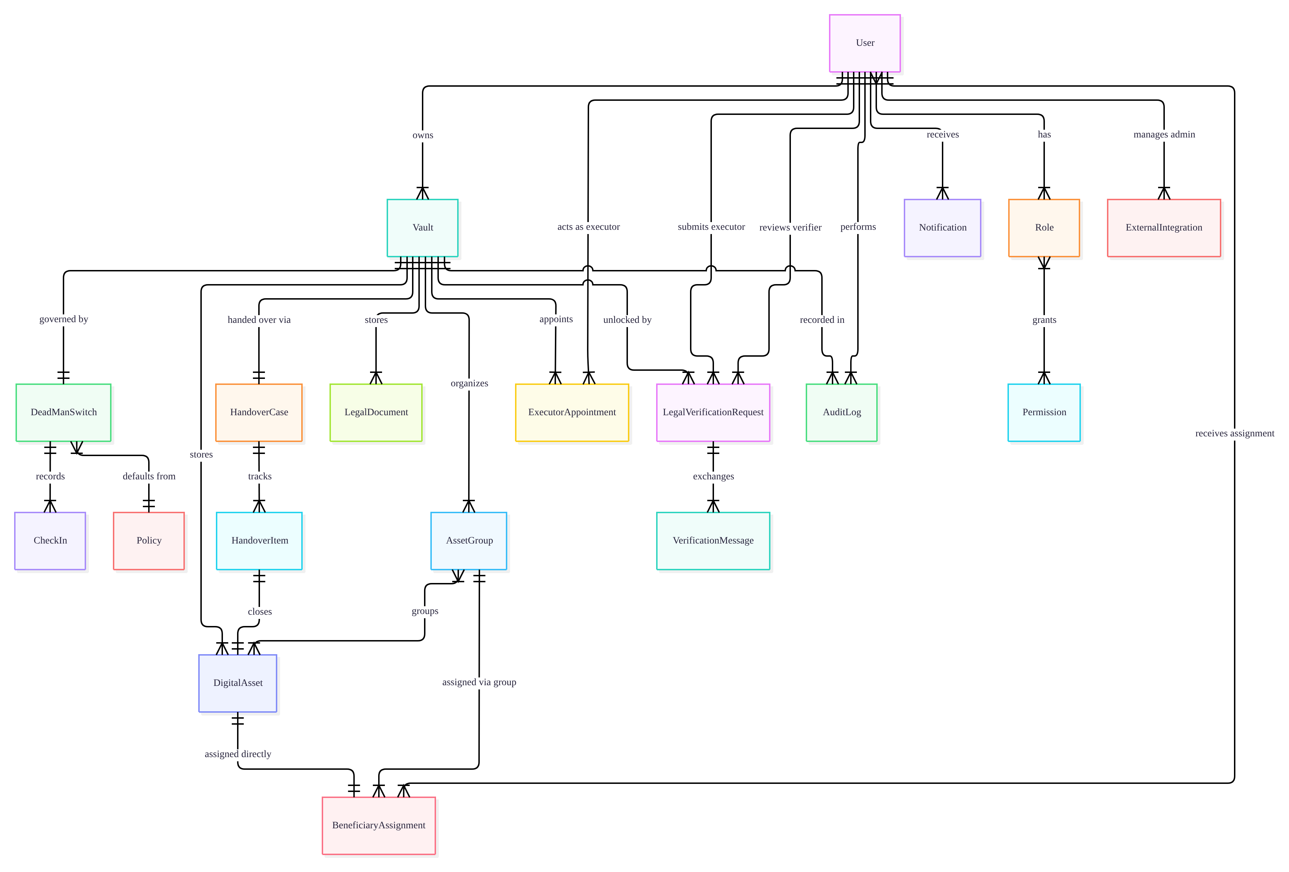
Figure 4. Entity Relationship (Conceptual) Diagram of LegacyVault

III. Analysis models

III.1 Interaction diagrams

III.1.1 Sequence Diagram
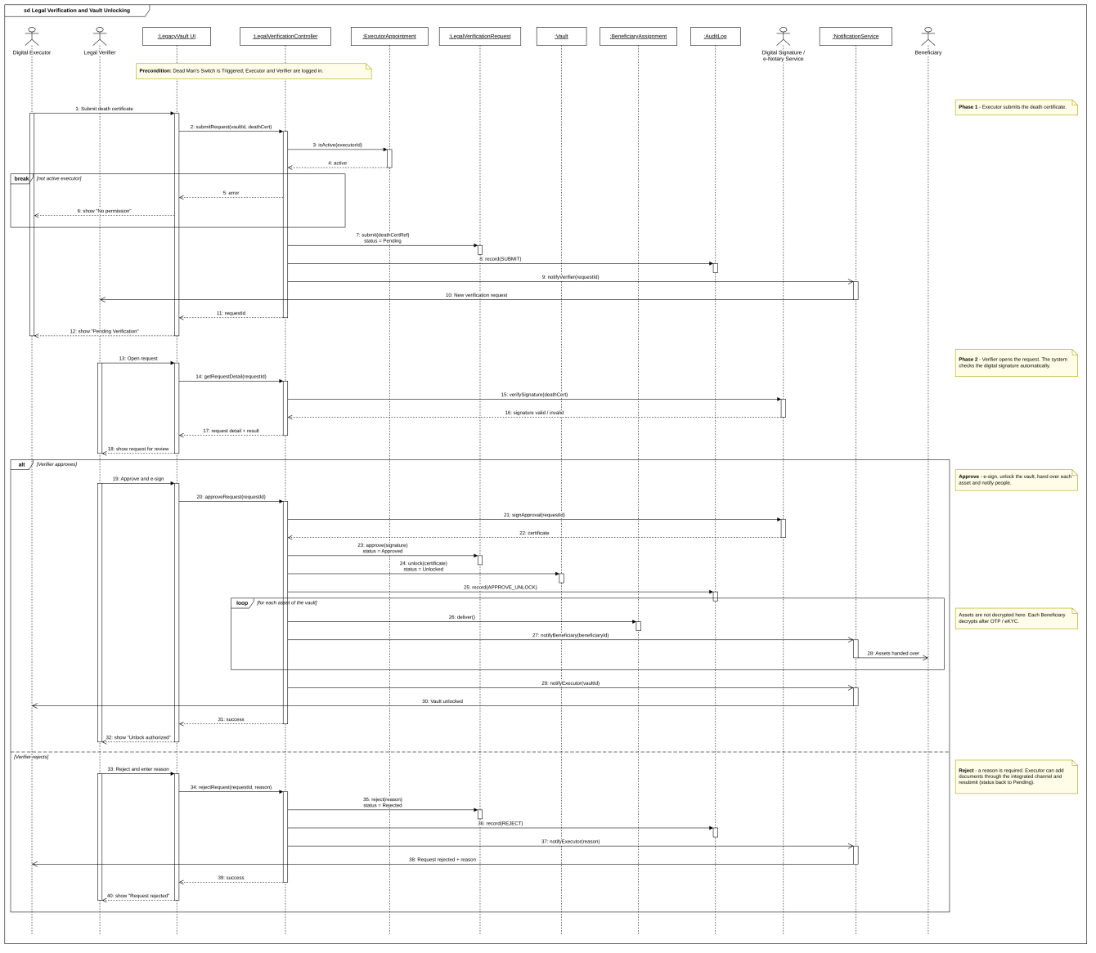
Figure 5. Sequence Diagram – Legal Verification and Vault Unlocking
The sequence diagram "Legal Verification and Vault Unlocking" starts when the Dead Man's Switch is Triggered. Phase 1: the executor submits the death certificate (the system checks that the executor is active and notifies the verifier). Phase 2: the verifier opens the request and the system validates the digital signature. If the verifier approves, the request is e-signed, the vault is unlocked, each asset is delivered to its beneficiary and notifications are sent; if the verifier rejects, a reason is recorded and the executor is notified.

III.1.2 Communication Diagram
The communication diagram shows the objects that take part in the handover and the links between them. Messages are numbered in the order they are sent: the Dead Man's Switch notifies the Digital Executor (1), the executor submits the death certificate to the Legal Verification Request (2), the request is sent to the Legal Verifier (3) who approves and e-signs it (4), the vault is unlocked (5), an assignment is created for each asset (6), the Beneficiary is notified (7) and confirms receipt (8), and the handover progress is sent back to the executor (9).
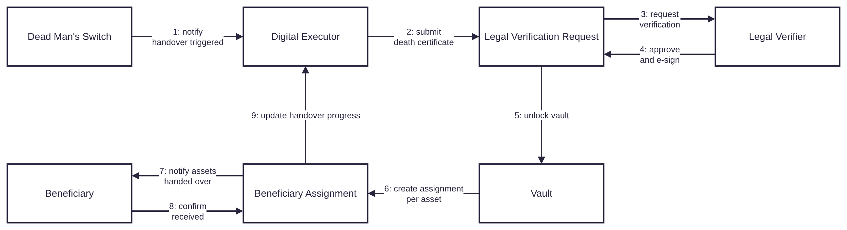
Figure 6. Communication Diagram – Digital Asset Handover

III.2 State diagram
The state diagram follows the life cycle of a vault from the Dead Man's Switch to the end of the handover.
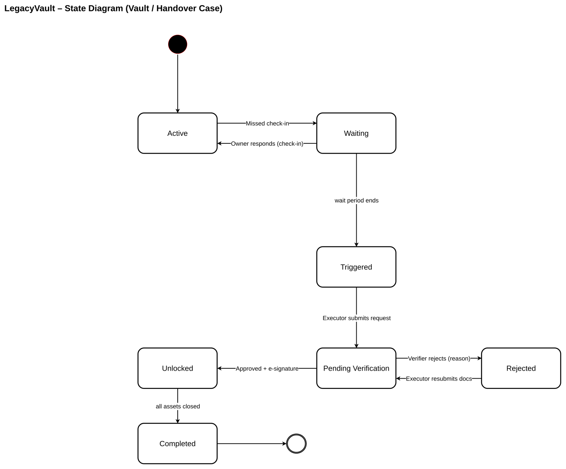
Figure 7. State Diagram – Vault / Handover Case

Each state belongs to one entity of the class diagram:
State | Entity / attribute | Description
Active | DeadManSwitch.status | The vault is monitored; check-ins are scheduled. Entered at the start and whenever the owner responds.
Waiting | DeadManSwitch.status | The owner missed a check-in; the waiting period is running and reminders are sent. The owner can still respond.
Triggered | DeadManSwitch.status | The waiting period expired; the handover is triggered and the executor is notified.
Pending Verification | LegalVerificationRequest.status | The executor submitted the request and the verifier is reviewing it.
Rejected | LegalVerificationRequest.status | The verifier rejected the request with a reason; the executor can resubmit.
Unlocked | Vault.status | The request is approved and e-signed; the vault is unlocked and the per-asset handover is running.
Completed | HandoverCase.status | All asset assignments are closed.

IV. Design specification

IV.1 Integrated Communication Diagrams
The integrated communication diagram shows how the actors and the internal services collaborate during the whole flow. Messages are numbered in the order they are sent (1–20); nested numbers such as 4.1 or 12.2.1 are calls made while processing the parent message.
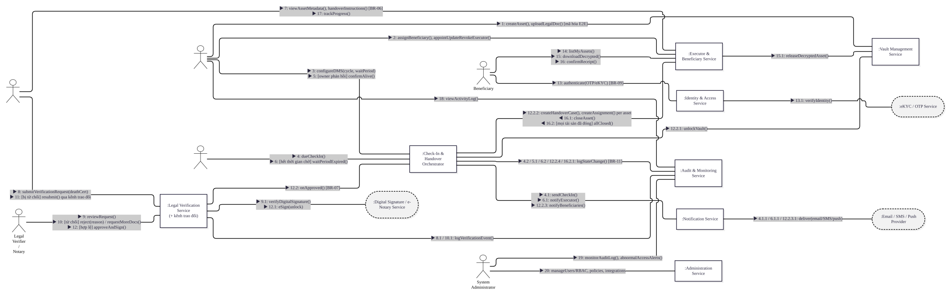
Figure 8. Integrated Communication Diagram

IV.2 Component and Package Diagram

IV.2.1 Component Diagram
The Web Application sends requests to the LegacyVault Server (API). The server uses the Database and five services: Identity & Access, Vault Management, Legal Verification, Check-In & Handover and Audit & Administration. The Legal Verification and Check-In & Handover services use the Notification service to send alerts. Three external providers are used: OTP / eKYC, Digital Signature / e-Notary and Email / SMS / Push.
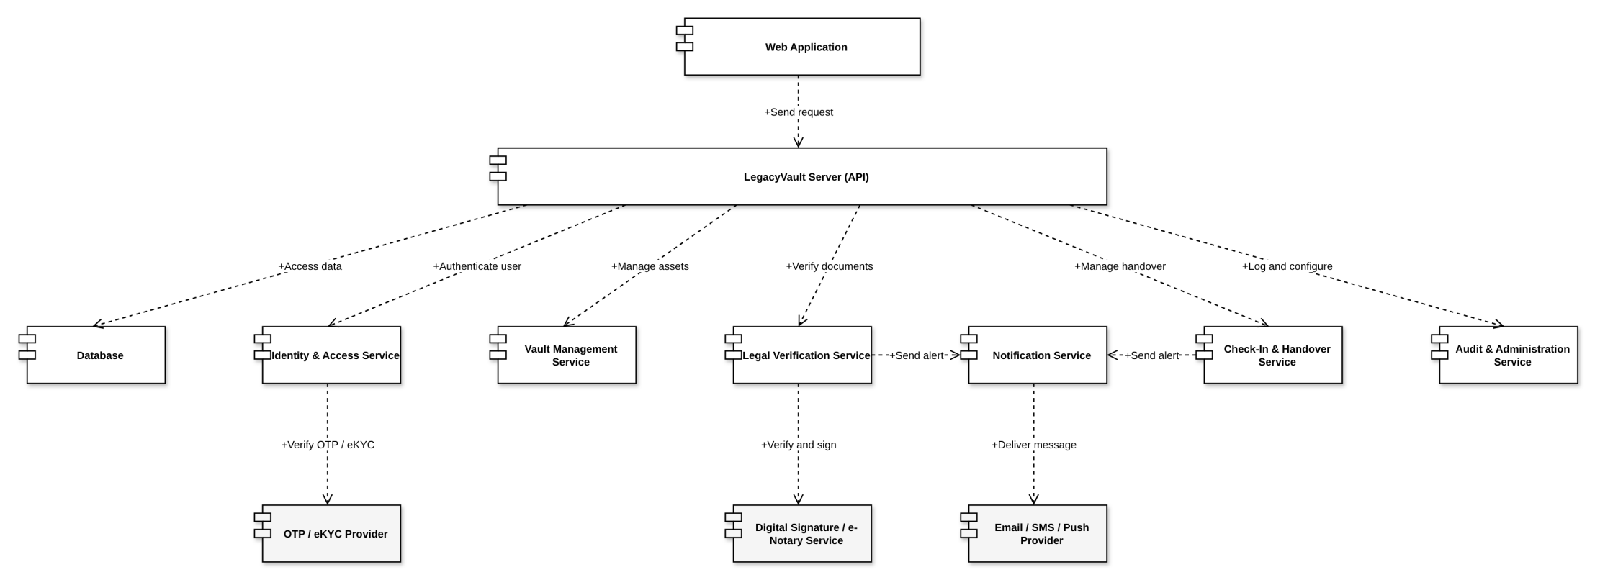
Figure 9. Component Diagram

IV.2.2 Package Diagram
The system is divided into 11 packages. Digital Asset Handover and Dead Man's Switch are the top-level packages of the flow: Dead Man's Switch uses Digital Vault Management, Notification Management, System Configuration and Digital Asset Handover; Digital Asset Handover uses Legal Verification, Beneficiary & Executor Management, Encryption & Security, Identity & Access Management, Notification Management and Audit & Monitoring. Legal Verification and Identity & Access Management use the External Integrations package.
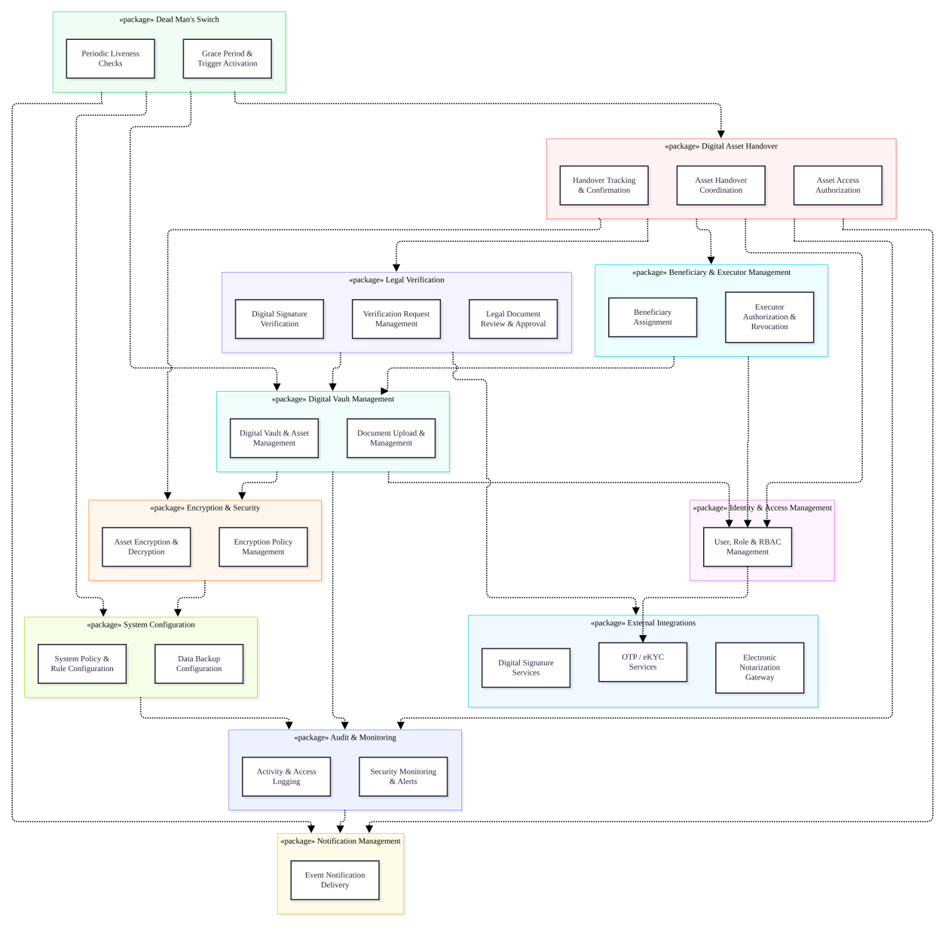
Figure 10. Package Diagram of LegacyVault
Package descriptions
No | Package | Description
01 | Identity & Access Management | User, Role & RBAC Management: users, roles, permissions and OTP / eKYC based authentication.
02 | Digital Vault Management | Digital Vault & Asset Management and Document Upload & Management: create vaults, asset profiles and legal documents.
03 | Encryption & Security | Asset Encryption & Decryption and Encryption Policy Management: end-to-end encryption of assets and documents.
04 | Beneficiary & Executor Management | Beneficiary Assignment and Executor Authorization & Revocation: who receives each asset and who runs the handover.
05 | Dead Man's Switch | Periodic Liveness Checks and Grace Period & Trigger Activation: check-ins, waiting period and handover trigger.
06 | Legal Verification | Verification Request Management, Legal Document Review & Approval and Digital Signature Verification.
07 | Digital Asset Handover | Asset Handover Coordination, Asset Access Authorization and Handover Tracking & Confirmation per asset.
08 | Notification Management | Event Notification Delivery: check-in, trigger, verification and handover messages.
09 | Audit & Monitoring | Activity & Access Logging and Security Monitoring & Alerts.
10 | System Configuration | System Policy & Rule Configuration and Data Backup Configuration.
11 | External Integrations | OTP / eKYC Services, Digital Signature Services and Electronic Notarization Gateway.

IV.3 Class diagram

IV.3.1 Domain Class Diagram
The class diagram contains 22 classes. Person is the parent of the five actors (VaultOwner, DigitalExecutor, Beneficiary, LegalVerifier, SystemAdministrator). Vault is the aggregate root: it contains asset groups, digital assets, legal documents and one DeadManSwitch. Handover is modelled by ExecutorAppointment, BeneficiaryAssignment, HandoverCase and LegalVerificationRequest with its VerificationMessage. Role and Permission support RBAC; AuditLog, SystemPolicy and IntegrationConfig support monitoring and administration.
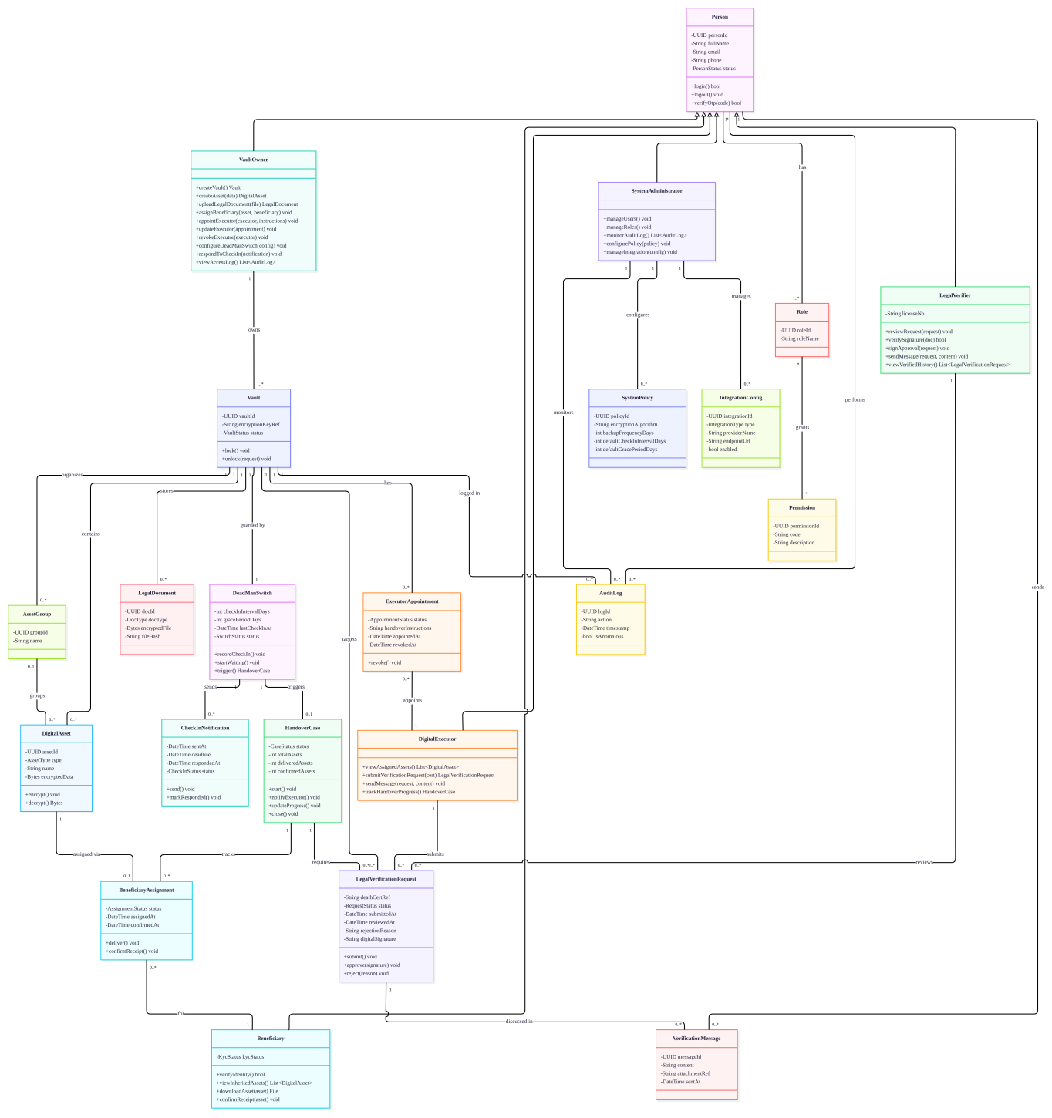
Figure 11. Class Diagram of LegacyVault

IV.3.2 Service and Repository Layers
The layered class diagram shows how the business logic is separated from data access. The Business layer contains four service classes (stereotype «control»): VaultService manages assets, legal documents, beneficiaries and the executor; DeadManSwitchService configures the switch, records check-ins and triggers the handover; LegalVerificationService submits, approves or rejects the verification request and unlocks the vault; HandoverService creates the assignment of each asset, delivers it and tracks the handover progress. Each service depends only on a repository interface (dashed arrow «uses»), and each interface is realized by an Impl class that accesses the database through a DbContext (dashed arrow with a hollow triangle «implements»). The services therefore never depend on the Impl classes, so the database technology can be replaced by writing a new Impl class without changing the business layer.
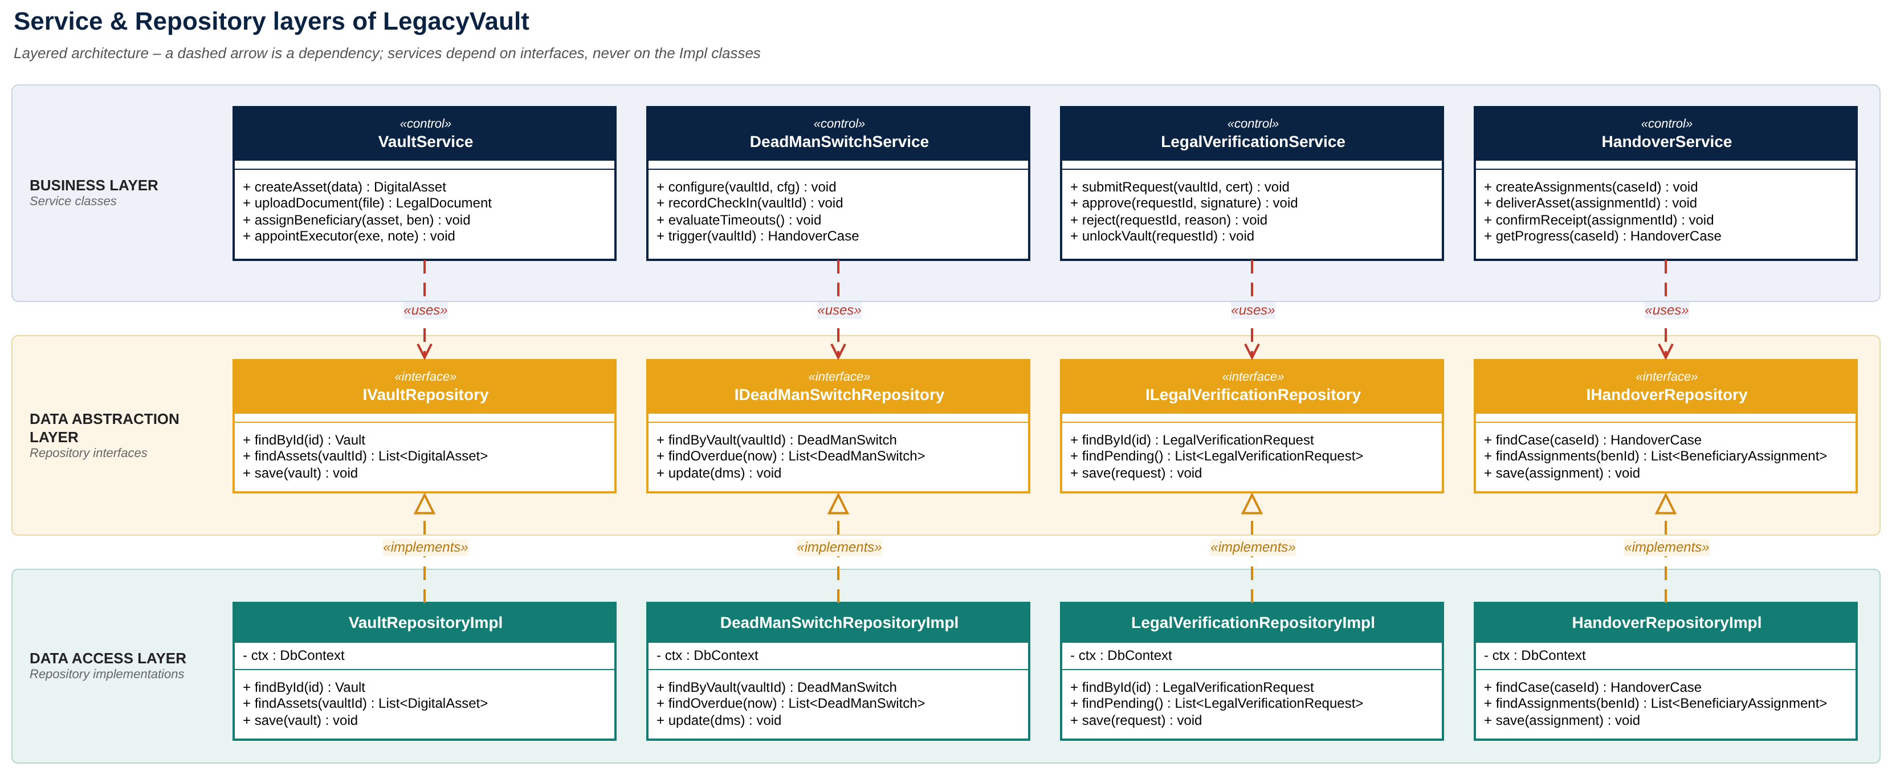
Figure 12. Service and Repository Layers Class Diagram of LegacyVault

IV.4 Database Design

IV.4.1 Conceptual Diagram
Figure 13. Conceptual Diagram of LegacyVault

IV.4.2 Logical Diagram
The logical diagram contains 21 tables with their keys (PK, FK, UK) and relationships: identity and RBAC, vault content, Dead Man's Switch, handover, legal verification, audit, notification, policy and external providers.
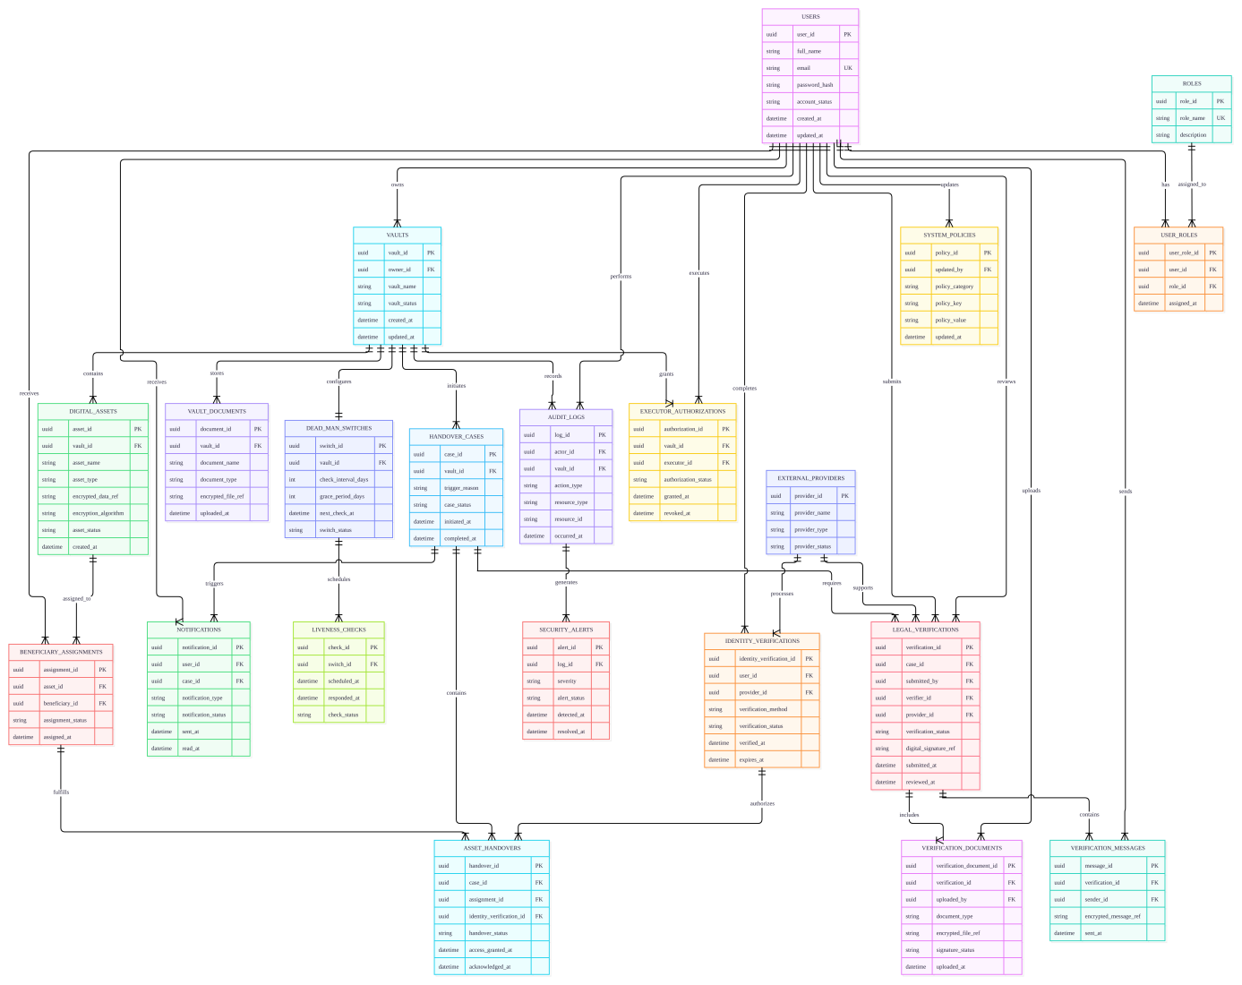
Figure 14. Logical Database Diagram of LegacyVault

