Next-best-item recommendation on hotel booking logs
Selection of a Modelling Methodology for Trip-Context Hotel Cluster Recommendation
A comparative analysis of five state-of-the-art candidate methods against the measured properties of the Expedia hotel recommendation dataset

Field | Value
Task | Ranking 100 hotel clusters for a search event, given trip context and any prior booking history of the user
Dataset | Expedia Hotel Recommendations — 37,670,293 logged events, 3,000,693 bookings, 813,985 booking users, 2013-01-07 to 2014-12-31
Evaluation | Temporal split; full ranking over the complete item set; Recall@K, NDCG@K, MRR at K = 5, 10, 20
Candidates considered | Five methods drawn from competition results and peer-reviewed work published within the last three years, each with a public reference implementation
Outcome | A single methodology is selected in Section 11; the remaining candidates are retained only where Section 12 assigns them an explicit auxiliary role
Date | 23 September 2026

1. Introduction

1.1 Problem formulation
A traveller issues a hotel search characterised by a destination, a set of stay dates, a party composition, a booking channel and a device. The system must rank a closed set of 100 hotel clusters so that the cluster the traveller subsequently books appears as high as possible in the ranking. A hotel cluster is an anonymised grouping of hotels sharing latent characteristics; it carries no name, description or attribute vector, and serves here as a proxy for a room category or packaged offering.
Two properties distinguish this formulation from the mainstream recommendation setting. The item set is closed and small, so ranking is exhaustive rather than a retrieval problem. And the decision context is unusually rich: every event carries the composition of the travelling party, the stay dates, the distance between origin and destination, and whether the booking forms part of a package — information that is observed before the outcome and is therefore available at inference time.

1.2 Task setting and evaluation protocol
Training signal is the booking event. Click events, which constitute 92.03% of logged rows, are treated as a distinct and weaker event type and are never used as positive ground truth. The evaluation protocol is fixed before any model is trained and is not revised thereafter.
Protocol element | Setting
Split | Temporal, at the 80th percentile of booking timestamp: 2,400,554 training bookings, 600,139 test bookings. Validation is the calendar quarter immediately preceding the test window.
Candidate set | All 100 clusters for every test event. No sampled negatives, no candidate pre-filtering.
Accuracy metrics | Recall@K, NDCG@K, MRR at K = 5, 10, 20.
Beyond-accuracy metrics | Intra-list diversity, popularity bias, and catalogue coverage sliced per destination and per season.
Reported slices | Cold users (no training booking, 30.14% of test events), light users (one or two), warm users (three or more).
Repetition | Fixed seeds; mean and standard deviation over at least three seeds where training cost permits.

1.3 Objective and scope
The objective of this report is to select one modelling methodology and to justify that selection against measured properties of the data rather than against general reputation. Section 2 establishes those properties. Section 3 converts them into fitness criteria. Sections 5 to 9 assess five candidate methods, each drawn from a competition result or peer-reviewed publication of the last three years and each carrying a public reference implementation. Sections 10 and 11 resolve the comparison and state the selection. Section 12 specifies the resulting implementation.
Methods that exist primarily as evaluation floors — global and context-conditioned frequency tables, neighbourhood models, latent-factor collaborative filtering without context — are not treated as candidates. They enter the report only in Section 12.3, where they define the measured thresholds a selected model must clear before any result is considered valid.

2. Data characteristics governing method selection

2.1 Item space and interaction volume
The item set contains 100 clusters and the booking table contains 3,000,693 events over 723 days, giving 2,360,713 distinct user–cluster pairs. Figure 1 shows how bookings distribute across the item set.
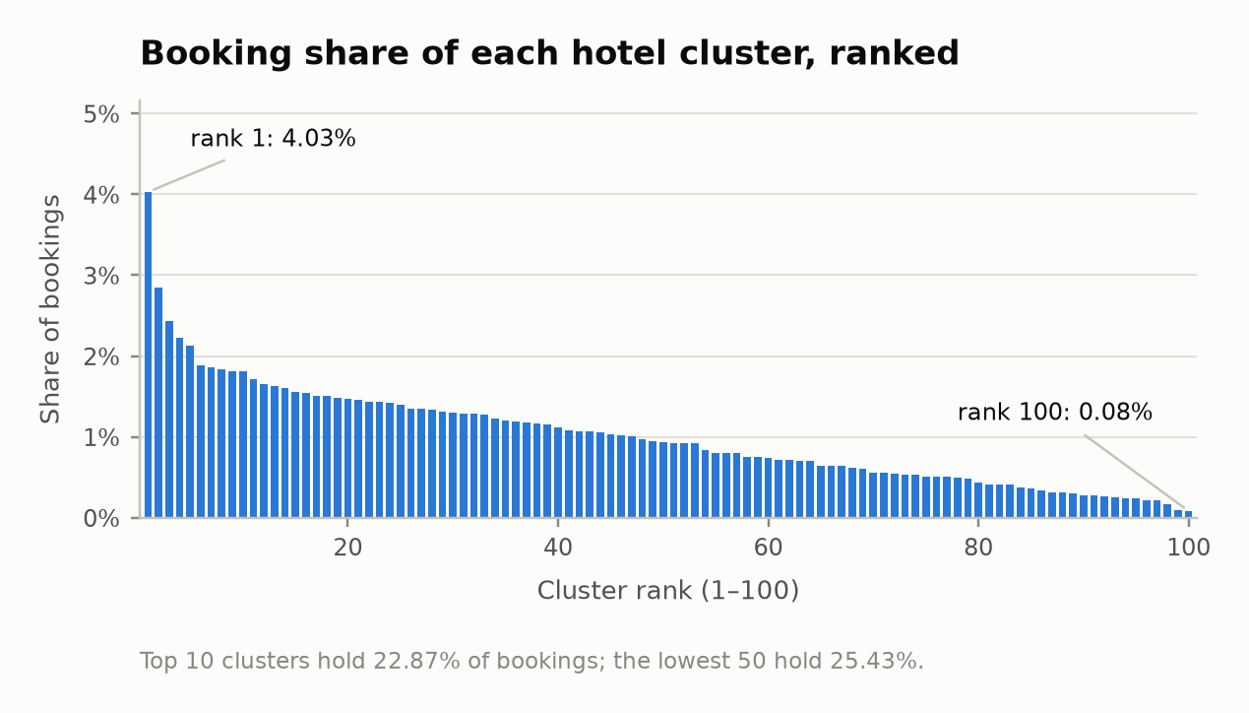
Figure 1. Booking share per hotel cluster, ranked. No item receives more than 4.03% of bookings and none fewer than 0.08%.
The distribution is close to flat by the standards of a recommendation catalogue. The head is weak — the most frequent cluster accounts for 4.03% of bookings — and there is no long tail: every cluster carries at least 2,465 bookings over the full dataset (1,943 within the temporal training split alone). Item cold start does not exist in this dataset, and item-side representations will be well estimated under any method. Differences between methods must therefore originate on the user and context side.
The long tail sits one level up, in the search destination. Figure 2 shows the concentration of bookings across destination rank bands.
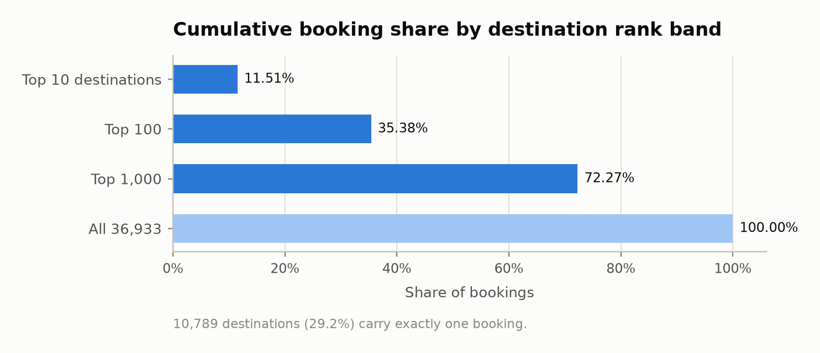
Figure 2. Cumulative booking share by destination rank band, over 36,933 destinations with at least one booking.
Almost three quarters of bookings fall in the thousand most frequent destinations, while 10,789 destinations carry a single booking each. The field has 59,455 distinct values across the full log. Any method that consumes this field must either learn an embedding for it or encode it with a minimum-count threshold and an explicit fallback; the hotel market field, with 2,118 values and 99.998% test coverage, is the natural fallback level.

2.2 User history depth
Figure 3 shows the distribution of bookings per user across the 813,985 users who booked at least once.
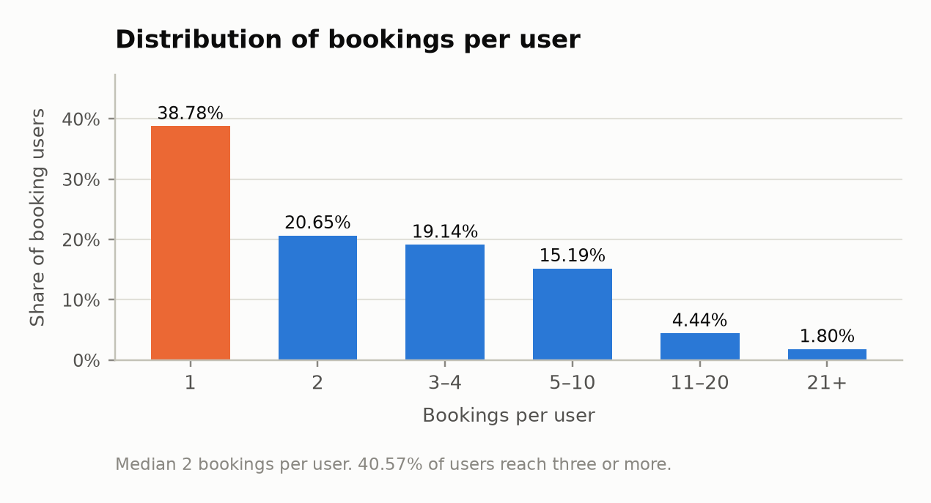
Figure 3. Bookings per user. The first bar — users with exactly one booking — cannot contribute a sequential training example.
The median user contributes two bookings; 38.78% contribute exactly one. Only 40.57% of users reach three bookings, the point at which a sequence model has both context and a target within the same user history. Of test events, 30.14% belong to users absent from training entirely, and 21.33% of bookings repeat a cluster the same user booked before.
These figures bound what any sequence-based method can contribute. Its advantage is confined to the 69.86% of test events whose user appears in training, and its training signal to the 40.57% of users with sufficient depth. Evaluated over the full test set, such a method reports a number dominated by whatever fallback covers the remainder.

2.3 Context signal strength
Figure 4 measures how far the cluster distribution moves when conditioned on each context field, using the mean Jensen–Shannon divergence between the conditional and marginal distributions.
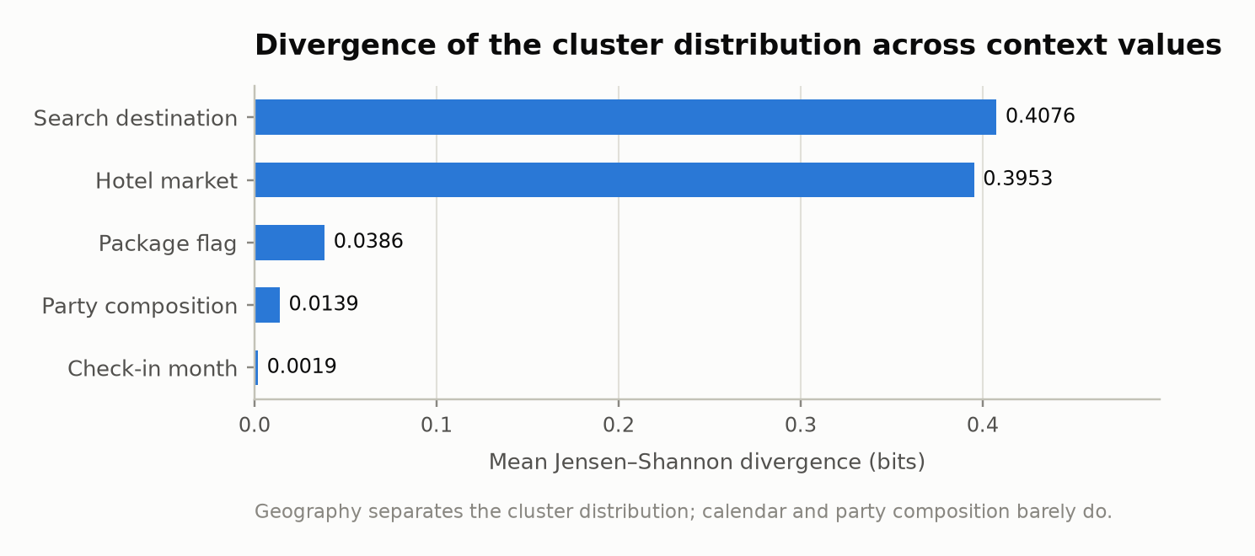
Figure 4. Mean Jensen–Shannon divergence of the cluster distribution across the values of each context field.
Geography dominates by two orders of magnitude. Conditioning on the search destination moves the distribution by 0.4076 bits and on the hotel market by 0.3953 bits; the package flag moves it by 0.0386 bits, party composition by 0.0139 bits and check-in month by 0.0019 bits. In 75 of the 78 most frequent destinations the most-booked cluster differs from the global most-booked cluster; the most concentrated destination sends 72.2% of its bookings to a single cluster.
Figure 5 translates that divergence into attainable accuracy, by scoring a simple frequency table conditioned on each variable under the protocol of Section 1.2.
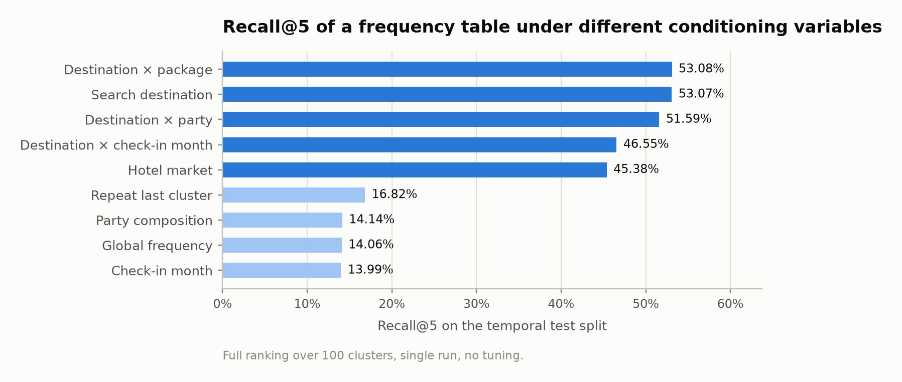
Figure 5. Recall@5 of a conditional frequency table on the temporal test split, by conditioning variable.
Three observations follow, and each constrains method selection directly. First, destination conditioning alone attains Recall@5 of 53.07% against 14.06% for a global frequency table — a factor of 3.77. Second, conditioning on calendar month or party composition in isolation contributes nothing measurable, at 13.99% and 14.14% respectively. Third, the composite destination × check-in month rule reaches only 46.55%, which is 12.3% below destination alone: the counts fragment faster than the added conditioning informs.
The third observation is the central motivation for a learned model. Naive conditioning cannot combine context variables because it cannot share statistical strength across their combinations. Seasonality is present in the data — the destination mix shifts by up to 0.0566 bits between check-in months, and family bookings concentrate 14.63% of their check-ins in August against 5.93% in September — but it is expressed as an interaction with destination and party, not as a main effect. A method that cannot represent feature interactions will not recover it.

2.4 Temporal non-stationarity
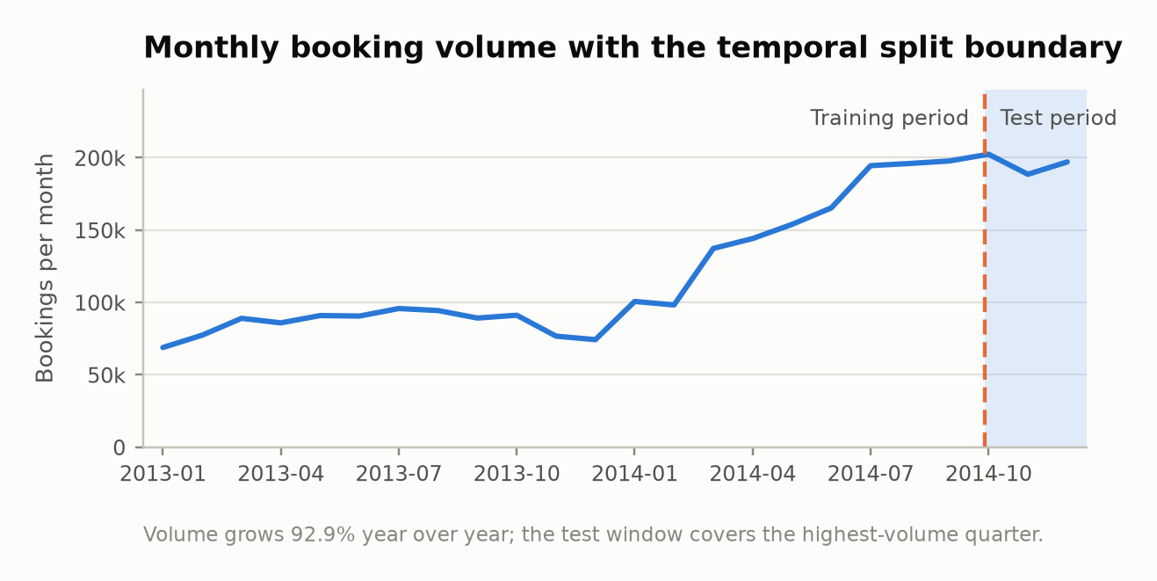
Figure 6. Monthly booking volume across the two-year window, with the temporal split boundary marked.
Booking volume grows 92.9% from 2013 to 2014, and the ratio of 2014 to 2013 volume rises monotonically from 1.27 in February to 2.65 in December. The daily conversion rate falls over the same period, from a 9.17% mean in 2013 to 7.60% in 2014. The test window therefore differs from the average training month in both volume and composition: it covers the highest-volume quarter of the series and the lowest package share, 9.42% in December 2014 against 21.78% in January 2014.
Two requirements follow. Training-set statistics computed without time weighting over-represent 2013 and under-represent the period the model will be tested on. And validation must be drawn from the quarter immediately preceding the test window rather than sampled at random from the training period, since a random sample of a steeply growing series does not resemble its most recent segment.

2.5 Derived constraints
Measured property | Constraint on admissible methods
Closed item set of 100 clusters, no item cold start | Exhaustive ranking and full softmax are tractable. Methods whose contribution is efficient retrieval over a large catalogue address a problem that does not arise here.
Destination field with 59,455 values and a heavy singleton tail | The method must provide either a learned embedding for high-cardinality categorical input or a count-thresholded encoding with a defined fallback level.
Median user history of two bookings; 30.14% of test users unseen | Methods that require a user history at inference time must declare a fallback for roughly a third of the test set, and that fallback then determines a third of the reported score.
Context signal concentrated in interactions rather than main effects | The method must represent feature interactions explicitly. Additive or single-variable conditioning is insufficient.
Steep volume growth and falling conversion across the split | The method must accommodate recency weighting or time-derived features, and must be validated on the most recent training period.
Anonymous item identifiers without text or attributes | Methods that consume item text require that text to be constructed from training statistics, which changes what the method is being tested on.

3. Fitness criteria
The criteria below follow from Section 2. They are stated as conditions with a defined measurement rather than as weighted scores, so that each candidate assessment in Sections 5 to 9 can be checked independently and disagreement can be localised to a single criterion.

3.1 Quantitative criteria
Criterion | Condition | Basis
Q1 — Cold-user coverage | The method produces a ranking for a user with no prior booking without recourse to a substitute model. | 30.14% of test events belong to such users (Section 2.2). A method failing Q1 has a third of its reported score determined by its fallback rather than by itself.
Q2 — Interaction representation | The method represents interactions between context variables without those interactions being enumerated by hand. | Destination × month conditioning loses 12.3% against destination alone through count fragmentation (Section 2.3).
Q3 — High-cardinality handling | The method consumes a categorical field of 59,455 values without overfitting its 10,789 singleton values. | Section 2.1.
Q4 — Sequential sufficiency | The method's central mechanism remains informative at a median history length of two. | Section 2.2. This criterion is diagnostic rather than disqualifying: failure indicates that the method's distinguishing mechanism is inactive on this data.
Q5 — Compute envelope | Full training and evaluation complete within a two-to-three week project budget on a single workstation, with GPU access optional. | Ranking 100 items over 3,000,693 events is inexpensive; the cost differences between candidates arise in training, not inference.

3.2 Qualitative criteria
Criterion | Condition
L1 — Evidence quality | Reported advantages are supported by results that have been independently reproduced, or by a competition outcome on a comparable task, rather than by single-paper claims in a literature with documented replication failures.
L2 — Attribution of contribution | The method permits the contribution of each context group to be isolated by retraining, without architectural modification. This is required to report which context drives the ranking, which is a stated research objective and not merely a diagnostic convenience.
L3 — Implementation risk | The path from raw log to reported metric passes through a small number of well-documented components, and failure of any single component does not invalidate the remainder of the study.
L4 — Transferability of findings | Conclusions drawn from the method apply to the resort-hospitality setting the study targets, in which trip context is observable and per-customer history is short.

4. Candidate methods

4.1 Admission of candidates
Five candidates are admitted. Each is a current, actively used method with a public reference implementation, and each is the leading representative of a distinct hypothesis about where predictive signal resides in this task.
Section | Candidate | Hypothesis under test | Provenance
5 | Gradient-boosted ranking | Signal resides in trip context, and is best extracted by a tabular learner with automatic interaction discovery. | Winning approach in the RecSys Challenge 2024 news track; standing reference on tabular prediction [6][7].
6 | Context-aware deep ranking (DeepFM, DCN-class) | Signal resides in trip context, and high-cardinality fields are best handled by learned embeddings with factorised interactions. | Established CTR and context-aware ranking family, benchmarked openly [8].
7 | Sequential neural models (GRU4Rec, SASRec) | Signal resides in the order of a user's prior bookings. | Standing state of the art for sequential recommendation; subject of a 2024–2025 reproducibility study [1][2][3].
8 | Trip-context hybrid with session-based factorisation head | Signal resides in the trip as a sequence, scored against item embeddings through a learned trip representation. | Winning architecture of the Booking.com WSDM WebTour 2021 challenge, the closest published analogue to this task [9][10][11].
9 | LLM reranking over synthesised item profiles | Signal can be recovered by language-model reasoning over a textual rendering of context, particularly where collaborative signal is absent. | Zero-shot LLM ranking line, with reference implementation and 2025–2026 diagnostic studies [12][13][14].

4.2 State-of-the-art lines excluded on structural grounds
The following are current and actively published, and are excluded not on quality but because their distinguishing mechanism addresses a constraint absent from this task.
Line | Mechanism | Reason for exclusion
Generative retrieval with semantic identifiers | Items are quantised into decodable token sequences and generated autoregressively. | Semantic identifiers compress a large catalogue into a tractable vocabulary. With 100 items the vocabulary is already smaller than a typical codebook, so the mechanism removes nothing and adds a quantisation step between model and item.
Large-scale generative sequence architectures | Transduction over very long behavioural streams at industrial throughput. | The binding constraint here is history length, which is short, not catalogue size or serving throughput.
Diffusion recommenders | Iterative denoising of an interaction vector. | A 2026 reproducibility study reports both replication failure and a conceptual mismatch for this family [4].
Graph neural session models | Message passing over an item transition graph. | A 100-node item graph supports little structure beyond a transition matrix, and the advantage over tuned neighbourhood methods is contested [3].
Masked-language sequential models (BERT4Rec) | Bidirectional masked prediction over item sequences. | Published configurations do not reproduce [2]; the sequential hypothesis is represented by candidates 7 and 8 at lower replication risk.

4.3 Reading reported results on this dataset
Published accuracy figures on this dataset require qualification. Test rows can be matched back to training rows on a composite key of user location country, region and city, hotel market, and origin–destination distance. Because that distance is a near-unique continuous value for a given user–destination pair, the match re-identifies the same search. Public accounts of the associated competition report that roughly one third of the test set was recoverable this way, with conventional classifiers layered on top to cover the remainder [15][16].
Three consequences hold throughout this report. Leaderboard standings from that competition are not treated as evidence of model quality. Published figures on this dataset — reported in the range of 0.4885 to 0.496 MAP@5 for gradient-boosted and ensemble classifiers — are cited as context only, since it cannot be verified whether the leakage path was excluded. And origin–destination distance is retained as a legitimate context feature, being genuine trip information, while the composite match above is never constructed.

5. Gradient-boosted ranking

5.1 Formulation and reference implementation
An ensemble of gradient-boosted decision trees is fitted over the trip-context feature vector. Two formulations are available. The multiclass formulation treats the booked cluster as one of 100 classes and produces a ranking from the class posterior. The learning-to-rank formulation expands each search event into 100 candidate rows and optimises a ranking objective directly, which additionally admits cluster-side features such as the historical frequency of a cluster within the destination in question. Reference implementations are mature and stable.

5.2 Reported performance and evidence base
The learning-to-rank formulation won the news recommendation track of the RecSys Challenge 2024 [6]. On tabular prediction generally, gradient boosting remains the reference against which deep architectures are measured, and comparative studies continue to find it competitive or superior [7]. On this dataset specifically, the published figures noted in Section 4.3 were obtained with tree ensembles, subject to the leakage qualification stated there.

5.3 Fitness against quantitative criteria
Criterion | Assessment
Q1 Cold-user coverage | Satisfied without provision. A user with no history is a row whose history-derived features are absent; the trees split on context instead. No fallback model is required, so no part of the reported score is attributable to a substitute.
Q2 Interaction representation | Satisfied. Interactions are discovered by successive splits; destination × month and party × month arise without being enumerated.
Q3 High-cardinality handling | Satisfied with a stated construction. Native categorical handling would overfit the singleton tail, so destination enters as a count-thresholded target or frequency encoding with fallback to hotel market. This is a specification requirement, recorded in Section 12.1, not a deficiency.
Q4 Sequential sufficiency | Not applicable. The method makes no sequential claim; prior-booking information enters as aggregate features where present.
Q5 Compute envelope | Satisfied comfortably in the multiclass formulation, which trains on CPU in under an hour. The learning-to-rank formulation multiplies the training table by 100 and requires event-level subsampling.

5.4 Fitness against qualitative criteria
L1 is met by a competition result on a comparable ranking task and by a broad tabular literature rather than by isolated claims. L2 is met directly: a context group is removed by dropping its columns and retraining, so the ablation required to attribute contribution costs one training run per group and no architectural change. L3 is the strongest of any candidate — a single library, a single feature table, and no framework-specific data format. L4 holds, because the features the model consumes are exactly the fields a hospitality operator observes at booking time, and feature attribution over them is interpretable as an operational finding rather than only as a diagnostic.
The method offers no methodological novelty. Its contribution to the study lies in the ablation and the comparison it makes possible, not in the architecture.

5.5 Cost, failure modes and residual risk
The dominant failure mode is target leakage through the encoding of destination, which must be fitted within the training fold only. The learning-to-rank variant carries a memory risk from candidate expansion, mitigated by subsampling events rather than rows within an event. Neither risk threatens the study, because the multiclass formulation is independently sufficient and can be delivered first.

6. Context-aware deep ranking

6.1 Formulation and reference implementation
Factorisation machines model pairwise interactions between all features through factorised weights, which suits sparse categorical context. DeepFM adds a neural branch sharing the same embeddings, and the deep-and-cross family replaces the explicit second-order term with learned higher-order crossing. All are available in maintained recommendation frameworks and in open CTR benchmarking suites.

6.2 Reported performance and evidence base
This family is the standing approach for context-aware ranking with high-cardinality categorical features, and open benchmarking efforts have made its comparison protocols explicit [8]. The evidence for the deep variants specifically is weaker than their prominence suggests: benchmarking work has not established a decisive advantage over a well-tuned factorisation machine on typical tabular context, and reported gains are frequently within the range attributable to tuning budget.

6.3 Fitness against quantitative criteria
Criterion | Assessment
Q1 Cold-user coverage | Satisfied conditionally. If the user identifier is included as a feature, an unseen user maps to an untrained embedding and the model degrades unpredictably for 30.14% of test events. Satisfying Q1 requires excluding the user identifier and relying on context alone, which is a deliberate specification choice rather than a default.
Q2 Interaction representation | Satisfied, and this is the family's defining strength: second-order interactions are modelled explicitly across all feature pairs rather than discovered greedily.
Q3 High-cardinality handling | Satisfied natively. An embedding table over 59,455 destination values is learned end to end, with regularisation absorbing the singleton tail. This is the clearest advantage of this family over Section 5.
Q4 Sequential sufficiency | Not applicable; no sequential claim.
Q5 Compute envelope | Satisfied, with a GPU preferred. Training is longer than gradient boosting by roughly an order of magnitude but remains within budget.

6.4 Fitness against qualitative criteria
L1 is partially met: the family is well established, but the specific claim that its deep variants outperform a tuned factorisation machine on context of this shape is not settled. L2 is met with more effort than in Section 5 — removing a feature group requires rebuilding the embedding configuration and retraining, which is mechanical but slower, and attribution through learned embeddings is less directly interpretable than split-based importance. L3 is moderate: the framework imposes its own data format and training loop, and hyperparameter sensitivity is higher. L4 holds on the same grounds as Section 5.

6.5 Cost, failure modes and residual risk
The principal risk is that an under-tuned instance of this family is compared against a well-tuned gradient-boosted model, producing a conclusion about tuning budget rather than about architecture. Since the two families test the same hypothesis — that signal resides in trip context — a mis-specified comparison between them would be the most consequential error available in this study.

7. Sequential neural models

7.1 Formulation and reference implementation
A user history is treated as an ordered sequence of items and the next item is predicted from a learned representation of the prefix. GRU4Rec encodes the prefix recurrently; SASRec encodes it with self-attention. Both are implemented in maintained recommendation frameworks with consistent configuration interfaces.

7.2 Reported performance and evidence base
A 2024–2025 reproducibility study across six benchmark datasets reports that GRU4Rec outperforms SASRec, BERT4Rec, NARM and CORE at the standard embedding width of 50, and that the ordering reverses only when embedding width reaches 256 or more [1]. The same study reports that framework implementations of these models can score materially below independent implementations, which places a qualification on any number produced through a framework. Independently, session-based nearest-neighbour heuristics have been shown to outperform GRU4Rec on a majority of datasets tested [3], and the broader literature documents repeated failures of neural recommenders to surpass well-tuned simple baselines [5].

7.3 Fitness against quantitative criteria
Criterion | Assessment
Q1 Cold-user coverage | Not satisfied. A user with no prior booking has no sequence, and the model cannot produce a ranking without a substitute. The substitute then determines the outcome for 30.14% of test events.
Q2 Interaction representation | Partially satisfied, and only in configurations that admit side features. In the standard formulation the model consumes item identifiers alone and therefore does not use trip context at all.
Q3 High-cardinality handling | Not exercised. Destination is not an input in the standard formulation.
Q4 Sequential sufficiency | Not satisfied. With a median history of two bookings, the prefix available to the encoder is typically a single item, and 38.78% of users cannot form a training example. The mechanism that distinguishes this family is largely inactive on this data.
Q5 Compute envelope | Satisfied with a GPU; marginal without one.

7.4 Fitness against qualitative criteria
L1 is met in the sense that the evidence base is extensive, but that evidence is largely negative for this setting: the reproducibility literature establishes that the family's reported advantages are fragile and configuration-dependent. L2 is poor — isolating a context contribution requires moving to a side-feature-capable architecture, which changes the model rather than ablating it. L3 is the weakest of the non-LLM candidates, since the sequence pipeline, the framework data format and the training loop are all new components on the critical path. L4 is questionable: a conclusion drawn on two-booking histories does not transfer to a setting where history is either longer or, as in resort hospitality, largely absent.

7.5 Cost, failure modes and residual risk
The characteristic failure is a mediocre result that is then misreported as evidence that sequential modelling is ineffective, when the accurate statement is that the data contains too little sequential structure for the mechanism to engage. Distinguishing the two requires measuring the sequential structure of the histories directly, which is itself an established procedure [17] and is retained in Section 12.4.

8. Trip-context hybrid with session-based factorisation head

8.1 Formulation and reference implementation
This is the architecture family that won the Booking.com WSDM WebTour 2021 challenge, whose task — predicting the final city of a multi-destination trip from the preceding bookings, over anonymised identifiers and with trip context attached — is the closest published analogue to the present task. The winning system combined three encoders, a multilayer perceptron, a gated recurrent network and a transformer, each fitted with a session-based matrix factorisation head that learns a linear map between the trip representation and the item embedding table and scores by inner product. Sequence reversal was used as augmentation. Reported leaderboard accuracy was 0.5939 precision@4, 2.8% ahead of the runner-up [9][10][11].

8.2 Reported performance and evidence base
The evidence is a single competition outcome, but an unusually relevant one: the task shape, the anonymised item space and the presence of trip context all match. The two components reported to improve every encoder variant — the factorisation head and sequence reversal — are architecture-independent and transferable. The counterweight is that the result has not been independently reproduced, and that competition solutions are ensembles tuned to a specific leaderboard.

8.3 Fitness against quantitative criteria
Criterion | Assessment
Q1 Cold-user coverage | Not satisfied in the trip-sequence formulation. The head scores a trip representation, and a user with no prior booking supplies none.
Q2 Interaction representation | Satisfied. Trip context is fused into the encoder input, and the winning design demonstrates that this fusion is where its advantage originates.
Q3 High-cardinality handling | Satisfied through embeddings, on the same basis as Section 6.
Q4 Sequential sufficiency | Not satisfied, and the mismatch is more acute than for Section 7. In the source task a trip is a sequence of several cities booked within one journey; here the equivalent sequence is a user's bookings across unrelated trips, with a median length of two. Sequence reversal as augmentation additionally assumes partial symmetry of order, which is defensible within a single multi-city journey and not across independent trips.
Q5 Compute envelope | Marginal. A faithful implementation is an ensemble of three encoders; a single-encoder reduction is affordable but is then no longer the method whose evidence is being cited.

8.4 Fitness against qualitative criteria
L1 rests on one unreplicated result. L2 is poor, as in Section 7. L3 is the weakest of all candidates: three encoders, a custom scoring head and an augmentation scheme, all on the critical path, with partial credit only if the ensemble is completed. L4 is strong in principle — the source task is the nearest published analogue — but that strength is contingent on the sequence assumption that Q4 rejects.

8.5 Cost, failure modes and residual risk
The method is expensive precisely where this dataset provides least return. Its two transferable components, however, do not require adopting the architecture: the factorisation scoring head is a small modification to any model that learns item embeddings, and sequence reversal is a data transformation. Both are retained as optional extensions in Section 12.4 rather than as a candidate methodology.

9. LLM reranking over synthesised item profiles

9.1 Formulation and reference implementation
A first-stage model produces a shortlist, and a language model reorders it from a prompt containing the user context and a description of each candidate item. The reference implementation formats interaction history and candidate list into an instruction and parses the returned ordering [12].
This task supplies no item text. A cluster is an integer, and presenting bare integers to a language model tests nothing. The only admissible construction is to synthesise a textual profile for each of the 100 clusters from training statistics alone — its leading destinations and markets, its check-in month distribution, its party composition mix, its package share and its distance band — rendered by a deterministic template so that every statement in the profile traces to a training measurement. The method under test is then reasoning over that rendering, which must be stated as such.

9.2 Reported performance and evidence base
Zero-shot ranking ability is established but qualified: language models exhibit position bias and popularity bias in this role, partly mitigated by candidate shuffling across repeated calls and by recency-focused prompting [12]. Diagnostic work published in 2026 reports low retrieval coverage, severe exposure bias and weak score discrimination for rerankers in cold-start settings, and quantifies the cost — an 8-billion-parameter reranker processing 58.7 pairs per second at 36 GB of memory, roughly three orders of magnitude slower than a collaborative retriever [13]. A 2025 survey positions the approach as most valuable precisely where collaborative signal is absent [14].

9.3 Fitness against quantitative criteria
Criterion | Assessment
Q1 Cold-user coverage | Satisfied, and uniquely so: the method requires no interaction history, only context. This is its strongest claim on this dataset.
Q2 Interaction representation | Unverifiable. Any interaction reasoning occurs inside the model and cannot be isolated or audited.
Q3 High-cardinality handling | Satisfied indirectly, by naming the destination in the prompt rather than encoding it.
Q4 Sequential sufficiency | Not applicable.
Q5 Compute envelope | Not satisfied at full scale. Reranking 600,139 test events is infeasible; the method is evaluable only on a stratified subsample, and its reported figure is then not comparable to a full-test-set figure without qualification.

9.4 Fitness against qualitative criteria
L1 is the weakest of the candidates: the evidence base is recent, the reported failure modes are severe, and results depend on a hosted model whose version may change between runs. L2 is not met at all — contribution cannot be attributed. L3 is moderate in engineering terms but carries an unusual outcome risk, in that a correctly implemented study may return no measurable improvement. L4 is high where it applies, since the cold-start case is the operationally important one in resort hospitality.

9.5 Cost, failure modes and residual risk
The method cannot serve as a retrieval stage at any scale and therefore cannot be a primary methodology; it is structurally a second stage over some other model's output. Its cost is controlled entirely by subsample size. The failure mode of consequence is not error but null result, which remains publishable provided the design permits the null to be interpreted — which requires a three-way comparison between full profiles, profiles with destination statistics removed, and bare identifiers.

10. Comparative analysis

10.1 Criteria that do not separate the candidates
Q3 does not discriminate. Every candidate handles the destination field adequately, whether by learned embedding (Sections 6, 7, 8), by count-thresholded encoding (Section 5) or by naming it in a prompt (Section 9). Q5 does not discriminate among the first four candidates; all fit the budget, differing by factors that do not change feasibility. L4 does not discriminate strongly, since all five address a setting in which trip context is observable.

10.2 Criteria that separate the candidates
Criterion | Gradient-boosted ranking | Context-aware deep ranking | Sequential neural | Trip-context hybrid | LLM reranking
Q1 Cold users (30.14% of test) | Native | Native if user ID excluded | Requires substitute | Requires substitute | Native
Q2 Interactions | Discovered | Modelled explicitly | Only with side features | Fused in encoder | Not auditable
Q4 Sequence at median length 2 | Not claimed | Not claimed | Mechanism inactive | Mechanism inactive | Not claimed
L1 Evidence quality | Competition result plus broad literature | Established family, contested deep gain | Extensive but largely negative | One unreplicated result | Recent, severe failure modes
L2 Attribution by retraining | Direct | Mechanical but slower | Requires architecture change | Requires architecture change | Not possible
L3 Implementation risk | Lowest | Moderate | High | Highest | Moderate with null-result risk
Scale of evaluation | Full test set | Full test set | Full test set | Full test set | Subsample only

10.3 Resolution of the leading pair
Q4 removes Sections 7 and 8 from contention as primary methodologies. Neither fails on quality; both fail because the mechanism that distinguishes them — order within a user history — is inactive at a median history length of two, and because both then also fail Q1, leaving a third of the test set to a substitute model. Their standing evidence describes settings with substantially deeper histories and does not transfer. Section 9 is excluded as a primary methodology on Q5 and L2 jointly: it cannot rank the full item set at test scale, and its contribution cannot be attributed, which conflicts with the objective of reporting which context drives the ranking.
That leaves two candidates that share a hypothesis — that signal resides in trip context — and differ in how they extract it. The comparison reduces to three points.
- Cold-user handling. Gradient boosting satisfies Q1 with no design decision. The deep family satisfies it only if the user identifier is excluded, which is a defensible choice but one that removes the collaborative component the family is usually credited with, leaving a context-only model competing on the same ground as gradient boosting.
- Evidence quality under equal tuning. The deep family's reported advantage over well-tuned factorisation and tree baselines on tabular context is not established [7][8]. In a study with a fixed tuning budget across all entries, this is the decisive asymmetry: a result favouring the deep model would be difficult to separate from a tuning artefact, whereas gradient boosting reaches its competitive region with little tuning.
- Attribution. L2 is a stated objective, not a convenience. Gradient boosting isolates a context group by dropping columns and retraining, and reports split-based importance over the same features an operator observes. The deep family requires embedding reconfiguration per ablation and yields attributions that are harder to interpret operationally.
The single advantage of the deep family — native embedding of a 59,455-value categorical field — is real but addressable. Count-thresholded encoding with fallback to hotel market covers 99.998% of test events (Section 2.1), which bounds the residual disadvantage tightly.

11. Selected methodology

11.1 Selection
Gradient-boosted ranking over trip context is selected as the primary modelling methodology for this study.
The selection follows from the alignment between the method and the four measured properties that define this task. Predictive signal is concentrated in context rather than in history, and the method consumes context directly. That signal is expressed through interactions rather than main effects, and the method discovers interactions without enumeration. A third of the test set has no user history, and the method requires none. The contribution of each context group must be attributable, and the method permits attribution by retraining without architectural change. No competing candidate satisfies all four; the two sequential candidates satisfy neither of the first three, and the language-model candidate satisfies the third alone.

11.2 Evidence against the closest alternative
The closest alternative is context-aware deep ranking, which shares the selected method's hypothesis and differs only in extraction mechanism. It is not selected for three reasons, stated in decreasing order of weight.
First, its reported advantage over tuned tree and factorisation baselines on context of this shape is not established in the open benchmarking literature [8], while its tuning sensitivity is higher. Under the fixed and equal tuning budget this study imposes, an outcome favouring the deep model could not be distinguished from a budget artefact, and an outcome favouring the tree model would be correspondingly uninformative. Second, satisfying the cold-user criterion requires excluding the user identifier, which strips the family of its collaborative component and reduces it to a context-only model — the same object the selected method already is, reached by a longer route. Third, attribution of context contribution is a stated objective of this study, and the selected method supports it by construction at one training run per feature group.
The alternative's one structural advantage, native high-cardinality embedding, is bounded by the fallback coverage figure in Section 2.1 and does not outweigh the three points above.

11.3 Conditions for revision
The selection is contingent on measurements reported in Section 2 and would be revised under any of the following, each stated with the observation that would trigger it.
Condition | Observation that would trigger revision
Sequential structure proves substantial | The direct measurement of sequential structure specified in Section 12.4 indicates that order carries information at the observed history lengths, contradicting the inference drawn from Figure 3.
Encoding of destination proves inadequate | The selected model fails to reach the destination-conditioned reference point of Section 12.3 on the destination tail, indicating that count-thresholded encoding loses information a learned embedding would retain.
The item space changes | The study moves to an item space with text or attributes, which would make the language-model candidate a first-class contender rather than a second-stage extension.
The history distribution changes | A dataset change raising the median user history materially above two would restore the mechanism that Q4 currently finds inactive.

12. Implementation design

12.1 Model specification
Element | Specification
Formulation | Multiclass over 100 clusters as the primary model. The learning-to-rank formulation with candidate expansion is an extension, admitted only after the primary model is fully evaluated.
Trip-context features | Party composition (adults, children, rooms, derived party type), lead time in days, stay length in nights, check-in month and day of week, package flag, booking channel, device flag, site and point-of-sale, origin–destination distance with an explicit missingness indicator covering the 33.83% of bookings where it is absent.
Geography features | Search destination, destination type, hotel continent, hotel country, hotel market, user location country, region and city.
Destination encoding | Count-thresholded target encoding fitted within the training fold only, with fallback to hotel market below the count threshold and to the global prior below that. The threshold is selected on the validation quarter.
History features | Where a user appears in training: number of prior bookings, previously booked clusters, recency of the last booking. Absent for cold users, with an explicit indicator rather than imputation.
Recency handling | Sample weighting by booking date, with the decay constant selected on the validation quarter, motivated by the growth curve in Figure 6.

12.2 Training and validation protocol
The split of Section 1.2 is fixed before training. Hyperparameters are selected on the validation quarter, which is the three months preceding the test boundary; the test set is scored once per configuration and is not used for selection. All encodings are fitted on training data only and applied unchanged to validation and test. Seeds are fixed and results are reported as a mean with standard deviation over at least three seeds. Metrics are computed by a single evaluation component that consumes a ranked list per test event, so that any auxiliary model in Section 12.4 is scored identically.

12.3 Validity reference points
Four measured thresholds are established before the selected model is trained, and the model is not reported until it clears them. These are validity checks, not competing methods.
Reference point | Measured Recall@5 | Function
Global frequency table | 14.06% | Detects gross implementation error. Any model below this is broken.
Destination-conditioned frequency table | 53.07% | The operative threshold. A learned model that does not exceed this has not demonstrated that it extracts anything beyond a conditional count.
Destination × check-in month frequency table | 46.55% | Quantifies the fragmentation loss the learned model is expected to recover, and bounds the value attributable to interaction modelling.
Repeat-last-cluster rule | 16.82% | Bounds the contribution attributable to repetition alone, given that 21.33% of bookings repeat a previously booked cluster.

12.4 Ablation and auxiliary measurements
- Context-group ablation. The model is retrained with each context group removed in turn — party, dates and season, package, geography, channel — and the change in Recall@K and NDCG@K is reported per group and per user slice. This is the primary evidence for which context drives the ranking.
- Sequential-structure measurement. The degree of sequential structure in user booking histories is measured directly [17], to establish whether the inference drawn in Section 10.3 holds, and to satisfy the first revision condition of Section 11.3.
- Transferable components from Section 8. The factorisation scoring head and sequence-reversal augmentation are evaluated as optional additions where the model learns item embeddings, since both were reported to improve every encoder variant in the source result and neither requires adopting that architecture.
- Second-stage language-model reranking. Retained as an extension over the selected model's shortlist, restricted to a stratified subsample, with the three-way comparison of Section 9.5 and with cost and latency recorded per request. Reported separately from the main results and never as a full-test-set figure.

12.5 Schedule
Stage | Work | Duration
1 | Evaluation component and metric tests against hand-computed examples; construction of the processed booking table from the raw log in a single pass. | 2 days
2 | Reference points of Section 12.3 reproduced under the evaluation component. | 1 day
3 | Primary model: feature construction, destination encoding, multiclass training, validation-based tuning. | 2 days
4 | Context-group ablation across all groups and user slices. | 1 day
5 | Sequential-structure measurement and the optional components of Section 12.4. | 1 day
6 | Seed repetition, slice analysis, beyond-accuracy metrics. | 1 day
7 | Second-stage reranking extension on the stratified subsample. | 2 days
8 | Learning-to-rank formulation, if stages 1 to 7 complete ahead of schedule. | 2 days

13. Threats to validity
- The item is a proxy. A hotel cluster is an anonymised grouping, not a room category or package, and every operational conclusion inherits that substitution.
- Published figures on this dataset are qualified by the leakage path of Section 4.3, and it cannot be verified whether individual published results excluded it.
- The rejection of the sequential candidates rests on an inference from history-length distribution. The direct measurement in Section 12.4 tests that inference; until it is reported, the rejection is provisional.
- Seasonality is not observable in the cluster distribution at the aggregate level, at 0.0019 bits for check-in month. Seasonal conclusions are admissible only from per-destination slices.
- The comparison in Section 10 is between method families, not between specific implementations. Framework implementations of the same model differ materially in reported accuracy [1], so any figure produced in this study is a statement about a named implementation and version.
- Catalogue coverage is near-trivial with 100 items; intra-list diversity and popularity bias are the beyond-accuracy metrics that carry information here.
- Item profiles constructed for the second-stage extension are derived data generated from training statistics by a deterministic template, and are labelled as such wherever results depend on them.
- Dataset terms permit research use and do not permit redistribution of the raw data.

14. Reproducibility note
Every dataset figure quoted in this report is the output of a profiling pass over the complete event log, persisted to disk and consumed unchanged by the report and by the figure-generation code; no figure in the text is estimated or restated from a secondary source. Figures 1 to 6 are generated from those persisted outputs by a single script, so they cannot diverge from the values quoted in the surrounding text. The probe underlying Figure 5 uses the split, candidate set and metric definition of Section 1.2, executed once without tuning, and is reported as a probe rather than as a model result. Library names and versions are recorded with each result produced under Section 12.

15. References
[1] F. Betello, A. Purificato, F. Siciliano, G. Trappolini, A. Bacciu, N. Tonellotto, F. Silvestri. A Reproducible Analysis of Sequential Recommender Systems. IEEE Access, 2024/2025. Code: github.com/antoniopurificato/recsys_repro_conf https://arxiv.org/abs/2408.03873
[2] A. Petrov, C. Macdonald. A Systematic Review and Replicability Study of BERT4Rec for Sequential Recommendation. RecSys, 2022. https://dl.acm.org/doi/10.1145/3523227.3548487
[3] M. Ludewig, D. Jannach. Evaluation of Session-based Recommendation Algorithms, and subsequent empirical comparisons of neural and non-neural approaches. https://arxiv.org/abs/1803.09587
[4] M. Benigni, M. Ferrari Dacrema, D. Jannach. Diffusion Recommender Models and the Illusion of Progress: A Concerning Study of Reproducibility and a Conceptual Mismatch. ACM Transactions on Recommender Systems, 2026.
[5] M. Ferrari Dacrema, P. Cremonesi, D. Jannach. Are We Really Making Much Progress? A Worrying Analysis of Recent Neural Recommendation Approaches. RecSys, 2019. https://dl.acm.org/doi/10.1145/3298689.3347058
[6] Leveraging LightGBM Ranker for Efficient Large-Scale News Recommendation Systems. Proceedings of the RecSys Challenge, 2024. https://dl.acm.org/doi/10.1145/3687151.3687156
[7] A Closer Look at Deep Learning Methods on Tabular Datasets. 2024. https://arxiv.org/abs/2407.00956
[8] J. Zhu et al. BARS: Towards Open Benchmarking for Recommender Systems. 2022. https://arxiv.org/abs/2205.09626
[9] D. Goldenberg, P. Kofman et al. Booking.com WSDM WebTour 2021 Challenge. WebTour workshop, WSDM, 2021. https://ceur-ws.org/Vol-2855/challenge_short_1.pdf
[10] B. Schifferer, C. Deotte, J.-F. Puget, G. de Souza Pereira Moreira, G. Titericz, J. Liu, R. Ak. Using Deep Learning to Win the Booking.com WSDM WebTour21 Challenge on Sequential Recommendations. https://www.semanticscholar.org/paper/14725948107666fd9c84a6b25db785c1e69cb145
[11] NVIDIA. How to Build a Winning Deep Learning Powered Recommender System, Part 3 — session-based matrix factorisation head and reversed-trip augmentation. https://developer.nvidia.com/blog/how-to-build-a-winning-deep-learning-powered-recommender-system-part-3/
[12] Y. Hou et al. Large Language Models are Zero-Shot Rankers for Recommender Systems. ECIR, 2024. Code: github.com/RUCAIBox/LLMRank https://github.com/RUCAIBox/LLMRank
[13] Diagnosing LLM-based Rerankers in Cold-Start Recommender Systems: Coverage, Exposure and Practical Mitigations. 2026. https://arxiv.org/abs/2604.16318
[14] Cold-Start Recommendation towards the Era of Large Language Models: A Comprehensive Survey and Roadmap. 2025. https://arxiv.org/abs/2501.01945
[15] Documentation of the leakage path in the Expedia hotel recommendation competition, based on user location fields and origin–destination distance. https://www.dataquest.io/blog/kaggle-tutorial/
[16] S. Mandal. Kaggle: Expedia Hotel Recommendations — In Practice. 2016. https://mandalsubhajit.wordpress.com/2016/05/26/kaggle-expedia-hotel-recommendations/
[17] Does It Look Sequential? An Analysis of Datasets for Evaluation of Sequential Recommendations. 2024. https://arxiv.org/abs/2408.12008
[18] RecBole: a unified recommendation library, version 1.2.1, 2025 — reference implementations for the sequential and context-aware candidates. https://github.com/RUCAIBox/RecBole

