Tên : Lê Quốc Trung
Lớp : 12_CNTT4
MSSV : 1250080215
Lab6

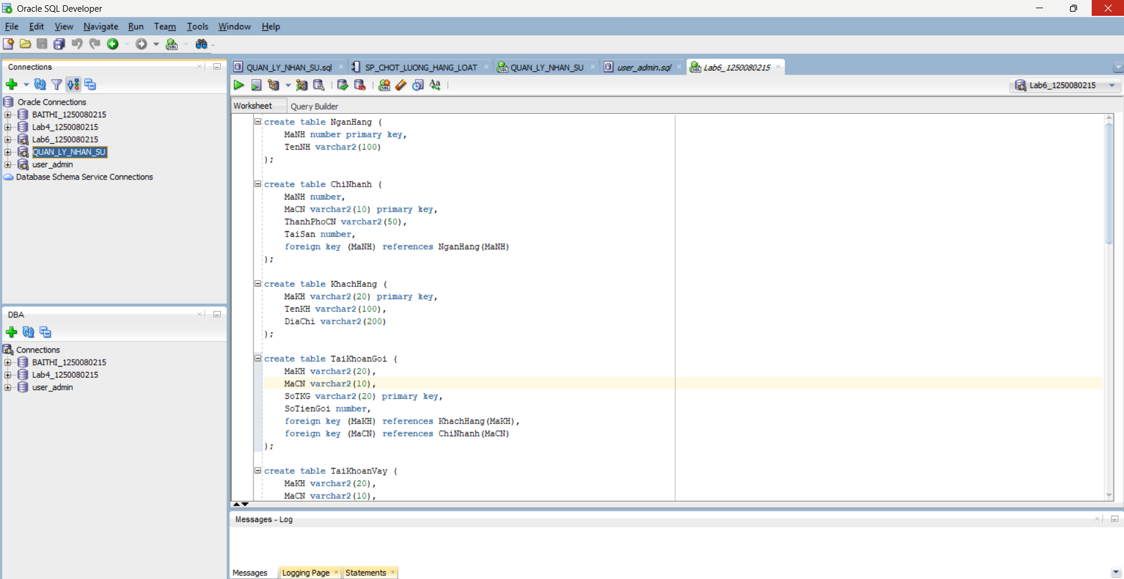

create table NganHang (
MaNH number primary key,
TenNH varchar2(100)
);

create table ChiNhanh (
MaNH number,
MaCN varchar2(10) primary key,
ThanhPhoCN varchar2(50),
TaiSan number,
foreign key (MaNH) references NganHang(MaNH)
);

create table KhachHang (
MaKH varchar2(20) primary key,
TenKH varchar2(100),
DiaChi varchar2(200)
);

create table TaiKhoanGoi (
MaKH varchar2(20),
MaCN varchar2(10),
SoTKG varchar2(20) primary key,
SoTienGoi number,
foreign key (MaKH) references KhachHang(MaKH),
foreign key (MaCN) references ChiNhanh(MaCN)
);

create table TaiKhoanVay (
MaKH varchar2(20),
MaCN varchar2(10),
SoTKV varchar2(20) primary key,
SoTienVay number,
foreign key (MaKH) references KhachHang(MaKH),
foreign key (MaCN) references ChiNhanh(MaCN)
);

insert into NganHang values (1, 'Ngan Hang Cong Thuong');
insert into NganHang values (2, 'Ngan Hang Ngoai Thuong');
insert into NganHang values (3, 'Ngan Hang Nong Nghiep');
insert into NganHang values (4, 'Ngan Hang A Chau');
insert into NganHang values (5, 'Ngan Hang Thuong Tin');
insert into ChiNhanh values (1, 'CN01', 'Da Lat', 2000000000);
insert into ChiNhanh values (2, 'CN02', 'Nha Trang', 2700000000);
insert into ChiNhanh values (3, 'CN03', 'Thanh Hoa', 4500000000);
insert into ChiNhanh values (4, 'CN04', 'TP HCM', 6000000000);
insert into ChiNhanh values (5, 'CN05', 'Da Nang', 7000000000);
insert into ChiNhanh values (1, 'CN11', 'TP HCM', 5000000000);
insert into ChiNhanh values (2, 'CN12', 'Hue', 1400000000);
insert into ChiNhanh values (3, 'CN13', 'Da Nang', 3600000000);
insert into ChiNhanh values (4, 'CN14', 'Ha Noi', 5700000000);
insert into ChiNhanh values (1, 'CN21', 'Ha Noi', 3500000000);
insert into ChiNhanh values (2, 'CN22', 'Ha Noi', 4500000000);
insert into ChiNhanh values (3, 'CN23', 'Da Lat', 2400000000);
insert into ChiNhanh values (1, 'CN31', 'Da Nang', 4000000000);
insert into ChiNhanh values (2, 'CN32', 'TP HCM', 5600000000);
insert into ChiNhanh values (3, 'CN33', 'Can Tho', 5400000000);
insert into ChiNhanh values (3, 'CN43', 'Nam Dinh', 3600000000);
insert into KhachHang values ('111222333', 'Ho Thi Thanh Thao', '456 Le Duan, Ha Noi');
insert into KhachHang values ('112233445', 'Tran Van Tien', '12 Dien Bien Phu, Q1, TP HCM');
insert into KhachHang values ('123123123', 'Phan Thi Quynh Nhu', '54 Hai Ba Trung, Ha Noi');
insert into KhachHang values ('123412341', 'Nguyen Van Thao', '34 Tran Phu, TP Nha Trang');
insert into KhachHang values ('123456789', 'Nguyen Thi Hoa', '1/4 Hoang Van Thu, Da Lat');
insert into KhachHang values ('221133445', 'Nguyen Thi Kim Mai', '4 Tran Binh Trong, Da Lat');
insert into KhachHang values ('222111333', 'Do Tien Dong', '123 Tran Phu, Nam Dinh');
insert into KhachHang values ('331122445', 'Bui Thi Dong', '345 Tran Hung Dao, Thanh Hoa');
insert into KhachHang values ('333111222', 'Tran Dinh Hung', '783 Ly Thuong Kiet, Can Tho');
insert into KhachHang values ('441122335', 'Nguyen Dinh Cuong', 'P12 Thanh Xuan Nam, Ha Noi');
insert into KhachHang values ('456456456', 'Tran Nam Son', '5 Le Duan, TP Da Nang');
insert into KhachHang values ('551122334', 'Tran Thi Khanh Van', '1A Ho Tung Mau, Da Lat');
insert into KhachHang values ('987654321', 'Ho Thanh Son', '209 Tran Hung Dao, Q5, TP HCM');
insert into TaiKhoanGoi values ('123123123', 'CN01', '00001A', 10000000);
insert into TaiKhoanGoi values ('123456789', 'CN01', '00001C', 127000000);
insert into TaiKhoanGoi values ('221133445', 'CN02', '00002A', 12500000);
insert into TaiKhoanGoi values ('456456456', 'CN03', '00003H', 123000000);
insert into TaiKhoanGoi values ('222111333', 'CN05', '00005A', 1200000);
insert into TaiKhoanGoi values ('987654321', 'CN05', '00005D', 345000000);
insert into TaiKhoanGoi values ('123412341', 'CN05', '00005N', 45000000);
insert into TaiKhoanGoi values ('331122445', 'CN13', '00003A', 27000000);
insert into TaiKhoanGoi values ('551122334', 'CN14', '00004D', 560000000);
insert into TaiKhoanGoi values ('123456789', 'CN14', '00004P', 35400000);
insert into TaiKhoanGoi values ('123412341', 'CN21', '00001B', 67000000);
insert into TaiKhoanGoi values ('222111333', 'CN22', '00002G', 56000000);
insert into TaiKhoanGoi values ('987654321', 'CN23', '00004F', 4500000);
insert into TaiKhoanGoi values ('333111222', 'CN33', '00003D', 47000000);
insert into TaiKhoanVay values ('111222333', 'CN01', '10001A', 10000000);
insert into TaiKhoanVay values ('333111222', 'CN02', '10002A', 6000000);
insert into TaiKhoanVay values ('551122334', 'CN04', '10004A', 20000000);
insert into TaiKhoanVay values ('221133445', 'CN05', '10005G', 15000000);
insert into TaiKhoanVay values ('987654321', 'CN11', '10001D', 45000000);
insert into TaiKhoanVay values ('112233445', 'CN12', '10002D', 12000000);
insert into TaiKhoanVay values ('441122335', 'CN13', '10003F', 5500000);
insert into TaiKhoanVay values ('123123123', 'CN14', '10005A', 12500000);
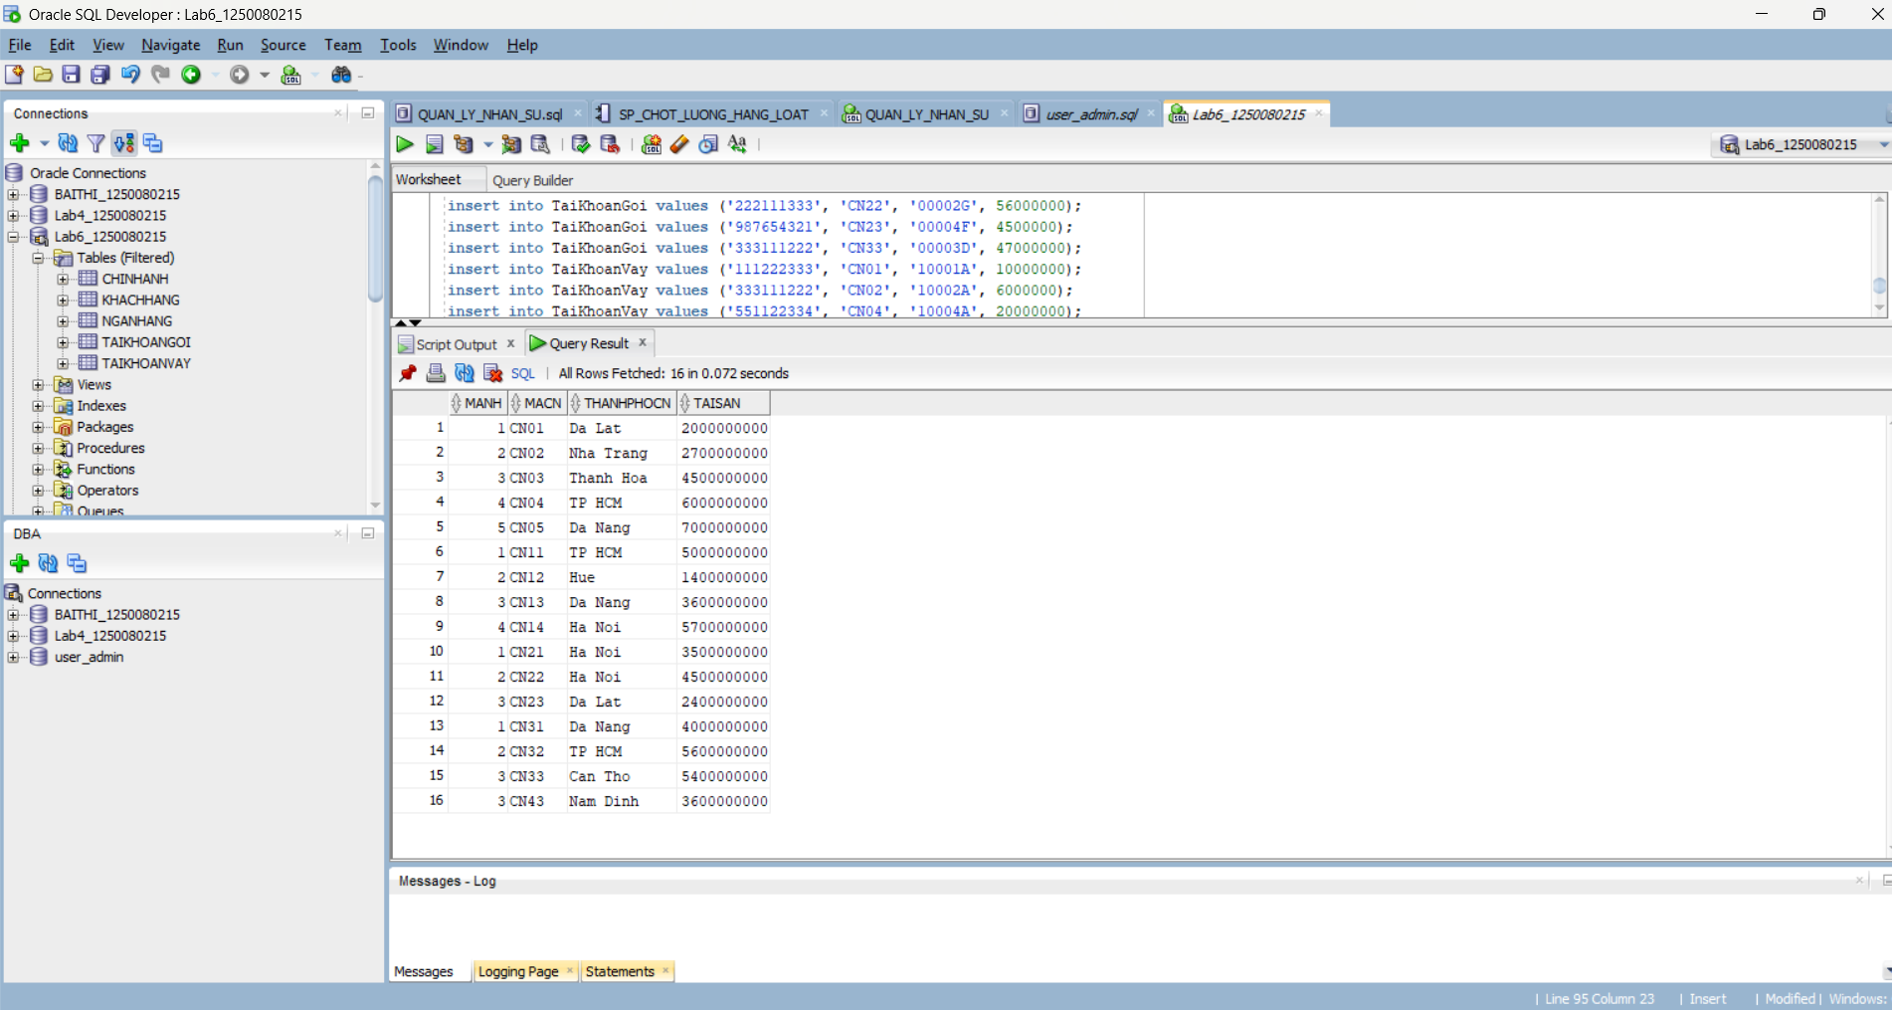
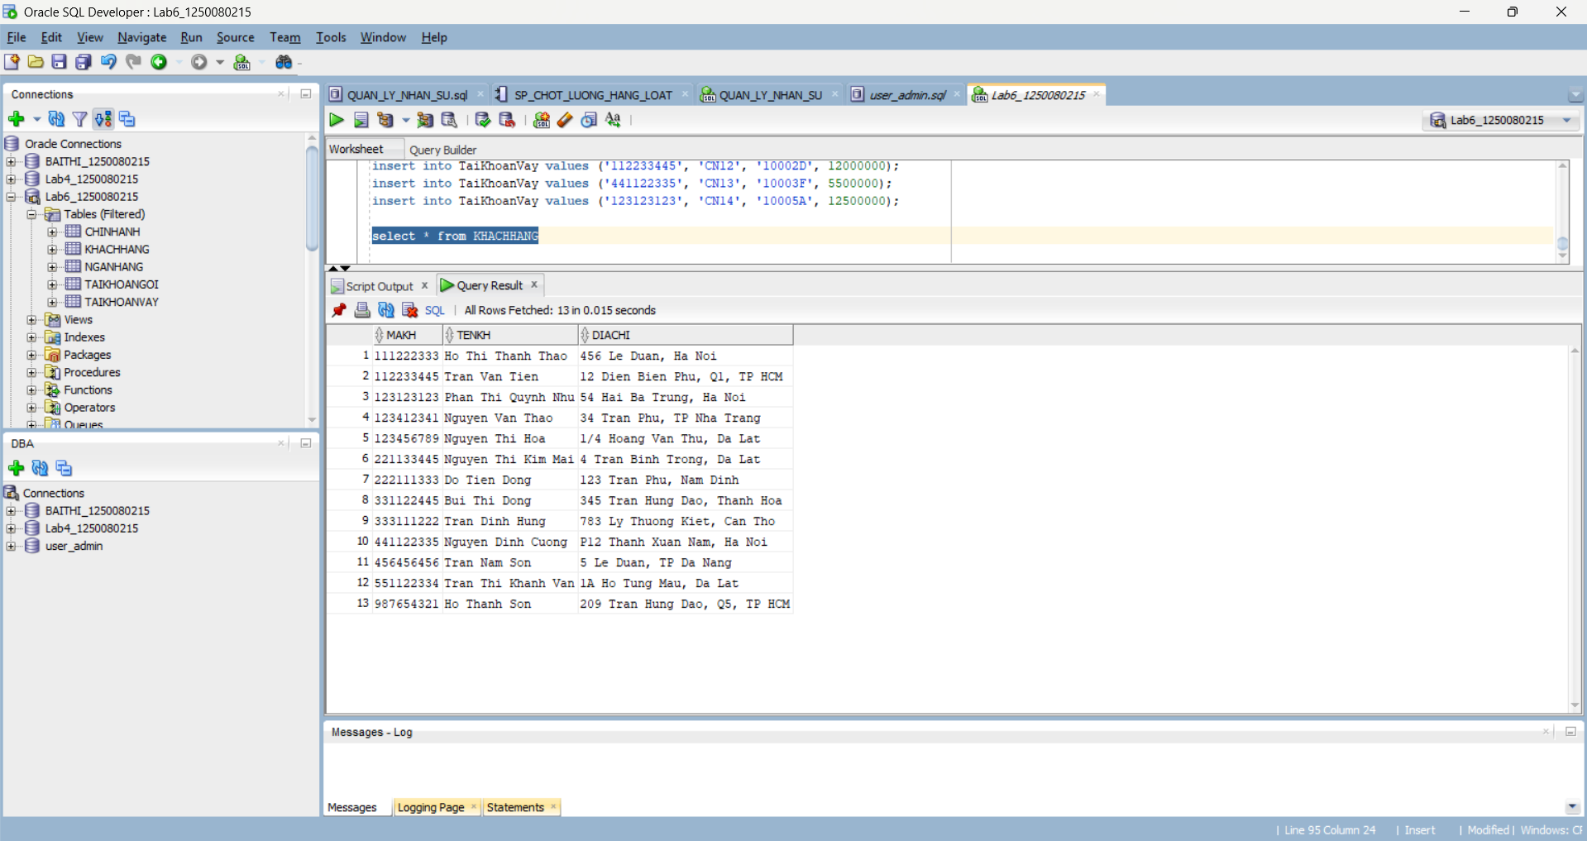
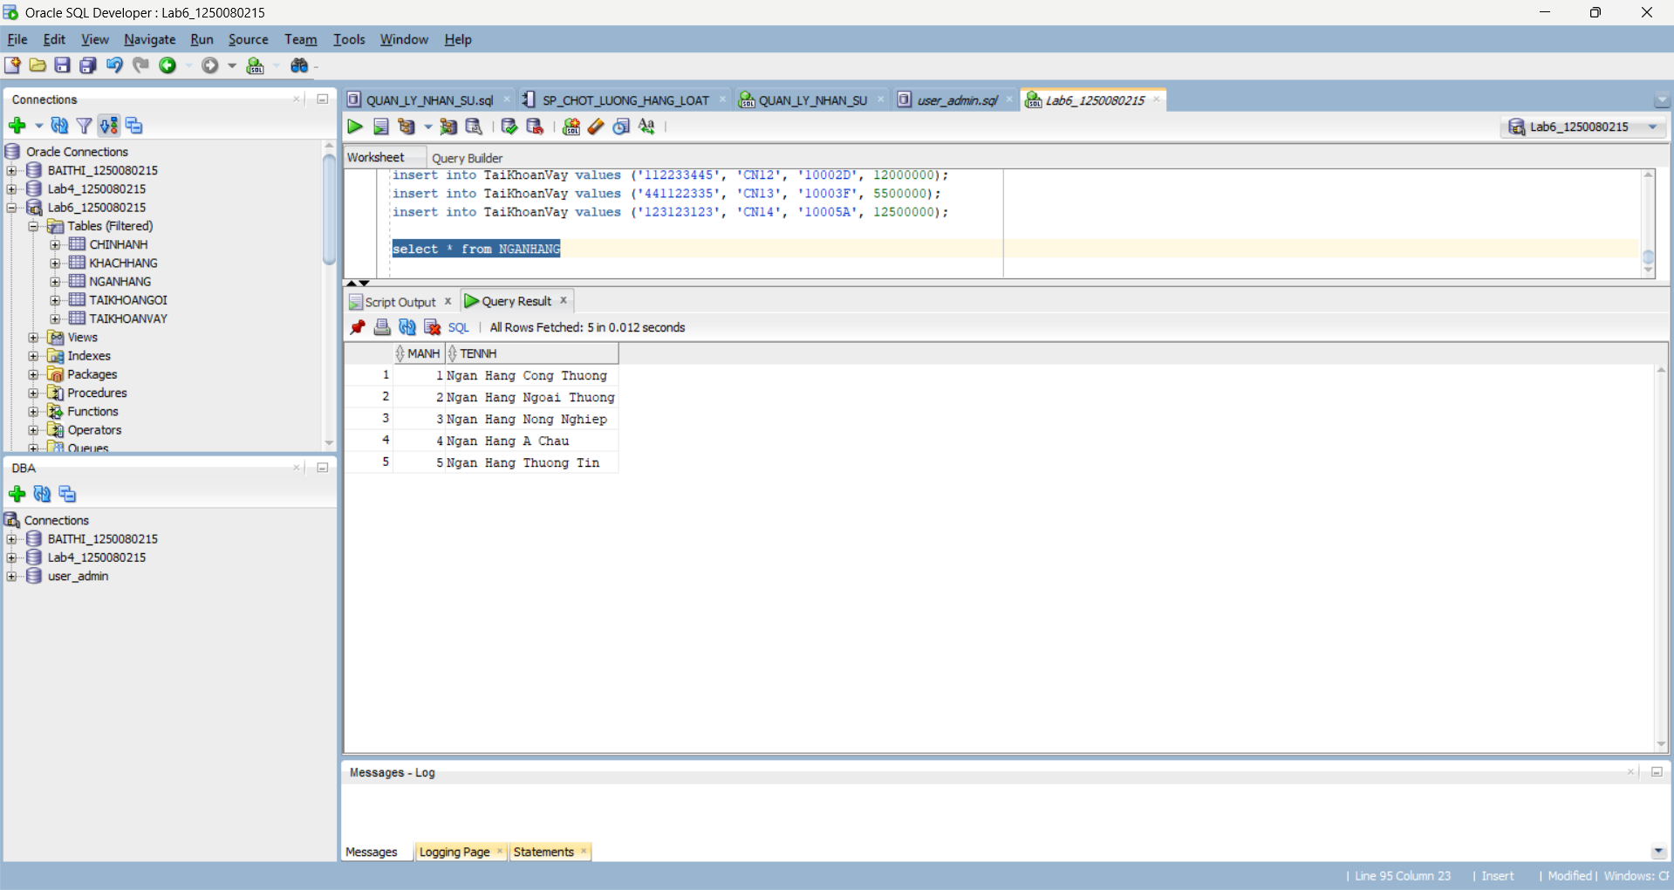

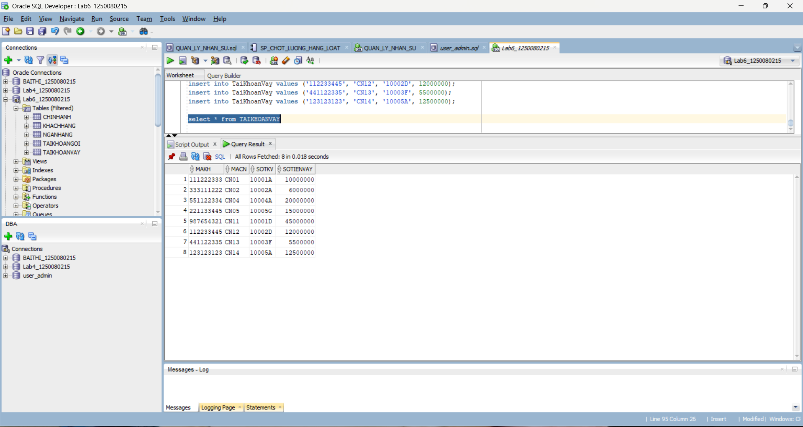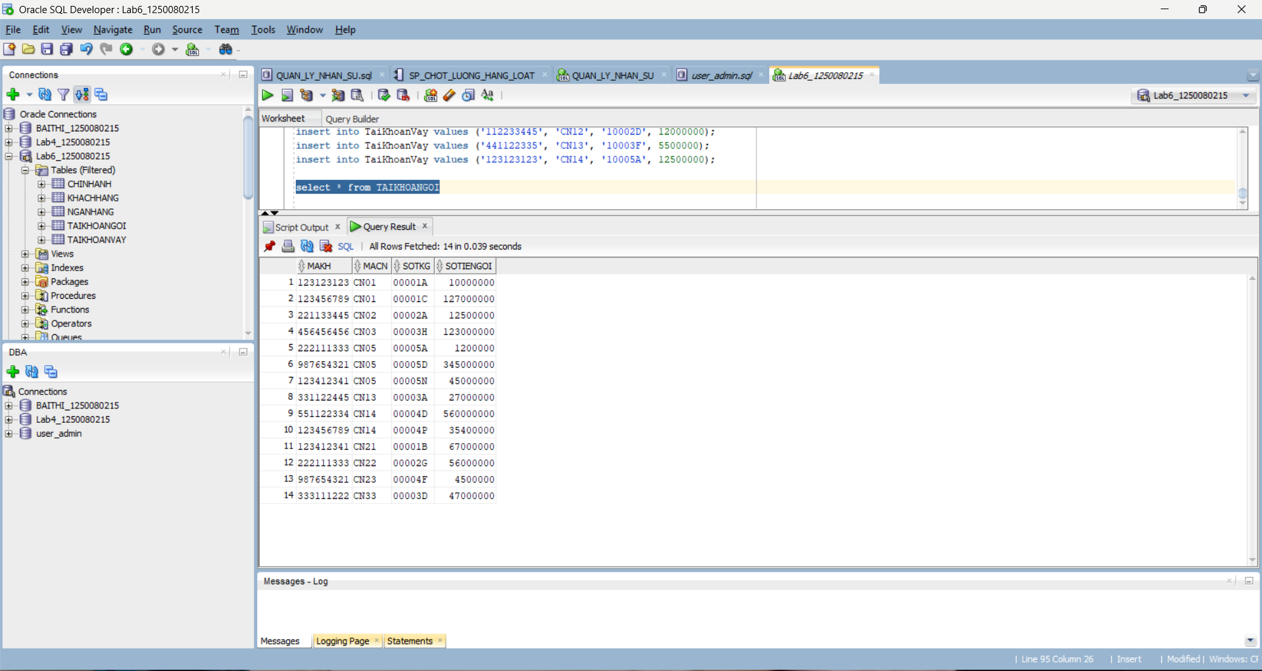
---1---
select distinct n.TenNH
from NganHang n join ChiNhanh c on n.MaNH = c.MaNH
where c.ThanhPhoCN = 'Da Lat';

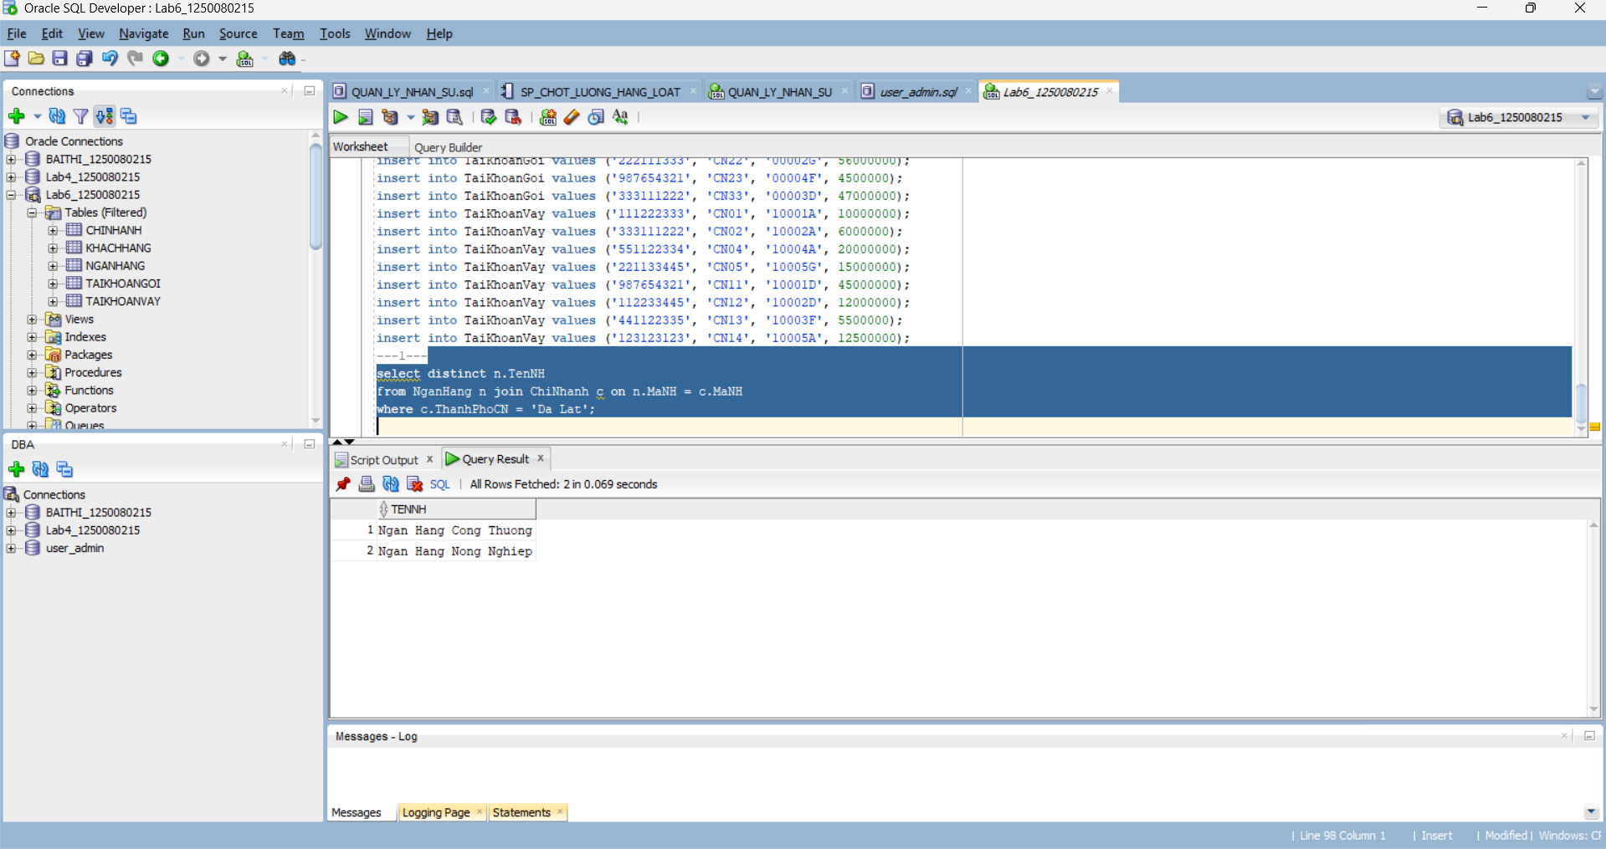
---2---
select distinct c.ThanhPhoCN
from ChiNhanh c join NganHang n on c.MaNH = n.MaNH
where n.TenNH = 'Ngan Hang Cong Thuong';
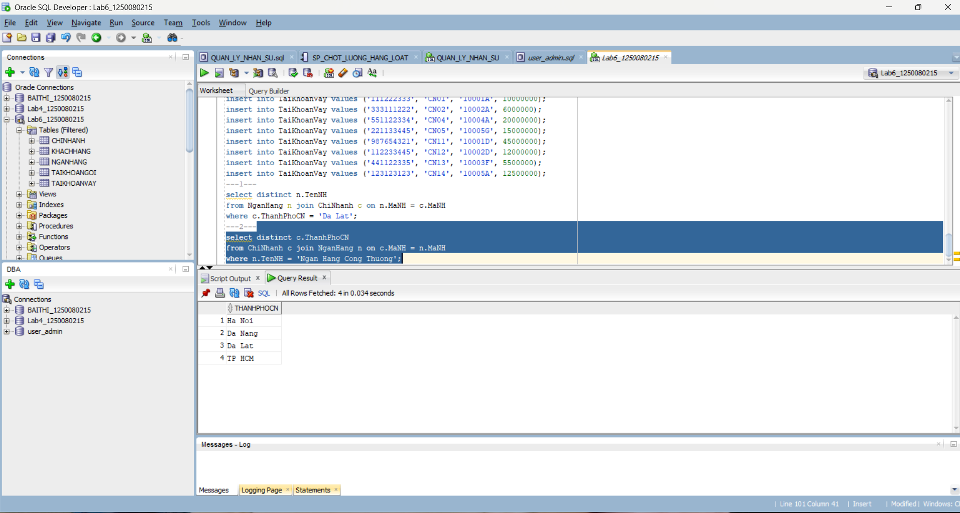
---3---
select c.* from ChiNhanh c join NganHang n on c.MaNH = n.MaNH
where n.TenNH = 'Ngan Hang Cong Thuong' and c.ThanhPhoCN = 'TP HCM';
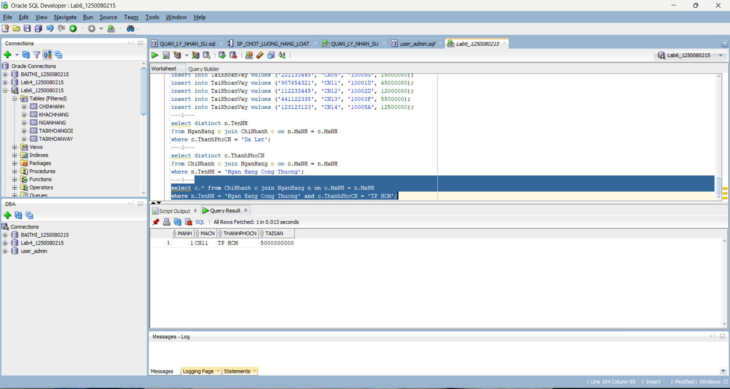
---4---
select n.TenNH, c.* from NganHang n left join ChiNhanh c on n.MaNH = c.MaNH;
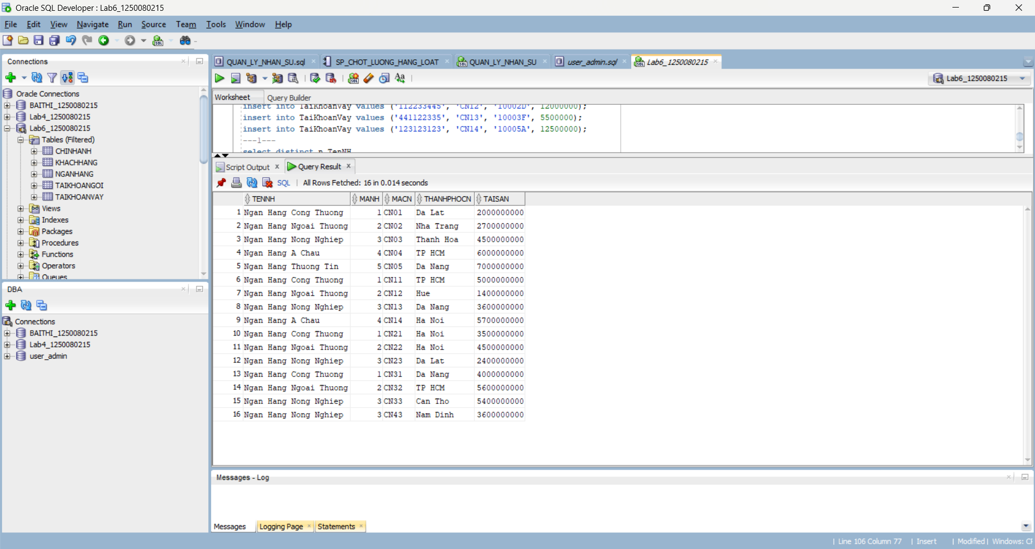
---5---
select * from KhachHang where DiaChi like '%Ha Noi%';
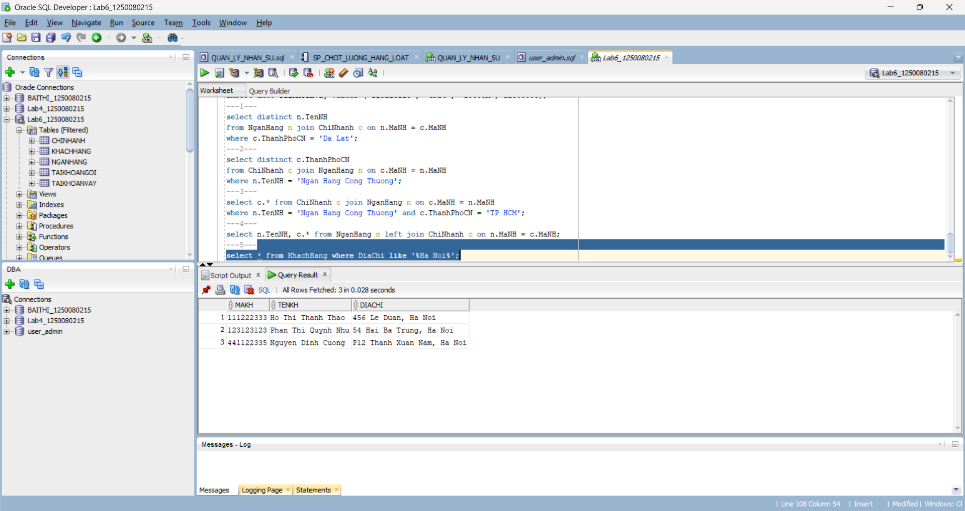
---6---
select * from KhachHang where TenKH like '%Son';
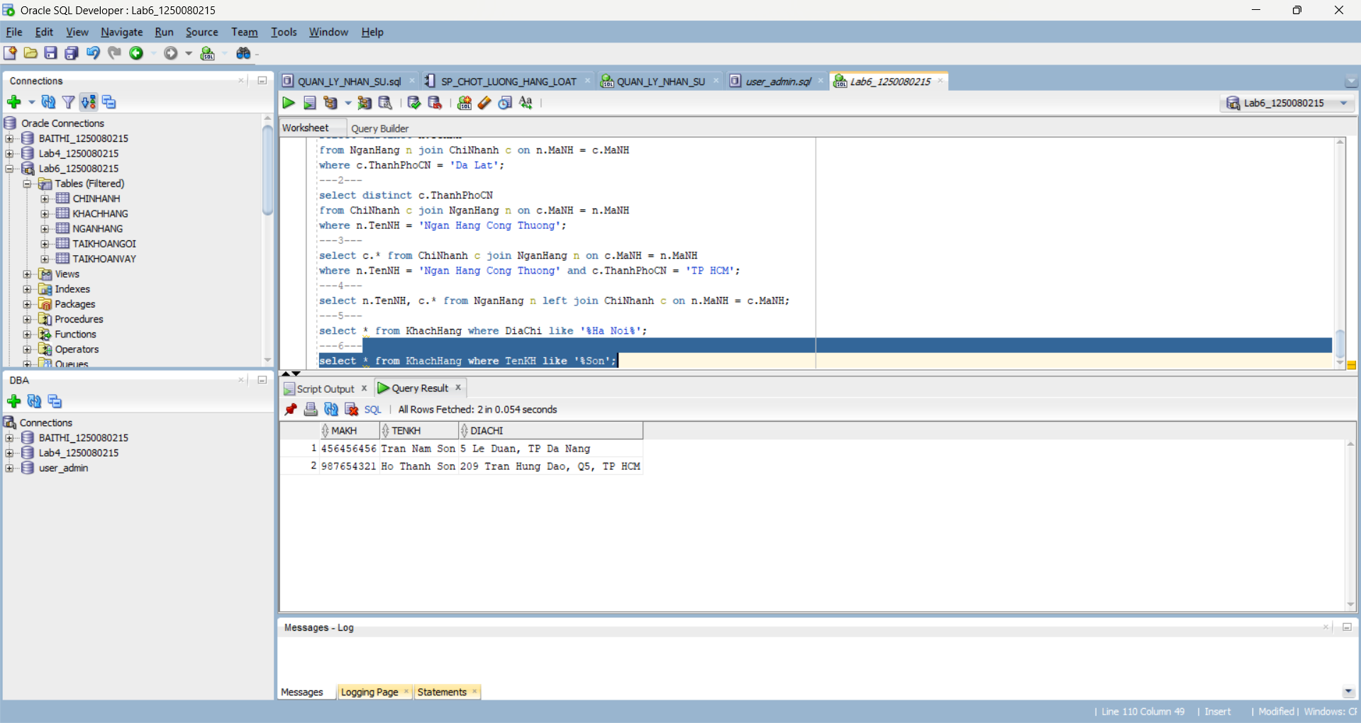
---7---
select * from KhachHang where DiaChi like '%Tran Hung Dao%';
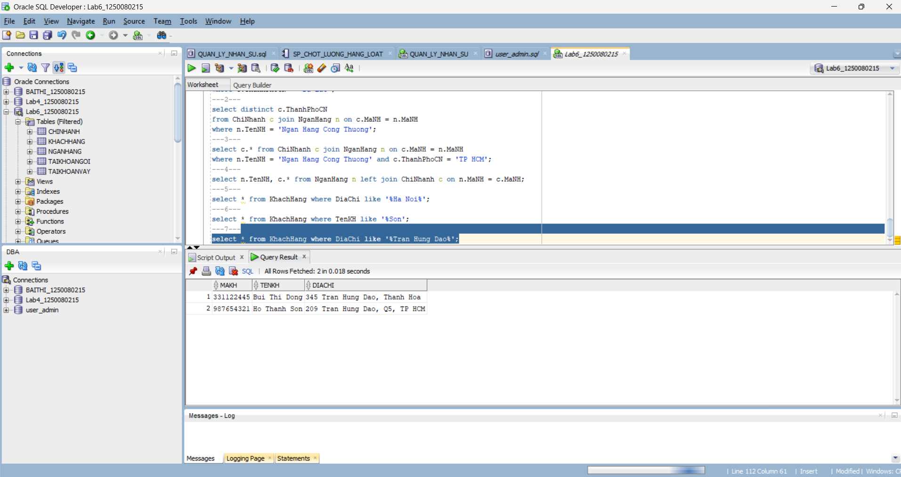
---8---
select * from KhachHang where TenKH like '%Thao';
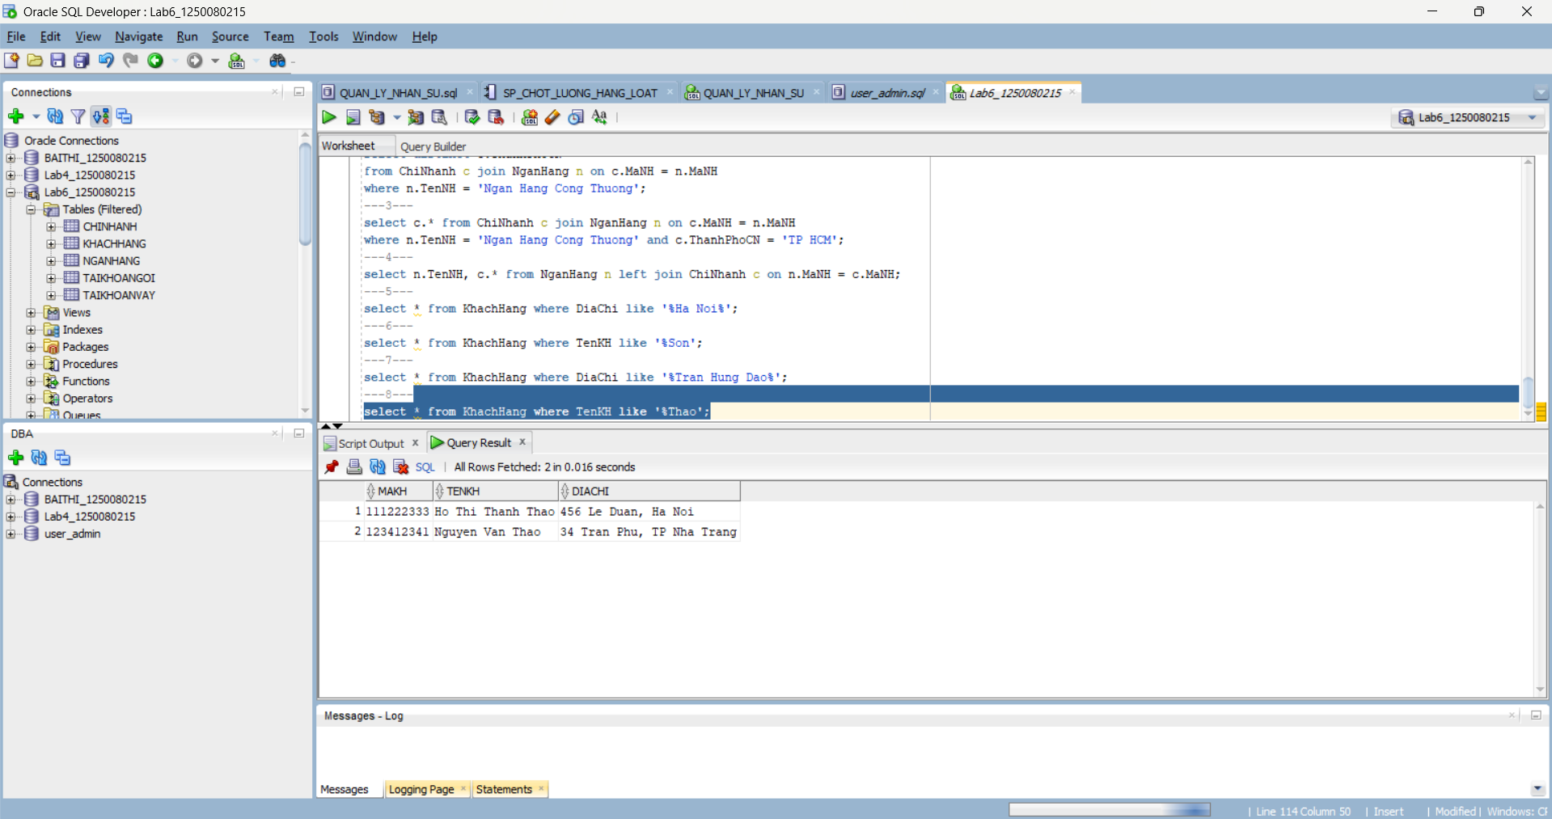
---9---
select * from KhachHang
where MaKH like '11%' and DiaChi like '%TP HCM%';
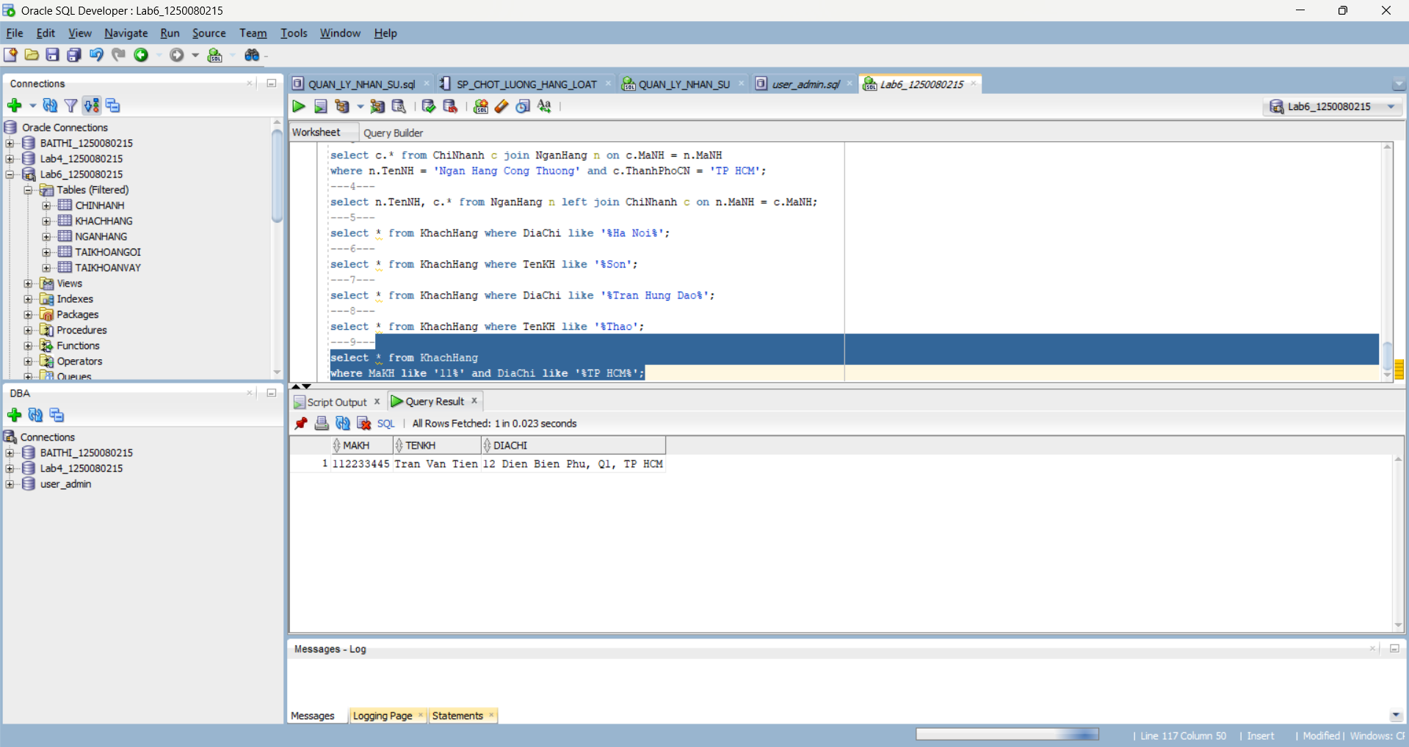
---10---
select n.TenNH, c.ThanhPhoCN, c.TaiSan
from NganHang n join ChiNhanh c on n.MaNH = c.MaNH
order by c.TaiSan asc, c.ThanhPhoCN asc;
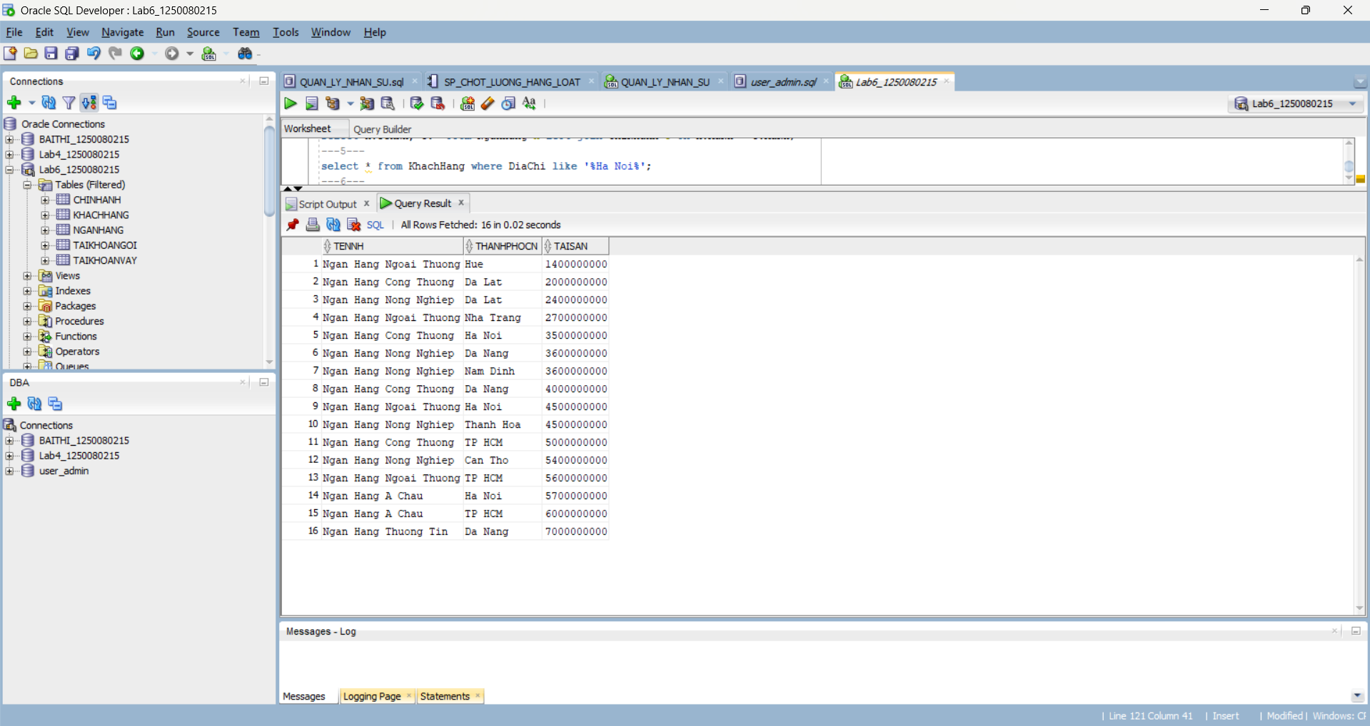
---11---
select n.TenNH, c.* from NganHang n join ChiNhanh c on n.MaNH = c.MaNH
where c.TaiSan > 3000000000 and c.TaiSan < 5000000000;
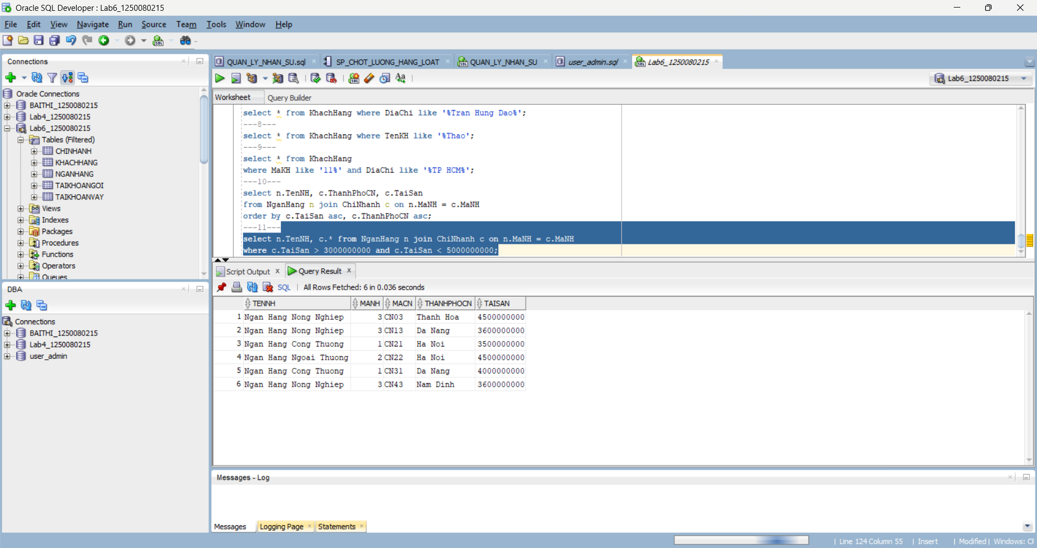
---12---
select n.TenNH, avg(c.TaiSan) as TaiSanTB
from NganHang n join ChiNhanh c on n.MaNH = c.MaNH
group by n.TenNH;
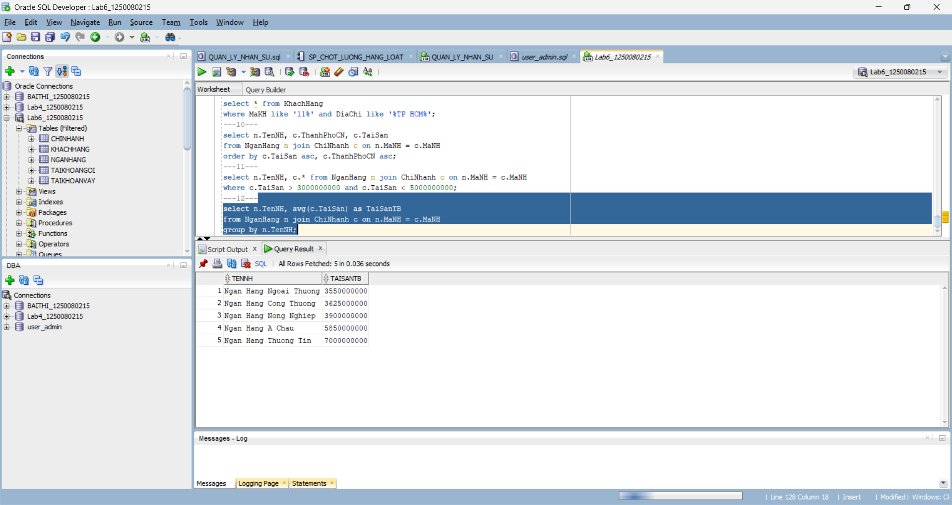
---13---
select distinct k.* from KhachHang k
join TaiKhoanVay v on k.MaKH = v.MaKH
join ChiNhanh c on v.MaCN = c.MaCN
join NganHang n on c.MaNH = n.MaNH
where n.TenNH = 'Ngan Hang Cong Thuong' and k.TenKH like '%Thao';
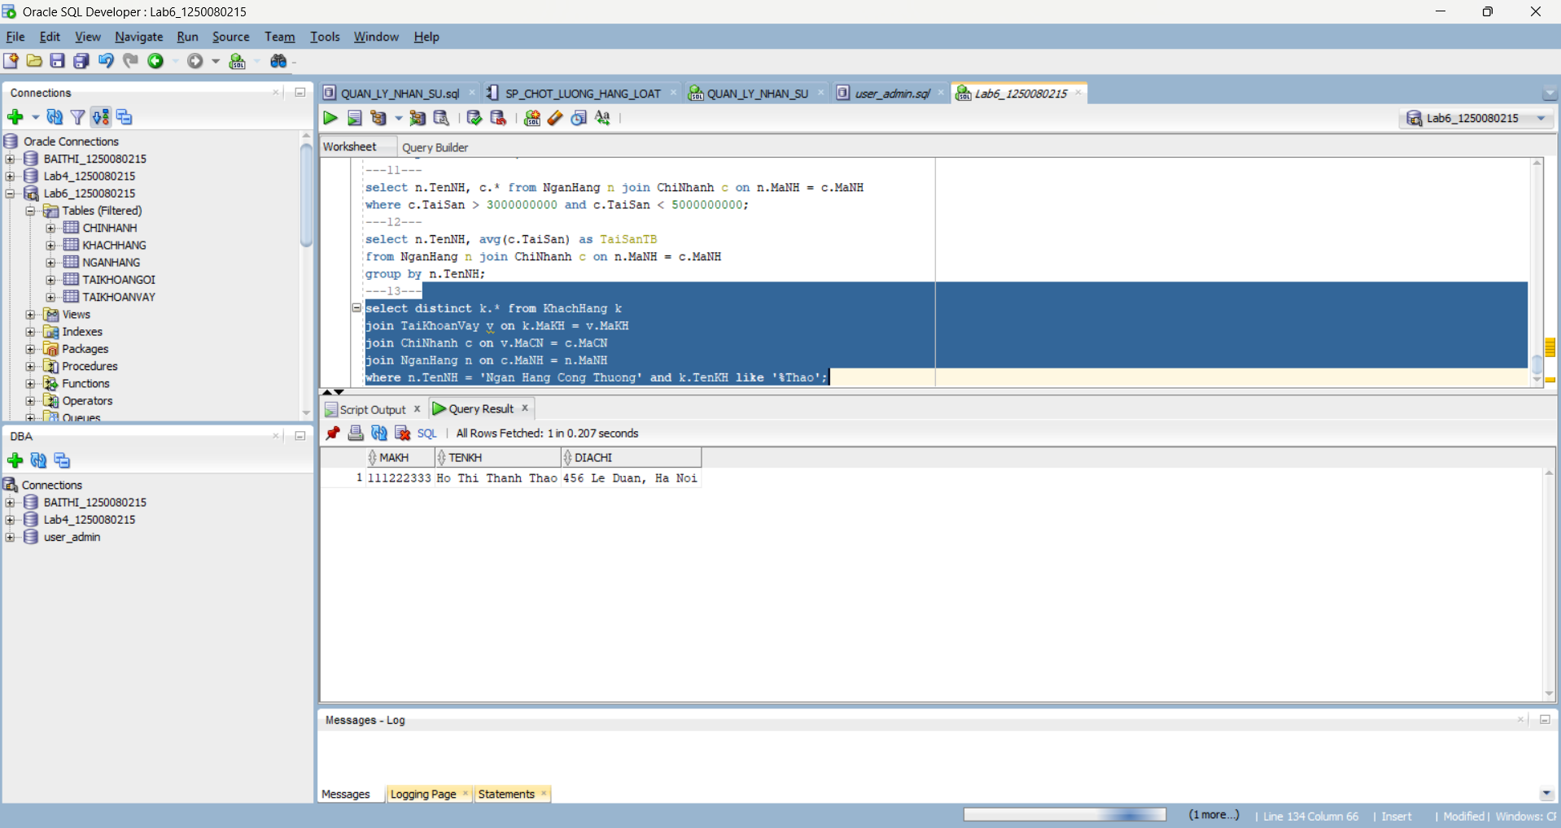
---14---
select n.TenNH, sum(c.TaiSan) as TongTaiSan
from NganHang n join ChiNhanh c on n.MaNH = c.MaNH
group by n.TenNH;
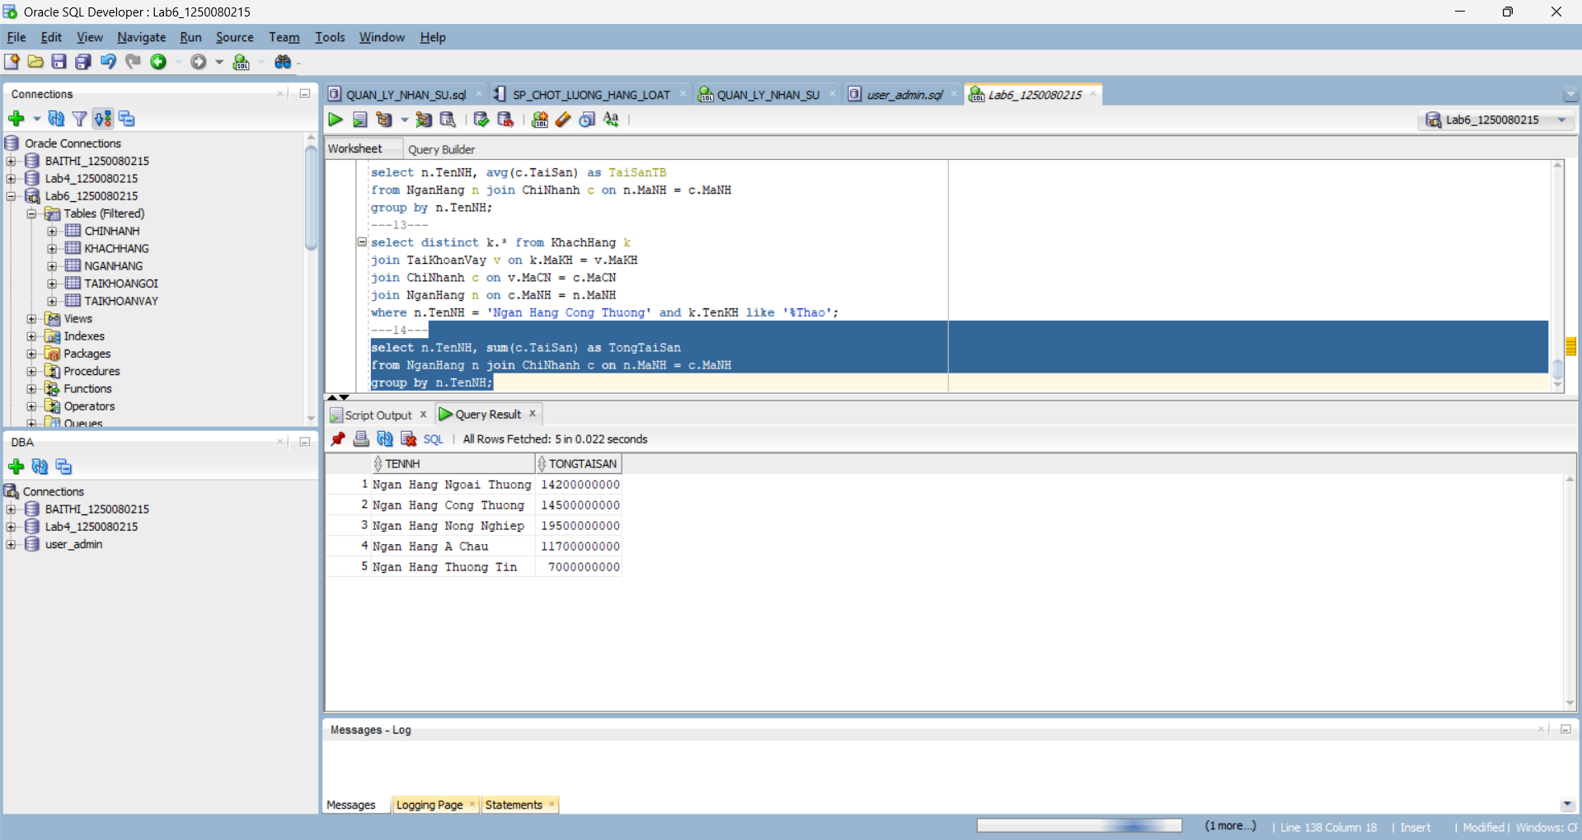
---15---
select MaCN, TaiSan
from ChiNhanh
where TaiSan = (select max(TaiSan) from ChiNhanh);
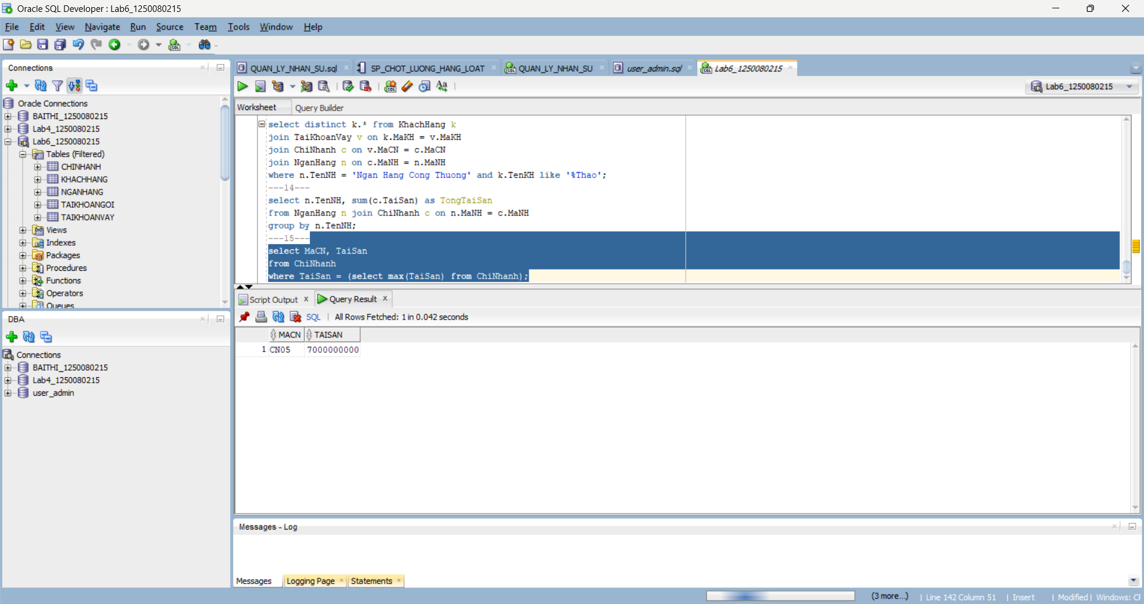
---16---
select distinct k.* from KhachHang k
join TaiKhoanGoi g on k.MaKH = g.MaKH
join ChiNhanh c on g.MaCN = c.MaCN
join NganHang n on c.MaNH = n.MaNH
where n.TenNH = 'Ngan Hang A Chau';
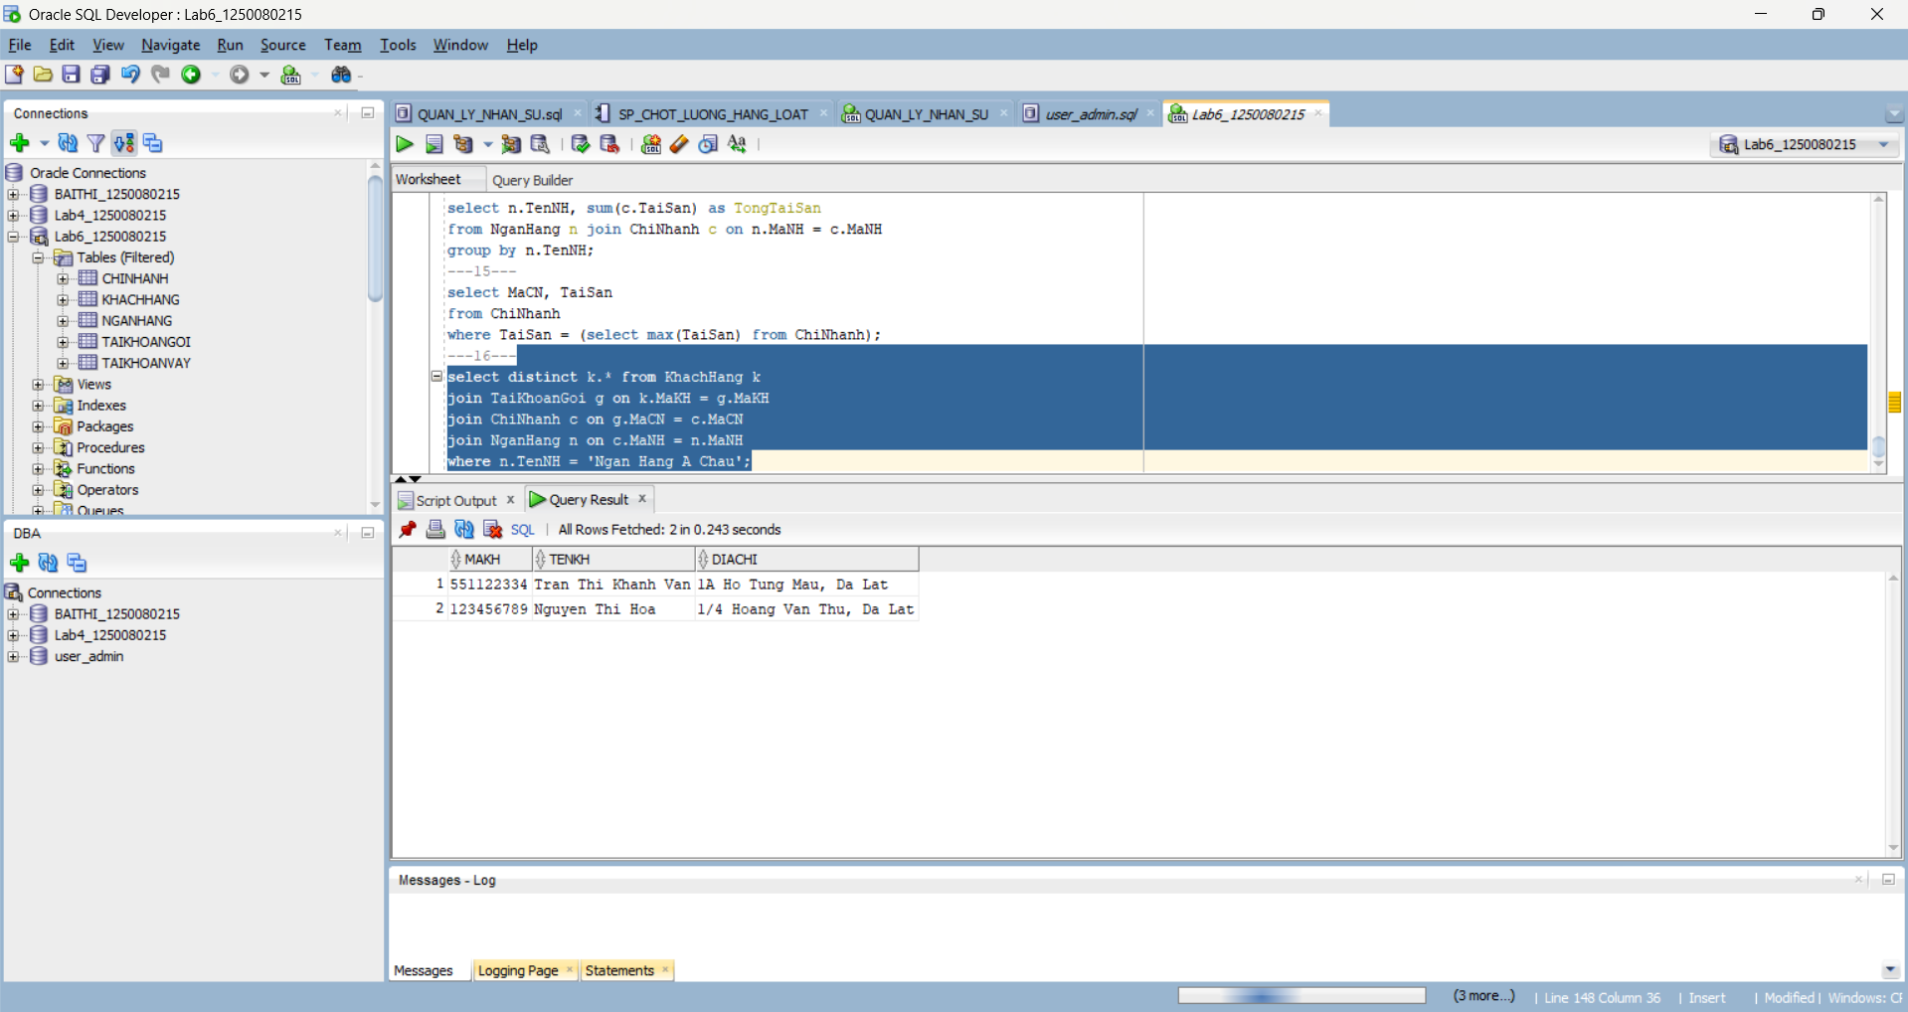
---17---
select v.SoTKV
from TaiKhoanVay v
join ChiNhanh c on v.MaCN = c.MaCN
join NganHang n on c.MaNH = n.MaNH
where n.TenNH = 'Ngan Hang Ngoai Thuong' and v.SoTienVay > 1200000;
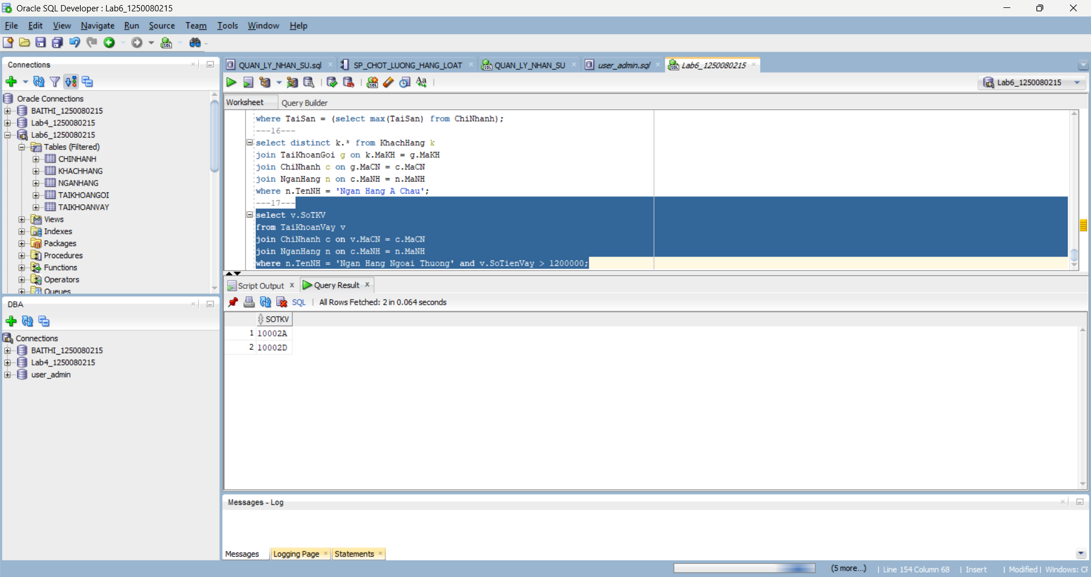
---18---
select MaCN, sum(SoTienGoi) as TongGoi
from TaiKhoanGoi
group by MaCN;
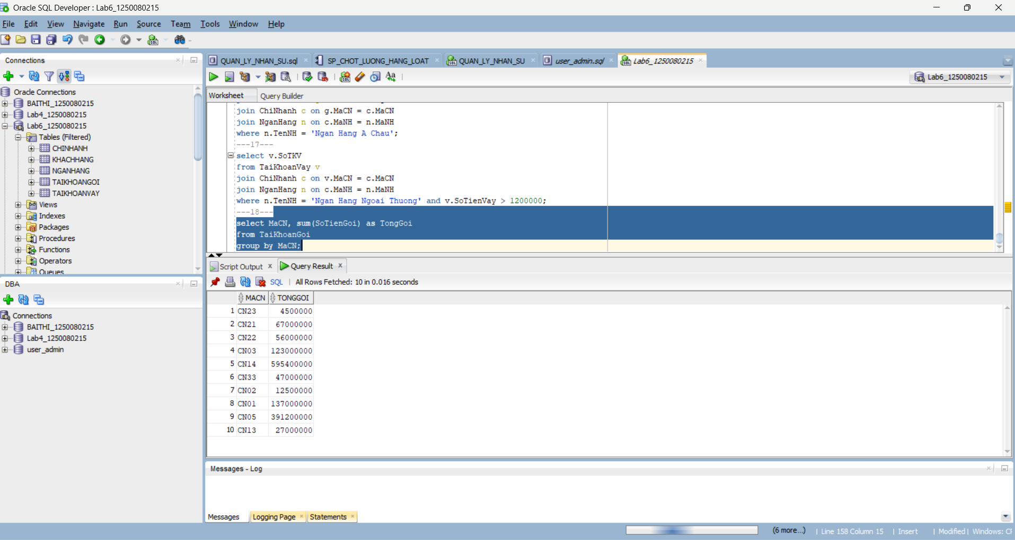
---19---
select k.TenKH, g.SoTKG, g.SoTienGoi, v.SoTKV, v.SoTienVay
from KhachHang k
left join TaiKhoanGoi g on k.MaKH = g.MaKH
left join TaiKhoanVay v on k.MaKH = v.MaKH
where k.TenKH like '%Son';
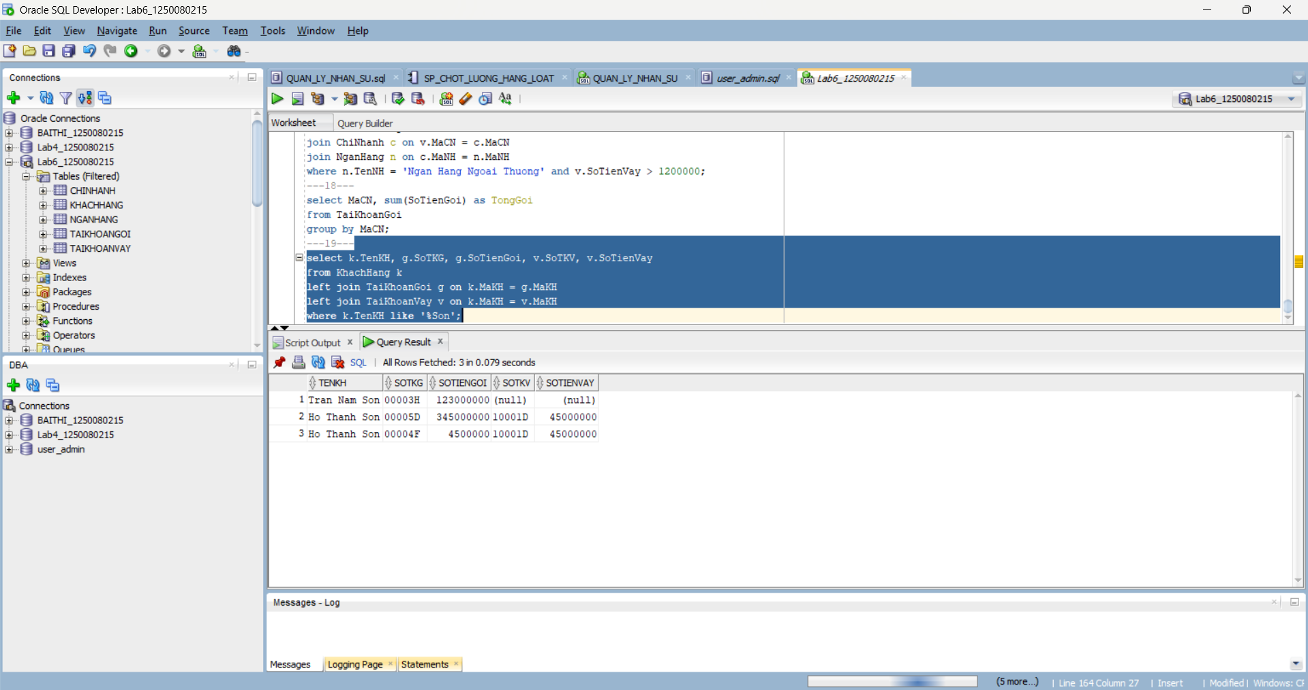
---20---
select k.MaKH, k.TenKH, sum(v.SoTienVay) as TongVay
from KhachHang k join TaiKhoanVay v on k.MaKH = v.MaKH
group by k.MaKH, k.TenKH
having sum(v.SoTienVay) > 30000000;
