

GEN ÈSE

21st FEB, 2017

POWERED BY

**WEB TECH**

WT

***GENESE*** | **Food**

21st February 2017

STORY

## Problem

Per every individual present on campus, time is of the essence. Packed with voluminous assignments to complete, social lifestyles to perform as well as other responsibilities to execute, one cannot waste the little time s/he has. However, the ASC Cafeteria, Big Ben defied the stipulated time we set to spend at the cafeteria. Take Kofi for instance. Kofi is a final year student pressed with time and needs to get his food quickly without joining a long queue or waiting in a loud environment when he could be working on his final year project gradually.

## Where does Genese come in?

At Genese we asked ourselves, “How might we help Kofi order his daily meals and simultaneously attend to other responsibilities?” Thus the birth of **FOOD©.**

**FOOD©** is an online platform that allows users to order meals from their preferred cafeteria(currently alpha version supplies meals from BigBen) right on their smart devices and as well have the option to have it delivered to them or ping them when the food is ready without having to waste much time waiting for ones meal to be ready. On our platform, you can order your favorite meal, add snacks, beverages and water on the side. The combination of a meal is left to your imagination. The cool feature of our application is to allow fellow food users deliver your food to you. Dwelling at Columbiana, Charlot, Dufie or anywhere on campus, no worries, our algorithm will match you to fellow food users near your location and have them deliver your meal to you at a fee.

# Client Page

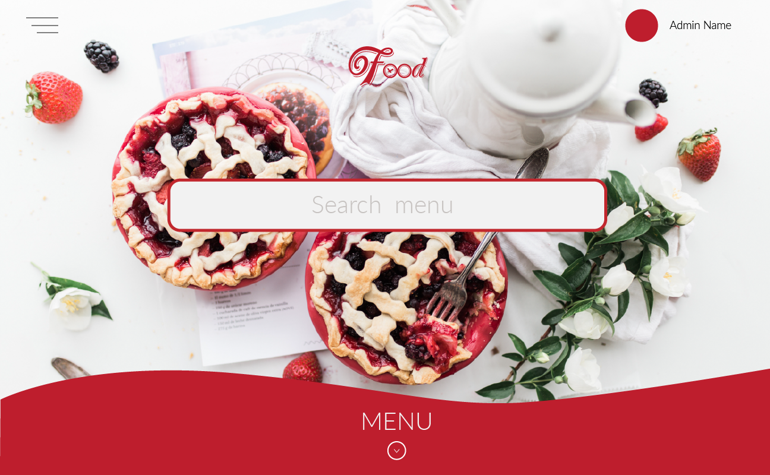

The user is met with a neatly designed homepage with a search bar. Our intention was to allow the user search for meals in cases of urgency. Once the user types a keyword, our database is queried with the word in the input box as the keyword. Once the query is complete, a modal appears with the associative meal displayed per the keyword typed into the input box.

The client page also displays the user’s name only if one has signed in.

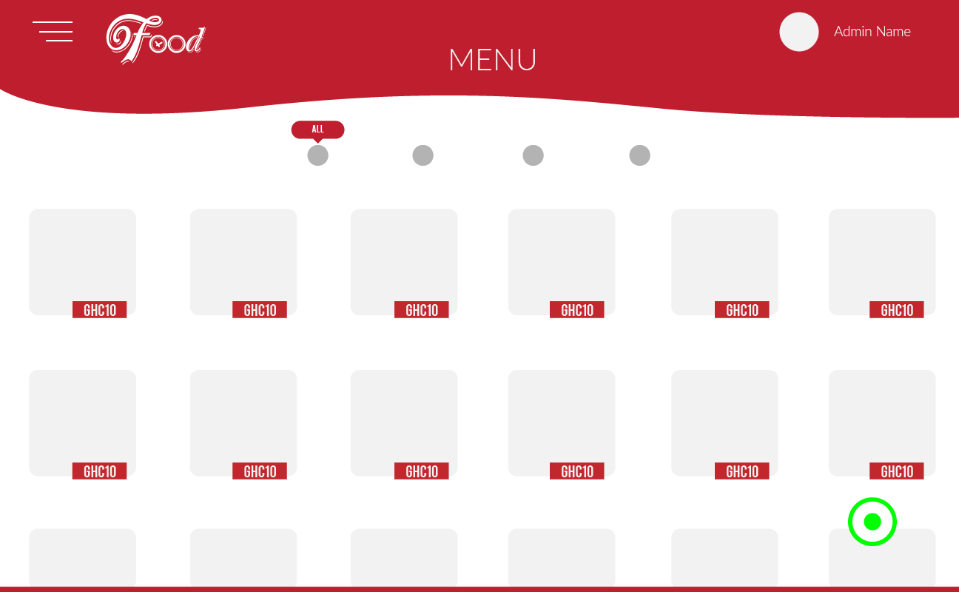

Instead of typing a keyword, the user can also scroll down to the real time menu of the cafeteria. The menu page displays the various dishes or items present in the database. Per the selection of the option above, a specific list of items are displayed.

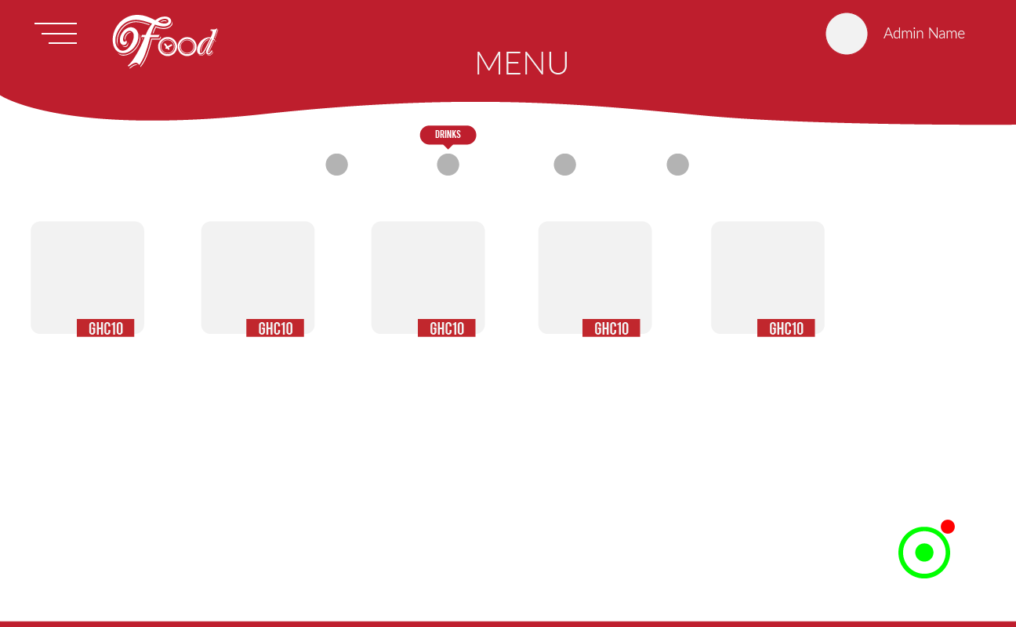

* All – displays every item present in the database as well as their respective prices.
* Main meal – displays the various *available* meals present in the database eg. Jollof, yam, vermicelli rice, etc.
* Drinks – displays *available* liquid products.
* Pastries – displays the *available* pastries in the cafeteria.

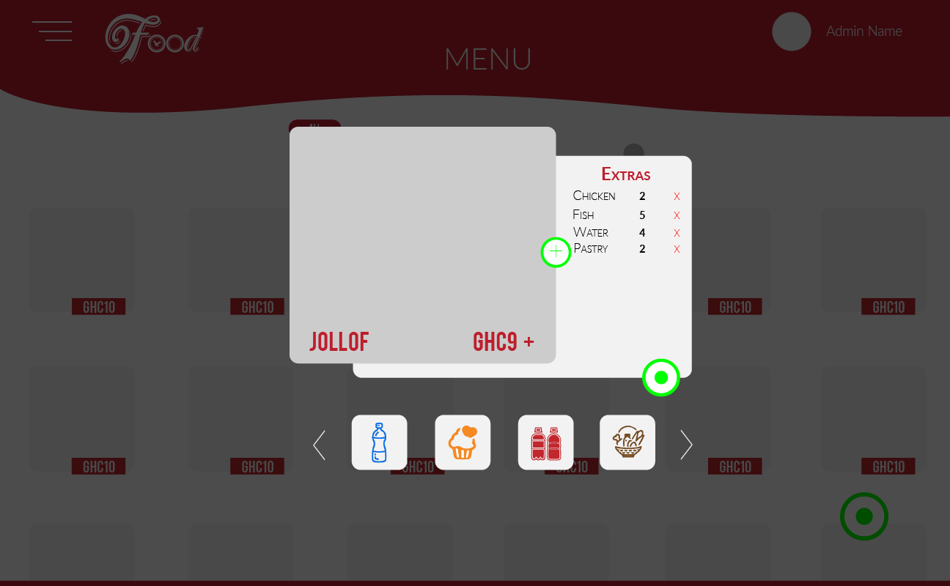

Kofi our final year student can browse through the available meals present at the cafeteria and can select any meal per his preference. The architecture of our platform allows Kofi to organize the meal he wants to order without any distractions. We do know that individuals prefer a more garnished meal thus, our platform allows Kofi to add any extra item if he pleases. All items are categorized so it makes data presentation easy on the eye to the user.