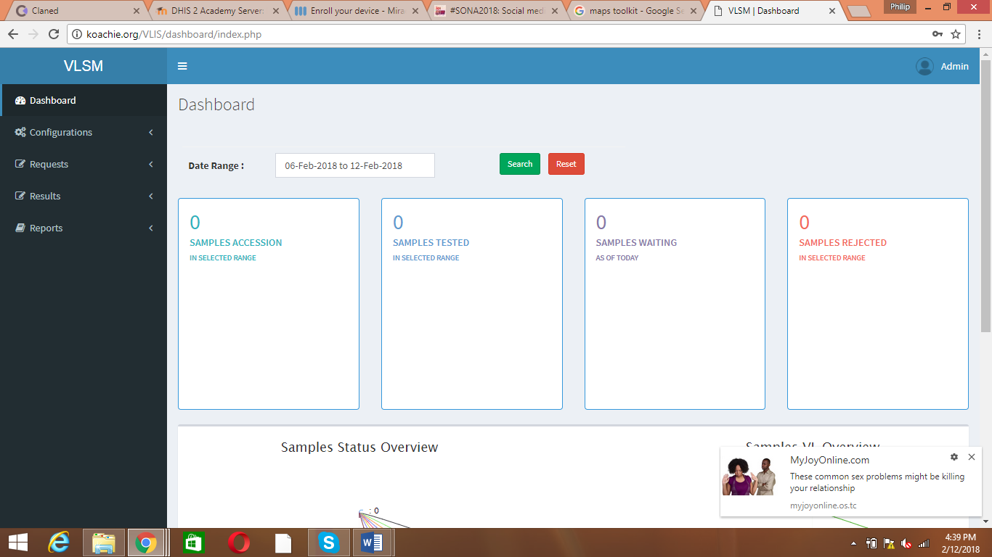

Please change VLSM to eVLIS

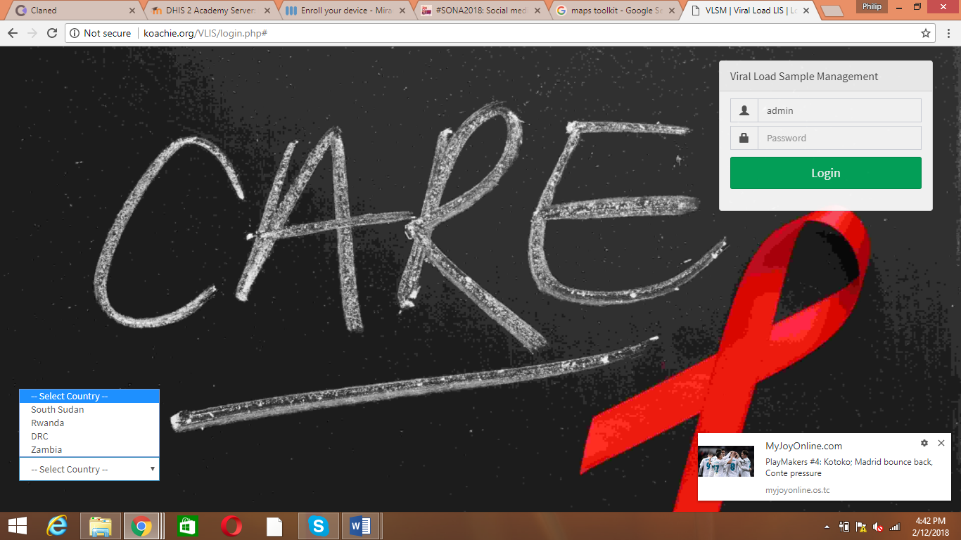

Let’s replace attached background photo here

Let’s place attached Ghana Health Service Logo here

Let’s remove the countries and only maintain download forms. Let’s link it with # as I prepare to get the required forms for upload and downloading

Replace it with Electronic Viral Load Information System

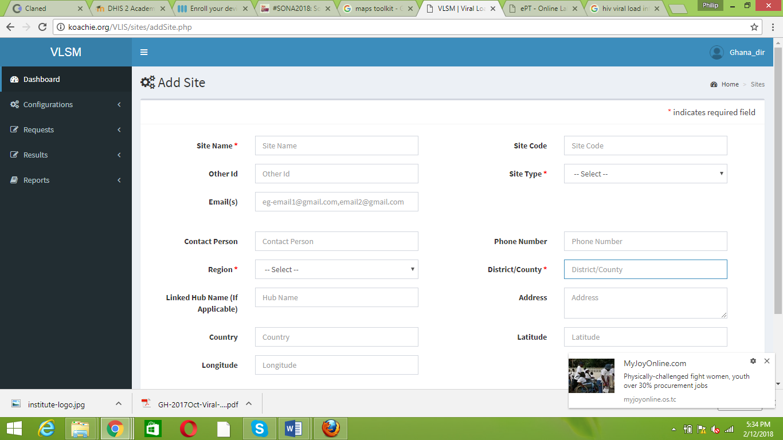

Replace it with site ID

Let’s populate it with Ghana ten regions

Let’s make it District alone

Let’s take this one off

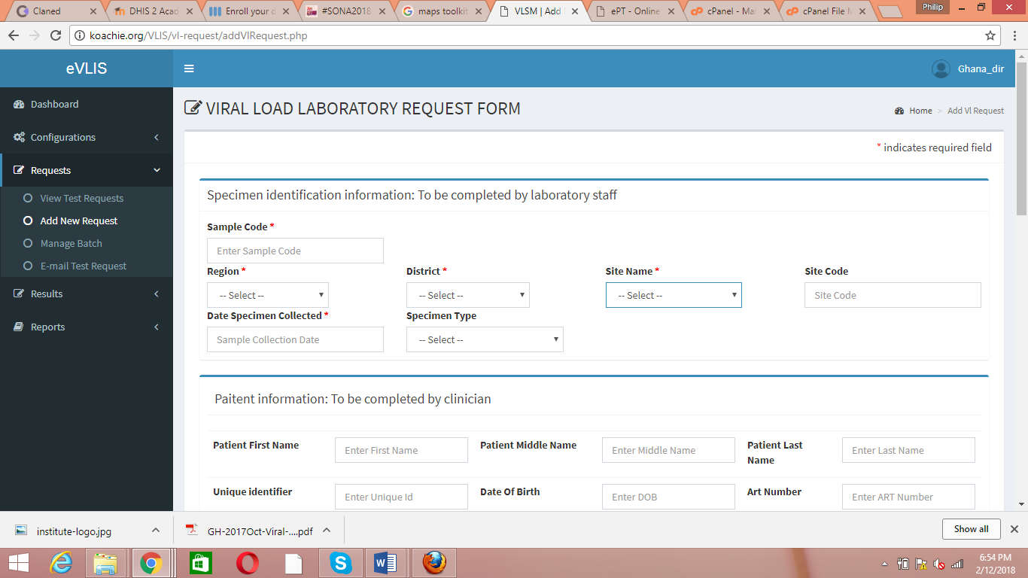

Replace it with Specimen ID

Replace it with Site ID