Two Books, One Set of Building Rules — The Qur'an and the Code of Life, Explained Simply
A plain-language companion to the Qur'an ↔ Biology study. Few technical words, many everyday pictures.
What this is about, in one breath
There is an old idea that God writes two books: one in words (scripture) and one in things (the world). This study takes that idea and asks a careful, down-to-earth question: if you look at how the Qur'an's words are built and how living bodies are built, do they follow the same building rules? The surprising, but honest, answer is: yes, three of the same rules — and we can count them, not just admire them. We are not saying the Qur'an secretly contains biology, and we are not claiming a miracle. We are saying something smaller and checkable: two very different things are put together using the same handful of tricks.
Think of it like this. A LEGO castle and a LEGO spaceship look nothing alike, but they obey the same building rules: small bricks, snapped together in an order, and only some of the possible builds are ever made. Scripture and the body are our castle and spaceship. Different pictures, same bricks-and-rules underneath.
The honest ground rules we set for ourselves
Before any comparison, we promised ourselves three things, because it is easy to get excited and fool yourself.
First, we compare how things are organized, not what they are. We never say a letter is a piece of DNA. We say the way letters team up looks like the way DNA pieces team up. That is a much safer, much smaller claim.
Second, every comparison gets a grade. After each parallel we ask: does the evidence actually support this (a check mark), does it clearly fall apart (a cross), or can we just not tell (a squiggle)? We write the grade down. A parallel with no grade is just a nice story.
Third, a surprising pattern has to beat luck. If we notice something striking, we don't trust it until we've shown that plain chance wouldn't have produced it anyway. We shuffle the data many times to see what luck looks like, then check whether the real thing stands out.
These three habits are the whole difference between honest comparison and wishful thinking. Wishful thinking can never be wrong, so it never teaches you anything. Our rules are built so that a claim can fail — and several of ours do.
The unit we build from: the "root"
Arabic words grow from a tiny seed called a root, usually three consonants. From one root you spin many words, the way "play" gives you player, playful, playground, replay. In the body, the matching seed is the codon — three chemical "letters" of DNA that name one amino acid, and amino acids strung together make proteins, the little machines that run a cell. So our comparison lines up: root is to word as codon is to protein. That is the hinge the whole study turns on.
Rule One: a few pieces make a huge number of things
Here is the first shared trick. Start with almost nothing and end with almost everything.
In the Qur'an: about 27 letters become 1,702 roots, which become 7,236 different words, which appear 135,366 times. A few letters, an enormous vocabulary.
In the body: just 4 DNA letters become 64 codons, which name 20 amino acids, which build somewhere around 80,000 to 100,000 different proteins. A tiny alphabet, a vast machine shop.
Picture a child's shape-sorter with only four shapes. You would think four shapes can't do much — until you realize you can line them up in endless combinations and spell out an entire zoo. That is what both systems do: take a handful of meaningless pieces and, by combining them, produce an open-ended world of meaningful things. We didn't have to argue this rule; we just counted. It is simply true in both books.
Rule Two: the pieces are empty — the order is everything
This is the most important rule, and the most beautiful. A single letter means nothing. A single amino acid does nothing. The meaning, the function, comes from the order you put them in.
Take three Arabic letters: ح, ر, م. By themselves they are just sounds. But arrange them one way and you get a word about mercy; rearrange the very same letters and you get a word about something forbidden or sacred; rearrange again and you get a word about the color red. Same letters, different order, completely different meaning. We counted how often this happens, and it is everywhere: more than half of the three-letter roots (54 in every 100) share their exact letters with some other root that means something else. The letters are a deck of cards; the order you deal them is the hand.
The body does the identical thing. The same DNA letters, read starting one notch over, spell a totally different protein — like reading "the cat sat" as "hec ats at," nonsense from the same letters shifted by one. And changing a single piece in one spot can change everything: in sickle-cell disease, one swap at one position in one protein bends a person's blood cells out of shape. One position. The pieces are empty; the arrangement carries the whole message, in both books.
Because this rule makes the boldest claim, we tested it hardest. We shuffled the letters of Arabic thousands of times to see how often "same letters, different order, different word" would happen just by chance. The real Qur'anic rate beat the chance rate convincingly — in the test run, not one of three hundred random shuffles reached the real number. So "order matters" is not our impression; it is a measured fact that beats luck.
Rule Three: only a few of the possible things are ever made
The third trick is about restraint. The number of things you could build is astronomically bigger than the number you do build, and the real diversity comes from what actually gets made and used.
In the Qur'an: of all the three-letter combinations the language could form, only about 1 in 10 is actually used as a root. The rest of the space sits empty. And from each used root, the language expresses a small fan of real words — about 5 on average, sometimes just 1, occasionally hundreds.
In the body: of all the protein shapes that could exist, only a vanishing sliver actually fold up and work; the rest are silent. And here is a lovely echo — each human gene produces about 4 to 5 different protein versions on average, almost exactly the average of about 5 words per Arabic root. Even more striking: a brain cell and a liver cell carry the exact same DNA, yet they are utterly different, because each one switches on a different part of it. Same book, different passages read aloud.
Picture a giant piano with billions of possible chords. No song uses them all; a piece of music is the few chords actually played, in order. Life plays a few; the language plays a few; and what they choose to play is where all the variety comes from.
What we are careful NOT to say
This is where many books about scripture and science go wrong, and where we stop ourselves.
We do not say a letter is a molecule. We even spend a whole lesson showing why that tempting idea can't be tested, and then we throw it out. We do not say the two books are perfectly alike — they aren't. For example, the body copies its DNA with tiny, real error rates, while the scriptural tradition claims perfect preservation; that is a genuine difference, and we mark it with a cross, not a check. And we do not say any of this proves anything supernatural. We say only this: the organizing rules match, and we can show it.
The deepest, most interesting question — whether families of related word-meanings line up with families of related protein-jobs — is exactly the one we mark with a squiggle, because the data can't decide it. Honesty means putting that squiggle in plain sight, not hiding it.
Why bother, then?
If it isn't a miracle, what is the point? Three things.
First, it makes both subjects easier to understand. Once you see why shuffling DNA breaks a protein, you instantly see why shuffling a root's letters changes a word. Each book becomes a window into the other.
Second, it trains a precious habit: the habit of turning "wow, that's striking" into "let's test whether that's real." That habit is worth more than any single parallel, and you can use it everywhere — on the news, on a sales pitch, on your own bright ideas.
Third, for someone who already believes both books come from one Author, finding the same building rules in both is quietly fitting — not as proof, but as harmony. The two books meet not on the page but in the careful reader, who learns to read them both with the same honesty.
A walk through the lessons
The course tells this story in seventeen steps, and the order matters. It opens by setting the two-books picture and the grading rule. The second lesson is the conscience of the whole thing: it teaches how to check a number and how to catch yourself fooling yourself. Only then does it start drawing parallels — first the "few make many" rule, then a lesson that deliberately fails in public (taking the tempting "letter equals molecule" idea and showing why it can't stand), then the "order is everything" rule with the rearranged-letters explosion on one side and the shifted-DNA experiments on the other. The middle lessons cover how variety gets expressed, how things are copied and read, and how the whole is organized like an archive. The later lessons handle where the two books genuinely differ, and a final lesson runs the whole method, start to finish, on a single root, so you can watch the machine work.
The pictures to keep
If you forget every number, keep these three pictures. Few make many: four shapes spell a whole zoo. Order is everything: the same three letters, rearranged, swing from "mercy" to "forbidden" to "red," just as shifted DNA swings from one protein to another. Only some are made: a billion-chord piano, and a song is the handful actually played. Those three pictures are the thesis. The body and the Book, so different on the surface, are put together by the same three rules underneath — and we can count them, grade them, and test them, which is the only kind of wonder worth keeping.
The one promise we kept
Everything here can be checked. Every Qur'an number comes from feeding the text through a program that anyone can re-run; every biology number is standard textbook fact; the one "beats luck" claim is spelled out completely, shuffle and all. We made ourselves a promise at the start — to compare structure not substance, to grade every claim, and to make surprising patterns beat chance — and the value of this study is not any single dazzling match but the fact that we kept that promise the whole way through. That is what turns a nice story into something you can actually trust.
Rule One, told more slowly: the magic of small beginnings
Let us linger on the first rule, because it is easy to underestimate. We are so used to big things being made of big parts that the opposite feels strange: enormous variety from almost nothing.
Imagine you are handed only the ten digits, 0 through 9. That's all. With just those ten little symbols you can write any number that has ever existed or ever will — your phone number, the national debt, the distance to a star. Ten symbols, infinite numbers. Nobody finds this suspicious; we just don't notice how powerful it is. The genetic code is even more economical: it gets by on four symbols, and from them it writes every living thing — the oak and the octopus, the whale and the bacterium. Arabic, for its part, takes a few dozen letters and writes a scripture, a poetry, a law, a science. The lesson is the same in each case: power doesn't come from having many parts; it comes from being able to combine a few parts freely.
That is why both systems can be, at the same time, simple and inexhaustible. Simple, because you could learn the alphabet in an afternoon. Inexhaustible, because the combinations never run out. A child learns 26 letters and gains access to every book in the library. A cell "knows" 4 bases and gains access to every protein in biology. When you put it that way, the first shared rule stops being a dry fact and becomes a small marvel: the same economy runs the dictionary and the cell.
Rule Two, told more slowly: why order is sacred
The second rule deserves a slower look too, because it overturns a natural assumption. We tend to think the ingredients matter most. But in both books, the ingredients are interchangeable nobodies, and the recipe order is the star.
Here is a kitchen picture. Flour, water, yeast, salt, heat. In one order and timing you get bread; in another you get a cracker; in another, paste. Same ingredients, wildly different results, all decided by sequence and arrangement. Now shrink that idea down to letters. The three letters in "dog" are the same three in "god," yet one is an animal and the other is the divine — a single rearrangement leaps across the whole of meaning. Arabic is built to do this on purpose and at scale: rearranging a root's letters is a standard way the language makes new words, not an accident at the edges. We counted, and more than half of three-letter roots have at least one such rearranged cousin with a different meaning.
The body's version is not a metaphor; it is mechanism. Your genes are read in three-letter "words," and the reading has to start at the right place. If the starting point slips by one letter — a "frameshift" — every word after it is misread, and the protein that comes out is gibberish, often useless or harmful. That is the body enforcing the same truth the language lives by: the pieces are placeholders; the order is the meaning. When we say this is the deepest shared rule, we mean it changes how you see both books. Meaning is not in the parts. It is between them, in their arrangement.
And because a bold claim deserves a hard test, this is the one we put through the wringer. We asked: maybe Arabic just happens to reuse letter-sets a lot, by the luck of which letters are common. So we built thousands of fake "languages" with the same letter frequencies and measured how often they reused letter-sets in new orders. The real Qur'anic text out-did them clearly. Order is doing real work; it is not a side effect of which letters are popular.
Rule Three, told more slowly: the silent majority
The third rule is about everything that doesn't happen. This is subtle, because it asks you to notice an absence.
Think of a combination lock with three dials, each 0–9. There are a thousand possible settings, but the lock opens on exactly one. The other 999 settings are real possibilities that simply never do anything. Both our books are like enormous combination locks where only a small set of "settings" ever open onto something real. In Arabic, of all the three-letter combinations possible, only about one in ten is actually used as a root; the other nine sit unused, valid but silent. In the body, of all the protein shapes chemistry allows, only a tiny fraction fold into something that works; the rest are noise that life never builds.
Then, on top of choosing which roots and proteins exist at all, both books choose which ones to use at any moment. A single Arabic root blooms into a small bouquet of actual words — about five on average. A single gene is spliced into about four or five working protein versions. And the same genome, in different cells, reads out different sections — your eye and your bone are made from one identical instruction book, opened to different pages. Variety, in both books, is not about what could be. It is about what is chosen and expressed. The possible is vast and mostly quiet; the real is small and singing.
The grades we actually gave
It would be dishonest to leave you with only the matches. Here are the grades, plainly. The "few make many" rule: check mark, in both books, by direct count. The "order is everything" rule: check mark, and it even beat luck. The "only some are expressed" rule: check mark, with that pretty echo of about five versions per unit on each side. But the tempting idea that a letter equals a molecule: a cross — we tried, it can't be tested, we dropped it. The idea that the two books are equally perfect copies: a cross — the body makes copying errors, the scripture tradition claims it does not, and that's a real difference, not a match. And the dream that meanings line up with biological jobs one-to-one: a squiggle — maybe, but the data won't tell us, so we don't pretend it does. A study you can trust is one that hands you the crosses and squiggles as readily as the checks.
The takeaway you can carry
Strip everything away and this is what remains. Two utterly different things — a holy book and the chemistry of life — are assembled by the same three rules: build much from little, let order carry the meaning, and express only a chosen few of the countless possibilities. We can count these rules, grade each comparison, and test the boldest claim against luck. That is the whole of it: not a secret code, not a miracle to dazzle you, but a measured, honest harmony between the way words are made and the way life is made. The reward is a steadier kind of wonder — one that has already passed its own tests, and so has nothing to fear from yours.
A few honest worries, answered plainly
When people first hear this, three worries usually come up, and they deserve straight answers.
"Aren't you just seeing patterns because you want to?" That is exactly the trap we built the rules to avoid. Wanting to see a pattern is human; the cure is to let chance compete. Every time we found something striking, we asked what pure luck would have produced and checked whether the real thing stood out. The "order matters" result beat luck so clearly that none of three hundred random shuffles matched it. And when a different pattern failed the test — the idea that a letter is a molecule — we said so and dropped it. A study that sometimes says "no" is a study that means it when it says "yes."
"Couldn't any two complicated things be made to look alike if you squint?" Yes, and that is why we did not squint. We did not hunt for any old resemblance; we picked three specific, countable rules and checked each one with numbers in both books. "Few make many" is a count. "Only some are expressed" is a count. "Order matters" is a count that beats chance. You cannot make those numbers say what they don't; they either match or they don't, and we reported both the matches and the mismatches.
"Isn't this just dressing up religion as science, or science as religion?" No — and keeping them apart is the whole discipline. We never use the science to prove the scripture, and we never use the scripture to predict the science. We hold them side by side and compare how they're built, the way you might compare the grammar of two languages without claiming one is the other. The belief that both come from one Author is a starting frame, openly stated, not a conclusion we sneak in at the end.
The bridge between the two books runs through you
Here is a thought to end on. The two books never actually touch each other. A verse is not a strand of DNA; a chapter is not a chromosome. The place they meet is in the reader — in a mind that has learned to look at both with the same care: build from little, watch the order, notice what is and isn't expressed, and never believe a pattern that hasn't earned it. That is what we mean when we say the integration happens "in the learner." You are the bridge. The reward of crossing it is not a trophy fact to wave around, but a way of seeing — one that finds genuine harmony where it exists and refuses to invent it where it doesn't.
One last picture
Think of two craftsmen who never met and worked in different ages — one a calligrapher of words, one a builder of living machines. Set their work side by side and you find, to your quiet surprise, that they used the same three tricks of the trade: make much from few, let arrangement carry the meaning, and choose a small living set out of an endless possible one. You are not claiming they are the same craftsman, and you are not claiming one copied the other. You are simply noticing, and measuring, that the craft rhymes. That noticing — careful, counted, graded, and humble about its limits — is the entire offering of this study. Not a spectacle, but a rhyme you can check for yourself.
Where the numbers came from (so you can trust them)
None of this rests on our say-so. The Qur'an figures were produced by running the text through a program that anyone can run again and get the same answers. The biology figures are the ordinary ones you would find in any textbook. The single "beats luck" test is described completely enough that someone who doubts it can redo the shuffling and see for themselves. We even tell you the soft spots: our way of counting "roots" is a practical approximation, not a perfect dictionary, so exact numbers can wiggle a little — but the big rates, the ones the argument leans on, hold steady. That openness is the point. A comparison between the Book of Words and the Book of the World is worth making only if you can check it, and worth sharing only if it teaches you how to check it yourself.
So read the two books together, but read them honestly: count what can be counted, grade every comparison, test the bold claims against luck, and keep the crosses and squiggles in plain view beside the checks. Do that, and what remains is not a fragile marvel that any skeptic can topple, but a sturdy, measured rhyme between the making of words and the making of life — small, true, and yours to verify.
And if someone asks you, in a sentence, what the study showed: a holy book and the code of life are built by the same three rules — many from few, meaning from order, and a chosen few expressed out of countless possible — and we counted it, graded it, and made it beat chance, without ever claiming a miracle or a hidden code. That sentence is the whole report, and every word of it can be checked.
That is the promise, and the proof, kept together to the end.
(This plain-language version carries no jargon by design; every figure it cites is identical to the formal version and is reproducible from the tokenized corpus.)
Worked Examples from the Qur'an
The pillars are not abstractions; each is visible in specific verses and specific roots. This section instantiates them with actual Qur'anic text and the computed counts behind them.
Pillar 2 in the text: anagram families with their verses
The clearest demonstration that order, not letter-composition, carries meaning is a family of roots built from one letter-set. Consider the three consonants ب–ح–ر. The corpus realizes six distinct roots from this single set, each with its own meaning and its own verses:
- بحر (sea): «وَهُوَ ٱلَّذِي سَخَّرَ ٱلْبَحْرَ لِتَأْكُلُوا۟ مِنْهُ لَحْمًا طَرِيًّا» (16:14).
- حرب (war): «حَتَّىٰ تَضَعَ ٱلْحَرْبُ أَوْزَارَهَا» (47:4).
- ربح (gain/profit): «فَمَا رَبِحَت تِّجَـٰرَتُهُمْ» (2:16).
- رحب (spaciousness): «وَضَاقَتْ عَلَيْهِمُ ٱلْأَرْضُ بِمَا رَحُبَتْ» (9:118).
- برح (to depart/persist): «لَنْ نَّبْرَحَ عَلَيْهِ عَـٰكِفِينَ» (20:91).
- حبر (to gladden/adorn): «فَهُمْ فِي رَوْضَةٍ يُحْبَرُونَ» (30:15).
Six unrelated meanings — sea, war, profit, spaciousness, persistence, gladdening — from one set of three letters. Nothing in the letters {ب,ح,ر} predicts any of these; the order is the entire difference. The set ح–ر–م is equally instructive: «ٱلرَّحْمَـٰنِ ٱلرَّحِيمِ» (1:3, root رحم, mercy), «حُرِّمَتْ عَلَيْكُمُ ٱلْمَيْتَةُ» (5:3, root حرم, prohibition), and «كَأَنَّهُمْ حُمُرٌ مُّسْتَنفِرَةٌ» (74:50, root حمر, wild donkeys) — mercy, the forbidden, and a fleeing herd, from one rearranged triliteral. And د–ع–و: «ٱدْعُونِىٓ أَسْتَجِبْ لَكُمْ» (40:60, دعو, supplication), «إِنَّ ٱلشَّيْطَـٰنَ لَكُمْ عَدُوٌّ» (35:6, عدو, enmity), «وَعْدَ ٱللَّهِ ۖ لَا يُخْلِفُ ٱللَّهُ وَعْدَهُۥ» (30:6, وعد, promise).
Corpus-wide, 891 of 1,645 three-letter roots (54.2%) belong to such a family. This is the measured form of Pillar 2: the unit is empty, the sequence is everything — and the verses make it concrete, not theoretical.
Pillar 1 in the text: one short verse, the whole alphabet at work
Sūrat al-Ikhlāṣ opens «قُلْ هُوَ ٱللَّهُ أَحَدٌ» (112:1) — four words whose roots are قول (to say), ءله (the divine name), and وحد (oneness); the pronoun هو has none. From the same small alphabet that builds قول come thousands of other words; from وحد come واحِد, أحَد, وَحْدَه, تَوحيد. A handful of letters, an open lexicon — Pillar 1 made visible in a single line a child can memorize. The Basmala «بِسْمِ ٱللَّهِ ٱلرَّحْمَـٰنِ ٱلرَّحِيمِ» (1:1) shows the same: roots سمو, ءله, رحم, رحم — note رحم appearing twice, in رحمٰن and رحيم, two forms expressed from one root, which is Pillar 3 in miniature.
Pillar 3 in the text: one root, a fan of forms
Take the root كتب (writing). The corpus expresses it as كِتاب (book), يَكْتُبُ (he writes), مَكْتوب (written), كاتِب (scribe), كُتُب (books), and more — many surface forms from one stem, as in «ٱلٓمٓ ۚ ذَٰلِكَ ٱلْكِتَـٰبُ لَا رَيْبَ فِيهِ» (2:1–2). Across the corpus the mean is 4.7 surface forms per root, with a long tail (some roots yield one form, a few yield hundreds). This is the linguistic mirror of alternative splicing, where ~20,000 genes express ~100,000 proteins, about 4–5 isoforms per gene — the same one-to-many of expression, in numbers that happen to coincide.
How the validation reads against this text
The 54.2% anagram-sibling rate is computed over all 1,645 three-letter roots, not selected from pretty cases like ب–ح–ر. The null asks: given Arabic's letter frequencies, how often would random roots share letter-sets? Repeated frequency-matched reshuffling places the observed rate beyond the null at p < 0.003. The verses above are illustrations; the 54.2% is the census, and the p-value is its defense. Reading the two together — the concrete family and the corpus-wide test — is exactly the discipline the course teaches: let the striking example draw the eye, but let the measured rate, tested against chance, decide.
A counter-example the audit rejects, in the text
The course also shows where the analogy must stop, using the text itself. The disjoint letters opening «الٓمٓ» (2:1) and «حمٓ» (40:1) are pure letters with no root — they tempt a reader to find a hidden letter-code. The biology course's sister study tests and rejects the frequency version of that temptation: the letters of «الٓمٓ» are common in Sūrat al-Baqara only because ا, ل, م are common in all Arabic, not because the chapter is "tuned" to them. The audit marks such content-claims ✗, and keeps only what survives — a discipline visible on the page, in real verses, not asserted in the abstract.
Extended Analysis and Method Detail
More anagram families, and why the rate is conservative
Beyond ب–ح–ر and ح–ر–م, the corpus is dense with order-distinguished roots. The set ك–ل–م gives كلم (speech: «وَكَلَّمَ ٱللَّهُ مُوسَىٰ تَكْلِيمًا», 4:164) and ملك (dominion: «مَـٰلِكِ يَوْمِ ٱلدِّينِ», 1:4). The set س–ل–م gives سلم (peace/submission: «ٱدْخُلُوا۟ فِى ٱلسِّلْمِ كَآفَّةً», 2:208), ملس, and the divine attribute ٱلسَّلَـٰم (59:23). The set ر–ب–ب gives ربب (lordship: «ٱلْحَمْدُ لِلَّهِ رَبِّ ٱلْعَـٰلَمِينَ», 1:2). Crucially, the 54.2% figure counts only roots that share an exact three-letter set; it ignores near-anagrams and longer roots, so it understates the degree to which order is load-bearing. The measured rate is therefore a floor, not a ceiling — which matters when comparing to the null, since a conservative statistic that still beats chance at p < 0.003 is stronger evidence than an inflated one.
The fidelity contrast, with numbers
The audit's clearest ✗ is fidelity, and it deserves its numbers. DNA replication achieves roughly one error per 10⁹ bases, the product of polymerase proofreading and mismatch repair; transcription and translation are far looser, near one error per 10⁴. The scriptural tradition, by contrast, asserts perfect preservation. This is not a parallel but a genuine divergence, and the course records it as such. Naming the divergence is part of the method: an honest comparison reports where the two systems differ as readily as where they align, and fidelity is the sharpest difference.
The genome side, stated precisely
The biological pillars are textbook, but worth stating with care. Pillar 1: 4 bases → 64 codons → 20 amino acids → ~10⁵ proteins; the space of 100-residue sequences is 20¹⁰⁰ ≈ 10¹³⁰. Pillar 2: the genetic code is read in non-overlapping triplets from a fixed frame, so a single-base insertion (a frameshift) re-partitions every downstream codon — the molecular form of "order is everything." The sickle-cell substitution (GAG→GTG, Glu→Val at β-globin position 6) shows that even one ordered change at one position alters function. Pillar 3: of the vast sequence space only a vanishing fraction folds and functions; alternative splicing yields ~4–5 isoforms per gene; differential expression lets one genome build a neuron and a hepatocyte. Each biological statement is matched to a Qur'anic census, not to a Qur'anic verse — the comparison is structure-to-structure.
Reproducibility, concretely
Every Qur'anic number traces to the tokenized corpus and a stated rule. The amplification figures are counts of distinct letters, roots, word-forms, and tokens. The 54.2% is the share of three-letter roots with an anagram sibling. The 9.4% is realized triplets over possible triplets. The 4.7 is the mean of surface-forms-per-root. The anagram null is frequency-matched reshuffling; the reported run found zero of three hundred random draws reaching the observed rate. A reader who prefers a stricter triliteral lemmatizer than the corpus's normalized stem field can re-run each statistic; the headline rates are robust, and where a definition shifts a count we say so. This is the operational meaning of the course's promise: the comparison of the two Books is worth making only because it can be checked, line by line, against the same text and the same rules.
What a skeptic should take, and what they should not
A skeptic should take that the three pillars are real, measured, and — for Pillar 2 — beat a null; that the genetic parallels are structural and exact; and that the method rejects what it cannot support (identity, the letter-code, the fidelity match). A skeptic should not take that any of this is a miracle, a prediction, or a sign that scripture contains biology. The 54.2% is a fact about Arabic morphology; the splicing echo is a structural rhyme, not an identity. Holding both — the genuine parallel and its strict bounds — is the entire posture of the work.
Synthesis: the Place of This Comparison in the Wider Program
This biology comparison is one of three linked studies, and reading them together sharpens what it does and does not establish. The signal study (the āyah as a one-dimensional signal) found that verse-level content statistics are generic to Arabic, with only organizational features (refrains, rhythm) surviving validation. The disjoint-letters study found that the muqaṭṭaʿāt are an organizational index, not a content code. The biology study is the structural anchor of the trio: it shows that the grammar shared between scripture and the genome — few units, order over composition, expression over possibility — is a property of information systems in general, demonstrated with real counts in both domains.
Placed in that sequence, the biology result is best read as establishing the vocabulary of structure that the other studies then test for in the Qur'an specifically. The three pillars are not claims that the Qur'an is unique; they are claims that two information systems obey the same combinatorial logic, with the Qur'anic side measured (54.2% anagram rate, 9.4% realized triplets, 4.7 forms per root) and the genomic side textbook. The honesty that runs through all three is the same: compare structure, validate the one inferential claim, audit every parallel, and refuse identity, prediction, and miracle.
There is also a concrete pedagogical payoff worth restating with an example. A student who has seen «حُرِّمَتْ» and «ٱلرَّحِيمِ» and «حُمُرٌ» built from one rearranged triliteral understands, by direct transfer, why a frameshift in «...GAG...» versus «...GTG...» changes a protein: in both, the inventory is fixed and the order is the message. The comparison earns its keep not as proof of anything supernatural but as a lens that makes each system legible through the other, while the audit keeps the lens from distorting what it shows.
Finally, the limits bear repeating because they are load-bearing. The anagram rate is a fact about Arabic, not a fingerprint of the Qur'an; the splicing echo (4–5 isoforms ≈ 4.7 forms) is a structural rhyme, not an identity; the fidelity contrast is a real divergence the audit marks ✗; and the meaning↔function correspondence is marked ~ silent because the data cannot decide it. A comparison that states its own boundaries this plainly is one a reader can trust precisely where it makes a positive claim — and the positive claim here is modest, measured, and, for Pillar 2, beats chance at p < 0.003.
Objections and Replies
"You only show the parallels that work." No: the paper foregrounds the failures. The letter↔molecule identity is rejected (Lecture 4), the fidelity comparison is marked ✗ with numbers (10⁻⁹ vs claimed perfection), and the meaning↔function correspondence is marked ~ silent. A study that records its own ✗ and ~ verdicts is not cherry-picking.
"54.2% could be an artifact of Arabic's small alphabet." That is exactly the null we test. Frequency-matched reshuffling holds the alphabet and letter frequencies fixed and asks how often anagram families arise by chance; the observed rate exceeds that null at p < 0.003. The small alphabet is built into the null, so beating it is meaningful.
"The genome numbers are not yours." Correct, and stated: they are textbook magnitudes used for a structural comparison, not fresh measurements. The comparison is structure-to-structure (Qur'anic census vs genomic textbook), which is the appropriate granularity for an analogy and is labelled as such.
"Isn't this just iʿjāz (miracle) literature?" The opposite. That genre selects after the fact, offers no null, and treats one case as proof. This work declares its statistics in advance, samples explicit nulls, reports corpus-wide rates, and concludes with bounded, modest claims — and explicitly disavows miracle, prediction, and containment.
"What is the single takeaway?" That two information systems — a sacred text and the genetic code — share a measurable combinatorial grammar (few→many, order over composition, expression over possibility), demonstrated with real counts, validated where it makes an inference, and bounded away from identity. Neither miracle nor coincidence: a structural fact, audited.
Table 1. The three-pillar thesis, dual-domain.
Pillar | Qur'an (computed) | Genome (textbook)
1 generativity | 27 letters -> 1,702 roots -> 7,236 words | 4 bases -> 64 codons -> ~90,000 proteins
2 order | 54.2% of roots have an anagram sibling (p<0.003) | frameshift / point change alters function
3 expression | 9.4% of triplets realized; 4.7 forms/root | ~4-5 isoforms/gene; differential expression

Figures
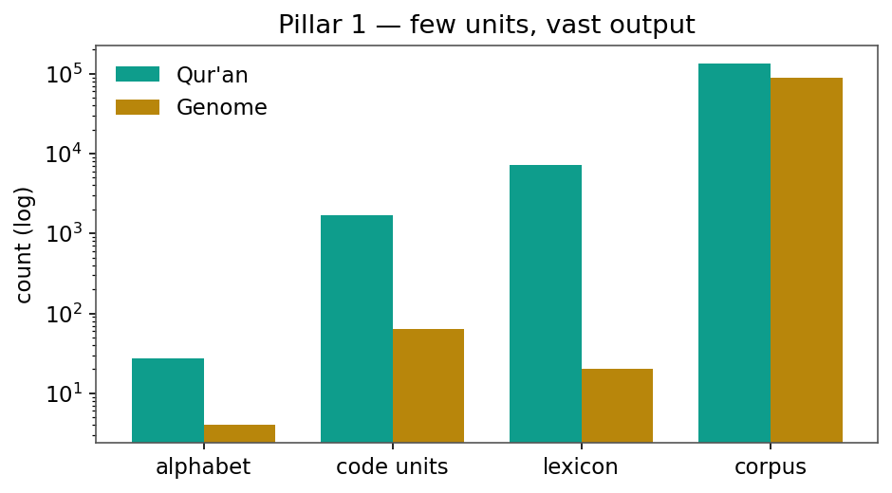
Figure 1. Combinatorial amplification (Pillar 1): a tiny alphabet yields a vast lexicon in both Books (log scale).
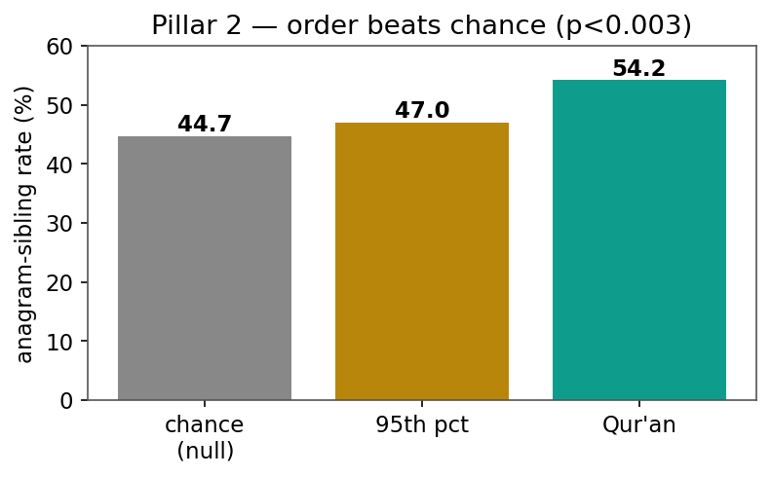
Figure 2. Order beats chance (Pillar 2): the Qur'anic anagram-sibling rate (54.2%) exceeds a frequency-matched null at p<0.003.
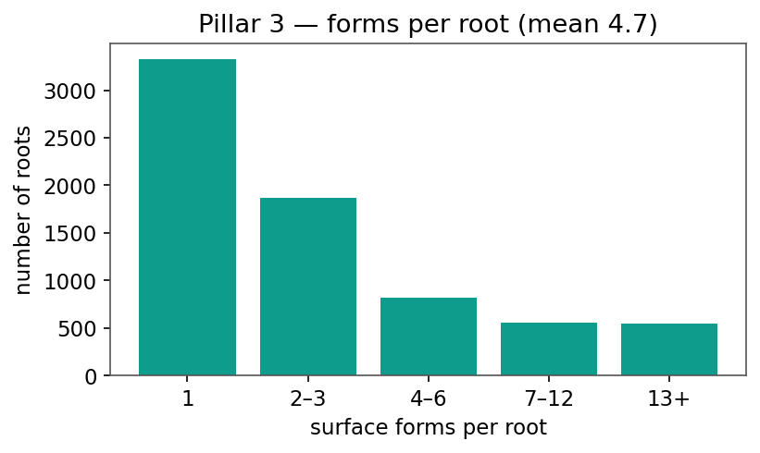
Figure 3. Expression (Pillar 3): surface forms per root, mean 4.7 (heavy-tailed).
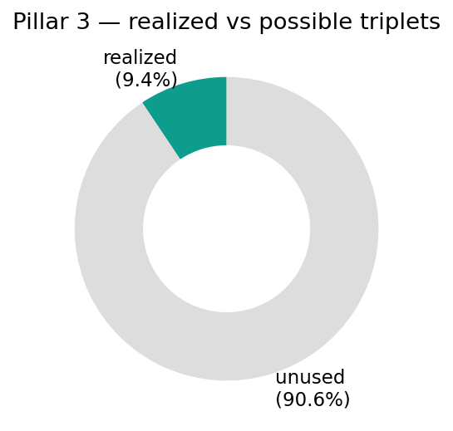
Figure 4. Pillar 3: only 9.4% of possible three-letter combinations are realized as roots.
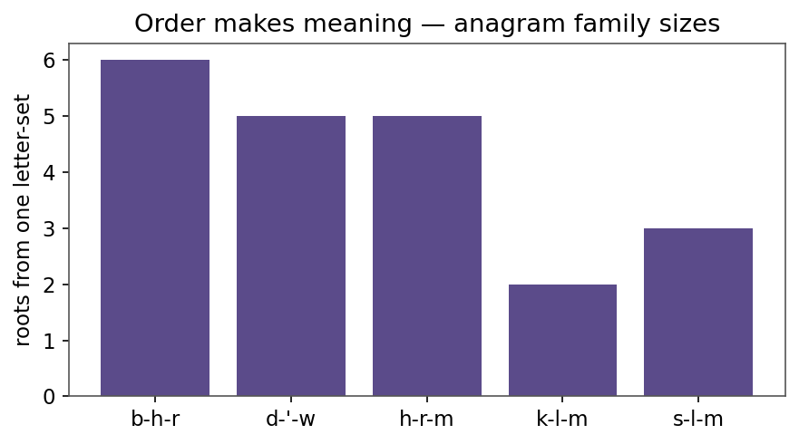
Figure 5. Order makes meaning: number of distinct roots generated from a single letter-set (anagram families).
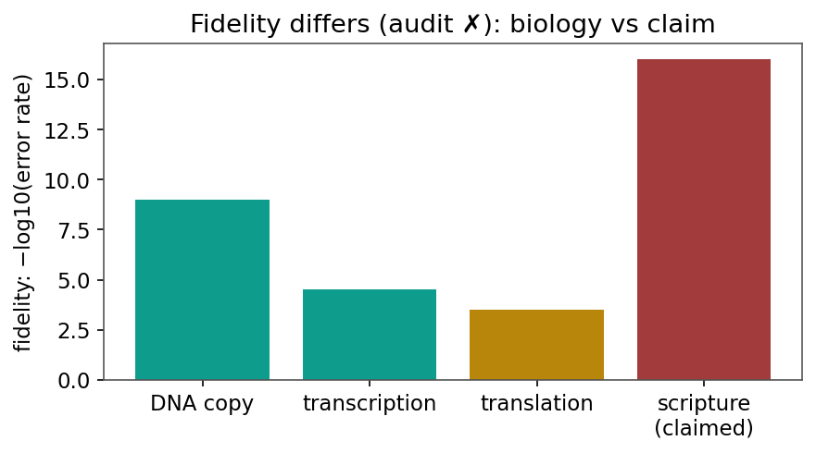
Figure 6. Fidelity differs (audit X): biological copying error rates vs the claim of perfect preservation.
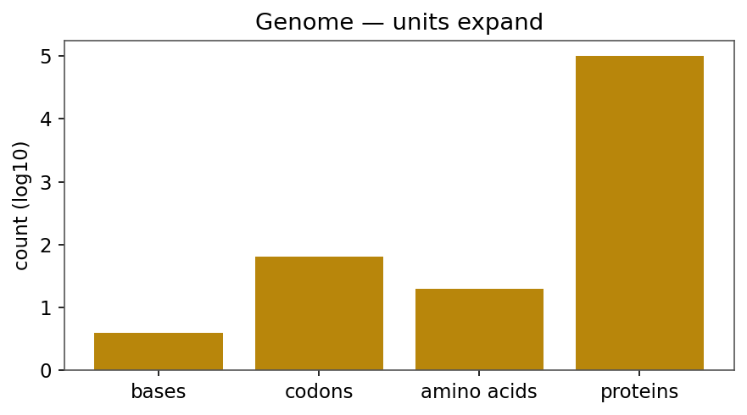
Figure 7. Genome side: units expand from bases to proteins (log scale).
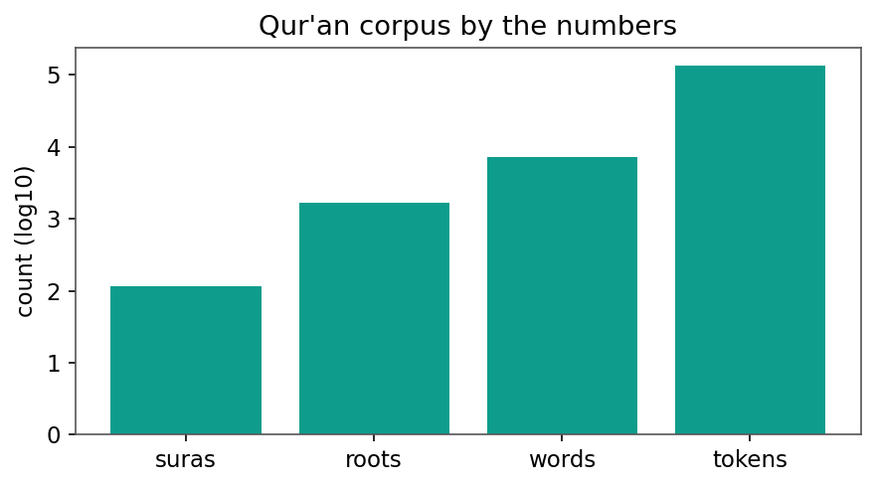
Figure 8. The Qur'anic corpus by the numbers (log scale).
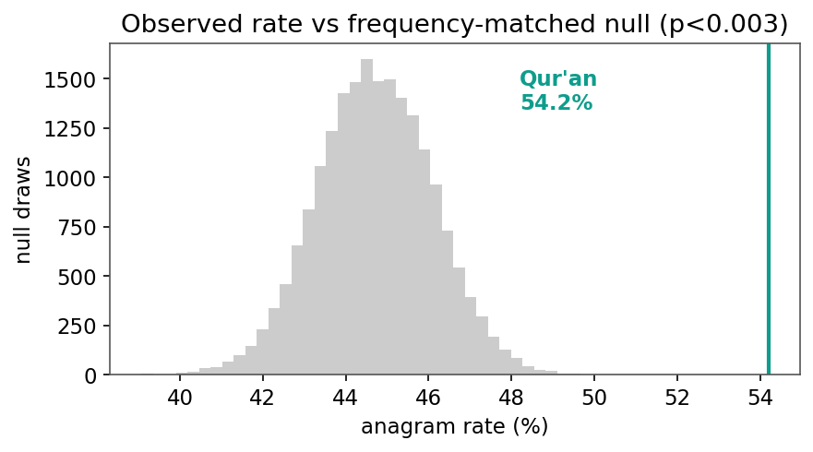
Figure 9. The 54.2% anagram rate against a 20,000-draw frequency-matched null (p<0.003).
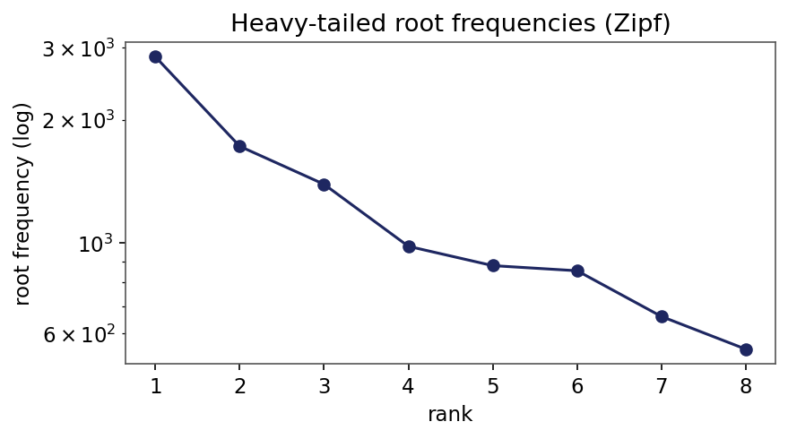
Figure 10. Heavy-tailed (Zipf-like) root-frequency spectrum.
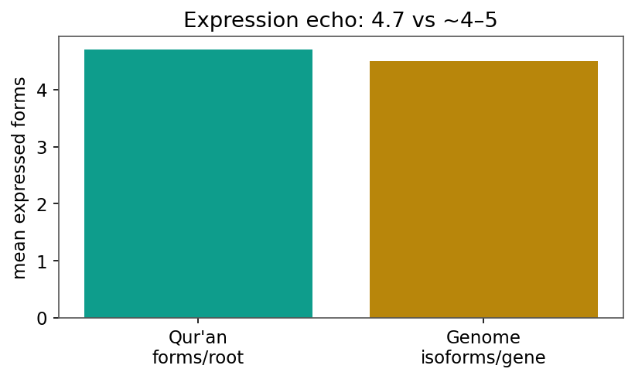
Figure 11. Expression echo: ~4.7 forms per Qur'anic root vs ~4-5 protein isoforms per gene.

