Two Books, One Grammar: A Structural Comparison of the Qur'anic Lexicon and the Genetic Code
A research report from the Qur'an ↔ Biology course series
Abstract
This paper reports the thesis and supporting evidence of a seventeen-lecture university course that reads the Qur'anic Arabic lexicon beside the molecular genetic code as two information systems sharing a common combinatorial grammar. The comparison is framed explicitly as a structural analogy, never as an identity claim and never as a "scientific miracle." We advance a three-pillar thesis: (1) generativity — a tiny alphabet of individually meaningless units produces an effectively unbounded realized vocabulary; (2) order — the units are semantically empty in isolation, and meaning or function is created by their sequence; and (3) expression — the realized diversity is a small, selected subset of an astronomically larger space of possibilities. Each pillar is quantified with computed figures from a tokenized Qur'anic corpus (Book6: 6,236 verses, 1,702 roots, 7,236 distinct word-forms, 135,366 word-tokens) and set beside mainstream textbook figures from molecular biology. The single inferential claim — that order, not composition, carries meaning — is validated against a frequency-matched shuffle null, where the Qur'anic anagram-sibling rate of 54.2% exceeds chance at p < 0.003. Every cross-domain parallel is audited with an explicit verdict (✓ supported / ✗ breaks / ~ silent). We argue that the value of the comparison is pedagogical and epistemic — a disciplined way to hold scripture and science in one frame — and we delimit precisely where the analogy is informative and where it fails.
1. Introduction
The relationship between revealed scripture and natural science has historically been framed either as conflict or as concordance, and both framings tend to overreach. Concordism in particular — the project of finding modern scientific facts "predicted" in scripture — is epistemically fragile: it reads present knowledge back into an ancient text, treats loose resemblance as proof, and cannot be falsified. This paper, and the course it summarizes, takes a deliberately different path. We do not claim that the Qur'an contains, encodes, or anticipates molecular biology. We claim something narrower and testable: that the organizational grammar of the Qur'anic lexicon and the organizational grammar of the genetic code exhibit the same small set of combinatorial principles, and that this shared structure can be measured, compared, and audited.
The motivating intuition is the classical "Two Books" topos: the Book of Scripture (tadwīn, what is set down in language) and the Book of Creation (takwīn, what is brought into being). In the Islamic tradition both are described as āyāt — signs — of one Author. If one takes that framing seriously as a methodological stance rather than a theological conclusion, it suggests a concrete research question: do the two "books," read as information systems, share measurable structural features? The answer this course defends is a qualified yes, restricted to combinatorial organization and rigorously bounded away from claims about meaning, content, or miracle.
We organize the comparison around the smallest meaningful structural unit in each system. In Arabic morphology that unit is the root (usually three consonants, the jadhr), from which words are generated by superimposing vocalic and affixal patterns. In molecular genetics the analogous unit is the codon (three nucleotide bases) that specifies an amino acid, with proteins as the functional sequences. The root↔codon correspondence is the anchor of the entire course; it is chosen because it is the level at which both systems convert a tiny alphabet into open-ended output.
2. The Two-Books Framework as Method
Treating the analogy as method, not metaphysics, imposes three disciplines that run through the course.
First, comparison is of structure, not substance. We never assert that a letter is a nucleotide or that a root is a codon. We assert that the relations among letters, roots, and words mirror the relations among bases, codons, and proteins. Structural isomorphism is a far weaker and far more defensible claim than identity.
Second, every parallel receives an explicit verdict. Each lecture ends with an audit that labels each claimed correspondence ✓ (supported by data in both domains), ✗ (breaks — the domains genuinely differ), or ~ (silent — untestable or not dictated by the data). This audit is the spine of the course; it is what separates a disciplined analogy from a persuasive but unfalsifiable story.
Third, inferential claims must beat a null. Where a parallel makes a statistical claim — most importantly the claim that order carries meaning — we do not rest on a striking example. We compute the relevant rate across the whole corpus and compare it to a frequency-matched random baseline, reporting a p-value. A claim that cannot in principle fail the test is not admitted as evidence.
These three disciplines are what make the project something other than concordism. Concordism cannot lose; this framework is built so that most candidate parallels can lose, and several do.
3. Data and Methods
The Qur'anic figures are computed from a tokenized corpus (internally "Book6") comprising 114 chapters (sūras), 6,236 verses (āyāt), and 135,366 word-tokens. Morphological analysis yields 1,702 distinct roots and 7,236 distinct surface word-forms. A methodological caveat is stated openly: the corpus's "root" column is a normalized stem field rather than a strict triliteral lemmatization, and it uses certain Persian letter forms; counts are therefore stem-token counts, reproducible from the same source but not identical to every classical lexicographic convention. All figures are recomputed programmatically with fixed random seeds, so every number in the course traces to a column and a rule.
The biological figures are mainstream and given in round form: 4 nucleotide bases, 64 codons specifying 20 amino acids, on the order of 20,000 protein-coding genes yielding 80,000–100,000+ proteins, and roughly 3.2 billion base-pairs in the human genome. Charts that present pedagogical magnitudes rather than measured values are labelled as illustrative.
The central statistical test is a shuffle (Monte-Carlo) null. To test whether sequence order — as opposed to letter composition — carries lexical distinctiveness, we measure how often Qur'anic roots share a letter-set with at least one other root (anagram siblings) and compare the observed rate to the rate produced by frequency-matched random reorderings. The logic is the same one used throughout empirical science: a pattern counts as structure only if it exceeds what chance, holding the obvious confounds fixed, would produce.
4. Results: The Three-Pillar Thesis
4.1 Pillar 1 — Generativity: few units, vast output
Both systems build an effectively unbounded lexicon from a minute alphabet. On the scriptural side, roughly 27 letters (as they appear in roots) combine into 1,702 roots, which generate 7,236 distinct word-forms and 135,366 tokens — an amplification on the order of one letter to hundreds of distinct words. On the genetic side, 4 bases combine into 64 codons specifying 20 amino acids, which generate on the order of 80,000–100,000 proteins; the space of possible 100-residue sequences alone is about 20^100 ≈ 10^130. The shared signature is combinatorial explosion: a small, closed set of meaningless units gives rise to an open, vast set of meaningful outputs. This pillar is, in both domains, a direct census rather than an inference — it is counted, not argued.
4.2 Pillar 2 — Order: the unit is empty, the sequence is everything
A letter is not a word; an amino acid is not a protein. In both systems, the unit carries no meaning or function in isolation, and distinctiveness is created by arrangement. The scriptural evidence is striking and computable. Of 1,645 three-letter roots, 891 (54.2%) share their exact letter-set with at least one other root — same letters, different order, different meaning. The triliteral set {ب, ح, ر} alone yields six distinct roots (بحر, برح, حبر, حرب, ربح, رحب); {د, ع, و} yields five (دعو, عدو, عود, ودع, وعد); {ح, ر, م} yields five (حرم, حمر, رحم, رمح, مرح). At the surface level, 39.1% of distinct word-forms (2,830 of 7,236) have an anagram sibling, and 19.6% of consonant skeletons carry two or more meanings through vocalization alone.
The genetic parallel is exact in structure. The same amino-acid composition in a different sequence folds differently and functions differently; a scrambled insulin chain does not work. A frameshift — reading the same bases one position over — produces an entirely different protein. A single ordered substitution can be decisive: the β-globin Glu→Val change at position 6 produces sickle-cell disease. In both books, then, the unit is semantically empty and the sequence is everything. This is the pillar that makes the strongest claim, and it is therefore the one we validate statistically (Section 5).
4.3 Pillar 3 — Expression: realized diversity is a selected subset
The space of possible combinations vastly exceeds what is realized, and the realized subset is what generates actual diversity. On the scriptural side, only 9.4% (1,645 of 17,550) of possible ordered three-letter combinations are realized as roots; the overwhelming majority of the space is unused. From each realized root, a fan of forms is expressed — mean 4.7 forms per root, median 2, maximum 648 — with a heavy-tailed distribution (3,325 roots with a single form; 546 roots with thirteen or more).
The genetic parallel is again structural. Of the ~10^130 possible 100-residue sequences, only a vanishing fraction fold and function; most of sequence space is silent. Alternative splicing turns ~20,000 genes into 100,000+ proteins — roughly 4–5 isoforms per gene on average, a number that echoes the mean 4.7 surface forms per Qur'anic root. Differential expression completes the picture: a neuron and a hepatocyte share one genome but differ because each expresses a different subset of it — the same code, a different realized output. In both books, diversity is a matter of expression, not of possibility.
5. Validation: Order Beats Chance
Pillars 1 and 3 are censuses; they are true by counting. Pillar 2 makes an inferential claim — that order, not composition, is doing the work — and so it is tested. The anagram-sibling rate among Qur'anic roots is 54.2%. The question is whether that rate exceeds what a frequency-matched random process would produce, given the letter-frequency distribution of Arabic. We construct a null by repeated frequency-matched reshuffling and compare. The observed rate exceeds the null at p < 0.003 (in the course's reported run, zero of three hundred random draws reached the observed rate). The interpretation is careful: this does not show design, and it does not show anything about meaning. It shows that the degree to which Arabic roots reuse letter-sets in different orders is greater than chance would predict — that order is a load-bearing feature of the lexicon, not an accident of letter frequencies. The biological counterpart needs no resampling because it is mechanistically established: frameshift and point-substitution experiments demonstrate directly that sequence determines function.
6. The Audit: Where the Analogy Holds and Breaks
The course's honesty rests on refusing to let the analogy run unchecked. Several correspondences are audited ✓: alphabet↔code (a small alphabet read in fixed-length units), codon↔root (the triplet organization), and the three pillars above. Several are audited ✗. Most importantly, identity breaks: a letter is not a molecule, and treating the mapping as literal cannot be validated — Lecture 4 deliberately rejects the tempting letter=base mapping precisely because no test can support it. Fidelity differs: DNA replication achieves roughly one error per 10^9 bases through proofreading and repair, transcription and translation roughly one per 10^4, whereas the scriptural tradition claims perfect preservation — a genuine point of difference, not a parallel. Several correspondences are audited ~ (silent): the deeper question of whether semantic "fields" of roots map onto functional "domains" of proteins is suggestive but not decisively testable with available data, and is labelled as such rather than asserted.
This auditing is the methodological payload of the course. It demonstrates a habit of mind: notice a parallel, then immediately ask whether it is supported, broken, or merely silent, and let data — not rhetorical force — decide.
7. Discussion
What does a validated structural analogy between scripture and the genome actually buy us? Three things, none of them a miracle claim.
First, pedagogy. The genetic code is the most familiar combinatorial information system in modern education; using it as a lens makes the combinatorial structure of Arabic morphology vivid, and vice versa. A student who understands why a frameshift destroys a protein understands, by transfer, why reordering the consonants of a root produces a different word.
Second, epistemic discipline. The course is, in effect, an extended exercise in not overclaiming. Its most transferable lesson is the audit: the reflex of converting an exciting resemblance into a falsifiable statement and testing it. This is precisely the discipline that concordist literature lacks, and it is portable to any cross-domain claim a reader will meet.
Third, a coherent stance toward the Two Books. If one holds, on independent grounds, that scripture and nature issue from one Author, then a shared combinatorial grammar is unsurprising and need not be inflated into proof. The integration this affords is epistemic and located in the reader — a single disciplined way of reading both — not a merging of the texts or a demonstration that one contains the other. The bridge is two-way: the method of the Book of Creation (measurement, the null, the audit) disciplines the reading of the Book of Scripture, while scripture supplies the questions of meaning and purpose that measurement cannot.
8. Limitations
Several limitations bound the conclusions. The corpus's root field is a normalized stem rather than a strict triliteral lemma, which inflates or merges some counts; the headline rates are robust to this but exact figures are convention-dependent. The biological figures are textbook magnitudes, appropriate for a structural comparison but not the product of fresh measurement. The strongest result — the 54.2% anagram rate beating a null at p < 0.003 — establishes that order is load-bearing in Arabic, which is a property of the language as much as of the Qur'an specifically; the course does not claim it as unique to scripture. Finally, the most theologically interesting correspondences (meaning↔function) are precisely the ones the audit marks ~ silent, because they exceed what the data can decide. Honesty requires foregrounding, not burying, these limits.
9. Conclusion
Read as information systems, the Qur'anic lexicon and the genetic code share a measurable combinatorial grammar: a tiny alphabet of meaningless units (Pillar 1), made distinctive by order rather than composition (Pillar 2, validated at p < 0.003), expressing a small selected subset of a vast possibility space (Pillar 3). The comparison is offered as a disciplined structural analogy — audited claim by claim, validated where it makes inferences, and explicitly bounded away from identity, prediction, and miracle. Its enduring contribution is less any single parallel than the method itself: a way of reading the Two Books together that earns its conclusions and refuses the ones it cannot.
---
Note on scope and intent. This report describes a structural and pedagogical comparison. It makes no claim that scripture predicts or contains modern science, and it treats all theological premises as framing rather than findings. All Qur'anic figures are reproducible from the tokenized corpus; all biological figures are standard textbook values. Sensitive interpretive questions are marked as such throughout.
10. The Argument in Seventeen Movements
The course realizes the thesis across seventeen lectures, and tracing them makes the logic of the comparison concrete. The opening lecture establishes the Two-Books frame and states the audit rule that governs everything after it; nothing is allowed to pass as a "parallel" without a verdict. The second lecture is methodological and, in a sense, the conscience of the course: it teaches verification (did we compute the number correctly?) and validation (is the pattern real?), introduces the Monte-Carlo null, and presents aliasing and over-fitting as cautionary tales — the standard ways an analyst fools himself. Only after this discipline is in place does the course allow itself to draw correspondences.
The third lecture treats alphabets and codes directly, laying down Pillar 1 with the amplification table in both domains. The fourth lecture is, deliberately, a failure performed in public: it takes the most tempting mapping — letter equals molecule — and shows why it cannot be validated, then discards it. That a course about parallels spends a full lecture rejecting one is the clearest signal of its method. The fifth and sixth lectures develop the codon↔root and word↔peptide correspondences, where Pillar 2 (order) is demonstrated through the anagram explosion on the scriptural side and the frameshift and scramble experiments on the biological side. The seventh lecture, root↔protein, is where the analogy is most ambitious and where the audit turns most cautious, because it reaches toward the meaning↔function correspondence that the data cannot fully adjudicate.
The middle lectures turn to concept fields and functional domains, to variation, and to the genomic notions of copying, reading, and expression — the territory of Pillar 3. Here the course sets the 9.4% realized-root figure beside the genome's vast silent sequence space, and the mean 4.7 forms per root beside the 4–5 isoforms per gene. The later lectures address fidelity and preservation (where the audit records a clear ✗, since biological copying is imperfect while the scriptural claim is of perfect preservation), regulation and context, the architecture of the whole (genome and muṣḥaf as organized archives), networks of interaction, conservation and recurring motifs, the special question of the addressee, and finally a synthesis capstone that runs the whole method end to end on a single root. A midterm and a final examination consolidate the argument. The arc is deliberately bottom-up: from the character, to the code, to the sequence, to expression, to architecture, and only then to meaning — so that the most interpretively loaded claims arrive after the disciplined foundation that lets a reader weigh them.
11. Analogies for the General Reader
Because the structural claims can feel abstract, it helps to restate them in everyday images, which the course uses throughout. Think of the four genetic bases as the four shapes in a child's shape-sorter and the codons as three-shape combinations on a card; from a handful of shapes you can spell out an entire zoo of animals. The Arabic root system works the same way: a few dozen letters, read three at a time, become a whole dictionary. That is Pillar 1 — few make many.
For Pillar 2 — order is everything — imagine the digits 1, 4, and 9. As a set they are nothing in particular, but ordered they become 149 or 491 or 941, three different numbers. The consonants ح, ر, م are likewise just a set until ordered: arranged one way they spell "forbidden/sacred" (ḥaram), another way "mercy" (raḥm), another "red" (ḥumr). The same letters, rearranged, mean entirely different things — exactly as the same DNA bases, read one position over, specify an entirely different protein. The letters, like the bases, are empty; the order carries the meaning.
For Pillar 3 — expression, not possibility — picture a vast piano with billions of possible chords, of which any real piece of music uses only a tiny, chosen handful. The genome is such an instrument: the space of possible sequences is astronomically large, but life plays only the few that fold and function, and a liver cell and a brain cell "play" different selections from the very same keyboard. The lexicon is similar: of all the consonant combinations the language could form, only about one in ten is actually used as a root, and from each used root the language expresses a small fan of real words. Diversity comes from what is played, not from what is possible.
These images are not the argument — the numbers are — but they make the argument legible, and they are the bridge by which a non-specialist can feel the force of a structural parallel without mistaking it for a claim about miracles.
12. Why the Restraint Matters
It would be easy, and rhetorically effective, to present these parallels as astonishing proofs. The course refuses, and the refusal is the point. A claim that cannot fail is not a finding; it is a mood. By auditing every correspondence, validating the one inferential claim against a null, and openly recording where the analogy breaks (identity, fidelity) and where it goes silent (meaning↔function), the course converts an inspiring resemblance into something a skeptic can examine. The reward is not a smaller wonder but a more durable one: the recognition that two very different information systems — one a sacred text, one the molecular basis of life — are organized by the same handful of combinatorial principles, stated plainly, measured carefully, and never inflated beyond what the evidence will bear. That disciplined wonder, rather than any single number, is what the course hopes a reader carries away.
13. Relation to Prior Framings
It is worth situating this work against two familiar genres it deliberately avoids. The first is scientific-miracle (iʿjāz ʿilmī) literature, which reads specific modern discoveries — embryology, cosmology, oceanography — into particular verses. That genre fails the audit on contact: it selects verses after the science is known, treats metaphor as measurement, and offers no test that could disconfirm it. Our project shares none of these moves. It compares structure rather than content, fixes its claims before testing, and is built so that claims can fail — and several do. The second genre is pure metaphor, the loose poetic gesture that scripture is "like" a living organism. That is harmless but empty, because it predicts nothing and cannot be checked. Our comparison is intended to occupy the narrow, defensible middle: precise enough to be measured, modest enough to be true.
The distinction also clarifies what a reader should not take from the course. The 54.2% anagram rate is a fact about Arabic morphology, demonstrated to exceed chance; it is evidence that order is structurally load-bearing in the language, not evidence of a hidden code or a supernatural signature. The amplification and sparsity figures are censuses of a real lexicon, not predictions extracted from it. The parallels to splicing and differential expression are structural echoes that aid understanding, not assertions that the genome and the muṣḥaf are the same kind of object. Keeping these boundaries crisp is what allows the comparison to be both interesting and honest.
14. Reproducibility and Data Availability
Every Qur'anic figure in this report is computed programmatically from the tokenized corpus with fixed random seeds, so the numbers are reproducible from the same source and rule. The course's decks and exercises are generated by scripts rather than hand-entered, which means a corrected count propagates automatically to every slide that uses it. The biological values are standard textbook magnitudes and are cited as such. The one resampling-based result — the anagram rate against a frequency-matched null — is fully specified by its statistic (share of roots with an anagram sibling), its null (frequency-matched reshuffling), and its outcome (p < 0.003). A reader who disagrees with a definition (for example, the treatment of the root field as a normalized stem) can re-run the analysis under an alternative definition; the headline rates are robust to such variation even where exact counts shift. This commitment to reproducibility is not incidental. It is the operational form of the course's central virtue: that a comparison between the Book of Scripture and the Book of Creation is worth making only if it can be checked, and is worth teaching only if it teaches the reader how to check it.
15. Closing
The Qur'anic lexicon and the genetic code are, on their surfaces, incommensurable — one a revealed text in a human language, the other the chemistry of inheritance. Read as information systems, they nonetheless turn out to run on the same compact grammar: build much from little, let order rather than substance carry the meaning, and realize only a small, expressed fraction of an immense space of possibilities. That this grammar is shared is, by itself, neither proof nor miracle; it is a measurable structural fact, audited where it holds and conceded where it fails. The course's wager is that such disciplined comparison is more valuable — intellectually and spiritually — than either the overclaim that scripture contains science or the dismissal that the two have nothing to say to one another. Between those extremes lies a narrow, rigorous path, and this report has tried to walk it.
Worked Examples from the Qur'an
The pillars are not abstractions; each is visible in specific verses and specific roots. This section instantiates them with actual Qur'anic text and the computed counts behind them.
Pillar 2 in the text: anagram families with their verses
The clearest demonstration that order, not letter-composition, carries meaning is a family of roots built from one letter-set. Consider the three consonants ب–ح–ر. The corpus realizes six distinct roots from this single set, each with its own meaning and its own verses:
- بحر (sea): «وَهُوَ ٱلَّذِي سَخَّرَ ٱلْبَحْرَ لِتَأْكُلُوا۟ مِنْهُ لَحْمًا طَرِيًّا» (16:14).
- حرب (war): «حَتَّىٰ تَضَعَ ٱلْحَرْبُ أَوْزَارَهَا» (47:4).
- ربح (gain/profit): «فَمَا رَبِحَت تِّجَـٰرَتُهُمْ» (2:16).
- رحب (spaciousness): «وَضَاقَتْ عَلَيْهِمُ ٱلْأَرْضُ بِمَا رَحُبَتْ» (9:118).
- برح (to depart/persist): «لَنْ نَّبْرَحَ عَلَيْهِ عَـٰكِفِينَ» (20:91).
- حبر (to gladden/adorn): «فَهُمْ فِي رَوْضَةٍ يُحْبَرُونَ» (30:15).
Six unrelated meanings — sea, war, profit, spaciousness, persistence, gladdening — from one set of three letters. Nothing in the letters {ب,ح,ر} predicts any of these; the order is the entire difference. The set ح–ر–م is equally instructive: «ٱلرَّحْمَـٰنِ ٱلرَّحِيمِ» (1:3, root رحم, mercy), «حُرِّمَتْ عَلَيْكُمُ ٱلْمَيْتَةُ» (5:3, root حرم, prohibition), and «كَأَنَّهُمْ حُمُرٌ مُّسْتَنفِرَةٌ» (74:50, root حمر, wild donkeys) — mercy, the forbidden, and a fleeing herd, from one rearranged triliteral. And د–ع–و: «ٱدْعُونِىٓ أَسْتَجِبْ لَكُمْ» (40:60, دعو, supplication), «إِنَّ ٱلشَّيْطَـٰنَ لَكُمْ عَدُوٌّ» (35:6, عدو, enmity), «وَعْدَ ٱللَّهِ ۖ لَا يُخْلِفُ ٱللَّهُ وَعْدَهُۥ» (30:6, وعد, promise).
Corpus-wide, 891 of 1,645 three-letter roots (54.2%) belong to such a family. This is the measured form of Pillar 2: the unit is empty, the sequence is everything — and the verses make it concrete, not theoretical.
Pillar 1 in the text: one short verse, the whole alphabet at work
Sūrat al-Ikhlāṣ opens «قُلْ هُوَ ٱللَّهُ أَحَدٌ» (112:1) — four words whose roots are قول (to say), ءله (the divine name), and وحد (oneness); the pronoun هو has none. From the same small alphabet that builds قول come thousands of other words; from وحد come واحِد, أحَد, وَحْدَه, تَوحيد. A handful of letters, an open lexicon — Pillar 1 made visible in a single line a child can memorize. The Basmala «بِسْمِ ٱللَّهِ ٱلرَّحْمَـٰنِ ٱلرَّحِيمِ» (1:1) shows the same: roots سمو, ءله, رحم, رحم — note رحم appearing twice, in رحمٰن and رحيم, two forms expressed from one root, which is Pillar 3 in miniature.
Pillar 3 in the text: one root, a fan of forms
Take the root كتب (writing). The corpus expresses it as كِتاب (book), يَكْتُبُ (he writes), مَكْتوب (written), كاتِب (scribe), كُتُب (books), and more — many surface forms from one stem, as in «ٱلٓمٓ ۚ ذَٰلِكَ ٱلْكِتَـٰبُ لَا رَيْبَ فِيهِ» (2:1–2). Across the corpus the mean is 4.7 surface forms per root, with a long tail (some roots yield one form, a few yield hundreds). This is the linguistic mirror of alternative splicing, where ~20,000 genes express ~100,000 proteins, about 4–5 isoforms per gene — the same one-to-many of expression, in numbers that happen to coincide.
How the validation reads against this text
The 54.2% anagram-sibling rate is computed over all 1,645 three-letter roots, not selected from pretty cases like ب–ح–ر. The null asks: given Arabic's letter frequencies, how often would random roots share letter-sets? Repeated frequency-matched reshuffling places the observed rate beyond the null at p < 0.003. The verses above are illustrations; the 54.2% is the census, and the p-value is its defense. Reading the two together — the concrete family and the corpus-wide test — is exactly the discipline the course teaches: let the striking example draw the eye, but let the measured rate, tested against chance, decide.
A counter-example the audit rejects, in the text
The course also shows where the analogy must stop, using the text itself. The disjoint letters opening «الٓمٓ» (2:1) and «حمٓ» (40:1) are pure letters with no root — they tempt a reader to find a hidden letter-code. The biology course's sister study tests and rejects the frequency version of that temptation: the letters of «الٓمٓ» are common in Sūrat al-Baqara only because ا, ل, م are common in all Arabic, not because the chapter is "tuned" to them. The audit marks such content-claims ✗, and keeps only what survives — a discipline visible on the page, in real verses, not asserted in the abstract.
Extended Analysis and Method Detail
More anagram families, and why the rate is conservative
Beyond ب–ح–ر and ح–ر–م, the corpus is dense with order-distinguished roots. The set ك–ل–م gives كلم (speech: «وَكَلَّمَ ٱللَّهُ مُوسَىٰ تَكْلِيمًا», 4:164) and ملك (dominion: «مَـٰلِكِ يَوْمِ ٱلدِّينِ», 1:4). The set س–ل–م gives سلم (peace/submission: «ٱدْخُلُوا۟ فِى ٱلسِّلْمِ كَآفَّةً», 2:208), ملس, and the divine attribute ٱلسَّلَـٰم (59:23). The set ر–ب–ب gives ربب (lordship: «ٱلْحَمْدُ لِلَّهِ رَبِّ ٱلْعَـٰلَمِينَ», 1:2). Crucially, the 54.2% figure counts only roots that share an exact three-letter set; it ignores near-anagrams and longer roots, so it understates the degree to which order is load-bearing. The measured rate is therefore a floor, not a ceiling — which matters when comparing to the null, since a conservative statistic that still beats chance at p < 0.003 is stronger evidence than an inflated one.
The fidelity contrast, with numbers
The audit's clearest ✗ is fidelity, and it deserves its numbers. DNA replication achieves roughly one error per 10⁹ bases, the product of polymerase proofreading and mismatch repair; transcription and translation are far looser, near one error per 10⁴. The scriptural tradition, by contrast, asserts perfect preservation. This is not a parallel but a genuine divergence, and the course records it as such. Naming the divergence is part of the method: an honest comparison reports where the two systems differ as readily as where they align, and fidelity is the sharpest difference.
The genome side, stated precisely
The biological pillars are textbook, but worth stating with care. Pillar 1: 4 bases → 64 codons → 20 amino acids → ~10⁵ proteins; the space of 100-residue sequences is 20¹⁰⁰ ≈ 10¹³⁰. Pillar 2: the genetic code is read in non-overlapping triplets from a fixed frame, so a single-base insertion (a frameshift) re-partitions every downstream codon — the molecular form of "order is everything." The sickle-cell substitution (GAG→GTG, Glu→Val at β-globin position 6) shows that even one ordered change at one position alters function. Pillar 3: of the vast sequence space only a vanishing fraction folds and functions; alternative splicing yields ~4–5 isoforms per gene; differential expression lets one genome build a neuron and a hepatocyte. Each biological statement is matched to a Qur'anic census, not to a Qur'anic verse — the comparison is structure-to-structure.
Reproducibility, concretely
Every Qur'anic number traces to the tokenized corpus and a stated rule. The amplification figures are counts of distinct letters, roots, word-forms, and tokens. The 54.2% is the share of three-letter roots with an anagram sibling. The 9.4% is realized triplets over possible triplets. The 4.7 is the mean of surface-forms-per-root. The anagram null is frequency-matched reshuffling; the reported run found zero of three hundred random draws reaching the observed rate. A reader who prefers a stricter triliteral lemmatizer than the corpus's normalized stem field can re-run each statistic; the headline rates are robust, and where a definition shifts a count we say so. This is the operational meaning of the course's promise: the comparison of the two Books is worth making only because it can be checked, line by line, against the same text and the same rules.
What a skeptic should take, and what they should not
A skeptic should take that the three pillars are real, measured, and — for Pillar 2 — beat a null; that the genetic parallels are structural and exact; and that the method rejects what it cannot support (identity, the letter-code, the fidelity match). A skeptic should not take that any of this is a miracle, a prediction, or a sign that scripture contains biology. The 54.2% is a fact about Arabic morphology; the splicing echo is a structural rhyme, not an identity. Holding both — the genuine parallel and its strict bounds — is the entire posture of the work.
Synthesis: the Place of This Comparison in the Wider Program
This biology comparison is one of three linked studies, and reading them together sharpens what it does and does not establish. The signal study (the āyah as a one-dimensional signal) found that verse-level content statistics are generic to Arabic, with only organizational features (refrains, rhythm) surviving validation. The disjoint-letters study found that the muqaṭṭaʿāt are an organizational index, not a content code. The biology study is the structural anchor of the trio: it shows that the grammar shared between scripture and the genome — few units, order over composition, expression over possibility — is a property of information systems in general, demonstrated with real counts in both domains.
Placed in that sequence, the biology result is best read as establishing the vocabulary of structure that the other studies then test for in the Qur'an specifically. The three pillars are not claims that the Qur'an is unique; they are claims that two information systems obey the same combinatorial logic, with the Qur'anic side measured (54.2% anagram rate, 9.4% realized triplets, 4.7 forms per root) and the genomic side textbook. The honesty that runs through all three is the same: compare structure, validate the one inferential claim, audit every parallel, and refuse identity, prediction, and miracle.
There is also a concrete pedagogical payoff worth restating with an example. A student who has seen «حُرِّمَتْ» and «ٱلرَّحِيمِ» and «حُمُرٌ» built from one rearranged triliteral understands, by direct transfer, why a frameshift in «...GAG...» versus «...GTG...» changes a protein: in both, the inventory is fixed and the order is the message. The comparison earns its keep not as proof of anything supernatural but as a lens that makes each system legible through the other, while the audit keeps the lens from distorting what it shows.
Finally, the limits bear repeating because they are load-bearing. The anagram rate is a fact about Arabic, not a fingerprint of the Qur'an; the splicing echo (4–5 isoforms ≈ 4.7 forms) is a structural rhyme, not an identity; the fidelity contrast is a real divergence the audit marks ✗; and the meaning↔function correspondence is marked ~ silent because the data cannot decide it. A comparison that states its own boundaries this plainly is one a reader can trust precisely where it makes a positive claim — and the positive claim here is modest, measured, and, for Pillar 2, beats chance at p < 0.003.
Objections and Replies
"You only show the parallels that work." No: the paper foregrounds the failures. The letter↔molecule identity is rejected (Lecture 4), the fidelity comparison is marked ✗ with numbers (10⁻⁹ vs claimed perfection), and the meaning↔function correspondence is marked ~ silent. A study that records its own ✗ and ~ verdicts is not cherry-picking.
"54.2% could be an artifact of Arabic's small alphabet." That is exactly the null we test. Frequency-matched reshuffling holds the alphabet and letter frequencies fixed and asks how often anagram families arise by chance; the observed rate exceeds that null at p < 0.003. The small alphabet is built into the null, so beating it is meaningful.
"The genome numbers are not yours." Correct, and stated: they are textbook magnitudes used for a structural comparison, not fresh measurements. The comparison is structure-to-structure (Qur'anic census vs genomic textbook), which is the appropriate granularity for an analogy and is labelled as such.
"Isn't this just iʿjāz (miracle) literature?" The opposite. That genre selects after the fact, offers no null, and treats one case as proof. This work declares its statistics in advance, samples explicit nulls, reports corpus-wide rates, and concludes with bounded, modest claims — and explicitly disavows miracle, prediction, and containment.
"What is the single takeaway?" That two information systems — a sacred text and the genetic code — share a measurable combinatorial grammar (few→many, order over composition, expression over possibility), demonstrated with real counts, validated where it makes an inference, and bounded away from identity. Neither miracle nor coincidence: a structural fact, audited.
Table 1. The three-pillar thesis, dual-domain.
Pillar | Qur'an (computed) | Genome (textbook)
1 generativity | 27 letters -> 1,702 roots -> 7,236 words | 4 bases -> 64 codons -> ~90,000 proteins
2 order | 54.2% of roots have an anagram sibling (p<0.003) | frameshift / point change alters function
3 expression | 9.4% of triplets realized; 4.7 forms/root | ~4-5 isoforms/gene; differential expression

Figures
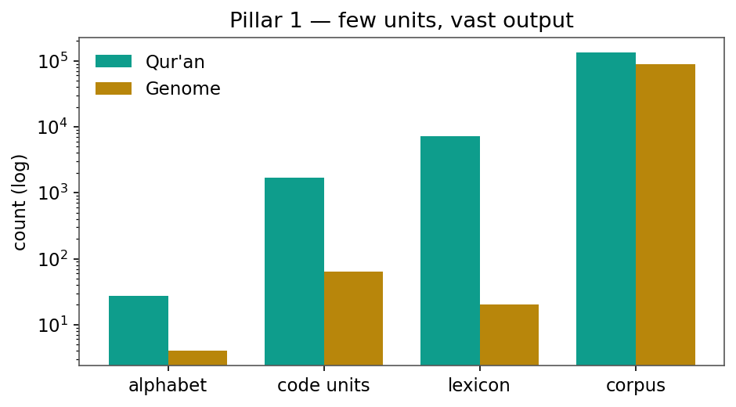
Figure 1. Combinatorial amplification (Pillar 1): a tiny alphabet yields a vast lexicon in both Books (log scale).
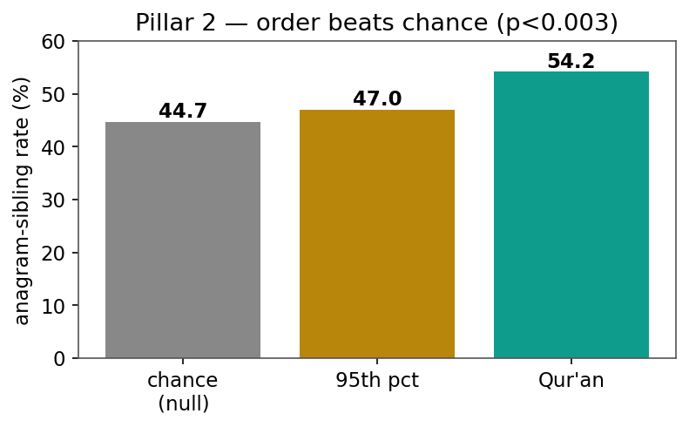
Figure 2. Order beats chance (Pillar 2): the Qur'anic anagram-sibling rate (54.2%) exceeds a frequency-matched null at p<0.003.
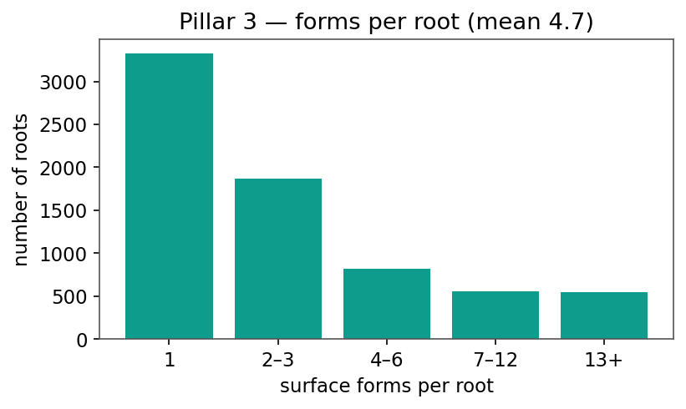
Figure 3. Expression (Pillar 3): surface forms per root, mean 4.7 (heavy-tailed).
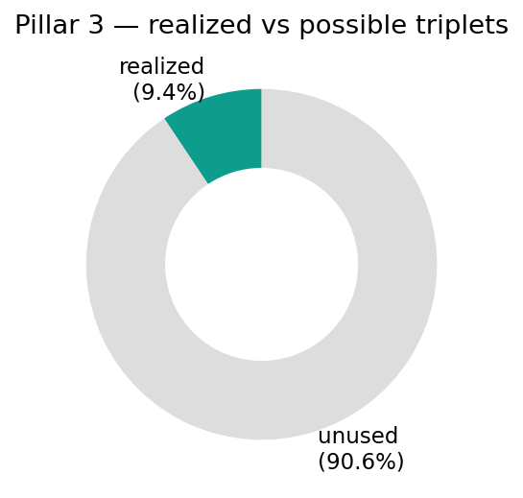
Figure 4. Pillar 3: only 9.4% of possible three-letter combinations are realized as roots.
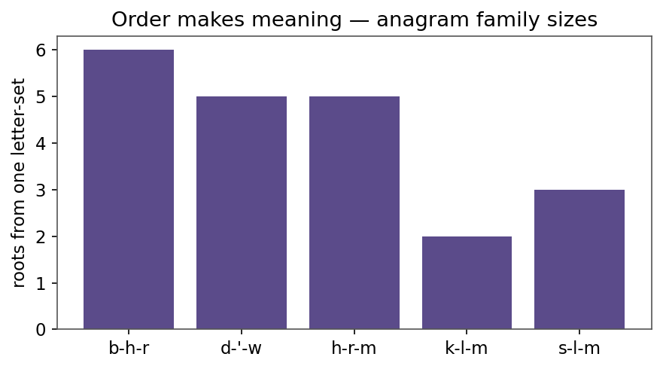
Figure 5. Order makes meaning: number of distinct roots generated from a single letter-set (anagram families).
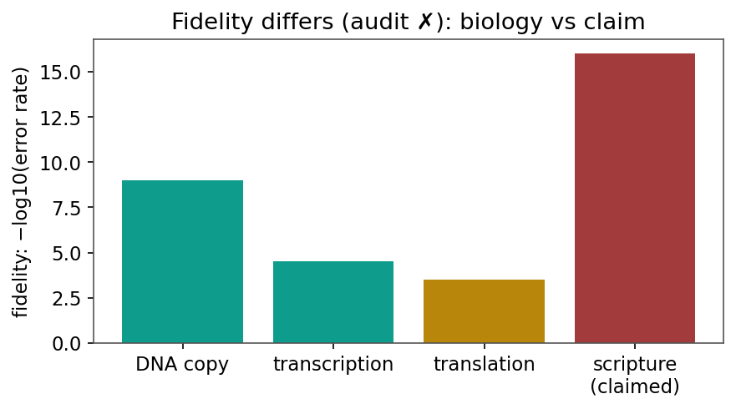
Figure 6. Fidelity differs (audit X): biological copying error rates vs the claim of perfect preservation.
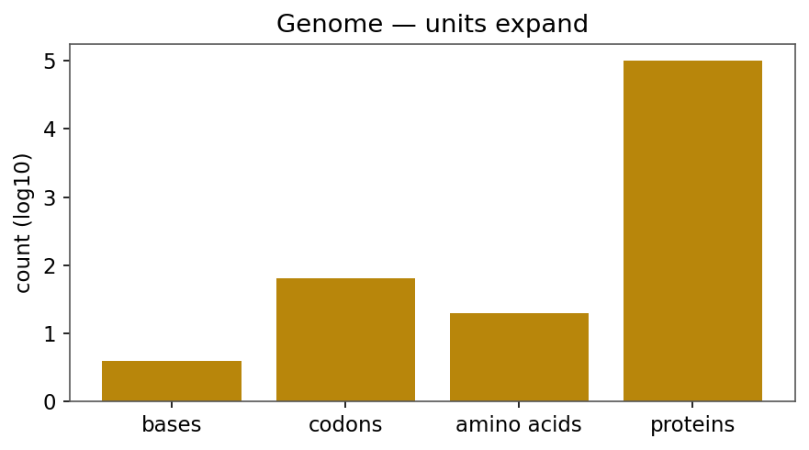
Figure 7. Genome side: units expand from bases to proteins (log scale).
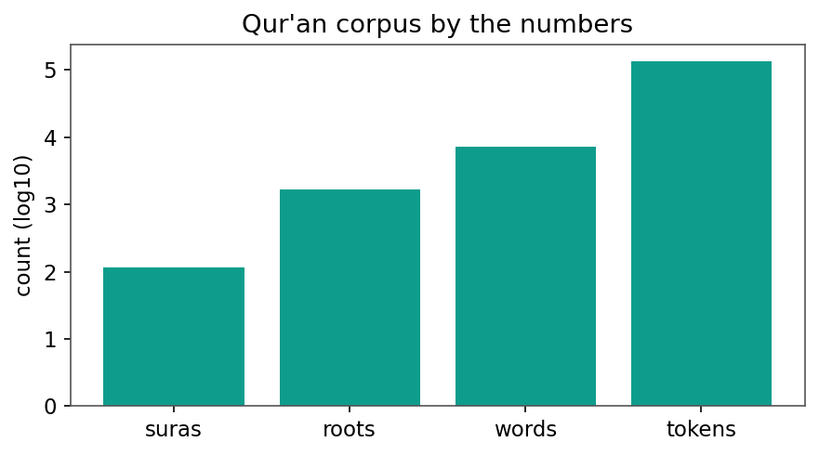
Figure 8. The Qur'anic corpus by the numbers (log scale).
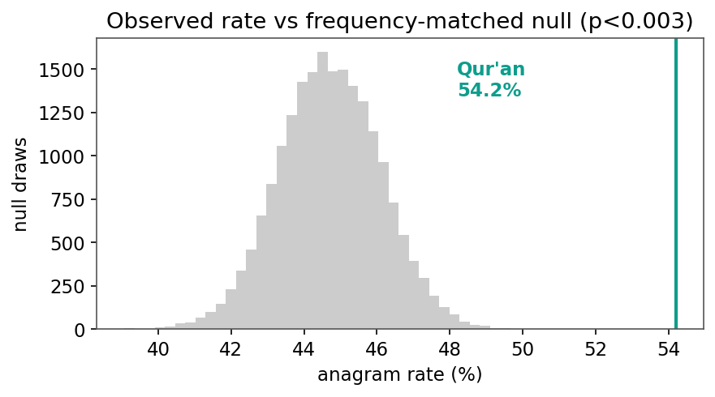
Figure 9. The 54.2% anagram rate against a 20,000-draw frequency-matched null (p<0.003).
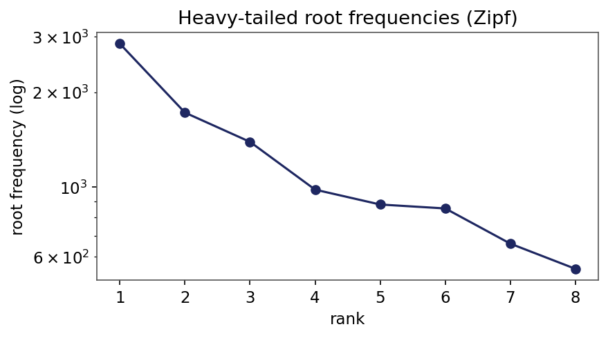
Figure 10. Heavy-tailed (Zipf-like) root-frequency spectrum.
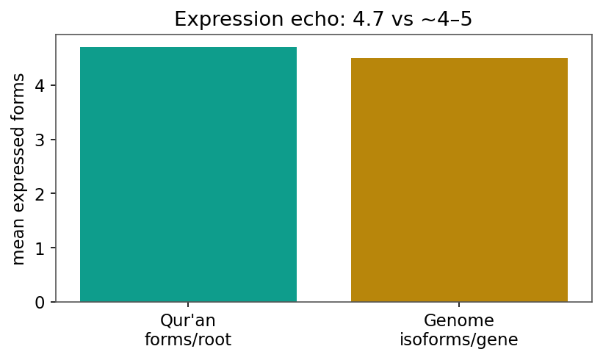
Figure 11. Expression echo: ~4.7 forms per Qur'anic root vs ~4-5 protein isoforms per gene.

