Biology — Using the App & Reading the Composition
A live walkthrough on one sūra (al-Fatiha), theme: the genome lens — letters as bases, roots as codons. Numbers computed from Book6 by the app's engine. Honest rule: composition is dominated by common letters and by length; read it against that, not as a code.
Part A — Walkthrough: al-Fatiha, the composition way
1. Open base composition
- App → Two Books → Biology → 🧪 Base composition. Choose your sūra from the selector.
2. Read the base (letter) composition
The app shows how often each letter appears, against the corpus baseline. For al-Fatiha the most frequent letter accounts for 19.18% of its 146 letters. Deviations from the baseline are small — every sūra draws on the same alphabet.
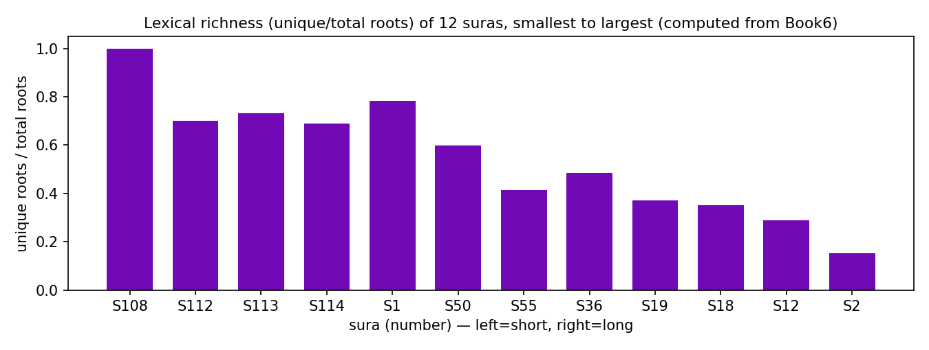
Lexical richness of 12 suras, ordered short→long (computed from Book6). Longer suras repeat roots, so richness falls — a length effect.
3. Read codon (root) diversity — lexical richness
On the 📏 Sequence complexity tab, find your sūra. al-Fatiha uses 18 distinct roots across 23 root-tokens — richness 0.783. Short sūras score high; long sūras (which repeat vocabulary) score low.
Part B — The key skill: composition vs the length confound
Base composition (which letters) and lexical richness (unique ÷ total roots) both shift with sūra length. Always read a sūra's numbers against its size before calling anything special.
al-Fatiha — what the app computes | value
total letters | 146
most frequent letter — share | 19.18%
root-tokens | 23
distinct roots | 18
lexical richness (unique ÷ total) | 0.783
Part C — The cross-check rule
- Report one computed fact (a composition or richness value) plus one labeled interpretation.
- Never read base composition as a hidden code — it is dominated by the commonest letters and by length. Say only what the data licenses.

