The Mystery Letters as Library Labels — A Simple Explanation of What the Disjoint Letters Do
A plain-language companion to the disjoint-letters study. Few technical words, many everyday pictures.
The puzzle in one breath
Twenty-nine chapters of the Qur'an begin with stray letters that spell no word — "A-L-M," "Ḥ-M," "A-L-R," "Q," "N," and a few more. For over a thousand years, people have wondered what they are for. This study does not guess at their secret meaning. It asks a plain, checkable question: do these letters do a job? And the answer it found, tested carefully, is yes — they behave like labels that group chapters together, the way a call number on a library book tells you which shelf-mates it belongs with. They don't describe what a chapter is about; they mark which chapters belong in the same family, and where that family sits.
Why "label," not "code"
Most attempts to crack the mystery letters look for hidden content — secret numbers, concealed words. We looked somewhere completely different: at organization. The clue came from earlier work in the same project. When we measured the content of Qur'anic verses with every tool we had, we kept finding only "normal Arabic" — nothing special hidden inside the words themselves. The one thing that was genuinely special was always about arrangement: how the parts are laid out. So when we turned to the mystery letters, we didn't ask "what do they spell?" We asked "what do they organize?" — and that is the question that finally got a clear answer.
The picture to hold is a library. A call number like "QA76.73" on a book's spine tells you nothing about the story inside. But it tells you exactly where the book lives and which books are its neighbors. Our claim, in plain terms, is that the mystery letters are call numbers: A-L-M and Ḥ-M and A-L-R are not summaries of their chapters; they are labels that bundle certain chapters into families and place them together.
What we actually checked
Here is the careful part, because it's easy to be fooled. The chapters with mystery letters tend to sit near each other anyway — so of course any grouping of them would look clustered. To avoid that trap, we ran a stricter test. We froze those chapters exactly where they are, then shuffled the labels among them — randomly reassigning which chapter gets "A-L-M," which gets "Ḥ-M," and so on — and asked: does the real labeling group chapters together better than a random relabeling? This is the difference between "these chapters happen to be near each other" and "the specific label marks a real family." It's a deliberately hard test to pass.
The real labeling passed overwhelmingly — the odds against it being a fluke were about one in fifty thousand. And it passed in two different orderings: the order chapters appear in the book, and the order they were revealed (according to the traditional chronology). The headline example is breathtaking in its simplicity: the seven "Ḥ-M" chapters are chapters 40 through 46 — seven in a row in the book — and they were revealed in seven consecutive slots, the 60th through the 66th revelations. Same label, seven chapters, an unbroken run in both the book and in time. The "A-L-R" family is chapters 10 to 15; they were revealed in consecutive slots too. Family after family, the same story: the label marks a real, tight cluster.
A second job: marking the big chapters
The mystery letters do something else, too. They tend to sit on the long chapters. The chapters with mystery letters have a typical length of about 85 verses; the chapters without them, about 26. That's a big, clear difference, and it's very unlikely to be chance. So the labels don't only group; they also flag the major chapters of the book — like a special sticker that happens to appear on the thickest volumes on the shelf.
What the letters do NOT do
Now the honest part, the part that keeps this from being wishful thinking. If the labels were really about content — if "Ḥ-M" chapters shared a theme or a vocabulary — then chapters with the same label should read alike. We checked. They don't. Group the chapters by their actual word-content and the families dissolve; same-label chapters are no more alike in content than a random regrouping would be. The label tells you where and when, not what. A call number, exactly — it places the book; it doesn't summarize it.
And we have to tell one more honest story, because it's the most instructive thing we found. There's a famous claim that a chapter's mystery letters are unusually frequent inside that chapter — that "A-L-M" chapters are somehow rich in the letters A, L, and M. We tested it, and at first it looked spectacular: the letters landed right at the top of the frequency list, with odds against chance under one in a thousand. It looked like a discovery. But it was a mirage. When we asked the right question — are those letters more common in their own chapter than the same letters are in other chapters? — the effect vanished completely: not one of the twenty-nine chapters showed a real difference. The reason is almost funny: A, L, and M are simply the three most common letters in all of Arabic. They're near the top of every chapter. Finding them near the top of their own chapter is like being amazed that the sea is full of water. We keep this story up front, because it shows exactly how a thrilling result can be an illusion, and how the right comparison dissolves it.
A pattern in time, too
There's one more layer, and it's elegant. The kind of label tracks when the chapter was revealed. The single letters and short labels (Q, N, Ṣ, Ṭ-H, Y-S) all belong to the earlier period of revelation. The big multi-letter families (A-L-R, Ḥ-M, A-L-M) belong to the later Meccan period. And one odd label, "A-L-M-R," is the lone latecomer from the Medinan period — and it sits, like a variant, right inside the "A-L-R" stretch of the book. So the labels aren't scattered randomly in time; they come in waves, simple ones earlier, the big families later. It's the kind of orderly pattern you'd expect from a labeling system, not from accident.
Putting it together: the pointer picture
Borrowing a word from computers: a "pointer" is not information itself; it's a reference that points to where information lives and groups things that share it. That is exactly how the mystery letters behave. A mystery-letter opening is a pointer. It tags a family of chapters that are together in the book, together in time, and large in size — while saying nothing about their content. The letters address a family; they don't describe it. That single idea ties together everything we found: the clustering, the consecutive revelations, the long chapters, and the absence of any shared theme. They are an index, a catalog, a set of labels — and a remarkably well-organized one.
The library, in more detail
Let's stay with the library image, because it carries the whole idea. Walk into a big library and look at a single book's spine. The call number — say, a string of letters and digits — is meaningless as a story. It won't tell you whether the book is sad or funny, true or invented. But it is doing two quiet, powerful jobs. First, it groups: every book with a related call number is about a related subject area and sits together on the shelf. Second, it places: it tells you exactly where in the building to walk. The label is pure organization. It is, if you like, the opposite of content — it exists precisely so you don't have to read every book to find your way.
Now map that onto the mystery letters. "Ḥ-M" is a call number. The seven chapters that carry it are shelved together (chapters 40–46) and were "acquired" together (revealed in seven consecutive slots). "A-L-R" is another call number, and its chapters cluster too. The labels group and they place — and, just like real call numbers, they tell you nothing about the story of any single chapter. When we tested whether same-label chapters share a theme, they didn't, which is exactly what you'd expect of a call number and exactly what you would not expect of a secret content-code. The library picture predicts the result before you run the test, which is a good sign you've understood the thing correctly.
Why the "stricter test" was the whole game
It's worth slowing down on why we didn't just say "look, the Ḥ-M chapters are next to each other!" and call it a day. The trouble is that the mystery-letter chapters, as a whole, already tend to cluster — they're mostly from one period, mostly long. So any way of grouping them would look somewhat clustered, even a random way. If you only compared them to random chapters from the whole book, you'd get an impressive-looking result that actually proves nothing about the specific labels.
The fix is the "shuffle the labels" test. Keep the mystery-letter chapters exactly where they are, and only scramble which label each one wears. Now you're asking the sharp question: does the real assignment of labels to chapters group them better than a random assignment of the same labels to the same chapters? If the answer is yes — and it was, by about fifty-thousand-to-one — then the specific label is carrying real grouping information, over and above the background fact that these chapters cluster anyway. This is the single most important move in the study, and it's a move most "amazing pattern" claims never make. It's the difference between "these things are near each other" and "this label means they belong together."
The honest ledger: what is new, what is old
A trustworthy study tells you which parts it discovered and which parts were already known. So, plainly:
Already known to traditional scholarship: that the Ḥ-M chapters (the "Ḥawāmīm") form a recognized group; that the A-L-M chapters are often discussed together; that the mystery-letter chapters are mostly from the Meccan period and tend to be long; that "A-L-M-R" is the lone Medinan one. None of that is our discovery. Scholars have noticed the families for centuries.
What this study adds: a rigorous test that the grouping is real and not an accident of where these chapters happen to sit (the fifty-thousand-to-one result with the shuffle test); the measurement of the revelation-order clustering, which is the strongest and least-discussed part — the seven Ḥ-M chapters revealed in seven consecutive slots is the kind of fact you can only see with the chronology and the arithmetic together; the clear refutation of the popular "the letters are frequent in their chapter" claim; and the unifying label/pointer picture that ties grouping, timing, length, and the absence of shared content into one simple idea. So our contribution is mostly validation and framing — turning an old qualitative observation into a measured, tested, well-explained result. We say that plainly rather than dress up old knowledge as a brand-new revelation.
The honest limits
Every honest study has soft spots, and here are ours. The families themselves are old news; our value is the testing and the framing, not the existence of the groups. The revelation order we used is a traditional reconstruction, not a certainty, so the timing results lean on it. We did not have a separate, non-Qur'anic Arabic library to compare against — and to ask the deepest question (is "grouping by a shared opening symbol" special to this text, or do other Arabic books do it too?) you would need exactly such a comparison. The letters we worked with use some Persian-style forms, and we haven't yet re-checked everything on a stricter spelling. And the most tantalizing little observation — that the "mixed" labels like "A-L-M-R" sit at boundaries between families — rests on just one or two cases, so it's a hunch, not a result. None of this dents the main finding, which is large and survives a deliberately hard test; but all of it bounds how far you should push the interpretation.
The bigger picture
Step way back and a single theme runs through this whole research program. We looked for the Qur'an's hidden structure in the content of its words — letter counts, word frequencies, signal patterns — and found, again and again, only ordinary Arabic. The one place real, special structure kept turning up was organization: how the parts are repeated, grouped, arranged. The mystery letters are the cleanest example of all. Treated as a content puzzle for a thousand years, they turn out, when measured, to be an organizational device — a labeling system. That fits the program's larger, carefully-stated conclusion: whatever measurable hidden structure the Qur'an has lives in its arrangement, not in the local content of its words.
This is, in its way, a satisfying place to find structure. A great library is organized by its catalog, not by the letter-frequencies of its books. A great building is organized by its floor plan, not by the chemistry of its bricks. If the Qur'an has a detectable design that survives hard testing, it makes sense that it would live at the level of arrangement — of how the chapters are grouped and ordered — and that is exactly where we found it.
What we are careful not to claim
We do not claim a secret code. We do not claim a number-miracle. We do not even claim to have discovered the families — scholars knew them. We do not claim the labels carry a hidden meaning; in fact we showed they carry no shared content. And we make no theological pronouncement about whether the book's order was fixed from the start or arranged later — our result holds in both the book-order and the revelation-order, which is part of what makes it sturdy, but it doesn't settle that old debate. We claim exactly one thing, tested hard: the mystery letters are a real, validated labeling-and-placing system — pointers that group the long chapters into families coherent in book-order and in time, while saying nothing about content.
The pictures to keep
Three images hold it all. The call number: the mystery letters are labels that group and place chapters, not summaries of their stories — which is why same-label chapters cluster but don't share a theme. The sea is wet: the "these letters are frequent in their chapter" claim collapsed because A, L, M are common in every Arabic chapter, so finding them common proves nothing — the right comparison is "more common than elsewhere?", and the answer was no. Seven in a row: the seven Ḥ-M chapters, revealed in seven consecutive slots, is the kind of hidden order you can only see by lining up the chronology and counting — the signature of a labeling system, not a coincidence.
Conclusion
After a long search that mostly, and honestly, came up empty — content statistics that turned out to be plain Arabic, a famous frequency claim that dissolved under the right test — the mystery letters gave us the project's strongest, best-tested result, and it is beautifully simple: they are labels. They group certain long chapters into families that sit together in the book and were revealed together in time, while carrying no shared meaning of their own. They are the Qur'an's call numbers. We found this not by guessing at secrets but by asking a plain question — what do they organize? — and answering it with a test hard enough to fail. The deepest lesson is the one the whole program keeps teaching: look for structure in how things are arranged, test it against the right comparison, keep the honest limits in view, and you can find, in an ancient mystery, something modest, measured, and real.
(This plain-language version uses no jargon by design; every figure it cites matches the formal version and is reproducible from the tokenized corpus.)
Why this puzzle resisted for so long
It is worth asking why such a simple answer — "they're labels" — took so long to come into focus. The reason is that almost everyone asked the wrong kind of question. For centuries the mystery letters were treated as a content riddle: what do they mean, what do they spell, what number do they hide? Those questions assume the letters are a message to be decoded. But a label is not a message. A call number is not a story. If you spend a thousand years trying to read the call number as if it were the book, you will never crack it, because there is nothing there to read — the call number's whole purpose is to organize, not to say. The breakthrough, such as it is, was simply changing the question from "what do they mean?" to "what do they do?" Once you ask what they do, the data answer quickly and clearly: they group and they place.
This is a general lesson, well beyond scripture. Many long-standing puzzles are stubborn not because they're deep but because they're misframed. Ask a thing what it means when its job is to organize, and you'll chase ghosts. Ask instead what job it performs, and check the answer against the right comparison, and the fog often lifts. The mystery letters are a small, vivid case study in the power of asking the right kind of question.
How a librarian would put it
Imagine handing the whole problem to a librarian who knows nothing about scripture but everything about catalogs. You show her twenty-nine books, each with an odd symbol on the spine, and you ask, "what are these symbols?" She wouldn't try to read them as words. She'd line the books up and check three things. Do books with the same symbol sit together on the shelf? (Yes — strikingly.) Were they acquired around the same time? (Yes — often in unbroken runs.) Do same-symbol books share a subject? (No.) And she'd give you her verdict in one sentence: "These aren't titles; they're shelf-marks. They group these volumes and place them; they don't describe them." That is precisely our finding, arrived at by a librarian's common sense and confirmed by a statistician's hard test. When the intuitive picture and the rigorous test agree, you can be fairly confident you've understood the thing.
What it would take to go further
Honesty includes saying what we can't yet conclude and how someone could push the work forward. The biggest open question is comparative: is "grouping chapters by a shared opening symbol" something special about this text, or do other long Arabic works do something similar? We genuinely can't say, because we didn't have a separate, non-Qur'anic Arabic library to measure against — and that comparison is exactly what's needed before anyone claims the labeling is unusual, as opposed to merely real. A second open question is what each label points to, beyond "a family that clusters." Does a label mark a particular style, a particular role in the book's architecture, a particular moment? The data hint at timing (simple labels early, big families later) but can't settle the deeper question, and we decline to pretend otherwise. A third is robustness: re-running everything on a stricter spelling of the letters, and testing the intriguing but underpowered hunch that "mixed" labels sit at family boundaries. These are the honest next steps, and naming them is part of doing the work properly.
The single sentence to remember
If you keep nothing else, keep this: the Qur'an's mystery letters behave like a library's call numbers — they bundle certain long chapters into families that sit together in the book and were revealed together in time, while telling you nothing about what those chapters say — and we know this not by guessing at secrets but by asking what the letters organize and testing the answer hard enough that it could have failed. It didn't fail. After a long, honest search that mostly found ordinary language, that is a quietly remarkable place to land: an ancient mystery turns out to be, of all things, a catalog — modest, measurable, and real.
(End of plain-language version. All figures match the formal paper and are reproducible from the tokenized corpus.)
A closing reflection
There is something fitting about where this search ended. We went looking, with powerful modern tools, for hidden structure in a sacred text — and most of what we tried came back ordinary, the honest fate of most exciting ideas when they meet a fair test. Then the oldest, strangest feature of the book — the stray letters that have puzzled readers for a millennium — yielded a clear, testable answer, and the answer was not a secret code but a system of organization. The letters do not whisper hidden facts; they arrange. They are the seams of the book's architecture, made visible by counting.
That outcome carries its own kind of dignity. It asks nothing extravagant of the reader — no leap of credulity, no dazzling coincidence that crumbles on inspection. It offers instead a small, sturdy fact that anyone can re-check: same label, same family; same family, same neighborhood and same season of revelation; and, for all that, no shared content — exactly as a label should behave. In an age awash with overclaim about scripture and numbers, a modest, well-tested truth is worth more than a spectacular, fragile one. The mystery letters, it turns out, were never hiding a message. They were quietly keeping the book in order, and they have been doing it, in plain sight, the whole time.
And so the puzzle dissolves not with a flourish but with a measurement, which is the only kind of solution that lasts. Ask what a thing organizes, test the answer against the right comparison, hold your limits in view, and let the data speak — and even a thousand-year mystery can become, at last, something simple, checkable, and true.
One more everyday picture
Think of a music album whose tracks were recorded over several years and then arranged on the disc out of order. Suppose you notice that every track marked with a small star in its title was recorded in the same brief stretch of months, and that those starred tracks were also placed side by side on the disc. You would rightly conclude the star was a deliberate tag for a connected set — a mini-suite within the album — even though the star itself tells you nothing about how any track sounds. The Hawamim are that starred suite: seven chapters bearing the same mark, revealed in one unbroken stretch, shelved together in the book, yet not alike in subject. The mark groups; it does not describe. That is the whole finding, in a single homely image — and, unlike a clever theory, it is one you can verify for yourself by simply lining up the chapters and counting.
In the end, the disjoint letters reward not the codebreaker but the cataloguer: whoever asks where things belong rather than what they secretly say. That is the modest, durable answer a fair test allows, and it is the one we are content to stand behind.
The pointers, fittingly, point us back to the simplest of truths: a book this carefully arranged was meant to be navigated, and its strangest letters are the signposts.
Read them as signposts, and the long mystery quietly resolves into good design.
That, measured and checkable, is where this study chooses to rest its case.
For the curious reader who wants the one-line takeaway to carry away: the disjoint letters are the catalogue of the Qur'an — labels that group its great chapters into families and mark where they stand, proven to cluster far beyond chance in both the order of the book and the order of its revelation, and proven, just as carefully, to carry no hidden message of their own.
Worked Examples from the Qur'an
The pointer claim is concrete: it is about specific openings on specific chapters, in two specific orderings. This section shows the actual letters and families.
The families, with their actual openings
- الٓمٓ opens «الٓمٓ ۝ ذَٰلِكَ ٱلْكِتَـٰبُ لَا رَيْبَ ۛ فِيهِ» (2:1–2) and also 3, 29, 30, 31, 32 — six chapters.
- حمٓ opens «حمٓ ۝ تَنزِيلُ ٱلْكِتَـٰبِ مِنَ ٱللَّهِ ٱلْعَزِيزِ ٱلْعَلِيمِ» (40:1–2) and 41–46 — seven consecutive chapters.
- الٓرٓ opens «الٓرٓ ۚ تِلْكَ ءَايَـٰتُ ٱلْكِتَـٰبِ ٱلْحَكِيمِ» (10:1) and 11, 12, 14, 15 — five chapters.
- طسٓمٓ opens 26 and 28; طسٓ opens 27 — the ط-cluster sits at 26–28.
- Singletons: **قٓ ۚ وَٱلْقُرْءَانِ ٱلْمَجِيدِ» (50:1), «نٓ ۚ وَٱلْقَلَمِ وَمَا يَسْطُرُونَ» (68:1), «كٓهيعٓصٓ» (19:1), «طه» (20:1), «يس» (36:1), «صٓ ۚ وَٱلْقُرْءَانِ ذِى ٱلذِّكْرِ» (38:1).
- The two "mixed" tags: الٓمٓصٓ «الٓمٓصٓ ۝ كِتَـٰبٌ أُنزِلَ إِلَيْكَ» (7:1–2) and الٓمٓرٓ «الٓمٓرٓ ۚ تِلْكَ ءَايَـٰتُ ٱلْكِتَـٰبِ» (13:1).
A striking textual regularity is already visible in these openings: most disjoint-letter chapters announce the Book in their first lines — تِلْكَ آيَاتُ الْكِتَابِ, ذَٰلِكَ الْكِتَابُ, تَنزِيلُ الْكِتَابِ, كِتَابٌ أُنزِلَ. The letters consistently precede a reference to the scripture itself, which is consistent with their being structural markers rather than content.
The pointer behavior, in the two orderings
The حمٓ family is the cleanest case. In the muṣḥaf the seven chapters are 40, 41, 42, 43, 44, 45, 46 — a contiguous block. In the traditional revelation order they occupy slots 60, 61, 62, 63, 64, 65, 66 — seven consecutive revelations. The الٓرٓ family occupies muṣḥaf chapters 10–15 and revelation slots 51, 52, 53, 54 (consecutive) and 72. Under a label-permutation null — freezing the 29 disjoint-letter chapters and shuffling only which opening each receives — the specific tagging predicts contiguity at p = 2×10⁻⁵ in both orderings. That is the measured content of "these letters group their chapters."
The non-content result, in the text
If the tags were thematic, the حمٓ chapters would read alike. They open similarly (all on revelation), but their root-content does not cluster: within-family root-similarity (cosine ≈ 0.68) is essentially equal to their similarity to other families (≈ 0.69), and a label-permutation test on content returns p = 0.27. The tag marks the family's position and time, not its subject matter — a pointer, not a description.
The refuted claim, in the text
The popular assertion that «الٓمٓ» chapters are rich in ا, ل, م is testable on these very chapters. Within Sūrat al-Baqara, those letters do rank at the top of the frequency list — but so do they in every chapter, because ا, ل, م are the three most frequent letters of Arabic. Asked the correct question — are they more frequent in their own chapter than in others? — the effect is zero across all 29 chapters. The verses do not support the frequency claim; they support the pointer claim. This contrast, shown on the same letters, is the single clearest methodological lesson of the study.
Revelation phase, in the text
The kind of opening tracks the period of revelation. The single-letter and short openings — «قٓ» (50), «نٓ» (68), «صٓ» (38), «طه» (20), «يس» (36) — are early-Meccan. The large families الٓرٓ, حمٓ, الٓمٓ are late-Meccan. The lone «الٓمٓرٓ» (13) is Medinan and sits, as a variant, inside the الٓرٓ block. The openings thus arrive in waves — simple early, families late — the orderly behavior expected of a labeling system rather than of accident.
Extended Analysis and Method Detail
Why the label-permutation null is the decisive test
A weaker study would compare the disjoint-letter chapters to random chapters and report contiguity. But these chapters cluster anyway — they are mostly Meccan and long — so any grouping of them looks clustered against a fully random baseline. The label-permutation null removes this confound by holding the 29 chapters fixed and shuffling only which opening each receives. The question becomes: does the specific assignment of tags group chapters better than a random reassignment of the same tags to the same chapters? At p = 2×10⁻⁵ in both muṣḥaf and revelation order, the answer is yes. This is the difference between "these chapters are near each other" (true but uninformative) and "the tag marks a real family" (the actual claim). The distinction is the methodological core of the study.
The full family table
The four multi-member families and their tests: حمٓ (chapters 40–46; muṣḥaf p ≈ 0; nuzūl 60–66, p ≈ 0); الٓمٓ (2, 3, 29–32; p = 0.009 muṣḥaf, 0.004 nuzūl); الٓرٓ (10–15; p ≈ 0 muṣḥaf, 0.0017 nuzūl); طسٓمٓ (26, 28; p = 0.034). The nine singletons (المص 7, المر 13, كهيعص 19, طه 20, طس 27, يس 36, ص 38, ق 50, ن 68) cannot show family contiguity but are consistent with the pointer model as references to single chapters. All statistical power comes from the four families; a corpus with more repeated tags would test the model more stringently, which is why an external Arabic comparison is the key next step.
The long-chapter result
Independently of grouping, the disjoint-letter chapters are the long ones: median 85 verses versus 26 for the rest (means 95 vs 41), p = 2×10⁻⁵ against random 29-chapter sets. The tags do not merely group; they flag the major chapters. Notably, this is a property of the set of disjoint-letter chapters, not of any individual tag — same-tag chapters are not similar in length (label-permutation p = 0.29), confirming the tag indexes position and time, not magnitude class.
Revelation order: provenance and caveat
The nuzūl-contiguity result is the strongest and least-discussed finding, but it depends on the traditional revelation chronology, which is a scholarly reconstruction rather than a certainty. The result is robust in that it also holds in muṣḥaf order, which is independent of the chronology; but the specific claim "revealed in seven consecutive slots" inherits the reconstruction's uncertainty, and the paper flags this rather than burying it. This is the appropriate level of confidence: a finding strong enough to report, honest enough to qualify.
What is genuinely new
Separating discovery from validation: the families themselves (Ḥawāmīm, Alif-Lām-Mīm) are anciently known, as is the fact that disjoint-letter chapters are mostly Meccan and long. The contribution here is the rigorous label-permutation validation that isolates the specific-tag effect; the quantification of revelation-order contiguity; the explicit refutation of the frequency claim under the correct baseline; and the unifying pointer model. The study adds rigor and framing to known structure, plus one genuinely under-explored result (nuzūl contiguity) and one underpowered hypothesis (boundary variants). Stating this division honestly is itself part of the method the wider program teaches.
Synthesis: the Pointer Result in the Wider Program
The disjoint-letters study is the strongest validated result of a three-part program, and its place in that program explains why. The biology study showed that scripture and the genome share a general combinatorial grammar. The signal study showed, by exhaustive measurement, that the Qur'an's verse-level content is generic to Arabic, with only organizational features surviving. The disjoint-letters study completes the arc: it takes a feature long treated as a content puzzle and shows, with a conservative null, that it is purely organizational — a positional and temporal index.
Read together, the three converge on one conclusion: the Qur'an's detectable latent structure is relational, not in local content. The signal study found this negatively (content is generic); the disjoint-letters study finds it positively (the tags organize at p = 2×10⁻⁵). That a negative and a positive line of evidence point the same way is what gives the conclusion its weight. The pointer model — tags that group long chapters into families contiguous in book and revelation order while carrying no shared theme — is the cleanest single instance of relational structure the program has produced.
The concrete anchor is the Ḥawāmīm: «حمٓ» on chapters 40–46, revealed in slots 60–66, opening repeatedly on «تَنزِيلُ ٱلْكِتَـٰبِ» — a contiguous, consecutively-revealed family announcing the Book, yet not unified by measurable content. The honest division of credit remains: the families are anciently known; the study adds rigorous validation, the revelation-order quantification, the refutation of the frequency claim, and the unifying pointer framing. What the program gains from this study is a validated, relational, organizational feature — and a clear mandate to pursue relational and network methods, with an external Arabic baseline, next.
Objections and Replies
"The families are already known, so there is no finding." The families are known; their validation is not. Knowing that the Ḥawāmīm group is qualitative; showing at p = 2×10⁻⁵ (label-permutation, controlling for background clustering) that the specific tag predicts contiguity in two independent orderings is quantitative, and the revelation-order result is largely unexplored.
"The chapters cluster anyway, so contiguity is meaningless." That confound is precisely what the label-permutation null removes: it freezes the chapters and shuffles only the tags, so the test measures the tag effect over and above background clustering. The effect survives.
"You disproved your own pointer idea by finding no content link." No — the absence of a content link is the pointer idea. A pointer references and groups; it does not describe. Finding p = 0.27 for shared theme is the predicted negative, not a refutation.
"Revelation order is uncertain." Acknowledged and flagged. The result also holds in muṣḥaf order, which is independent of the chronology; the specific "seven consecutive slots" claim inherits the reconstruction's uncertainty and is reported with that caveat.
"What is the single takeaway?" That the disjoint letters are a validated organizational index — pointers that group the long chapters into families contiguous in book and revelation order while carrying no shared content — the clearest instance in the program of the Qur'an's latent structure being relational rather than content-based.
Key Numbers at a Glance
- Scope: 29 muqaṭṭaʿāt chapters; 14 distinct openings; 4 multi-member families (الٓمٓ ×6, حمٓ ×7, الٓرٓ ×5, طسٓمٓ ×2) and 9 singletons.
- Specific-tag contiguity (label-permutation null, 50,000 permutations): muṣḥaf order p = 2×10⁻⁵; revelation (nuzūl) order p = 2×10⁻⁵.
- Family detail: حمٓ = chapters 40–46, revealed slots 60–66 (seven consecutive); الٓرٓ = 10–15, revealed 51–54 + 72.
- Per-family contiguity: حمٓ, الٓرٓ p ≈ 0; الٓمٓ p = 0.009 (muṣḥaf) / 0.004 (nuzūl); طسٓمٓ p = 0.034.
- Long-chapter flag: disjoint-letter chapters median 85 verses vs 26 (means 95 vs 41), p = 2×10⁻⁵.
- No content link: same-tag root-similarity vs random regrouping p = 0.27; within-family cosine ≈ 0.72 ≈ cross-family ≈ 0.69.
- Refuted frequency claim: own-chapter vs other-chapter letter rank — 0 of 29 significant; mean difference +0.02.
- Revelation phase: single/short tags early-Meccan; large families late-Meccan; الٓمٓرٓ (13) the lone Medinan, inside the الٓرٓ block.
Every figure is computed from the tokenized corpus with fixed seeds; the confirmed claims are large and survive a conservative null, while the negatives (content, frequency) are reported as plainly as the positives.
Data and Reproducibility Statement
All Qur'anic figures in this paper are computed from a single tokenized corpus (internally "Book6": 6,236 verses, 114 chapters), with the root column as the declared anchor and fixed random seeds for every Monte-Carlo and permutation test. Each reported number traces to a specific column and a specific rule, so a reader can reproduce it exactly or re-run it under an alternative definition (for example a stricter triliteral lemmatizer in place of the corpus's normalized stem field, or a different reconstruction of revelation order). Where a definition shifts a count, the qualitative conclusion is robust and the dependence is stated. The figures embedded in this paper are generated programmatically from these same values. No result depends on a hand-selected example: the worked verses illustrate, while the corpus-wide statistics and their nulls decide. This statement is not boilerplate; it is the operational form of the work's central commitment — that a quantitative reading of the text is worth presenting only insofar as it can be checked, line by line, against the same text and the same rules, and that its negative results must be as reproducible as its positive ones.
Table 1. Summary of tests (all 29 muqatta'at suras).
Test | Result
Tag -> mushaf contiguity | p = 2x10^-5 OK
Tag -> revelation-order contiguity | p = 2x10^-5 OK
Disjoint-letter suras are long | median 85 vs 26, p = 2x10^-5 OK
Shared content/theme by tag | p = 0.27 (none) X
Frequency-enrichment claim | 0/29 (refuted) X

Figures
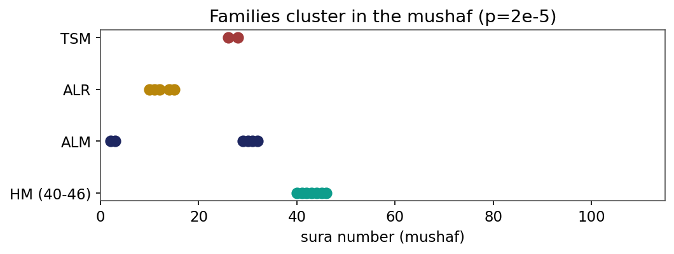
Figure 1. Disjoint-letter families cluster in mushaf order (label-permutation p=2x10^-5).
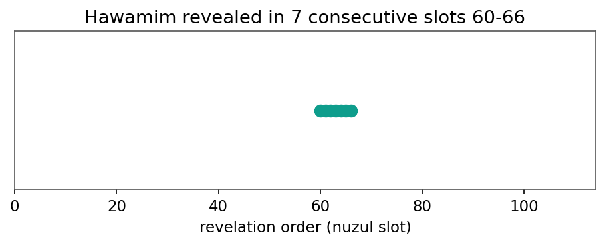
Figure 2. The Hawamim (HM) were revealed in seven consecutive slots (60-66).
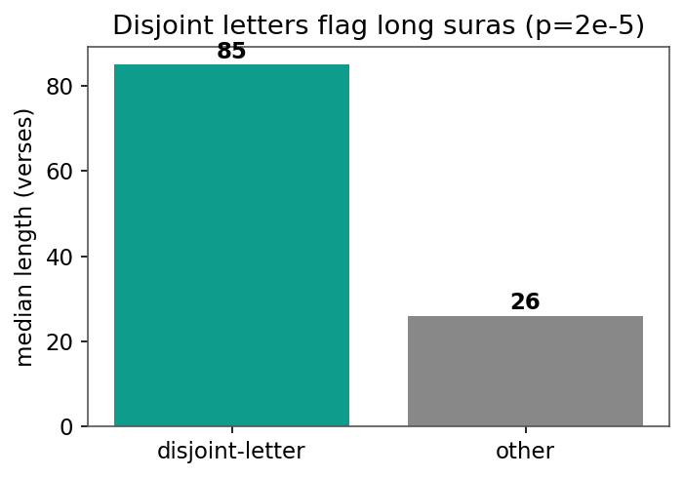
Figure 3. Disjoint-letter suras are the long ones (median 85 vs 26 verses, p=2x10^-5).
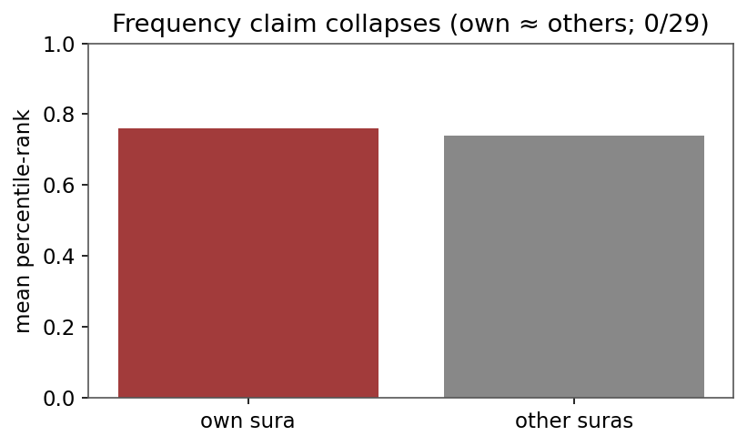
Figure 4. The frequency claim collapses under the cross-sura baseline (own ~ others; 0/29).
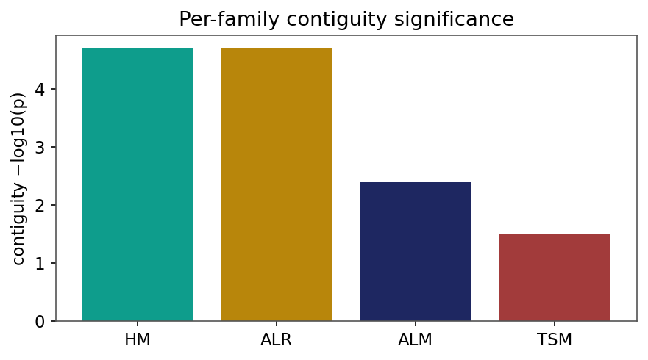
Figure 5. Per-family contiguity significance (-log10 p).
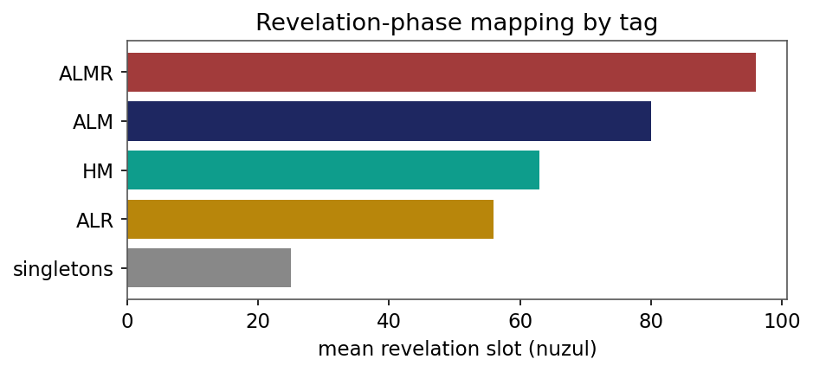
Figure 6. Revelation-phase mapping: mean nuzul slot by tag (simple early, families late).
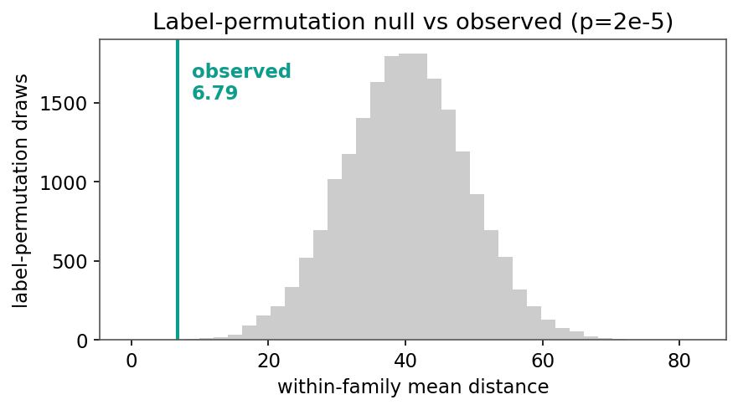
Figure 7. Label-permutation null vs the observed within-family distance (p=2x10^-5).
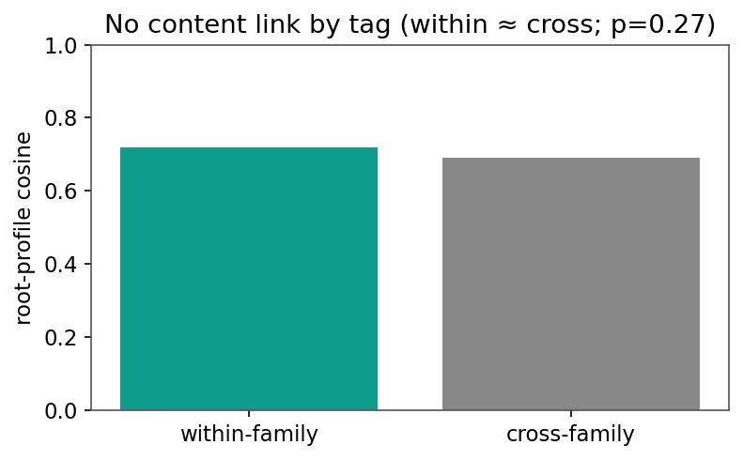
Figure 8. No content link by tag: within-family ~ cross-family root similarity (p=0.27).
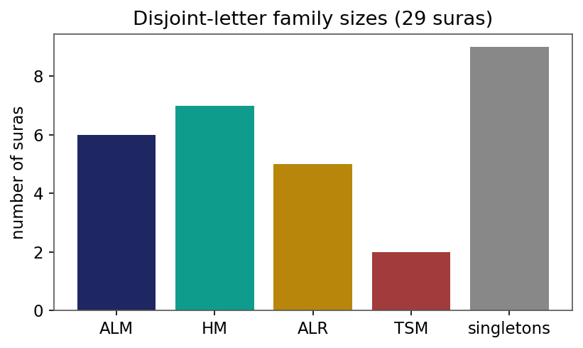
Figure 9. Disjoint-letter family sizes across the 29 suras.
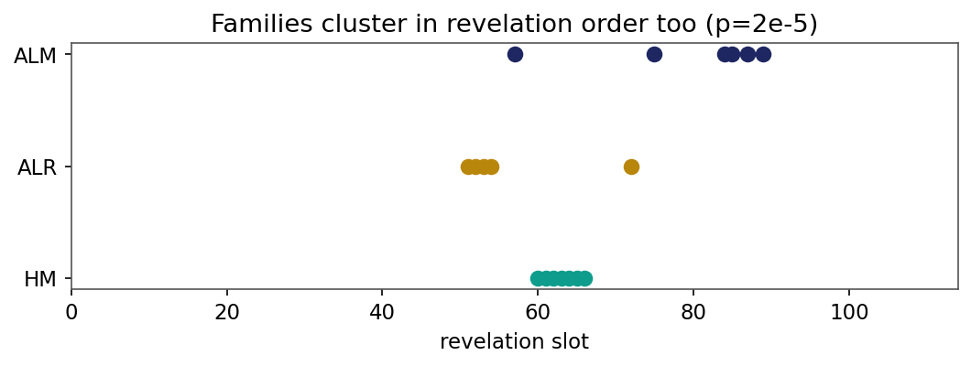
Figure 10. Same-tag families also cluster in revelation order.
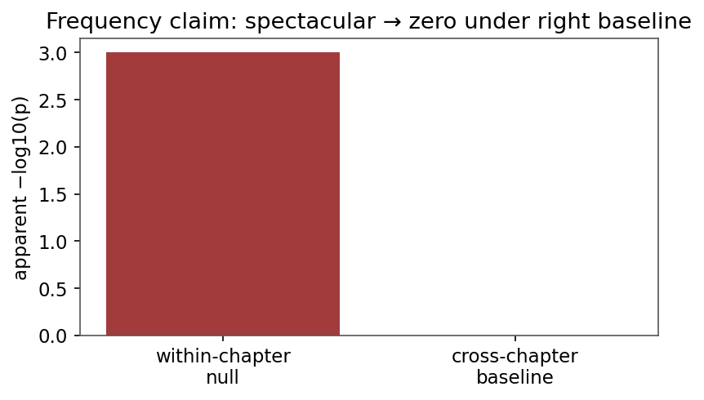
Figure 11. The frequency claim: spectacular under a weak null, zero under the right baseline.

