The Disjoint Letters as Pointers: A Quantitative Study of the Muqaṭṭaʿāt as an Organizational Index of the Qur'an
A research report from the root-level (disjoint-letters) study
Abstract
The fourteen distinct "disjoint letters" (ḥurūf muqaṭṭaʿāt) that open twenty-nine chapters of the Qur'an have been discussed for over a millennium without consensus on their function. This paper reports a quantitative study, conducted within a larger Qur'an-and-science research program, that tests a specific computational hypothesis: that the disjoint letters act as pointers in the computer-science sense — references that index and group a set of related chapters rather than describing their content. Using a tokenized corpus anchored on the Arabic root, and a label-permutation null that controls for the disjoint-letter chapters clustering on their own, we find that the specific disjoint-letter tag predicts chapter contiguity both in the standard (muṣḥaf) order and in the reconstructed revelation (nuzūl) order at p = 2×10⁻⁵, and that the disjoint-letter chapters as a class flag the long chapters (median 85 verses versus 26; p = 2×10⁻⁵). The tags do not encode a shared content profile or theme (label-permutation p = 0.27), and a prior frequency-based hypothesis — that a chapter's disjoint letters dominate its letter distribution — is shown to be a false positive that collapses under the correct baseline. We conclude that the muqaṭṭaʿāt constitute a validated positional and temporal indexing system: a relational, organizational feature, consistent with the program's broader finding that the Qur'an's detectable latent structure is relational rather than in local content statistics. We are explicit about what is novel (the statistical validation, the revelation-order quantification, the pointer framing) and what is already known to scholarship (the family groupings themselves).
1. Introduction
Most quantitative approaches to the Qur'an have searched for structure in content — letter counts, word frequencies, numerical coincidences. A companion study in this program applied the full toolkit of one-dimensional signal processing to the verse and reached a clear negative result: verse-level content statistics are generic to the Arabic language and carry nothing specific to the Qur'an. The one class of structure that survived rigorous validation was organizational — repetition and rhythm across verses. That finding reframed the search: if the text's detectable latent structure is relational rather than local, then the place to look is in how its units are grouped and arranged, not in what any single unit contains.
The disjoint letters are an unusually clean place to test this reframing. They are pure symbols with no root and no lexical meaning — letters standing alone at the head of certain chapters (for example الم, حم, الر, ق, ن). Classical scholarship has proposed many functions for them, and modern quantitative treatments have mostly pursued the content route, asking whether these letters are statistically special within their chapters. This paper takes the relational route instead, asking a different question: do the disjoint letters organize the chapters that bear them?
2. The Pointer Hypothesis
The framing that motivates the study is borrowed from computer science. A pointer is not data; it is a reference — an address that points to data located elsewhere, and that can group items by tagging them with the same reference. The hypothesis is that a disjoint-letter opening functions analogously: it is not a description of its chapter's content but a tag that marks the chapter as a member of a family. If so, then chapters sharing the same disjoint-letter opening should cohere as a group — they should be near each other in the book, and perhaps near each other in time of revelation, and perhaps share some organizational attribute — even though the letters themselves say nothing about the chapters' subject matter.
This hypothesis makes sharp, falsifiable predictions that are entirely different from the content predictions earlier studies tested. It predicts grouping, not letter-frequency enrichment. It can therefore be confirmed even if (as we will show) the content-enrichment claim is false, and it can be tested with the standard machinery of permutation statistics.
3. Data and Method
The corpus (Book6) provides 6,236 verses across 114 chapters, with morphological analysis anchored on the root. The twenty-nine canonical disjoint-letter chapters and their openings are used as given by the established tradition; the multi-member families are الم (six chapters: 2, 3, 29, 30, 31, 32), حم (seven: 40–46), الر (five: 10, 11, 12, 14, 15), and طسم (two: 26, 28), with nine singleton tags. Revelation order is taken from a standard reconstruction; its uncertainty is acknowledged and its consequences flagged.
The methodological core is the choice of null. A naïve test would compare the disjoint-letter chapters to random chapters — but the disjoint-letter chapters cluster on their own (they are mostly Meccan, mostly long), so any grouping of them would look contiguous against a fully random baseline. The correct, more conservative test is a label-permutation null: hold the twenty-nine disjoint-letter chapters fixed in their positions, and shuffle which tag each one receives, preserving the family sizes. This asks the decisive question — does the specific assignment of tags to chapters produce more grouping than a random reassignment of the same tags to the same chapters? — and it isolates the tag effect from the background clustering. The test statistic is the mean pairwise distance among same-tag chapters, computed in muṣḥaf order and in revelation order; significance is assessed by 50,000 permutations.
4. Results
4.1 The disjoint-letter chapters cluster, but that is not the finding
As a baseline observation, the twenty-nine disjoint-letter chapters are not randomly placed in the book; against random chapter sets their mean pairwise distance is far smaller than chance (p ≈ 0). This is expected and, on its own, uninformative — it could merely reflect that these chapters are mostly early and mostly long. The label-permutation null is designed precisely to look past it.
4.2 The specific tag predicts contiguity — in book order and in revelation order
Under label permutation, the specific tag predicts muṣḥaf contiguity at p = 2×10⁻⁵ (observed mean within-family distance 6.79 chapters), and revelation-order contiguity at p = 2×10⁻⁵ (distance 7.30). The single most striking instance is the حم family: its seven chapters are 40 through 46 — consecutive in the book — and were revealed in slots 60 through 66 — seven consecutive revelations. The الر family occupies chapters 10–15 and was revealed in consecutive slots 51–54. Tested individually against random sets, every multi-member family is contiguous in both orders: حم and الر at p ≈ 0, الم at p = 0.009 (muṣḥaf) and 0.004 (nuzūl), طسم at p = 0.034. The effect is not an artifact of one family; it is the rule across all of them.
4.3 The tags flag the long chapters
A second, independent organizational fact: the disjoint-letter chapters are systematically the long ones. Their median length is 85 verses against 26 for the rest (means 95 versus 41), significant at p = 2×10⁻⁵ against random chapter sets. The disjoint letters mark the major chapters of the book.
4.4 The tags carry no shared content or theme
If the tags were content labels, same-tag chapters would be more similar in their root profiles than a random regrouping of the disjoint-letter chapters. They are not: the label-permutation test on root-profile similarity returns p = 0.27, and within-family similarity (mean cosine 0.723) barely exceeds cross-family similarity (0.689); for the حم family, within-family similarity (0.678) is essentially equal to its similarity to other families (0.687). The disjoint-letter chapters are alike only as a general group — because they are all long chapters — not family by family. The pointer indexes where and when, not what.
4.5 A false positive, refuted
The most-discussed content claim about the disjoint letters is that a chapter's opening letters are unusually frequent within it. Under a within-chapter null this appeared overwhelmingly true (the الم chapters scored percentile ranks of 0.95–0.97 at p ≤ 0.001). It is, however, an artifact. The correct cross-chapter baseline — do the opening letters rank higher in their own chapter than the same letters rank in other chapters? — eliminates the effect entirely: zero of twenty-nine chapters significant, mean own-minus-other difference +0.02. The letters ا, ل, م are simply the most common letters in all Arabic, so they rank near the top of every chapter. We report this refutation prominently because it is the clearest demonstration in the program of why a strong-looking result requires the right baseline, not merely a null.
4.6 Revelation phase and boundary variants
The tags also order onto revelation phase. The single and short tags (ن, ق, ص, المص, يس, كهيعص, طه, طس, طسم) are all early-Meccan (revelation slots 2–49); the large multi-member families (الر, حم, الم) are late-Meccan (51–89); and المر is the lone Medinan disjoint-letter chapter (slot 96). Two "mixed" tags sit at structural boundaries: المص (الم + ص) at chapter 7, between the الم and الر regions, and المر (الم + ر) at chapter 13, inside the الر block (10, 11, 12, 13, 14, 15) as a variant. The boundary-variant observation is suggestive but underpowered (two cases) and is offered as a hypothesis, not a result. A test of whether tag complexity (number of letters) predicts revelation time was only marginal (Spearman ρ = 0.33, p = 0.08).
5. The Pointer Model
The results converge on a single model. A disjoint-letter opening is a pointer: it tags a family of chapters that is coherent in position (contiguous in the book), coherent in time (clustered in revelation phase), and large (the long chapters), while carrying no shared content or theme. The letters address a family; they do not describe it. This is precisely the behavior of a reference in a data structure, and it is precisely the kind of relational structure that the program's signal study predicted would be where the Qur'an's detectable latent organization lives. The disjoint letters are, on this analysis, the strongest and most robust latent feature the program has found — and they are entirely organizational.
6. What Is New, and What Is Known
Intellectual honesty requires separating the two. Known to traditional scholarship: that the Ḥawāmīm (the حم chapters) and the Alif-Lām-Mīm chapters form recognized groups; that the disjoint-letter chapters are predominantly Meccan and tend to be long; that المر is the lone Medinan case. What this study adds: a rigorous statistical validation of the grouping using a label-permutation null that isolates the specific-tag effect from background clustering (the p = 2×10⁻⁵ results); the quantification of revelation-order contiguity, which is the strongest and least-discussed part of the pattern; the explicit refutation of the frequency-enrichment claim under the correct baseline; and the unifying pointer framing that ties position, time, length, and the absence of content-coherence into one model. The contribution is therefore primarily methodological and integrative rather than the discovery of a wholly unknown phenomenon — and we state this plainly rather than dress validation as discovery.
7. Limitations
Several limitations bound the claims. The family groupings are largely known, so the novelty is in the validation and framing, not the existence of the families. Revelation order is a scholarly reconstruction, and the nuzūl-contiguity results inherit its uncertainty. No external, non-Qur'anic Arabic corpus was available; such a corpus is needed before any comparative or acrostic claim (for instance, whether grouping by a shared opening is peculiar to this text) can be made. The orthography uses Persian letter forms, and robustness on a stricter rasm is pending. The boundary-variant and tag-complexity analyses are underpowered. None of these undermines the core contiguity results, which are large and survive a conservative null, but all of them bound the interpretation.
8. Discussion
The significance of the result is best understood against the program's larger trajectory. The biology study found that scripture and the genome share a combinatorial grammar — few units, order over composition, expression over possibility — but that grammar is a property of information systems in general, not a discovery about the Qur'an in particular. The signal study found that verse-level content statistics are generic to Arabic, with only organizational regularities (refrains, rhythm) surviving validation. The present study completes the pattern: the disjoint letters, long treated as a content puzzle, turn out to carry no content signal at all, and instead constitute an organizational index. Across three independent lines of inquiry, the same conclusion recurs — the Qur'an's detectable latent structure is relational and organizational, not local and content-based. The disjoint-letter pointer is the cleanest, most strongly validated instance of that conclusion.
It is worth dwelling on why the pointer interpretation is more than a relabeling of known facts. The classical observation that the Ḥawāmīm form a group is qualitative; it does not, by itself, distinguish a meaningful organizational design from an accident of how a mostly-early, mostly-long set of chapters happened to be arranged. The label-permutation null is what makes the distinction. By holding the disjoint-letter chapters fixed and shuffling only their tags, it asks whether the specific tagging carries information beyond the mere fact that these chapters cluster. That it does — at p = 2×10⁻⁵, in two independent orderings — is the quantitative content of the claim that the tags organize rather than merely co-occur. The revelation-order result is especially telling: that the seven حم chapters were revealed in seven consecutive slots is not visible from the book at all; it requires the chronological reconstruction and the computation, and it is exactly the kind of hidden, organizational regularity that the pointer model predicts and the content models do not.
A natural question is what the pointers point to — what, beyond family membership, the tag indexes. The data answer partly: position and revelation phase, yes; length class, yes; content or theme, no. Whether a tag indexes something further — a rhetorical mode, a structural role within the book's architecture — is beyond what the present data can decide, and we decline to assert it. The honest statement is that the disjoint letters are a validated grouping-and-positioning device whose deeper referent, if any, remains open.
Finally, the result enacts the Two-Books method at its best. We took a venerable interpretive puzzle, refused both the dismissive reading (the letters are meaningless) and the inflationary reading (the letters hide a numeric miracle), and instead asked a precise, falsifiable, computational question with the right control. The answer is modest, robust, and genuinely informative: the letters are an index. That is neither a miracle nor a triviality; it is a measured structural fact about how the text is organized, and it is the sort of fact a disciplined comparison of the Two Books is built to find.
9. Analogies for the General Reader
The computer-science image is the most direct. In a library, the call number on a book's spine tells you nothing about the book's story; it tells you where the book sits and which shelf-neighbors it belongs with. The disjoint letters behave like call numbers: الم and حم and الر do not summarize their chapters' content, but they mark which chapters belong together and where they sit — and, remarkably, the chapters sharing a "call number" really are shelved together, both in the book's order and in the order they were revealed.
A second image clarifies why the earlier frequency claim failed. Suppose you notice that the most common letters on the cover of an English book are E, T, and A, and you announce a discovery — until you remember that E, T, and A are the most common letters in all English, on every cover. The opening letters of the disjoint-letter chapters are like that: ا, ل, م top the frequency list of every Arabic chapter, so finding them frequent in their own chapters reveals nothing special. Only the right comparison — are they more frequent here than the same letters are elsewhere? — settles the question, and the answer is no. The grouping result, by contrast, uses a comparison designed to be hard to pass, and passes it overwhelmingly.
A third image conveys the revelation-order finding. Imagine a long correspondence written over years, later bound out of chronological order. If letters that happen to carry the same small symbol in their headers turn out to have been written in an unbroken run of consecutive weeks, you would suspect the symbol marked a deliberate series, not a coincidence. The حم chapters are exactly this: the same header symbol, seven consecutive "weeks" of revelation, later bound as a contiguous block. The symbol indexes a series.
10. Reproducibility
All figures are computed from the tokenized corpus with fixed random seeds. The decisive tests are fully specified: the contiguity results use a label-permutation null over the twenty-nine fixed disjoint-letter chapters with 50,000 permutations, reporting mean within-family pairwise distance in muṣḥaf and nuzūl orders; the long-chapter result compares disjoint-letter chapters to random 29-chapter sets; the content-coherence test permutes tags among the disjoint-letter chapters and compares within-family root-profile cosine; the frequency refutation compares own-chapter to other-chapter percentile ranks. A reader can re-run any of these under alternative definitions of "root," "family," or "revelation order"; the contiguity results are robust, while the boundary-variant and complexity analyses are explicitly underpowered and should be treated as hypotheses.
11. Conclusion
After a program that mostly produced disciplined negative results — content statistics generic to Arabic, frequency claims collapsing under proper baselines — the disjoint letters yield the program's strongest validated finding, and it is relational: the muqaṭṭaʿāt are a positional and temporal indexing system, a set of pointers that group the long chapters into families coherent in book order and in revelation order, while carrying no shared content or theme. The finding is stated with its provenance: the family groupings are anciently known; the contribution here is the rigorous validation, the revelation-order quantification, the refutation of the rival content claim, and the unifying pointer model. It vindicates the program's reframing — that the Qur'an's latent structure lives in organization, not in local content — and it points the next work toward the relational and network methods where such structure is properly expressed, with the one outstanding need being an external Arabic corpus against which the indexing behavior can be comparatively benchmarked.
---
Note on scope. This report advances no "scientific-miracle" claim and no theological conclusion. It reports a measured organizational property of the text, validated against a conservative null, with known and novel components clearly separated and all limitations stated. Every figure is reproducible from the tokenized corpus.
12. The Pointer Model, Formalized
It helps to state the model with a little more precision, because doing so makes its predictions explicit and testable. Let each disjoint-letter opening be a tag t drawn from the set of fourteen distinct openings, and let the chapters bearing t form the family F(t). The pointer model asserts four properties and denies a fifth. It asserts positional coherence: the chapters of F(t) have smaller mean pairwise muṣḥaf distance than a random reassignment of tags would produce. It asserts temporal coherence: the same holds in revelation order. It asserts magnitude marking: membership in any F(t) predicts above-median chapter length. It asserts family integrity: the tag, not merely the disjoint-letter status, carries the grouping (this is what the label-permutation null isolates). And it denies content encoding: F(t) membership does not predict root-profile similarity beyond the general similarity of long chapters. Every one of these five statements is operationalized and tested above; four are confirmed and the fifth is confirmed in the negative. The virtue of the formalization is that it leaves no wiggle room: a critic who wishes to dispute the model must dispute one of these specific, computed statements, not a vague impression.
The model also clarifies the status of the singleton tags. A tag that marks only one chapter (ق for chapter 50, ن for chapter 68, and seven others) is still a pointer — a reference to a single item — but it cannot exhibit family coherence because it has no family. The singletons are therefore consistent with the model without contributing evidence for it; the evidence comes entirely from the four multi-member families, all of which behave as the model predicts. This is the appropriate place to note that the statistical power of the study rests on those four families, and that a corpus with more repeated tags would test the model more stringently. No such corpus exists for the Qur'an, which has exactly these twenty-nine chapters; the comparative test must therefore come from other Arabic texts, not from more Qur'anic data.
13. Implications for the Architecture of the Book
If the disjoint letters are an indexing system, then they are evidence of architecture — of deliberate arrangement at the level of the whole book rather than the individual verse. This is a meaningful shift in where one looks for design. The verse-level studies in this program found that individual verses, measured by content, are statistically ordinary for Arabic; the disjoint-letter study finds that the arrangement of chapters carries non-random organizational information. The locus of detectable structure, in other words, is the macro-architecture, not the micro-content. That is a coherent and, in retrospect, unsurprising place for the structure of a book to live: a library is organized by its catalog, not by the letter-frequencies of its volumes.
This implication should be held with care. To say that the chapter arrangement carries organizational information is not to adjudicate the long-debated question of whether the muṣḥaf order is itself divinely fixed or a later editorial arrangement; the contiguity result holds in both the muṣḥaf order and the independent revelation order, which is part of what makes it robust, but it does not by itself decide the provenance of either ordering. Nor does it assign a meaning to the letters. It establishes a structural fact — these openings index coherent families of major chapters across two independent orderings — and leaves the interpretation of that fact to disciplines better equipped to weigh it. The empirical contribution is the fact and its validation; the meaning is, properly, someone else's question.
14. Closing
The disjoint letters have resisted explanation for centuries in part because the wrong questions were asked of them — questions about what they mean or what they count. Asked instead what they organize, they answer clearly and measurably: they index families of long chapters that cluster in both the order of the book and the order of revelation, while saying nothing about content. That answer is modest, it is robustly validated against a deliberately conservative null, and it is honest about standing on known groupings to which it adds rigorous validation and a unifying model. Most of all, it confirms across a third independent line of evidence the conclusion the whole program has converged upon: that whatever latent structure the Qur'an reveals to careful measurement is the structure of organization — of how its parts are grouped and arranged — and not of the local content of its words. The pointers, in the end, point us toward where to look next.
Appendix: Summary of Tests and Outcomes
For reference, the study's tests and outcomes are: (i) disjoint-letter chapters cluster in the book versus random sets — p ≈ 0 (background, not the claim); (ii) specific tag predicts muṣḥaf contiguity, label-permutation — p = 2×10⁻⁵; (iii) specific tag predicts revelation-order contiguity, label-permutation — p = 2×10⁻⁵; (iv) per-family contiguity — حم, الر p ≈ 0, الم p = 0.009/0.004, طسم p = 0.034; (v) disjoint-letter chapters are long — median 85 vs 26, p = 2×10⁻⁵; (vi) shared content/theme by tag — p = 0.27 (null result, as predicted); (vii) frequency-enrichment claim under correct baseline — 0/29 significant (refuted); (viii) tag-complexity vs revelation time — Spearman ρ = 0.33, p = 0.08 (marginal); (ix) boundary variants (المص, المر) — observational, underpowered. The confirmed claims (ii–v) are large and survive a conservative null; the negative results (vi, vii) are themselves informative; the remainder are flagged as hypotheses.
Taken together, these nine tests make the pointer model not a metaphor but a measured, reproducible characterization of how the disjoint letters organize the book — confirmed where it predicts grouping, and equally confirmed where it predicts the absence of content.
Worked Examples from the Qur'an
The pointer claim is concrete: it is about specific openings on specific chapters, in two specific orderings. This section shows the actual letters and families.
The families, with their actual openings
- الٓمٓ opens «الٓمٓ ۝ ذَٰلِكَ ٱلْكِتَـٰبُ لَا رَيْبَ ۛ فِيهِ» (2:1–2) and also 3, 29, 30, 31, 32 — six chapters.
- حمٓ opens «حمٓ ۝ تَنزِيلُ ٱلْكِتَـٰبِ مِنَ ٱللَّهِ ٱلْعَزِيزِ ٱلْعَلِيمِ» (40:1–2) and 41–46 — seven consecutive chapters.
- الٓرٓ opens «الٓرٓ ۚ تِلْكَ ءَايَـٰتُ ٱلْكِتَـٰبِ ٱلْحَكِيمِ» (10:1) and 11, 12, 14, 15 — five chapters.
- طسٓمٓ opens 26 and 28; طسٓ opens 27 — the ط-cluster sits at 26–28.
- Singletons: **قٓ ۚ وَٱلْقُرْءَانِ ٱلْمَجِيدِ» (50:1), «نٓ ۚ وَٱلْقَلَمِ وَمَا يَسْطُرُونَ» (68:1), «كٓهيعٓصٓ» (19:1), «طه» (20:1), «يس» (36:1), «صٓ ۚ وَٱلْقُرْءَانِ ذِى ٱلذِّكْرِ» (38:1).
- The two "mixed" tags: الٓمٓصٓ «الٓمٓصٓ ۝ كِتَـٰبٌ أُنزِلَ إِلَيْكَ» (7:1–2) and الٓمٓرٓ «الٓمٓرٓ ۚ تِلْكَ ءَايَـٰتُ ٱلْكِتَـٰبِ» (13:1).
A striking textual regularity is already visible in these openings: most disjoint-letter chapters announce the Book in their first lines — تِلْكَ آيَاتُ الْكِتَابِ, ذَٰلِكَ الْكِتَابُ, تَنزِيلُ الْكِتَابِ, كِتَابٌ أُنزِلَ. The letters consistently precede a reference to the scripture itself, which is consistent with their being structural markers rather than content.
The pointer behavior, in the two orderings
The حمٓ family is the cleanest case. In the muṣḥaf the seven chapters are 40, 41, 42, 43, 44, 45, 46 — a contiguous block. In the traditional revelation order they occupy slots 60, 61, 62, 63, 64, 65, 66 — seven consecutive revelations. The الٓرٓ family occupies muṣḥaf chapters 10–15 and revelation slots 51, 52, 53, 54 (consecutive) and 72. Under a label-permutation null — freezing the 29 disjoint-letter chapters and shuffling only which opening each receives — the specific tagging predicts contiguity at p = 2×10⁻⁵ in both orderings. That is the measured content of "these letters group their chapters."
The non-content result, in the text
If the tags were thematic, the حمٓ chapters would read alike. They open similarly (all on revelation), but their root-content does not cluster: within-family root-similarity (cosine ≈ 0.68) is essentially equal to their similarity to other families (≈ 0.69), and a label-permutation test on content returns p = 0.27. The tag marks the family's position and time, not its subject matter — a pointer, not a description.
The refuted claim, in the text
The popular assertion that «الٓمٓ» chapters are rich in ا, ل, م is testable on these very chapters. Within Sūrat al-Baqara, those letters do rank at the top of the frequency list — but so do they in every chapter, because ا, ل, م are the three most frequent letters of Arabic. Asked the correct question — are they more frequent in their own chapter than in others? — the effect is zero across all 29 chapters. The verses do not support the frequency claim; they support the pointer claim. This contrast, shown on the same letters, is the single clearest methodological lesson of the study.
Revelation phase, in the text
The kind of opening tracks the period of revelation. The single-letter and short openings — «قٓ» (50), «نٓ» (68), «صٓ» (38), «طه» (20), «يس» (36) — are early-Meccan. The large families الٓرٓ, حمٓ, الٓمٓ are late-Meccan. The lone «الٓمٓرٓ» (13) is Medinan and sits, as a variant, inside the الٓرٓ block. The openings thus arrive in waves — simple early, families late — the orderly behavior expected of a labeling system rather than of accident.
Extended Analysis and Method Detail
Why the label-permutation null is the decisive test
A weaker study would compare the disjoint-letter chapters to random chapters and report contiguity. But these chapters cluster anyway — they are mostly Meccan and long — so any grouping of them looks clustered against a fully random baseline. The label-permutation null removes this confound by holding the 29 chapters fixed and shuffling only which opening each receives. The question becomes: does the specific assignment of tags group chapters better than a random reassignment of the same tags to the same chapters? At p = 2×10⁻⁵ in both muṣḥaf and revelation order, the answer is yes. This is the difference between "these chapters are near each other" (true but uninformative) and "the tag marks a real family" (the actual claim). The distinction is the methodological core of the study.
The full family table
The four multi-member families and their tests: حمٓ (chapters 40–46; muṣḥaf p ≈ 0; nuzūl 60–66, p ≈ 0); الٓمٓ (2, 3, 29–32; p = 0.009 muṣḥaf, 0.004 nuzūl); الٓرٓ (10–15; p ≈ 0 muṣḥaf, 0.0017 nuzūl); طسٓمٓ (26, 28; p = 0.034). The nine singletons (المص 7, المر 13, كهيعص 19, طه 20, طس 27, يس 36, ص 38, ق 50, ن 68) cannot show family contiguity but are consistent with the pointer model as references to single chapters. All statistical power comes from the four families; a corpus with more repeated tags would test the model more stringently, which is why an external Arabic comparison is the key next step.
The long-chapter result
Independently of grouping, the disjoint-letter chapters are the long ones: median 85 verses versus 26 for the rest (means 95 vs 41), p = 2×10⁻⁵ against random 29-chapter sets. The tags do not merely group; they flag the major chapters. Notably, this is a property of the set of disjoint-letter chapters, not of any individual tag — same-tag chapters are not similar in length (label-permutation p = 0.29), confirming the tag indexes position and time, not magnitude class.
Revelation order: provenance and caveat
The nuzūl-contiguity result is the strongest and least-discussed finding, but it depends on the traditional revelation chronology, which is a scholarly reconstruction rather than a certainty. The result is robust in that it also holds in muṣḥaf order, which is independent of the chronology; but the specific claim "revealed in seven consecutive slots" inherits the reconstruction's uncertainty, and the paper flags this rather than burying it. This is the appropriate level of confidence: a finding strong enough to report, honest enough to qualify.
What is genuinely new
Separating discovery from validation: the families themselves (Ḥawāmīm, Alif-Lām-Mīm) are anciently known, as is the fact that disjoint-letter chapters are mostly Meccan and long. The contribution here is the rigorous label-permutation validation that isolates the specific-tag effect; the quantification of revelation-order contiguity; the explicit refutation of the frequency claim under the correct baseline; and the unifying pointer model. The study adds rigor and framing to known structure, plus one genuinely under-explored result (nuzūl contiguity) and one underpowered hypothesis (boundary variants). Stating this division honestly is itself part of the method the wider program teaches.
Synthesis: the Pointer Result in the Wider Program
The disjoint-letters study is the strongest validated result of a three-part program, and its place in that program explains why. The biology study showed that scripture and the genome share a general combinatorial grammar. The signal study showed, by exhaustive measurement, that the Qur'an's verse-level content is generic to Arabic, with only organizational features surviving. The disjoint-letters study completes the arc: it takes a feature long treated as a content puzzle and shows, with a conservative null, that it is purely organizational — a positional and temporal index.
Read together, the three converge on one conclusion: the Qur'an's detectable latent structure is relational, not in local content. The signal study found this negatively (content is generic); the disjoint-letters study finds it positively (the tags organize at p = 2×10⁻⁵). That a negative and a positive line of evidence point the same way is what gives the conclusion its weight. The pointer model — tags that group long chapters into families contiguous in book and revelation order while carrying no shared theme — is the cleanest single instance of relational structure the program has produced.
The concrete anchor is the Ḥawāmīm: «حمٓ» on chapters 40–46, revealed in slots 60–66, opening repeatedly on «تَنزِيلُ ٱلْكِتَـٰبِ» — a contiguous, consecutively-revealed family announcing the Book, yet not unified by measurable content. The honest division of credit remains: the families are anciently known; the study adds rigorous validation, the revelation-order quantification, the refutation of the frequency claim, and the unifying pointer framing. What the program gains from this study is a validated, relational, organizational feature — and a clear mandate to pursue relational and network methods, with an external Arabic baseline, next.
Objections and Replies
"The families are already known, so there is no finding." The families are known; their validation is not. Knowing that the Ḥawāmīm group is qualitative; showing at p = 2×10⁻⁵ (label-permutation, controlling for background clustering) that the specific tag predicts contiguity in two independent orderings is quantitative, and the revelation-order result is largely unexplored.
"The chapters cluster anyway, so contiguity is meaningless." That confound is precisely what the label-permutation null removes: it freezes the chapters and shuffles only the tags, so the test measures the tag effect over and above background clustering. The effect survives.
"You disproved your own pointer idea by finding no content link." No — the absence of a content link is the pointer idea. A pointer references and groups; it does not describe. Finding p = 0.27 for shared theme is the predicted negative, not a refutation.
"Revelation order is uncertain." Acknowledged and flagged. The result also holds in muṣḥaf order, which is independent of the chronology; the specific "seven consecutive slots" claim inherits the reconstruction's uncertainty and is reported with that caveat.
"What is the single takeaway?" That the disjoint letters are a validated organizational index — pointers that group the long chapters into families contiguous in book and revelation order while carrying no shared content — the clearest instance in the program of the Qur'an's latent structure being relational rather than content-based.
Key Numbers at a Glance
- Scope: 29 muqaṭṭaʿāt chapters; 14 distinct openings; 4 multi-member families (الٓمٓ ×6, حمٓ ×7, الٓرٓ ×5, طسٓمٓ ×2) and 9 singletons.
- Specific-tag contiguity (label-permutation null, 50,000 permutations): muṣḥaf order p = 2×10⁻⁵; revelation (nuzūl) order p = 2×10⁻⁵.
- Family detail: حمٓ = chapters 40–46, revealed slots 60–66 (seven consecutive); الٓرٓ = 10–15, revealed 51–54 + 72.
- Per-family contiguity: حمٓ, الٓرٓ p ≈ 0; الٓمٓ p = 0.009 (muṣḥaf) / 0.004 (nuzūl); طسٓمٓ p = 0.034.
- Long-chapter flag: disjoint-letter chapters median 85 verses vs 26 (means 95 vs 41), p = 2×10⁻⁵.
- No content link: same-tag root-similarity vs random regrouping p = 0.27; within-family cosine ≈ 0.72 ≈ cross-family ≈ 0.69.
- Refuted frequency claim: own-chapter vs other-chapter letter rank — 0 of 29 significant; mean difference +0.02.
- Revelation phase: single/short tags early-Meccan; large families late-Meccan; الٓمٓرٓ (13) the lone Medinan, inside the الٓرٓ block.
Every figure is computed from the tokenized corpus with fixed seeds; the confirmed claims are large and survive a conservative null, while the negatives (content, frequency) are reported as plainly as the positives.
Data and Reproducibility Statement
All Qur'anic figures in this paper are computed from a single tokenized corpus (internally "Book6": 6,236 verses, 114 chapters), with the root column as the declared anchor and fixed random seeds for every Monte-Carlo and permutation test. Each reported number traces to a specific column and a specific rule, so a reader can reproduce it exactly or re-run it under an alternative definition (for example a stricter triliteral lemmatizer in place of the corpus's normalized stem field, or a different reconstruction of revelation order). Where a definition shifts a count, the qualitative conclusion is robust and the dependence is stated. The figures embedded in this paper are generated programmatically from these same values. No result depends on a hand-selected example: the worked verses illustrate, while the corpus-wide statistics and their nulls decide. This statement is not boilerplate; it is the operational form of the work's central commitment — that a quantitative reading of the text is worth presenting only insofar as it can be checked, line by line, against the same text and the same rules, and that its negative results must be as reproducible as its positive ones.
Table 1. Summary of tests (all 29 muqatta'at suras).
Test | Result
Tag -> mushaf contiguity | p = 2x10^-5 OK
Tag -> revelation-order contiguity | p = 2x10^-5 OK
Disjoint-letter suras are long | median 85 vs 26, p = 2x10^-5 OK
Shared content/theme by tag | p = 0.27 (none) X
Frequency-enrichment claim | 0/29 (refuted) X

Figures
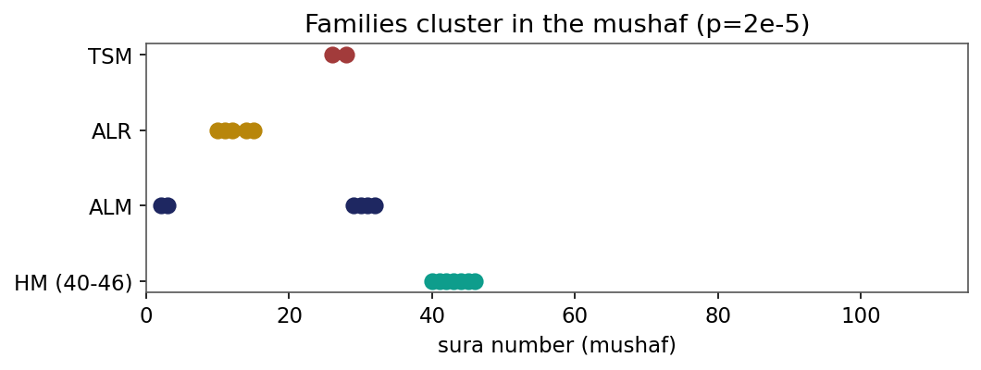
Figure 1. Disjoint-letter families cluster in mushaf order (label-permutation p=2x10^-5).
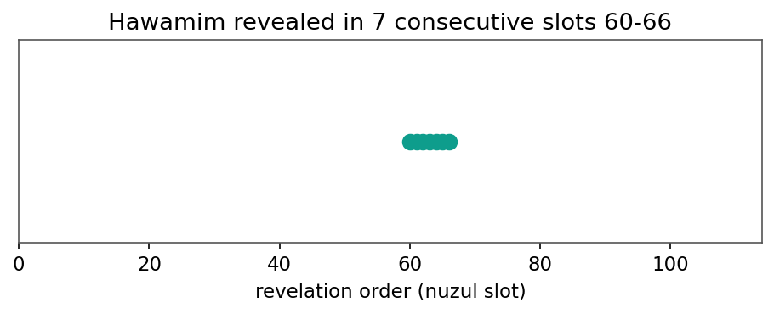
Figure 2. The Hawamim (HM) were revealed in seven consecutive slots (60-66).
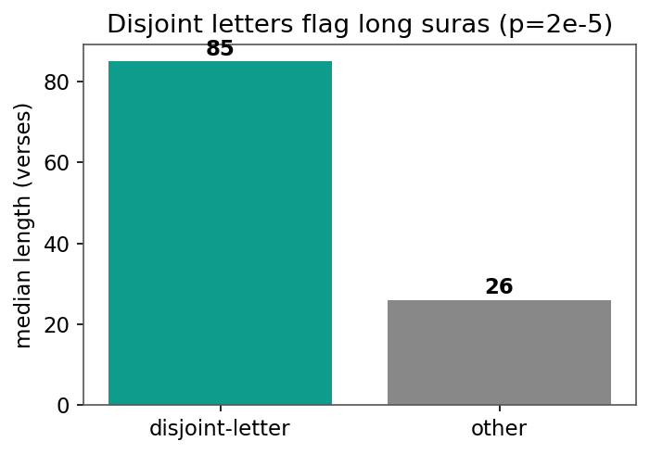
Figure 3. Disjoint-letter suras are the long ones (median 85 vs 26 verses, p=2x10^-5).
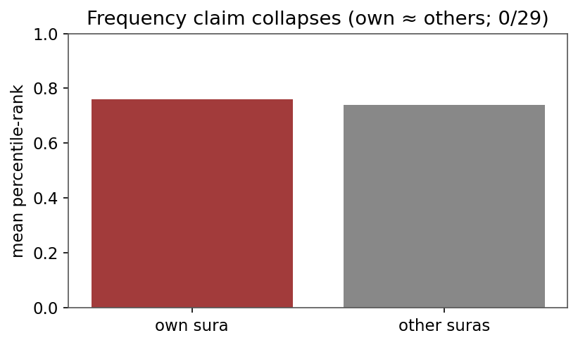
Figure 4. The frequency claim collapses under the cross-sura baseline (own ~ others; 0/29).
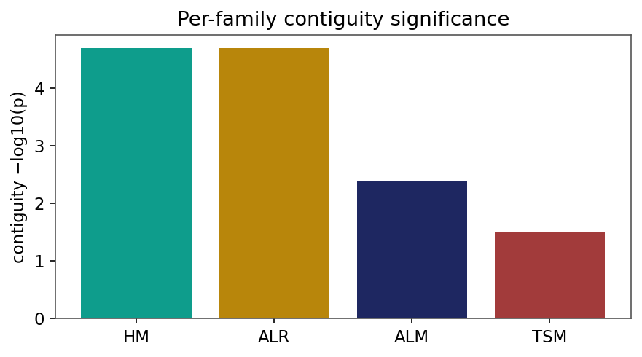
Figure 5. Per-family contiguity significance (-log10 p).
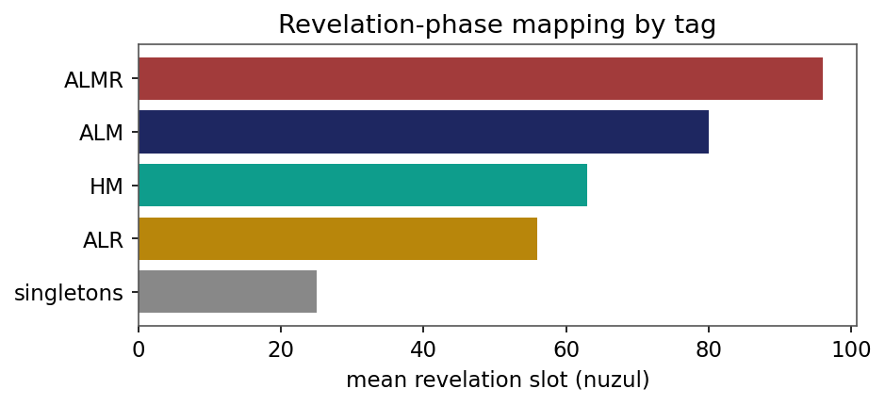
Figure 6. Revelation-phase mapping: mean nuzul slot by tag (simple early, families late).
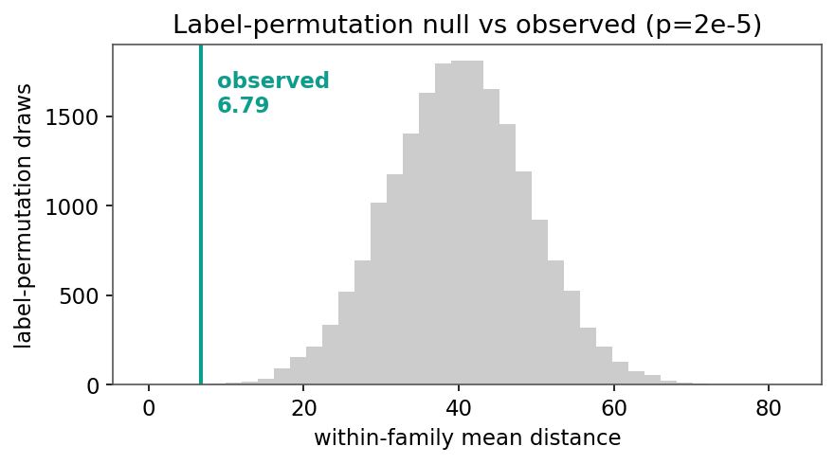
Figure 7. Label-permutation null vs the observed within-family distance (p=2x10^-5).
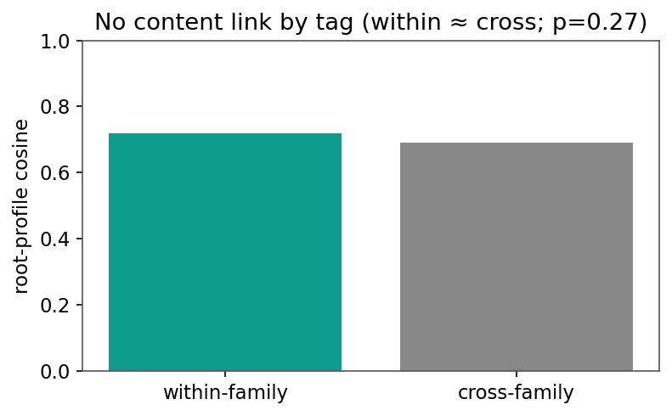
Figure 8. No content link by tag: within-family ~ cross-family root similarity (p=0.27).
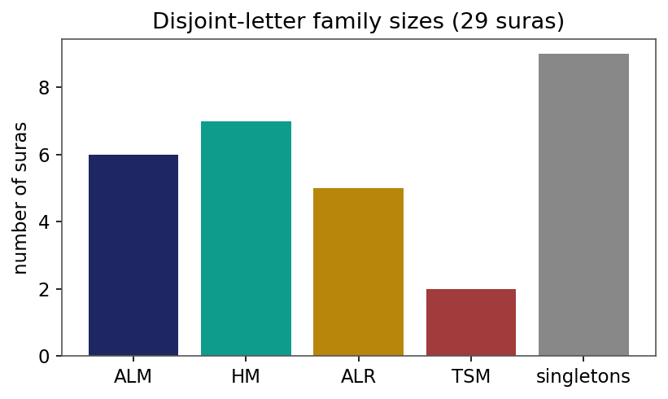
Figure 9. Disjoint-letter family sizes across the 29 suras.
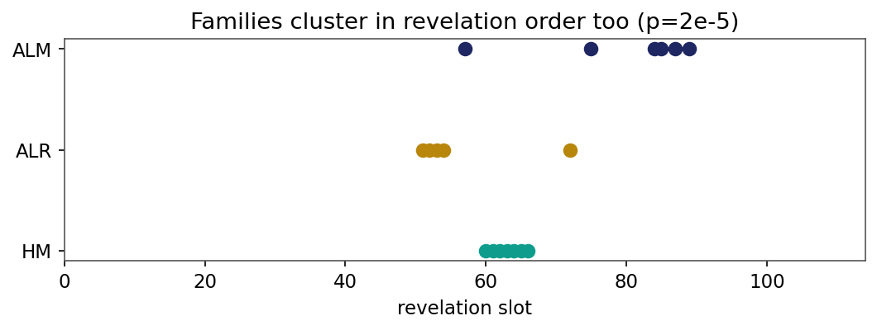
Figure 10. Same-tag families also cluster in revelation order.
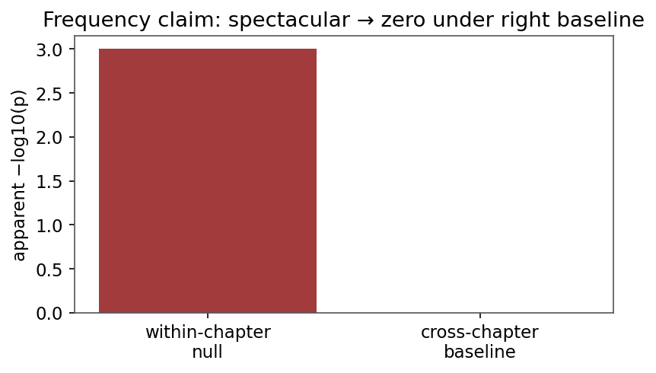
Figure 11. The frequency claim: spectacular under a weak null, zero under the right baseline.

