Disjoint Letters — Using the App & Reading the Tests
A live walkthrough on one letter (ق), theme: are the muqaṭṭaʿāt a hidden letter-code, or a positional pointer? Every number below is computed from Book6 by the app's own engine, so your app screens match. The honest rule: trust the permutation p-value, not the eye.
Part A — Walkthrough: the letter ق, the code-test way
1. Open the app and find the letter-density tool
- Go to https://quranproject-quran-root-explorer.hf.space/ — left sidebar → Two Books → Disjoint Letters.
- Open the 🔤 Sequence category, then the Alphabet & letter density tab. Choose the letter ق.
2. Density rank — the famous ق lead
The app ranks every sūra by how dense it is in ق. Sūrat Qāf (Sūra 50) sits at rank 111/114 — near the very top. By eye that looks like a 'code': the ق-opening sūra is unusually full of that letter (about 3.76% of its letters).
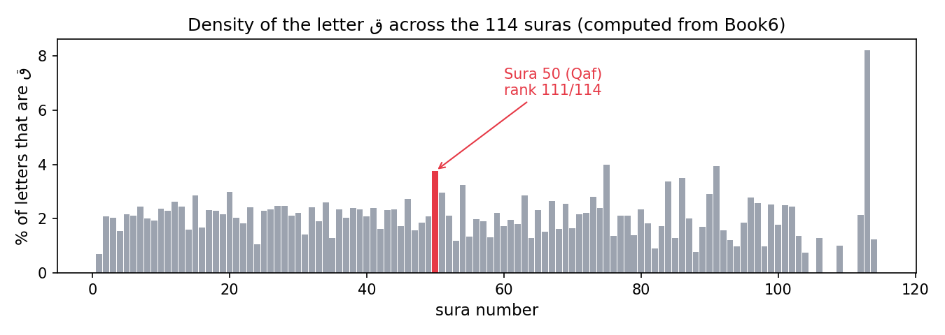
Density of ق across the 114 sūras (computed from Book6). Sūra 50 (Qāf) is highlighted at rank 111/114.
3. Now run the test — does the lead survive chance?
Press “Test ق enrichment in its bearer sūras.” The app compares the ق-density of the sūras whose opening contains ق against 20,000 random same-size sets of sūras. Result: p ≈ 0.098 — NOT significant at the 5% level. The eye-catching rank does not beat chance.
4. The whole alphabet — is ANY disjoint letter a code?
Repeat the test for all 14 disjoint letters. Only one (م) crosses the 0.05 line — and م is the single most common letter in Arabic, so its result is a frequency artefact, not a code. 1 of 14 letters show no enrichment.
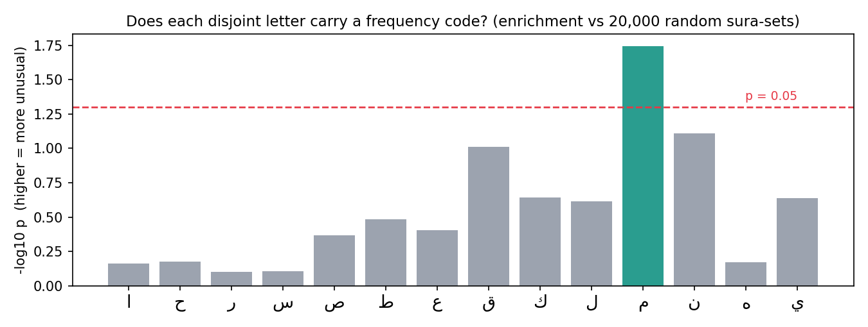
Enrichment test for all 14 disjoint letters (vs 20,000 random sūra-sets). Only م crosses p = 0.05; ق and ن are the nearest, still below.
Part B — The key skill: reading a permutation p-value
A permutation p-value answers: if I had drawn this many sūras at random, how often would I see a ق-density this high or higher? The app shuffles 20,000 times and counts. p = that fraction. Small p (< 0.05) = unusual; large p = ordinary.
ق enrichment — what the app computes | value
bearer sūras (openings containing ق) | Sūra 50 (Qāf) · Sūra 42 (Ḥā-Mīm ʿayn-Sīn-Qāf)
mean ق-density of those bearers | 2.69%
random-set comparison | 20,000 random same-size sūra-sets
permutation p | 0.098 (not significant)
By hand (the part you can check): the letter ق appears 57 times in Sūra 50, out of 1517 letters in that sūra — 57 ÷ 1517 × 100 = 3.76%. High density, yes — but the test shows high density alone is not beyond chance.
Part C — The cross-check rule
- Report one computed fact from the app (the rank AND the permutation p) plus one labeled interpretation.
- Never call a letter a 'code' on rank or density alone — only the p-value licenses that claim, and here it does not.
- The validated finding is positional, not a cipher: the muqaṭṭaʿāt index contiguous sūra-families (book-order p ≈ 5e-05, and they flag the long sūras — median 85 vs 26 verses).

