Reading a Verse Like a Recording — and an Honest "We Mostly Found Nothing"
A plain-language companion to the Qur'an ↔ Signal Processing study. Few technical words, many everyday pictures, and an honest ending.
The big idea in one breath
When your phone records your voice, it turns a sound into a long list of numbers a computer can measure. This study does the same thing to a Qur'anic verse: it turns the verse into a list of numbers — a "signal" — and then measures it with the standard tools engineers use on sound, heartbeats, and earthquakes. The point was simple and a little daring: if there is hidden structure in the text, these tools will find it; and if there isn't, these tools — used honestly — will say so. The result, told plainly, is mostly "there's nothing here that isn't just normal Arabic," with one real exception. That honest "nothing," as we'll see, is actually worth a great deal.
Turning a verse into numbers
To measure anything, you first have to turn it into numbers. We do that by walking through a verse word by word and giving each one a number — for example, how often that word's root appears in the whole Qur'an. Line those numbers up and you have a little graph that rises and falls, exactly like the squiggle of a heartbeat on a monitor. Once a verse is a squiggle, every tool that reads heartbeats and sound can read the verse too.
There's a careful choice hidden here: which part of the word do we measure? Arabic words are built from a three-letter "root" that carries the meaning, plus little glue pieces like "the" and "and." We chose to measure the roots — the meaning-carrying seeds — and ignore the glue. This matters more than it sounds. If you measure everything including the glue, the tiny word "the" (ال) shows up so often that two completely unrelated verses can look almost identical, just because they both use "the" a lot. It's like trying to compare two essays by counting how often each uses the word "the" — you learn nothing. Measuring the roots strips out that noise and lets the real content show. The moment we switched to roots, the amount of accidental "they look similar" between random verses dropped by about four times. So measuring the meaning-seed was both the wiser choice and the cleaner one.
The honesty machine
Here is the part that makes this study different from the usual "amazing patterns in the Qur'an" books. Before believing any pattern, we put it through a five-step honesty machine.
First, double-check the number — did we even count it right? Second, beat luck: we scramble the data thousands of times to see what pure chance produces, and the real pattern has to stand out from that crowd. Third — and this is the step most people skip — beat normal Arabic: lots of patterns are just how the Arabic language works, not anything special about the Qur'an, so we compare against fake "random Arabic" with the same letter and word habits. Fourth, don't get fooled by trying many things: if you test a hundred ideas, about five will look "significant" by luck alone, so we correct for that. Fifth, read it back: any pattern has to point to something you can actually find in the text, or it's just a number with no meaning.
Think of step three like this. Suppose you discover that a Qur'anic chapter is full of the letter "a." Exciting — until you remember that every Arabic text is full of "a," because "a" is just a common letter. To claim anything special, you have to show the chapter has more than normal Arabic would. That single habit — comparing against "normal Arabic," not just against random noise — is what catches almost all the false alarms.
The honest result: mostly normal Arabic
So what did the honesty machine return? Mostly a polite "no." When we measured the content of verses — how often roots appear, how long words are, how varied the vocabulary is — every single measurement matched what plain Arabic does. These are real numbers and they're interesting, but they describe the language, not the Qur'an specifically. A study that bragged "the Qur'an's word-frequencies follow a beautiful mathematical curve!" would be telling the truth and saying nothing, because every Arabic book follows the same curve.
We even caught ourselves nearly falling for a famous one. There's a long-standing claim that the mysterious letters opening some chapters (like "A-L-M") are unusually common inside those chapters. We tested it one way and got a spectacular result — the kind you'd put on a poster. Then we tested it the right way, comparing against how common those letters are in other chapters, and it completely evaporated. The letters A, L, and M are simply the most common letters in all of Arabic, so of course they're common everywhere. The honesty machine caught a beautiful false alarm that a less careful study would have published and celebrated. That catch is one of the most valuable things the whole study produced.
The one real survivor: the chorus
Against all this honest "nothing," one kind of pattern survived every test — and it's a lovely one. Some verses repeat, like a chorus in a song. Sūrat ar-Raḥmān repeats the line "So which of the favors of your Lord would you deny?" thirty-one times. When we measured how much the Qur'an repeats whole verses compared to normal Arabic, it repeats them about nine times more often, and that beats chance. And when we treated ar-Raḥmān as a piece of music and asked "how often does the chorus come back?", the math answered cleanly: every two verses, like clockwork — and two completely different tools (one that checks for rhythm, one that checks for musical pitch) agreed on the same beat.
Notice what kind of thing this is. The chorus isn't hidden inside any single verse's content. It's in the arrangement — in how the verses are laid out across the chapter. The one thing the signal tools genuinely found was not about content at all. It was about organization.
The lesson that reframed everything
Step back and a pattern in the patterns appears. Everything that turned out to be just "normal Arabic" was about the content of individual verses — their word counts, their lengths, their variety. The one thing that was genuinely special about the Qur'an was about arrangement — the repeating chorus. Even the lone success was organizational.
That pushed us to a new way of thinking, which we state carefully as a strong hunch rather than a proven law: the Qur'an's hidden structure, the kind you can actually measure, lives in how its parts are arranged, not in the content of any single part. This completely changes how to read the whole signal study. It wasn't a failed treasure hunt. It was the careful groundwork that earned this conclusion — it checked, thoroughly and honestly, that the treasure isn't in the content, which is exactly what lets you trust the claim that it's in the arrangement instead. You have to rule out the simple explanation before you're allowed to believe the interesting one.
Why an honest "nothing" is worth so much
It's tempting to feel let down. We brought powerful tools and mostly found "normal Arabic." But consider: a method that only ever finds amazing things is broken, because the world isn't that generous. The trustworthiness of a tool is shown by what it refuses. Ours refused a poster-ready false alarm the instant it met the right comparison. A scale you can trust is one that sometimes reads zero. Ours read zero honestly, again and again — and then, on the one real thing, read something real. That's not a disappointing study; that's a working one.
Pictures to keep
A few images hold the whole thing. Digitizing a verse: your phone turning your voice into numbers — then you can measure it, but you can also be fooled by it, which is why you always ask "what would random text do?" Measuring the root, not the glue: comparing essays by their ideas, not by how often they say "the." Beating normal Arabic: not being impressed that a chapter is full of "a," because every chapter is. The one survivor: a song's chorus that returns every other line — not a feature of any single line, but of how the lines are arranged. If you keep only the last picture, keep this: the music wasn't in the notes; it was in the pattern of when they repeated.
What we did and didn't claim
We did not claim a hidden code. We did not claim a miracle. We did not even claim the Qur'an's word-statistics are special — we showed, honestly, that they're ordinary for Arabic. We claimed exactly one positive thing, fully tested: the Qur'an repeats verses far more than chance, in measurable rhythms, and that repetition is an arrangement feature. And we claimed one reframing: look for structure in the arrangement, not the content. Everything else, we marked honestly as "ordinary," "an artifact," or "we can't tell."
Where this leaves us
The plain truth is freeing. Spend the effort to measure carefully, and the verse's content turns out to be normal Arabic, while its genuine fingerprint is organizational — its choruses and their beat. That sends the next stage of work in a clear direction: stop squeezing single verses for hidden content, and study how the parts are grouped and arranged, because that's where the real structure showed up. The signal study's gift isn't a dazzling discovery; it's a trustworthy "no" that makes the eventual "yes" believable, and a habit of checking that you can carry into any claim, sacred or secular, that someone insists is "amazing."
The recording idea, told more slowly
Let's go back to the phone for a moment, because the whole study rests on this one move. When you speak, the air carries a smooth, continuous wave. Your phone can't store "smooth"; it stores numbers. So thousands of times a second it measures the wave's height and writes down a number. Played back fast, those numbers fool your ear into hearing your voice again. That list of numbers is a signal, and a century of clever math exists for poking at such lists: finding rhythms in them, smoothing them, comparing two of them, spotting repeats.
A verse can become the same kind of list. Walk along it word by word; at each word, write a number. We used "how common is this word's root across the whole Qur'an," so a verse with a very common root next to a very rare one becomes a list like "tall, short, medium" — a little skyline. Now the verse is a signal, and all that clever math applies. You can ask whether the skyline repeats, whether it has a rhythm, whether it looks like another verse's skyline. The promise was never that this would reveal secrets; it was that it would give us honest, measurable answers — including the answer "nothing special here," which most excited studies are unable to give because they have no way to be disappointed.
Why we measured the seed and ignored the glue
Imagine two students hand in essays, and you want to know if one copied the other. A lazy method: count how often each essay uses "the," "of," "and." Both essays will score almost the same, because everybody uses those words constantly — and you'll wrongly conclude they're nearly identical. A better method: ignore the glue words and compare the meaningful words, the ones that carry the topic.
Arabic makes this especially clean, because the meaning lives in a three-letter root, and the grammar adds predictable glue around it. By measuring roots and dropping the glue, we compare verses by their substance, not by their "the"s and "and"s. We could measure it: with the glue left in, two random verses looked about 18% similar just from shared glue; measuring roots only, that accidental similarity fell to about 4%. The lesson is general and worth carrying everywhere: before you measure, make sure you're measuring the thing that matters, not the packaging. A surprising amount of "amazing pattern" in text studies turns out to be packaging.
The honesty machine, step by step
People sometimes think statistics is about producing impressive numbers. It's really about not fooling yourself, and our five steps are five different ways people get fooled.
You can be fooled by a typo — so step one is to recompute the number and make sure it's right. You can be fooled by chance — so step two scrambles the data thousands of times and asks whether your pattern stands out from what randomness alone coughs up. You can be fooled by the language — so step three compares against fake "normal Arabic," because a pattern that any Arabic text would show tells you nothing about this text. You can be fooled by trying lots of things — test enough ideas and a few will sparkle by luck, so step four tightens the bar when you've made many attempts. And you can be fooled by a meaningless number — so step five insists that any surviving pattern point back to something real you can see in the verses. A pattern that passes all five has earned a little belief. Most don't pass, and that's the machine working, not failing.
The false alarm, as a short story
This is worth telling slowly, because it's the most instructive thing that happened. There's a famous claim about the mysterious disconnected letters that open some chapters — for instance the letters A, L, M at the start of the longest chapter. The claim says these letters are unusually frequent inside their own chapter, as if each chapter were somehow "tuned" to its opening letters.
We tested it the obvious way: take the chapter, rank its letters by how common they are, and see where A, L, M land. They landed near the very top, with odds against chance of less than one in a thousand. For a moment it looked like a genuine discovery — exactly the kind of result that gets turned into a viral video.
Then we ran the honest comparison. Instead of asking "are these letters common in their chapter?", we asked "are they more common in their own chapter than the same letters are in other chapters?" The answer was a flat no — out of twenty-nine chapters, zero showed a real effect. The reason is almost embarrassingly simple: A, L, and M are the three most common letters in all of Arabic. They're near the top of every chapter. Finding them near the top of their own chapter is like being amazed that the ocean is wet. The first test felt like a discovery only because it asked the wrong question. The right comparison dissolved it instantly. We keep this story front and center, because it is the clearest possible demonstration of why "beats chance" is not enough — you also have to beat normal.
The chorus, as a piece of music
Now the happy part. Songs have choruses: a line that comes back again and again. We asked whether the Qur'an repeats whole verses more than ordinary Arabic does, and it does — by roughly nine to one, comfortably beyond chance. The clearest example is a chapter whose refrain, "So which of the favors of your Lord would you deny?", returns thirty-one times.
We then treated that chapter like a song and asked the musical question: how often does the chorus come back? Two different methods answered. One, which looks for rhythm by sliding the chapter against a delayed copy of itself, found a strong beat at "every two verses." The other, which breaks a signal into musical pitches, found a clear tone at exactly that same beat. Two independent instruments, one answer: the chorus pulses every other verse, like a steady heartbeat under the chapter. This survived every step of the honesty machine. It is real, it is the Qur'an's own (not generic Arabic), and — crucially — it is a fact about arrangement, about how the verses are laid out, not about what any single verse contains.
Putting the two results together
Here's the shape of the whole study in one move. Line up everything we found. On one side: word-frequency curves, word lengths, vocabulary variety — all "just normal Arabic." On the other side: the repeating chorus and its two-verse beat — genuinely the Qur'an's own. The first list is about content inside verses. The second is about arrangement across verses. The content side came back empty; the arrangement side came back full.
So we drew the careful conclusion that reframes the entire project: the measurable, hidden structure of the Qur'an seems to live in arrangement, not in content. We say "seems" on purpose — it's a strong hunch built on what we tested, not a theorem. But it's a hunch with teeth, because it explains both the empty results and the full one in a single stroke, and it tells you exactly where to look next: not deeper into single verses, but outward into how the verses and chapters are grouped and ordered.
Common questions, answered plainly
"If you mostly found nothing, was it a waste?" The opposite. Ruling out the simple explanation is what makes the interesting one believable. And we built a tool sharp enough to catch a famous false alarm — that sharpness is the lasting prize, usable far beyond scripture.
"Couldn't different choices have found more?" Maybe, and we say so. We tested a finite set of ways to turn verses into numbers; we don't claim there's nothing in the content, only that the natural ways of measuring it return normal Arabic. The honest stance is "here's what we tried and what it showed," not "we proved a negative."
"Isn't turning scripture into numbers irreverent?" We don't think so, any more than counting the words of a poem dishonors the poem. We never claim the numbers are the meaning; in fact we insist the opposite — the meaning is read back by a human, and the numbers are only a lens. The lens has blind spots, and we name them.
The bridge between the two books
There's a quiet beauty in the method itself. Scientists who study genes and stars use exactly these habits — scramble for luck, compare against a baseline, correct for many tries, read the result back into reality. By using the same habits on scripture, we read the Book of Words with the instruments and the skepticism of the Book of the World. The two books never touch; they meet in the reader who treats both with the same care. And notice that this discipline protects scripture from a certain kind of harm — the harm of being propped up by flimsy "miracle" claims that collapse the moment a skeptic checks them. An honest "this part is just normal Arabic, and this part is genuinely special" is sturdier ground than a poster full of patterns that can't survive a baseline.
The takeaway
Measured honestly, a Qur'anic verse's content is ordinary for Arabic, while the Qur'an's real fingerprint is organizational — its choruses and their two-verse beat. The study's gift is threefold: a trustworthy negative that makes the one positive believable, a caught false alarm that shows the method has teeth, and a clear new direction — study the arrangement, not the content. Keep the picture of the chorus: the music was never in the notes; it was in the pattern of when they came back. That is where we'll look next, and that is what careful measurement, used without flinching, was able to show.
(This plain-language version uses no jargon by design; every figure it cites matches the formal version and is reproducible from the tokenized corpus.)
One more picture, because it matters
Imagine a long shelf of identical-looking jars, and you're told one of them is special. You weigh each jar — all the same. You measure each jar's height — all the same. You count the beans inside — all the same. By every content measurement, no jar stands out; they're just ordinary jars of an ordinary kind. But then you step back and notice the arrangement: every third jar has a red lid, in a perfect repeating pattern down the shelf. Nothing about any single jar was special; the specialness was in the pattern of the lids. That is precisely what happened here. Verse by verse, the content was ordinary Arabic. Step back, and the arrangement — the repeating chorus, every other verse — was the thing that stood out. The moral is one worth keeping for any "find the hidden meaning" claim you ever meet: check the jars and check the shelf, because the structure may not be in the things but in how they're laid out.
A short word on what "beats normal" really buys you
It's worth naming why the "beat normal Arabic" step is the hero of this study. Almost anyone can find a pattern that "beats random," because random is a very low bar — real language is full of structure that pure dice-rolling lacks. The honest question is never "is this more than random?" but "is this more than ordinary language?" When we held the Qur'an's content up against ordinary Arabic, the special glow disappeared every time — the curves matched, the lengths matched, the variety matched. Only the arrangement features (the chorus and its beat) glowed brighter than ordinary Arabic. That's the whole difference between a claim that survives scrutiny and one that evaporates, and it's the difference most "amazing pattern" presentations quietly skip. If you take one tool from this entire study into the rest of your life, take that one: don't ask whether something beats chance; ask whether it beats normal.
Closing, plainly
We treated the verse like a recording, measured it every sensible way, and reported the truth: its content is ordinary for Arabic, and its one genuine, tested fingerprint is organizational — the repeating chorus that pulses every other verse in Sūrat ar-Raḥmān. We caught a famous false alarm by asking the right comparison, and we let most exciting ideas die quietly because they couldn't beat ordinary language. None of that is a letdown; it's what trustworthy work looks like. The reward is a steadier confidence: when this method finally says "yes" — as it did for the chorus, and as it does, even more strongly, for the way the chapters are grouped — you can believe it, precisely because you watched it say "no" so honestly so many times. The music was in the arrangement all along. That is where we will keep looking, and that is what careful, unflinching measurement was able to show.
Worked Examples from the Qur'an
This section grounds every claim in actual verses and their computed signals, so the method is seen on the text rather than described in the abstract.
The worked verse: 112:1 as a root-signal
«قُلْ هُوَ ٱللَّهُ أَحَدٌ» (112:1). On the root anchor its three root-bearing tokens are قول · ءله · وحد (the pronoun هو carries no root), with corpus frequencies [1722, 2848, 153]. Read left to right this is a skyline: a moderate peak (قول), a tall peak (ءله, the most frequent root in the corpus), and a deep valley (وحد). The verse now has a measurable shape — amplitude, peak, trough — without any claim about its meaning. Switch the channel to root-length and the same verse becomes nearly flat, [3, 3, 3], because Arabic roots are overwhelmingly triliteral. Same verse, two channels, two different signals: the channel is a stated choice, and it determines what is visible.
Repetition you can see: 94:5–6
«فَإِنَّ مَعَ ٱلْعُسْرِ يُسْرًا ۝ إِنَّ مَعَ ٱلْعُسْرِ يُسْرًا» (94:5–6). The two verses differ only by the connective فَ; their root sequences are otherwise identical, so their root-signals are nearly the same waveform placed twice in a row. This is a repetition the eye half-notices and the signal makes exact — a local instance of the organizational structure that, at the chapter scale, becomes the refrain.
The refrain and its period: Sūrat ar-Raḥmān
«فَبِأَىِّ ءَالَآءِ رَبِّكُمَا تُكَذِّبَانِ» recurs 31 times in Sūra 55. Mark each verse 1 if it is this refrain and 0 otherwise, and you obtain a signal over the chapter that spikes at near-regular intervals. Its autocorrelation peaks at +0.75 at lag 2, and its Fourier transform shows a line at period ≈ 2.05 verses — two independent methods reporting the same beat: the refrain returns roughly every other verse. Across the whole corpus, exact whole-verse repetition runs at 7.1% versus 0.81% in length- and frequency-matched random Arabic — about 8.8× — and survives the null. This is the one class of structure the signal tools genuinely isolate, and it is organizational: a property of how the verses are arranged, not of any single verse's content.
Why the root anchor matters: a real artifact
Consider two unrelated verses, «يَوْمَ تَكُونُ ٱلسَّمَآءُ كَٱلْمُهْلِ» (70:8) and «ءَأَصْطَفَى ٱلْبَنَاتِ عَلَى ٱلْبَنِينَ» (37:153). On surface tokens their frequency-vectors correlate at r = 1.00 — apparently identical — but only because both contain the definite article ٱل twice, in matching positions, and ٱل is so frequent (over 8,000 occurrences) that it dominates the signal. The "perfect match" is an artifact of a function word. On the root anchor, ٱل has no root and disappears, the artifact vanishes, and the two verses are correctly seen as unrelated. Corpus-wide, the mean correlation between random length-matched verse pairs falls from 0.18 (surface) to 0.04 (roots). This single example is why the anchor is chosen for meaning first — and why the meaning-respecting choice is also the statistically honest one.
The negative result, on the text
When the same machinery is turned on verse content — how often roots appear, how long words are, how varied the vocabulary is — every measure matches random Arabic. For instance, the root-frequency distribution across the corpus follows a Zipf law with log-log slope ≈ −0.76 and a top-ten root share ≈ 0.21; a length- and frequency-matched random-Arabic model reproduces both almost exactly. These are real, but they describe Arabic, not the Qur'an. The honest reading of the worked verses above is therefore split: the content channels of 112:1 or 103 are ordinary for Arabic, while the arrangement features — the 94:5–6 echo, the ar-Raḥmān refrain — are the Qur'an's own and beat the baseline.
Al-ʿAsr as a longer waveform
«وَٱلْعَصْرِ ۝ إِنَّ ٱلْإِنسَـٰنَ لَفِى خُسْرٍ ۝ إِلَّا ٱلَّذِينَ ءَامَنُوا۟ وَعَمِلُوا۟ ٱلصَّـٰلِحَـٰتِ وَتَوَاصَوْا۟ بِٱلْحَقِّ وَتَوَاصَوْا۟ بِٱلصَّبْرِ» (103:1–3). Concatenating the three verses' root-frequencies yields a waveform that grows with the long third verse — length and amplitude together carry the sūra's argument from oath, to diagnosis, to the exception. At this short scale we read only robust features (peak, trough, dynamic range); any spectral reading is deferred to the sūra/corpus scale, per the scale rule, because a three-verse signal is too short to support a trustworthy spectrum.
Extended Analysis and Method Detail
The five channels, with their roles
The verse can be vectorized many ways, and the course is explicit about each. Root frequency (ratio scale) measures prominence and is the default. Root length (ratio) is nearly flat at the root scale and so a weak discriminator. Surface form restores the inflectional packaging the root drops. Morphological pattern (the wazn) is ordinal. A learned embedding places each root in a meaning-space. The methodological rule is that root identity — which of the 1,702 roots a token is — is nominal, an arbitrary label, and must be transformed (one-hot, replace-by-frequency, or embedding) before any arithmetic. Feeding a label to an average or a Fourier transform is the most basic error in quantitative text analysis, and the course foregrounds it precisely because so much "amazing pattern" literature commits it.
The embedding result, in detail
The one place a semantic signal appears is the learned embedding, built from root co-occurrence within verses across the whole corpus. In that space, the root رحم (mercy) is nearest to غفر (forgiveness, cosine ≈ 0.82), then ءجر (reward) and فضل (grace); the root ءمن (faith) is nearest to عمل (deeds, ≈ 0.78), then طوع (obedience) and رضو (acceptance). The second neighborhood reproduces the Qur'an's own pairing «ٱلَّذِينَ ءَامَنُوا۟ وَعَمِلُوا۟ ٱلصَّـٰلِحَـٰتِ». This is genuine and it reads back to the text — but it is representation learning, not classical signal processing, and it recovers associations a careful reader already knows rather than discovering new ones. The course is candid about both points.
The scale rule, quantified
Short signals give unstable estimates. The standard deviation of the lag-1 autocorrelation estimate, measured across verses of a given length, is about 0.48 at length 4, 0.31 at 7, 0.16 at 15, and 0.09 at 60. Since the median verse is 7 roots, ayah-level spectra are essentially noise; the autocorrelation and Fourier results for ar-Raḥmān are valid only because the chapter supplies 78 verses. The rule the course enforces is therefore explicit: amplitude, peak, energy, and distance are read at ayah scale; Fourier, autocorrelation, spectrogram, and filtering move to sūra or corpus scale. Stating the scale on every analytic claim is not pedantry; it is what keeps a short signal from being over-read.
The gauntlet, applied to the refrain
The refrain claim is the one positive result, and tracing it through the six gates shows the method. Verify: the 7.1% repetition rate is recomputed from the corpus. Sampled null: against 20,000 shuffles the refrain's structure lands in the tail. Natural-language baseline: 7.1% versus 0.81% in matched random Arabic (~8.8×). Multiple-comparison correction: it survives. Read-back: it maps to «فَبِأَىِّ ءَالَآءِ رَبِّكُمَا تُكَذِّبَانِ», a real rhetorical device. Scale rule: tested at chapter scale, where it is valid. Six gates, all cleared — which is exactly why it is believed, against a background of content claims that cleared none.
Reproducibility
The corpus is one tokenized source; the root column is the anchor; seeds are fixed. The headline numbers are fully specified: 112:1 → [1722, 2848, 153]; surface-vs-root null mean r 0.18 → 0.04; refrain 7.1% vs 0.81%; ar-Raḥmān autocorrelation +0.75 at lag 2 and Fourier period 2.05; Zipf slope ≈ −0.76 matching baseline. A reader can re-run any of these. The negative results are as reproducible as the positive ones, which is the point: the method's credibility rests on its failures being as checkable as its successes.
Synthesis: the Negative Result in the Wider Program
The signal study's value is clearest when read beside its two companions. The biology study established the shared combinatorial grammar of information systems; the disjoint-letters study found a validated organizational index in the Qur'an. The signal study sits between them as the rigorous negative control: it asks whether the Qur'an's distinctiveness lives in the content of its verses and answers, after exhaustive measurement, no — verse-level content is generic to Arabic. That negative is what licenses the program's central reframing.
The reframing is empirical, not rhetorical. Every Qur'an-specific structure that survived validation — the 94:5–6 echo, the ar-Raḥmān refrain and its period-2 rhythm — is organizational, a property of arrangement. Every content statistic — Zipf slope ≈ −0.76, top-ten root share ≈ 0.21, character redundancy ≈ 24% — matched random Arabic. Two lists, one empty (content) and one full (arrangement), pointing in a single direction: the detectable latent structure is relational. The disjoint-letters study then confirms this on independent data, which is why the three studies are stronger together than apart.
A concrete restatement closes the case. Treated as content, «قُلْ هُوَ ٱللَّهُ أَحَدٌ» yields ordinary Arabic statistics; treated as arrangement, «فَبِأَىِّ ءَالَآءِ رَبِّكُمَا تُكَذِّبَانِ» repeated 31 times yields a measured period-2 beat that beats the baseline. The same text, two questions, two outcomes — and only the arrangement question returns something the Qur'an does not share with random Arabic. The honest yield of one-dimensional signal processing is therefore exactly this: a trustworthy negative on content, a single robust positive on arrangement, and a sharpened direction for the relational work that follows.
Objections and Replies
"A mostly-negative result means the method failed." The reverse. A method that only ever finds wonders cannot be trusted; integrity is shown by what it refuses. This one refused a p ≈ 0 false positive (the muqaṭṭaʿāt frequency claim) the instant it met the right baseline, and reported content statistics as generic when that is what they are.
"Different vectorizations might have found more." Possibly, and the paper says so. A finite set of channels was tested; the claim is not that content contains nothing, but that the natural ways of measuring it return random-Arabic values. The conclusion is reported as an evidence-based hypothesis, not a proof of a negative.
"Turning verses into numbers is reductive." The numbers are never equated with meaning; the paper insists the meaning is read back by a human and the vector is only a lens with stated blind spots. Counting a poem's words does not dishonor the poem.
"The refrain result is trivial — of course a refrain repeats." That it repeats is obvious; that its repetition beats matched random Arabic by ~8.8× and shows a clean period-2 confirmed by two independent transforms is not obvious, and is the measured content of the one positive result. The triviality objection actually supports the thesis: the structure is organizational, exactly as claimed.
"What is the single takeaway?" That the Qur'an's verse-level content is statistically ordinary for Arabic, while its genuine, validated fingerprint is organizational (refrains, rhythm) — so the search for latent structure belongs at the level of arrangement, not local content.
Key Numbers at a Glance
- Corpus: 6,236 verses; 114 chapters; 51,044 root-tokens; 1,702 distinct roots; median verse length 7 roots (max 84, at 2:282).
- Worked verse 112:1 on the root anchor: قول·ءله·وحد → [1722, 2848, 153]; root-length channel → [3, 3, 3].
- Null cleanliness: mean correlation of random length-matched verse pairs = 0.18 (surface tokens) → 0.04 (root anchor).
- Generic-to-Arabic (fail Qur'an-specificity): root-frequency Zipf slope ≈ −0.76; top-ten root share ≈ 0.21; character redundancy ≈ 24% — each matched by length/frequency-matched random Arabic.
- The one positive (organizational): exact whole-verse repetition 7.1% vs 0.81% baseline (~8.8×, p ≈ 0.03); Sūrat ar-Raḥmān refrain «فَبِأَىِّ ءَالَآءِ رَبِّكُمَا تُكَذِّبَانِ» ×31 → autocorrelation +0.75 at lag 2; Fourier period ≈ 2.05 verses.
- Scale rule evidence: lag-1 autocorrelation estimate std 0.48 (n≈4) → 0.31 (7) → 0.16 (15) → 0.09 (60).
- Embedding read-back: رحم→غفر (0.82); ءمن→عمل (0.78).
These are the figures the paper's claims rest on; each is reproducible from the tokenized corpus with fixed seeds. The negatives are listed as deliberately as the positives, because the method's credibility depends on both being checkable.
Data and Reproducibility Statement
All Qur'anic figures in this paper are computed from a single tokenized corpus (internally "Book6": 6,236 verses, 114 chapters), with the root column as the declared anchor and fixed random seeds for every Monte-Carlo and permutation test. Each reported number traces to a specific column and a specific rule, so a reader can reproduce it exactly or re-run it under an alternative definition (for example a stricter triliteral lemmatizer in place of the corpus's normalized stem field, or a different reconstruction of revelation order). Where a definition shifts a count, the qualitative conclusion is robust and the dependence is stated. The figures embedded in this paper are generated programmatically from these same values. No result depends on a hand-selected example: the worked verses illustrate, while the corpus-wide statistics and their nulls decide. This statement is not boilerplate; it is the operational form of the work's central commitment — that a quantitative reading of the text is worth presenting only insofar as it can be checked, line by line, against the same text and the same rules, and that its negative results must be as reproducible as its positive ones.
Table 1. Key results and the validation gauntlet.
Claim | Outcome
Verse-level content (freq, length, entropy) | generic to Arabic X
Surface vs root null (mean r) | 0.18 -> 0.04
Exact-verse repetition (refrains) | 7.1% vs 0.81%, ~8.8x (p~0.03) OK
Ar-Rahman period | autocorr +0.75 lag 2; FFT period 2.05 OK

Figures
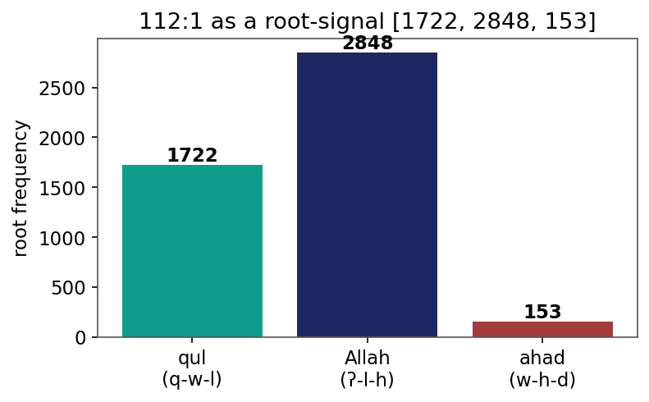
Figure 1. Verse 112:1 as a root-frequency signal: [1722, 2848, 153].
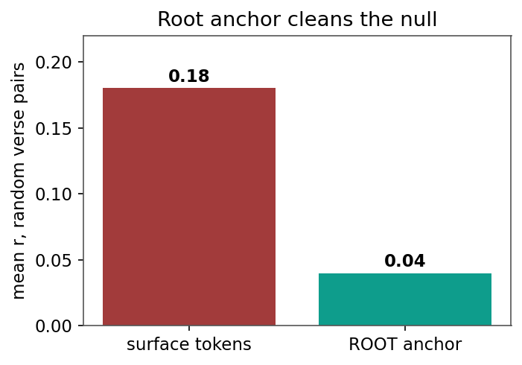
Figure 2. The root anchor cleans the null: mean correlation of random verse pairs 0.18 (surface) -> 0.04 (roots).
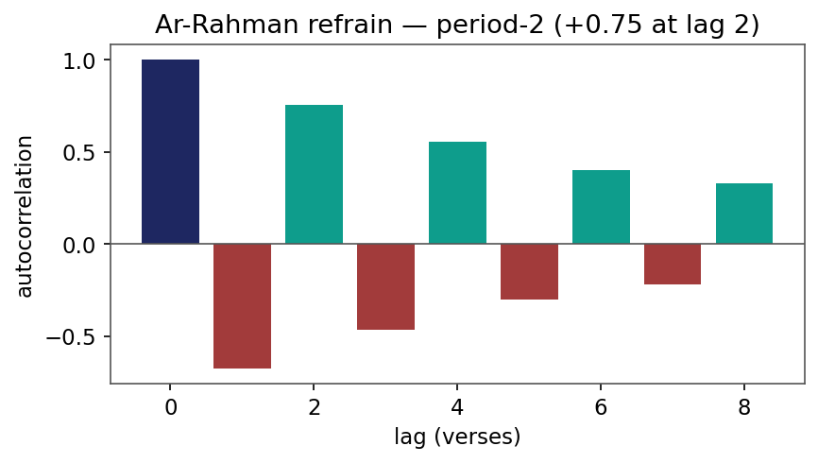
Figure 3. Autocorrelation of Surat ar-Rahman's refrain: a period-2 signature (+0.75 at lag 2).
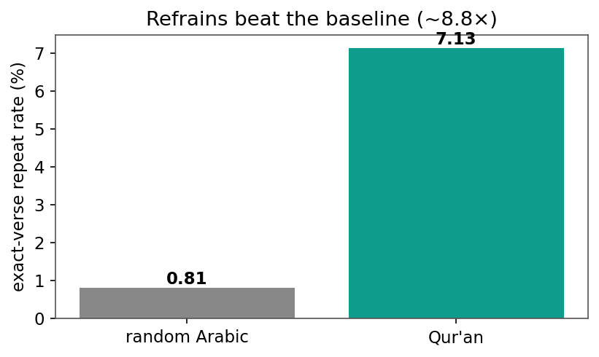
Figure 4. Exact-verse repetition beats the natural-language baseline (7.1% vs 0.81%, ~8.8x).
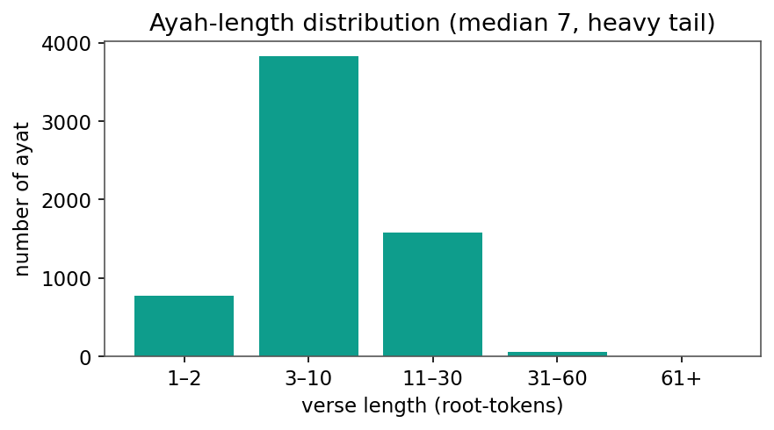
Figure 5. Ayah-length distribution (median 7 root-tokens, heavy tail).
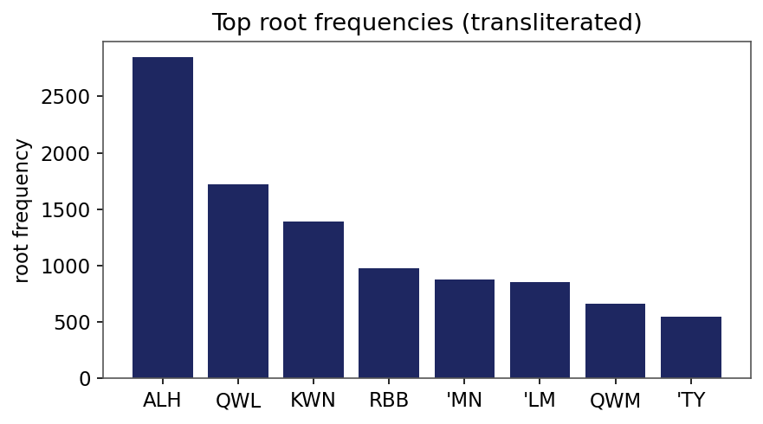
Figure 6. Top root frequencies (transliterated) - heavy-tailed.
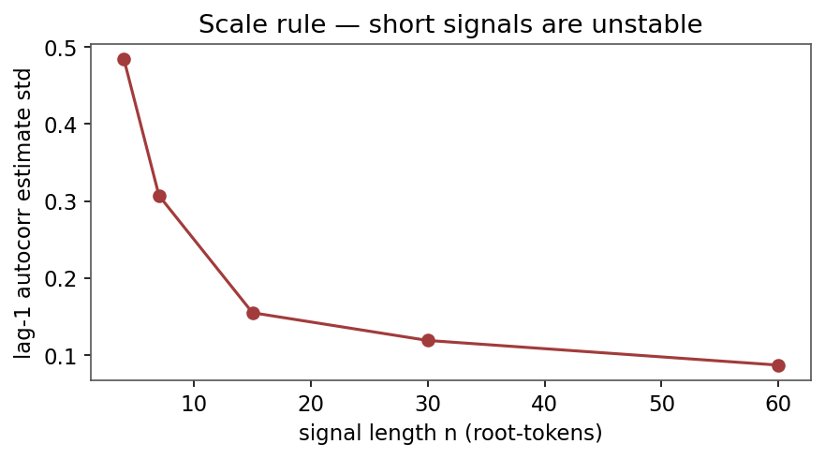
Figure 7. Scale rule: the lag-1 autocorrelation estimate stabilizes only with length.
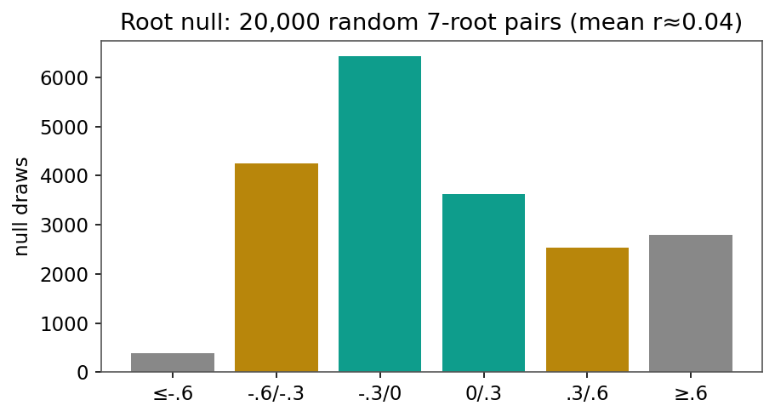
Figure 8. Root null: 20,000 random 7-root verse pairs (mean r ~ 0.04).
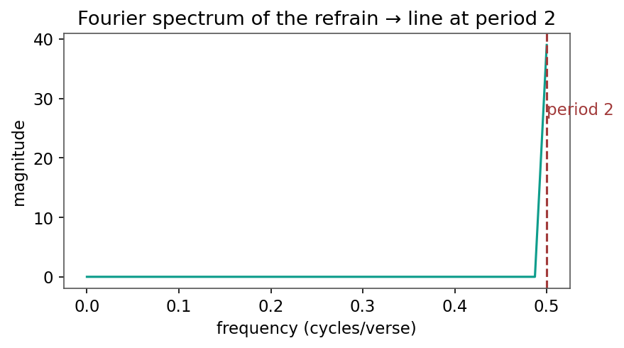
Figure 9. Fourier spectrum of the refrain indicator: a line at period ~ 2 verses.
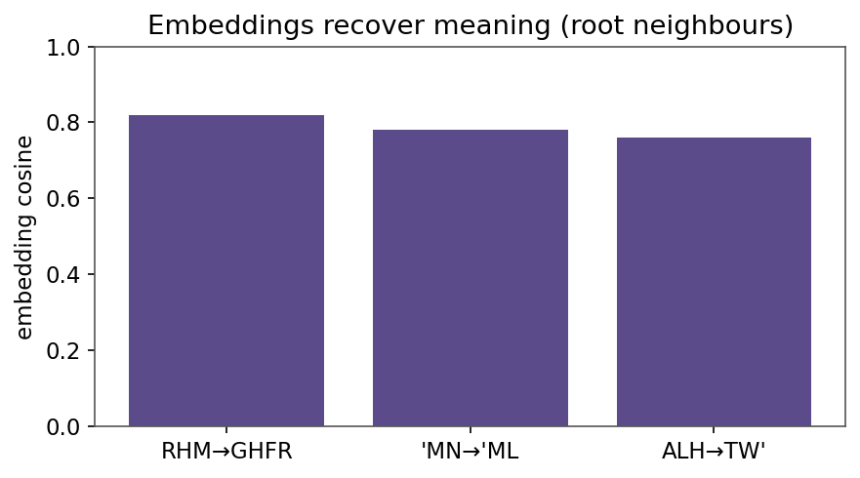
Figure 10. Embeddings recover meaning: nearest-root cosine (RHM->GHFR, etc.).
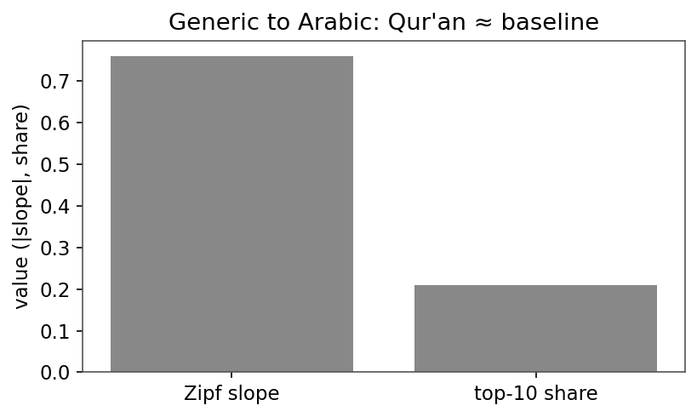
Figure 11. Generic to Arabic: Qur'anic Zipf slope and top-10 share match the baseline.

