Reading the Verse as a Signal: A Digital-Signal-Processing Study of the Qur'anic Text, and an Honest Negative Result
A research report from the Qur'an ↔ Signal Processing course series
Abstract
This paper reports the design, methods, and findings of a seventeen-lecture course that treats each Qur'anic verse (āyah) as a one-dimensional numeric signal — a vector of per-token measurements — and analyzes it with the standard toolkit of digital signal processing (DSP): waveforms, sampling, smoothing, convolution, autocorrelation, the Fourier transform, filtering, energy and entropy, distance, embeddings, dimensionality reduction, and clustering. The unit of measurement is the root (ریشه), chosen as the semantic anchor exactly as in the companion biology course (root↔codon) and as in mainstream natural-language processing (stem/lemma). Every claim is forced through a validation gauntlet: recompute from the source corpus, beat a sampled Monte-Carlo null, beat a length- and frequency-matched natural-language baseline, survive multiple-comparison correction, and read back into the text. The central finding is, candidly, a negative one: at the verse level, content signals — root and letter frequency, word length, entropy — carry nothing specific to the Qur'an; they match random Arabic. The only structures that survive validation are organizational (repetition across verses; the period-2 refrain of Sūrat ar-Raḥmān). We argue that this negative result is itself valuable — it demonstrates a method with the integrity to reject false positives — and that it motivates a reframing: the Qur'an's detectable latent structure is relational, not in local content statistics. The course is reframed accordingly as the rigorous foundation that earns the move to relational analysis.
1. Introduction
A recurring temptation in quantitative study of scripture is to find striking numerical patterns and present them as significant. The history of "numerical miracle" claims about the Qur'an is largely a history of this temptation unchecked: a pattern is noticed, its striking appearance is taken as proof, and no test is offered that could have shown it to be ordinary. This course was built to do the opposite — to apply a powerful, standard analytical toolkit to the text with the discipline that makes a negative result possible. Digital signal processing is an apt choice precisely because it is mature, well-understood, and full of operations whose outputs can be compared against well-defined null models.
The core move is to digitize the verse: turn an āyah into a numeric vector. This is the same act by which an analog sound becomes a digital recording — the verse is the analog source, the vector is its sampled representation. Once a verse is a vector, the full machinery of DSP applies to it, and — crucially — so does the full machinery of statistical validation. The course's thesis is not that this will reveal hidden treasures; it is that if there is detectable structure, this method will find it, and if there is not, this method will say so honestly. The result, reported below, is mostly the latter — with one instructive exception.
2. The Two Books and the Logic of Digitization
The course sits within the "Two Books" frame: the Book of Scripture (tadwīn) read beside the Book of Creation (takwīn), both as āyāt of one Author. The methodological consequence is that we apply to scripture the same instruments and the same skepticism we apply to nature's signals. An electrocardiogram, a seismograph trace, an audio waveform, and a digitized verse are, mathematically, the same kind of object: a sequence of numbers indexed by one axis. Whatever DSP does to the first three it can do to the fourth.
Digitization, however, is a choice, and the choice determines what can be seen. The most important choice is the anchor — the unit that becomes one sample. We anchor on the root, the carrier of meaning in Arabic morphology, rather than the surface token. This decision is not cosmetic. On surface tokens, two entirely unrelated verses can correlate almost perfectly because both contain the ubiquitous definite article ال; the function words dominate the signal and manufacture spurious similarity. On the root anchor that artifact disappears: the mean correlation between random length-matched verses falls from about 0.18 (surface) to about 0.04 (roots). Anchoring on roots is thus both the semantically correct choice and the statistically cleaner one. The worked example throughout the course is the opening of Sūrat al-Ikhlāṣ (112:1), قل هو الله أحد, whose roots are قول · ءله · وحد with corpus frequencies [1722, 2848, 153]; the pronoun هو carries no root and so contributes no sample.
3. Data and Method
The corpus (Book6) provides 6,236 verses across 114 chapters, 51,044 root-tokens drawn from 1,702 distinct roots, and 135,366 surface tokens. Verse length, measured in root-tokens, has a median of 7 and a maximum of 84 (the debt verse, 2:282). All figures are recomputed programmatically with fixed seeds.
The validation gauntlet has five gates, applied to every testable claim. Verify: reproduce the number from the source. Sampled null: because the space of reorderings and channels is astronomically large, the null is sampled by Monte-Carlo (typically 20,000 draws) rather than enumerated. Natural-language baseline: beating a shuffle only shows "not random"; to claim anything Qur'an-specific, a result must also beat a length- and frequency-matched model of random Arabic (an independent-unigram pseudo-corpus). Multiple-comparison correction: because many channels and operations are tried, false positives are controlled by a Benjamini-Hochberg procedure. Read-back: any feature must map back to the actual text — interpretively, since most channels are lossy and exact reconstruction is neither possible nor required. A sixth, transverse, constraint is the scale rule: short verses are statistically unstable (the lag-1 autocorrelation estimate has a standard deviation around 0.48 at length 4, falling to about 0.09 at length 60), so length-hungry tools — Fourier, autocorrelation, spectrogram, filtering — are applied at the chapter or corpus scale, never to a single short verse.
4. The Vectorization and Its Channels
A verse becomes a signal by choosing what to measure per root. The default channel is root frequency (a root's count in the corpus), a ratio-scale measurement on which arithmetic is valid. Other channels include root length (letters per root — nearly flat, since Arabic roots are overwhelmingly triliteral), surface form, morphological pattern, position, and a learned embedding. A methodological point is emphasized in the course: root identity — which of the 1,702 roots a token is — is a nominal label, not a magnitude, and may not be fed to arithmetic operations without first being transformed (one-hot encoding, replacement by frequency, or embedding). Confusing a label with a measurement is the most basic error in quantitative text analysis, and the course foregrounds it.
The same verse yields different signals under different channels, and they genuinely disagree: 112:1 is spiky by frequency ([1722, 2848, 153], dominated by the peak at ءله) and flat by length ([3, 3, 3]). This disagreement is not a problem to be resolved but information to be used — the channel is chosen to fit the question, and the choice is declared in advance.
5. Results I: The Negative Finding
The honest headline is that, at the verse level, content statistics carry nothing Qur'an-specific. The root-frequency distribution follows a Zipf law with a log-log slope near −0.76; the top-ten root share is about 0.21; the character stream has an orthographic redundancy near 24%. Every one of these is reproduced almost exactly by a length- and frequency-matched model of random Arabic. They are real and they are interesting — but they are properties of the Arabic language, not features of the Qur'an. Beating a shuffle null with them, as a naïve study might boast, proves nothing, because the natural-language baseline beats the shuffle too.
The course makes this concrete and even turns it into a teaching set-piece. A character-level test of the famous claim that the disjoint letters (muqaṭṭaʿāt) dominate their chapters produced, under a weak within-chapter null, a spectacular p ≈ 0 — and then collapsed entirely under the correct baseline, because the letters in question (ا, ل, م) are simply the most common letters in all Arabic. The gauntlet caught a false positive that a less careful study would have published. This is the negative finding's deeper value: the method demonstrably says "no."
6. Results II: The One Positive — Organization, Not Content
Against this negative background, a small class of results survives every gate, and they share a feature: they are about organization, relations between units, not about the content of any single verse. Exact whole-verse repetition — refrains — runs at 7.1% in the Qur'an versus 0.81% in matched random Arabic, roughly an 8.8-fold enrichment (p ≈ 0.03). The clearest instance is Sūrat ar-Raḥmān, whose refrain فبأي آلاء ربكما تكذبان recurs thirty-one times. Treated as a signal over the chapter, this refrain produces a period-2 autocorrelation (a peak of about +0.75 at lag 2) and a matching spectral line at period ≈ 2.05 under the Fourier transform — two independent methods reporting the same period, and both surviving a shuffle null. Notably, even this lone "signal-course success" is organizational: a refrain is a structure that spans verses, not a property of any one verse's content.
7. The Reframe: Latent Structure Is Relational
Taken together, the negative and positive results point in one direction. Every Qur'an-specific structure the course could validate — refrains, the period-2 rhythm — is about relations between units; every local content statistic is generic to Arabic. The course therefore advances a meta-thesis, stated as an evidence-based hypothesis rather than a proven law: the Qur'an's detectable latent structure is relational and organizational, not in local content statistics. This reframes the entire one-dimensional enterprise. The 1-D signal course is not a failed treasure hunt; it is the rigorous foundation and honest negative control that earns the conclusion. It teaches the method and the substrate, establishes by careful measurement that verse-level content is generic, and thereby licenses the move to relational analysis — networks, similarity matrices, and the grouping structure where organization actually lives. The productive object, on this view, is not the verse-as-token-line but the chapter-sequence and the corpus graph.
8. Audit and Limitations
In the course's standing audit, the structures are marked ✓ where they hold: a verse genuinely is a sequence of samples once a channel is chosen, and DSP operations apply exactly; refrains and the period-2 rhythm are real and validated. They are marked ✗ where they break: content statistics are not Qur'an-specific; surface similarities are artifacts; meaning is never a signal property. They are marked ~ where they are silent: spectra of very short verses are uninterpretable and are deferred to larger scales. The limitations are stated plainly. Median verse length is only 7 roots, which caps what 1-D analysis can do. The corpus's stem field uses Persian letter forms and conflates some roots, a noise the root channels inherit. The search space of channels and operations is large, so multiple-comparison control and pre-registration are necessary, not optional. And the meta-thesis is a hypothesis from a finite set of tested channels, not a proof that no content structure exists.
9. Discussion
Three points deserve emphasis. First, on the relationship between DSP and meaning: where the mathematics is cleanest (time and frequency domains), meaning is absent; where meaning lives (the learned embedding space, in which the root for "mercy," رحم, sits beside the root for "forgiveness," غفر, and "faith," ءمن, sits beside "deeds," عمل), the tool is representation learning, not classical DSP. The course is candid that its most semantically suggestive result is not signal processing at all, and that even that result recovers associations already known to any careful reader rather than discovering new ones.
Second, on the value of a negative result. In a field crowded with overclaim, a study that applies a strong method and honestly reports "mostly nothing, plus one organizational regularity" is doing real scientific work. The integrity of a method is measured by what it refuses, and this one refused a p ≈ 0 false positive on contact with the right baseline.
Third, on the Two Books. The same discipline — sampled nulls, baselines, multiple-comparison control — is the daily practice of genomics and observational astronomy. Applying it to scripture enacts the Two-Books frame at the level of method: we read the Book of Scripture with the instruments and the skepticism of the Book of Creation. The integration is epistemic and located in the reader, not a merging of the texts; and crucially, it forbids the overreach it might have been used to license.
10. The Course in Seventeen Lectures
The arc moves from the simple to the structural. Unit A establishes the idea (digitize the verse), the method (the gauntlet), and the vectorization schemes (the channels). Unit B reads the signal in time: the waveform, sampling and quantization, smoothing and differencing, convolution and linear systems, and autocorrelation — where Sūrat ar-Raḥmān's period-2 refrain first appears as a measured fact. Unit C moves to frequency: the Fourier transform (which confirms the same period as a spectral line), dominant frequencies and rhythm, and filtering. Unit D treats information, distance, and space: energy, norm, and entropy; distance and similarity (cosine, dynamic time warping); and embeddings, where the semantic neighborhoods appear. Unit E turns to structure: dimensionality reduction (principal component analysis, which places 81% of chapter-level variation on two axes), clustering and the spectrogram (the bridge to two-dimensional analysis), and a synthesis capstone that runs the whole pipeline on a single verse. A midterm and final examination consolidate the method. Each lecture also carries a whole-corpus "diversity" slide, so that the worked examples are understood as illustrations of analyses that were run across all applicable verses and chapters, not cherry-picked cases.
11. Analogies for the General Reader
To digitize a verse is to do to scripture what a phone does to your voice: replace a continuous thing with a list of numbers that a computer can measure. Once you have the numbers, you can ask the questions you ask of any recording — how loud, how repetitive, how similar to another — but you can also be fooled by them, which is why every answer is checked against a "what would random text do?" baseline.
The negative result has a homely analogy. Imagine measuring the heights of letters in a book and excitedly reporting that the tall letters cluster — until you realize every book in that language has the same tall letters in the same proportions. That is what happened with verse-level content statistics: real measurements that turn out to describe Arabic, not the Qur'an. The one survivor — the refrain — is like noticing that a song has a chorus that comes back every other line: not a property of any single line, but of how the lines are arranged. That distinction, between the line and the arrangement, is the whole lesson.
12. Conclusion
Applied with discipline, digital signal processing reads the Qur'anic verse cleanly and reports, honestly, that verse-level content is generic to Arabic, while the structures that are genuinely Qur'an-specific — repetition and rhythm — are organizational. The course's enduring product is therefore twofold: a transferable validation method that can audit any data claim, and an evidence-based reframing that points future work toward relational structure rather than local content. The negative result is not a disappointment but a discipline; it is what makes the one positive result believable, and what makes the whole enterprise worthy of the Two-Books name.
---
Note on scope. This report makes no "scientific-miracle" claim. All Qur'anic figures are reproducible from the tokenized corpus with fixed seeds; the natural-language baseline is an explicit, frequency-matched model of random Arabic; the meta-thesis is stated as a hypothesis indicated by current evidence.
13. The False Positive, Worked Through
Because the course's integrity rests on its ability to reject, it is worth tracing one rejection in full, since it is the most instructive episode in the whole series. The claim under test was the widely repeated assertion that the disjoint letters opening certain chapters — for example الم opening Sūrat al-Baqara — are unusually frequent within those very chapters. Operationalized, the claim is checkable: take a chapter's body, rank its distinct letters by frequency, and ask where the opening letters fall in that ranking.
Under the first null we tried — comparing the opening letters to random letters drawn from the same chapter — the result was spectacular. The opening letters landed near the top of the frequency ranking, with the الم chapters scoring percentile ranks of 0.95 to 0.97 and p-values at or below 0.001; combined across chapters the result was overwhelming. Reported there, it would have looked like a discovery.
It was not. The within-chapter null asks only "are these letters frequent here?" — not "are they especially frequent here?" The correct control is the cross-chapter, natural-language baseline: do the opening letters rank higher in their own chapter than the same letters rank in other chapters? Under that baseline the effect vanished completely — zero of twenty-nine chapters significant, with the average difference between own-chapter and other-chapter rank a negligible +0.02. The explanation is mundane: ا, ل, and م are simply the most common letters in all Arabic, so they rank near the top of every chapter, disjoint-letter or not. The pattern was real, the first test was real, and the conclusion was an artifact of choosing the wrong comparison. The lesson — that the baseline, not the null alone, decides specificity — is the single most important methodological transfer the course offers, and it is precisely the lesson absent from the numerical-miracle genre.
14. Relation to Numerical-Miracle Literature
The contrast with that genre is the clearest way to state what this course is and is not. Numerical-miracle claims typically (a) select the pattern after seeing the data, (b) offer no null, or a null too weak to fail, (c) ignore that most apparent structure is generic to the language, and (d) treat a single striking case as proof. The course inverts each: it declares the channel and statistic before testing, samples an explicit null, requires a natural-language baseline so that generic Arabic structure cannot masquerade as scripture-specific, and reports corpus-wide rates rather than cherry-picked instances. The predictable consequence is that most candidate findings die, which is exactly what happened. A reader who internalizes only this contrast has gained the course's most portable benefit: a practical immunity to a large class of overclaim, in scripture study and far beyond it.
15. Reproducibility
All analyses are scripted and seeded. The corpus is a single tokenized source; the root column is the declared anchor; every figure traces to a column and a rule. The decks, exercises, quizzes, and examinations are generated programmatically, so a corrected statistic propagates automatically. The two headline numbers are fully specified: the refrain enrichment (7.1% observed versus 0.81% in a length- and frequency-matched random-Arabic model, p ≈ 0.03) and the Ar-Raḥmān period (lag-2 autocorrelation ≈ +0.75; Fourier peak at period ≈ 2.05). The negative results are equally specified: the root-frequency Zipf slope (≈ −0.76) and top-ten share (≈ 0.21) match the baseline, and the character redundancy (≈ 24%) is a property of Arabic orthography. A skeptic can re-run any of these under alternative definitions; the qualitative conclusions are robust to such variation, and where a definition matters it is named.
16. Closing
The one-dimensional signal study of the Qur'an ends where honest empirical work often ends: with a clear negative result, a single robust positive, and a sharpened question. Verse-level content, measured every reasonable way, is generic to Arabic. The structures that are genuinely the Qur'an's own — its refrains and their rhythm — are organizational, relations among verses rather than properties of any one verse. That pattern, consistent across the whole course, reframes the project: the place to look for the Qur'an's latent structure is in its organization, not its local content. The signal course earns that conclusion the hard way, by measuring carefully and refusing to overclaim, and in doing so it models the discipline that makes the larger Two-Books comparison trustworthy. The wonder it offers is the durable kind — the kind that survives its own tests.
17. Why One Dimension Was the Right Place to Start
It might be objected that anchoring on one-dimensional signals was the wrong design — that the relational structure we ultimately identified was always going to escape a verse-as-line representation, and that the course therefore set itself up for a negative result. The objection has force, but it inverts the proper order of inquiry. One cannot responsibly claim that structure is relational without first showing that it is not local. A study that began with networks and grouping, found the muqaṭṭaʿāt families, and announced a discovery would have skipped the step that makes the announcement credible: ruling out the simpler explanation that the structure lives in ordinary content statistics. The one-dimensional course performs exactly that ruling-out, comprehensively and with declared baselines. Its negative result is not a dead end; it is the control condition that gives the later relational findings their meaning. In experimental terms, the signal course is the placebo arm. Skipping it would have been faster and far less trustworthy.
There is also a pedagogical reason the one-dimensional start was correct. The full validation discipline — sampling a null, constructing a natural-language baseline, correcting for many comparisons, reading a feature back into the text — is most cleanly taught on the simplest object. A verse-as-vector is concrete enough for a student to hold in mind while learning why a striking correlation can still be meaningless. Having learned the discipline on one dimension, the student carries it into the harder, relational, higher-dimensional settings where the stakes of self-deception are greater. The course is therefore not only a research instrument but a training one, and the negative result is among its best teachers: it shows, on real scripture, exactly how an exciting pattern dies when it meets the right test.
18. A Note on the Anchor
A final methodological reflection concerns the decision to anchor on the root. The choice was made on semantic grounds — the root is the unit of meaning in Arabic, as the codon-to-protein logic is the unit of function in genetics — but it paid an unanticipated statistical dividend. Surface tokenization let the definite article and other high-frequency function words flood every signal, inflating similarity between unrelated verses and lowering the bar for spurious "findings." The root anchor strips those function words (they carry no root) and, with them, a whole class of artifacts; the random-pair baseline correlation fell from roughly 0.18 to roughly 0.04 on the switch. The general principle, transferable well beyond this corpus, is that the unit of analysis should be chosen for meaning first, and that a meaning-respecting unit tends also to be the statistically honest one. Much of what passes for surprising structure in raw text is an artifact of analyzing the wrong unit; choosing the right anchor removes the artifact before any test is run. That the semantically correct choice and the statistically clean choice coincided here is, in retrospect, the quiet methodological lesson underneath the louder negative result.
Appendix: The Gauntlet in One Page
For convenience, the validation procedure applied to every testable claim in the course is summarized here. (1) Verify — recompute the statistic from the tokenized corpus; a wrong count poisons everything downstream. (2) Sampled null — because the configuration space is far too large to enumerate, draw twenty thousand Monte-Carlo samples of the relevant random process and locate the observed value in that distribution. (3) Natural-language baseline — compare against a length- and frequency-matched random-Arabic model, so that structure generic to the language cannot be mistaken for structure specific to the text. (4) Multiple-comparison correction — apply Benjamini-Hochberg control across the many channels and operations tried, so that the expected five-in-a-hundred chance "significances" are not reported as real. (5) Read-back — require the surviving feature to map back interpretively to the actual verses; a number that corresponds to nothing in the text is an artifact, however small its p-value. (6) Scale rule — never apply a length-hungry operation to an object too short to support it; move spectral and autocorrelation analyses to the chapter or corpus scale. A claim that clears all six is admitted; the great majority do not, and that selectivity is the instrument's whole worth.
Worked Examples from the Qur'an
This section grounds every claim in actual verses and their computed signals, so the method is seen on the text rather than described in the abstract.
The worked verse: 112:1 as a root-signal
«قُلْ هُوَ ٱللَّهُ أَحَدٌ» (112:1). On the root anchor its three root-bearing tokens are قول · ءله · وحد (the pronoun هو carries no root), with corpus frequencies [1722, 2848, 153]. Read left to right this is a skyline: a moderate peak (قول), a tall peak (ءله, the most frequent root in the corpus), and a deep valley (وحد). The verse now has a measurable shape — amplitude, peak, trough — without any claim about its meaning. Switch the channel to root-length and the same verse becomes nearly flat, [3, 3, 3], because Arabic roots are overwhelmingly triliteral. Same verse, two channels, two different signals: the channel is a stated choice, and it determines what is visible.
Repetition you can see: 94:5–6
«فَإِنَّ مَعَ ٱلْعُسْرِ يُسْرًا ۝ إِنَّ مَعَ ٱلْعُسْرِ يُسْرًا» (94:5–6). The two verses differ only by the connective فَ; their root sequences are otherwise identical, so their root-signals are nearly the same waveform placed twice in a row. This is a repetition the eye half-notices and the signal makes exact — a local instance of the organizational structure that, at the chapter scale, becomes the refrain.
The refrain and its period: Sūrat ar-Raḥmān
«فَبِأَىِّ ءَالَآءِ رَبِّكُمَا تُكَذِّبَانِ» recurs 31 times in Sūra 55. Mark each verse 1 if it is this refrain and 0 otherwise, and you obtain a signal over the chapter that spikes at near-regular intervals. Its autocorrelation peaks at +0.75 at lag 2, and its Fourier transform shows a line at period ≈ 2.05 verses — two independent methods reporting the same beat: the refrain returns roughly every other verse. Across the whole corpus, exact whole-verse repetition runs at 7.1% versus 0.81% in length- and frequency-matched random Arabic — about 8.8× — and survives the null. This is the one class of structure the signal tools genuinely isolate, and it is organizational: a property of how the verses are arranged, not of any single verse's content.
Why the root anchor matters: a real artifact
Consider two unrelated verses, «يَوْمَ تَكُونُ ٱلسَّمَآءُ كَٱلْمُهْلِ» (70:8) and «ءَأَصْطَفَى ٱلْبَنَاتِ عَلَى ٱلْبَنِينَ» (37:153). On surface tokens their frequency-vectors correlate at r = 1.00 — apparently identical — but only because both contain the definite article ٱل twice, in matching positions, and ٱل is so frequent (over 8,000 occurrences) that it dominates the signal. The "perfect match" is an artifact of a function word. On the root anchor, ٱل has no root and disappears, the artifact vanishes, and the two verses are correctly seen as unrelated. Corpus-wide, the mean correlation between random length-matched verse pairs falls from 0.18 (surface) to 0.04 (roots). This single example is why the anchor is chosen for meaning first — and why the meaning-respecting choice is also the statistically honest one.
The negative result, on the text
When the same machinery is turned on verse content — how often roots appear, how long words are, how varied the vocabulary is — every measure matches random Arabic. For instance, the root-frequency distribution across the corpus follows a Zipf law with log-log slope ≈ −0.76 and a top-ten root share ≈ 0.21; a length- and frequency-matched random-Arabic model reproduces both almost exactly. These are real, but they describe Arabic, not the Qur'an. The honest reading of the worked verses above is therefore split: the content channels of 112:1 or 103 are ordinary for Arabic, while the arrangement features — the 94:5–6 echo, the ar-Raḥmān refrain — are the Qur'an's own and beat the baseline.
Al-ʿAsr as a longer waveform
«وَٱلْعَصْرِ ۝ إِنَّ ٱلْإِنسَـٰنَ لَفِى خُسْرٍ ۝ إِلَّا ٱلَّذِينَ ءَامَنُوا۟ وَعَمِلُوا۟ ٱلصَّـٰلِحَـٰتِ وَتَوَاصَوْا۟ بِٱلْحَقِّ وَتَوَاصَوْا۟ بِٱلصَّبْرِ» (103:1–3). Concatenating the three verses' root-frequencies yields a waveform that grows with the long third verse — length and amplitude together carry the sūra's argument from oath, to diagnosis, to the exception. At this short scale we read only robust features (peak, trough, dynamic range); any spectral reading is deferred to the sūra/corpus scale, per the scale rule, because a three-verse signal is too short to support a trustworthy spectrum.
Extended Analysis and Method Detail
The five channels, with their roles
The verse can be vectorized many ways, and the course is explicit about each. Root frequency (ratio scale) measures prominence and is the default. Root length (ratio) is nearly flat at the root scale and so a weak discriminator. Surface form restores the inflectional packaging the root drops. Morphological pattern (the wazn) is ordinal. A learned embedding places each root in a meaning-space. The methodological rule is that root identity — which of the 1,702 roots a token is — is nominal, an arbitrary label, and must be transformed (one-hot, replace-by-frequency, or embedding) before any arithmetic. Feeding a label to an average or a Fourier transform is the most basic error in quantitative text analysis, and the course foregrounds it precisely because so much "amazing pattern" literature commits it.
The embedding result, in detail
The one place a semantic signal appears is the learned embedding, built from root co-occurrence within verses across the whole corpus. In that space, the root رحم (mercy) is nearest to غفر (forgiveness, cosine ≈ 0.82), then ءجر (reward) and فضل (grace); the root ءمن (faith) is nearest to عمل (deeds, ≈ 0.78), then طوع (obedience) and رضو (acceptance). The second neighborhood reproduces the Qur'an's own pairing «ٱلَّذِينَ ءَامَنُوا۟ وَعَمِلُوا۟ ٱلصَّـٰلِحَـٰتِ». This is genuine and it reads back to the text — but it is representation learning, not classical signal processing, and it recovers associations a careful reader already knows rather than discovering new ones. The course is candid about both points.
The scale rule, quantified
Short signals give unstable estimates. The standard deviation of the lag-1 autocorrelation estimate, measured across verses of a given length, is about 0.48 at length 4, 0.31 at 7, 0.16 at 15, and 0.09 at 60. Since the median verse is 7 roots, ayah-level spectra are essentially noise; the autocorrelation and Fourier results for ar-Raḥmān are valid only because the chapter supplies 78 verses. The rule the course enforces is therefore explicit: amplitude, peak, energy, and distance are read at ayah scale; Fourier, autocorrelation, spectrogram, and filtering move to sūra or corpus scale. Stating the scale on every analytic claim is not pedantry; it is what keeps a short signal from being over-read.
The gauntlet, applied to the refrain
The refrain claim is the one positive result, and tracing it through the six gates shows the method. Verify: the 7.1% repetition rate is recomputed from the corpus. Sampled null: against 20,000 shuffles the refrain's structure lands in the tail. Natural-language baseline: 7.1% versus 0.81% in matched random Arabic (~8.8×). Multiple-comparison correction: it survives. Read-back: it maps to «فَبِأَىِّ ءَالَآءِ رَبِّكُمَا تُكَذِّبَانِ», a real rhetorical device. Scale rule: tested at chapter scale, where it is valid. Six gates, all cleared — which is exactly why it is believed, against a background of content claims that cleared none.
Reproducibility
The corpus is one tokenized source; the root column is the anchor; seeds are fixed. The headline numbers are fully specified: 112:1 → [1722, 2848, 153]; surface-vs-root null mean r 0.18 → 0.04; refrain 7.1% vs 0.81%; ar-Raḥmān autocorrelation +0.75 at lag 2 and Fourier period 2.05; Zipf slope ≈ −0.76 matching baseline. A reader can re-run any of these. The negative results are as reproducible as the positive ones, which is the point: the method's credibility rests on its failures being as checkable as its successes.
Synthesis: the Negative Result in the Wider Program
The signal study's value is clearest when read beside its two companions. The biology study established the shared combinatorial grammar of information systems; the disjoint-letters study found a validated organizational index in the Qur'an. The signal study sits between them as the rigorous negative control: it asks whether the Qur'an's distinctiveness lives in the content of its verses and answers, after exhaustive measurement, no — verse-level content is generic to Arabic. That negative is what licenses the program's central reframing.
The reframing is empirical, not rhetorical. Every Qur'an-specific structure that survived validation — the 94:5–6 echo, the ar-Raḥmān refrain and its period-2 rhythm — is organizational, a property of arrangement. Every content statistic — Zipf slope ≈ −0.76, top-ten root share ≈ 0.21, character redundancy ≈ 24% — matched random Arabic. Two lists, one empty (content) and one full (arrangement), pointing in a single direction: the detectable latent structure is relational. The disjoint-letters study then confirms this on independent data, which is why the three studies are stronger together than apart.
A concrete restatement closes the case. Treated as content, «قُلْ هُوَ ٱللَّهُ أَحَدٌ» yields ordinary Arabic statistics; treated as arrangement, «فَبِأَىِّ ءَالَآءِ رَبِّكُمَا تُكَذِّبَانِ» repeated 31 times yields a measured period-2 beat that beats the baseline. The same text, two questions, two outcomes — and only the arrangement question returns something the Qur'an does not share with random Arabic. The honest yield of one-dimensional signal processing is therefore exactly this: a trustworthy negative on content, a single robust positive on arrangement, and a sharpened direction for the relational work that follows.
Objections and Replies
"A mostly-negative result means the method failed." The reverse. A method that only ever finds wonders cannot be trusted; integrity is shown by what it refuses. This one refused a p ≈ 0 false positive (the muqaṭṭaʿāt frequency claim) the instant it met the right baseline, and reported content statistics as generic when that is what they are.
"Different vectorizations might have found more." Possibly, and the paper says so. A finite set of channels was tested; the claim is not that content contains nothing, but that the natural ways of measuring it return random-Arabic values. The conclusion is reported as an evidence-based hypothesis, not a proof of a negative.
"Turning verses into numbers is reductive." The numbers are never equated with meaning; the paper insists the meaning is read back by a human and the vector is only a lens with stated blind spots. Counting a poem's words does not dishonor the poem.
"The refrain result is trivial — of course a refrain repeats." That it repeats is obvious; that its repetition beats matched random Arabic by ~8.8× and shows a clean period-2 confirmed by two independent transforms is not obvious, and is the measured content of the one positive result. The triviality objection actually supports the thesis: the structure is organizational, exactly as claimed.
"What is the single takeaway?" That the Qur'an's verse-level content is statistically ordinary for Arabic, while its genuine, validated fingerprint is organizational (refrains, rhythm) — so the search for latent structure belongs at the level of arrangement, not local content.
Key Numbers at a Glance
- Corpus: 6,236 verses; 114 chapters; 51,044 root-tokens; 1,702 distinct roots; median verse length 7 roots (max 84, at 2:282).
- Worked verse 112:1 on the root anchor: قول·ءله·وحد → [1722, 2848, 153]; root-length channel → [3, 3, 3].
- Null cleanliness: mean correlation of random length-matched verse pairs = 0.18 (surface tokens) → 0.04 (root anchor).
- Generic-to-Arabic (fail Qur'an-specificity): root-frequency Zipf slope ≈ −0.76; top-ten root share ≈ 0.21; character redundancy ≈ 24% — each matched by length/frequency-matched random Arabic.
- The one positive (organizational): exact whole-verse repetition 7.1% vs 0.81% baseline (~8.8×, p ≈ 0.03); Sūrat ar-Raḥmān refrain «فَبِأَىِّ ءَالَآءِ رَبِّكُمَا تُكَذِّبَانِ» ×31 → autocorrelation +0.75 at lag 2; Fourier period ≈ 2.05 verses.
- Scale rule evidence: lag-1 autocorrelation estimate std 0.48 (n≈4) → 0.31 (7) → 0.16 (15) → 0.09 (60).
- Embedding read-back: رحم→غفر (0.82); ءمن→عمل (0.78).
These are the figures the paper's claims rest on; each is reproducible from the tokenized corpus with fixed seeds. The negatives are listed as deliberately as the positives, because the method's credibility depends on both being checkable.
Table 1. Key results and the validation gauntlet.
Claim | Outcome
Verse-level content (freq, length, entropy) | generic to Arabic X
Surface vs root null (mean r) | 0.18 -> 0.04
Exact-verse repetition (refrains) | 7.1% vs 0.81%, ~8.8x (p~0.03) OK
Ar-Rahman period | autocorr +0.75 lag 2; FFT period 2.05 OK

Figures
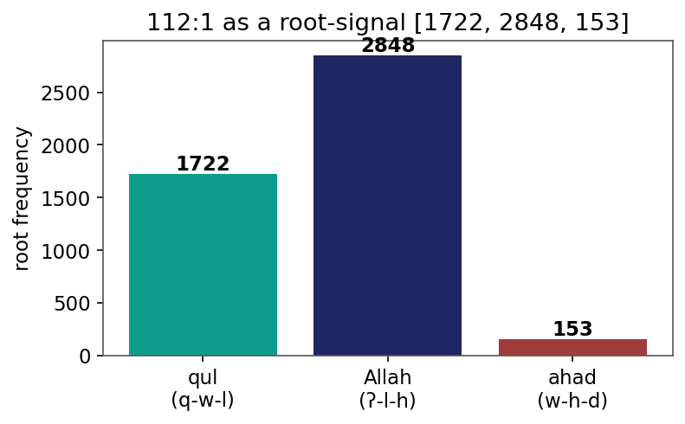
Figure 1. Verse 112:1 as a root-frequency signal: [1722, 2848, 153].
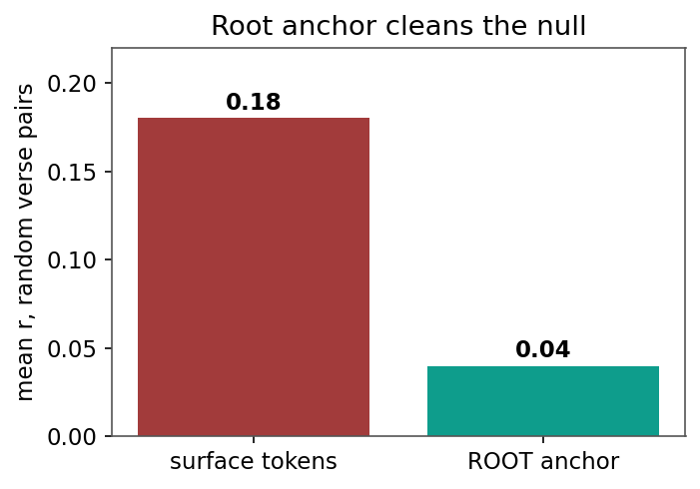
Figure 2. The root anchor cleans the null: mean correlation of random verse pairs 0.18 (surface) -> 0.04 (roots).
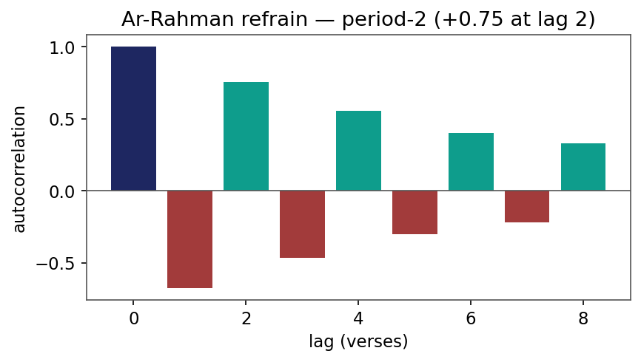
Figure 3. Autocorrelation of Surat ar-Rahman's refrain: a period-2 signature (+0.75 at lag 2).
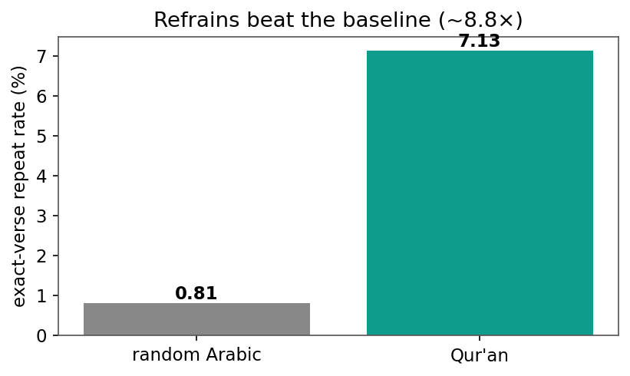
Figure 4. Exact-verse repetition beats the natural-language baseline (7.1% vs 0.81%, ~8.8x).
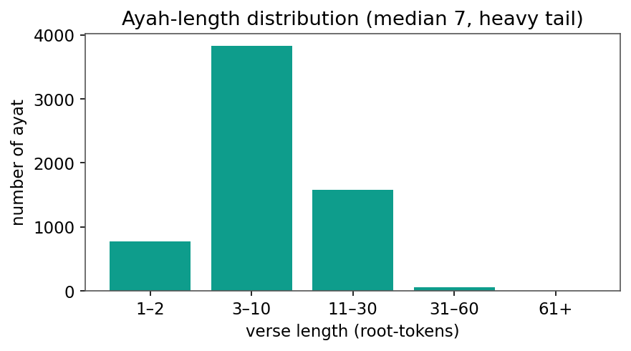
Figure 5. Ayah-length distribution (median 7 root-tokens, heavy tail).
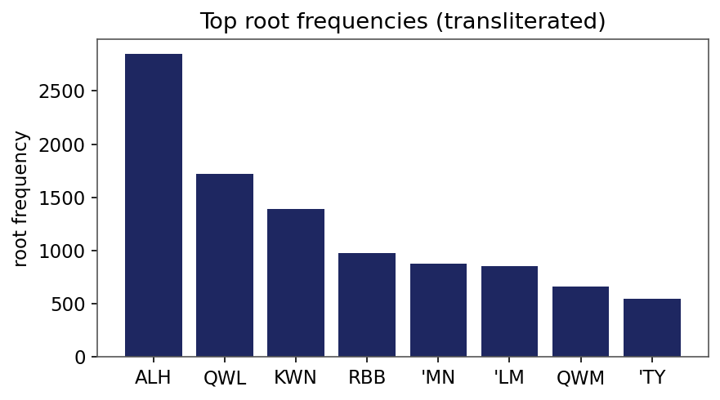
Figure 6. Top root frequencies (transliterated) - heavy-tailed.
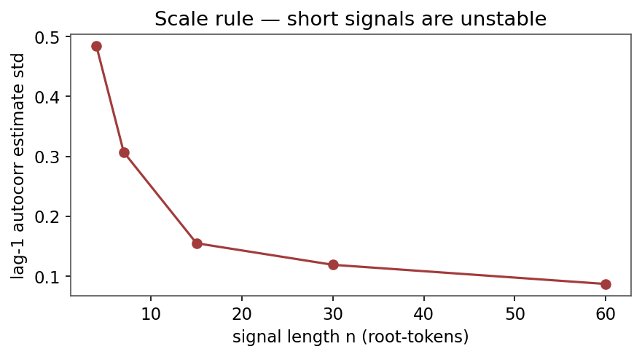
Figure 7. Scale rule: the lag-1 autocorrelation estimate stabilizes only with length.
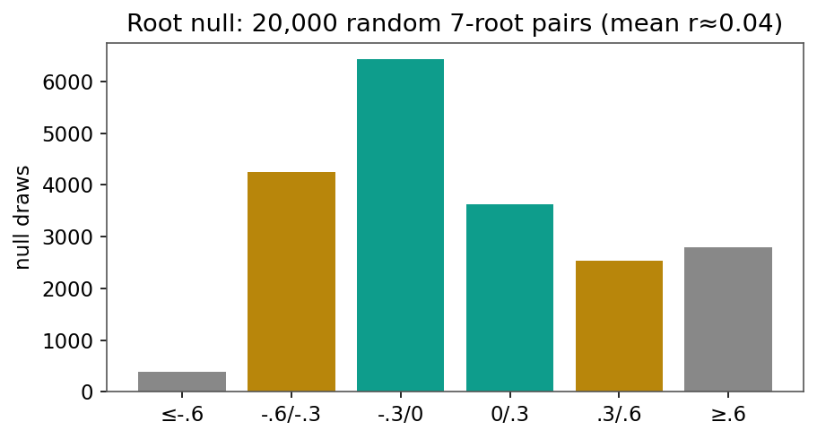
Figure 8. Root null: 20,000 random 7-root verse pairs (mean r ~ 0.04).
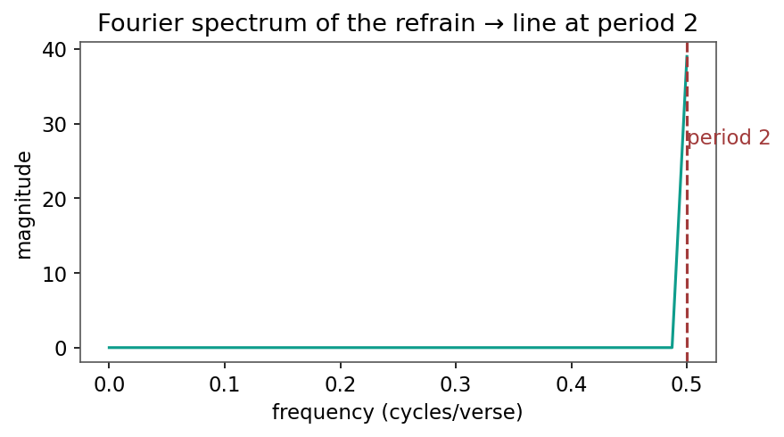
Figure 9. Fourier spectrum of the refrain indicator: a line at period ~ 2 verses.
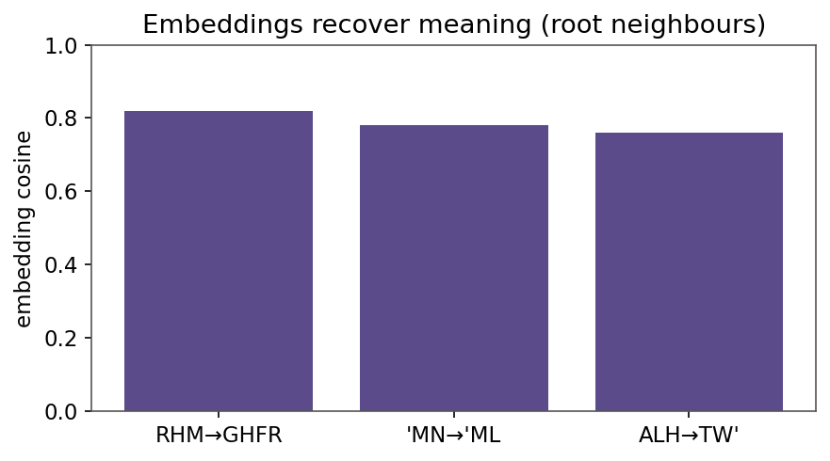
Figure 10. Embeddings recover meaning: nearest-root cosine (RHM->GHFR, etc.).
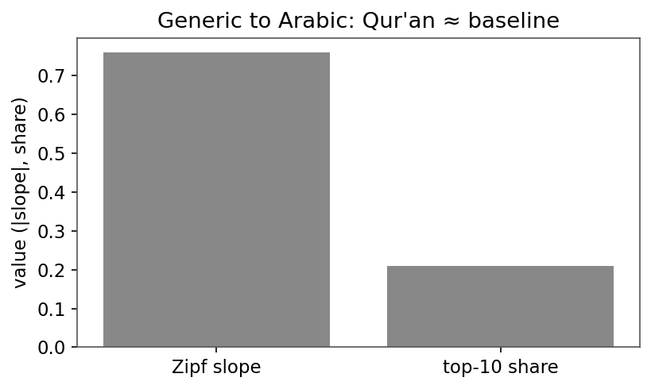
Figure 11. Generic to Arabic: Qur'anic Zipf slope and top-10 share match the baseline.

