Signal — Using the App & Reading the Tests
A live walkthrough on one root (ẓulm), theme: does a root CLUSTER in bursts or spread evenly through the text? Numbers computed from Book6 by the app's engine. Honest rule: trust the Fano factor and its permutation p, not the eye.
Part A — Walkthrough: ẓulm, the dispersion way
1. Open the recurrence tool
- App → Two Books → Signal → 🔁 Root recurrence. Pick your root from the list.
2. Read the dispersion metrics
The app marks every āyah where the root occurs as a 1, else 0, and measures the gaps between hits. For ẓulm: 290 occurrences, mean gap 19.4 āyahs, Fano factor 39.93. Fano > 1 means bursty (clustered); ≈ 1 means random (Poisson); < 1 means evenly spaced.
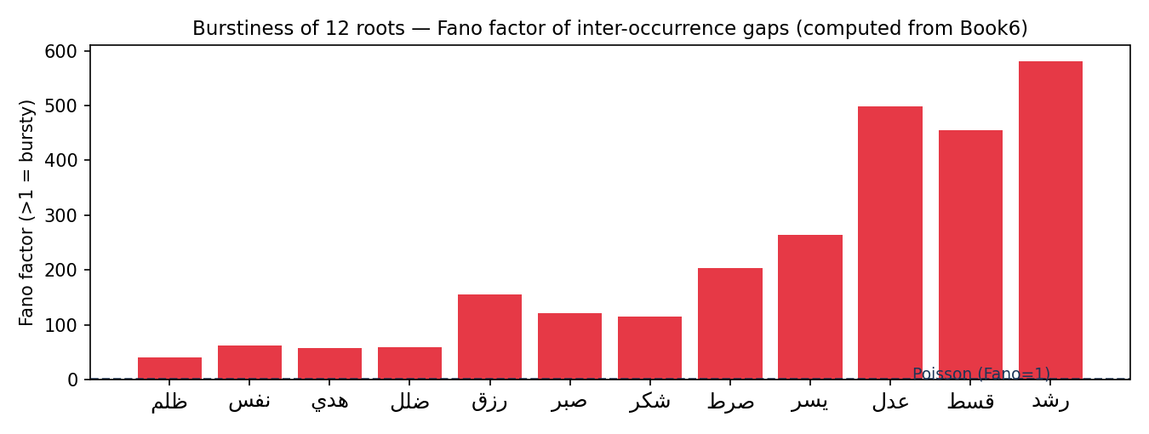
Fano factor of 12 roots (computed from Book6). Bars above the dashed Poisson line are bursty/clustered.
3. Run the test — is the clustering beyond chance?
Press the dispersion-test button. The app compares the root's Fano factor against 5,000 random placements of the same number of hits. For ẓulm: p ≈ 0.0002 → verdict: bursty/clustered. Most content roots cluster, because the Qur'an returns to a theme in passages.
Part B — The key skill: Fano factor and its p-value
Fano factor = variance ÷ mean of the gaps between occurrences. A memoryless (Poisson) process gives Fano ≈ 1. The permutation p = the fraction of random placements whose Fano is ≥ the observed one. Small p = clustering beyond chance.
ẓulm — what the app computes | value
occurrences | 290 āyahs
mean gap between occurrences | 19.4 āyahs
Fano factor (variance ÷ mean of gaps) | 39.93
dispersion p (vs 5,000 random placements) | 0.0002
verdict | bursty/clustered
Part C — The cross-check rule
- Report one computed fact (Fano AND its permutation p) plus one labeled interpretation.
- A high Fano is not a 'miracle' — it usually means the theme recurs in clustered passages. Say what the test licenses, no more.

