Week 1 — Using the App & Reading Every Plot
A live walkthrough on one root (ظلم), theme: frequency. Screenshots are real captures from the app; the last figure is a high-res close-up.

Part A — Walkthrough: ظلم, the frequency way

1. Open the app and enter the root
- Go to: https://quranproject-quran-root-explorer.hf.space/ (opens on “Module 1 · Root Exploration”).
- Type the letters in the input box (Arabic). Suggestions filter live; for ظلم you get “1 of 1 matches”. Click Analyze (or press Enter).
- Result banner: “Currently analyzing 1 root · 290 ayahs matched · matching: normalized.”
- On the per-root card click “Open ‘ظلم’ in Per Root Profile” (or use Per Root Profile in the left sidebar).
📷 SCREENSHOT 1 — the home screen: input bar + Analyze + suggestion chips (optional: paste here)

2. Per Root Profile — headline metrics
- Layer 1 gives the headline numbers for the root:
Ayahs | Surahs | Surface forms | Percentile | Tier
290 | 59 | 17 | 98.59% | ubiquitous
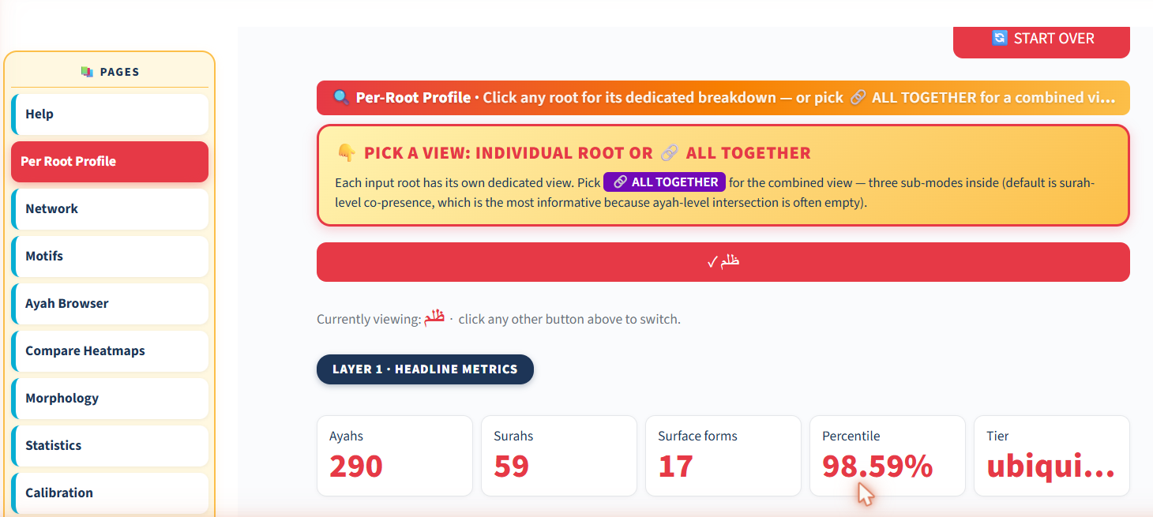
Real screenshot — Layer 1 headline metrics for ظلم (290 ayahs · 59 surahs · 98.59th percentile · ubiquitous).
- First occurrence 2:17 (al-Baqara) · last 76:31 (al-Insan).
- Percentile 98.59% = more frequent than ~98.6% of all roots (the app’s normalized rank).
- Compute two rates: per 1,000 ayahs (ayah-freq ÷ 6236 × 1000 = 46.5) and per 1,000 roots (term-freq ÷ 51,024 × 1000 = 6.17). Ayahs vary in size, so the root-rate is size-true.

Part B — Reading the frequency charts (real captures)

3. Layer 2 · Ayah hits per surah + Surface forms
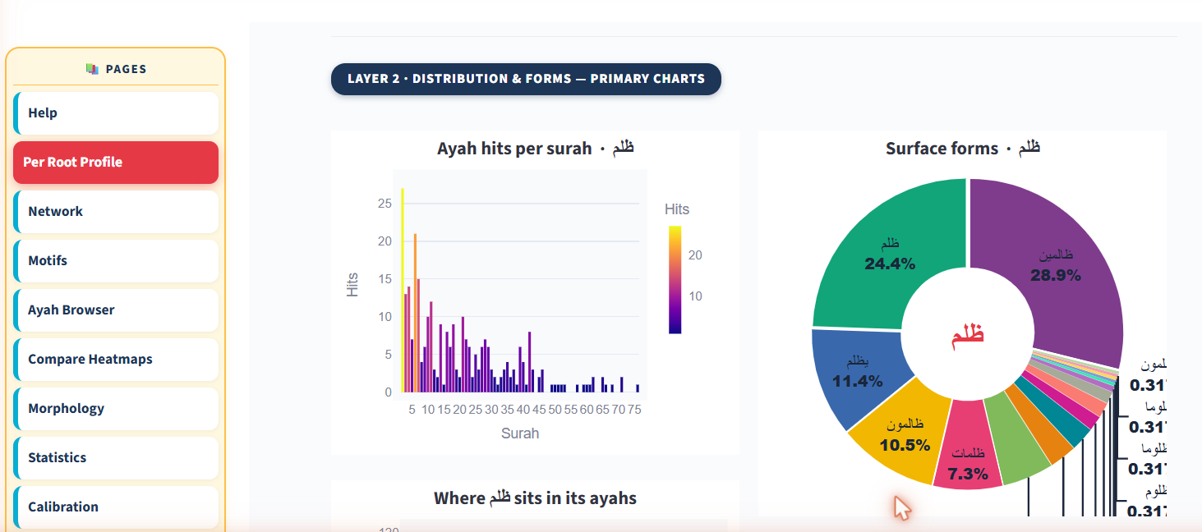
Real screenshot — Layer 2 primary charts for ظلم.
- Left (Ayah hits per surah): each bar is a surah; height & colour = hits. Tall bars cluster in the early, long surahs — the length effect.
- Right (Surface forms): 17 spellings collapse into one root — ظالمين 28.9%, ظلم 24.4%, يظلم 11.4%, ظالمون 10.5%, ظلمات 7.3%.
- Lesson: frequency counts the ROOT, not any single spelling.
- The in-app donut clips the small-slice labels; a clean close-up is in §6.

4. Where ظلم sits + Lengths of its ayahs
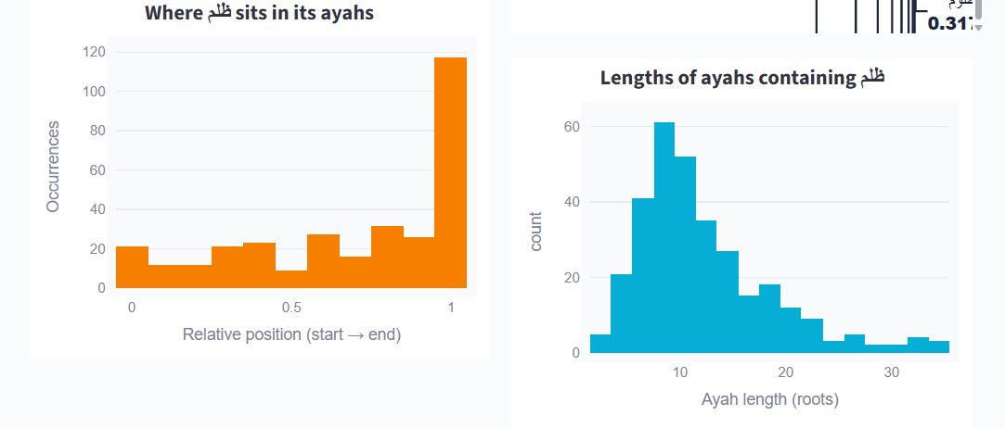
Real screenshot — position within the ayah, and host-ayah lengths.
- Left (position 0→1): ظلم leans toward the END of its verses (tall last bar).
- Right (ayah length): its host verses peak around 8–12 roots (host-verse length).

5. Beyond frequency (preview): partners & particles
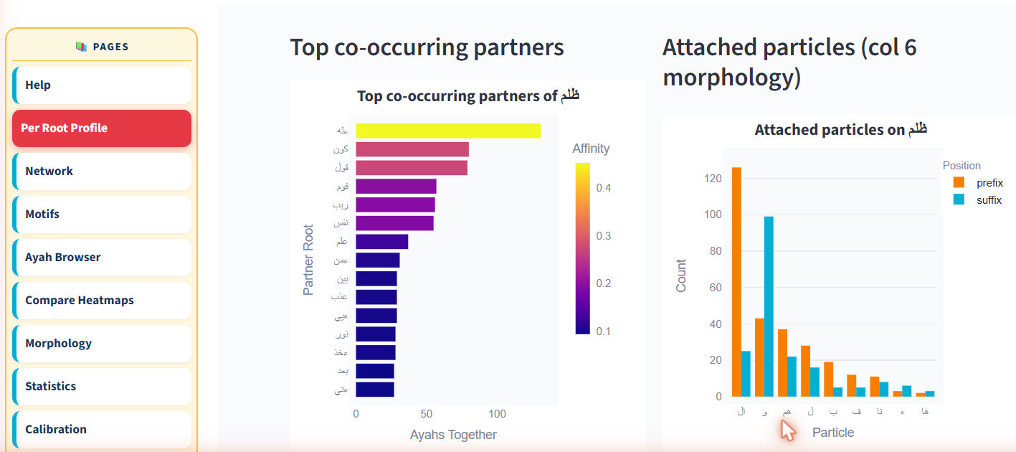
Real screenshot — top co-occurring partners and attached particles for ظلم.
- Top partners by affinity: ءله، كون، قول، قوم، ريب، نفس — this is Week 4–5 material, shown here only to orient you.
- For Week 1, stay on frequency; note these exist and move on.

6. Surface-forms — clean close-up
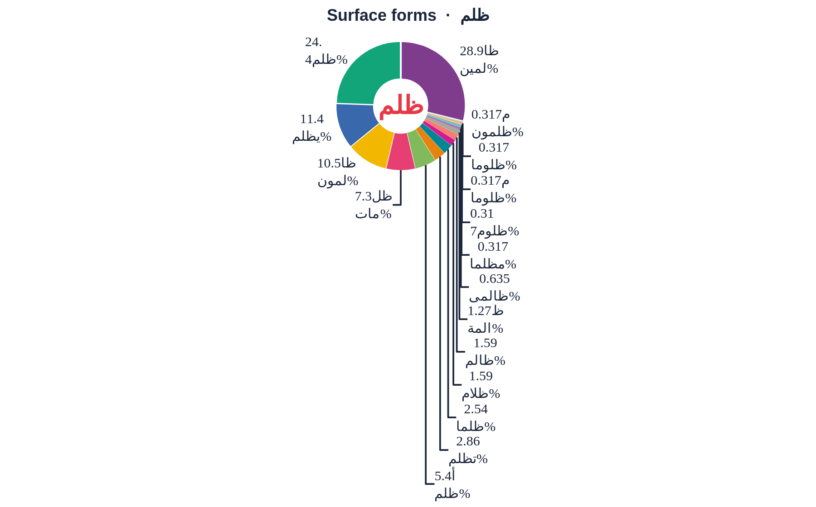
High-res export of the same donut, with all 17 surface forms legible.

Part C — The course gallery plots
- The Week-1 teaching figure built from Book6 (same data, designed for the lecture).

7. Figure 1 — frequency aspects
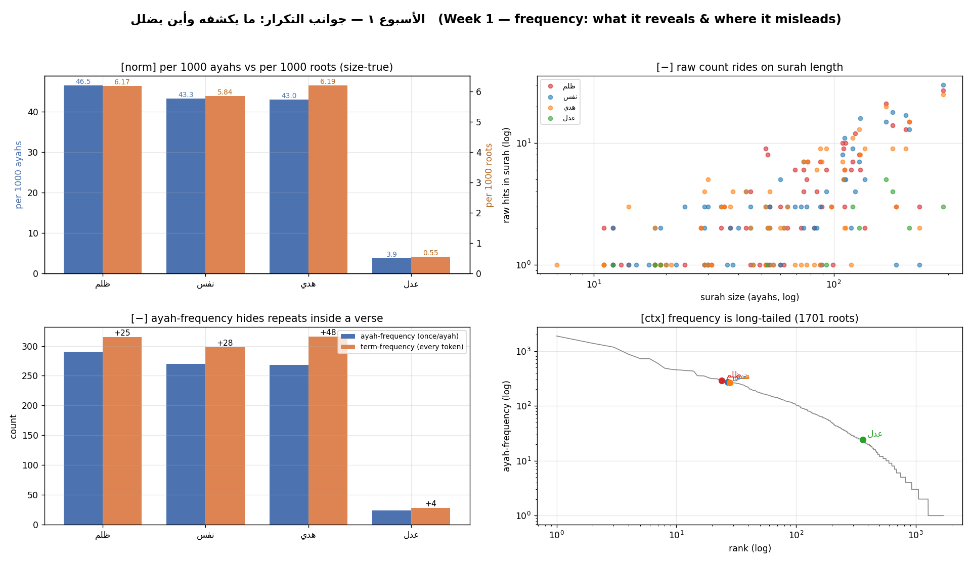
Figure 1 — frequency: what it reveals and where it misleads.
- [+] rate per 1000 · [−] count vs surah length · [−] ayah- vs term-frequency · [ctx] Zipf tail.

The cross-check rule
- Every claim must be reproducible in the app.
- Report one computed fact + one labeled interpretation.

