Week 1 — Worked Example: Surah al-Fatiha
Computing frequency by hand, step by step. 7 ayahs, 23 root-tokens, 18 distinct roots.

Step 0 — The text, tokenized
- Each ayah → content tokens → roots. The article ال and clitics are split off and dropped.
Ayah | Root-tokens | Roots | #tok | #dist.
1 | إسم الله رحمن رحیم | سمو ءله رحم رحم | 4 | 3
2 | حمد الله رب عالمین | حمد ءله ربب علم | 4 | 4
3 | رحمن رحیم | رحم رحم | 2 | 1
4 | مالک یوم دین | ملک یوم دین | 3 | 3
5 | نعبد نستعین | عبد عون | 2 | 2
6 | اهد صراط مستقیم | هدی صرط قوم | 3 | 3
7 | صراط أنعم غیر مغضوب ضالین | صرط نعم غیر غضب ضلل | 5 | 5
Total | — | 18 distinct roots | 23 | 18

Step 1 — List the distinct roots (18)
- سمو، ءله، رحم، حمد، ربب، علم، ملک، یوم، دین، عبد، عون، هدی، صرط، قوم، نعم، غیر، غضب، ضلل

Step 2 — Frequency: count by ayah, then by token
- Ayah-frequency = number of ayahs the root appears in (count once per ayah).
- Term-frequency = number of tokens (count every occurrence).
Root | Ayah-freq | Term-freq | Note
ءله | 2 | 2 | appears in ayahs 1 & 2
رحم | 2 | 4 | “رحمن رحیم” recurs in ayahs 1 & 3 — uttered 4×
صرط | 2 | 2 | ayahs 6 & 7
15 others | 1 | 1 | each occurs once
- Lesson: رحم has ayah-frequency 2 but is uttered 4 times — ayah-counting hides repetition.

Step 3 — Within-surah rate (normalized)
- Within al-Fatiha, ءله is in 2 of 7 ayahs → 2 ÷ 7 × 1000 = 285.7 per 1000.
- Across surahs, compare only such normalized rates — never raw counts.

Figure — al-Fatiha at a glance
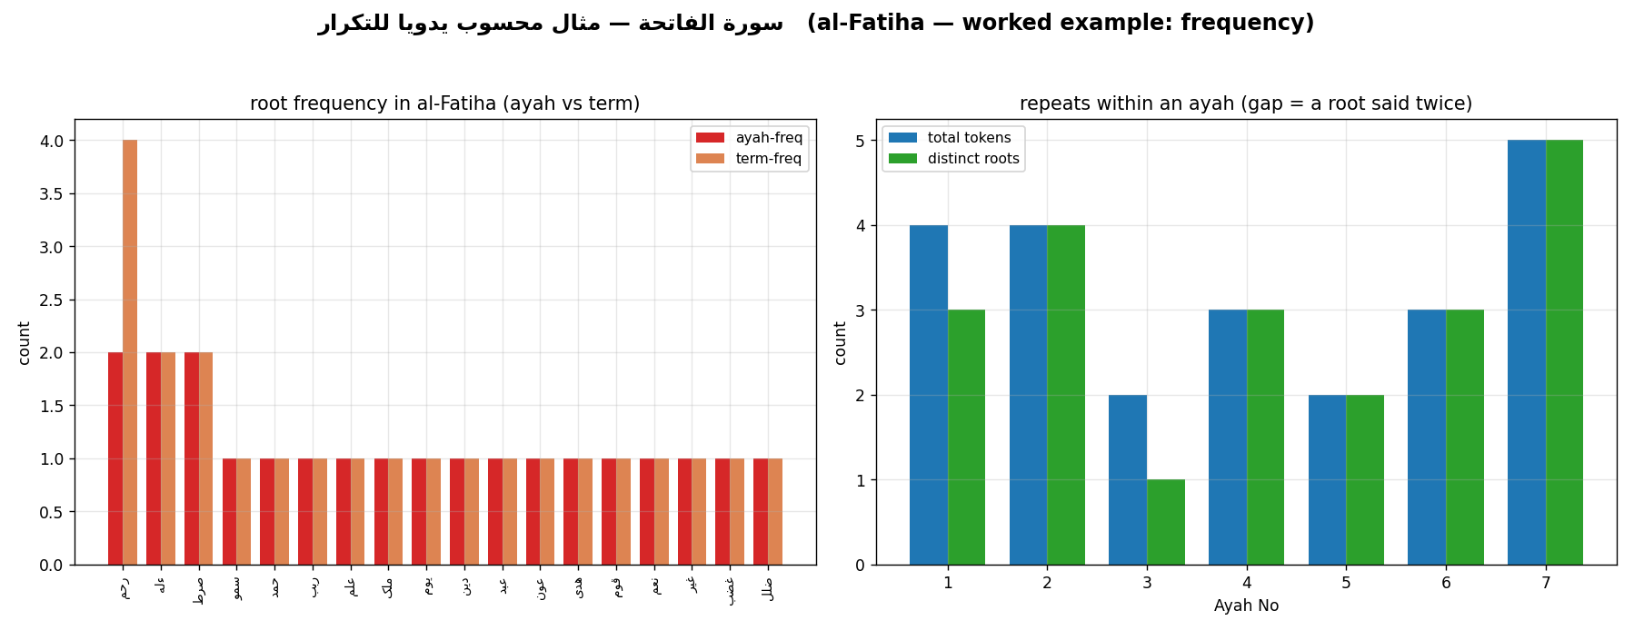
al-Fatiha: root frequency (ayah vs term) and repeats within an ayah.

Model two-sentence reading
- Fact: “In al-Fatiha, رحم has ayah-frequency 2 but term-frequency 4 — the only root uttered four times.”
- Interpretation: “I read this repetition as foregrounding mercy at the surah’s opening.”

Now you try — exercise
- Take Surah al-Ikhlas (112).
- Tabulate tokens → roots; compute ayah- and term-frequency.
- Write one computed fact + one labeled interpretation.

