Week 1 — Frequency & Density
Lecture notes (outline). “From Frequency to Structure.” Every value computed from Book6 via the Quran Root Explorer.

1. Session goal
- Measure how often a root appears — and read that measure honestly.
- Separate computed fact from interpretation from week 1.
- Roots this week: ظلم، نفس، هدي، عدل.

2. What we measure

Frequency
- Frequency = how often a root occurs in the corpus.
- Ayah-frequency — counted once per ayah (document frequency); the app’s default.
- Term-frequency — every token counted, including repeats inside one ayah.

Density
- Density = roots per unit of text.
- Per ayah — distinct roots in a verse (verse “thickness”).
- Per surah — hits per 1000 ayahs of that surah (size-normalized).

3. Why raw counts mislead — the core unlearning
- Long surahs accrue more hits just by length, not by emphasis.
- Raw frequency tracks surah size (Fig 1, panel 2).
- Fix 1 — rate per 1000 ayahs: comparable across the corpus (share of verses).
- Fix 1b — rate per 1000 ROOTS: ayahs vary in size, so also divide by total root-tokens (51,024) — the size-true rate.
  - e.g. ظلم leads هدي per-ayah (46.5 > 43.0) but trails per-root (6.17 < 6.19) — the ranking flips.
- Fix 2 — density per surah: reveals the true “home.”
- Fix 3 — support floor: ignore micro-surahs that spike density.

4. What the count gives — and what it does not
- Gives: salience, comparability (once normalized), spread vs concentration.
- Does not give: context, word order, syntax.
- Does not give: part of speech or sense — the root collapses all of them.
  - e.g. علم yields a verb, a noun, and a participle — one single root.
- Frequency ≠ importance; it is a first question, not an answer.

5. Concentration & spread
- Breadth — how many of 114 surahs the root touches.
- Gini — 0 = perfectly even, 1 = all in one surah.
- Top-3 share — % of a root’s hits in its three busiest surahs.

6. Figure 1 — Frequency aspects
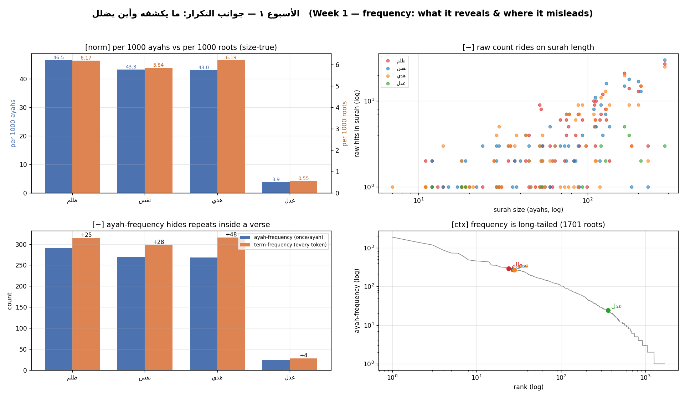
Figure 1. Frequency: what it reveals and where it misleads.
- [norm] two rates — per 1000 ayahs (ظلم 46.5) and per 1000 roots (ظلم 6.17, size-true).
- [−] Raw count rises with surah length (log–log scatter).
- [−] Ayah-frequency hides repeats — هدي: 268 ayahs but 316 tokens.
- [ctx] Frequency is long-tailed across all 1,701 roots.

7. Figure 2 — Density aspects
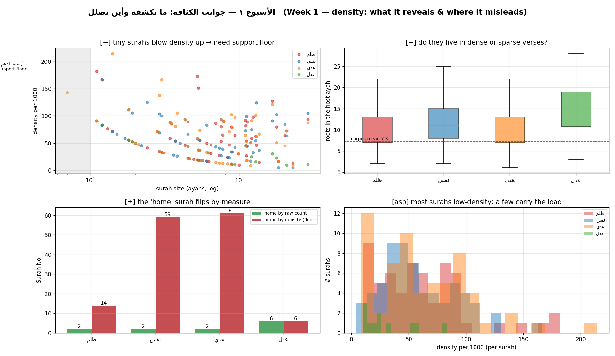
Figure 2. Density: what it reveals and where it misleads.
- [−] Tiny surahs inflate density → the support floor exists for this reason.
- [+] Host-verse thickness: do these roots sit in dense or sparse verses?
- [±] The “home” surah flips between raw count and density.
- [asp] A few surahs carry most of a root’s weight.

8. Figure 3 — Concentration & spread
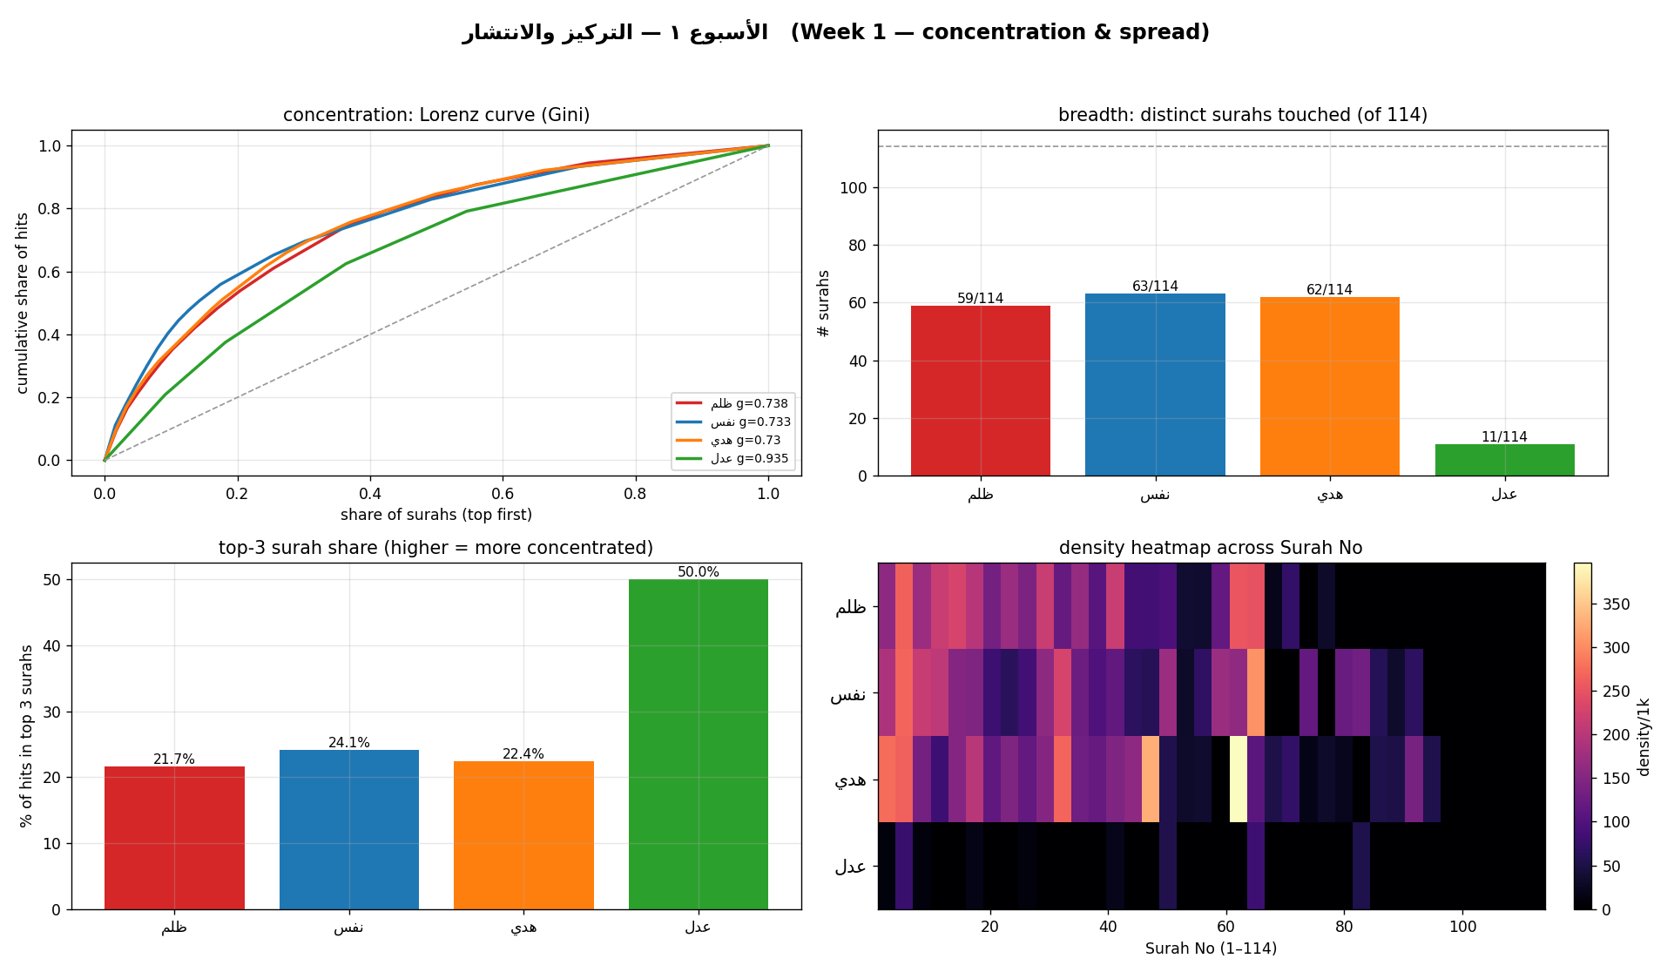
Figure 3. Concentration and spread across surahs.
- Lorenz / Gini — عدل is the most concentrated (g = 0.935).
- Breadth — ظلم 59, نفس 63, هدي 62, عدل 11 surahs.
- Top-3 share — higher bar = more concentrated.
- Heatmap — where each root’s density lives across the mushaf.

9. The two-sentence reading (discipline)
- Sentence 1 — one computed fact, with its normalization stated.
- Sentence 2 — one labeled interpretation (“I read this as …”).
- Never disguise interpretation as fact.

10. This week’s exercise
- Retrieve your assigned root’s ayah-frequency; express it as a rate per 1000.
- Find its density “home” surah (apply the support floor).
- Submit one screenshot + a two-sentence reading the night before class.

