Week 1 — Frequency (Lecture Notes, v2)
45-minute lecture, expanded along the revised outline. Outline style. Every value computed from Book6 via the Quran Root Explorer.

1. Opening & course frame (0–3 min)
- What “measuring” the Qur’an means: turning reading into counting that can be reproduced and checked.
- The course’s one rule: state a computed fact, then a separately labeled interpretation — never blur them.
- Why measure at all: memory and intuition are powerful but unauditable; a count can be wrong, but it can be checked.
- Today’s question: how often does a root appear? — the simplest, most objective layer.
- What we will NOT claim today: importance, meaning, or relationships — only presence.

2. Conceptual foundation — what frequency analysis is (3–9 min)
- The method: count how often a meaning-bearing unit occurs in a text (the word-frequency / “bag-of-words” tradition in corpus linguistics).
- “Bag of words”: temporarily set aside order and grammar; ask only what is present, and how often.
- Core working assumption: how often a text names something is a SIGNAL of emphasis — a measurable trace, not proof, of what it dwells on.
- Why start here: frequency is the most objective, reproducible layer; distribution, partners, co-occurrence, and motifs all build on these counts.
- Honest limit, stated up front: a signal of emphasis is not a verdict on importance — we return to this in §7.

3. From text to countable units — tokenization & preprocessing (9–16 min)
- Tokenization: split each ayah into word-tokens.
- Reduction to the root (3-consonant core): collapse inflection so كَتَبَ / يَكْتُبُ / كِتاب all count under كتب — we count concepts, not surface forms.
- Normalization of letters & diacritics (hamza variants, alif-maqsura/ya, stripping harakat) so the same root matches across sources.
- Content-word filter: keep meaning-bearing roots (nouns/verbs); function words — particles, pronouns, prepositions (في، من، الذي، و) — carry grammar, not theme, and mostly have no triliteral root, so the root layer drops them.
- The counting unit: once per ayah (document frequency) — one long verse cannot dominate by repeating a root.
- This reduction is lossy on purpose; exactly what we discard, and why it matters, is §7.
Surface form(s) | Root | What the step does
كَتَبَ · يَكْتُبُ · كِتاب | كتب | inflection collapsed — count the concept, not the spelling
الرَّحْمٰن · الرَّحِيم | رحم | many word-forms reduce to one root
في · مِن · الذي · وَ | — | function words: no triliteral root → dropped

4. Normalization to a rate (16–20 min)
- Raw counts can’t be compared: a larger text yields larger counts regardless of emphasis.
- Rate per 1,000 ayahs = ayah-freq ÷ 6,236 × 1,000. Worked: صبر → 93 ayahs → 14.9 / 1k ayahs.
- But ayahs vary in length, so per-1,000-ayahs is still not fully size-true.
- Rate per 1,000 ROOTS = term-freq ÷ 51,024 × 1,000 (all root-tokens). Worked: صبر → 103 tokens → 2.02 / 1k roots.
- Report both: per-1k-ayahs = share of verses; per-1k-roots = share of all root-occurrences (size-true).
- Watch the flip: ظلم > هدي per ayah (46.5 vs 43.0) but هدي > ظلم per root (6.19 vs 6.17) — the denominator changes the ranking.

5. The Qur’anic data — reading it (20–27 min)
- Walk the themed-root ladder (below): rates fall from ظلم 46.5/1k to عسر 1.9/1k.
- Three bands: pervasive (≥25/1k: ظلم، نفس، هدي، ضلل), mid (5–25: رزق، صبر، شكر، صرط، يسر), rare (<5: عدل، قسط، رشد، عسر).
- The bands are descriptive, not a law of the text — they orient attention, nothing more.
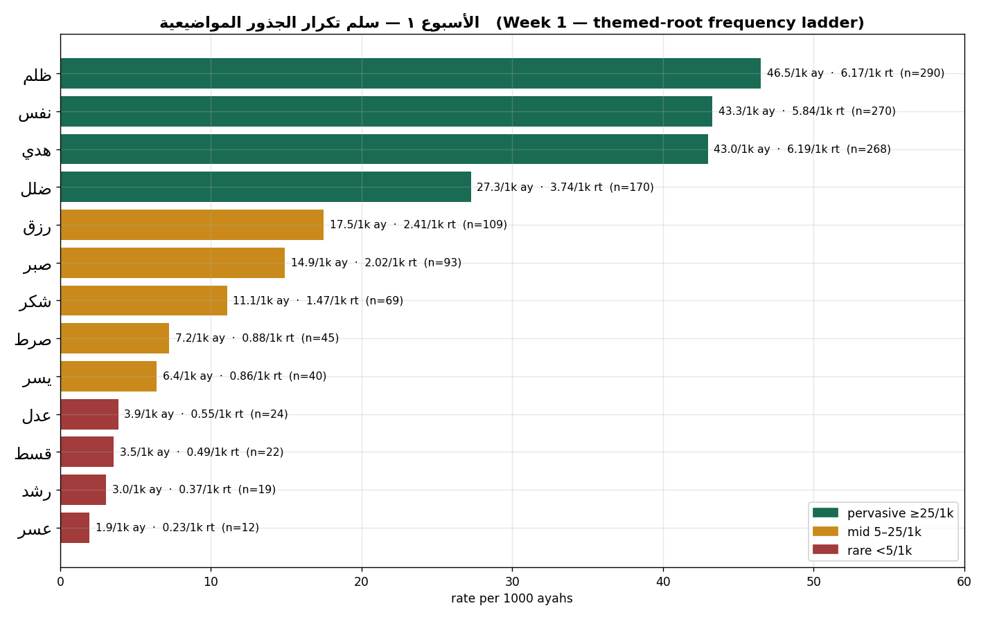
Themed-root frequency ladder — per 1,000 ayahs (with the size-true per-1,000-roots rate and raw n).
- Live retrieval in the app (below): ظلم → 290 ayahs; عدل → 24 ayahs.
- Reading habit: always pair a root’s rate with its raw count and its size-true rate before saying anything.
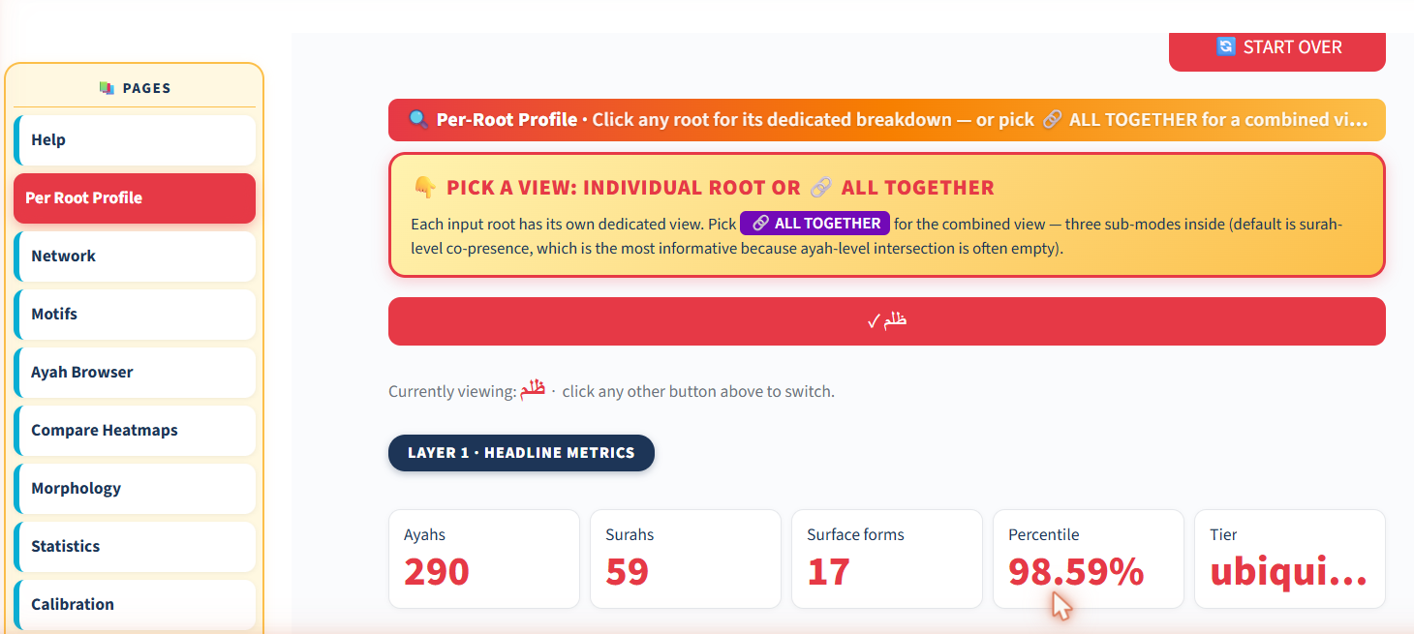
Live in the app — Per-Root Profile headline metrics for ظلم (290 ayahs, 98.59th percentile, ubiquitous).

6. The headline finding & the “unlearn” (27–32 min)
- Predict-then-check: ask the room — which is named more, عدل (justice) or ظلم (injustice)?
- Intuition often says justice; the data says injustice: ظلم 290 vs عدل 24 — about 12× more.
- A genuine unlearning: the corpus names the violation far more than the ideal.
- Caution before over-reading: this is presence, not endorsement — ظلم is named overwhelmingly to condemn it (polarity is verified later).
- The fact stands regardless of interpretation; the interpretation must be labeled.

7. Advantages, disadvantages & limits — what it gives, what it loses (32–39 min)

Advantages
- Objective & reproducible: anyone re-running the count gets the same numbers.
- Scalable: tallies all 6,236 ayahs / 1,701 roots — no reader could count this by hand.
- Comparable: via rates, puts roots — and whole texts — on one scale.
- Scoping: shows WHERE to look deeper before investing effort.

What is lost — context, above all
- Stance/polarity lost: a root is counted whether the ayah affirms, negates, questions, or condemns it (كفر counted whether disbelief is described or quoted-and-refuted).
- Speaker lost: God, prophet, opponents — all undistinguished.
- Polysemy collapsed: ظلم = injustice AND ظلمات = darkness, counted as one.
- Syntax lost: subject vs object — who does what to whom — is gone.
- Relationships lost: no sense yet of which roots travel together (Weeks 4–5).

What frequency gives vs. does not
- Gives: how present a root is, its relative emphasis, a reproducible baseline.
- Does not give: meaning-in-context, polarity, who/why, or any relationship between roots.
- Rule of thumb: frequency SCOPES inquiry; it does not SETTLE it.
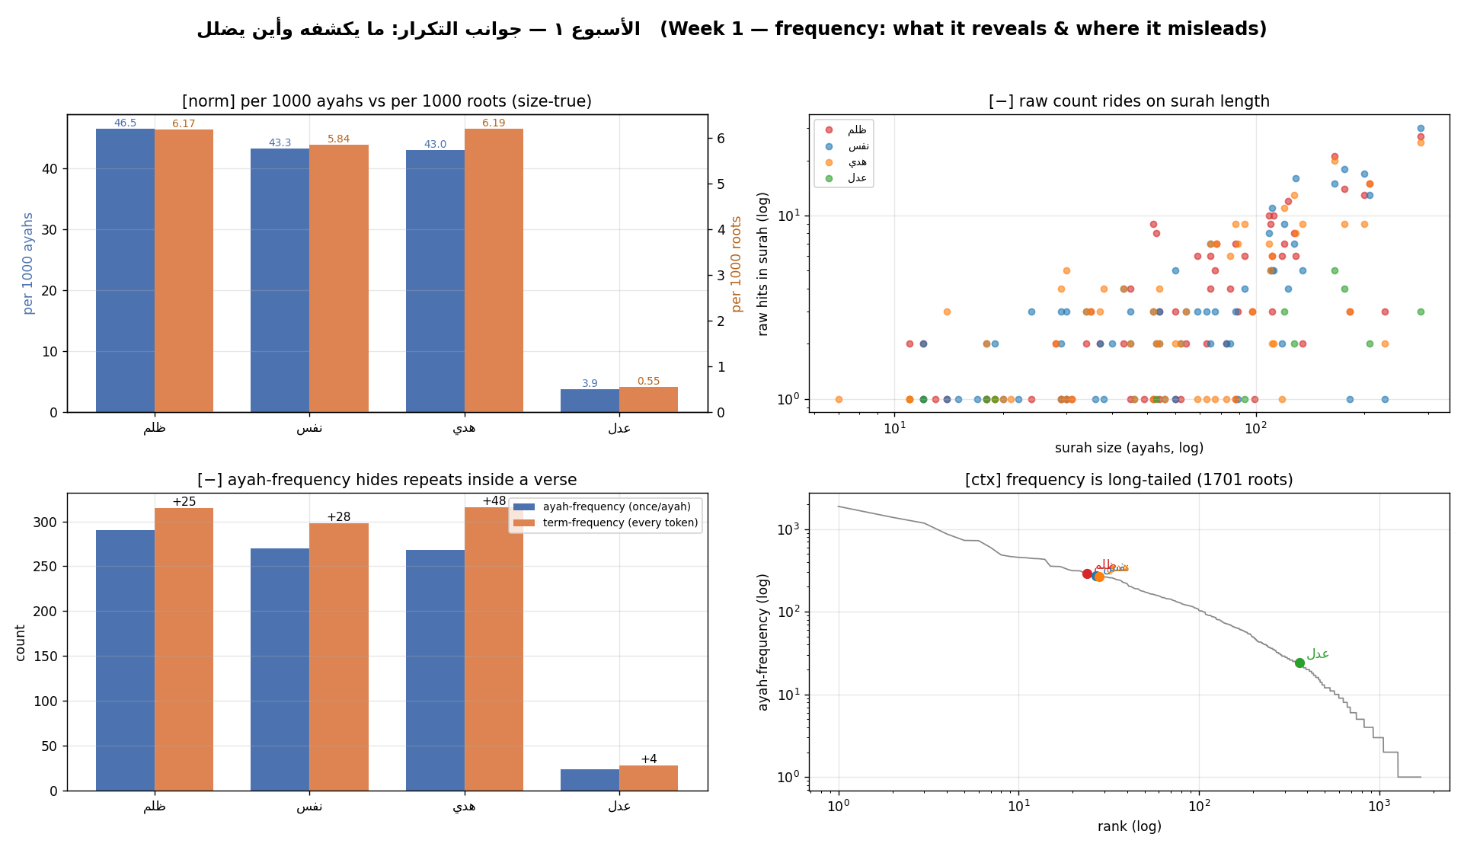
Frequency — what it reveals and where it misleads (rates, the length confound, ayah-vs-term, the long tail).

8. Fact vs. interpretation — the discipline (39–42 min)
- Separate the computed fact (ظلم 290 vs عدل 24) from any reading of it.
- Model the two-sentence form: one fact (with normalization) + one labeled interpretation.
- Fact: “ظلم is named in 290 ayahs (46.5/1k ayahs, 6.17/1k roots) — about 12× عدل.”
- Interpretation: “I read this as the text foregrounding the diagnosis of wrong over the abstract ideal.”
- Peer test: can a classmate tell which sentence is fact and which is interpretation? If not, rewrite.

9. Wrap & bridge (42–45 min)
- Takeaway: presence is a RATE, not a count — it can defy intuition, but it is context-blind.
- Individual relevance: which root’s prominence (or rarity) surprises you, and why?
- Social relevance: a community’s moral vocabulary shows in what it names most — and what it rarely names.
- The task: your assigned root + surah; record BOTH rates; one fact + one interpretation.
- Bridge to Week 2: frequency says how much; next we ask WHERE — distribution & concentration.

