Week 2 — Using the App & Reading Every Distribution Plot
A live walkthrough on one root (ظلم), theme: distribution & concentration. Figures below are computed from Book6 — the same corpus the app analyzes — so your app screens will match them. Size-true rule: read density per 1,000 ROOT-TOKENS.
Part A — Walkthrough: ظلم, the distribution way
1. Open the app and analyze the root
- Go to https://quranproject-quran-root-explorer.hf.space/ , type ظلم, click Analyze.
- The result banner reads “290 ayahs matched.” Open the Per-Root Profile (left sidebar).
2. Per-Root Profile — the headline metrics
Read the profile card: ظلم is named in 290 ayahs, spans 59 of the 114 surahs (its breadth), sits at the 98.6th percentile, and its concentration is top-3 share 21.7%, Gini 0.74. Crucially, its size-true home is Ibrahim — not al-Baqara.
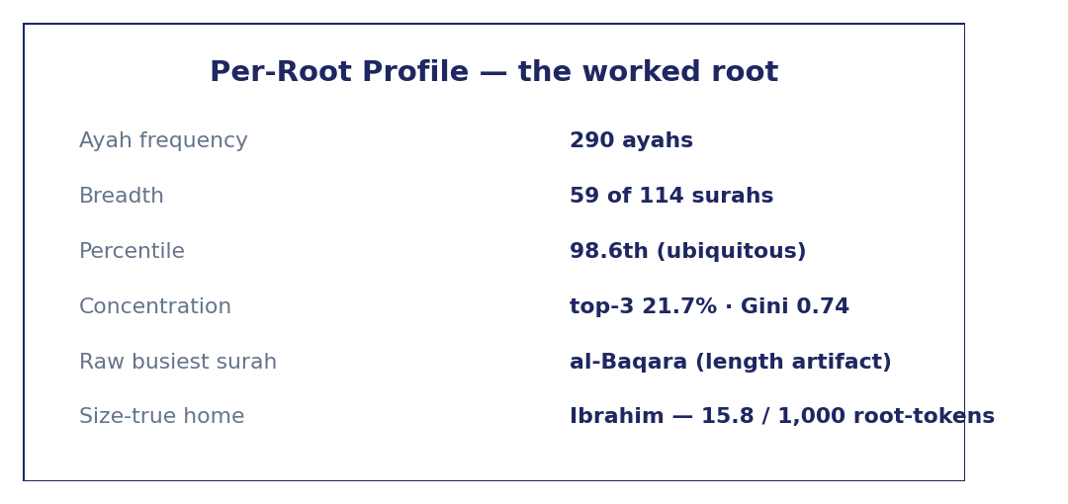
Per-Root Profile metrics for ظلم (computed from Book6).
3. The per-surah distribution chart
The “Ayah hits per surah” chart shows one bar per surah. al-Baqara towers over the rest — but that height is mostly surah length, not density. This is the length confound in a picture.
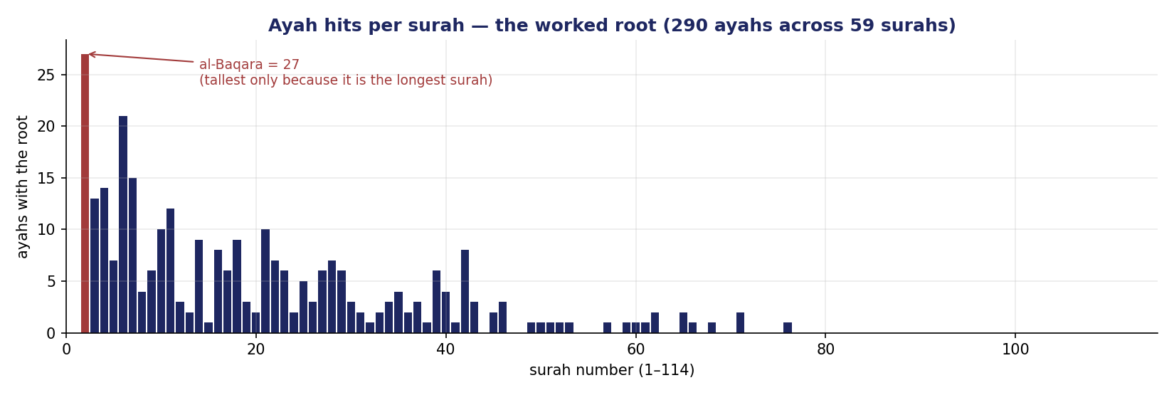
Ayah hits per surah for ظلم — al-Baqara is tallest only because it is the longest surah.
Read it correctly: the raw tallest bar (al-Baqara) is NOT the home. Normalize each surah by its root-tokens. For ظلم, the size-true home is Ibrahim at 15.8 per 1,000 root-tokens; al-Baqara is only 7.8.
4. Concentration — top-3 share and Gini
Read how unevenly the bars fall. For ظلم the three busiest surahs hold 21.7% of its ayahs and the Gini is 0.74 — moderately concentrated. The Lorenz curve makes concentration visible: the harder it bows, the more pooled.
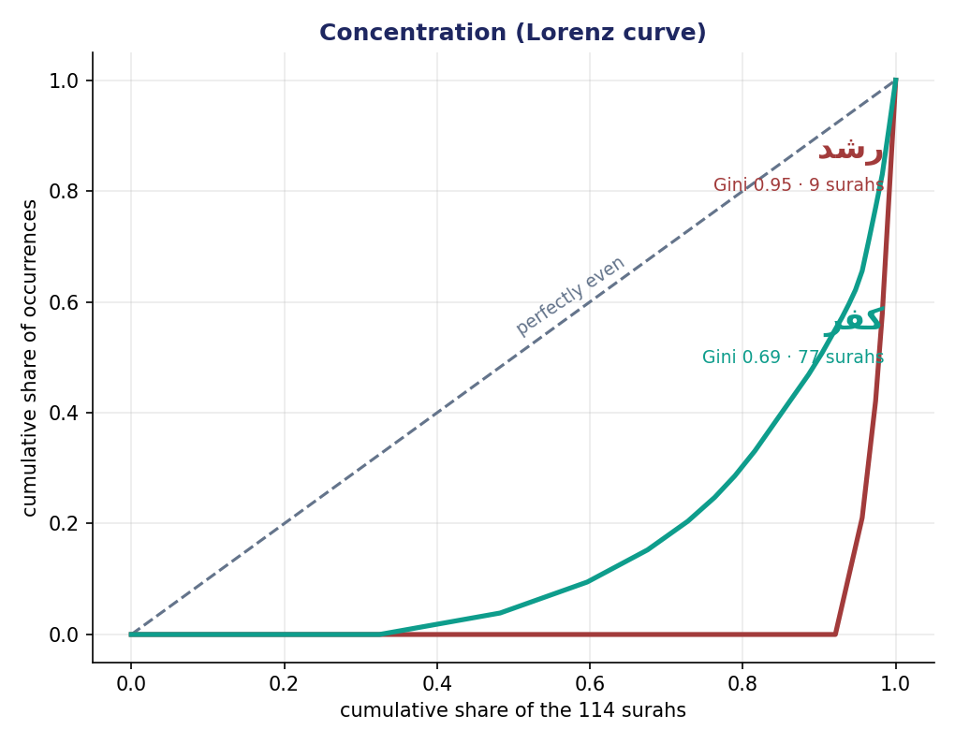
Lorenz curves: رشد concentrated (Gini 0.95) vs كفر spread (Gini 0.69).
Part B — Computing the size-true home (the key skill)
Surah | ظلم tokens | surah root-tokens | per 1,000 root-tokens
al-Baqara (raw busiest) | 31 | 3,966 | 7.8
Ibrahim (size-true home) | 9 | 568 | 15.8
- Divide each surah's root-tokens of ظلم by that surah's TOTAL root-tokens, ×1,000.
- Apply the support floor: count ≥ 3 AND surah ≥ 30 root-tokens. Both pass → home = Ibrahim.
- Never use raw hits, and never divide by ayah-count (ayahs vary in length too).
Part C — The cross-check rule
- Every claim must be reproducible in the app and the per-1,000-root-tokens calculation.
- Report one computed fact (with its size-true normalization + floor) + one labeled interpretation.

