Week 3 — Using the App: Reading Forms & Partners
A walkthrough on one root (ءمن). Figures are computed from Book6 — the same corpus the app analyzes — so your app screens will match them.
Part A — Surface forms
1. Analyze the root and open its forms
- Go to https://quranproject-quran-root-explorer.hf.space/ , type ءمن, click Analyze.
- Open the Per-Root Profile and find the Surface forms view (donut or list).
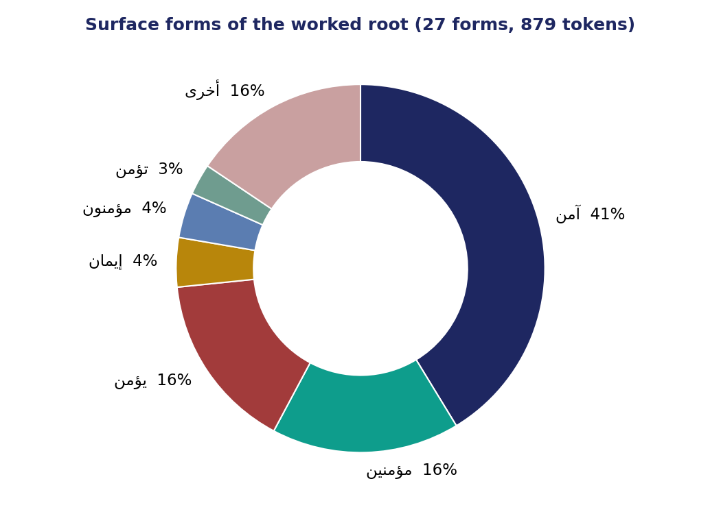
Surface forms of ءمن — 27 forms across 879 tokens; the verb آمن dominates at 41%.
2. Read it by pattern family
Don't stop at the spellings — group them by pattern. The verb forms (آمن، يؤمن) are the act; the participle (مؤمن) is the agent; the masdar (إيمان) is the abstract act; and the intensive (أمين) is an attribute. For ءمن the verb family dominates — faith is most often an act.
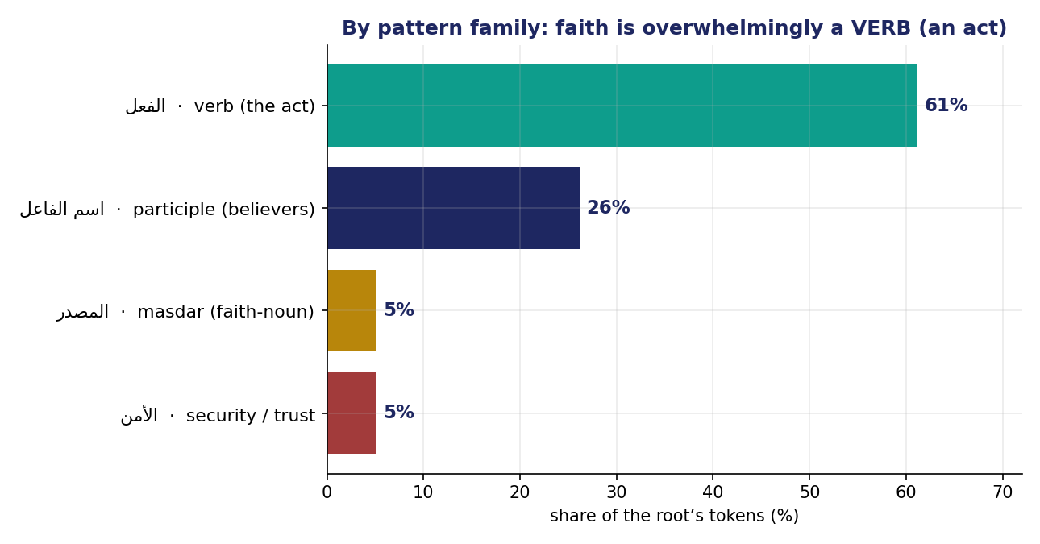
ءمن by pattern family: 61% verb (an act), 26% participle, 5% masdar, 5% security.
Watch for polysemy: the same root branches into أمن (security) and أمين (trustworthy) — a second sense living in the forms.
Part B — Partners
3. Open the co-occurring roots / partners panel
The partners panel lists the roots that share ayahs with your root, already frequency/length-controlled (the mechanism is Weeks 4–5). Read the top of the list.
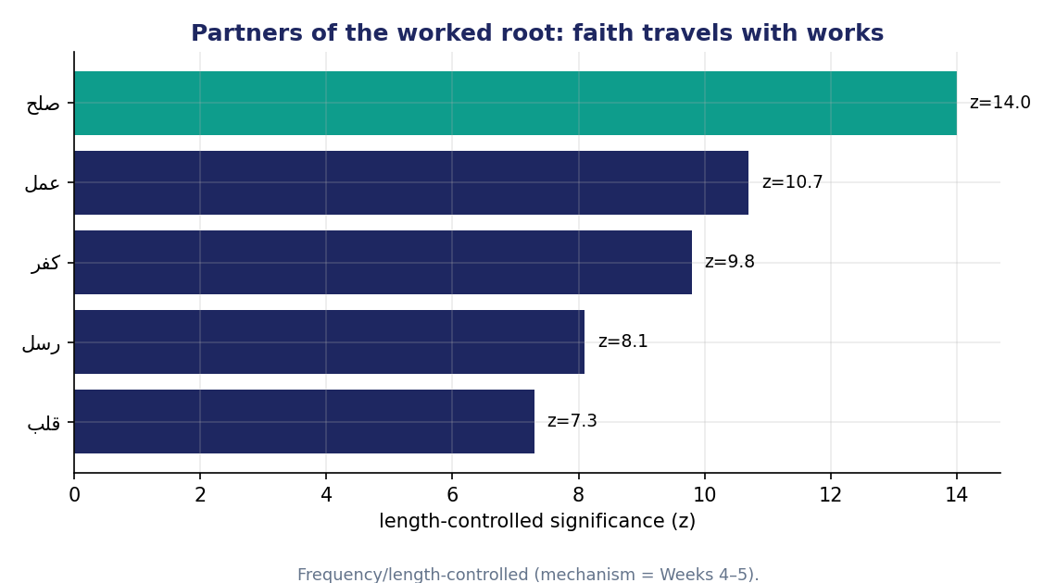
Partners of ءمن (length-controlled): صلح (righteous deeds) and عمل (works) lead — faith travels with works.
- Record the top three partners. For ءمن: صلح, عمل, then رسل / قلب.
- Flag any ANTONYM. ءمن co-occurs heavily with كفر (disbelief) — opposites are defined together.
Part C — The cross-check rule
- Every claim must be reproducible in the app and the Week-3 data bank.
- Report one computed fact (a form share or a partner's significance) + one labeled interpretation.

