Week 4 — Using the App: Finding a Root's True Companion
A walkthrough on one target (صلو). Figures are computed from Book6 — the same corpus the app analyzes — so your app screens will match them.
Part A — The raw co-occurrence list
1. Analyze the target and open its co-occurring roots
- Go to https://quranproject-quran-root-explorer.hf.space/ , type صلو, click Analyze.
- Open the co-occurring roots / partners panel. Note the shared-ayah (joint) count for each candidate.
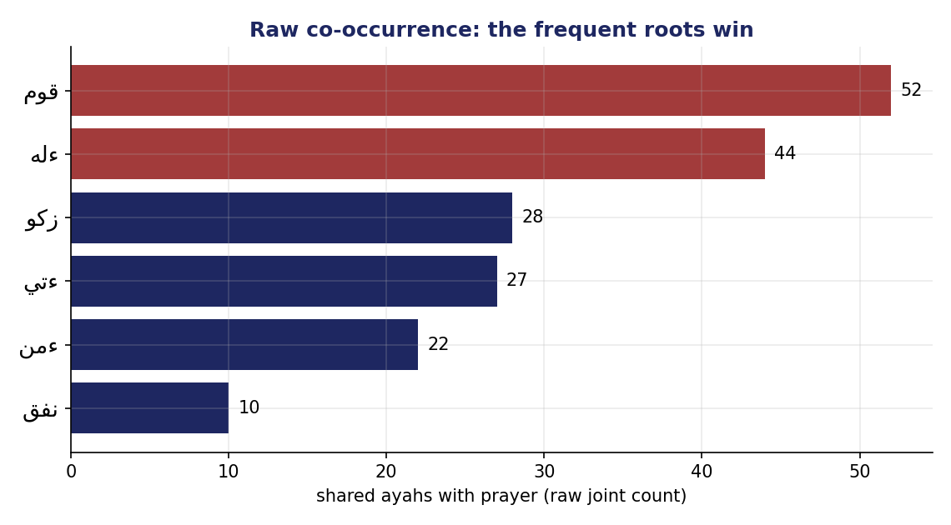
Raw co-occurrence with prayer — the frequent roots قوم and ءله top the list.
Do not stop here. The raw leaders قوم (establish) and ءله (God) lead because they are everywhere — they share ayahs with almost every root. Raw count rewards fame, not friendship.
Part B — Control for frequency
2. Compute the times-over-chance ratio
For each candidate: expected = freq(target) × freq(candidate) ÷ 6,236; ratio = observed ÷ expected. For prayer, God's 44 shared ayahs are only ×1.6 (expected ≈ 27), while zakat's 28 are ×34.6 (expected ≈ 0.8).
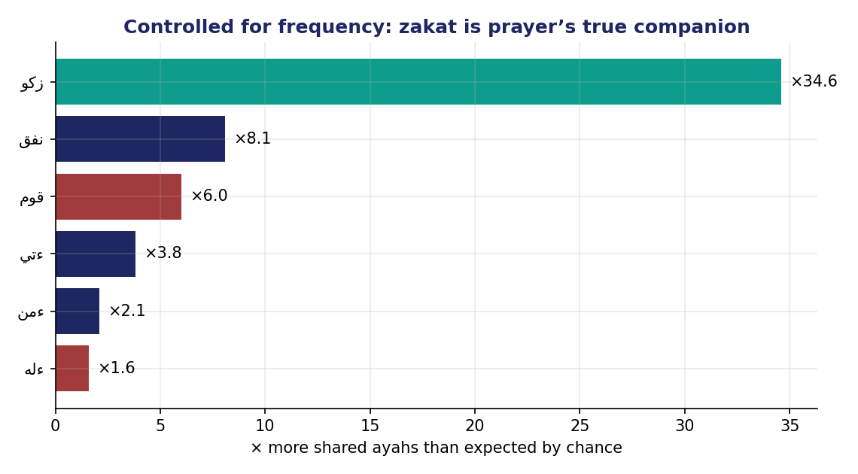
Controlled for frequency, zakat is prayer's true companion — ×34.6 over chance.
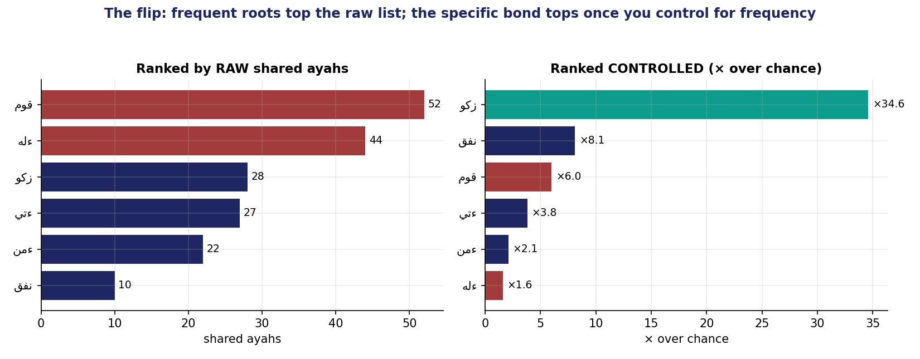
The flip: قوم / God top the raw list; zakat tops once you control for frequency.
- Report the controlled winner. For صلو it is زكو — half of all zakat ayahs sit with prayer.
- Apply the support floor. Ignore any pair with fewer than 5 shared ayahs.
Part C — The cross-check rule
- Every claim must be reproducible in the app and the Week-4 data bank.
- Report one computed fact (a controlled ratio) + one labeled interpretation.
- Remember the limits: this control ignores ayah length (Week 5), shows no direction (Week 6), and association is not cause.

