Week 5 — Using the App: delivering a verdict on a pair
A walkthrough on صلو ↔ زكو. Figures are computed from Book6 — the same corpus the app analyzes — so your app screens will match them.
Part A — Read the three numbers
1. Analyze the pair
- Open the app, analyze صلو, and open its co-occurrence / pair panel; select زكو as the partner.
- Record the joint count (28), the length-aware lift (×23.6), and the Monte-Carlo p-value (< 0.001).
2. Read the Monte-Carlo result
The app shows how the observed overlap compares to the null distribution from thousands of shuffles. For صلو↔زكو, chance never reaches 28 — the bond is off the chart.
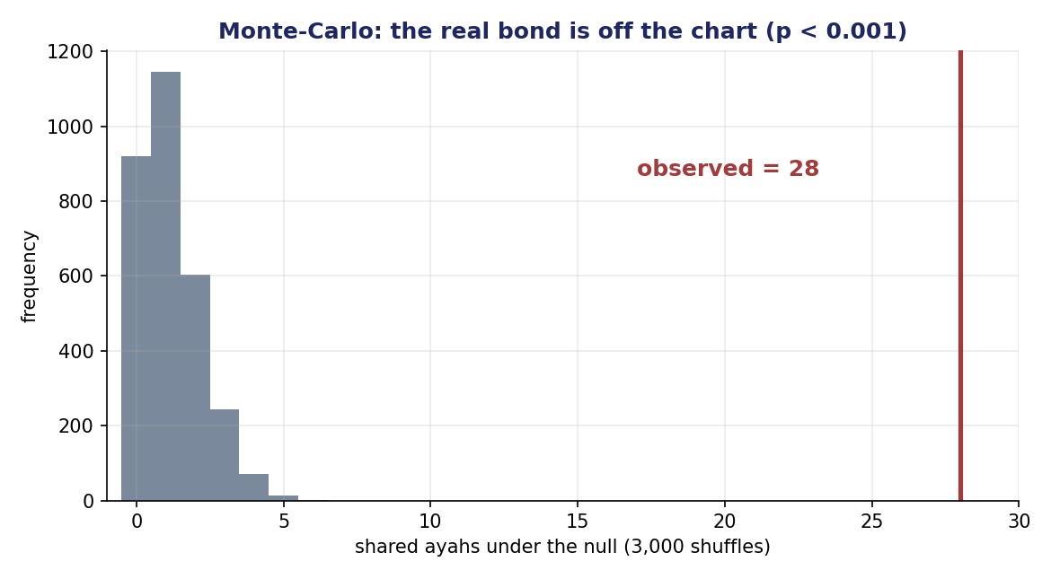
Monte-Carlo for صلو↔زكو: chance gives 0–3 shared ayahs; observed is 28 (p < 0.001).
Part B — Assign the tier
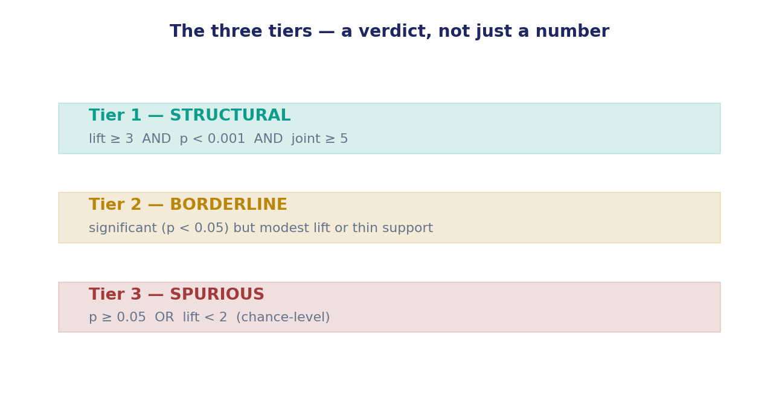
The tier rule — structural / borderline / spurious.
Apply it: lift ×23.6 ≥ 3 ✓, p < 0.001 ✓, joint 28 ≥ 5 ✓ → Tier 1, STRUCTURAL.
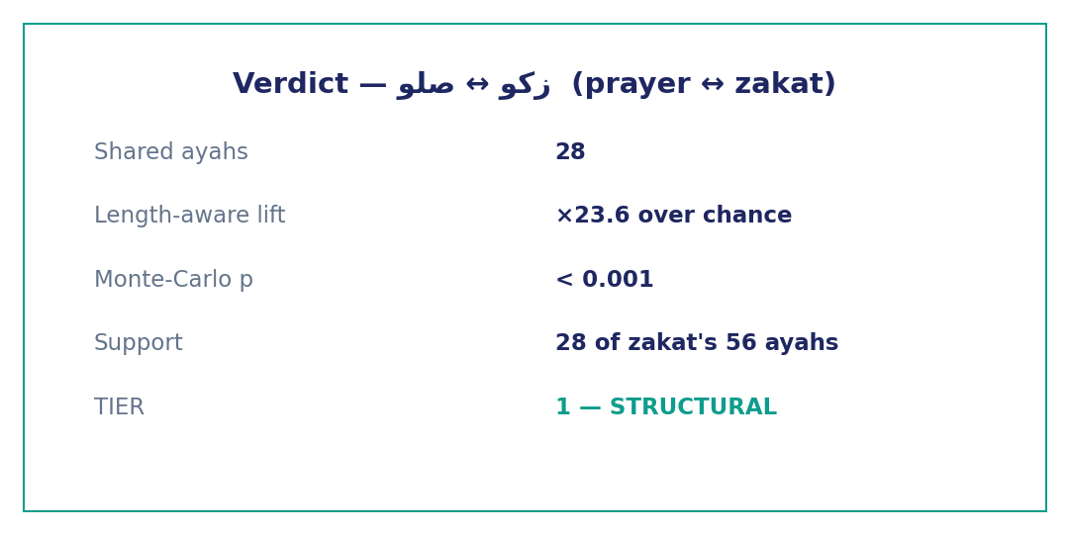
The verdict card for صلو↔زكو.
Part C — Don't be fooled by a big count
Try قول ↔ شيء: joint 113 (the biggest in our set), but lift ×0.8 and p ≈ 0.99 → Tier 3, SPURIOUS. A big shared count is not a bond — always read the lift and the p-value, not the raw count.
The cross-check rule
- Every claim reproducible in the app and the Week-5 data bank.
- Report one fact (lift + p + tier) + one labeled interpretation.
- Limits: the tier judges reality, not direction (Week 6) or meaning.

