Qurat-ul-ain
Day 2 practice task

HTML Tags Used and Learned
While creating my IEEE University Society webpage, I used and learned the following HTML tags:
HTML Tag | Purpose
<!DOCTYPE html> | Defines the document as an HTML5 document.
<html> | The root element of the HTML document.
<head> | Contains information and settings about the webpage.
<meta> | Provides metadata such as character encoding and viewport settings.
<title> | Defines the title displayed on the browser tab.
<body> | Contains all the visible content of the webpage.
<header> | Defines the introductory/header area of the webpage.
<nav> | Defines the navigation section of the webpage.
<ul> | Creates an unordered list.
<li> | Defines an individual list item.
<a> | Creates hyperlinks for navigation and external links.
<main> | Defines the main content of the webpage.
<section> | Divides the webpage into different sections.
<article> | Represents an independent piece of content, such as an event or information section.
<h1> | Defines the main heading of the webpage.
<h2> | Defines major section headings.
<h3> | Defines subheadings within sections.
<p> | Defines paragraphs of text.
<strong> | Gives strong importance to text and normally displays it in bold.
<footer> | Defines the footer area of the webpage.
<!-- --> | Creates comments in HTML that are not displayed on the webpage.

What I Learned:
Through this task, I learned how to create a structured HTML webpage using different HTML elements. I learned how to organize content using headings, paragraphs, sections, articles, lists, navigation, and footer elements.
I also learned how to create links using the <a> tag and how to use attributes such as href and mailto. I learned the difference between different semantic HTML elements such as <header>, <nav>, <main>, <section>, <article>, and <footer>.
By completing this webpage, I gained practical experience in creating a properly structured HTML page without using CSS.

Conclusion:
This task helped me understand the basic structure of an HTML webpage and gave me practical experience using different HTML tags. I can now create a basic structured webpage using headings, paragraphs, links, lists, sections, articles, navigation, and footer elements.
Code:
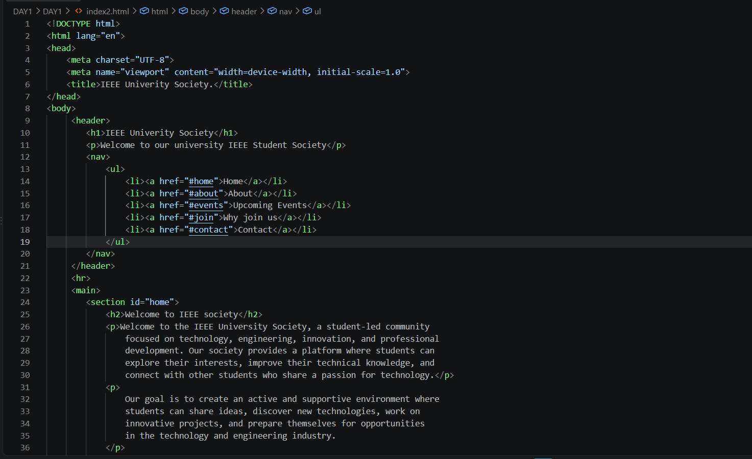
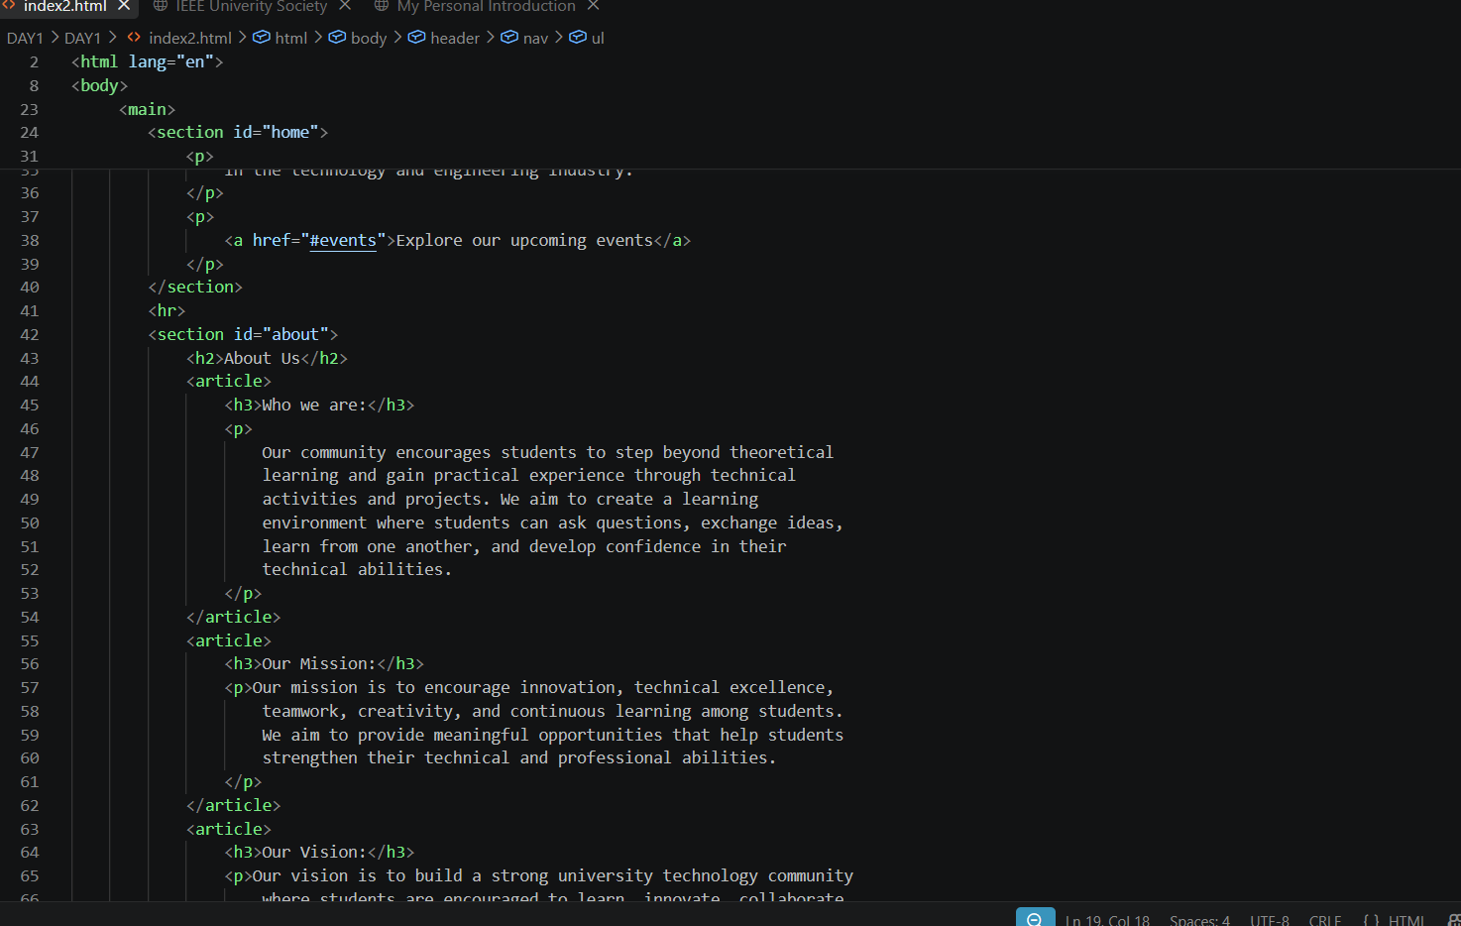
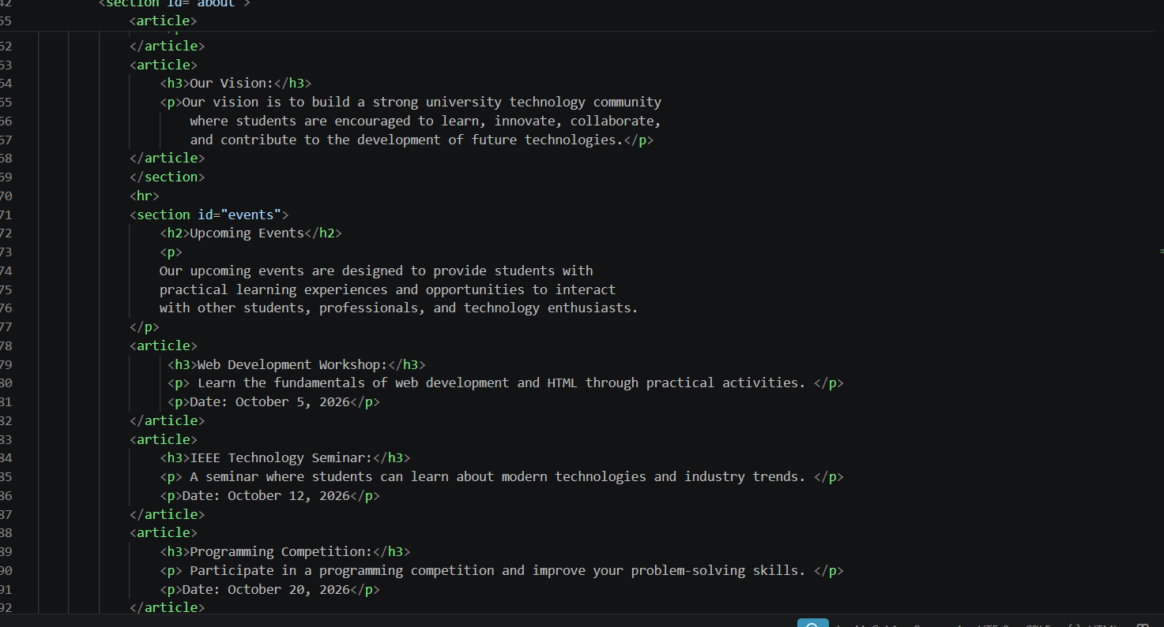
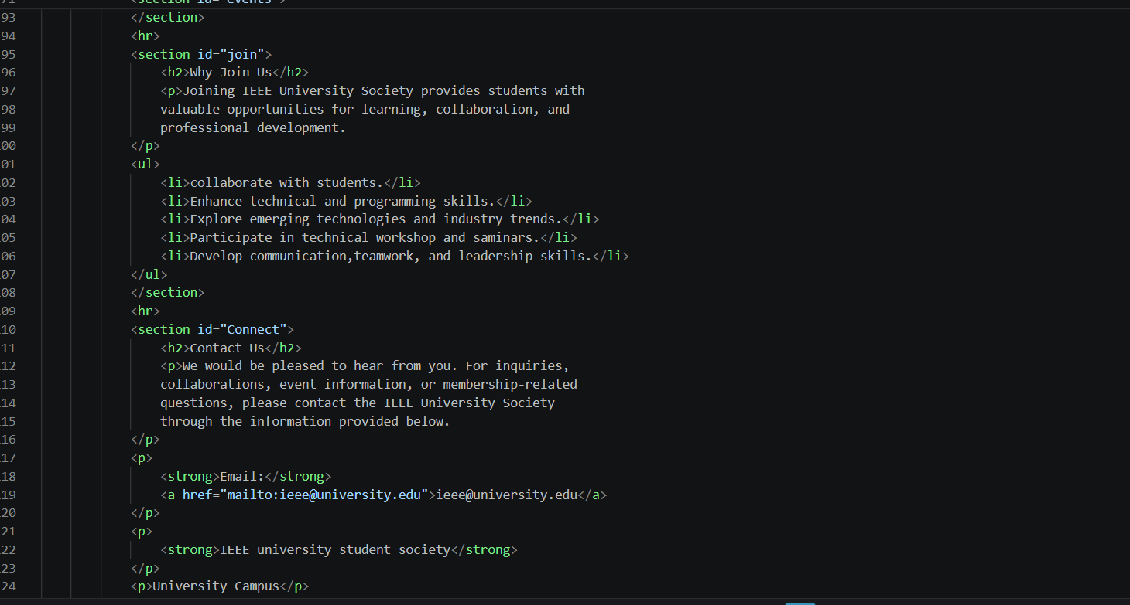
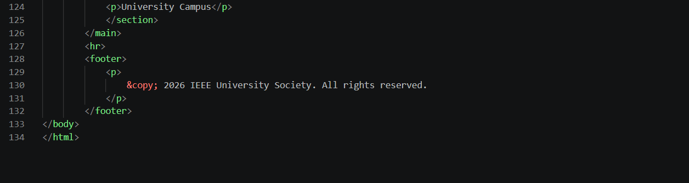

Result:
