<Fitness Club Website/Membership Management System>

**Software Requirements Specification**

Version 1.0



**Group Id: <S230276DC0** (BC190402690)**>**

**Supervisor Name : <** Abdullah Qamar**>**

**Revision History**

|  |  |  |  |
| --- | --- | --- | --- |
| **Date (dd/mm/yyyy)** | **Version** | **Description** | **Author** |
| 31/05/ 2023 | 1.0 | The Gym/Fitness Club Membership Management System is a web application aimed at helping gym and fitness clubs effectively manage their memberships. It offers features such as membership sign-up and renewal, fee management, personalized member dashboards, integration with RFID or biometric systems, membership analytics, member communication, automated notifications, fitness training routines, and customer diet plans. The system utilizes technologies such as PHP Laravel 9, React, and MySQL for backend, frontend, and database respectively. The project will be supervised by Abdullah Qamar, and a well-defined work plan will be followed using an appropriate methodology. The system aims to streamline administrative processes, improve member engagement, and provide a seamless and personalized experience for gym club members. | BC190402690 |
|  |  |  |  |
|  |  |  |  |
|  |  |  |  |

**Table of Contents**

1. Scope (of the project)
2. Functional Requirements Non Functional requirements
3. Use Case Diagram
4. Usage Scenarios
5. Adopted Methodology
6. Work Plan

**SRS Document**

Scope of Project:

The scope of the Gym/Fitness Club Membership Management System project is to develop a comprehensive web application that caters to the specific needs of gym and fitness clubs in managing their memberships efficiently. The system aims to streamline the administrative processes involved in membership management, enhance member experience and satisfaction, and provide valuable features to support the overall health and wellness goals of club members.

The project encompasses the following key components within its scope:

1. **Membership Sign-up and Renewal:** The system will provide functionality for new members to sign up for memberships, either online or through an administrative interface. It will offer different membership levels and pricing options to cater to the diverse needs of club members. Additionally, existing members will have the convenience of renewing their memberships when they expire.
2. **Fee Management:** A robust fee management system will be incorporated to handle membership fees, payments, and related financial transactions. The system will support different payment methods and provide flexibility in applying discounts, managing installment plans, and tracking payment history.
3. **Personalized Member Dashboard:** Each member will have access to a personalized dashboard where they can view and manage their account details. The dashboard will provide an overview of membership status, class attendance records, progress tracking towards fitness goals, and relevant notifications. Members will also be able to update their personal information and view their payment history.
4. **RFID or Biometric Integration:** To streamline the check-in and check-out processes, the system will integrate with RFID card or biometric systems. This integration may involve the use of RFID cards or biometric readers such as fingerprint or facial recognition scanners, enabling quick and secure access to the gym facilities.
5. **Membership Analytics:** The system will generate comprehensive analytics and reports to track member engagement, retention rates, and other key metrics. These insights will help gym and fitness club administrators make data-driven decisions to improve their services and member satisfaction.
6. **Member Communication:** Effective communication between gym staff and members is vital. The system will facilitate communication through various channels, including email, SMS, or other messaging platforms. Gym staff will be able to send automated messages to members, such as class reminders, promotions, and event notifications, keeping them engaged and informed.
7. **Automated Notifications:** The system will feature automated notifications to members who have not attended the gym for a certain period. These notifications will serve as gentle reminders, encouraging members to return and maintain their commitment to their fitness journey.
8. **Fitness Training Routines:** Personalized fitness training routines will be provided to members based on their specific goals and abilities. The system will offer workout plans tailored to individual preferences, helping members plan and track their exercise routines effectively.
9. **Customer Diet Plans:** To support members' overall health and wellness, the system will generate personalized diet plans based on their fitness goals and dietary preferences. This feature will provide members with nutritional recommendations aligned with their individual needs, aiding them in achieving their desired results.

The chosen technology stack for the project includes PHP Laravel 9 for the backend development, React for the frontend implementation, and MySQL for the database management. Communication will be facilitated using SMTP for emails and Trello for SMS messaging. Through the successful implementation of the Gym/Fitness Club Membership Management System, gym and fitness clubs will be able to streamline their administrative processes, improve member satisfaction, and foster a sense of community among their members. The system aims to provide a seamless and personalized experience for club members, empowering them to achieve their health and fitness goals effectively.

Functional and non Functional Requirements:

**Functional Requirements:**

**Membership Sign-up and Renewal:** The system should allow new members to sign up for memberships online or through the admin interface.

Different membership levels and pricing options should be available for selection during the sign-up process. Existing members should be able to conveniently renew their memberships when they expire.

**Fee Management:** The system should provide a comprehensive fee management module to handle membership fees, payments, and financial transactions.

It should support different payment methods and allow for the application of discounts and installment plans. The system should maintain a record of payment history for each member.

**Personalized Member Dashboard:** Each member should have a personalized dashboard displaying their account details.The dashboard should include information such as membership status, class attendance records, and progress towards fitness goals.

Members should be able to update their personal information through the dashboard.

**RFID or Biometric Integration:** The system should integrate with RFID card or biometric systems to facilitate member check-in and check-out processes.

This integration could involve the use of RFID cards or biometric readers like fingerprint or facial recognition scanners. Members should be able to access the gym facilities securely and conveniently using their assigned RFID cards or biometric data.

**Membership Analytics:** The system should generate analytics and reports to track member engagement, retention rates, and other relevant metrics.

These analytics should provide insights into member behavior, class attendance patterns, and overall gym performance.

Administrators should be able to analyze the data to make informed decisions for improving member experiences and services.

**Member Communication:** The system should facilitate communication between gym staff and members through various channels such as email, SMS, or other messaging platforms.Gym staff should be able to send automated messages to members, including class reminders, promotions, and event notifications.

Members should have the option to opt-in or opt-out of receiving communication through their preferred channels.

**Automated Notifications:** The system should be capable of sending automated notifications to members who have not attended the gym for a specific period of time.

These notifications should serve as reminders to encourage members to return to the gym and stay engaged with their fitness routine. The frequency and content of these notifications should be customizable by the gym administrators.

**Fitness Training Routines:** The system should provide personalized fitness training

routines for members based on their fitness goals and abilities.These training routines should be tailored to individual preferences, taking into account factors such as fitness level, exercise preferences, and any specific requirements.

Members should be able to access and track their assigned training routines through their member dashboard.

**Customer Diet Plans:** The system should generate personalized diet plans for members based on their fitness goals and dietary preferences.These diet plans should include nutritional recommendations and meal plans that align with the member's goals.

Members should be able to access and view their personalized diet plans through their member dashboard.

**Non-Functional Requirements:**

**Performance**: The system should be capable of handling a large number of simultaneous users and transactions without significant performance degradation.

Response times for user interactions and system operations should be fast and efficient.

**Security:** The system should ensure the security and privacy of member information.

Strong authentication and access control mechanisms should be implemented to protect sensitive data. Communication channels should be encrypted to prevent unauthorized access to member communication.

**Usability:** The system should have a user-friendly and intuitive interface for both administrators and members.

Navigation should be easy, and relevant information should be presented in a clear and organized manner. The system should support multiple languages or provide localization options to accommodate diverse user needs.

**Scalability:** The system should be designed to accommodate future growth and scalability. It should be capable of handling an increasing number of members and additional features without major architectural changes.

**Reliability:** The system should be highly reliable, minimizing the occurrence of errors and downtime.It should have appropriate backup and recovery mechanisms to ensure data integrity and availability.

**Integration:** The system should support integration with external systems such as payment gateways, email/SMS providers, and other third-party services as required.

**Accessibility:** The system should comply with accessibility standards to ensure equal access and usability for individuals with disabilities.

It should support assistive technologies and provide appropriate accommodations for users with visual, auditory, or motor impairments.

These functional and non-functional requirements serve as the foundation for developing a robust and efficient Gym/Fitness Club Membership Management System.

Use Case Diagram(s):

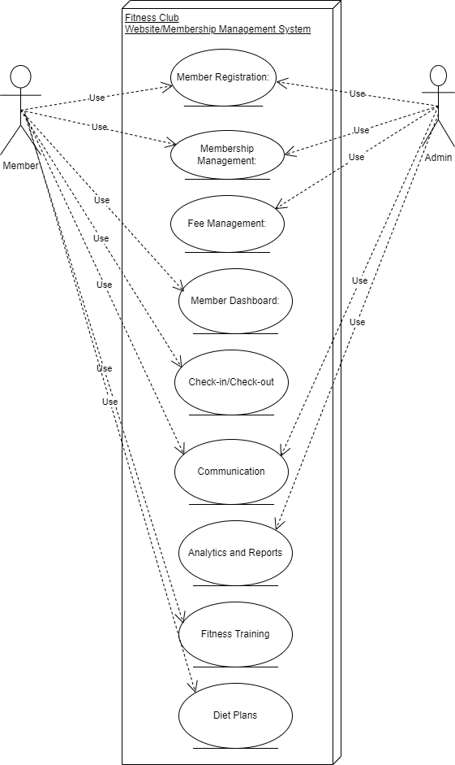

Usage Scenarios:

Certainly here’s a table format explaining the usage scenarios for each of the use cases in the use case diagram:

**Use Case: Member Registration (UC001)**

| Use Case Title | Member Registration (UC001) |
| --- | --- |
| Actions | 1. New Member signs up for membership online.  2. Administrator reviews and approves the registration. |
| Description | A new member provides required details and selects a membership level during the online sign-up process. An administrator verifies the provided information and approves the new member's registration. |
| Alternative Paths | - New Member signs up through the admin interface. |
| Pre-conditions | - The system allows new member registration. The administrator has the necessary privileges to approve registrations. |
| Post-conditions | The new member's account is created and approved. |
| Author | Analyst |
| Exceptions | - Invalid or incomplete information provided during sign-up.  - Administrator rejects the registration due to insufficient information or eligibility issues. |

**Use Case: Membership Management (UC002)**

| Use Case Title | **Membership Management (UC002)** |
| --- | --- |
| Actions | 1. Member requests to renew their membership.  2. Administrator upgrades or downgrades the membership. |
| Description | A member initiates the membership renewal process, either online or through the admin interface. An administrator receives a membership upgrade/downgrade request from a member and makes the necessary changes to the membership level. |
| Alternative Paths | None |
| Pre-conditions | - The member's account is active and has an expired membership.  - The member's account is active and the requested membership change is valid. |
| Post-conditions | - The member's membership is renewed and the account is updated accordingly.  - The member's membership level is updated as per the request. |
| Author | Analyst |
| Exceptions | - Member decides not to renew their membership  - Administrator rejects the membership change request due to eligibility or other constraints. |

**Use Case: Fee Management (UC003)**

| Use Case Title | **Fee Management (UC003)** |
| --- | --- |
| Actions | 1. Administrator sets membership fees and discounts.  2. Member pays the membership fee. |
| Description | An administrator defines the membership fees for different levels and configures any available discounts or payment options. A member selects a payment method and submits the membership fee either online or at the gym's front desk. |
| Alternative Paths | None |
| Pre-conditions | - The administrator has the necessary privileges to manage membership fees.  - The member has an active account and the membership fee has not been paid. |
| Post-conditions | - The membership fees and discounts are configured in the system.  - The member's payment is recorded, and their account reflects the updated payment status. |
| Author | Analyst |
| Exceptions | - Administrator applies incorrect fees or discounts.  - Member encounters an issue during the payment process. |

**Use Case: Member Dashboard (UC004)**

| Use Case Title | **Member Dashboard (UC004)** |
| --- | --- |
| Actions | 1. Member logs in to their account.  2. Member views account details and updates information. |
| Description | A member enters their login credentials to access their personalized dashboard. After logging in, a member can view their account details, update personal information, and make necessary changes to their profile. |
| Alternative Paths | None |
| Pre-conditions | - The member has a registered account.  - The member enters the correct login credentials. |
| Post-conditions | - The member is successfully logged into their account and can view/update their information. |
| Author | Analyst |
| Exceptions | - Member enters incorrect login credentials.  - Member encounters an error while updating their information. |

**Use Case: Check-in/Check-out (UC005)**

| Use Case Title | **Check-in/Check-out (UC005)** |
| --- | --- |
| Actions | 1. Member checks in at the gym.<br>2. Member checks out from the gym. |
| Description | A member uses their RFID card or biometric system to check-in upon arriving at the gym and check-out when leaving. The system records the member's check-in and check-out times and provides access to the gym facilities accordingly. |
| Alternative Paths | - Member forgets or loses their RFID card. |
| Pre-conditions | - The member has an active account and is physically present at the gym.<br>- The member has an active account and has previously checked in. |
| Post-conditions | - The member's check-in/check-out time is recorded, and they gain/lose access to the gym facilities. |
| Author | Analyst |
| Exceptions | - Member encounters issues with the check-out process.<br>- Member forgets or loses their RFID card. |

**Use Case: Communication (UC006)**

| Use Case Title | **Communication (UC006)** |
| --- | --- |
| Actions | 1. Administrator sends notifications to members.  2. Member receives notifications from the system. |
| Description | An administrator can send notifications to members via email, SMS, or other messaging platforms to inform them about upcoming classes, promotions, or events. Members receive automated notifications from the system regarding class reminders, promotions, or other relevant updates. |
| Alternative Paths | None |
| Pre-conditions | - The administrator has the necessary privileges to send notifications.  - The member has a registered account and has opted to receive notifications. |
| Post-conditions | - Members receive the notifications through their preferred communication channels. |
| Author | Analyst |
| Exceptions | - Administrator encounters issues while sending notifications.  - Member does not receive notifications due to incorrect contact details or preferences. |

**Use Case: Analytics and Reports (UC007)**

| Use Case Title | **Analytics and Reports (UC007)** |
| --- | --- |
| Actions | 1. Administrator generates analytics.  2. Administrator generates reports. |
| Description | An administrator can generate analytics and reports to track member engagement, retention, and other key metrics. The analytics provide insights for decision-making and improving services, while the reports summarize the club's performance, member attendance, and other relevant information. |
| Alternative Paths | None |
| Pre-conditions | - The administrator has the necessary privileges to generate analytics and reports. |
| Post-conditions | - Analytics and reports are generated based on the selected parameters and displayed for analysis. |
| Author | Analyst |
| Exceptions | - Administrator encounters issues while generating analytics or reports. |

**Use Case: Fitness Training (UC008)**

| Use Case Title | **Fitness Training (UC008)** |
| --- | --- |
| Actions | 1. Member views personalized fitness training routines.  2. Member tracks workout progress. |
| Description | A member can access their personalized dashboard to view fitness training routines recommended based on their fitness goals and abilities. They can track their workout progress, record sets and repetitions, and monitor their overall performance. |
| Alternative Paths | None |
| Pre-conditions | - The member has an active account and is logged in.  - The member's fitness goals and abilities are recorded in the system. |
| Post-conditions | - The member can view and follow the recommended fitness training routines.  - The member can track and record their workout progress. |
| Author | Analyst |
| Exceptions | - Member encounters issues while viewing fitness training routines or tracking workout progress. |

**Use Case: Customer Diet Plans (UC009)**

| Use Case Title | **Customer Diet Plans (UC009)** |
| --- | --- |
| Actions | 1. Member views personalized diet plans. |
| Description | A member can access their personalized dashboard to view diet plans tailored to their fitness goals and dietary preferences. The system provides diet plans that align with the member's goals and take into account their dietary restrictions or preferences. |
| Alternative Paths | None |
| Pre-conditions | - The member has an active account and is logged in.  - The member's fitness goals and dietary preferences are recorded in the system. |
| Post-conditions | - The member can view and follow the recommended diet plans.  - The member can make necessary adjustments to accommodate their preferences or restrictions. |
| Author | Analyst |
| Exceptions | - Member experiences issues while viewing the diet plans or encounters errors. |

Adopted Methodology

**The adopted methodology for the project is the VU Process Model, which is a combination of the waterfall and spiral models. The VU Process Model is an iterative and incremental approach that incorporates the strengths of both waterfall and spiral models to effectively manage software development projects. It aims to provide a structured and systematic approach while allowing flexibility for iterations and risk management.**

The VU Process Model consists of the following phases:

**Requirements Gathering:** In this phase, the project requirements are collected and analyzed in detail. The functional and non-functional requirements are identified, documented, and validated with stakeholders to ensure a clear understanding of the project scope.

**System Design:** Once the requirements are gathered, the system design phase begins. It involves creating the architectural design of the system, including database design, user interface design, and system component design. The design is reviewed and approved by stakeholders to ensure it aligns with the project goals. Implementation: In this phase, the system is developed based on the approved design. The coding and programming tasks are carried out by the development team using the selected technologies and programming languages. Unit testing is performed to ensure the individual components function correctly.

**Testing and Integration:** After the implementation phase, the system undergoes testing to identify and fix any defects or issues. Integration testing is performed to verify the proper functioning of the integrated system components. Test cases are executed, and bugs are reported, tracked, and resolved.

**Deployment:** Once the system passes the testing phase, it is deployed to the production environment. The necessary configurations and installations are performed to make the system available for end-users. User acceptance testing may also be conducted during this phase to ensure the system meets the requirements and expectations of the users.

**Maintenance and Support:** After the system is deployed, the maintenance and support phase begins. It involves monitoring the system, addressing any reported issues or bugs, and providing ongoing support to the users. Regular updates and enhancements may be implemented based on user feedback and changing requirements.

The VU Process Model combines the sequential and structured approach of the waterfall model with the iterative and risk-driven approach of the spiral model. It allows for a systematic progression through project phases while accommodating iterations, risk assessment, and mitigation. The model promotes stakeholder involvement, clear documentation, and effective communication throughout the project lifecycle.

By adopting the VU Process Model, the project team can ensure a well-defined development process, manage risks effectively, and deliver a high-quality software solution that meets the specified requirements.

**The Spiral Model diagram helps stakeholders and team members understand the iterative and risk-focused nature of the VU Process Model. It provides a visual representation of the project phases, highlighting the continuous evaluation and risk management aspects of the model.**

**Diagram:**

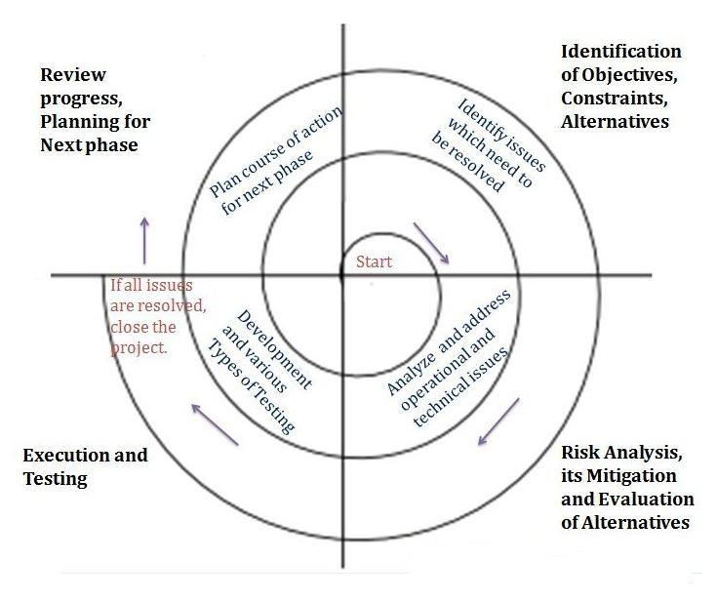

Work Plan

Screen Short for SRS

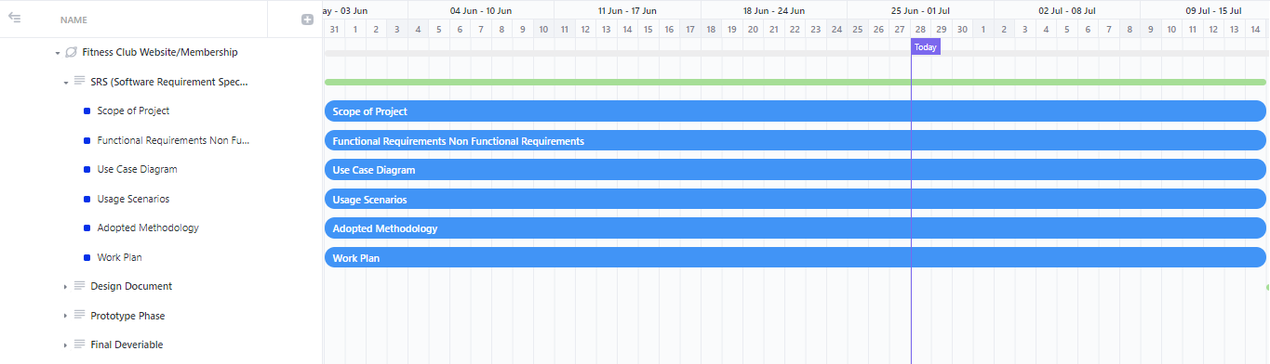

Screen Short for Design Phase

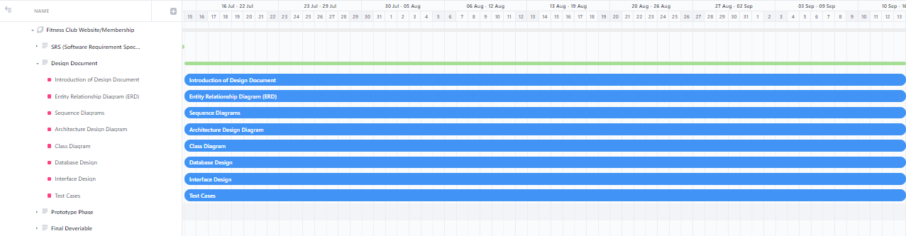

Screen Shot for Prototype Phase

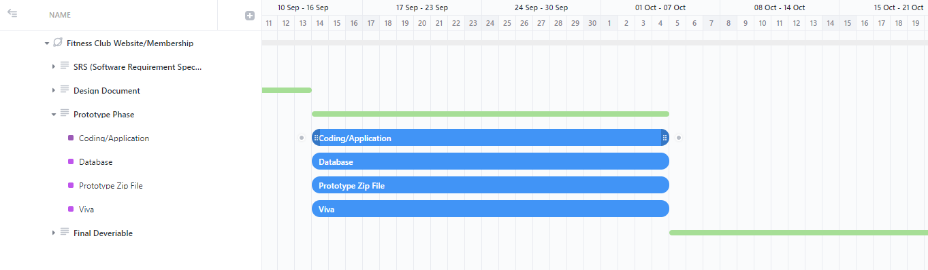

Screen Shoot for final Deliverable

