VELLORE INSTITUTE OF TECHNOLOGY VELLORE
School of Computer Science and Engineering (SCOPE)

MINI PROJECT REPORT

QureFlow Clinic Queue and Appointment Management Using MySQL

BCSE302P Database Systems Laboratory

Submitted by

S. No. | Name | Registration Number
1 | Kartikay Gupta | 24BCI0109
2 | Sreyanko Sinha | 24BCB0059

Under the guidance of
Dr. G. M. Karthik
Associate Professor, School of Computer Science and Engineering (SCOPE)
Vellore Institute of Technology, Vellore

Date of Submission: 19 October 2026

CERTIFICATE
This is to certify that the Mini Project Report titled QureFlow Clinic Queue and Appointment Management Using MySQL submitted by Kartikay Gupta (24BCI0109) and Sreyanko Sinha (24BCB0059), in partial fulfilment of the requirements of BCSE302P Database Systems Laboratory, is a record of their project work during the Fall Semester 2026-27.
Declaration of originality
We declare that this report describes our QureFlow project and its locally executed MySQL demonstration. The test identities and clinical organisations are synthetic. External technical documentation is acknowledged in the references, and execution results are distinguished from features requiring further device verification.
Kartikay Gupta | 24BCI0109
Sreyanko Sinha | 24BCB0059

Signature of the Faculty
Dr. G. M. Karthik
Associate Professor, SCOPE
VIT, Vellore
Place: Vellore
Date: 19 October 2026

ABSTRACT
QureFlow is a clinic queue and appointment management application designed to make visit planning and queue progression more transparent. This project presents its MySQL database variant for the Database Systems Laboratory. The implementation separates clinics, doctors, specialties, languages, users, appointments and queue tokens into relational tables with explicit keys and constraints. SQL joins, filters, ordering and pagination support doctor selection, while InnoDB transactions and row locks protect appointment capacity and concurrent queue operations. A stored function measures consultation duration, a procedure produces daily patient-flow results, three triggers enforce and record queue transitions, and an explicit cursor returns doctor workload. A React web interface communicates with an Express API through parameterised database queries. The same interface is packaged as an Android application, with local server discovery and anonymous connection verification. Testing covers valid workflows, invalid transitions, duplicate visits, clinic isolation, injection inputs and simultaneous bookings. All 24 MySQL integration cases passed in the recorded run, and browser booking and cancellation were verified against SQL records. The result is a reproducible database demonstration; production deployment and final hotspot acceptance on Android remain future verification tasks.
Keywords: MySQL, queue management, normalization, transactions, triggers, Android
TABLE OF CONTENTS
CERTIFICATE 2
ABSTRACT 3
1 INTRODUCTION 6
1.1 Problem Statement 6
1.2 Objectives 6
1.3 Importance of DBMS 6
1.4 Scope of the Project 7
2 SYSTEM REQUIREMENTS 8
2.1 Hardware Requirements 8
2.2 Software Requirements 8
3 DATABASE DESIGN 9
3.1 Entity Relationship Diagrams 9
3.2 Relational Schema 11
3.3 Schema Definition and Constraints 17
3.4 Normalization 18
4 IMPLEMENTATION 19
4.1 Functions 19
4.2 Procedures 20
4.3 Packages 21
4.4 Triggers 21
4.5 Cursors 23
4.6 SQL Search and Transaction Control 24
5 FRONT END AND ANDROID INTEGRATION 26
5.1 User Interface 26
5.2 Integration with the DBMS 30
5.3 Android Application 31
6 VERIFICATION AND TESTING 32
6.1 Test Cases 32
6.2 Output Screenshots 34
6.3 Validation of Functionality 36
7 RESULTS AND DISCUSSION 37
7.1 Achievements 37
7.2 Challenges Faced 37
7.3 Possible Improvements 37
8 CONCLUSION 38
8.1 Summary of Learning Outcomes 38
8.2 Future Scope 38
9 REFERENCES 39
10 APPENDICES 40
Appendix A Complete Schema Definition 40
Appendix B Additional Code and Source Map 45
Appendix C Terminal Demonstration 47
Appendix D Evidence Provenance 47

1 INTRODUCTION

1.1 Problem Statement
A manual clinic queue gives patients little visibility into their position and gives reception staff limited protection against duplicate entries or conflicting calls. Appointment records, doctor schedules and queue state can also diverge when they are maintained in separate spreadsheets. QureFlow brings these records into one database-backed workflow so that a patient can select a doctor and book a visit, while staff manage the corresponding queue.
The objective is to reduce avoidable uncertainty and waiting through better scheduling and queue visibility. The recorded experiments verify data integrity and workflow behaviour; they do not constitute a clinical study or quantify a reduction in real hospital waiting time.

1.2 Objectives
1. Design relational master data for clinics, doctors, specialties, languages and users.
2. Perform doctor selection, filtering, ordering and pagination through SQL queries.
3. Create appointments and tokens atomically while protecting slot capacity under concurrent requests.
4. Enforce queue transitions and audit changes with database constraints and triggers.
5. Integrate patient and staff web screens with the MySQL API and package the interface for Android.
6. Verify database objects and negative cases through repeatable tests and captured execution output.

1.3 Importance of DBMS
Primary and foreign keys connect records without storing the whole application as document blobs. Unique indexes prevent duplicate identities and conflicting active visits. Transactions let a booking either create all linked records or roll back. Row locks serialize competing updates to a doctor or appointment slot. Parameterised queries keep input values separate from SQL syntax, and application authorization restricts records to the permitted user and clinic. These controls address different failure modes and are used together.

1.4 Scope of the Project
The scope includes a local MySQL 8.4 database, patient and staff authentication for synthetic accounts, a doctor directory, scheduled appointments, queues, cancellation, audit records, daily analytics and an Android debug package. The earlier AWS DynamoDB/Cognito variant is retained separately; it is not the database or authentication path evaluated in this report.
Clinical diagnosis, automatic medical triage, billing, electronic health-record interoperability and production hospital deployment are outside this laboratory submission. Consultation estimates are operational guidance. Actual Android hotspot discovery remains a device acceptance item.

2 SYSTEM REQUIREMENTS

2.1 Hardware Requirements
The local execution workstation uses Windows 11 and 16 GB RAM. The following is a practical development recommendation, not a measured minimum specification.
Component | Specification
Processor | 64-bit processor with virtualization enabled for Docker Desktop
Memory | 8 GB or more recommended; 16 GB used for the recorded run
Storage | At least 10 GB free for dependencies, database volume and build tools
Network | Local Wi-Fi or phone hotspot for Android-to-computer testing
Optional device | Android API 24 or newer for installing the debug APK

2.2 Software Requirements
Category | Tool or version
Database | MySQL 8.4.11 with InnoDB, in the mysql:8.4 Docker image
Database client | MySQL command-line client inside the container; Workbench is optional
Backend | Node.js, TypeScript, Express 4 and mysql2/promise
Web interface | React 18, TypeScript 5, Vite 6 and Tailwind CSS
Authentication | Local synthetic accounts, bcrypt password hashes and JWT sessions
Android | Capacitor 8.5.3, SDK API 36, Gradle 8.14.3 and JDK 22
Verification | Node test runner, TypeScript execution and browser automation
Local endpoints | Web: localhost:5174; API: port 5001; MySQL: 127.0.0.1:3307

3 DATABASE DESIGN

3.1 Entity Relationship Diagrams
The database contains 18 base tables and four views. The diagrams divide the model into catalog data, visit data and operational state to keep names and cardinalities readable. Arrows follow parent-to-child relationships. A 1:N label permits zero or more children for a parent; a non-null foreign key requires each child to reference one parent.
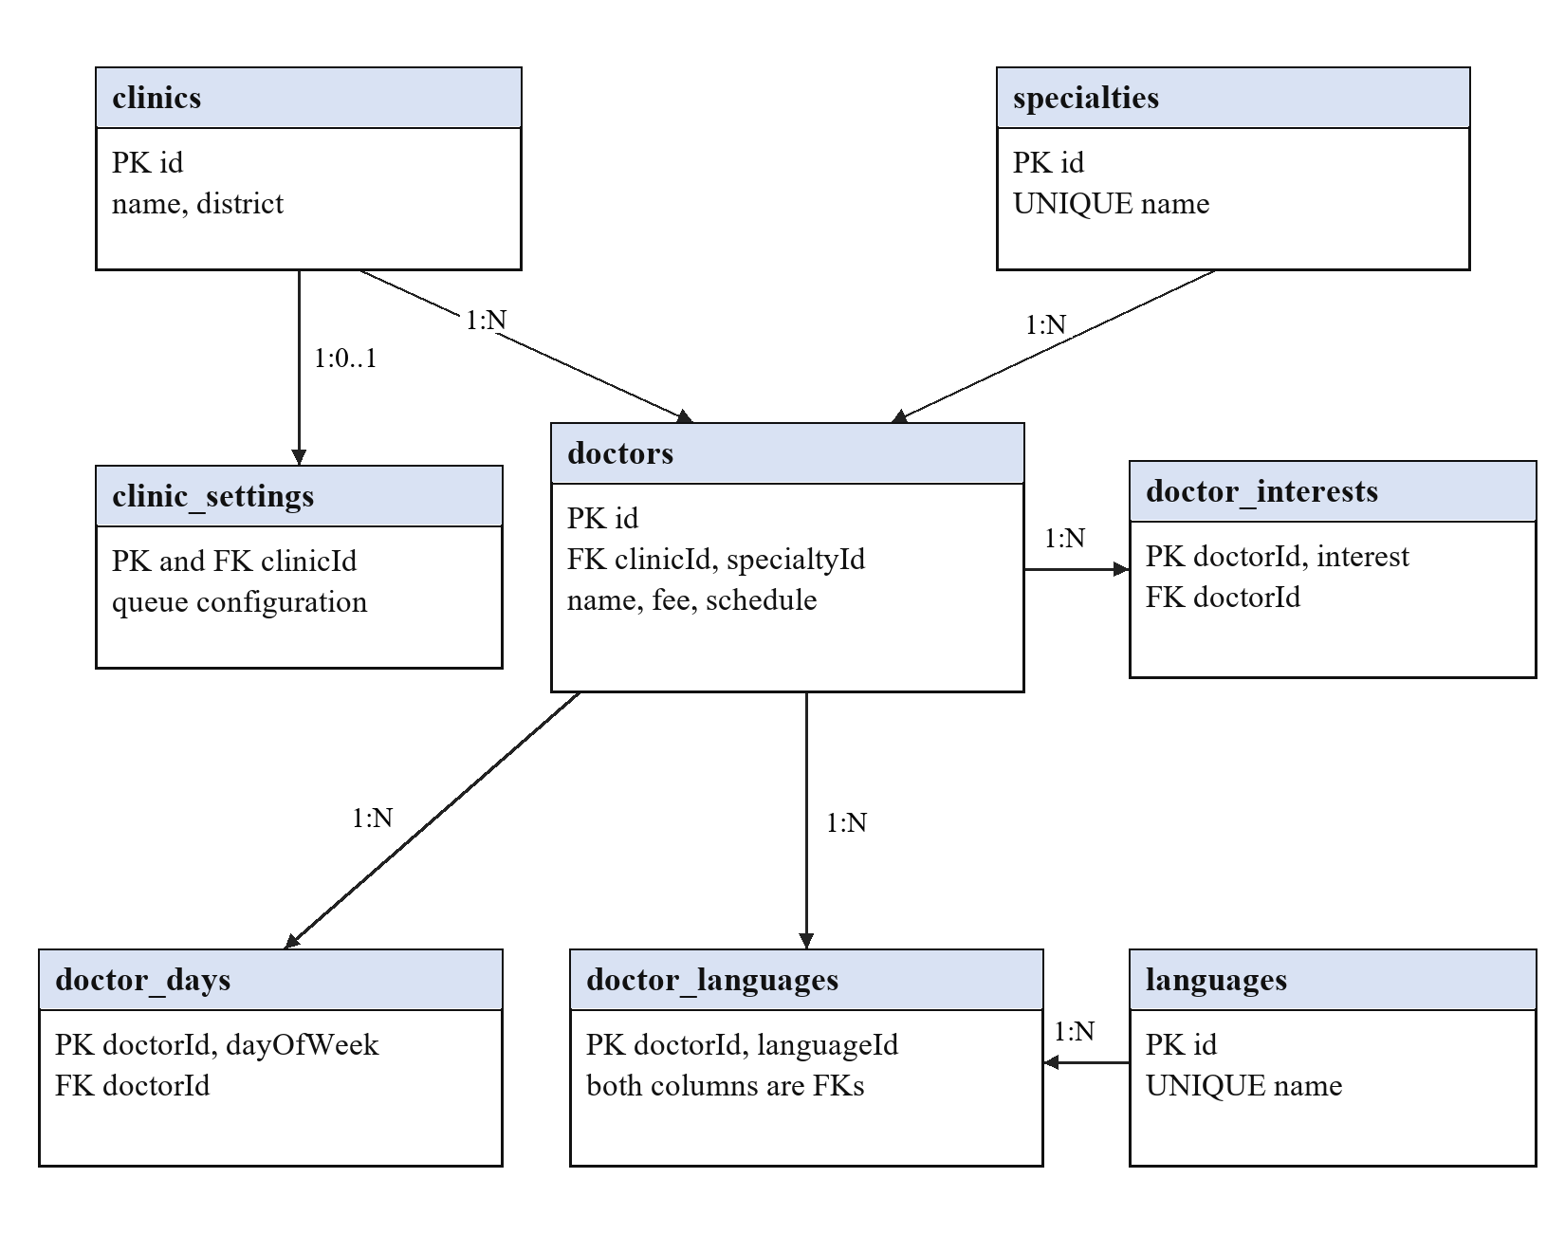
Figure 3.1 Catalog relations and doctor membership tables
Every doctor belongs to one clinic and one specialty. Languages form a many-to-many relationship through doctor_languages. The doctor_days and doctor_interests tables remove repeating lists. A clinic has at most one settings row.
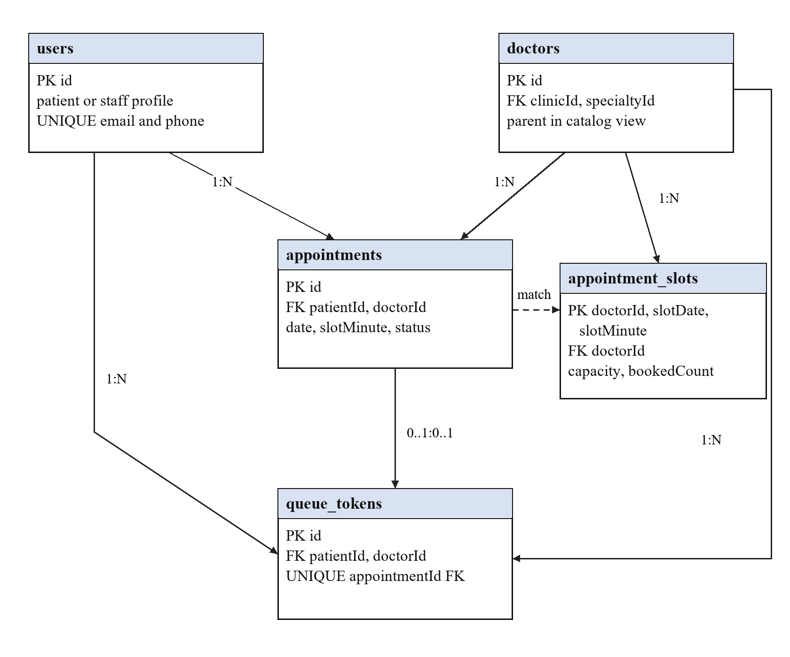
Figure 3.2 Appointment and token relationships
Appointments and tokens reference users and doctors. The patient role is checked by the API; the foreign key itself references users. A nullable unique appointmentId allows a token to be unlinked and prevents several tokens from claiming one appointment. The dashed slot match is maintained by application transactions and triggers; it is not a declared composite foreign key.
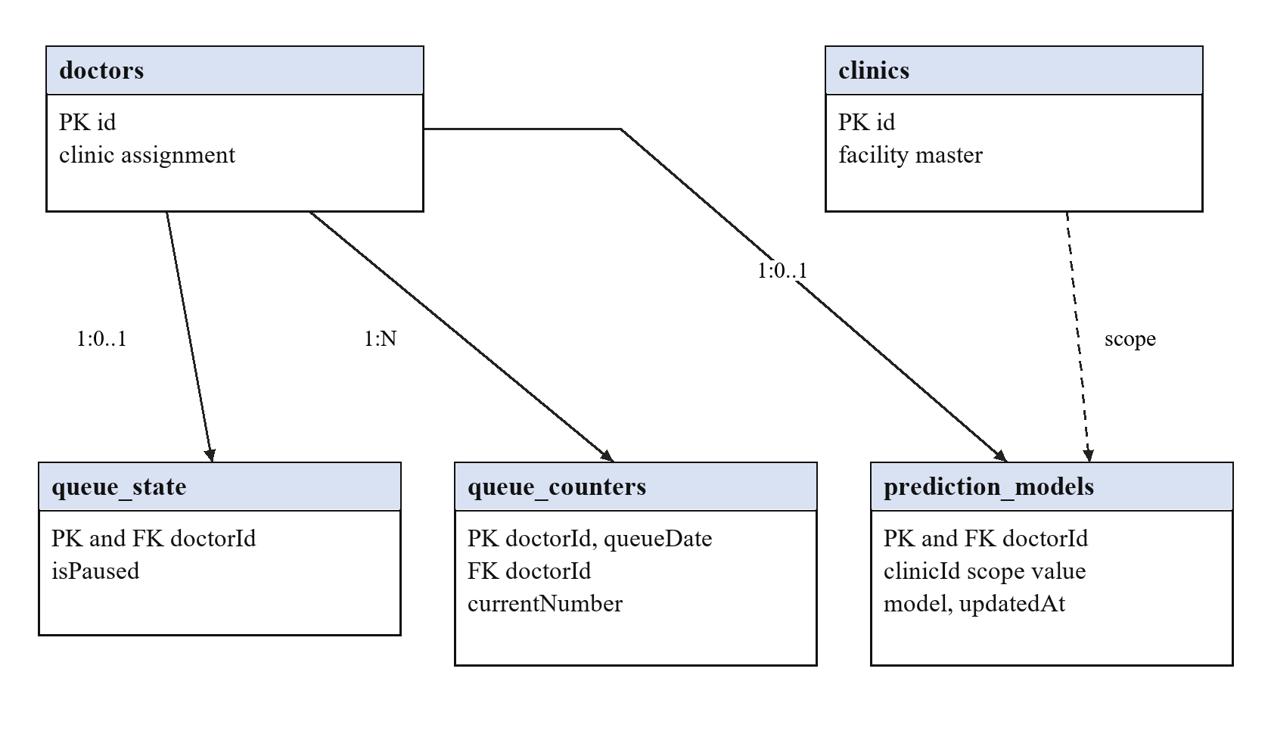
Figure 3.3 Per-doctor state and stored operational models
Counters, pause state and prediction models reference doctors. The dashed clinic-to-model line denotes a scope value without a declared foreign key. Optional staff assignments in users reference a clinic and doctor. Audit events store correlated identifiers without foreign keys; schema_migrations and demo_seed are independent support tables. All relations are listed below.

3.2 Relational Schema
Tables 3.1 to 3.18 list key and selected operational attributes for every base relation. The complete DDL in Appendix A defines all 199 columns, enumerated values, defaults, generated expressions and constraints. PK means primary key, FK means foreign key and UQ means a unique constraint or index.
Table 3.1 clinics
Attribute | Data type | Constraint | Description
id | varchar(100) | PK, NOT NULL | Record identifier
name | varchar(200) | NOT NULL | Display name
district | varchar(100) | NOT NULL | Clinic district
phone | varchar(20) | NOT NULL | Contact number

Table 3.2 specialties
Attribute | Data type | Constraint | Description
id | int | PK, NOT NULL | Record identifier
name | varchar(100) | UQ, NOT NULL | Display name

Table 3.3 languages
Attribute | Data type | Constraint | Description
id | int | PK, NOT NULL | Record identifier
name | varchar(60) | UQ, NOT NULL | Display name

Table 3.4 doctors
Attribute | Data type | Constraint | Description
id | varchar(100) | PK, NOT NULL | Record identifier
clinic​Id | varchar(100) | NOT NULL, FK clinics | Clinic reference or audit scope
specialty​Id | int | NOT NULL, FK specialties | Specialty reference
name | varchar(200) | NOT NULL | Display name
experience​Years | int | NOT NULL | Experience in years, 0 to 70
consultation​Fee | decimal(10,2) | NOT NULL | Non-negative consultation fee

Table 3.5 doctor_days
Attribute | Data type | Constraint | Description
doctor​Id | varchar(100) | PK, NOT NULL, FK doctors | Doctor reference
day​Of​Week | ENUM | PK, NOT NULL | Consultation weekday

Table 3.6 doctor_languages
Attribute | Data type | Constraint | Description
doctor​Id | varchar(100) | PK, NOT NULL, FK doctors | Doctor reference
language​Id | int | PK, NOT NULL, FK languages | Language reference

Table 3.7 doctor_interests
Attribute | Data type | Constraint | Description
doctor​Id | varchar(100) | PK, NOT NULL, FK doctors | Doctor reference
interest | varchar(200) | PK, NOT NULL | Doctor care interest

Table 3.8 users
Attribute | Data type | Constraint | Description
id | varchar(100) | PK, NOT NULL | Record identifier
name | varchar(200) | NOT NULL | Display name
phone | varchar(20) | UQ | Contact number
email | varchar(254) | UQ | Unique contact when present
role | ENUM | NOT NULL | Patient or permitted staff role
clinic​Id | varchar(100) | FK clinics | Clinic reference or audit scope
doctor​Id | varchar(100) | FK doctors | Doctor reference

Table 3.9 clinic_settings
Attribute | Data type | Constraint | Description
clinic​Id | varchar(100) | PK, NOT NULL, FK clinics | Clinic reference or audit scope
average​Consultation​Minutes | int | NOT NULL | Configured duration baseline
buffer​Minutes | int | NOT NULL | Non-negative slot buffer
allow​Walk​Ins | tinyint(1) | NOT NULL | Walk-in configuration

Table 3.10 queue_counters
Attribute | Data type | Constraint | Description
doctor​Id | varchar(100) | PK, NOT NULL, FK doctors | Doctor reference
queue​Date | date | PK, NOT NULL | Clinic-local queue date
current​Number | int | NOT NULL | Last allocated sequence

Table 3.11 queue_state
Attribute | Data type | Constraint | Description
doctor​Id | varchar(100) | PK, NOT NULL, FK doctors | Doctor reference
is​Paused | tinyint(1) | NOT NULL | Queue pause flag

Table 3.12 appointment_slots
Attribute | Data type | Constraint | Description
doctor​Id | varchar(100) | PK, NOT NULL, FK doctors | Doctor reference
slot​Date | date | PK, NOT NULL | Appointment date
slot​Minute | int | PK, NOT NULL | Minutes after midnight
booked​Count | int | NOT NULL | Current reserved places
capacity | int | NOT NULL | Maximum slot places

Table 3.13 appointments
Attribute | Data type | Constraint | Description
id | varchar(100) | PK, NOT NULL | Record identifier
patient​Id | varchar(100) | NOT NULL, FK users | Patient user reference
doctor​Id | varchar(100) | NOT NULL, FK doctors | Doctor reference
date | date | NOT NULL | Scheduled appointment date
slot​Minute | int | NOT NULL | Minutes after midnight
status | ENUM | NOT NULL | Allowed visit state

Table 3.14 queue_tokens
Attribute | Data type | Constraint | Description
id | varchar(100) | PK, NOT NULL | Record identifier
appointment​Id | varchar(100) | UQ, FK appointments | Optional linked appointment
patient​Id | varchar(100) | NOT NULL, FK users | Patient user reference
doctor​Id | varchar(100) | NOT NULL, FK doctors | Doctor reference
queue​Date | date | NOT NULL | Clinic-local queue date
token​Seq | int | NOT NULL | Per-doctor daily sequence
status | ENUM | NOT NULL | Allowed visit state
active​Patient​Id | varchar(100) | Generated | Generated active-patient claim
serving​Doctor​Id | varchar(100) | Generated | Generated current-consultation claim

Table 3.15 audit_events
Attribute | Data type | Constraint | Description
id | varchar(100) | PK, NOT NULL | Record identifier
clinic​Id | varchar(100) | Nullable | Clinic reference or audit scope
entity​Type | varchar(60) | NOT NULL | Audited entity category
entity​Id | varchar(100) | NOT NULL | Audited record identifier
action | varchar(60) | NOT NULL | Recorded operation
actor​Id | varchar(100) | NOT NULL | Initiating user or SQL client
request​Id | varchar(100) | NOT NULL | Correlation identifier

Table 3.16 prediction_models
Attribute | Data type | Constraint | Description
doctor​Id | varchar(100) | PK, NOT NULL, FK doctors | Doctor reference
clinic​Id | varchar(100) | NOT NULL | Clinic reference or audit scope
model | json | NOT NULL | Operational model JSON
updated​At | datetime(3) | NOT NULL | Last modification timestamp

Table 3.17 schema_migrations
Attribute | Data type | Constraint | Description
version | varchar(30) | PK, NOT NULL | Migration or fixture version
applied​At | datetime(3) | NOT NULL | Migration application time

Table 3.18 demo_seed
Attribute | Data type | Constraint | Description
version | varchar(30) | PK, NOT NULL | Migration or fixture version
seeded​At | datetime(3) | NOT NULL | Fixture installation time

3.3 Schema Definition and Constraints
The schema is created by versioned SQL files at startup. Important rules include unique non-null contact values, non-negative fees, valid schedule bounds, a bookedCount within capacity and foreign keys that reject orphan visits. MySQL uses InnoDB for these relations [1].
CREATE TABLE IF NOT EXISTS appointment_slots (
doctorId VARCHAR(100) NOT NULL, slotDate DATE NOT NULL, slotMinute INT NOT NULL,
bookedCount INT NOT NULL DEFAULT 0, capacity INT NOT NULL,
PRIMARY KEY (doctorId, slotDate, slotMinute), FOREIGN KEY (doctorId) REFERENCES doctors(id),
CHECK (bookedCount >= 0 AND bookedCount <= capacity), CHECK (capacity > 0)
);

The generated activePatientId is populated only for waiting/current tokens; a composite unique index with queueDate enforces one active visit per patient per day. Similarly, servingDoctorId is populated only for current tokens. A unique index on servingDoctorId and queueDate permits at most one current consultation per doctor per day. Token numbering is unique on doctorId, queueDate and tokenSeq.
UNIQUE active_visit (activePatientId, queueDate),
UNIQUE one_consultation (servingDoctorId, queueDate),
UNIQUE token_sequence (doctorId, queueDate, tokenSeq)

3.4 Normalization
An unnormalized visit sheet could repeat doctor and clinic details beside each patient, while keeping language and weekday lists in single cells. Updating a clinic address or deleting the last visit could then change or remove unrelated master information. The catalog decomposition removes these dependencies.
Normal form | Relations and dependencies | Anomaly addressed
1NF | Atomic master attributes; doctor_days and doctor_languages hold one membership per row. | Repeating weekday and language groups are removed.
2NF | In doctor_languages, the key is (doctorId, languageId). Doctor details stay in doctors; language names stay in languages. | Non-key attributes do not depend on only part of the membership key.
3NF | doctorId determines clinicId and specialtyId; their descriptive attributes are stored in clinics and specialties. | Doctor rows do not repeat clinic address or specialty name.
BCNF assessment | Simple lookup and membership relations satisfy the stated key dependencies. No blanket BCNF claim is made for the operational schema. | Operational copies and derived state are documented rather than hidden.

Key dependencies include doctorId -> doctor attributes, clinicId -> clinic attributes and (doctorId, slotDate, slotMinute) -> capacity, bookedCount. Doctor, clinic and specialty details are stored separately. Nullable email and phone are unique only when present.
Operational duplication remains: tokens repeat appointment details, clinic_settings copies a clinic name, and occupancy/counters are derived. Transactions and triggers maintain tested updates. Direct SQL edits require the same consistency rules.

4 IMPLEMENTATION
SQL source is maintained in backend/sql. The following snippets are taken from the project implementation. The function and daily-flow procedure are used by analytics; triggers execute as part of queue writes. The cursor is a read-only laboratory demonstration. The DBMS is MySQL, so these are MySQL stored programs rather than Oracle PL/SQL.

4.1 Functions
fn_consultation_minutes accepts two DATETIME(3) values and returns a DECIMAL(8,2) duration. It returns NULL for missing, reversed or longer-than-two-hour intervals and returns zero for an identical timestamp. The analytics query calls it when aggregating completed visits. This gives reporting one shared duration rule [2].
DELIMITER $$
CREATE FUNCTION fn_consultation_minutes(started DATETIME(3), finished DATETIME(3))
RETURNS DECIMAL(8,2) DETERMINISTIC NO SQL
BEGIN
IF started IS NULL OR finished IS NULL OR finished < started OR TIMESTAMPDIFF(SECOND,started,finished)>7200 THEN RETURN NULL; END IF;
RETURN ROUND(TIMESTAMPDIFF(MICROSECOND,started,finished)/60000000,2);
END$$
DELIMITER ;

The executed positive case returned 12.50 minutes. Missing and reversed inputs returned NULL.
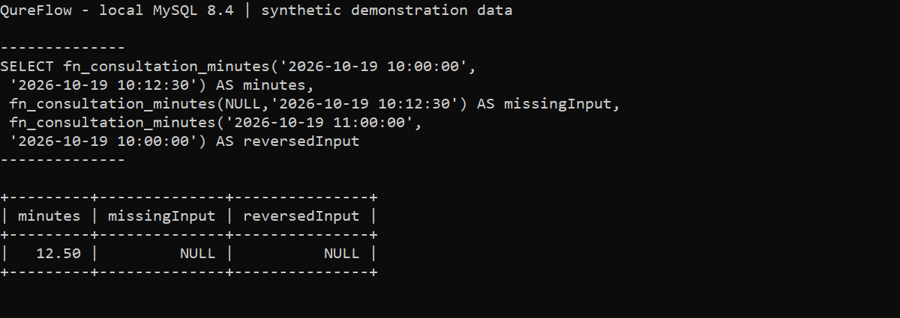
Figure 4.1 MySQL terminal execution of the consultation-duration function

4.2 Procedures
sp_daily_patient_flow takes a clinic identifier and an inclusive date range. A recursive date series is left-joined with daily_patient_flow, so a day without matching visits is returned with zero counts instead of disappearing from the chart. The backend calls this procedure for its 14-day analytics series [2].
DELIMITER $$
CREATE PROCEDURE sp_daily_patient_flow(IN facility VARCHAR(100), IN from_day DATE, IN until_day DATE)
READS SQL DATA
BEGIN
WITH RECURSIVE dates AS (SELECT from_day AS date UNION ALL SELECT date+INTERVAL 1 DAY FROM dates WHERE date<until_day)
SELECT dates.date,COALESCE(v.total,0) total,COALESCE(v.completed,0) completed,COALESCE(v.cancelled,0) cancelled,COALESCE(v.noShow,0) noShow
FROM dates LEFT JOIN daily_patient_flow v ON v.date=dates.date AND v.clinicId=facility ORDER BY dates.date;
END$$
DELIMITER ;

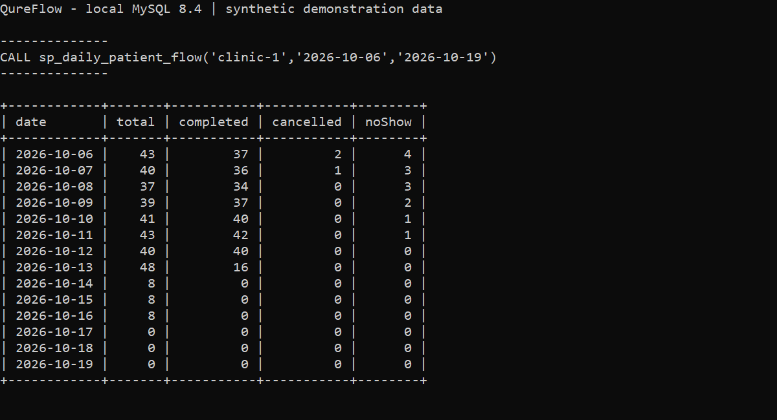
Figure 4.2 MySQL terminal procedure output including zero-volume days

4.3 Packages
MySQL 8.4 does not implement Oracle-style package specifications and bodies. Consequently, this project does not claim a PL/SQL package. The report retains this template section to make the platform choice explicit. Related SQL routines are deployed together in 002_routines.sql, while connection and repository functions are grouped in TypeScript modules; those modules are not database packages.
SELECT ROUTINE_NAME, ROUTINE_TYPE
FROM information_schema.ROUTINES
WHERE ROUTINE_SCHEMA = DATABASE();

The recorded database contains one stored function and two stored procedures. Package syntax from the Oracle examples in the template has not been inserted into the MySQL project.

4.4 Triggers
All three triggers operate at row level on queue_tokens. validate_token_transition runs BEFORE UPDATE and rejects invalid state changes or calling a patient while the doctor queue is paused. audit_token_insert runs AFTER INSERT and creates an audit event. synchronize_token_update runs AFTER UPDATE, maps token state to appointment state, releases cancelled/skipped slot occupancy and records the transition [3].
DELIMITER $$
CREATE TRIGGER validate_token_transition BEFORE UPDATE ON queue_tokens FOR EACH ROW
BEGIN
IF NEW.status<>OLD.status AND NOT (
OLD.status='waiting' AND NEW.status IN ('current','skipped','cancelled') OR
OLD.status='current' AND NEW.status IN ('completed','skipped')
) THEN SIGNAL SQLSTATE '45000' SET MESSAGE_TEXT='Invalid queue status transition'; END IF;
IF NEW.status='current' AND EXISTS(SELECT 1 FROM queue_state WHERE doctorId=NEW.doctorId AND isPaused=TRUE)
THEN SIGNAL SQLSTATE '45000' SET MESSAGE_TEXT='Resume the queue before calling a patient'; END IF;
END$$
DELIMITER ;

DELIMITER $$
CREATE TRIGGER synchronize_token_update AFTER UPDATE ON queue_tokens FOR EACH ROW
BEGIN
IF NEW.status<>OLD.status THEN
UPDATE appointments SET status=CASE NEW.status WHEN 'current' THEN 'in_consultation'
WHEN 'skipped' THEN 'no_show' ELSE NEW.status END,
version=version+1,updatedAt=UTC_TIMESTAMP(3)
WHERE id=NEW.appointmentId;
IF NEW.status IN ('cancelled','skipped') THEN
UPDATE appointment_slots s JOIN appointments a ON a.doctorId=s.doctorId AND a.date=s.slotDate AND a.slotMinute=s.slotMinute
SET s.bookedCount=GREATEST(0,s.bookedCount-1) WHERE a.id=NEW.appointmentId;
END IF;
INSERT INTO audit_events(id,clinicId,entityType,entityId,action,actorId,requestId,details)
SELECT UUID(),clinicId,'token',NEW.id,'status_changed',COALESCE(@qf_actor,'sql-client'),COALESCE(@qf_request,UUID()),
JSON_OBJECT('from',OLD.status,'to',NEW.status,'queueDate',NEW.queueDate) FROM doctors WHERE id=NEW.doctorId;
END IF;
END$$
DELIMITER ;

The trigger demonstration uses disposable synthetic records inside one transaction. Before cancellation the appointment was booked, the token waiting and bookedCount equal to one. After the token update, both records were cancelled and bookedCount was zero. The final ROLLBACK left zero demonstration users, appointments, tokens and audit events. The browser workflow independently verified the same linked-state behaviour on token A-001.

4.5 Cursors
sp_doctor_workload_cursor declares an explicit cursor over the clinic roster. It opens the cursor, fetches one doctor at a time, counts waiting tokens for the requested date and appends a JSON result. A NOT FOUND handler terminates the loop, and the cursor is closed before the result is returned. It demonstrates procedural row traversal; normal operational summaries use set-based aggregation [4].
DELIMITER $$
CREATE PROCEDURE sp_doctor_workload_cursor(IN facility VARCHAR(100), IN visit_day DATE)
READS SQL DATA
BEGIN
DECLARE finished BOOLEAN DEFAULT FALSE;
DECLARE doctor_key VARCHAR(100);
DECLARE doctor_name VARCHAR(200);
DECLARE waiting_count INT;
DECLARE result JSON DEFAULT JSON_ARRAY();
DECLARE roster CURSOR FOR SELECT id,name FROM doctors WHERE clinicId=facility ORDER BY name;
DECLARE CONTINUE HANDLER FOR NOT FOUND SET finished=TRUE;
OPEN roster;
read_roster: LOOP
FETCH roster INTO doctor_key,doctor_name;
IF finished THEN LEAVE read_roster; END IF;
SELECT COUNT(*) INTO waiting_count FROM queue_tokens WHERE doctorId=doctor_key AND queueDate=visit_day AND status='waiting';
SET result=JSON_ARRAY_APPEND(result,'$',JSON_OBJECT('doctorId',doctor_key,'name',doctor_name,'waiting',waiting_count));
END LOOP;
CLOSE roster;
SELECT result AS workload;
END$$
DELIMITER ;

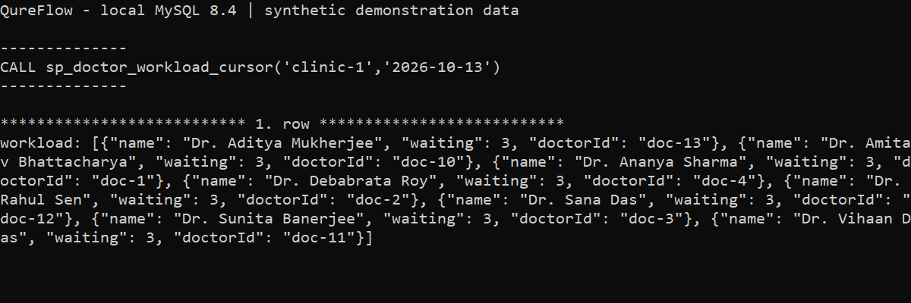
Figure 4.3 Cursor procedure and its JSON result in the MySQL terminal

4.6 SQL Search and Transaction Control
Directory search is performed by MySQL, including specialty and language membership, clinic scope, ordering and LIMIT/OFFSET. Values are bound as parameters. Sort expressions are selected from a whitelist rather than concatenated from free-form user input.
SELECT d.id, d.name, s.name AS specialty,
c.name AS clinic, d.consultationFee
FROM doctors d
JOIN specialties s ON s.id = d.specialtyId
JOIN clinics c ON c.id = d.clinicId
WHERE s.name = 'Gynecology' AND d.status = 'active'
ORDER BY d.consultationFee, d.name;

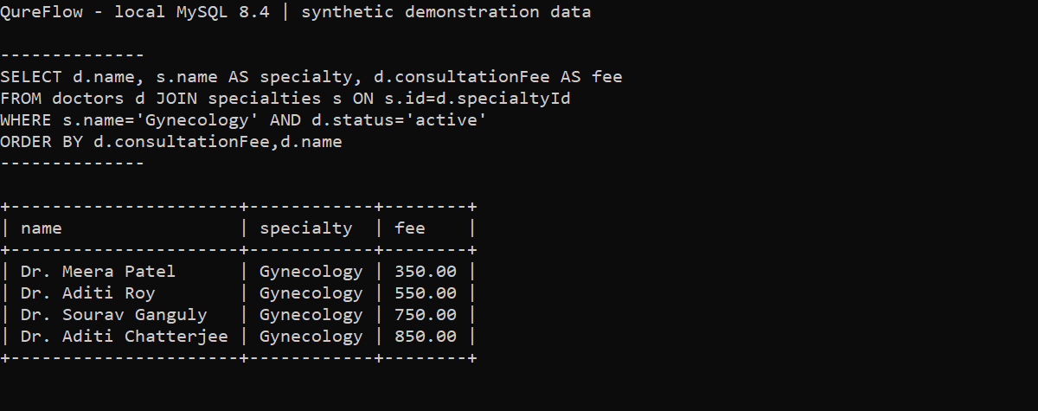
Figure 4.4 Terminal SQL join, specialty filter and fee-sorted result
Booking uses a pooled connection with BEGIN, COMMIT and ROLLBACK. The transaction locks the doctor and slot rows, checks capacity, inserts linked appointment/token records and updates occupancy. Queue calls and pause operations use a consistent doctor-first lock order. This avoids implementing concurrency protection solely as a JavaScript pre-check [5].
SELECT status FROM doctors WHERE id = ? FOR UPDATE;
SELECT bookedCount, capacity
FROM appointment_slots
WHERE doctorId = ? AND slotDate = ? AND slotMinute = ?
FOR UPDATE;

5 FRONT END AND ANDROID INTEGRATION

5.1 User Interface
Patient screens expose the directory, available slots, booking confirmation, appointment history and queue information. Staff screens expose clinic-scoped doctors, appointments, queues and analytics. The following images are actual screenshots of the running local web application, captured after API responses completed.
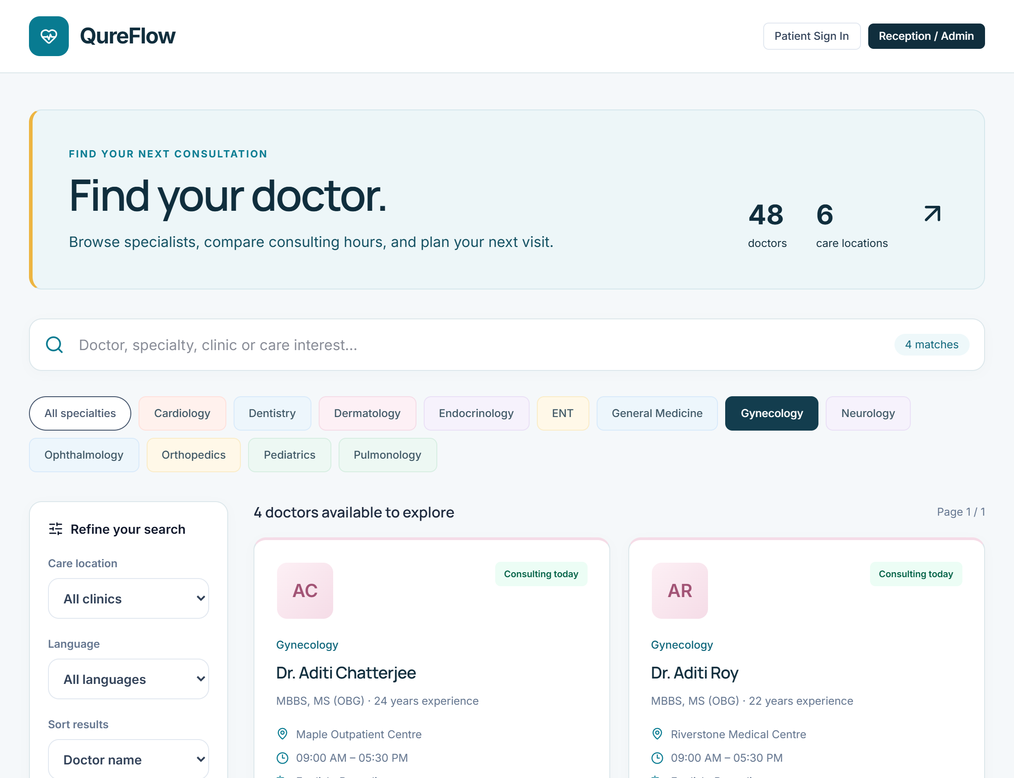
Figure 5.1 Web directory filtered to Gynecology using database results
The specialty selection is sent to the SQL search endpoint. The displayed doctors come from joined clinic and specialty records. Filtering and the selected sort order are applied by MySQL, with paginated results returned to the browser.
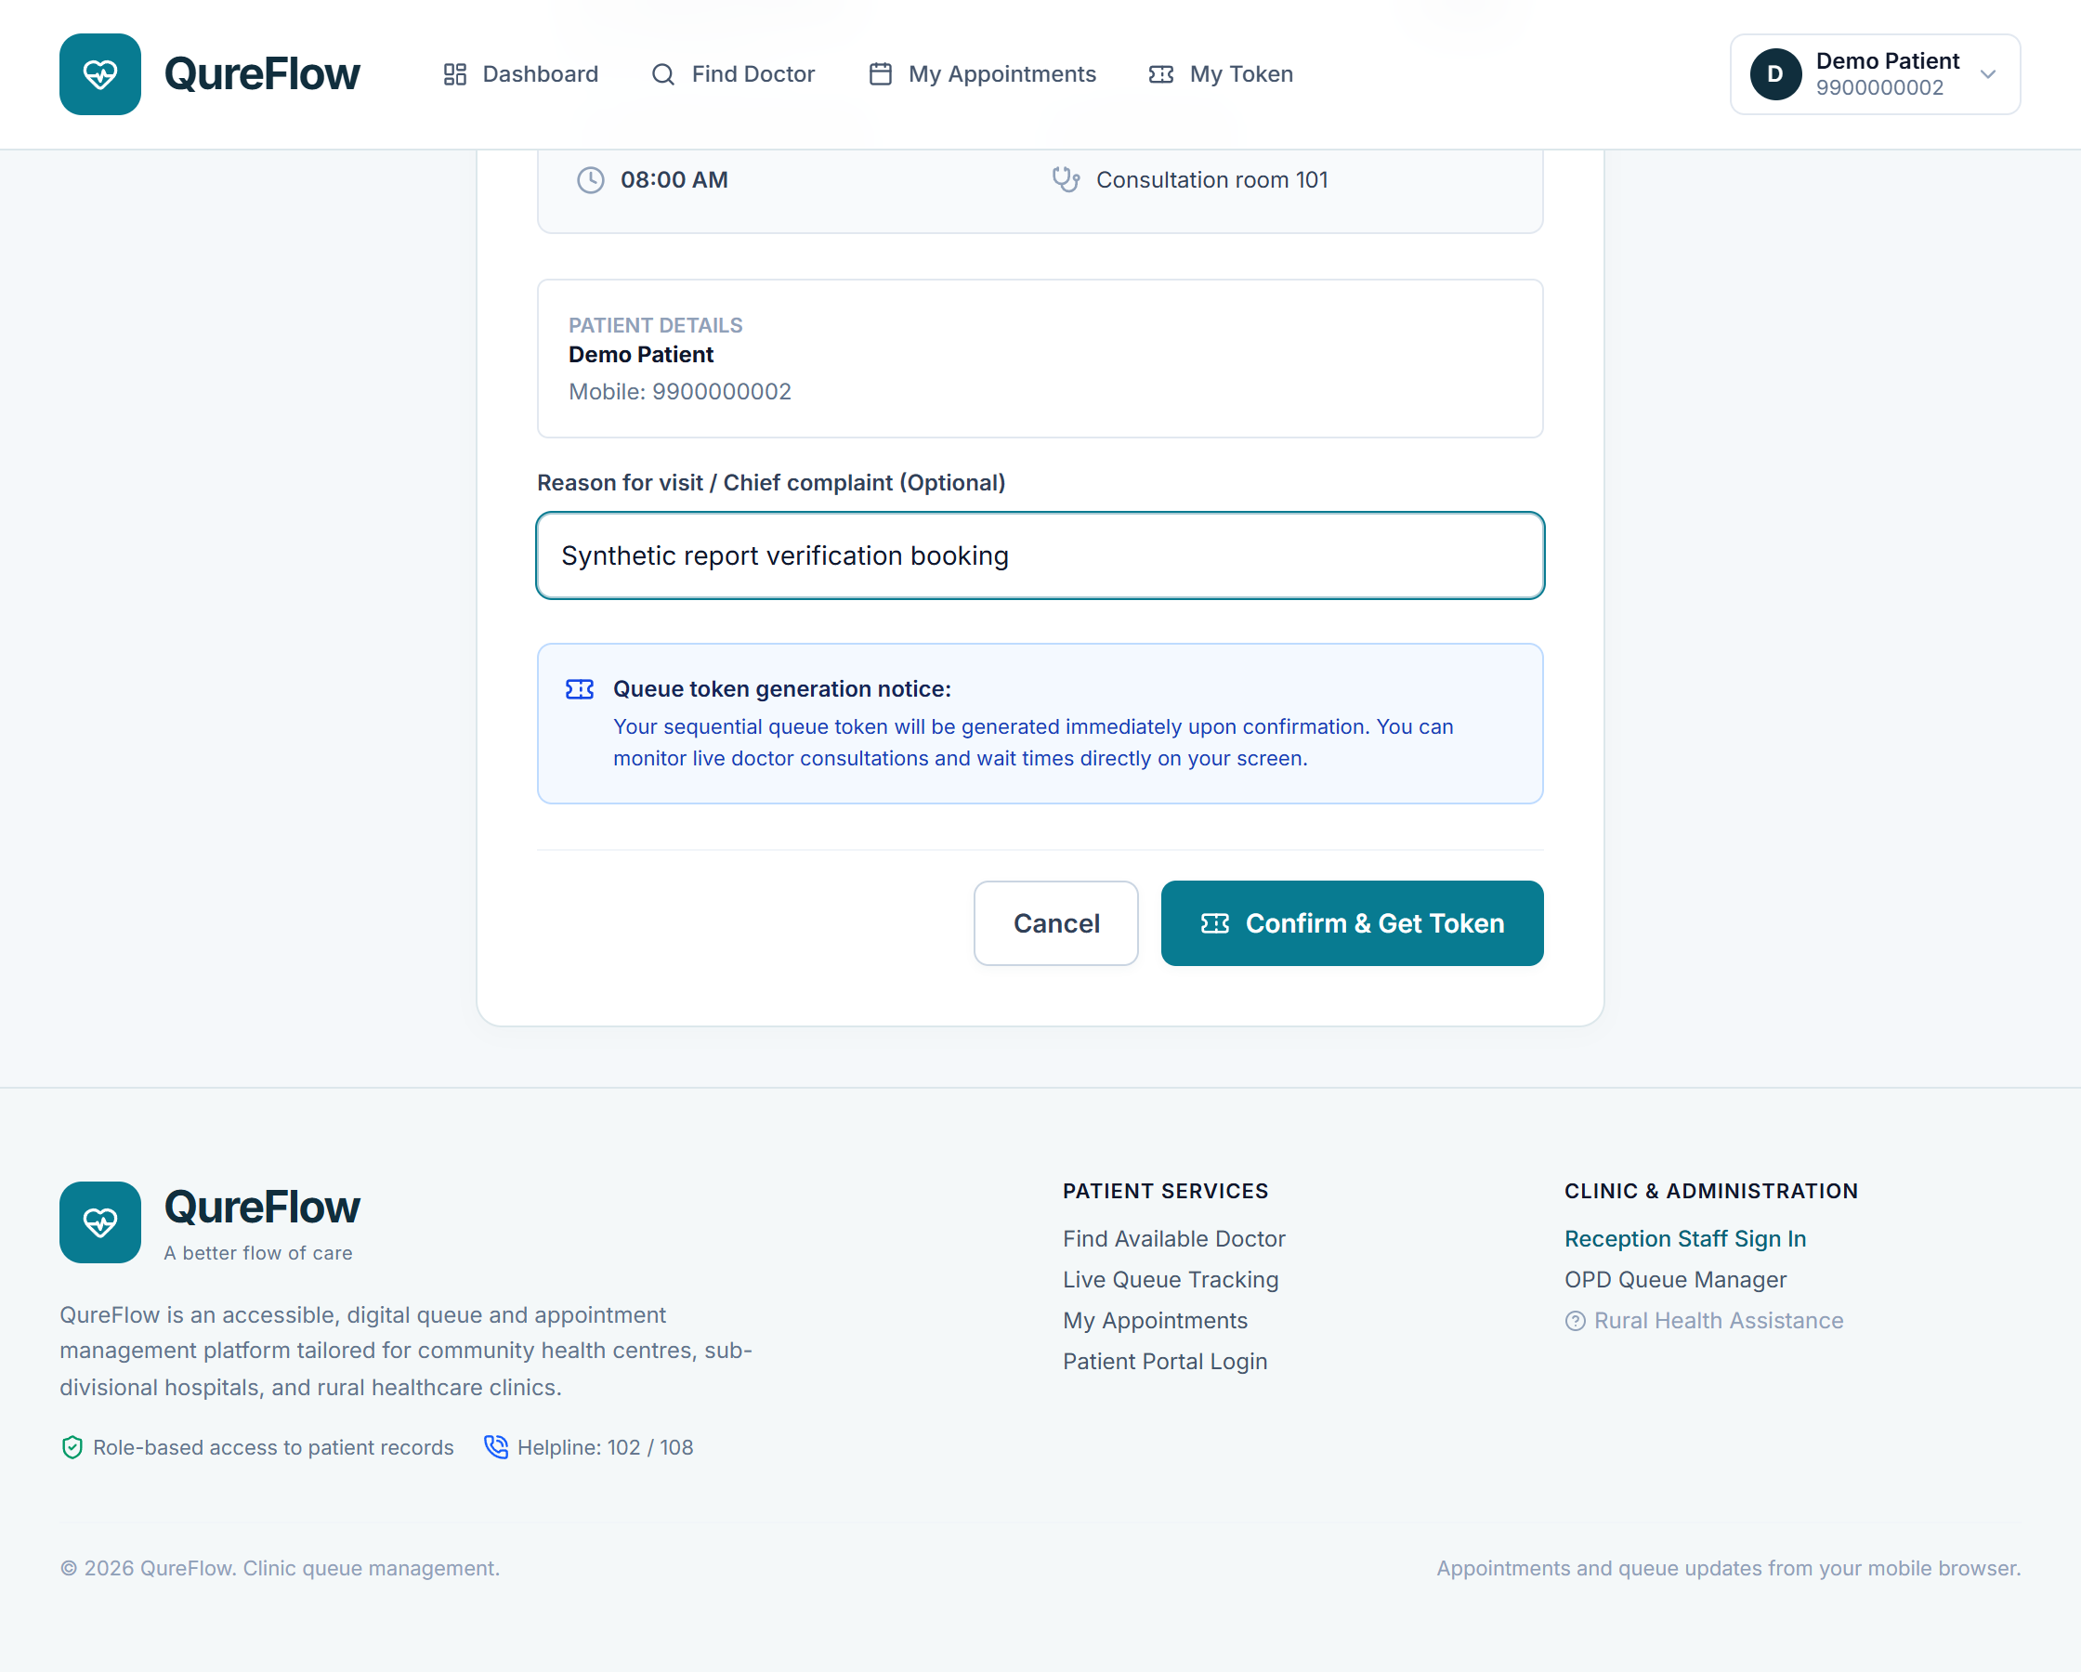
Figure 5.2 Patient confirmation before submitting the verification booking
The confirmation page shows the selected doctor, date and slot before any write is submitted. For this execution, the signed-in synthetic patient selected an 08:00 appointment on 20 October. The browser then submitted one booking request; the returned identifier was used for the independent SQL check.
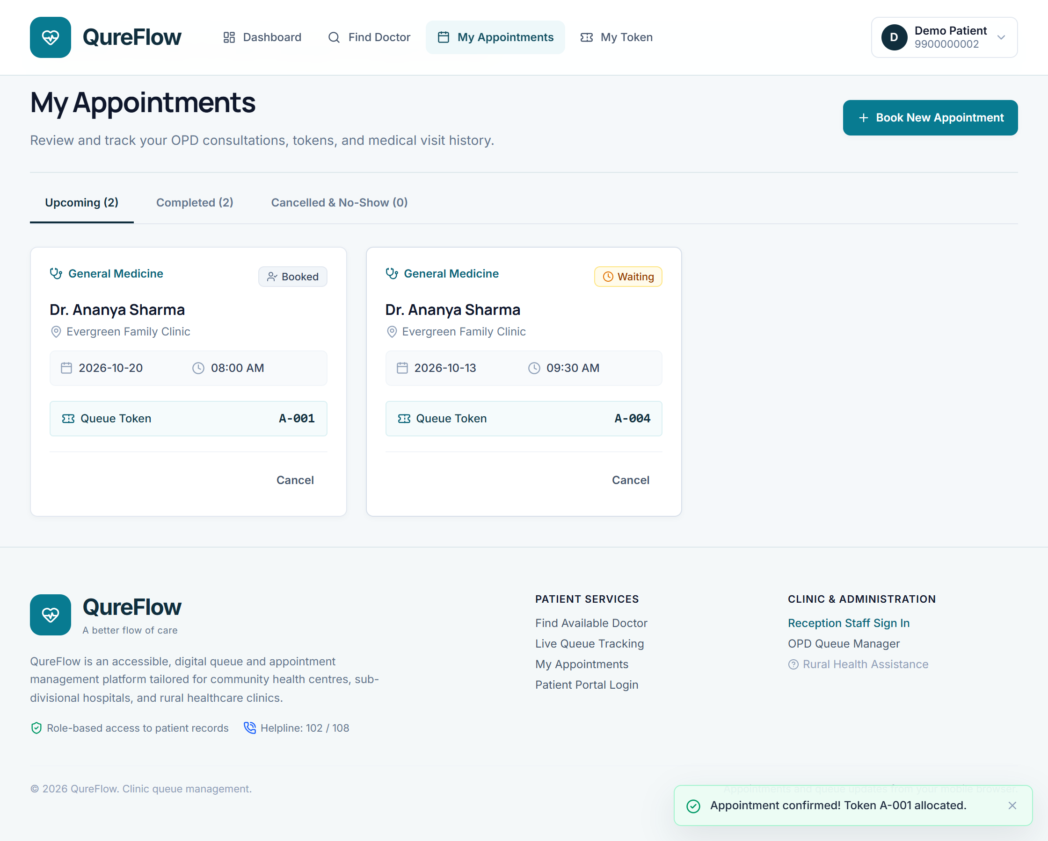
Figure 5.3 Confirmed browser booking for 20 October 2026
The appointment history displays the returned token A-001. At this point SQL showed an appointment in booked state, a linked waiting token and one reserved place. The comparison in Section 6 records the exact before and after values.
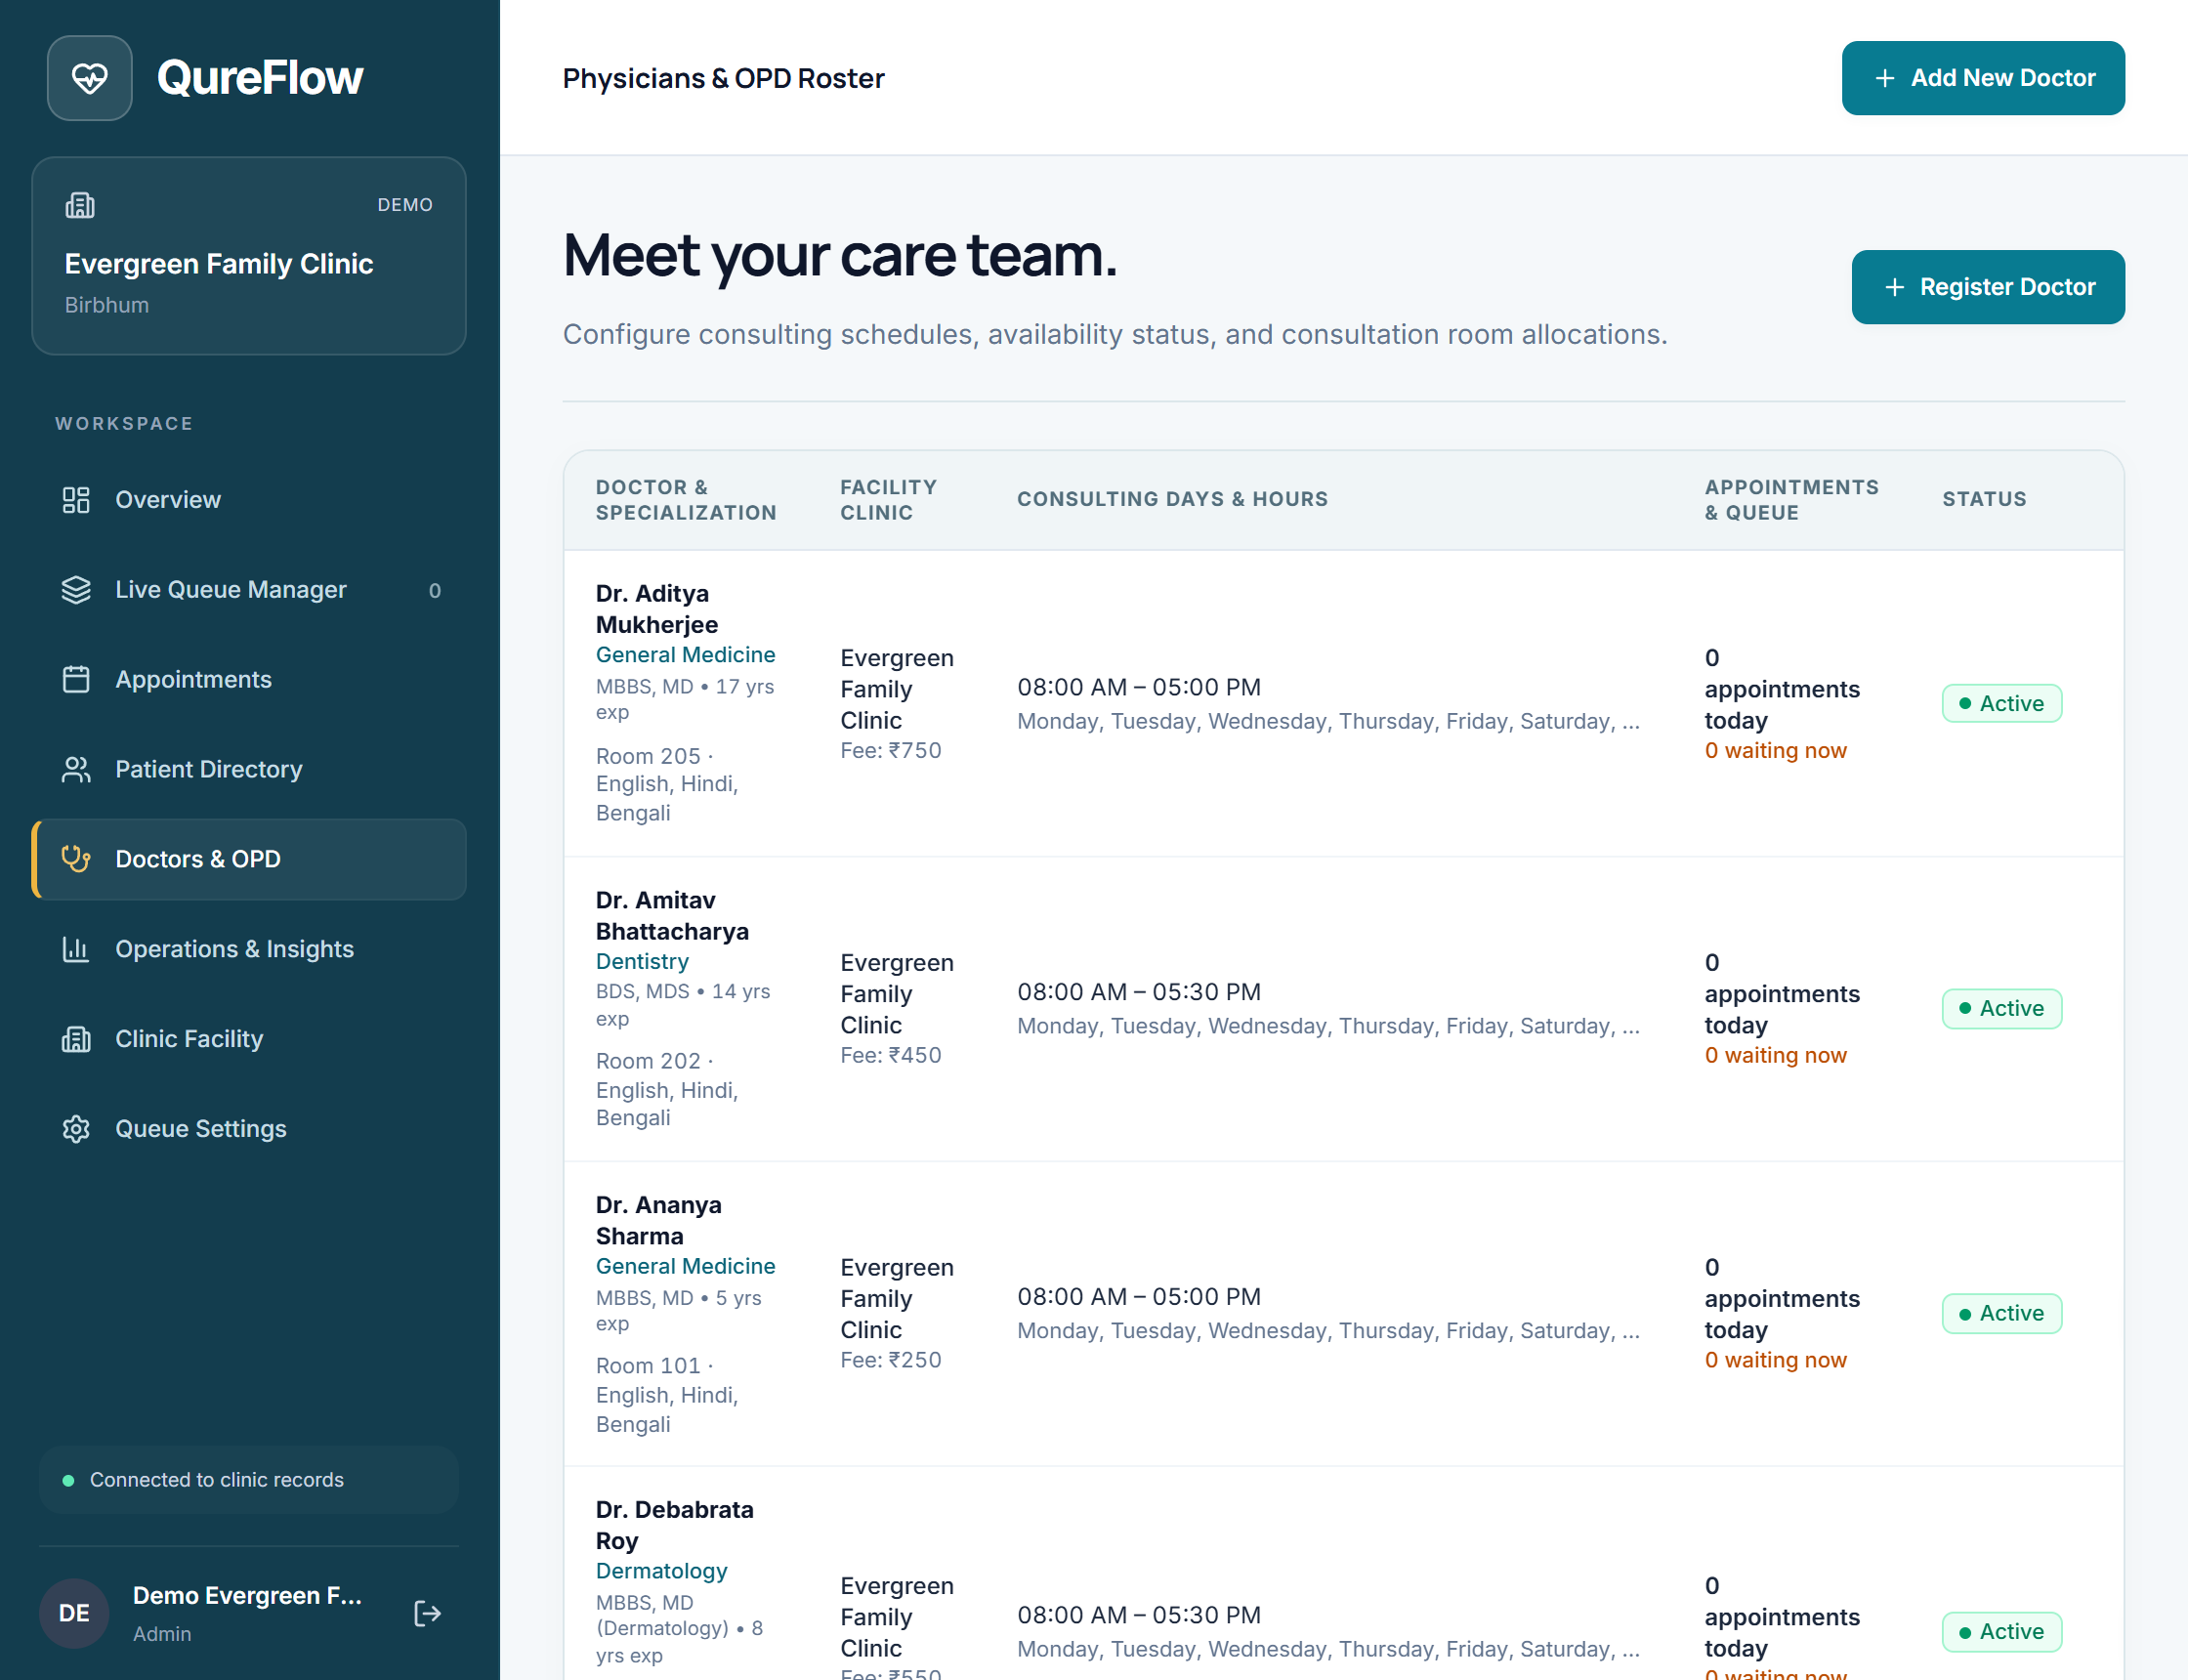
Figure 5.4 Clinic-scoped doctor administration after staff sign-in
Staff sign-in exposes the assigned clinic workflow. SQL queries and API authorization jointly apply clinic scope. Cross-clinic modification and patient attempts to use staff-only appointment filters were rejected in the recorded regression cases.
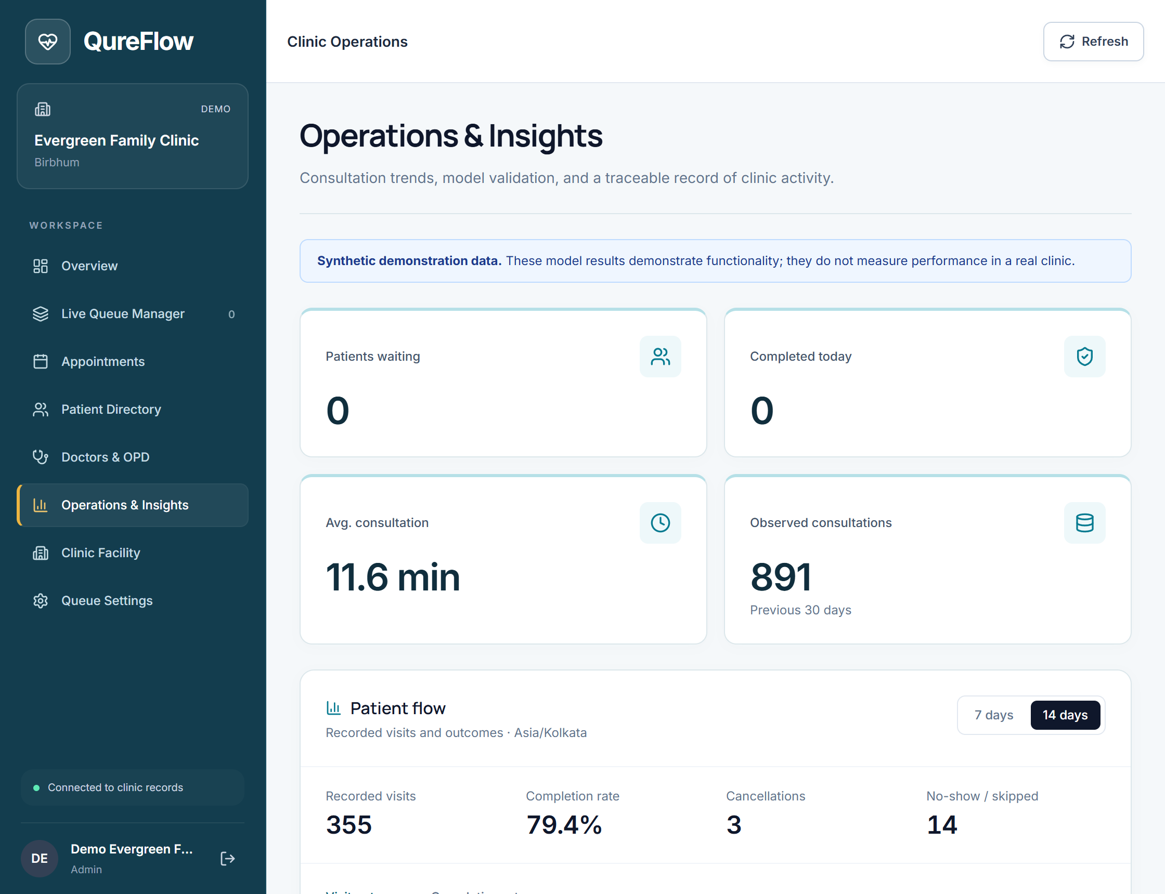
Figure 5.5 Clinic analytics summary computed from recorded SQL data

5.2 Integration with the DBMS
The React client sends HTTP requests to Express. The API validates the session and role, applies clinic scope and calls the MySQL repository through mysql2/promise. Database triggers run within the same transaction as the write that caused them. The API returns success only after the database operation has completed. Database passwords remain in the backend configuration.
const [rows] = await connection.execute(
'SELECT version FROM users WHERE id=? FOR UPDATE',
[userId]
);

The connection pool is configured for the local MySQL endpoint, uses UTC timestamps and disables multiple SQL statements per request. On a failed transaction the connection rolls back, resets the audit context variables and returns to the pool. The database stores clinic-local dates separately from event timestamps.

5.3 Android Application
Capacitor packages the React interface as com.qureflow.dbms. The verified debug APK is version 1.3, code 4, targeting SDK 36 with minimum API 24. It calls the same API rather than connecting directly to MySQL [6].
Connection discovery combines mDNS with a bounded UDP fallback for Wi-Fi/hotspot interfaces. Candidate addresses receive anonymous health checks before a saved clinic is selected. Reconnection pauses requests and cancels in-flight calls; interrupted writes are not replayed. Doctor reads reload after verification without resetting filters.
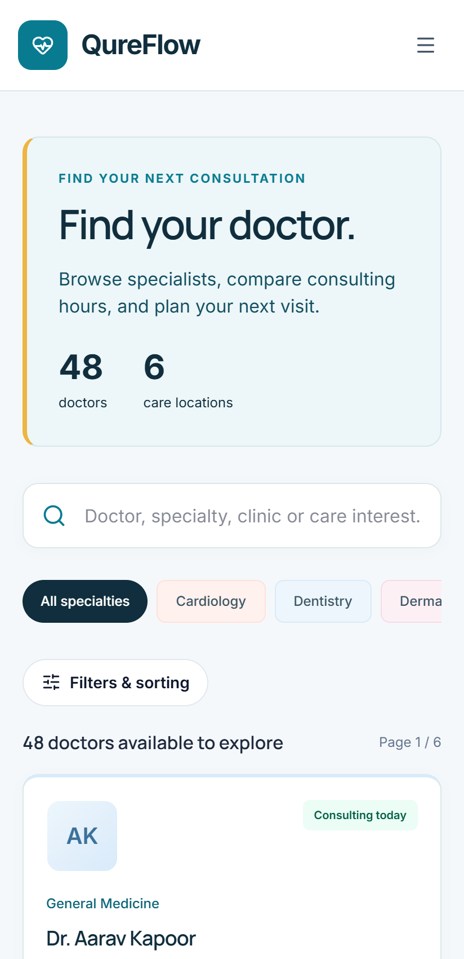
Figure 5.6 Responsive browser view at phone dimensions; this is not a native APK screenshot
APK compilation, package contents, signing and the absence of SQL credentials were verified. Hotspot discovery failed in the earlier build; final acceptance of the new Android hotspot path remains pending. A responsive browser image does not replace a native device execution test [7].

6 VERIFICATION AND TESTING

6.1 Test Cases
The MySQL suite creates a UUID-named test database, loads isolated synthetic records, executes the API/database assertions and removes the test database. It does not run these destructive test cases against the normal demonstration schema. The fresh run completed 24 individual cases with no failures; Node also reports the parent suite as one passing test entry.
Table 6.1 Executed database cases 1 to 8
TC ID | Description | Input | Expected output | Actual output | Result
TC01 | Joined directory | Specialty, Hindi and experience order | Correct filtering and order | Matched expected rows | Pass
TC02 | SQL injection | Injected search and sort expression | No injected results; invalid sort rejected | Search empty; HTTP 400 | Pass
TC03 | Pagination | Unknown specialty and page 999 | Empty page with accurate total | Totals preserved | Pass
TC04 | Authorization | Anonymous read and cross-clinic edits | 401 or 403 rejection | Requests denied | Pass
TC05 | Duplicate visit | Two concurrent joins for one patient | One active visit only | One succeeded | Pass
TC06 | Foreign key | Missing patient reference | Reject orphan token | FK error observed | Pass
TC07 | Priority order | Normal and emergency entries | Explicit emergency first | Correct next token | Pass
TC08 | Consultation claim | Second current token for doctor/date | Unique constraint rejects second | One current token | Pass

Table 6.2 Executed database cases 9 to 16
TC ID | Description | Input | Expected output | Actual output | Result
TC09 | Patient privacy | Another patient queue/cancel request | Conceal identity and deny mutation | Identity hidden; 403 | Pass
TC10 | Trigger transition | Complete then reopen token | Audit and invalid-state rejection | Reopening rejected | Pass
TC11 | Pause and resume | Call paused queue, then resume | Reject while paused; succeed later | Both assertions passed | Pass
TC12 | Atomic booking | Book available future slot | Linked appointment/token; occupancy 1 | Linked rows verified | Pass
TC13 | Full capacity | Book after capacity reached | Conflict without orphan records | Transaction rolled back | Pass
TC14 | Cancellation | Cancel linked visit | Both cancelled; occupancy released | Both states; count 0 | Pass
TC15 | Profile concurrency | Stale version and duplicate email | Reject conflicting updates | Both rejected | Pass
TC16 | Identity protection | New ID with existing identity | Existing account not overwritten | Original unchanged | Pass

Table 6.3 Executed database cases 17 to 24
TC ID | Description | Input | Expected output | Actual output | Result
TC17 | Staff pagination | Clinic-scoped appointment page | Correct page; patient forbidden | Rows and 403 verified | Pass
TC18 | Stored objects | Function, procedure, views, cursor | 12.5 minutes; 14 days; roster | Expected outputs matched | Pass
TC19 | Scoped filters | Injected patient filter and clinic read | No escape from authorized scope | Empty/authorized rows | Pass
TC20 | Buffer capacity | Change buffer and reuse slot | Newly opened place can be booked | Booking succeeded | Pass
TC21 | CHECK constraints | Negative fee and excess occupancy | Reject invalid rows | CHECK errors observed | Pass
TC22 | Invalid timing | Missing, reversed and long intervals | NULL results; zero for equal times | Expected values matched | Pass
TC23 | Concurrent capacity | Three patients, one remaining place | Exactly one successful booking | One success; count 1 | Pass
TC24 | API persistence | HTTP booking then cancellation | SQL linked rows and both states | 201 then 200; SQL matched | Pass

6.2 Output Screenshots
The following terminal captures show the executed test summary, SQL commands with their returned database values, and the saved cancellation state. The MySQL client prints each SQL statement before its result table.
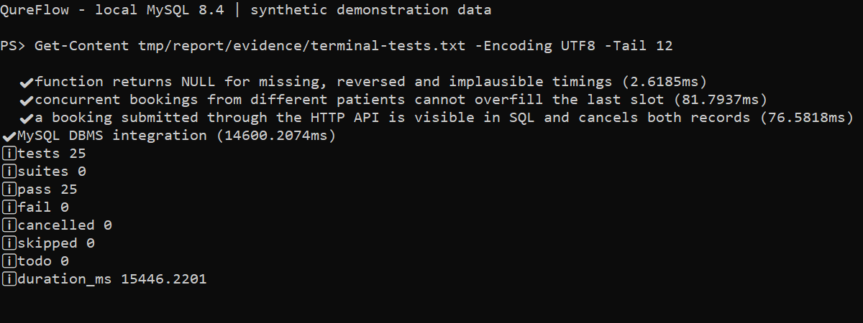
Figure 6.1 Terminal view of the executed test log showing zero failures
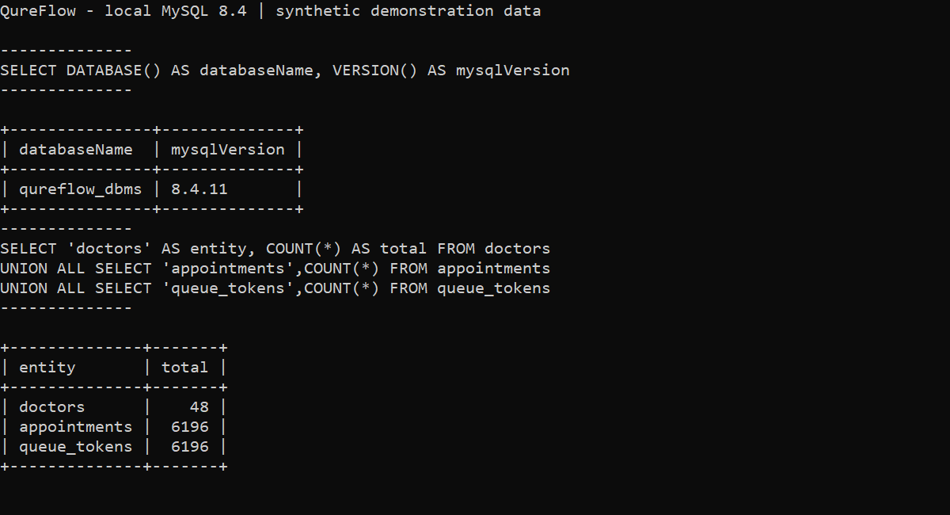
Figure 6.2 SQL commands and results for the database version and record counts
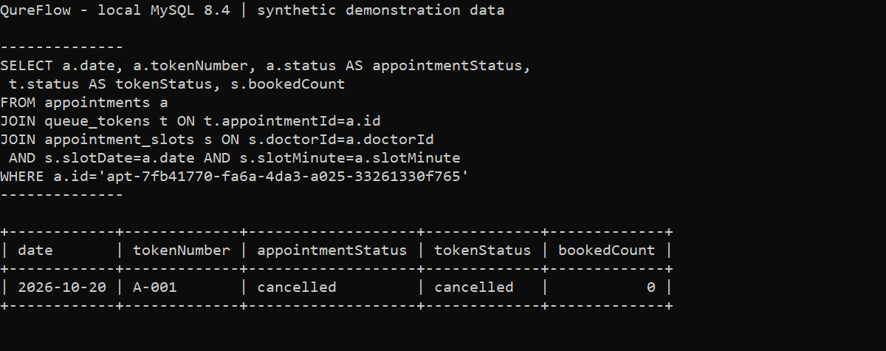
Figure 6.3 Terminal SQL join verifying the saved browser cancellation
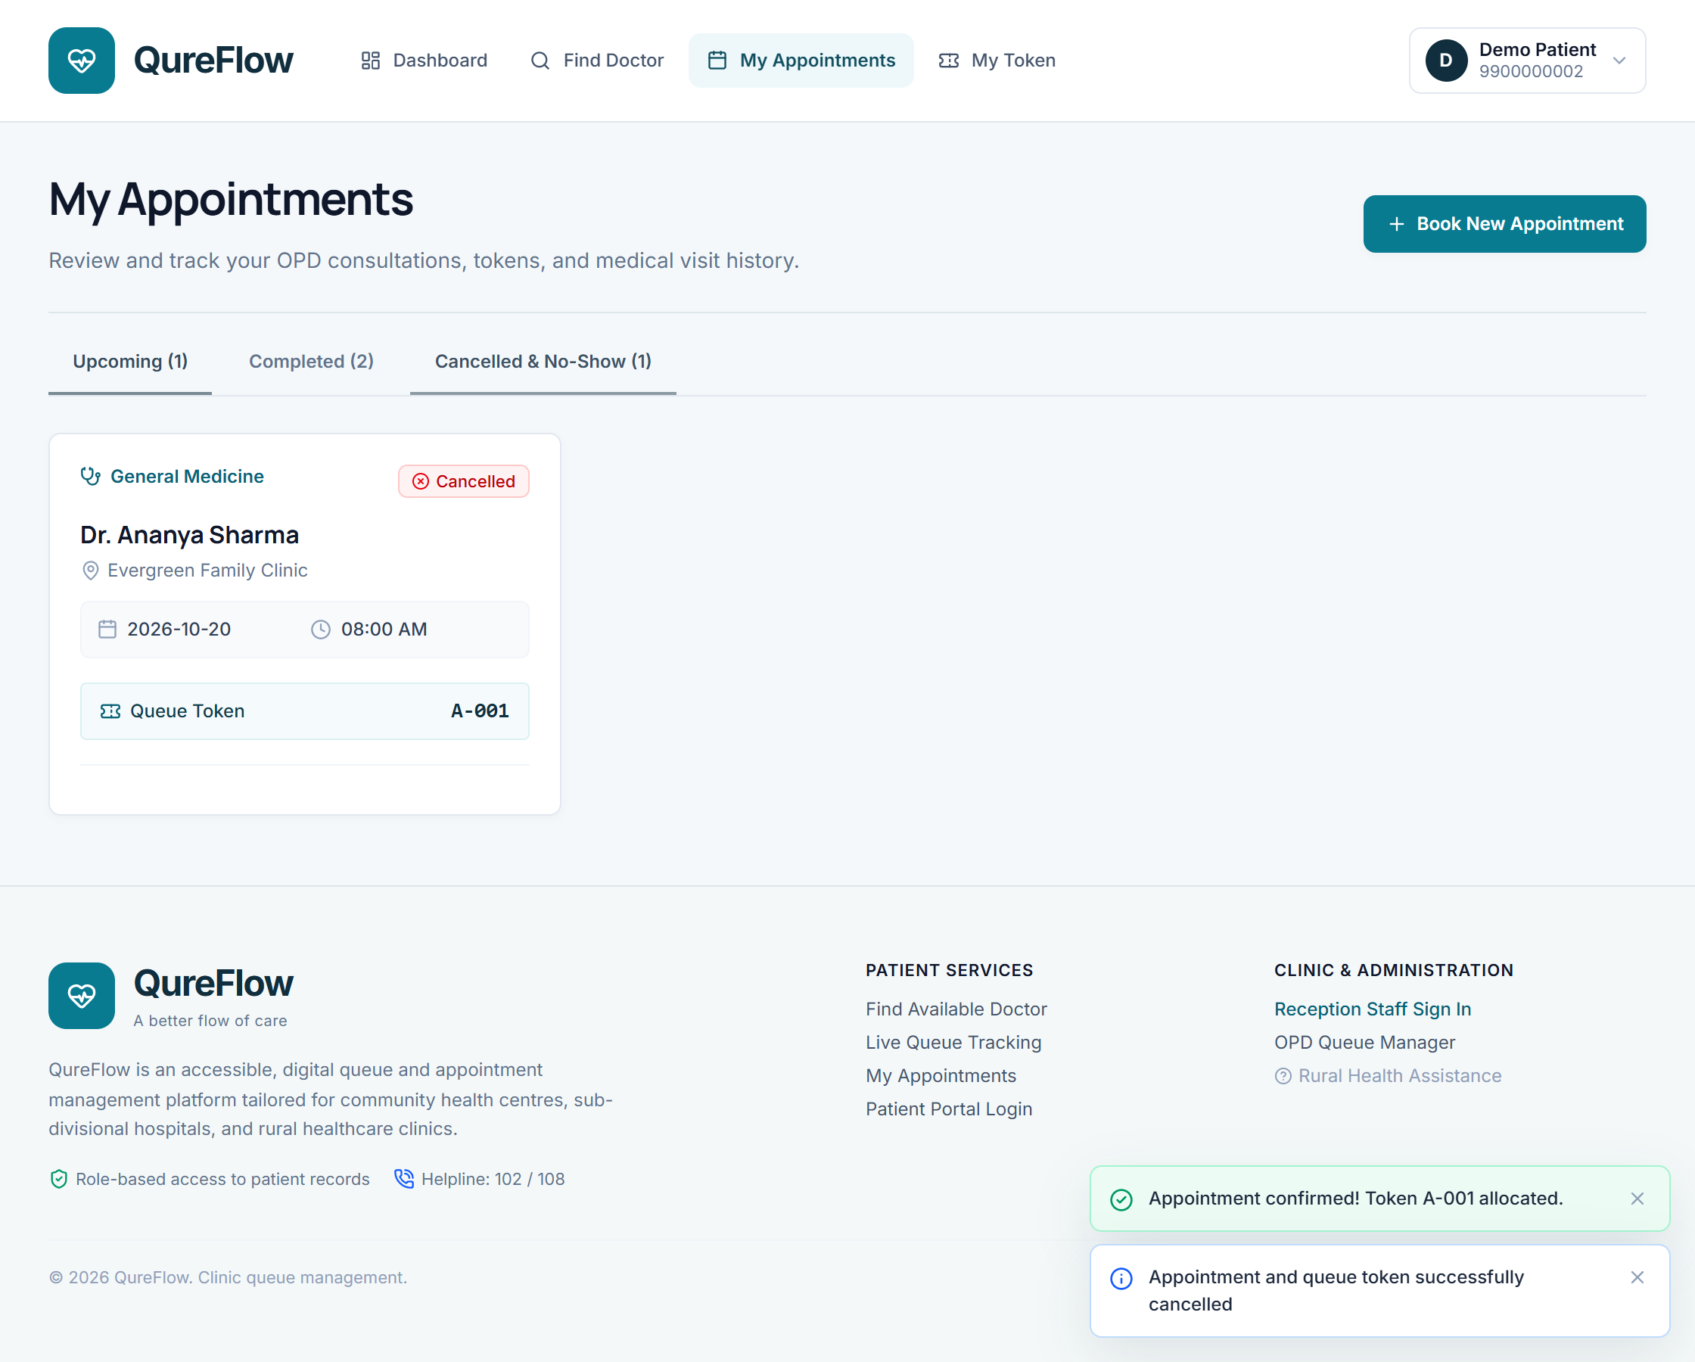
Figure 6.4 Browser appointment history after the verification cancellation

6.3 Validation of Functionality
The browser confirmation produced appointment apt-7fb41770-fa6a-4da3-a025-33261330f765 and token A-001. The independent SQL read found appointmentStatus=booked, tokenStatus=waiting and bookedCount=1. Cancellation through the browser changed both statuses to cancelled and released the slot to bookedCount=0. The final database contains 6,196 appointments and 6,196 queue tokens, including this cancelled verification record.
The SQL function returned 12.50 minutes; invalid timing inputs produced NULL. The daily procedure returned all 14 requested dates, including zero-volume days. The cursor returned the eight doctors assigned to clinic-1 for the selected fixture date. Separate negative tests verified foreign keys, CHECK constraints, illegal transitions, identity conflicts and capacity races.
Additional recorded checks passed 18 mobile/client tests and five discovery tests. These validate reconnection logic, protocol behaviour and local discovery exchange. They do not prove delivery of multicast or broadcast packets on every Android hotspot. APK package verification is kept separate from device acceptance.

7 RESULTS AND DISCUSSION

7.1 Achievements
Recorded item | Result
Database model | 18 base tables, 199 columns, 18 declared foreign keys and four views
Demonstration scale | Six fictional clinics, 48 doctors and 737 patient profiles
Visit records | 6,196 appointments and 6,196 tokens after browser verification
Stored objects | One function, two procedures and three triggers; one procedure uses a cursor
SQL verification | All 24 individual MySQL integration cases passed
Web integration | Browser booking and cancellation matched independent SQL reads
Android packaging | Version 1.3 built and signed; device hotspot acceptance pending

The evidence demonstrates relational consistency, SQL filtering and rejection of conflicting writes. It supports a reproducible local workflow, without establishing a real-world waiting-time reduction or production certification.

7.2 Challenges Faced
Migrating the workflow required explicit relations and SQL queries in place of document-oriented access patterns. Concurrent booking needed row locks and conditional constraints; cancellation needed one consistent update to the token, appointment and capacity counter. Failed operations were verified to roll back.
The phone could reach the API while hotspot discovery failed. A direct discovery fallback was added and locally tested. A cancelled doctor search also needed to reload after reconnection; a component regression verified the read refresh.

7.3 Possible Improvements
Next steps are native hotspot acceptance, HTTPS enrollment, backup and load tests, restricted database privileges and reconciliation of direct edits.

8 CONCLUSION

8.1 Summary of Learning Outcomes
QureFlow applies relational design to a queue-management workflow. The project combines normalized master data with explicit operational state, uses SQL joins and grouping for useful application queries, and protects writes with transactions, locks, foreign keys, checks, unique indexes and triggers. It also distinguishes a reusable stored function, a set-based reporting procedure and an explicit cursor procedure.
The most important outcome is reproducible verification. Positive and negative database cases, a real browser booking/cancellation and the matching SQL output demonstrate how interface actions affect stored records. The work also shows why API authorization, schema rules and network verification address different parts of the application rather than replacing one another.

8.2 Future Scope
The local demonstration can be extended toward clinic deployment after device, operational and security acceptance. Waiting-time models should be evaluated on consented operational timings and used as transparent scheduling guidance. They should not infer diagnoses or perform clinical triage. The original AWS variant and this MySQL laboratory variant should continue to be maintained as clearly separated configurations.

9 REFERENCES
[1] Oracle, "FOREIGN KEY Constraints," MySQL 8.4 Reference Manual. [Online]. Available: https://dev.mysql.com/doc/refman/8.4/en/create-table-foreign-keys.html. Accessed: Oct. 19, 2026.
[2] Oracle, "CREATE PROCEDURE and CREATE FUNCTION Statements," MySQL 8.4 Reference Manual. [Online]. Available: https://dev.mysql.com/doc/refman/8.4/en/create-procedure.html. Accessed: Oct. 19, 2026.
[3] Oracle, "CREATE TRIGGER Statement," MySQL 8.4 Reference Manual. [Online]. Available: https://dev.mysql.com/doc/refman/8.4/en/create-trigger.html. Accessed: Oct. 19, 2026.
[4] Oracle, "Cursors," MySQL 8.4 Reference Manual. [Online]. Available: https://dev.mysql.com/doc/refman/8.4/en/cursors.html. Accessed: Oct. 19, 2026.
[5] Oracle, "Locking Reads," MySQL 8.4 Reference Manual. [Online]. Available: https://dev.mysql.com/doc/refman/8.4/en/innodb-locking-reads.html. Accessed: Oct. 19, 2026.
[6] Capacitor, "Custom Native Android Code," Capacitor Documentation, v8. [Online]. Available: https://capacitorjs.com/docs/android/custom-code. Accessed: Oct. 19, 2026.
[7] Google, "Use network service discovery," Android Developers. [Online]. Available: https://developer.android.com/develop/connectivity/wifi/use-nsd. Accessed: Oct. 19, 2026.
[8] K. Gupta and S. Sinha, "QureFlow MySQL DBMS variant," project source and local execution records, 2026. Internal files: backend/sql/001_schema.sql, 002_routines.sql, backend/src/repositories/mysqlRepo.ts and backend/tests/mysql.test.ts.

10 APPENDICES

Appendix A Complete Schema Definition
The following is the executed project schema source. It defines all base relations and the four views; the report dictionary in Section 3.2 lists selected attributes for readability.
-- QureFlow DBMS variant. MySQL 8.4 / InnoDB; all data is local and synthetic.
CREATE TABLE IF NOT EXISTS schema_migrations (
version VARCHAR(30) PRIMARY KEY, appliedAt DATETIME(3) NOT NULL DEFAULT CURRENT_TIMESTAMP(3)
);
CREATE TABLE IF NOT EXISTS clinics (
id VARCHAR(100) PRIMARY KEY, name VARCHAR(200) NOT NULL, address VARCHAR(500) NOT NULL,
district VARCHAR(100) NOT NULL, state VARCHAR(100) NOT NULL, phone VARCHAR(20) NOT NULL,
email VARCHAR(254) NOT NULL, openingHours VARCHAR(100) NOT NULL, emergencyContact VARCHAR(30) NOT NULL,
metadata JSON, updatedAt DATETIME(3) NOT NULL DEFAULT CURRENT_TIMESTAMP(3)
);
CREATE TABLE IF NOT EXISTS specialties (
id INT AUTO_INCREMENT PRIMARY KEY, name VARCHAR(100) NOT NULL UNIQUE
);
CREATE TABLE IF NOT EXISTS languages (
id INT AUTO_INCREMENT PRIMARY KEY, name VARCHAR(60) NOT NULL UNIQUE
);
CREATE TABLE IF NOT EXISTS doctors (
id VARCHAR(100) PRIMARY KEY, clinicId VARCHAR(100) NOT NULL, specialtyId INT NOT NULL,
name VARCHAR(200) NOT NULL, qualifications VARCHAR(300) NOT NULL,
experienceYears INT NOT NULL CHECK (experienceYears BETWEEN 0 AND 70),
consultationFee DECIMAL(10,2) NOT NULL CHECK (consultationFee >= 0),
startMinute INT NOT NULL, endMinute INT NOT NULL, slotDurationMinutes INT NOT NULL CHECK (slotDurationMinutes BETWEEN 2 AND 30),
status ENUM('active','inactive') NOT NULL DEFAULT 'active', avatar VARCHAR(1000),
bio TEXT, roomNumber VARCHAR(30), department VARCHAR(100), registrationId VARCHAR(100), metadata JSON,
FOREIGN KEY (clinicId) REFERENCES clinics(id), FOREIGN KEY (specialtyId) REFERENCES specialties(id),
CHECK (startMinute >= 0 AND endMinute <= 1440 AND endMinute > startMinute),
INDEX doctors_directory (specialtyId, clinicId, status), INDEX doctors_fee (consultationFee), INDEX doctors_experience (experienceYears)
);
CREATE TABLE IF NOT EXISTS doctor_days (
doctorId VARCHAR(100) NOT NULL, dayOfWeek ENUM('Monday','Tuesday','Wednesday','Thursday','Friday','Saturday','Sunday') NOT NULL,
PRIMARY KEY (doctorId, dayOfWeek), FOREIGN KEY (doctorId) REFERENCES doctors(id)
);
CREATE TABLE IF NOT EXISTS doctor_languages (
doctorId VARCHAR(100) NOT NULL, languageId INT NOT NULL,
PRIMARY KEY (doctorId, languageId), FOREIGN KEY (doctorId) REFERENCES doctors(id), FOREIGN KEY (languageId) REFERENCES languages(id)
);
CREATE TABLE IF NOT EXISTS doctor_interests (
doctorId VARCHAR(100) NOT NULL, interest VARCHAR(200) NOT NULL,
PRIMARY KEY (doctorId, interest), FOREIGN KEY (doctorId) REFERENCES doctors(id)
);
CREATE TABLE IF NOT EXISTS users (
id VARCHAR(100) PRIMARY KEY, name VARCHAR(200) NOT NULL, phone VARCHAR(20) UNIQUE, email VARCHAR(254) UNIQUE,
role ENUM('patient','doctor','health_worker','admin') NOT NULL,
dob DATE, gender ENUM('Male','Female','Other'), staffId VARCHAR(100) UNIQUE, doctorId VARCHAR(100),
clinicId VARCHAR(100), passwordHash VARCHAR(255), cognitoSub VARCHAR(200) UNIQUE, sessionVersion INT NOT NULL DEFAULT 0,
version INT NOT NULL DEFAULT 1, metadata JSON, createdAt DATETIME(3) NOT NULL, updatedAt DATETIME(3) NOT NULL,
FOREIGN KEY (clinicId) REFERENCES clinics(id), FOREIGN KEY (doctorId) REFERENCES doctors(id)
);
CREATE TABLE IF NOT EXISTS clinic_settings (
clinicId VARCHAR(100) PRIMARY KEY, averageConsultationMinutes INT NOT NULL CHECK (averageConsultationMinutes BETWEEN 1 AND 120),
bufferMinutes INT NOT NULL DEFAULT 2 CHECK (bufferMinutes >= 0), allowWalkIns BOOLEAN NOT NULL DEFAULT TRUE,
allowEmergencyPriority BOOLEAN NOT NULL DEFAULT TRUE, notifyOnTwoAhead BOOLEAN NOT NULL DEFAULT FALSE,
autoTokenPrefixByDoctor BOOLEAN NOT NULL DEFAULT TRUE, clinicName VARCHAR(200) NOT NULL, contactNumber VARCHAR(30) NOT NULL,
FOREIGN KEY (clinicId) REFERENCES clinics(id)
);
CREATE TABLE IF NOT EXISTS queue_counters (
doctorId VARCHAR(100) NOT NULL, queueDate DATE NOT NULL, currentNumber INT NOT NULL DEFAULT 0,
PRIMARY KEY (doctorId, queueDate), FOREIGN KEY (doctorId) REFERENCES doctors(id)
);
CREATE TABLE IF NOT EXISTS queue_state (
doctorId VARCHAR(100) PRIMARY KEY, isPaused BOOLEAN NOT NULL DEFAULT FALSE,
FOREIGN KEY (doctorId) REFERENCES doctors(id)
);
CREATE TABLE IF NOT EXISTS appointment_slots (
doctorId VARCHAR(100) NOT NULL, slotDate DATE NOT NULL, slotMinute INT NOT NULL,
bookedCount INT NOT NULL DEFAULT 0, capacity INT NOT NULL,
PRIMARY KEY (doctorId, slotDate, slotMinute), FOREIGN KEY (doctorId) REFERENCES doctors(id),
CHECK (bookedCount >= 0 AND bookedCount <= capacity), CHECK (capacity > 0)
);
CREATE TABLE IF NOT EXISTS appointments (
id VARCHAR(100) PRIMARY KEY, patientId VARCHAR(100) NOT NULL, doctorId VARCHAR(100) NOT NULL,
date DATE NOT NULL, slotMinute INT NOT NULL, tokenNumber VARCHAR(100) NOT NULL,
status ENUM('booked','waiting','in_consultation','completed','cancelled','no_show') NOT NULL,
priority ENUM('normal','emergency') NOT NULL, isWalkIn BOOLEAN NOT NULL DEFAULT FALSE,
notes TEXT, version INT NOT NULL DEFAULT 1, metadata JSON, createdAt DATETIME(3) NOT NULL, updatedAt DATETIME(3) NOT NULL,
FOREIGN KEY (patientId) REFERENCES users(id), FOREIGN KEY (doctorId) REFERENCES doctors(id),
INDEX appointments_patient (patientId, date), INDEX appointments_doctor (doctorId, date, slotMinute)
);
CREATE TABLE IF NOT EXISTS queue_tokens (
id VARCHAR(100) PRIMARY KEY, appointmentId VARCHAR(100) UNIQUE,
patientId VARCHAR(100) NOT NULL, doctorId VARCHAR(100) NOT NULL, queueDate DATE NOT NULL,
tokenSeq INT NOT NULL, tokenNumber VARCHAR(100) NOT NULL, scheduledMinute INT,
priority ENUM('normal','emergency') NOT NULL DEFAULT 'normal', isWalkIn BOOLEAN NOT NULL DEFAULT FALSE,
status ENUM('waiting','current','completed','skipped','cancelled') NOT NULL,
createdAt DATETIME(3) NOT NULL, calledAt DATETIME(3), servedAt DATETIME(3),
version INT NOT NULL DEFAULT 1, updatedAt DATETIME(3) NOT NULL, metadata JSON,
activePatientId VARCHAR(100) GENERATED ALWAYS AS (CASE WHEN status IN ('waiting','current') THEN patientId ELSE NULL END) STORED,
servingDoctorId VARCHAR(100) GENERATED ALWAYS AS (CASE WHEN status = 'current' THEN doctorId ELSE NULL END) STORED,
UNIQUE active_visit (activePatientId, queueDate), UNIQUE one_consultation (servingDoctorId, queueDate),
UNIQUE token_sequence (doctorId, queueDate, tokenSeq),
FOREIGN KEY (patientId) REFERENCES users(id), FOREIGN KEY (doctorId) REFERENCES doctors(id),
FOREIGN KEY (appointmentId) REFERENCES appointments(id),
CHECK (servedAt IS NULL OR calledAt IS NOT NULL AND servedAt >= calledAt),
INDEX queue_waiting (doctorId, queueDate, status, priority, tokenSeq)
);
CREATE TABLE IF NOT EXISTS audit_events (
id VARCHAR(100) PRIMARY KEY, clinicId VARCHAR(100), entityType VARCHAR(60) NOT NULL, entityId VARCHAR(100) NOT NULL,
action VARCHAR(60) NOT NULL, actorId VARCHAR(100) NOT NULL, requestId VARCHAR(100) NOT NULL,
timestamp DATETIME(3) NOT NULL DEFAULT CURRENT_TIMESTAMP(3), details JSON,
INDEX audit_clinic (clinicId, timestamp)
);
CREATE TABLE IF NOT EXISTS prediction_models (
doctorId VARCHAR(100) PRIMARY KEY, clinicId VARCHAR(100) NOT NULL, model JSON NOT NULL,
updatedAt DATETIME(3) NOT NULL DEFAULT CURRENT_TIMESTAMP(3), FOREIGN KEY (doctorId) REFERENCES doctors(id)
);
CREATE TABLE IF NOT EXISTS demo_seed (
version VARCHAR(30) PRIMARY KEY, seededAt DATETIME(3) NOT NULL DEFAULT CURRENT_TIMESTAMP(3)
);
CREATE OR REPLACE VIEW doctor_directory AS
SELECT d.*, c.name AS clinicName, c.district, s.name AS specialization,
EXISTS(SELECT 1 FROM doctor_days dd WHERE dd.doctorId=d.id AND dd.dayOfWeek=DAYNAME(CONVERT_TZ(UTC_TIMESTAMP(),'+00:00','+05:30'))) AND d.status='active' AS isAvailableToday,
(SELECT JSON_ARRAYAGG(dayOfWeek) FROM doctor_days WHERE doctorId=d.id) AS consultationDays,
(SELECT JSON_ARRAYAGG(l.name) FROM doctor_languages dl JOIN languages l ON l.id=dl.languageId WHERE dl.doctorId=d.id) AS languages,
(SELECT JSON_ARRAYAGG(interest) FROM doctor_interests WHERE doctorId=d.id) AS clinicalInterests
FROM doctors d JOIN clinics c ON c.id=d.clinicId JOIN specialties s ON s.id=d.specialtyId;
CREATE OR REPLACE VIEW visit_details AS
SELECT t.*, u.name AS patientName, u.phone AS patientPhone, d.name AS doctorName,
d.clinicId, c.name AS clinicName
FROM queue_tokens t JOIN users u ON u.id=t.patientId JOIN doctors d ON d.id=t.doctorId JOIN clinics c ON c.id=d.clinicId;
CREATE OR REPLACE VIEW appointment_details AS
SELECT a.*, u.name AS patientName, u.phone AS patientPhone, d.name AS doctorName, s.name AS doctorSpecialization,
d.clinicId, c.name AS clinicName, t.id AS tokenId
FROM appointments a JOIN users u ON u.id=a.patientId JOIN doctors d ON d.id=a.doctorId
JOIN clinics c ON c.id=d.clinicId JOIN specialties s ON s.id=d.specialtyId
LEFT JOIN queue_tokens t ON t.appointmentId=a.id;
CREATE OR REPLACE VIEW daily_patient_flow AS
SELECT d.clinicId, t.queueDate AS date, COUNT(*) AS total,
SUM(t.status='completed') AS completed, SUM(t.status='cancelled') AS cancelled, SUM(t.status='skipped') AS noShow
FROM queue_tokens t JOIN doctors d ON d.id=t.doctorId GROUP BY d.clinicId,t.queueDate;

Appendix B Additional Code and Source Map
The transactional trigger demonstration is maintained in 004_transaction_demonstration.sql. Its disposable records are rolled back. The following excerpt is the actual cancellation and verification step.
UPDATE queue_tokens SET status='cancelled',updatedAt=UTC_TIMESTAMP(3) WHERE id=@token;
-- AFTER UPDATE trigger synchronizes the appointment and releases the slot.
SELECT a.id,a.status appointmentStatus,t.status tokenStatus,s.bookedCount
FROM appointments a JOIN queue_tokens t ON t.appointmentId=a.id
JOIN appointment_slots s ON s.doctorId=a.doctorId AND s.slotDate=a.date AND s.slotMinute=a.slotMinute WHERE a.id=@appointment;
SELECT action,actorId,details FROM audit_events WHERE entityId=@token ORDER BY timestamp;
ROLLBACK;
SELECT (SELECT COUNT(*) FROM users WHERE id=@patient) remainingUsers,
(SELECT COUNT(*) FROM appointments WHERE id=@appointment) remainingAppointments,
(SELECT COUNT(*) FROM queue_tokens WHERE id=@token) remainingTokens,
(SELECT COUNT(*) FROM audit_events WHERE entityId=@token) remainingAuditEvents;

Source file | Purpose
backend/sql/001_schema.sql | Relations, keys, checks, indexes and views
backend/sql/002_routines.sql | Function, two procedures and three triggers
backend/sql/003_demonstration_queries.sql | Manual search, aggregation and stored-object calls
backend/sql/004_transaction_demonstration.sql | Trigger synchronization and rollback verification
backend/src/dbms/connection.ts | Connection pool, transaction boundaries and error mapping
backend/src/repositories/mysqlRepo.ts | Parameterized queries, locking and persistence
backend/tests/mysql.test.ts | 24 isolated SQL/API regression cases
src/pages/patient/DoctorList.tsx | SQL-backed directory filters and reconnect refresh
android/app/src/main/java/com/qureflow/dbms | Native navigation and discovery bridge

Appendix C Terminal Demonstration
With Docker Desktop and the MySQL container running, open a separate PowerShell window. This command can be run from any folder and prompts for the local demonstration database password.
docker exec -it qureflow-dbms-mysql-1 mysql -uqureflow -p qureflow_dbms

At the mysql prompt, execute each statement with a terminating semicolon. The client uses the database directly; no patient endpoint accepts arbitrary SQL.
SHOW TABLES;
DESCRIBE doctors;
SELECT COUNT(*) AS totalDoctors FROM doctors;
SELECT name,experienceYears,consultationFee
FROM doctors ORDER BY consultationFee LIMIT 10;
SELECT fn_consultation_minutes(
'2026-10-19 10:00:00','2026-10-19 10:12:30'
) AS minutes;
SHOW TRIGGERS;
exit;

Appendix D Evidence Provenance
All web screenshots were captured from the running local application. SQL figures are native Windows console captures of the MySQL command-line client executing against the local Docker database. Each capture includes the SQL statement and its actual output; the cursor uses vertical result display. Figure 6.1 shows the tail of the actual integration-test log in a terminal. The capture script, SQL files, raw outputs, browser booking record and test log are retained under tmp/report for reproduction.
Tests and the rollback demonstration leave no disposable records. The browser workflow retains one cancelled synthetic booking: the visit count is therefore 6,196 rather than 6,195. The phone-sized image is a responsive browser view; native hotspot acceptance remains pending.

