**Accurate and Efficient Multi-scale Flow Simulation using a Hybrid CFD-MD Approach**

**Abstract**

We investigate numerical and computational issues associated with hybrid computational fluid dynamics (CFD) - molecular dynamics (MD) simulation methodologies. Our current hybrid CFD-MD simulation framework is based on reliable CFD and MD codes linked together through hybrid interfaces that are often based on constrained Lagrangian dynamics for data exchange between continuum and MD regions. We argue that (1) the statistical error associated with the sampled average of the molecular solution, and (2) hybrid boundary conditions via an extrapolation methodology, may lead to non-negligible spatial and temporal inaccuracies of the hybrid solution. Hence, in this study we propose two strategies for minimizing the statistical noise inherent in the MD solution: (1) optimization of coupling parameters through the molecular dynamic simulation of a stationary flow field, and (2) averaging over multiple independent replicas of the simulation system. In addition, we introduce a new temporal coupling scheme based on a 'prediction-correction' approach together with interpolation in time, which provides a more time-accurate hybrid constraint/boundary condition. With respect to computational performance, co-scheduling and load-balancing of logically distributed tasks are two important considerations in CFD-MD coupled simulations. We employ a BigJob computational framework, similar to a Pilot-job, and incorporate a load-balancing function for the computing efficiency of coupled simulation. The optimized hybrid framework is applied to solving two classical flow problems under Stokes conditions. One is the impulsively started Couette flow, and the other is an oscillating boundary Stokes flow, which is induced by the periodic motion of one flat plate in the channel system. We emphasize that (1) the determination of coupling parameters through the molecular dynamic simulation of a stationary flow and the averaging of multiple independent replicas contribute much on suppressing the statistical noise in relatively low-speed flow fields of O(10) m/s velocity, (2) the accuracy of unsteady flow solution is increased by applying a 'prediction-correction' temporal coupling scheme, and (3) efficient coupled simulation is conducted by employing a BigJob computational framework along with the load-balancing capability.

Keywords: Hybrid computational fluid dynamics particle dynamics approach, Constrained Lagrangian dynamics, Temporal coupling scheme, Simple API for Grid Applications, BigJob framework

1. **Introduction and Motivation**

A hybrid continuum dynamics - particle dynamics approach is an approach capable of describing accurately a flow at both macroscopic and molecular scales. In this approach the system is divided into two domains. A continuum formulation is used appropriately for one domain and a particle formulation (e.g. molecular dynamics) is applied to the other. Naturally the particle domain is more appropriate for material interfaces (e.g. fluid/solid or fluid/fluid) where molecular effects are more likely to be important. On the other hand, the continuum approach provides a better computational efficiency than particle dynamics with acceptable accuracy in solving the bulk flow field. In the hybrid approach the two domains are coupled through an overlap region/interface in which both formulations are valid. The overlap domain enables the exchange of conservative flow properties between the continuum and particle ones so that the respective solutions are mutually consistent. The information from the continuum domain is passed to the particle domain by imposing additional numerical modeling to preserve higher degree-of-freedom on the particle motion, while the particle domain provides boundary conditions to the continuum domain obtained through time and spatial averaging of the relevant variable.

Despite the recent developments reported in the literature, most of which tested against small idealized pure atomistic flow simulations for comparison, there are still methodological and implementation issues that need refinement, testing and validation. In this section, we will give a brief account of the numerical and computational issues associated with some of the previous hybrid CFD-MD implementations and outline our approach to address them effectively.

* 1. *Previous Works*

Hybrid CFD-MD simulations have utilized constrained Lagrangian dynamics, the Schwarz method, or a direct flux exchange method, depending on the methodology used to impose the solution matching in the overlap region/interface and the nature of the variables that exchange information in this region. O'Connell and Thompson were among the first to implement a hybrid CFD-MD simulation approach by introducing the overlap region that allows matching of the solutions from the two domains to relax smoothly before they are coupled together. Namely, they employed a relaxation method according to which the average MD velocity in an overlap region is forced to follow the continuum solution in the same region. In their implementation they use constrained Lagrangian dynamics according to which the particles are accelerated / decelerated in the overlap region so that on average they follow the continuum velocity. The drawback of their implementation is the arbitrariness of the relaxation rate and the lack of particle exchange (particle flux) between the two domains. This approach is refined by Nie et al., who imposed the spatial coupling between continuum equations and molecular dynamics through constrained dynamics implemented in the overlap region. The implementation of Nie at al. can also account for the presence of mass flux across the MD-continuum interface implemented via a particle exchange algorithm. The methodology has been applied to a variety of flow problems such as the impulsively started Couette flow, channel flow with rough walls, cavity flow, Poiseuille flow and the oscillating boundary problem. The use of direct constrained dynamics equation makes this approach easy to implement and computationally efficient. However, the absence of energy exchange modeling limits the applications to isothermal systems.

To alleviate some of these shortcomings, Hadjiconstantinou et al., have introduced a new hybrid simulation methodology based on the Schwarz method. In this approach, the continuum solution is used to generate the solution in the particle domain in which the particle velocities are drawn from a Maxwellian distribution such that the mean velocity and the corresponding standard deviation are determined by the continuum solution and temperature. This approach later was expanded to non-periodic boundary condition problems by Werder et al., who also expanded and refined the previous boundary force models so as to minimize local disturbance. An alternating Schwarz approach has been applied to the moving contact line problem, Poiseuille flow, flow around the cylinder, and Couette flow of water. The characteristics of decoupled physical time-scales between two domains makes this approach appealing when solving the flow field in problems in which hydrodynamic characteristic time scale is much larger than molecular dynamic time scale, i.e., micrometer system size.

In order to be able to simulate isothermal compressible flow, Flekkoy et al., introduced a new hybrid method based on continuity of mass and momentum fluxes across the MD-continuum interface, which later included energy transfer. Further developments were implemented by Delgado-Buscalioni and Coveney by introducing a particle insertion algorithm which satisfies the continuity of the mass flux along the interface while preserving the mean potential energy of the system. This approach has been applied to the study of Couette and Poiseuille flow, transversal wave, and oscillating boundary problem. According to Flekkoy et al., flux exchange directly implies adherence to the relevant conservation laws without the use of constitutive relations and equations of state (to maintain the conservation laws). However, it is pointed out that the sampling time to measure fluxes within acceptable statistical error is orders of magnitude larger than the time to measure densities.

* 1. *Numerical and Computational Issues*

Despite the recent developments and obvious advantages of a hybrid approach for flowing systems with scales straddling molecular to macroscopic (continuum) magnitudes over pure CFD or MD, a number of numerical and computational difficulties prevent this technique from being widely used. One of the difficulties is the lack of a clear methodology for defining an optimized set of parameters related to the coupling of the continuum and molecular domains. In general the flow solution obtained by a direct hybrid approach suffers from the existence of significant noise in the spatially averaged particle velocity mainly due to the inherent statistical fluctuations in the molecular description. Therefore, coupling parameters such as the size of the overlap domain and its position, the width of various layers and bins in the overlap region, and the sampling conditions, should be appropriately determined a priori in order to achieve more accurate numerical solutions. Many of these coupling parameters are problem dependent and this complicates the problem even further. Given the stochastic nature of the noise characterized by the mean velocities in the molecular domain of the coupling region, the characteristics of fluid and solid elements, as well as the geometric characteristics of material (e.g. fluid/solid) interfaces, it is difficult to develop a mathematical model capable of predicting the optimum coupling parameters. There have been some attempts to mitigate the inaccuracies associated with inherent statistical fluctuations by introduction of certain numerical damping terms in the equations of motion of the atoms in the overlap region or by defining a specific dynamic parameter to controlling the coupling intensity, but all of these eventually lead to some violation of energy and momentum conservation.

Important issues remain to be addressed in the hybrid implementations for studying flow physics at moderate or low velocity conditions. So far, most of the reported studies have been confined to relatively high-speed flow conditions, of the order of 100 m/s, in nanoscale systems; flow conditions chosen mainly to obtain a high speed shear rate in the overlapping region and, more importantly, to reduce the relative stochastic thermal noise associated with the velocity flow field. According to the mathematical models the noise level characterizing the average velocity in the coupling region in a hybrid CFD-MD implementation is proportional to , where u is the far field stream velocity, and to 1 / N, where N denotes the number of particles contained in the sampling layer. Therefore, by reducing the free stream velocity by, say, 10 times, in order the maintain the same noise level (same statistical error) would require the increase of the number of particles in the averaging bins by 100 times, assuming that the sampling duration is maintained constant. In general the increase of the sampling duration beyond the limits imposed by the physical time-scales of a given unsteady flow problem is to be avoided because it leads to unphysical effects.

The accuracy of temporal coupling schemes is of great importance when solving unsteady problems. In general the temporal coupling scheme encompasses the timing of data exchange between the CFD and MD solvers, so as to synchronize both solutions at the same physical time instant. In this one has to keep in mind that the interpretation of the term "instantaneous" regarding values of variables differs between the continuum and molecular formulations. The time-coupling models are inherently affected by time-lagging. This is more pronounced when backward-averaged molecular dynamic properties are in general communicated as instantaneous properties to the continuum domain. To address this shortcoming, Liu et al., proposed a multi-timescale algorithm by considering quasi-steadiness and Wang and He proposed passing the extrapolated continuum solution to the MD solver. Despite their success there are, however, serious limitations with these approaches as a multi-timescale algorithm is only valid if the characteristic time of the unsteady phenomenon is substantially longer than the integration (averaging) time of the MD solutions. This is also a prerequisite for the particle (MD) solution to be able to equilibrate subject to the constraint passed on from the continuum solution from one continuum time instant to another. The approach by Wang and He may therefore be a good compromise that may mitigate some of the time-lagging effects.

In addition to the above mentioned issues, there are computational challenges related to the integration of multiple application domains into a single problem set. Due to their very different computational kernels (e.g. one mesh-based, the other an unstructured particle-based), it is difficult to incorporate distinct CFD and MD codes under the umbrella of a single tightly-coupled application (i.e. unifying two application codes to share a single MPI communicator). One possible alternative can be to implement a coupling interface into one of the individual codes and design it such that this assumes control of the two separate codes as a virtually unified simulation package. This heterogeneous implementation raises additional computational challenges. For example, in the parallel execution of such a simulation package, on conventional production systems with batch queues, it cannot be guaranteed that two separate jobs will execute concurrently. Considering the computational characteristics of the current application, where the CFD and MD codes conduct frequent data exchange, the first job that completes a task will inevitably experience the idle waiting for its counterpart to finish its sequenced task without the explicit support for co-scheduling. Another important challenge is the need for efficient load-balancing which takes into account the individual application's performance. Even if the two simulations could run concurrently, without explicit load-management/balancing support, there is likely to be inefficient utilization of computing resources due to load imbalance. As the performance of each simulation component changes with computing resource and problem size, re-adjustment of allocated resources to each task according to their performance is required during the hybrid simulation.

* 1. *Objectives and Outline of the Paper*

The focus of this paper is to investigate numerical issues associated with the implementation of a typical hybrid CFD-MD methodology applied to investigate the flow in a nano/micro-fluidic system as well as with designing and developing of an efficient runtime framework for coupled multi-scale simulations. We present our implementation of a 'generic' hybrid CFD-MD interface which can be easily put together from various 'off the shelf' incompressible CFD and MD packages, as well as our model of a 'portable' framework that can be ported easily on most present day computer architectures.

We present the development of our hybrid simulation framework, based on constrained Lagrangian dynamics, and apply it to two prototype classical flow problems: the impulsively started Couette flow and an oscillating boundary Stokes flow. From the pure MD solution on zero-velocity flow field, we elaborate on our strategy for determining the optimized set of coupling parameters that minimize the level of the statistical noise characterizing the flow field obtained by the hybrid solver. In addition we extend our investigation into the moderate-speed flow regime (flow velocities of the order of 10 m/s), which is challenging and novel. The inherent large fluctuations of the solution in the overlap region associated with relatively low flow speed are reduced by a multiple replica averaging methodology. For the oscillating boundary Stokes flow simulation, we demonstrate a novel temporal coupling scheme, called 'prediction-correction approach' which provides improved accuracy by eliminating the overshoot/undershoot phenomena and diminishes the time-lagging pattern.

In terms of computational science, our study introduces a novel approach to coupled multi-physics simulations by utilizing the virtually unified simulation package, called "Pilot-Job". We argue that using the Pilot-Job approach has distinct advantages, such as: (i) elimination of the need for a co-scheduler while preserving performance, and (ii) enables dynamic resource allocation, which in turn is important for load-balancing across coupled simulations.

The paper is organized as follows. In Section 2 we give a brief description of the fundamental equations describing the CFD and MD formulations as well as details of the hybrid CFD-MD coupling scheme and its implementation. Technical details related to the implementation of an efficient CFD-MD simulation framework are presented in Section 3. In Section 4, we present the solutions to the two prototype problems (impulsively started Couette flow and oscillating boundary Stokes problem) obtained with our hybrid methodology. The performance and the optimization issues related to the solutions of the two test problems are described in Section 5. Recommendation for future work and conclusions are presented in Sections 6 and 7.

1. **Fundamentals of the Hybrid Coupled CFD-MD Simulation Toolkit**

The accuracy of a hybrid CFD-MD solution is governed by the underlying numerical schemes of the individual continuum and particle solvers as well as the coupling scheme. This section details and explains the features of baseline solvers and the structure of the hybrid coupling interface. Additional numerical treatments to improve the accuracy of hybrid CFD-MD simulations in various types of fluid systems are also addressed.

* 1. *Overview of the Continuum-Molecular Coupled Approach*

The hybrid CFD-MD approach stands on the proposition that (a) the molecular dynamic simulation produces a more physically accurate solution in its domain than the continuum model would, (b) a faster and more efficient CFD solver provides a physically accurate solution in the continuum domain, which would be prohibitive if a particle representation were to be used, and (c) the two solutions can be reconciled by the mutual exchange of information, the continuum solution providing the constraint to the particle solution while the latter providing a boundary condition to the former. So, the region within which molecular-level physics are important (e.g. a material interface) is treated and resolved by a molecular dynamic simulation, while the region within which the continuum-level physics adequately represent the transport processes on a macroscopic scale is treated and resolved by the continuum CFD. The continuum and particle (molecular) domains overlap, in this approach, so as to exchange information for the coupling. Obviously, the overlap domain must be one where both treatments/formulations are valid.

A detailed structure of the various domains associated with the hybrid CFD/MD methodology is described in Fig. 1. CFD solves the continuum equations in the “Pure CFD Region”, while MD resolves the microscopic (particle) flow in the “Pure MD region”. The latter is a solid stationary wall for the two test problems examined herein. The hybrid (overlap) region is placed sufficiently far from the solid wall to prevent direct constraint of the molecular-level physics in the proximity of the solid-fluid interface.



Figure 1: Schematic Diagram of the Hybrid Domain with Detailed View of Overlapping Zone; Overall continuum/atomistic computational domain including overlap region is shown on left figure. Detailed layer by layer explanation of overlapping region is indicated by right figure.

This overlap region is designed sufficiently large to contain five individual layers of sufficient width for the purpose of their existence. The widths of these layers are of course problem dependent. Their roles in the hybrid region are as follows. One layer (the bottom one in Fig. 1-left) provides information from the particle (MD) domain to the continuum one (denoted as ’MDtoCFD’). A second layer (the third one from the bottom in Fig. 1-left) provides information from the continuum domain to the particle one (denoted as ’CFDtoMD’). A third layer (the top one in Fig. 1-left) applies a fictitious external force which prevents particles from escaping from the hybrid domain. These three “active” layers are separated by buffer layers, which are placed so as to ensure smooth transitions and that there is no direct correlation between the “active” layers. Properties (e.g. velocity) of particles spatially located in the MDtoCFD layer are ensemble-averaged over all the particles in the layer and also averaged over a finite time (’sampling duration’). The average value is communicated to the continuum solver periodically with a fixed period (’sampling interval’).

The height of each layer is the same as the CFD cell height and averaged conservative properties in two consecutive layers are passed to continuum domain to be directly imposed as the viscous boundary condition on the Navier-Stokes solver with collocated data structure. The CFDtoMD layer imposes the instantaneous values of properties, velocity in this case, resulting from the continuum solver. This is done via and appropriate constraint to the MD particle-based conservation of momentum on every single particle (constrained dynamics) in the CFDtoMD layer. Thus, particles in this layer are constrained to attain the macroscopic flow property (velocity in this case) on average, while preserving their degree-of-freedom of translational motion. In the uppermost layer, a fictitious external force is exerted on particles to prevent them from escaping the particle domain. This force function is designed to be short-range so as not to be strong enough to influence the motion of the particles past the buffer layer in the CFDtoMD domain. The force stiffens as the particles approach the location where the force becomes infinite in a way that minimizes reflections while preventing the particles from drifting out of the particle domain. The buffer layers existing in between each “active” layer are set up to be wider than the interaction length scale of the particles (cutoff radius), in order to prevent direct interaction between particles in neighboring “active” layers.

2.2 *Governing Equations and Numerical Schemes*

*2.2.1. Continuum Incompressible Flow Formulation (CFD)*

The current in-house continuum hydrodynamics code solves the unsteady incompressible Navier-Stokes equations to demonstrate the isothermal nano-scale flow field:



where *ν* is the kinematic viscosity.

In this work, we adopted the pseudo-compressibility method [24] is adopted to form a hyperbolic system of equations which can be marched in pseudo-time. A time derivative of pressure is added to the continuity equation resulting in



where β denotes a pseudo-compressibility parameter, currently set to 2.5.

For time-accurate unsteady simulation, a dual time stepping method is adopted and it is combined with the LU-SGS (Lower-Upper Symmetric Gauss-Seidel) scheme [25] for the implicit time integration. The inviscid fluxes are upwind-differenced using Osher’s flux-difference splitting scheme [26]. For higher-order spatial accuracy, the MUSCL (Monotone Upstream-centered Schemes for Conservation Laws) [27] approach is used on an inviscid flux calculation. Viscous fluxes are calculated using the conventional second-order central differencing.

* + 1. *Molecular-Level Formulation (MD)*

In MD, an initial velocity is assigned to each atom, and Newton’s laws are employed at the atomic level to propagate the system’s motion through time evolution. To calculate pairwise interactions of particles in the system, the most commonly used Lennard-Jones (12-6) potential interaction model is employed and is define as:



where єij and σij denote the pair wise potential well depth and the atom size parameter respectively, and rij is the distance between the particle i and j. The term 1 /r12 dominating at short range distance repulsive behavior ij based on the Pauli principle to avoid overlapping the electronic clouds when particles are brought very close to each other. The term 1 /r6 dominates at ij long range attractive forces by Van der Waals dispersion forces. The cut-off distance σc is introduced here to reduce the computational cost and is set to be 2.2σ [28]. Namely when rij exceeds the cutoff the intermolecular force is set to zero without being calculated.

The time integration algorithm is required to integrate the equation of motion of the interacting particles and computing molecular trajectories, one of most common velocity Verlet algorithm is employed to compute the simulation.

In this work, the MD simulations were performed by using an appropriately modified version of the Large Atomic Molecular Massively Parallel Simulator (LAMMPS). It is a classical molecular dynamics open-source code written in C++ and developed by Sandia National Labs. [29]

* 1. *Hybrid Interfaces and Schemes*

Hybrid simulation requires the implementation of hybrid interfaces and schemes based on an individual code. In the current study, the file interface is designed to schedule the information exchange between continuum and discrete particle descriptions. A constrained Lagrangian dynamics model is implemented for hybrid simulation. A unit conversion routine is also implemented in the application code. These changes are summarized in Table 1.

Table 1: Implementation of hybrid interface on CFD and MD codes. Both codes are equipped with the ﬁle-based information exchange routine, to update the hybrid boundary condition. CFD code experiences the global change of its data structure to store the information of the entire ﬂuid system. MD code adopts

hybrid equations to impose the macroscopic information on microscopic domain and to ensure numerical stability.

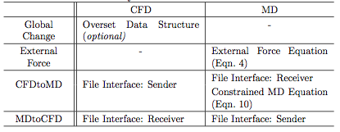

The CFD code employs the data structure of the overset mesh technique [30] to ease the handling of the coupling parameters. In other words, the entire fluid domain is generated because the CFD mesh system and pure MD region is turned off as the “hole” cell in the terminology of the overset technique. Likewise, MD to CFD and CFD to MD boundary cells are declared “Fringe” and “Donor” cells, respectively. The labor of mesh regeneration due to the change in coupling parameters (the position and depth of the hybrid layers) disappears with the overset data structure.

Both codes are equipped with the information exchange routine, which consists of one file sender and one file receiver. These file interfaces are scheduled to turn on every sampling interval. The instantaneous properties in the donor cells of the continuum domain are transferred to the MD site and referenced when the constrained Lagrangian dynamics equation is applied. The averaged molecular properties are sent to the CFD domain, and they are used as the boundary conditions of the fringe cells. All exchanged properties are written in the MD unit: thus, the CFD code is equipped with a velocity unit conversion function and an equation of state, which changes the pressure solution from the CFD site to the equivalent density property in the MD domain.

In addition to the file interface, additional equations of motion are employed on the MD code to describe accurately the influence of macroscopic flow variation on the particle domain. First, external force should be imposed to prevent the particles from leaving the control domain; the force is applied in the normal direction of the uppermost MD layer. A cost-effective classical external force model by [7] is employed as

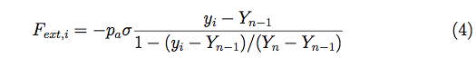

where *pa* denotes the average pressure in the MD region, *Yn* - *Yn-1* is the thickness of the uppermost layer to which the force is applied, and *Fext* is the external force acting on *ith* particle located on position *Yi* .

Next, at a specific time, the macroscopic flow properties are introduced on the CFD to MD layer to lead the motion of multiple particles in that layer. To satisfy mass conservation, a certain number of particles is inserted into or removed from this layer according to the mass flux by the CFD solution,

:5.tiff

where *A* is the horizontal area, *uy* is the vertical velocity component in the CFD solution, and *Δt* is the sampling interval.

A very complicated numerical intervention is required to maintain the momentum conservation. The average velocity of particles in *Jth* cell is equal to the velocity *uJ* in the continuum cell.

:6.tiff

where *vi* is the velocity of *ith* particle, and *NJ* is the number of particles in the cell. The Lagrangian derivative of Eq. (6) obtains

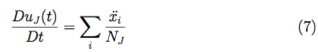

The Classical MD equation of motion can be generalized to obtain the constraint by adopting the fluctuation in the acceleration of each particle, *ζi*

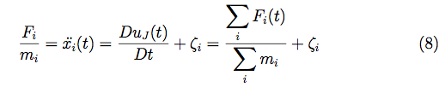

where *Fi* is the force on *ith* particle based on the interactions between particles, *mi* is mass of each atom, and Eq. (9) satisfies

:9.tiff

Finally, the constrained particle dynamics with the conventional equation of motion can be written as

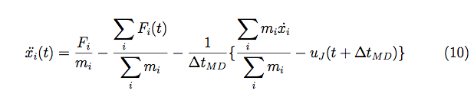

The continuum velocity and the mean microscopic velocity from MD over the control domain provide the synchronization of the mass and momentum consistent with Eq. (10).

* 1. *Statistical Error and Coupling Parameters*

Reduction of the statistical error in the averaged MD profile, which is the response of innate spatial/temporal locality in molecular dynamic systems, determines the accuracy of the CFD solution in hybrid simulation. According to the mathematical expression in the statistical error [15, 22], the ratio of the sampling noise compared with the macroscopic velocity is inversely proportional to the square root of spatial layer size and temporal sampling duration. For example, in order to maintain the same order of accuracy, reducing the macroscopic velocity by half requires either a system domain that is four times larger or a sampling that is four times longer .

With regard to the sampling duration with intervals, the size of the sampling layer and its position are coupling parameters, which define the scale and pattern of this noise. The layer size and sampling duration collectively work to reduce the noise by increasing the spatial and temporal sampling scales. The sampling interval is a factor that restricts the sampling duration. In unsteady simulations, a short sampling interval is preferred to update frequently the temporal variation in the flow field in hybrid boundary zones. This interval acts as the upper bound of the sampling duration. The location of the sampling layer is a secondary factor that can increase the strength of fluctuation locally. Conventionally, the sampling layer is placed far from the solid obstacle, at least 10σ above the bottom wall to solve the flow of the liquid argon [11], for example.

We introduce two numerical ideas to acquire an accurate hybrid solution. One is to measure quantitatively the scale of statistical noise, the domain in particular, and the other is to obtain an acceptable solution numerically. The former shows the initial guideline to determine the coupling parameter and the latter refines the accuracy of the former solution.

*2.4.1. Determining Coupling Conditions*

The statistical noise is a function of the characteristics of the fluid, surrounding solid elements, and geometric configurations, as well as the flow condition. Unfortunately, previous analyses on the strength of the statistical error [15, 22] failed to consider the stronger interaction near the fluid-solid interface and the shape of the domain. We sense that clear coupling parameters can be determined after the actual numerical simulation of that specific flow field.

Our intuition is that numerically detecting the strength of statistical noise solves the stationary flow of the same fluid domain by the MD method only. The procedure is as follows.

1. Empirical design of the sampling interval and the sampling layer's position[1]

2. Structure construction[2]

3. Simulation and collecting the temporal history of sampled velocity[3]

4. Data processing[4]

5. Determining the sampling layer size and the sampling duration[5],[6]

*2.4.2. Sampling Multiple Independent Experiments*

So far, all hybrid CFD-MD applications have been restricted to an extremely fast flow field of O(100) m/s velocity. The difficulty of solving a moderate-speed flow field by a hybrid approach is explained as follows. The hydrodynamic time scale is expressed as a function of characteristic size and kinematic viscosity, which implies that the sampling interval is fixed regardless of the change in velocity. This rigidity makes it impossible to handle the sampling duration. Increasing the system size proportional to the square of the velocity change remains the only possible way to maintain the same statistical accuracy. Unfortunately, submitting excessively large-scaled simulation on public supercomputers is unfavorable because allocation takes far too long. In the worse case, the simulation may exceed the capacity of the system. Thus, a different approach is necessary for efficiently simulating the low-speed flow field.

We propose sampling multiple independent hybrid simulations in a smaller domain instead of attempting to run a single hybrid simulation in a large domain. **The initial velocity component in the individual datasets is determined differently from a Maxwell-Boltzmann distribution.** Solutions for independent simulations are averaged to produce the final solution. The labor of manually administrating multiple job executions is resolved by using a BigJob framework, which is discussed in Section 3.

In addition to advantage for computing capability, sampling multiple experiments provides the advantage of less sensitivity to coupling conditions. Even if the coupling parameters are ill chosen, a highly noisy individual solution can be refined by a sufficient number of independent samples. This advantage also increases the value of capturing the magnitude of the statistical noise as discussed in Section 2.4.1. because the requirement of predicting the macroscopic velocity in the sampled layer becomes less important.

* 1. *Temporal Coupling Schemes*

Two conventionally used coupling strategies—synchronized and sequential—are depicted in Fig. 2. In synchronized coupling, CFD and MD codes exchange information in the overlapping region at each sampling interval (denoted by *Δt*) and independently evolve to the next exchange time step. In contrast, in sequential coupling, one domain advances to the next exchange time step and leads its counterpart to approach this point. Comparison of these two mechanisms shows that synchronized coupling has a far better parallel efficiency because both codes independently evolve to the next sampling interval, while the sequential approach is expected to produce a more time-accurate solution because the boundary condition of the following domain (the CFD domain shown in Fig. 2) is implicitly imposed. Unfortunately, both strategies contain the time-lagging phenomenon in the CFD boundary region because molecular dynamic properties averaged over the backward sampling duration (from *nΔt* - *nΔts* to *nΔt*) represent the CFD boundary condition at that instance (*nΔt*). Extrapolation from previous MD solutions is necessary to eliminate the time lag to half that of the sampling duration (*nΔts* /2) in the CFD boundary zone.

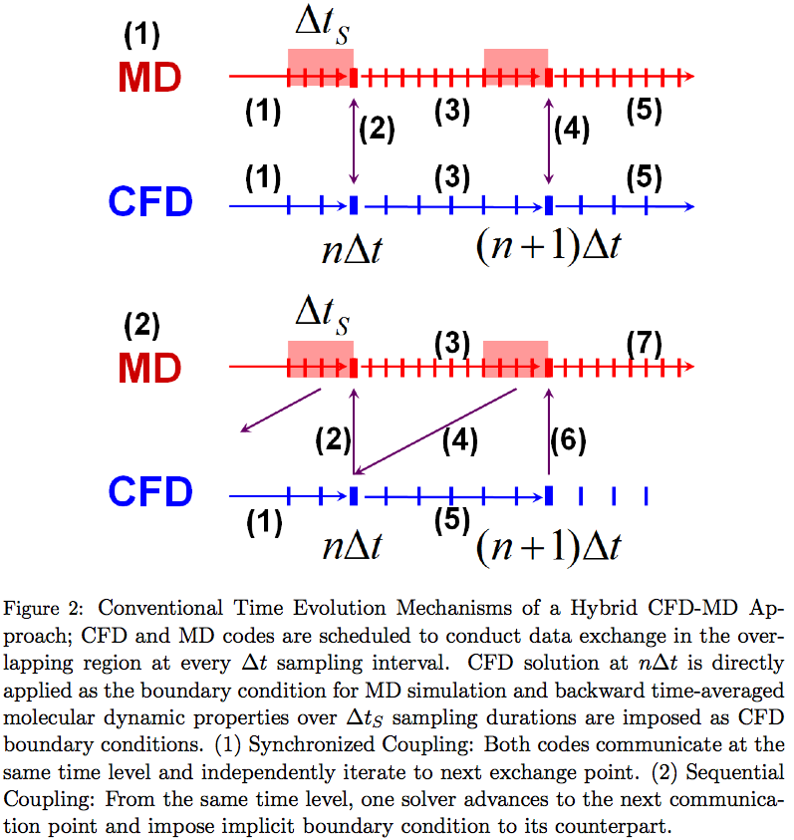

As is presented in Fig. 3-(0), Wang and He [10] proposed shifting the time axis of one domain by half of the sampling interval to eliminate this lagging effect. After both codes evolve by a sampling interval, the instantaneous CFD solution at *nΔt* is communicated with the averaged MD solution from *(n-1/2)Δt* to *(n+1/2)Δt*. Two previous solutions from the counterpart are extrapolated to impose hybrid boundary conditions. The benefit of imposing extrapolated boundary conditions is that the sampling duration can be designed to be as long as the sampling interval (*nΔts* = *nΔt*). However, the accuracy of the extrapolated solution is debatable. In this scheduling, two previous CFD solutions at *(n-1)Δt* and *nΔt* are extrapolated to produce the MD boundary conditions from *(n+1/2)Δt* to *(n+3/2)Δt*. Except when the velocity gradient is linear in time, the extrapolated properties fail to predict correct values throughout the simulation interval (from *(n+1/2)Δt* to *(n+3/2)Δt*). The only way to reduce this extrapolation error is to reduce the sampling interval, which is contradictory to the condition for reducing the statistical error.

A new scheme named the “prediction-correction approach” is also depicted in Fig. 3. The main difference from the default model is that the CFD code iterates additional time steps after it evolves to the next data exchange time. For example, in Fig. 3-(1), the CFD code additionally evolves by half of sampling interval after it approaches *nΔt*. The CFD code sends these predicted properties at *(n+1/2)Δt* to the MD site and receives averaged molecular properties around *nΔt*. The CFD code loads its previous flow profile at *nΔt* and runs the actual simulation to the next communication point at *(n+1)Δt*. A clear benefit of the current approach is that both solvers extrapolate their boundary conditions from current solutions (either exact solution or predicted values) instead of using previous history. This advantage eliminates the sensitivity of the extrapolated solution to the size of the sampling interval in the previous model, which enables the increase of the sampling interval.

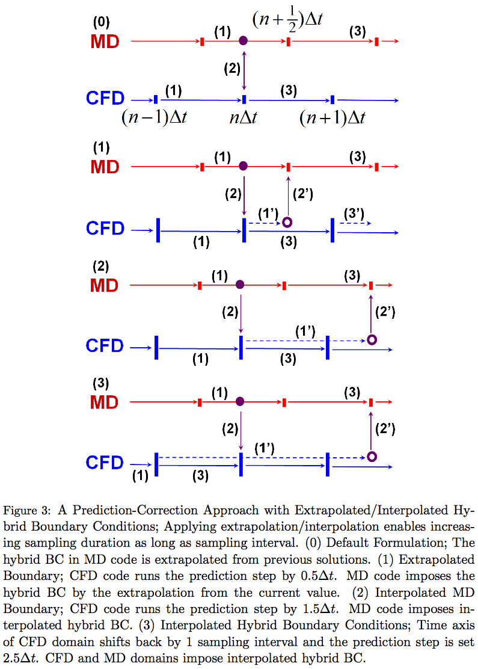

This approach is further refined to increase the accuracy of the hybrid boundary condition by increasing the prediction time scale. In Fig. 3-(2), the prediction time scale is increased by one more sampling intervals. While the MD solver evolves for one sampling interval, the CFD code iterates to the next communication point of MD time and space. This enables the interpolation of the MD boundary condition by the predicted CFD profiles. Figure 3-(3) demonstrates the imposition of interpolated boundary conditions on both domains. In this formulation, CFD time and space is shifted backward by one sampling interval and the prediction step is scheduled as *(5/2)Δt*.

The current numerical approach provides a more accurate time-variant solution by decreasing or eliminating the unfavorable overshoot/undershoot phenomena in extrapolations. Nevertheless, an additional computational cost is inevitable for CFD simulation. We propose that the current approach is used in the following conditions: (i) computational cost on CFD is quite smaller than that of MD, and (ii) the driving force that causes the flow variation is provided from the CFD domain. Without condition (i), the additional computational overhead for the prediction process will harm the performance of the simulation. If (ii) is not satisfied, the pattern of flow evolution cannot be predicted and the accuracy of the predicted solution is not guaranteed.

1. **Coupled Concurrent Multi-Scale (Continuum-Molecular) Simulation Framework**

Two important issues regarding the performance of hybrid simulations are co-scheduling and load balancing. Both can be resolved by adopting the Pilot-job concept. We explain the design of a multi-physics simulation framework that operates in the form of a single Pilot-job and contains a load-balancing function between distinct tasks.

*3.1. SAGA and SAGA-based Frameworks - An Efficient Runtime Environment for Coupled Multi-component Computations*

The simple API for grid applications (SAGA) is an API standardization effort within the open grid forum (OGF) [31], an international standards development body concerned primarily with standards for distributed computing. SAGA provides a simple, POSIX-style API to the most common grid functions at a sufficiently high-level of abstraction in order to be independent of diverse and dynamic grid environments. The SAGA specification defines interfaces for the most common grid-programming functions grouped as a set of functional packages (Fig. 4). Some key packages are the following:

- File package—provides methods for accessing local and remote file systems, browsing directories, moving, copying, and deleting files, setting access permissions, as well as zero-copy reading and writing.

- Job package—provides methods for describing, submitting, monitoring, and controlling local and remote jobs. Many parts of this package were derived from the largely adopted DRMAA.

- Stream package—provides methods for authenticated local and remote socket connections with hooks to support authorization and encryption schemes.

* Other packages—such as the RPC (remote procedure call) and replica package.

BigJob [32] is a SAGA-based Pilot-Job application, by which a number of sub-tasks can run in a pre-defined schedule with the specified number of processors whether or not they are coupled. We devised this solution to overcome the concurrent scheduling requirement of coupled CFD and MD jobs and to allocate resources for the load balancing of these codes. The advantage of the BigJob application over other Pilot-Job implementations is that it is infrastructure-neutral, thanks to various adaptors in SAGA.

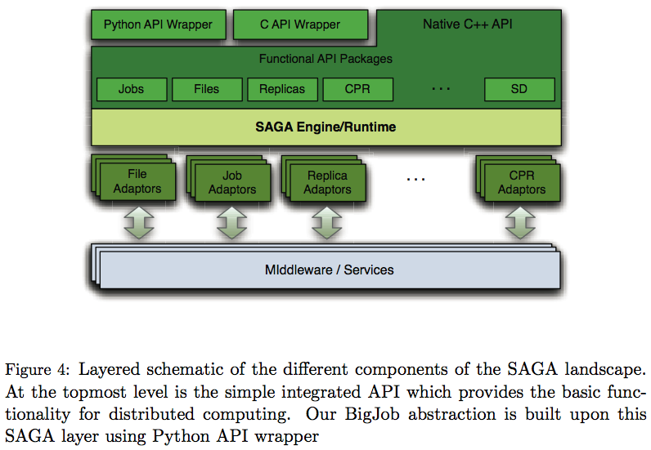

Fig. 5 shows the structure of BigJob and its operation flow. When a BigJob item is submitted to the remote resource, the application manager monitors the status of this Pilot-Job through the advert service. When resources are allocated to BigJob, the application manager allots the obtained resources to its sub-jobs, and a coupled simulation starts under the control of a multi-physics agent in the remote resource. The advert service is constantly notified about the status of a Pilot-Job from the queuing system and the status of sub-jobs from the multi-physics agent. It also delivers this information to the application manager by a push-pull mechanism. The application manager watches the status of the sub-jobs and, when the coupled simulation is finished, decides on the next event. If an individual simulation is of interest, the manager closes the BigJob allocation when the simulation is finished. In cases of multiple replica simulations or load-balanced coupled simulation, the manager re-launches the sub-jobs on the same BigJob allocation until all replicas or simulation loops are completed.

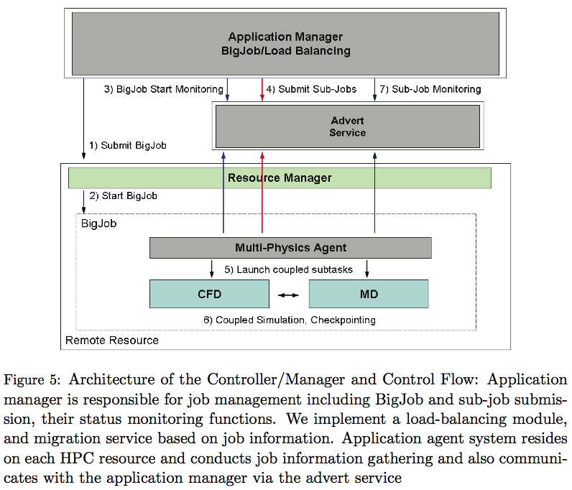

*3.2. Load-Balancing of Coupled Multi-Physics Simulation*

The load-balancing of a coupled simulation implies sufficient flexibility to re-distribute resources to the individual task according to the performance of an individual job. We will discuss the implementation and algorithm of a simple load balancer (LB) [33]; it is important to mention that the LB functions in the context of the SAGA-BigJob framework.

The idea is to assign more resources to heavier sub-jobs under the fixed resource allocation until all sub-jobs elapse at the same execution time. As it is impossible to predict the performance of each code in advance, we let the LB monitor the wall-clock time between the information exchange points of the coupled tasks and iteratively change the processor distribution until load balancing is achieved. As the individual solver is considered a black box, each application code is assumed to have the ideal parallel efficiency. In case the application codes are highly scalable, the LB can find the best condition after a few dynamic re-distributions. In addition, all processors in one node are assigned to one single task to prevent the interference (and performance degradation) observed when multiple MPI tasks share the node.

Let the computation time (between exchanges) of the two sub-jobs be *tCFD* and *tMD* , and the number of processors assigned to each domain be *PECFD* and *PEMD* , respectively. Subscripts C and N denote current and next states. Assuming ideal parallel efficiency, the total load of each application remains the same after resource re-allocation,

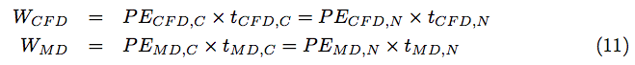

In spite of the re-allocation, the total number of processors utilized remains the same:

:12.tiff

Our objective is to reduce the computation time of a sub-job to the point where the two application components show the same computation between the exchange points, i.e., *tCFD, N* = *tMD, N* . Derived from Eq. 11 and Eq. 12, the optimal number of processors distributed for the CFD subtask would be:

:13.tiff

The MD simulation (sub-job) will follow a similar expression.

The above non-integer values proceed in discrete values expressed as the multiples of the number of CPU cores in a node. We chose the nearest discrete number to our load balancing as the optimal number of processors in each application.

* 1. *Implementation of an Execution Framework and Application-level Corrections*

A hybrid CFD-MD framework is evaluated by implementing the application manager shown in Fig. 5, which is written in PYTHON script language. By default, an application manager calls a number of SAGA functions in sequence, to allocate a vacant job, to run individual MPI simulations, to monitor its status, and to finalize the BigJob allocation.

In the case that the load-balancing capability is turned on, the situation becomes complicated. A single MPI job is not able to change its number of processors during the simulation, which implies that coupled codes should stop-and-restart to be assigned with the changed number of processors. Thus, sub-jobs are scheduled to have multiple restarts from the previous check-pointing solution, which we denote “simulation loop.” An LB is provided as a separate function in an application manager and is scheduled to run in between each restart of the sub-jobs.

The efficient functioning of the LB is predicated on application codes being able to restart effectively from their check-pointing data. Application codes should also be equipped with a generalized domain partitioning routine to run a simulation with any number of processors without harming their parallel efficiency. Another change implemented in the application codes is the time checking routine. The runtime of each application is meaningless in running a LB since this runtime contains idle waiting on the inter-domain information exchange as well as the individual simulation time. The actual runtime can be counted by putting a wall-time function before and after the information exchange routine.

The generation of an application manager and the changes in application codes raise the possible simulation scenarios shown in Fig. 6. The first (extreme left) scenario shows the time evolution of a coupled simulation under a conventional job submission (which we defined as scenario S0), and others using a BigJob application (denoted as S1). For S0, individual tasks with resource requirements of *PECFD* and *PEMD* , respectively, are independently submitted to the conventional queuing system, and the job scheduler recognizes these coupled tasks as two distinct jobs. Thus, on average, they start at different times. In this case, both tasks wait in the queue when no job is allocated (waiting stage). The first allocated job idles to perform data exchange with its counterpart (idling stage), and the actual simulation starts when both jobs are allocated (running stage). On the other hand, for scenario S1, a BigJob of size *PECFD* + *PEMD* is submitted to the queue, and coupled simulation directly starts when the resource is assigned to this BigJob. Because of the co-scheduling of sub-jobs, a BigJob is free from a long inactive mode, which is frequent in conventional job submission, while the total runtime is the same if the resource distribution to the sub-jobs is identical. However, eliminating the inactive mode in itself does not guarantee a reduction in the total runtime because a larger single allocation may result in a greater queue waiting time than that when two simulations request a smaller number of processors each (but with the same total). The same situation can arise for the load-balanced case with one BigJob (S1\lb). From the comparison between S1 and S0, we can estimate the performance gain by the concurrent start of distinct coupled codes. Compared with other scenarios, the S1\lb solution demonstrates the benefit of a load-balancing function on coupled simulations.

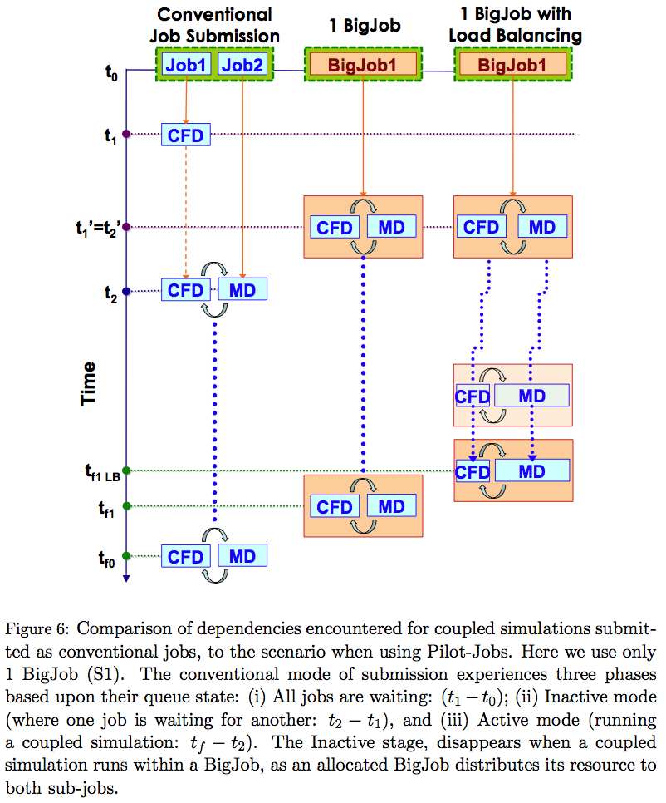

1. **Multi-physics Flow Simulations in Various Flow Conditions**

A hybrid CFD-MD framework is employed to solve the multi-physics flow in nano-scale. The experiment problems are the sudden-start Couette flow and the oscillating boundary issue. We start by determining the coupling parameters of the validation and verification of the hybrid simulation framework, and then proceed to the exploration of the moderate-speed flow simulation and the time-accurate hybrid simulation.

*4.1. Problem Description and Coupling Conditions*

All applications we examine are internal flow fields filled with liquid argon. The characteristic length of liquid argon is σ=3.405x10-10 and the time scale is τ=2.2x10-12. The Density is 0.81mσ-3, which means 0.81 atoms are included in the characteristic volume. The fluid domain is a channel system that consists of two parallel plates placed in a vertical direction. The domain is filled with liquid argon particles and both walls have artificial properties that are the same as those of liquid argon. The slip ratio between fluid and solid particles is set at 0.6 to satisfy the linear velocity gradient along a vertical direction [7]. The channel is 52 σ in height, which is O(10-8) meters. Applications covered in this work are periodic systems in a perpendicular direction, and the flow variation is derived by the horizontal motion of the upper plate.

As we proposed in Sec. 2.4.1., we solve a stationary flow in the particle domain to determine coupling conditions. Table 2 shows the average velocity depending on the layer size and sampling duration in the 10-8 meter domain. Experiments were conducted with different lengths of the domain from 35 σ to 70 and 140 σ. Noises at 0.2 non-dimensional height above the bottom wall are presented.

The results of the individual test show that mathematical expressions on the strength of noise according to the height of the sampled layer and sampling duration [15, 22] do not coincide with our experiment. The first table shows that increasing the height of the averaged layer from 0.1 to 6.4 σ reduces the statistical error by 4 times when the sampling duration is 1 τ. This ratio worsens as the sampling duration increases. The same situation occurs in the sampling duration, which is contradictory to the previous mathematical expressions that were introduced in Sec. 2.4. From the data analysis, we determined that the magnitude of the sampling noise, depending on the layer size and sampling duration, is far more complicated: *VN = a x SDb x LHc x SDd x ln(LH),* where *VN* represents the velocity magnitude of the noise whose unit is 1/1000th of the non-dimensional velocity, SD denotes sampling duration, and LH is the height of the layer.

This equation is rewritten in simpler logarithmic formulation as

:eq36-1.tiff

and these coefficients in our specific case are

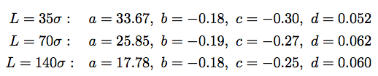

Another result we observed from the above mathematical expression is that increasing the system size in the periodic direction is more effective in reducing the noise. Setting SD and LH to 1 τ and 1 σ , we found that the magnitude of the noise reduces from 33.67 to 17.78 if the system size is quadrupled. This result supports previous mathematical expressions on statistical error.

The following conclusions are deduced from the sampling noise analysis of the stationary flow. First, previous analyses on statistical error cannot be applied in wall-bounded nanoscale systems. As our empirical equation presents, the layer height and sampling duration are coupled, and noise reduction by these factors is less effective than previously reported, which indicates that the actual measurement of the sampling noise is necessary to determine coupling parameters in the specific system. Second, increasing the size of sampling layer in the periodic direction is more effective in reducing the sampling noise. This leads us to the unfavorable conclusion that additional computational cost should be sacrificed to obtain an acceptable sampled solution.

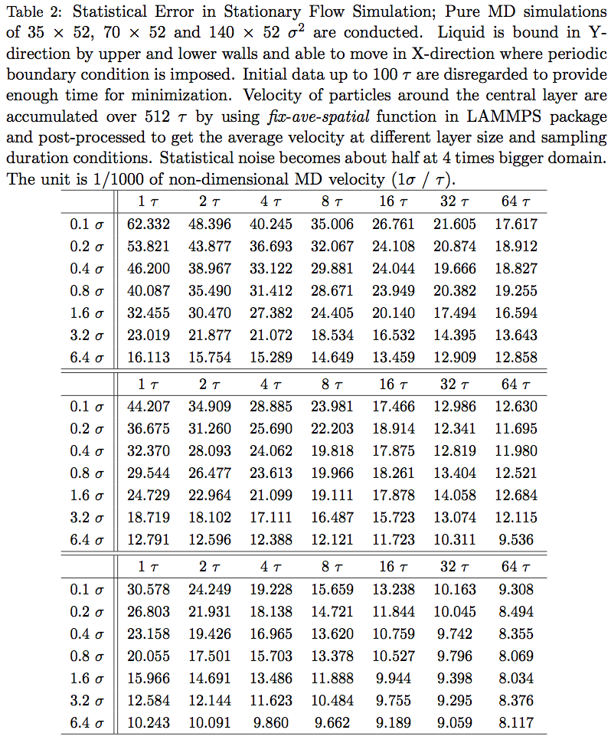

Finally, as depicted in Fig. 7, CFD and MD computational domains are generated based on the above experiment,. The pure MD region is specified as 10σ, which was reported to be sufficient to prevent strong fluctuation between fluid particles and wall materials from direct transportation to CFD domains [11], and implies that the steady-state velocity in the hybrid domain will be around 0.2 σ/τ. We designed the strength of the statistical error to not exceed 5 percent (≅ 0.01 σ/τ) of steady-state velocity. We then set the width of the MD domain in the principal flow direction at 140 σ—the cell size of CFD mesh to be 2σ in Y-direction, and the sampling duration to be 10 τ. Two layer boundary zones from the particle to the continuum domain are placed ahead of the pure MD region, from 10 to 14σ. Two layers of the continuum domain to the particle boundary are positioned from 18 to 22σ and the external force region is placed at the top of hybrid region, from 24 to 26σ.

*4.2. A Sudden-start Couette Flow*

A sudden-start Couette flow is simulated to verify the accuracy of the current framework with a multiple replica sampling approach for the moderate-speed flow simulation. This application has been widely used for the validation of a hybrid CFD-MD solver. [7, 11] The flow is initially set at stationary and the upper wall starts moving in a constant velocity (1 σ/τ). The physical boundary condition of the continuum domain governs the evolution of the whole flow field. Figure 8 presents a sudden-start Couette flow profile by CFD, MD, and hybrid simulations. Although a slight fluctuation in the solution is observed, pure CFD produces an identical result because an analytic solution and an MD simulation also describe the same flow physics. This result verifies the accuracy of the individual solver. The hybrid solution also shows a slight deviation from the analytic solution, which is the fluctuation of the sampled MD solution. Nevertheless, the hybrid simulation succeeds in demonstrating the same flow physics as the analytic solution. This variation can be diminished further if the solution is visualized over a longer temporal range, which has been observed in many previous studies. This capability proves that the current hybrid framework accurately analyzes the steady flow profile in nano-scaled systems.

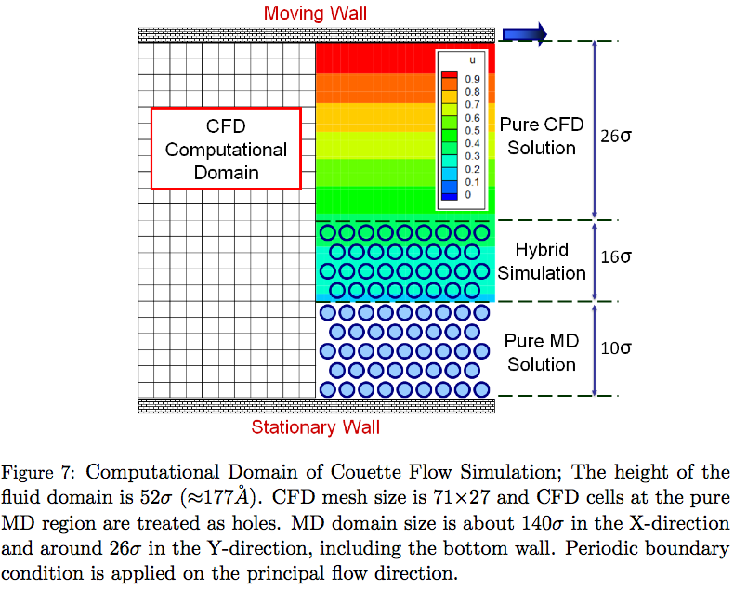

However, the flow condition in the above experiment is rather unrealistic, which motivates us to apply the hybrid scheme to the analysis of the moderate velocity flow. As discussed in Sec. 2.4.2., the hybrid simulation of the low-speed flow field is mathematically possible but technically bound by the computing capacity, since the computational domain becomes u2 times bigger in solving for a 1/u velocity field. Instead, we ran u2 independent simulations with the initial system size and different random number seeds in the LAMMPS package.

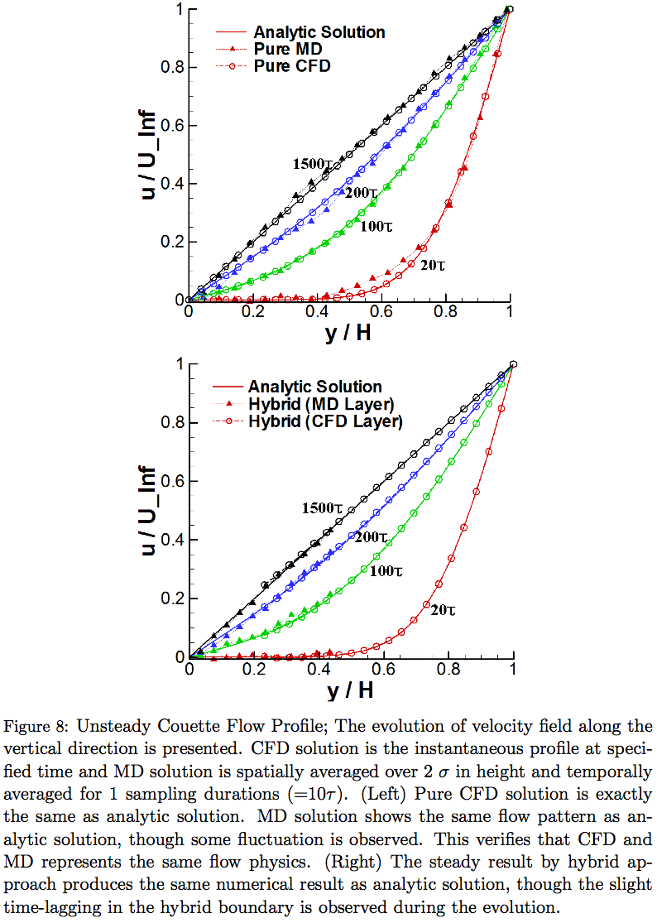

Fig. 9 presents the Couette flow profiles with different numbers of samples. All configurations and parameters are identical to the above validation problem except the upper plate velocity of 0.25 σ/τ. Changing the velocity to 1/4 implies that an average of 16 samples is required to achieve an acceptable numerical solution. The result supports the above supposition. The solution becomes very accurate when 16 individual runs are sampled. The reduction of statistical noise by multiple replica samplings is clearly verified in the graph presented in Fig. 10. The noise is seen to reduce by roughly half with 4 times more samples. The solution of sampling 16 runs shows about 5% of the noise compared with the analytic solution profile.

We compared the solution by multiple replica sampling with the solution in the increased system domain. Figure 11 shows the Couette flow profile with a 16 times larger system size in a horizontal direction and the comparison of velocity variation in the middle of the overlapping region. From the result, both ways (multiple replica sampling and increasing system size) produce acceptable numerical solutions compared with the analytic solution. Interestingly, the scale of the noise compared with the analytic solution is very similar in both ways, which verifies that the multiple replica sampling approach can replace increasing the system size to reduce the statistical error.

Collectively, the results of multiple samples show the same order of accuracy compared with the increase in the system size. Particularly in cases where the physical system is large, multiple replica sampling is more effective than directly increasing the system size, because excessively large-scaled jobs (in view of wall-time limit or number of resources requested) are very hard allocate. In addition, the labor of manually submitting multiple independent runs and managing data sets can be relieved by adopting a BigJob framework.

*4.3. A Physically Unsteady Flow Field: Oscillating Boundary Problem*

The accuracy of the designed temporal coupling scheme is verified by solving the unsteady oscillating boundary problem. In Couette flow simulation, which converges to a steady-state flow profile, the minor inaccuracy during the flow evolution can be eventually recovered. On the other hand, the inaccurate solution at one instance harms the flow field afterwards in this physically unsteady problem. Therefore, the accuracy of the temporal coupling scheme becomes more important. Furthermore, velocity in the hybrid region becomes far slower than in the Couette flow profile, so that the influence of noise from MD side is more critical in the current flow simulation. The computational domain and coupling conditions are the same as in the above Couette flow simulation. In this case, the upper wall boundary condition changes from the fixed velocity to the oscillatory wall, which is uwall(t) = (σ/τ) x sin(2πt/T). Period T is set to be 200τ.

Figure 12 shows the oscillatory velocity profile by pure CFD and hybrid simulations. The left figure shows that the velocity profiles at each time instance are roughly the same between the pure CFD and hybrid simulations in magnitude. This indicates that the hybrid simulation approach is also applicable to time-varying flow simulations. Meanwhile, the temporal variation of the horizontal velocity in the middle of the hybrid region expresses that the noise in the hybrid solution is not negligible considering the ratio between continuum and hybrid velocities. We claim that this noisy solution is caused by the combination of the sampling error and an inaccurate temporal coupling scheme. In order to determine accurately the effect of the temporal coupling scheme, we sampled multiple independent experiments and compared solutions with different temporal coupling schemes.

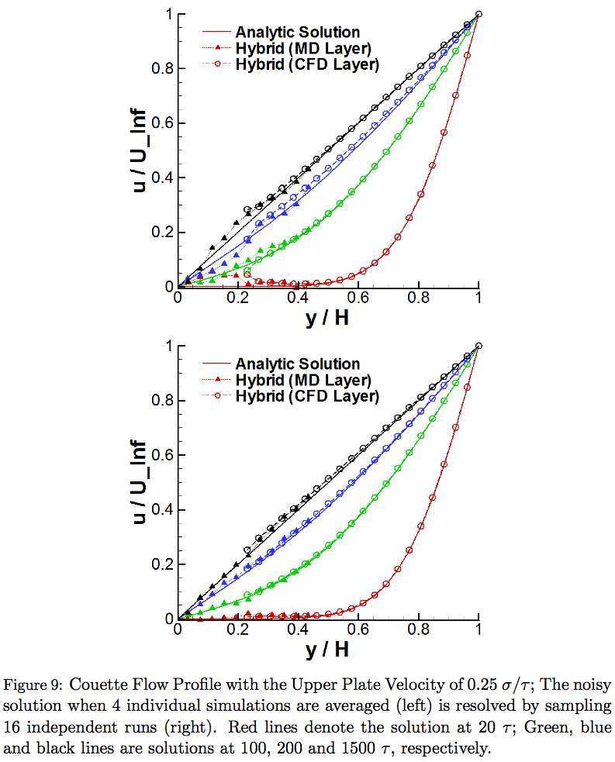

Comparison of the temporal evolutions in the velocity field by the different coupling schemes shown in Fig. 13, indicate a clear difference in the resolution of the overshoot/undershoot phenomena by the prediction-correction approach. Sufficient numbers of independent experiments were sampled to reduce the statistical error. A prediction time scale of 2.5 sampling intervals was chosen in the prediction-correction approach to impose the interpolated boundary conditions on both domains. In the conventional model, the maximal error is seen at peak points, which is a natural characteristic of the linear extrapolation in that it fails to predict correct values around a strong variation. This inaccuracy is resolved by using a prediction-correction approach and applying interpolated boundary conditions from the predicted flow properties. However, another numerical inaccuracy in the time-lagging pattern of the conventional model is also seen in the prediction-correction model and thus necessitates the implementation of higher-order interpolation schemes.

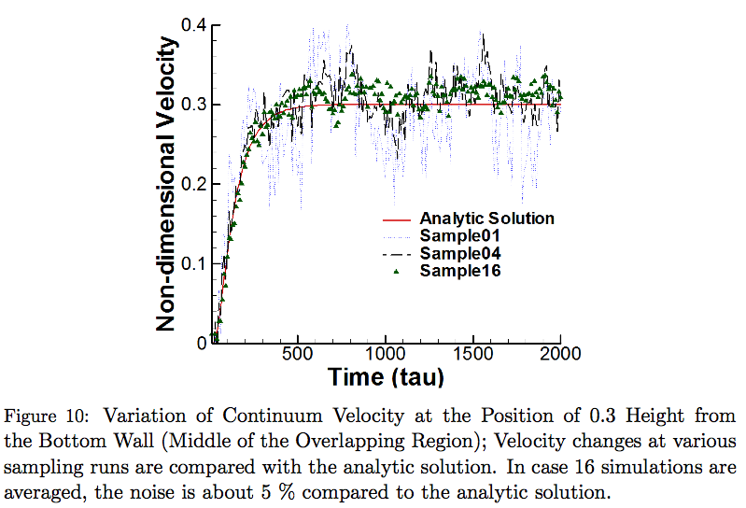

The plots shown in Fig. 14 quantify the scale of inaccuracy according to the imposition of the hybrid boundary condition. In the conventional model, the velocity difference ranges from -0.017 to 0.015 σ/τ. The magnitude of this error reduces as we apply the prediction-correction approach and increase the prediction time scale from 0.5 (corrected extrapolation) to 1.5 (MD interpolation) and 2.5 (both interpolation) sampling intervals. The clear difference between the conventional extrapolation model and corrected extrapolation in the prediction-correction approach demonstrates that the extrapolation from the two “previous” properties contains many more errors than extrapolation from the current value. The similar variations in extrapolation and MD interpolation in the prediction-correction approach indicate that the accuracy of the boundary condition in the CFD domain is as important as the boundary condition in the MD domain. Lastly, the solution error in the conventional model is reduced by half with the imposition of interpolated boundary conditions on both domains.

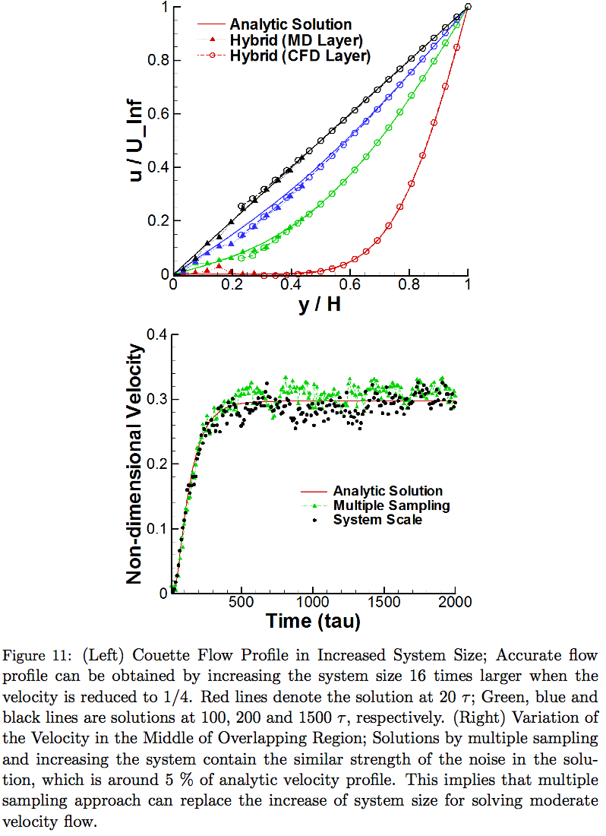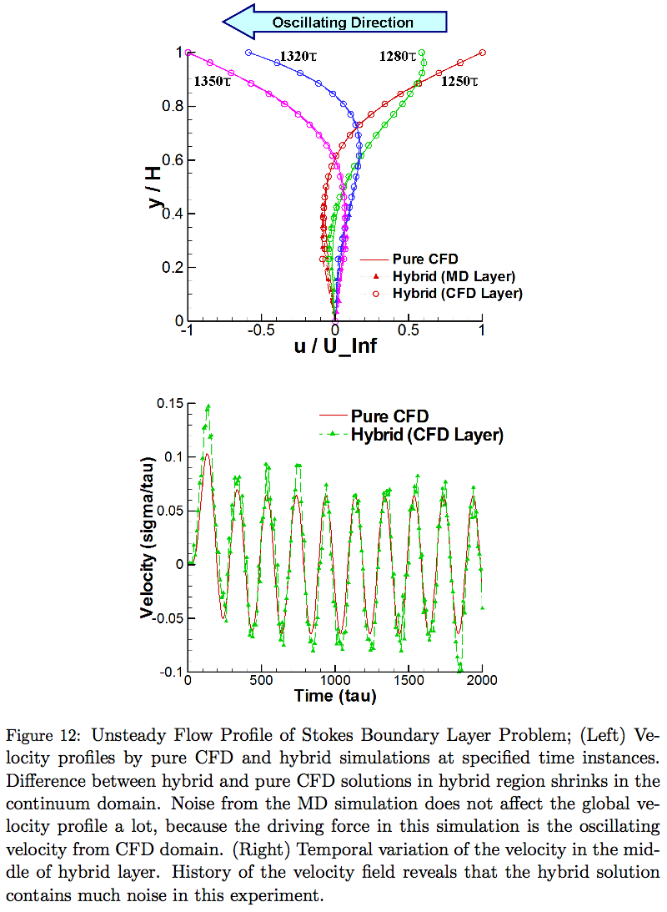

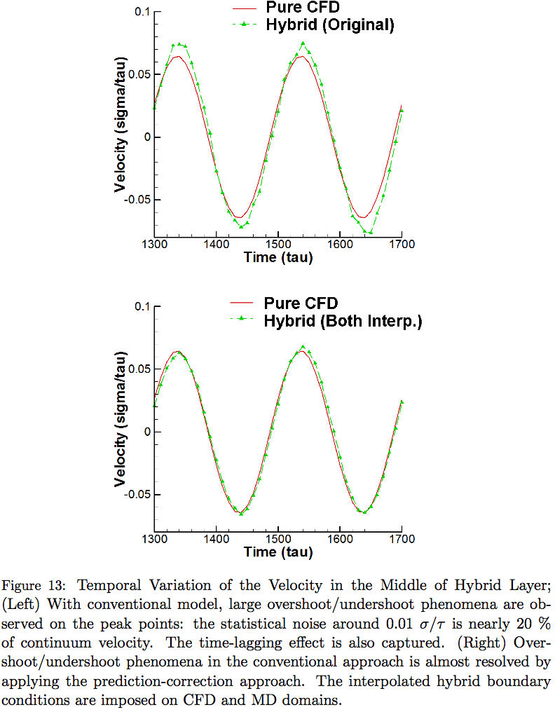

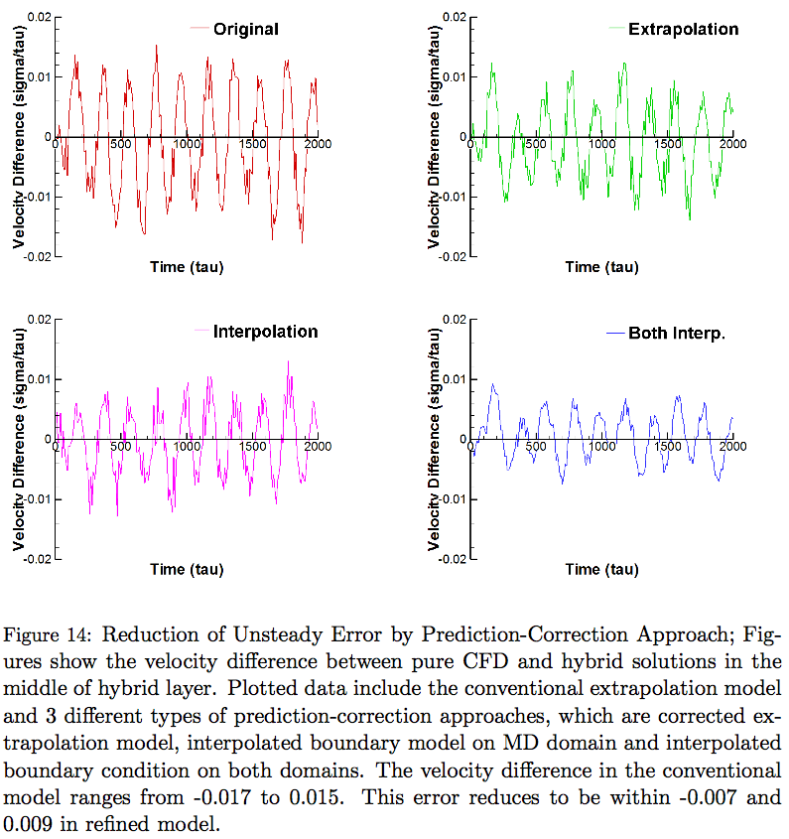

1. **Performance Analysis of a Multi-physics Simulation Framework**

The BigJob framework is expected to have a shorter total runtime in a coupled multi-task simulation than conventional (and direct) job submissions. **The logical bases are as follows:**

(1) Many supercomputing centers adopt a queuing policy of assigning higher priority to bigger jobs, which increases the probability that bigger tasks are allocated faster than smaller ones.

(2) Independently submitted multiple tasks are usually allocated at different physical times. Therefore, the requested wall-time limit should be sufficiently large to cover both maximal waiting time and computation time in case of coupled simulations. On the other hand, co-scheduling of coupled tasks is inherently guaranteed in a packaged job. Therefore, the wall-time limit can be determined according to the actual computation time.

(3) Load-balancing among multiple tasks can be achieved dynamically by changing the resource allocation to an individual task during the simulation. This change is be possible only when coupled distributed tasks are scheduled in the umbrella of a packaged job.

In this section, we present our numerical experiments to verify the above reasons.

*5.1. Waiting Time according to the Size and Wall-time Limit of an Individual Job*

Although many factors affect the waiting times, arguably the most important are existing job requests by the resource at the instant of submission, requested wall-time limits, and the number of processors requested. Two other factors are the backfilling capability (which allows the running of a small job between higher priority jobs with larger and longer resource requests) and the changes in the priority of the test job when a particular higher priority job joins the queue. Among these factors, the number of requested resources and wall-time limits can be handled by users and systematically accounted for.

We designed experiments to determine if running larger and/or longer simulations affects the actual waiting time in the queue. We submitted jobs of different sizes and different wall-time limits at the same time. Each time we submitted a job, we gathered the actual waiting time in the queue. We performed our experiments on a sufficiently large and crowded system of around 65000 cores. We argue that the use of this large and crowded system increases the credibility of our experiments: it reduces the possibility of self-interference between our job submissions (i.e., our requests are allocated in a succeeding pattern). Considering the internal queuing policy of supercomputing centers, such as credential, fair share, resource and service priority, each user account has a restricted number of concurrent job submission, and the allocation history affects the priority of the next submitted job. Thus, we submitted different wall-time limit jobs from different user accounts in the same group allocation, and we allowed enough idling time between individual experiments to recover the priority of each account to the initial level. Results from 10 independent experiments were averaged for measurement.

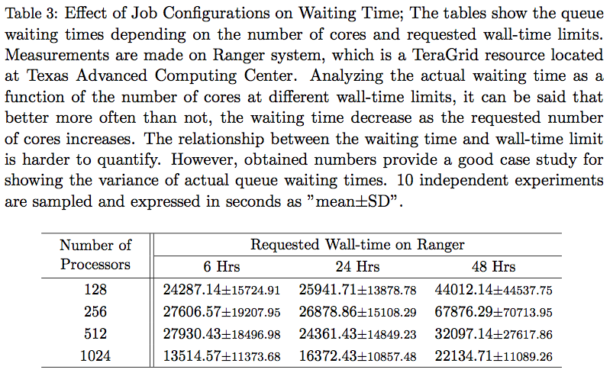

Table 3 demonstrates the queue waiting time according to the size and wall-time limit of the job. Regarding the influence of job sizes on waiting time, jobs with larger processor counts have typically lower wait times, with the exception at 128 cores, which is presumably affected by the backfilling capability. Waiting time with 1000+ cores shows a stiff decrease, particularly because it is granted higher priority in this queuing policy. The same applies to the increase in waiting time to the wall-time limit of 48, which is administrated by a different queue. The effect of the wall-time limit on waiting time is not clear in our experiment, in the case where they are in the same queue (6- and 24-hour jobs). Collectively, submitting a BigJob for the coupled simulation instead of individually submitting multiple smaller tasks at least provides comparable waiting times in the queue even when small jobs are “ideally” allocated (i.e., all jobs are allocated at the same time).

*5.2. Waiting Time for a Coupled Simulation*

Regarding the scenario maps in Fig. 5, the result in Sec. 5.1 provides the waiting time between a BigJob and a first-allocated conventional task. We expect more performance gain by eliminating the inactive idling time (i.e., the difference between the waiting times of the two jobs) with the BigJob application.

Table 4 presents the waiting time of a BigJob sized 2X and two conventional job submissions sized X each. We experimented with two different wall-time limits (6 and 24 hours) and two different processor requests (256 and 512 cores in total). A BigJob submission shows faster allocation, except a small number of processors are requested for a long time, although the waiting time for the first-to-start job was smaller in the conventional job submission mode (S0) than in the BigJob (S1) application. Interestingly, the inactive mode in conventional job submissions was observed to increase substantially as the wall-time limit increased: users get to waste more allocation time as they increase the wall-time limit. From the result, bigger and longer jobs tend to start faster (comparing individual experiments), but it is difficult to affirm this tendency as a general phenomenon because individual experiments were performed at different times.

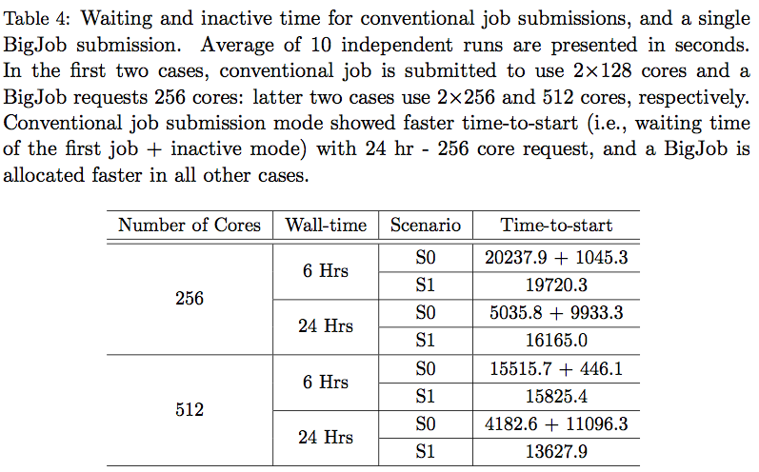

*5.3. Performance Gain through Load Balancing*

A BigJob framework in itself does not provide any performance gain during the simulation: a load balancer (LB) in a BigJob framework provides better parallel performance by redistributing processors to individual tasks within the context of the packaged job. LB measures the performance of individual tasks during a temporary stop and evolves application codes with a changed number of processors. Thus, each code is scheduled to stop and restart several times for the complete simulation, necessitating the capability of a application-level check-pointing and generic domain partitioning routine in application codes (both of which are incorporated capacities in most legacy codes).

The benefit of a LB in a BigJob framework is that it can be applied to any type of coupled applications. On the other hand, it is not highly recommended for the current application for two reasons: 1) in a hybrid CFD-MD simulation, MD usually requires far more computing power than most resources that are dedicated to molecular dynamic simulation; 2) computational cost for the current application in Sec. 4.1 is so small that it is not necessary to apply the load-balancing capability. These reasons led us to increase the computational cost of each simulation for evaluating the LB in a BigJob framework. In this experiment, the CFD domain size is increased by 500 times and the MD domain is increased by 20 times. Both CFD and MD codes are scheduled to have 10 simulation loops: start with the same number of processors and experience nine stop-and-restarts with changed resource allocation according to the result of the LB.

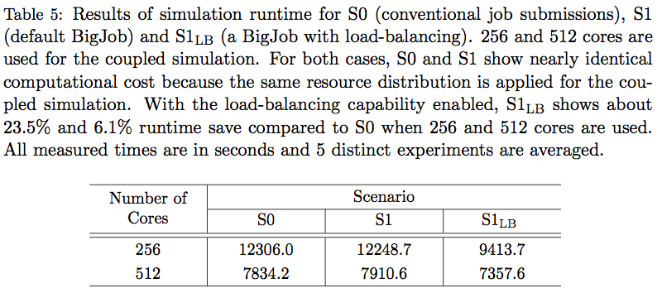

The runtimes of the coupled simulation with a single BigJob are shown in Table 5. In all scenarios, the same numbers of processors were initially assigned to CFD and MD simulations. Processors distribution in S1LB changed during the simulation according to the result of the LB function. For both simulations, the time difference between S0 and S1 is within 1%, which explains why the possible overhead of a BigJob due to communication with the advert server (for monitoring the status of sub-jobs) is negligible. In cases of load-balanced BigJob simulations, there is a significant reduction in the runtime (23.1%) compared with the default BigJob application when 256 processors are used. For a larger problem set, the performance gain through the application of a LB is relatively small (7.0%), the reason for which is discussed below.

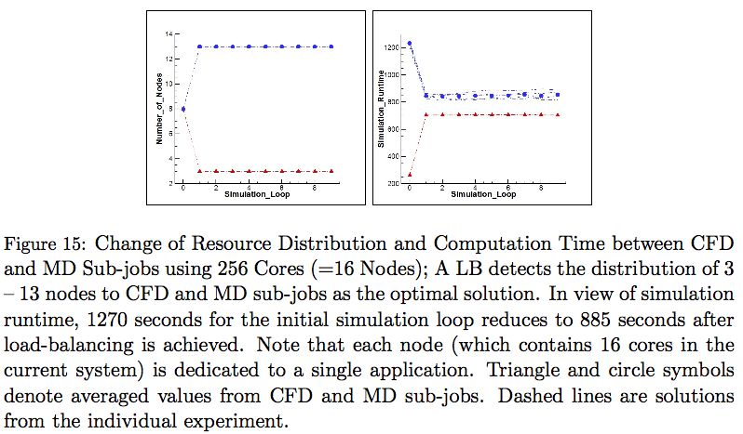

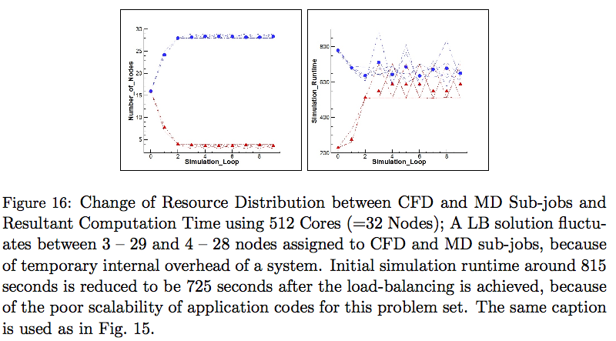

The validity of a LB can be discussed in terms of the change of processor distribution between sub-jobs throughout the simulation. For the result of the 256 cores (=16 nodes) simulation in Fig. 15, both CFD and MD subtasks were assigned with 8 nodes initially. From the next simulation loops, the processor distribution converged to 3 to 13 nodes between CFD and MD, respectively. This ratio was maintained throughout the simulation. CFD and MD computation times changed from 260 to 1235 seconds at the initial loop to 705 to 850 seconds after load balancing. Simulation runtimes were measured to be about 35 seconds longer than the slower simulation (MD simulation) per each simulation loop, which is the overhead by the initialization , I/O (input/output) and communication between coupled applications.

The result for the case of computation time evolution in 512 cores (=32 nodes) is presented in Fig. 16. Compared with the above experiment, which uses smaller cores, the load-balancing solution showed a noisier pattern. In detail, an LB failed to find the optimal solution at the first simulation loop, and the node allocation after load balancing fluctuated between 3–29 and 4–28 nodes in each application, which was caused by two reasons. First, the individual code has poor scalability. The initial simulation time for CFD and MD applications measured around 230 and 780 seconds, and the LB proposed a node distribution from 16–16 to 8–24. However, the computation time at the next simulation loop was measured to be 275 and 680 seconds, respectively. Therefore, the LB has to search for the optimal solution one more time. **Load balancing functions that are incorporated in schedulers cannot avoid this iterative searching, since they have to manage black-box applications without getting any information to estimate the problem size.** Another reason for the fluctuation is the momentary overhead in the computing system. In our experiment, when 28 nodes are used, MD simulation times vary from 610 seconds to 880 seconds, depending on the magnitude of the internal overhead. This variation indicates the necessity of an LB as a self-correcting tool in response to the instability of the system.

Two things remained for open discussion: 1) how to effectively measure the actual simulation time of individual task, and 2) how to determine the number of simulation loops. We put time checking routines between the inter-domain communication routine and accumulated the time for running the iteration loop of each code. Based on our knowledge, there is no way to systemically gather the individual simulation times except by this manual deployment. Regarding the number of simulation loops, an excessive number of loops increases the I/O-related overhead (storing the check-pointing solution and restarting from that). An insufficient number of loops increases the simulation time at the initial imbalanced configuration and degrades the capability of the LB for adapting to the unpredicted internal overhead.

1. **Next Step: Further Refinement**

The empirical mathematical equation on sampling noise has been presented in Sec. 4.1. We argue that this is a refined model compared to previous mathematical expressions. However, the formulation has not been verified by various systems and conditions: coefficients will be changing according to the distance from the wall, characteristics of fluid and solid elements, etc. More rigorous research is required to address a globally acceptable equation of sampling noise.

Unsteady flow simulation in Sec. 4.3 verifies that the prediction-correction approach provides more accurate solution than conventional temporal coupling scheme. The new approach is especially powerful in resolving the unfavorable overshoot/undershoot phenomena. On the other hand, the slight time-lagging effect in the conventional model has not been improved by the prediction-correction approach. We expect that this phenomenon can be resolved by applying higher-order extrapolation/interpolation on hybrid boundary regions.

1. **Conclusions**

Accurate and efficient multi-scale flow simulations by a hybrid CFD-MD simulation framework have been presented in this paper. Constrained Lagrangian dynamics equations of motion and file-based hybrid interfaces are implemented on a highly-reliable LAMMPS molecular dynamics package and a verified in-house incompressible CFD code. They are virtually integrated as a single BigJob framework.

A number of numerical issues which harm the accuracy of a hybrid solution have been explored. First, quantifying the sampling noise from a stationary flow has been proposed as a way of determining coupling parameters. We argue that our simple and intuitive idea unveils the influence of individual coupling parameter on the magnitude of statistical error and is very cost-effective in contrast to traditional trial-and-error approach. Moreover, the empirical equation derived from the stationary flow simulation describes that well-know mathematical expressions on statistical error are not accurate on nano-scale wall-bounded systems. Second, sampling multiple independent replicas has been introduced to refine the sampling noise of an individual solution and to explore to the low-speed flow regimes. This approach is superior to simulating a single large-scale problem set which is technically bound by computing capacity. The application to a Couette flow simulation in O(10) m/s velocity field is the first successful report of a moderate-speed flow simulation using a hybrid CFD-MD approach. Last, a prediction-correction approach has been designed for the accurate unsteady simulation. This approach acquires better solution by enabling the imposition of interpolated hybrid boundary conditions. The application to the oscillating boundary problem expresses that the current approach diminishes the overshoot/undershoot phenomena in the conventional methods.

Along with numerical issues, computational issues for the efficient coupled simulations have been also discussed. We introduced a BigJob framework and this directly solves the co-scheduling problem among logically separated sub-tasks. A simple load-balancing function is also implemented on a BigJob framework, to achieve the load-balancing among those separated-yet-coupled codes. From numerical experiments, we evaluate that a BigJob is very powerful in reducing the waiting time of the coupled simulation. Also, a simple load-balancing function employed in a BigJob is effective in reducing the simulation runtime.

We emphasize that above numerical investigations ease the challenge to the hybrid simulation and broaden the application area. Also, our computational experiments contribute on how to efficiently conduct coupled simulations.

1. The sampling interval is designed less than *1/100th* of hydrodynamic characteristic time; the location of the sampling layer is placed *O(10)* nanometers above the solid obstacle.
2. The height of the domain can be reduced by placing a specular wall on the top, in case the system is sufficiently large; the length of the domain along the periodic direction can be arbitrarily chosen. The optimal length is further determined by the relation between the strength of noise and number of particles, i.e., *Vnoise∝ 1/√N*.
3. Data collection starts as soon as the relaxation process is finished. The temporal history of averaged velocity from the smallest layer size with shortest sampling interval is stored.
4. The dataset produced around the location of sampling layer is spatially and temporally averaged to produce the spatial and temporal variation of the sampled velocity.
5. The noise is compared with the expected macroscopic velocity at that position, considering the linear velocity gradient from the wall to the far field. A paired condition, which produces a sufficiently small portion of noise and whose temporal duration is less thanthe designed sampling interval, is chosen to be the layer size and sampling duration of this hybrid simulation.

  
6. If no condition is satisfactory, the acceptable condition can be obtained by either increasing the length of the computational domain based on *Vnoise∝ 1/√N* or changing the position of the sampling layer and repeating data processing. The condition that generates the smallest MD domain in the hybrid simulation is chosen.