|  |
| --- |
|  |
|  |



Linux Assignment

Abstract

This Report aims to explain the Linux assignment give to the students and the steps taken to solve it

Qusai Alqattan

Qusakattan.qk@gmail.com

Contents

Introduction 3

Scripts 3

Backup Script 3

Steps 3

Demo 6

Health Check Script 8

# Introduction

This report aims to explain the Linux assignment give to the current cohort in the Atypon training program and the steps I toke to solve it

# Scripts

## Backup Script

This script backups and/or compresses multiple directories given by the user.

### Steps

1. The script prompts the user to enter the path where he wants to store the generated files, and the user should press ‘enter’ if he wants to use the current path using the code in figure 1

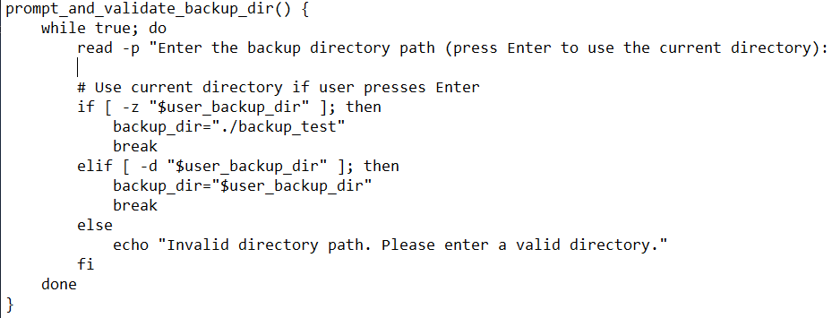

Figure 1

1. 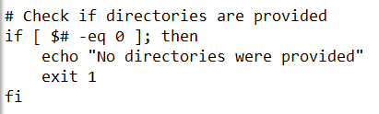Then the script checks whether or not the user has provided any paths, if not it exits with code 1 and notifies the user as we can see in figure 2

Figure 2

1. A screenshot of a computer program

   Description automatically generated It stores the current time and handles the directory where the backup file will be stored and creates the path of the log file as we can see in figure 3

Figure 3

1. Loops through the directories provided by the user and as we can see in figure 5 the loop does the following
   1. Checks if the directory is valid
   2. Gets the absolute path of the directory
   3. Gets the name of the parent directory and the base name of the wanted directory

Note: These two steps were needed because the script used to operate on the whole path and not just the wanted directory at the end of it

* 1. Ask the user what mode of operation he/she wants to do and validate the input using the function in figure 4

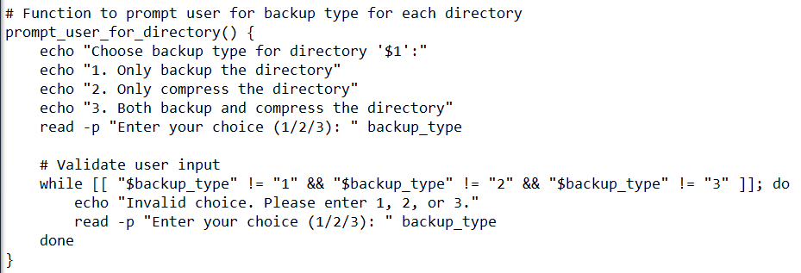

Figure 4

Note: The while loop in the function is made so the program will not terminate if the user entered an invalid input but instead he/she will be prompted again

* 1. Depending on the choice of the user the script backs up the directory and/or compresses it.
  2. 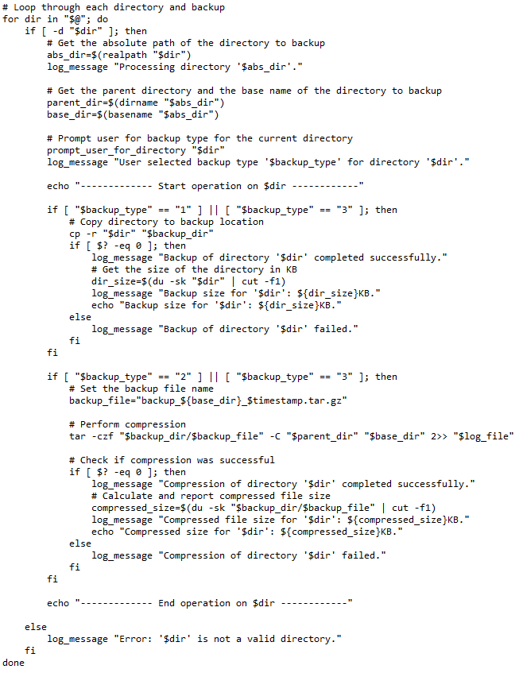If the operation was successful, the script calculates the size of the generated files otherwise it notifies the user

Figure 5

1. A close-up of a computer code

   Description automatically generatedLogs the timestamp when the operation was finished and notifies the user as we can see in figure 6

Figure 6

### Demo

In this demo we will backup a directory named ‘test’ it contains a text file, and is located in the same directory as the script, and we will do both operations on a second directory named ‘pics’ it contains many pictures, and it is in a different directory

1. We start with the files shown in figure 7

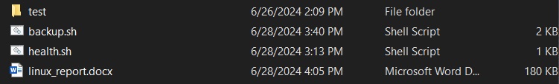

Figure 7

1. We use WSL terminal to run the script with the following command:

‘./backup.sh /mnt/c/Users/qusai/Desktop/out_study/atypon/assign/pics test’

1. The system will prompt the user to enter the path where he wants to store the generated files as seen in figure 8, we will press ‘enter’



Figure 8

1. The system will prompt us to choose the operation we want on the pics directory, as shown in figure 9, and as we can see In figure 10 the system printed the size of the backup file and the compressed file,

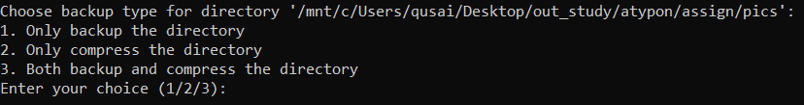

Figure 9

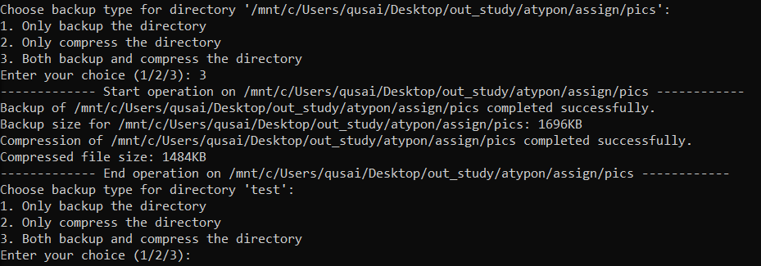

Figure 10

1. Then we enter 1 and the output can be seen in figure 11

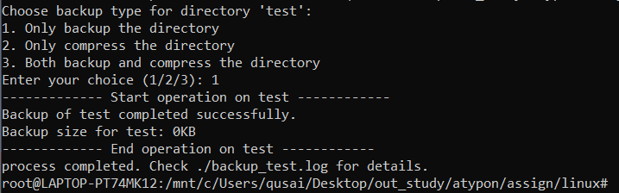

Figure 11

1. Now if we go to the directory, we will see two new directories the first is the log file named ‘backup_test.log’ and the second is the ‘backup_test’ where the output is stored
   1. Inside the ‘backup_test’ directory we can see three new directories: pics, test, and compressed pics, as shown in figure 12

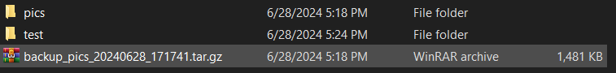

Figure 12

* 1. 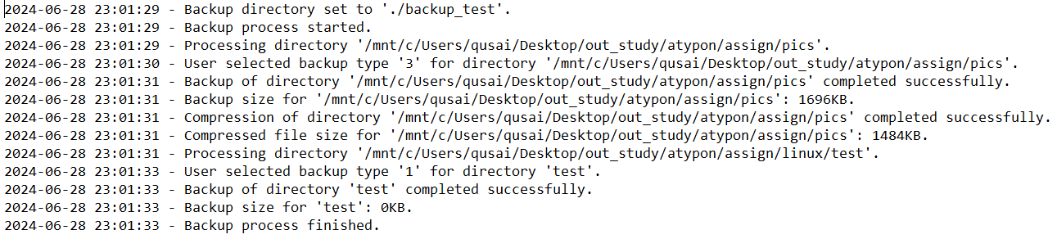Inside the log file we can see the log messages as shown in figure 13

Figure 13

## Health Check Script