

Faculty of Engineering and Technology
Electrical and Computer Engineering Department
Computer Networks Laboratory ENCS4130
Report #1
Experiment No. 4
Dynamic Routing 2 – OSPF

Prepared by: Alaa Moqade -1211910
Instructor: Amir Slimi
Teacher assistant: Tariq odeh

BIRZEIT
October – 2024

Abstract

In this experiment, we’re setting up a network in Cisco Packet Tracer with routers, switches, and PCs. Our goal is to configure IP routing with efficient subnetting and set up dynamic routing using the Open Shortest Path First (OSPF)protocol.
We’ll also explore how OSPF picks router IDs for each router, helping us understand the details of dynamic routing and network setup.

Contents

List Table in figure 2
List of Table 3
1. Theory 4
1.1. Introduction 4
1.2. Types of Dynamic Routing 4
1.3. OSPF Definition 5
1.4. OSPF Configuration 5
1.5. OSPF Advantages 5
2. Procedure and Discussion 6
2.1. Topology 6
2.2. configure the Ips for the PCs and Routers 7
2.2.1 configure Router 8
2.2.2 configure PC 10
10
2.3Configuring OSPF Routing 11
2.4 Changing the Cost 13
2.5. Summarization 14
2.6. Important Questions 15
2.5.1 Q1) 15
2.5.2 Q2) 15
2.5.3 Q3) 15
3. Results 16
4. Problem 18
4.1 Part one 19
4.1.1 topology 19
4.1.2Q1&Q2) 19
4.2 part 2 20
5.Conclusion 28
6. References 29

List Table in figure

Figure 1.1: static routing 6
Figure 2.1:dynamic routing 6
Figure 3:ospf topology 8
Figure 4:config router 0 10
Figure 5:config router 1 10
Figure 6:config router 2 11
Figure 7:config router 3 11
Figure 8:config all pc 12
Figure 9:config ospf router 0 13
Figure 10:config ospf router1 13
Figure 11:config ospf router2 14
Figure 12:config ospf router3 14
Figure 13:succesful connected 14
Figure 14:change bandwidth 15
Figure 15:router 1 id 17
Figure 16:successfully transmitted 18
Figure 17:tracert in pc0 19
Figure 18:problem topology 20
Figure 19:problem topology with ip 22
Figure 20:4.2config ospf in router 0 22
Figure 21:4.2 config ospf in r1 23
Figure 22:4.2 config ospf in r2 23
Figure 23:4.2 config ospf in r3 24
Figure 24:4.2 config loopback in r6 25
Figure 25:4.2tracert from r0 to r6 26
Figure 26:4.2 cost from r0 to r6 27
Figure 26:4.2 cost from r0 to r6 27
Figure 27:4.2 id for router 6 28
Figure 27:4.2 id for router 6 28

List of Table

Table 1:ip config for network 9
Table 2:Dijkstra’s algorithm 21
Table 3:4.2 bandwidth link 24

Theory

Introduction

Routing refers to the process of determining the optimal path for data packets to travel across a network and it can be configured in two ways: static and dynamic, Static routing is used in small networks with few routes to manage, as each route must be manually configured. In larger networks, static routing can support a dynamic routing setup, often to establish default routes or direct traffic to external networks.
Dynamic routing adapts automatically to changes in network topology, making it the preferred approach for medium to large networks. By using protocols that share route information and adjust paths, dynamic routing ensures efficient data flow across complex networks.[1]

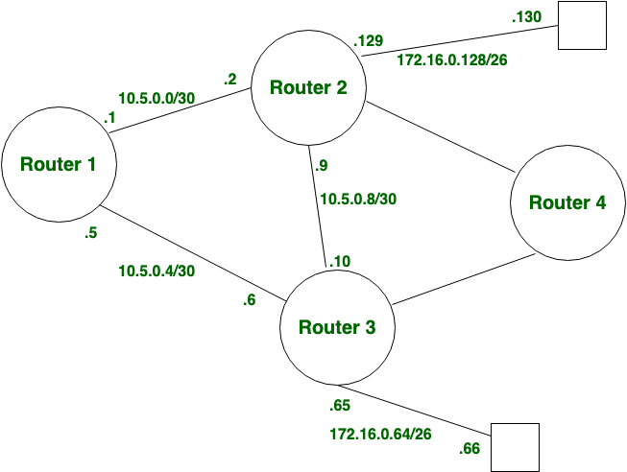
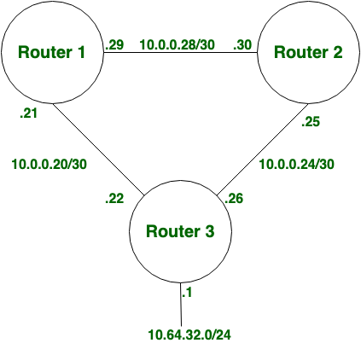
Figure 1.1: static routing

Figure 2.1:dynamic routing

Types of Dynamic Routing

Once the dynamic routing approach has been determined, engineers need to assess further considerations regarding the various dynamic routing protocols, which are classified into two primary groups: exterior gateway protocols (EGPs) and interior gateway protocols (IGPs). EGPs facilitate connections between multiple network domains and are termed "exterior" because they function beyond the individual domains associated with specific organizations or service providers. Conversely, IGPs are responsible for routing within these domains and are more widely adopted, as organizations generally manage their own network environments. The only EGP currently in use is the Border Gateway Protocol (BGP), while a range of IGPs addresses various network needs, with the most notable being Open Shortest Path First (OSPF), Enhanced Interior Gateway Routing Protocol (EIGRP), Intermediate System to Intermediate System (IS-IS), and Routing Information Protocol (RIP). These protocols can also be categorized into three distinct types: distance vector, link-state, and path vector, each exhibiting unique characteristics.[2]

OSPF Definition

OSPF, or Open Shortest Path First, is a link-state routing protocol designed for IP networks that operates on the principles of the Shortest Path First (SPF) algorithm. It is categorized as an Interior Gateway Protocol (IGP). Within an OSPF network, routers in the same area maintain a unified link-state database that outlines the area's topology. Each router generates its link-state database from link-state advertisements (LSAs) received from neighboring routers, as well as LSAs it creates itself. These LSAs are packets that contain details about neighboring routers and the associated path costs. Using the link-state database, each router then calculates a shortest-path spanning tree with itself as the root, utilizing the SPF algorithm.[3]

OSPF Configuration

This command starts the OSPF routing process with your process number. The process number is an arbitrary number. [4]
Router(config)# router ospf <process-id>
to Adding networks to the OSPF protocol
Router(config-router)# network <ID-ADDRESS> <WILDCARD-MASK> area <Area Id>

OSPF Advantages

OSPF (Open Shortest Path First) provides several advantages, including rapid convergence, multipath routing, and hierarchical network design, making it scalable for large networks. It allows for efficient traffic distribution through load balancing and maintains detailed network state knowledge. OSPF also supports route authentication, enhancing security while managing extensive networks.[3]

Procedure and Discussion

Topology

The topology after built in Cisco packet tracer, see fig 3.
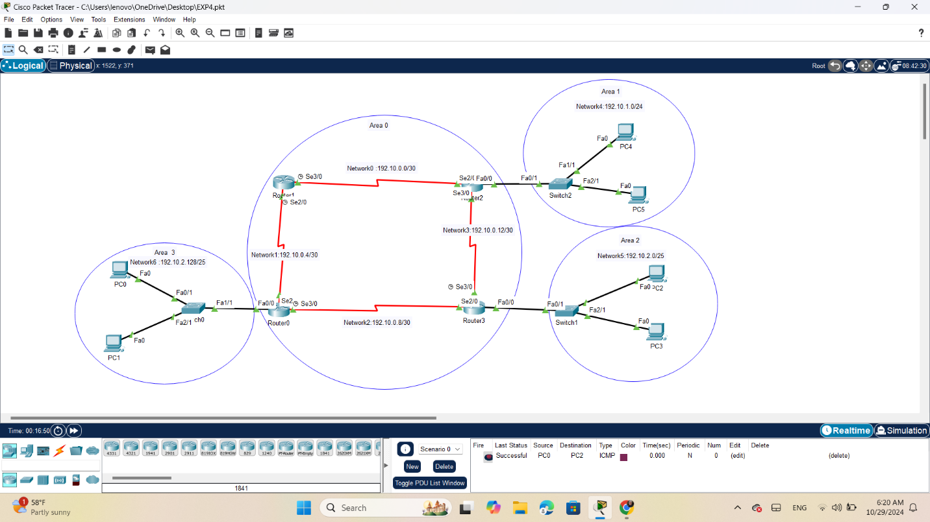
Figure 3:ospf topology

configure the Ips for the PCs and Routers

In this Table 1 show sub-netting the Ips of networks and PCs and identify the areas, each PC has been configured its IP address, subnet mask and gateway. Also, the routers have been turned on for each interface that we used in the network and each interface has been given a certain IP address, see fig 4,5,6,7,8.
Area | Network | Device | Interface | IP | Subnet Mask | Wildcard Mask
Area 0 | Network 0 192.10.0.0/30 | Router 2 | Se2/0 | 192.10.0.1 | 255.255.255.252 | 0.0.0.3
 |  | Router 1 | Se3/0 | 192.10.0.2 | 255.255.255.252 | 0.0.0.3
 | Network 1 192.10.0.4/30 | Router 0 | Se2/0 | 192.10.0.5 | 255.255.255.252 | 0.0.0.3
 |  | Router 1 | Se2/0 | 192.10.0.6 | 255.255.255.252 | 0.0.0.3
 | Network 2 192.10.0.8/30 | Router 0 | Se3/0 | 192.10.0.9 | 255.255.255.252 | 0.0.0.3
 |  | Router 3 | Se3/0 | 192.10.0.10 | 255.255.255.252 | 0.0.0.3
 | Network 3 192.10.0.12/30 | Router 2 | Se3/0 | 192.10.0.13 | 255.255.255.252 | 0.0.0.3
 |  | Router 3 | Se2/0 | 192.10.0.14 | 255.255.255.252 | 0.0.0.3
Area 1 | Network 4 192.10.1.0/24 | Router 2 | Fa0/0 | 192.10.1.1 | 255.255.255.0 | 0.0.0.255
 |  | PC4 | Fa0 | 192.10.1.2 | 255.255.255.0 | 0.0.0.255
 |  | PC5 | Fa0 | 192.10.1.3 | 255.255.255.0 | 0.0.0.255
Area 2 | Network 5 192.10.2.0/25 | Router 3 | Fa0/0 | 192.10.2.1 | 255.255.255.128 | 0.0.0.127
 |  | PC2 | Fa0 | 192.10.2.2 | 255.255.255.128 | 0.0.0.127
 |  | PC3 | Fa0 | 192.10.2.3 | 255.255.255.128 | 0.0.0.127
Area 3 | Network 6 192.10.2.128/25 | Router 0 | Fa0/0 | 192.10.2.129 | 255.255.255.128 | 0.0.0.127
 |  | PC0 | Fa0 | 192.10.2.130 | 255.255.255.128 | 0.0.0.127
 |  | PC1 | Fa0 | 192.10.2.131 | 255.255.255.128 | 0.0.0.127
Summarization 172.16.0.0/22 | 172.16.0.0/24 | Router 2 | Loopback0 | 172.16.0.1 | 255.255.255.0 | 0.0.0.255
 | 172.16.1.0/24 | Router 2 | Loopback1 | 172.16.1.1 | 255.255.255.0 | 0.0.0.255
 | 172.16.2.0/24 | Router 2 | Loopback2 | 172.16.2.1 | 255.255.255.0 | 0.0.0.255
 | 172.16.3.0/24 | Router 2 | Loopback3 | 172.16.3.1 | 255.255.255.0 | 0.0.0.255
Summarization 172.16.4.0/23 | 172.16.4.0/24 | Router 2 | Loopback4 | 172.16.4.1 | 255.255.255.0 | 0.0.0.255
 | 172.16.5.0/24 | Router 2 | Loopback5 | 172.16.5.1 | 255.255.255.0 | 0.0.0.255
Table 1:ip config for network

2.2.1 configure Router
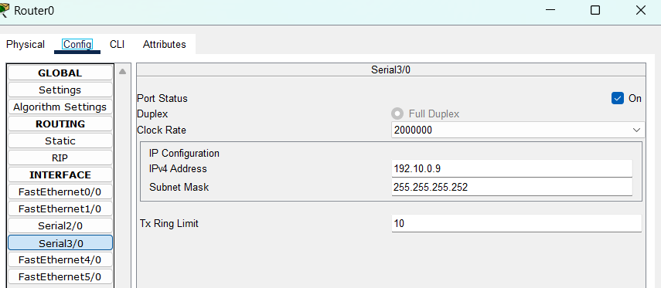
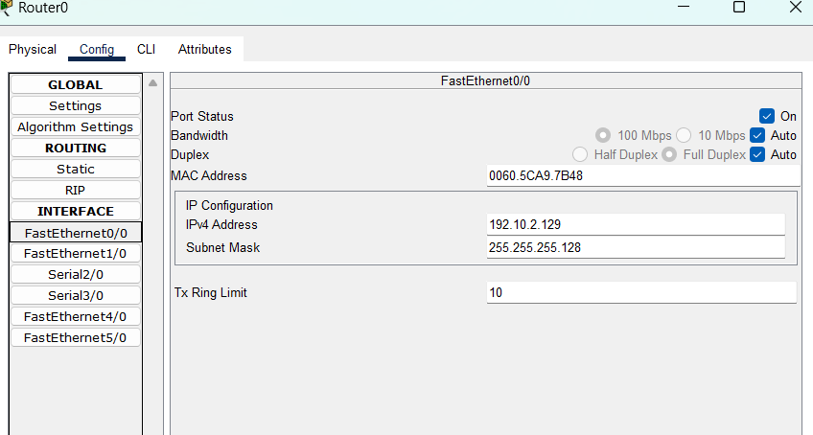
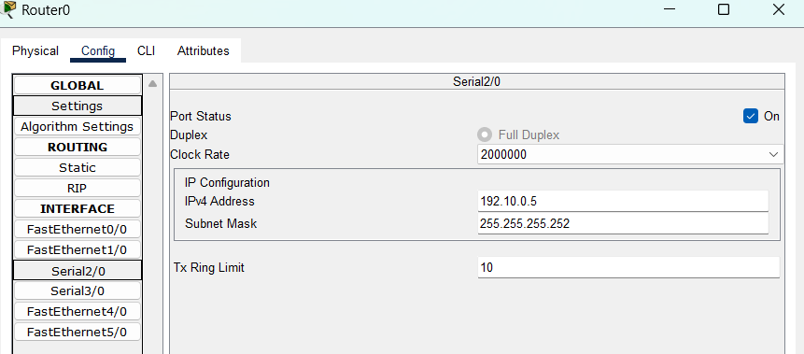

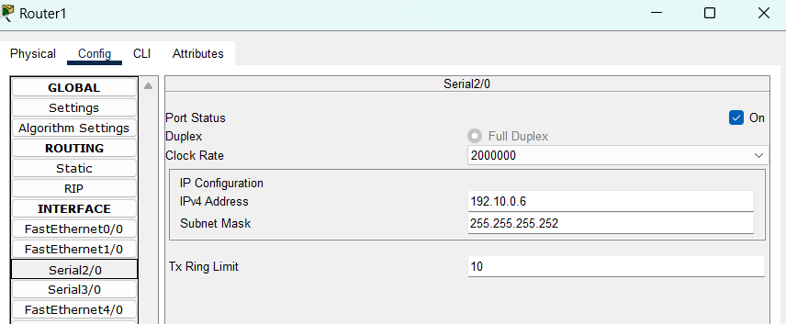
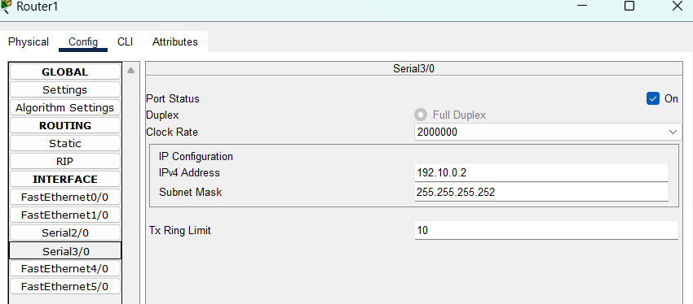
Figure 4:config router 0

Figure 5:config router 1

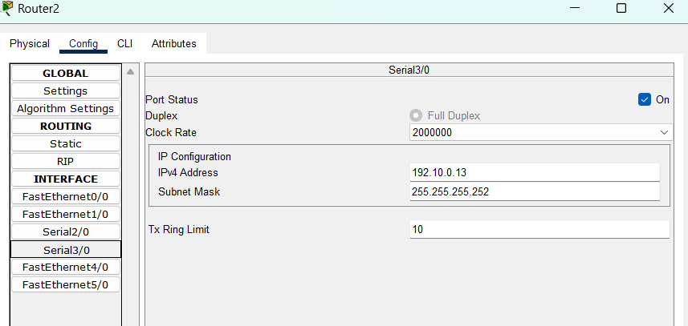
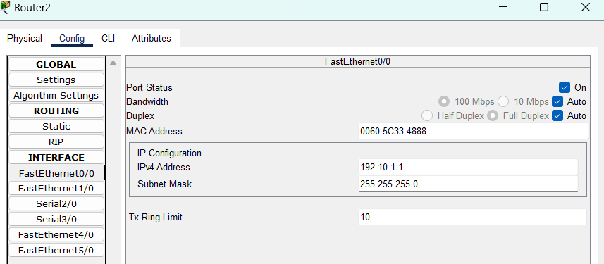
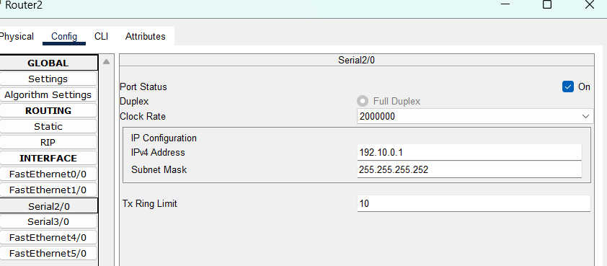

Figure 6:config router 2

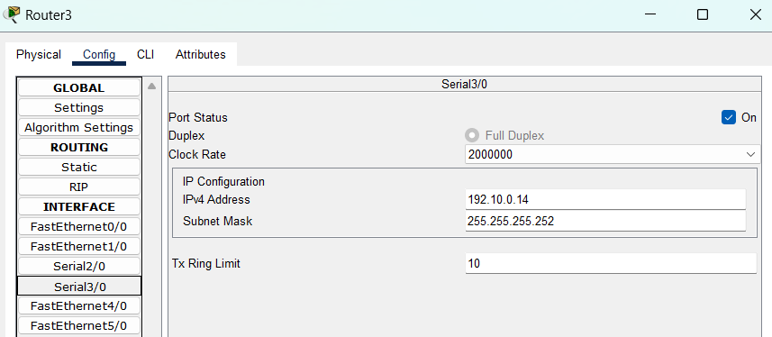
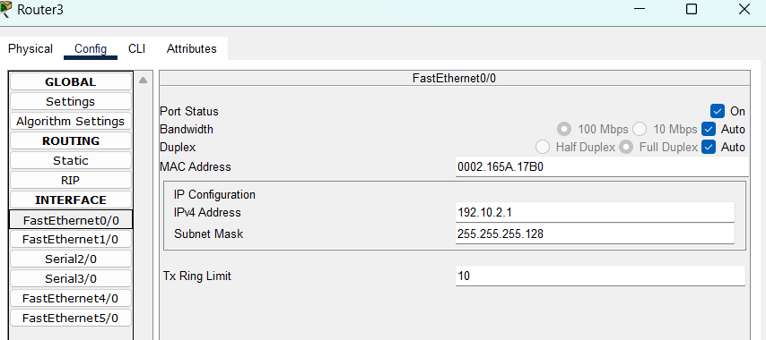
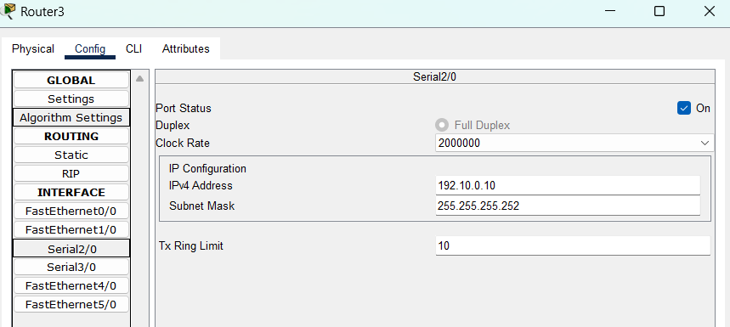

Figure 7:config router 3

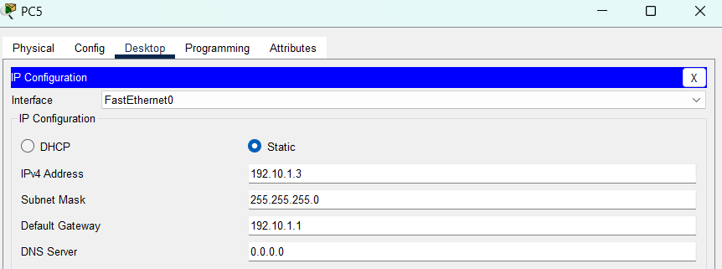
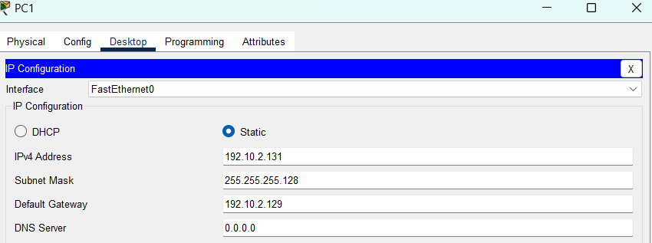
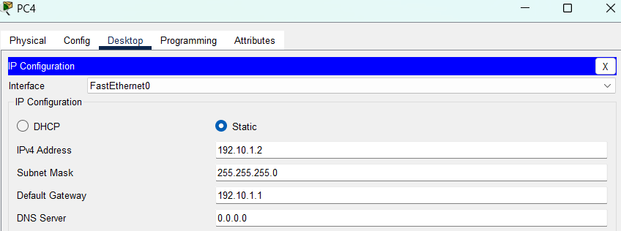
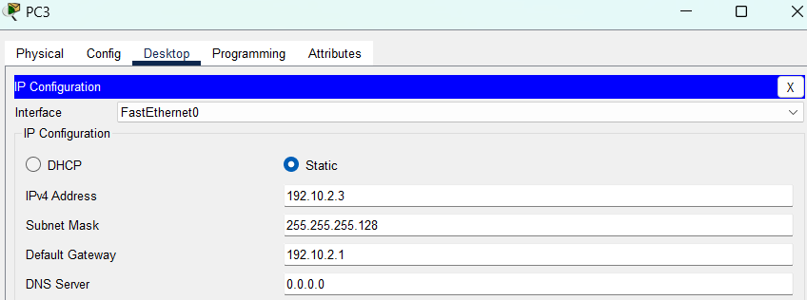
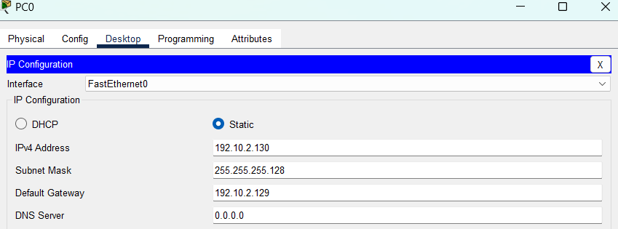
2.2.2 configure PC
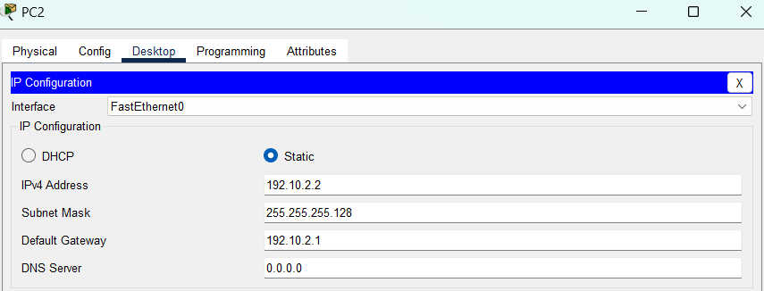
Figure 8:config all pc

2.3Configuring OSPF Routing

OSPF configuration is achieved by issuing commands on each router from to define the routing process ID and identify the networks associated with that router. This involves specifying the network address, corresponding wildcard mask, and the designated area number for each network, see fig 9,10,11,12.

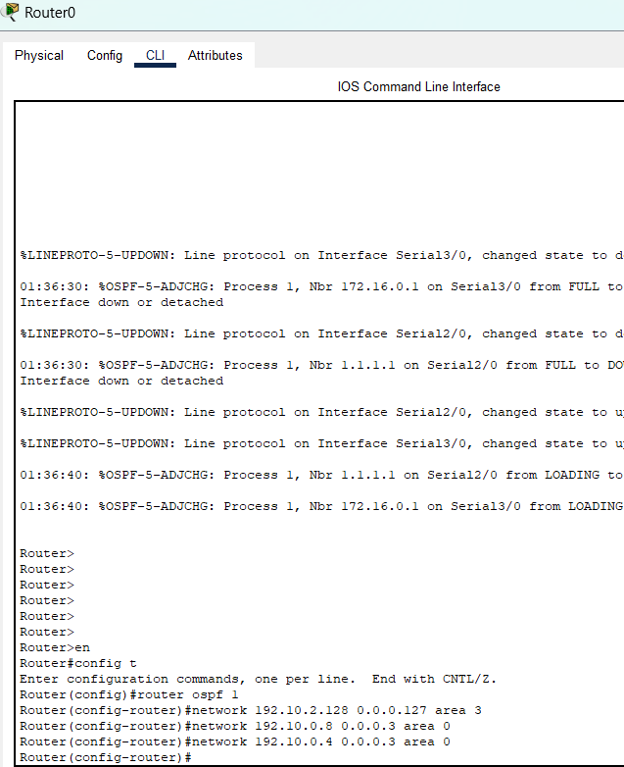
Figure 9:config ospf router 0

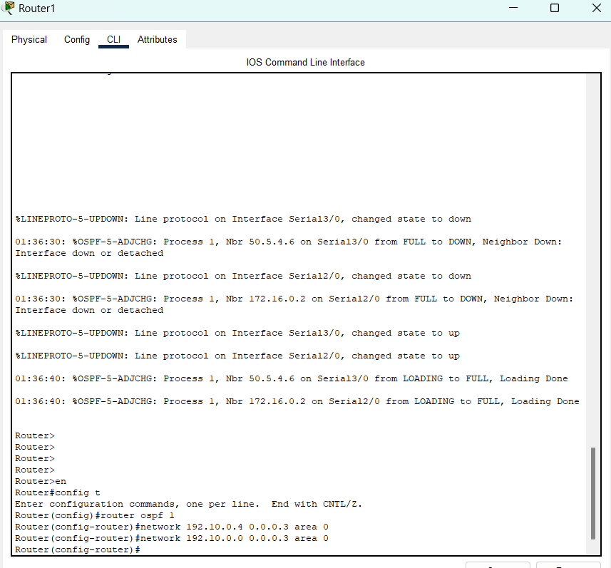
Figure 10:config ospf router1

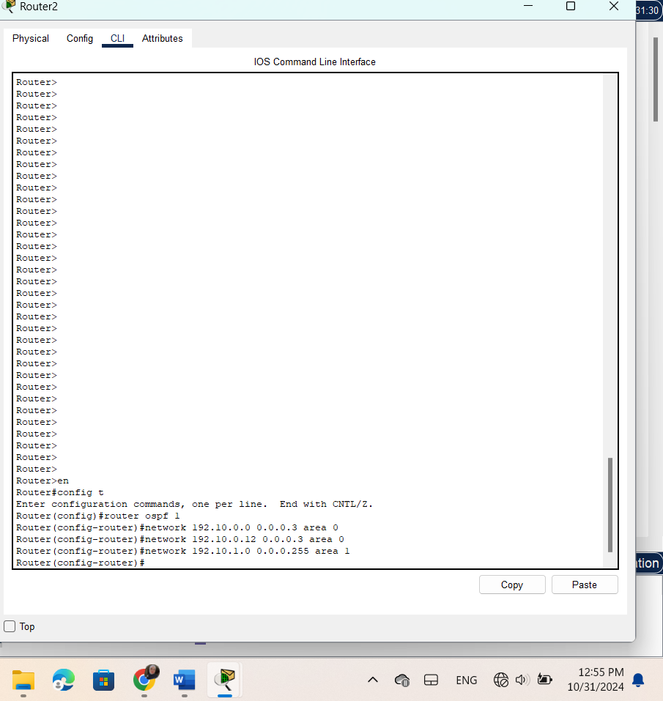
Figure 11:config ospf router2

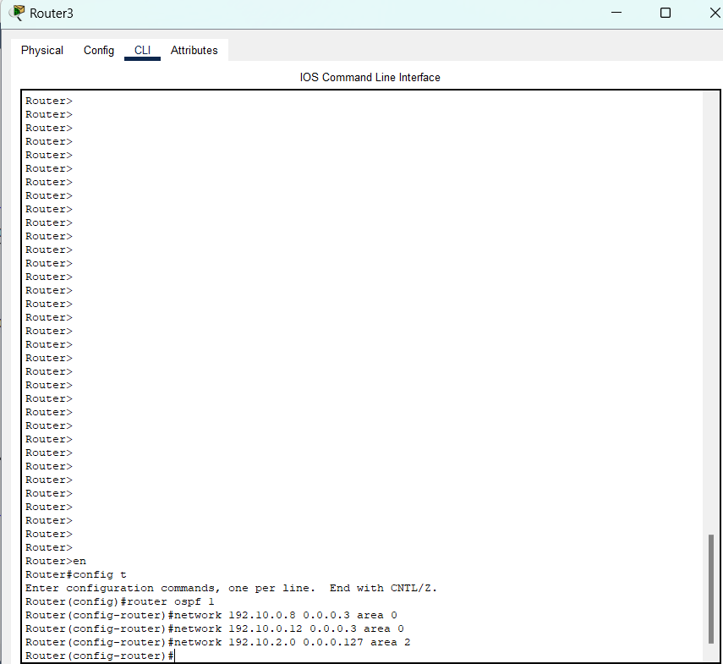
Figure 12:config ospf router3

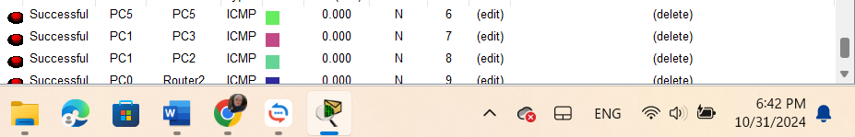

Figure 13:succesful connected

After configuration OSPF Process 1 starts, enabling OSPF routing on the router. The network 192.10.0.0/24 is advertised in Area 0, making it reachable within OSPF. The router discovers neighbors and exchanges routes, building a dynamic routing table with other OSPF routers, see fig 13,

2.4 Changing the Cost

To influence OSPF path selection, you can lower the cost on specific interfaces by adjusting their bandwidth, for example the cost of serial interface 2/0 in router 0 has changed from 1 to 5 by changing the bandwidth to 20000KB using this equation:
𝐵𝑎𝑛𝑑𝑤𝑖𝑑𝑡ℎ = 100𝑀𝐵/ 𝐶𝑜𝑠𝑡 = 100𝑀𝐵/ 5 = 20000𝐾
And using this command in router CLI:
Router(config) #interface se2/0
Router(config-if) #bandwidth 20000

the result as show in fig 14 :
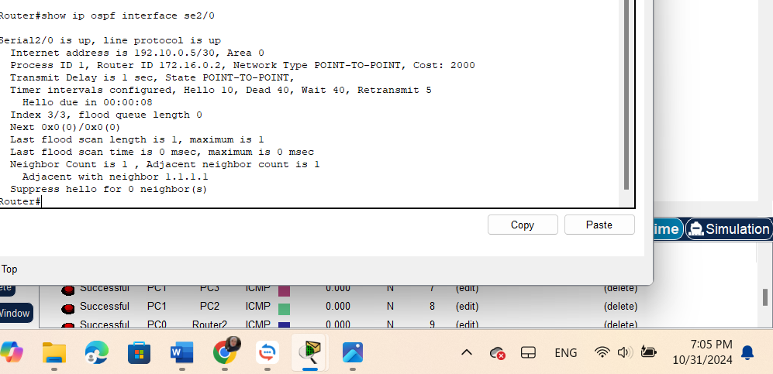
Figure 14:change bandwidth

2.5. Summarization

Summarization in OSPF reduces the number of routes that OSPF needs to process by combining multiple smaller networks into a single larger network. This minimizes the routing table entries, reducing CPU and memory usage on the router, for example:
To Identify and calculate the summarized network address and subnet mask, such as summarizing 172.16.0.0/24 to 172.16.3.0/24 into 172.16.0.0/22.
- Access OSPF configuration mode and add the summarized network using the command:
network 172.16.0.0 0.0.3.255 area 1.
- Repeat for other networks, summarizing 172.16.4.0/24 and 172.16.5.0/24 into 172.16.4.0/23 with
network 172.16.4.0 0.0.1.255 area 1.

2.6. Important Questions

2.5.1 Q1)
Why do we need for loopback interfaces?

The loopback interface is advantageous because it provides a stable IP address that remains active at all times. When OSPF is configured without a specified Router ID, it automatically selects one from the IP addresses of enabled interfaces. The loopback interface is an excellent choice for this purpose, as it remains up unless intentionally disabled. In contrast, other interfaces may go down due to link issues, making the loopback a reliable option for ensuring OSPF.

2.5.2 Q2)
What is the router-id for OSPF? And why do we need it?

The Router ID for OSPF is a unique identifier, typically represented as an IP address, assigned to each OSPF router. It distinguishes routers within the OSPF domain and is used in Link State Advertisements (LSAs) for identifying routing information sources. The Router ID is essential for establishing neighbor relationships and maintaining OSPF topology.

2.5.3 Q3)
Hardcode the router-id for R1, R2, and R3 as 1.1.1.1, 2.2.2.2, and 3.3.3.3 respectively. And Verify that.

In this fig 15 shows in router 1 how to configure the router-id for a router manually, and ensures that the router-id has changed in the router.

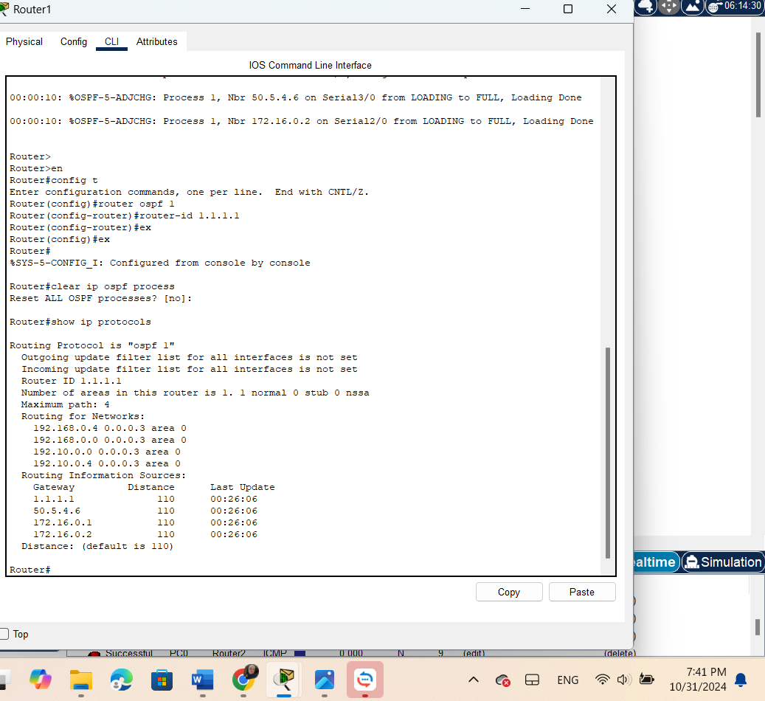
Figure 15:router 1 id

Results

Figure14 demonstrates that the messages have been successfully transmitted to the randomly selected PCs. This indicates that the devices within our network are communicating effectively with one another through dynamic routing, specifically utilizing OSPF as the routing protocol.

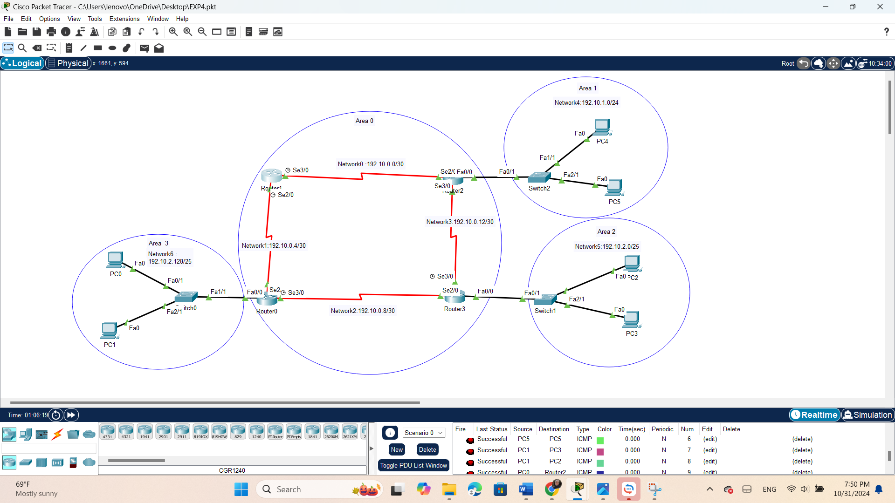
Figure 16:successfully transmitted

To observe the path taken by our message from PC0 to PC4, the tracert command was executed, as illustrated in Figure 17. This command provides a detailed view of the route traversed by the packets, including each hop along the way.

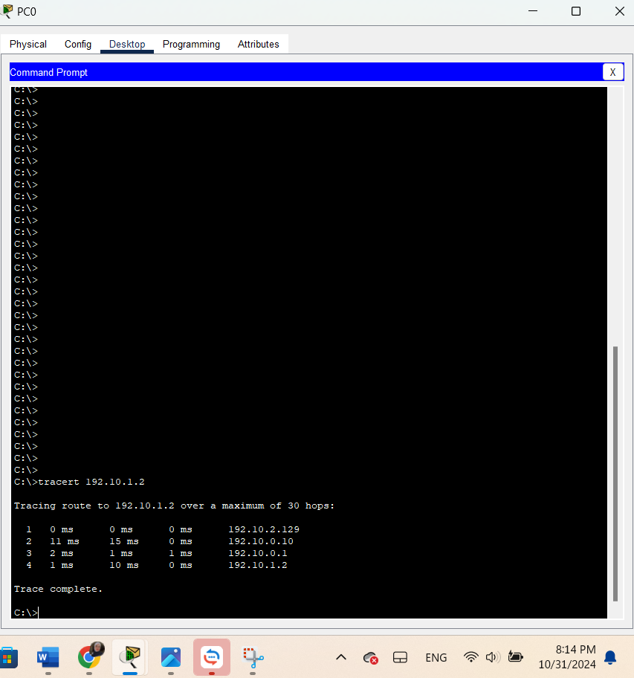

Figure 17:tracert in pc0

Problem

4.1 Part one

4.1.1 topology
this topology shows Every network connection has a cost.
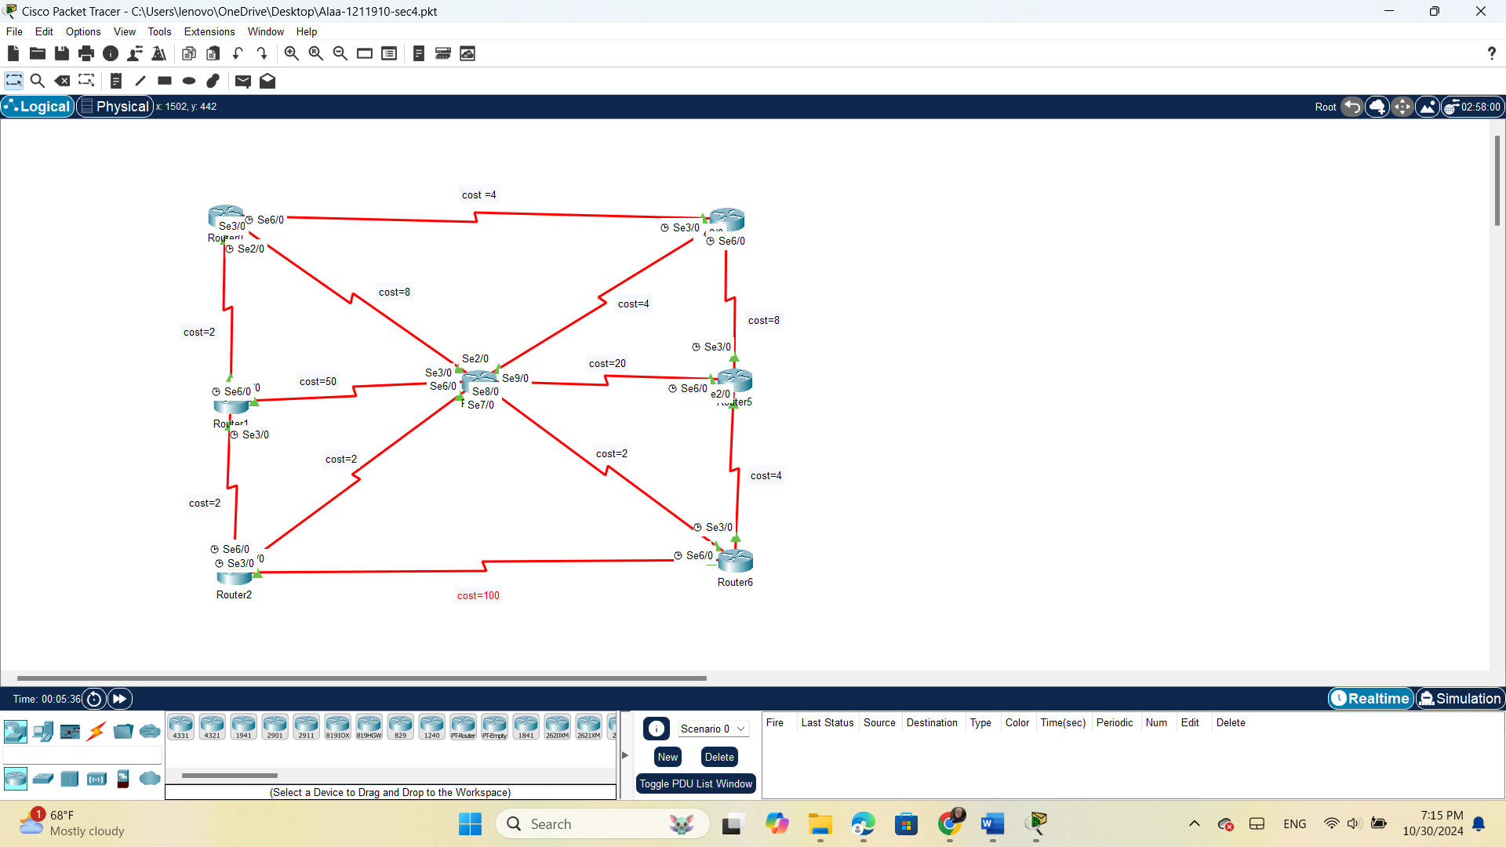
Figure 18:problem topology

4.1.2Q1&Q2) Find the shortest path from Router 0 to Router 6 using Dijkstra’s algorithm. Show your steps.

In this table 2 has been calculate the shortest path between Router0 and Router6.
using Dijkstra’s algorithm:

cost,(router number)
Router number | C(1) | C(2) | C(3) | C(4) | C(5) | C(6)
0 | 2,0 | ∞ | 8,0 | 4,0 | ∞ | ∞
0,1 |  | 4,1 | 8,0 | 4,0 | ∞ | ∞
0,1,2 |  |  | 6,2 | 4,0 | ∞ | 104,2
0,1,2,4 |  |  | 6,2 |  | 12,4 | 104,2
0,1,2,4,3 |  |  |  |  | 12,4 | 8,3
0,1,2,4,3,6 |  |  |  |  | 12,4/6
0,1,2,4,3,6,5
Table 2:Dijkstra’s algorithm

- The shortest path from Router0 to Router6 using Dijkstra’s algorithm:
6 (8,3) ← 3 (6, 2) ← 2 (4, 1) ← 1 (2, 0) ← 0
Then: 𝑅0 → 𝑅1 → 𝑅2 → 𝑅3 → 𝑅6

- The cost of the shortest path = 8

4.2 part 2

Q1) Build and configure the above topology using Packet Tracer software based on the following requirements:
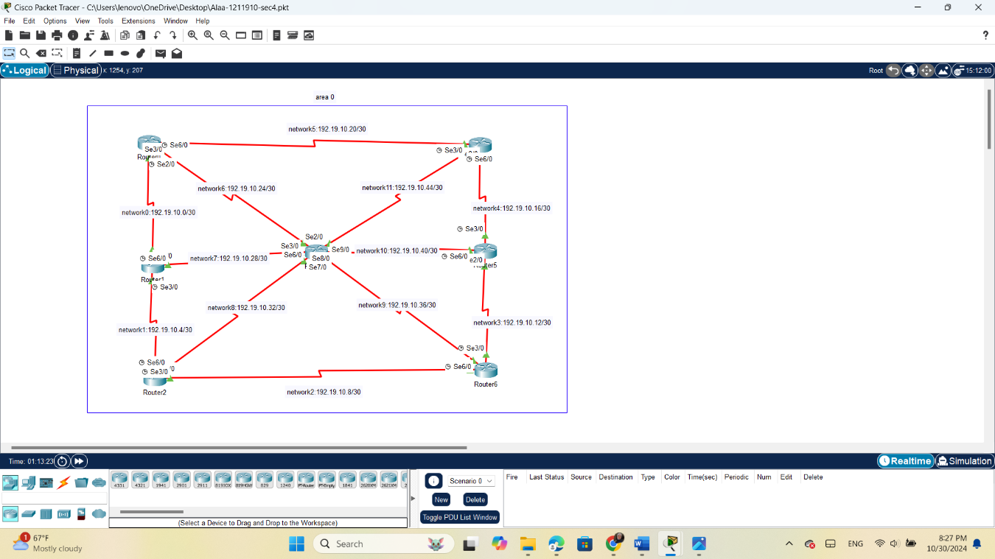
1)this topology show ip address for every network :
Figure 19:problem topology with ip
Q2&4)Configure OSPF and set bandwidth between links:
2.3.1 in router 0
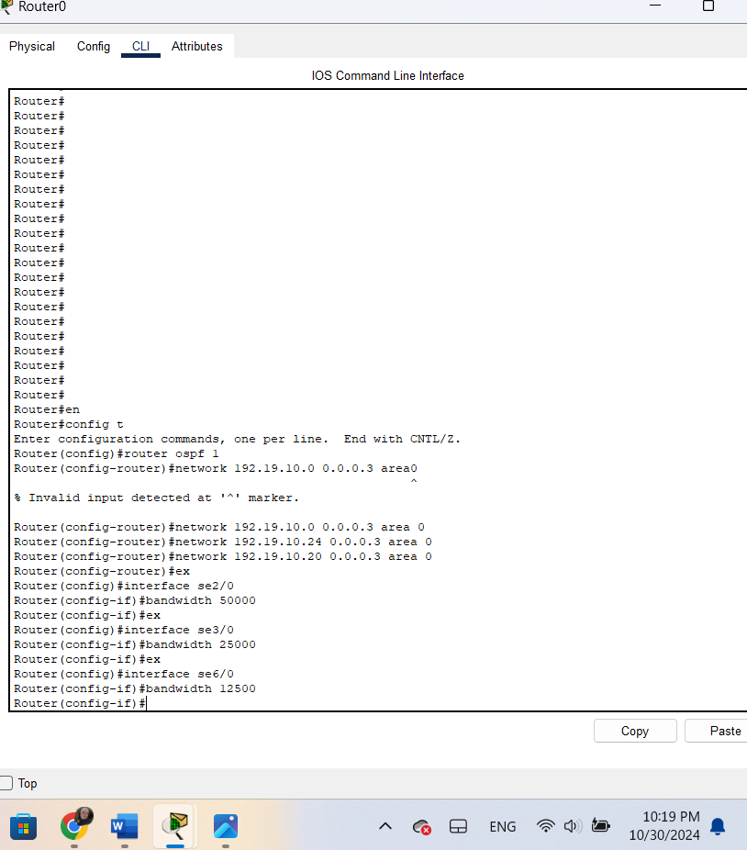

Figure 20:4.2config ospf in router 0

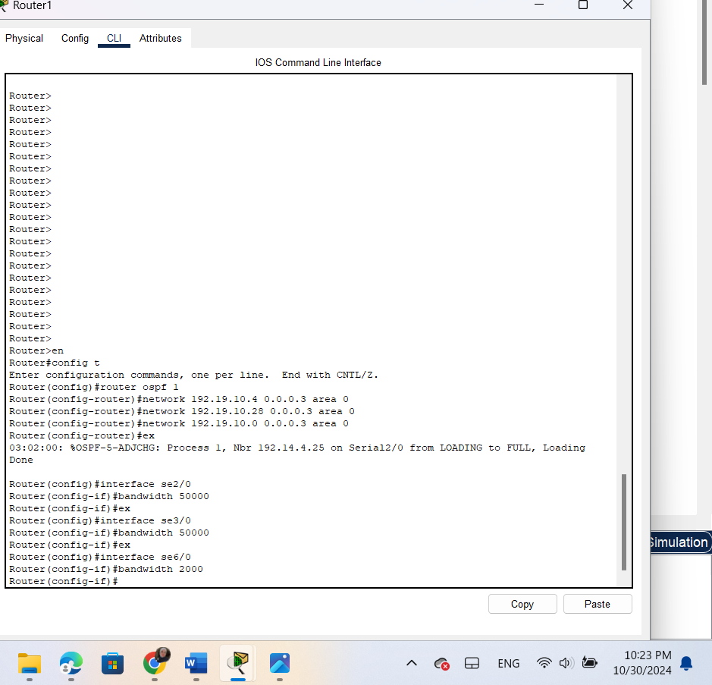
2.3.2 in router 1:

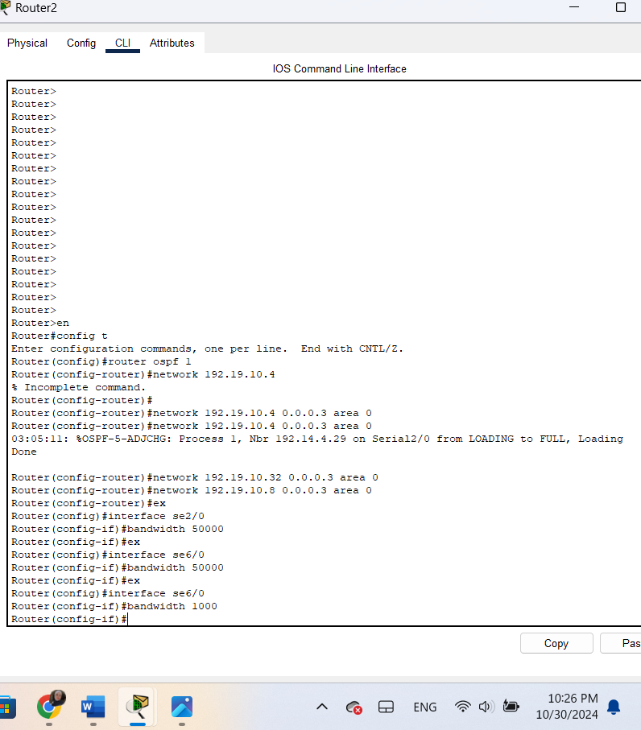
2.3.3 in router 2
Figure 21:4.2 config ospf in r1
Figure 22:4.2 config ospf in r2

2.3.4 in router 3
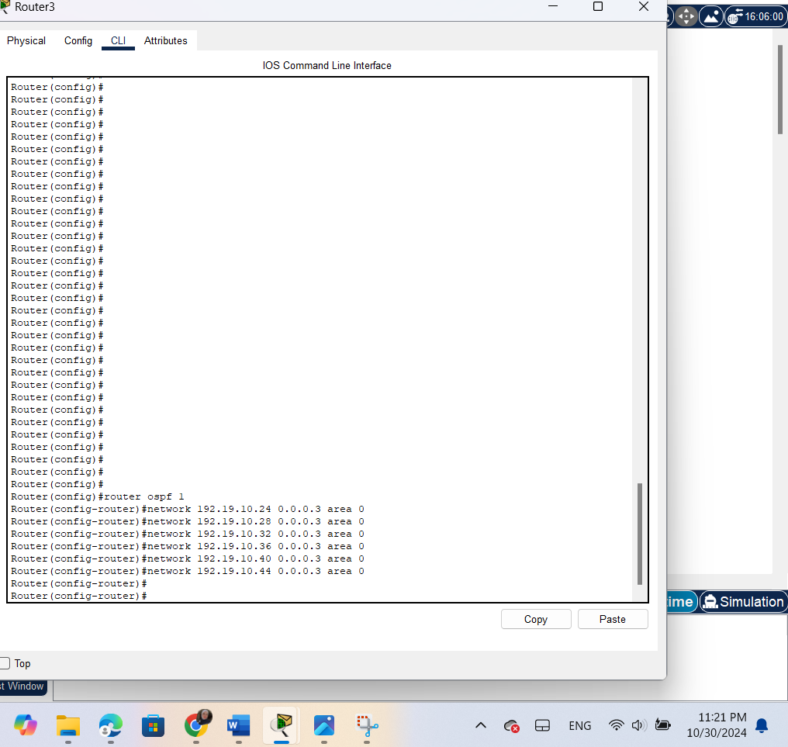
Figure 23:4.2 config ospf in r3

Q4)Configure bandwidth values between links table :
In this table shows how to calculate the bandwidths for each cost.
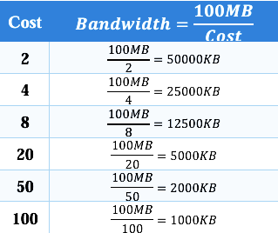

Table 3:4.2 bandwidth link

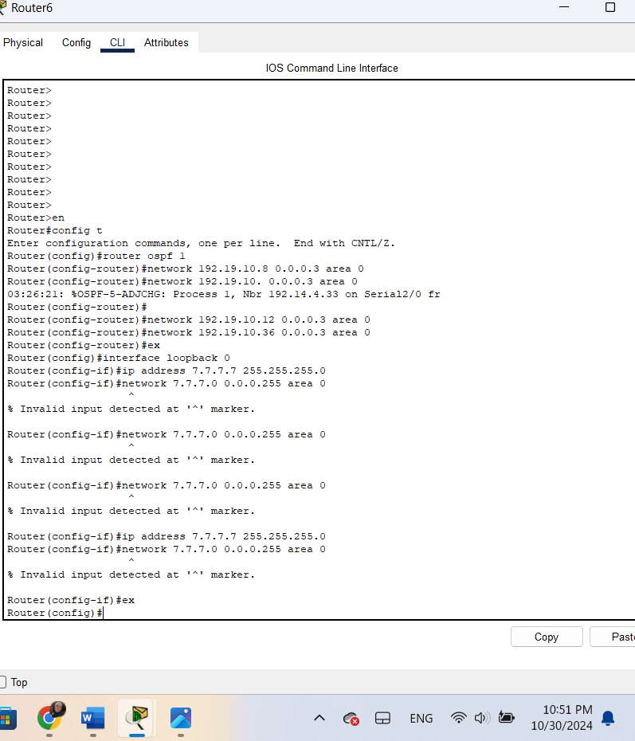
Q3) Configure Router 6 with a loopback IP address
Figure 24:4.2 config loopback in r6

Q5) Tracert from Router0 to Router7:
after tracert command executed, the packets passed throw 𝑅0 t0 𝑅1 to 𝑅2 to𝑅3 to 𝑅6 to reach the loopback interface which is path with the lowest cost and it is the same result when we calculated it using Dijkstra’s algorithm, see the image25 :

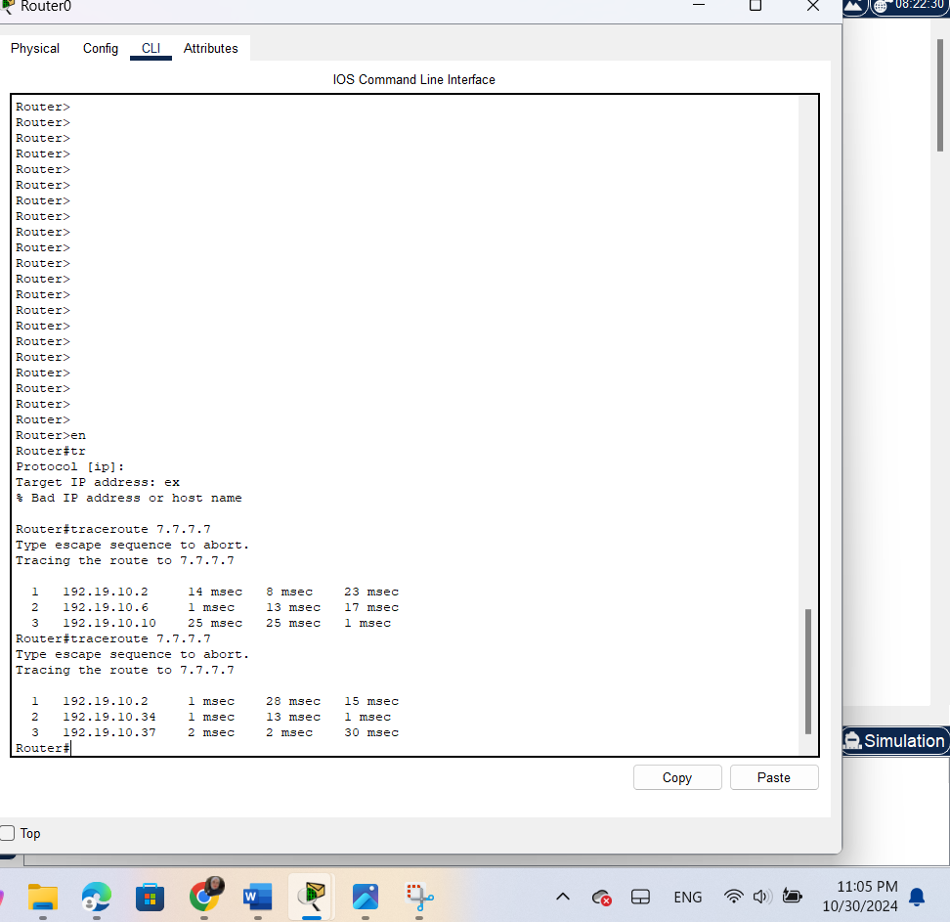
Figure 25:4.2tracert from r0 to r6

Q6) is the cost (metric) to get from Router 0 to Router 6
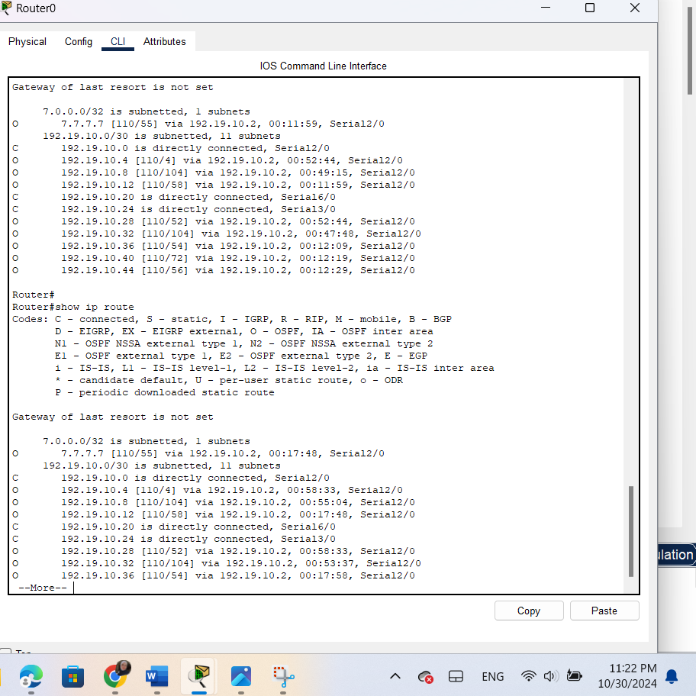
In this image 26 we can see the cost from Router0 to Router 6 in last line, but should be 8,but it shown 54, I have some error in configuration .
Figure 26:4.2 cost from r0 to r6

Figure 26:4.2 cost from r0 to r6

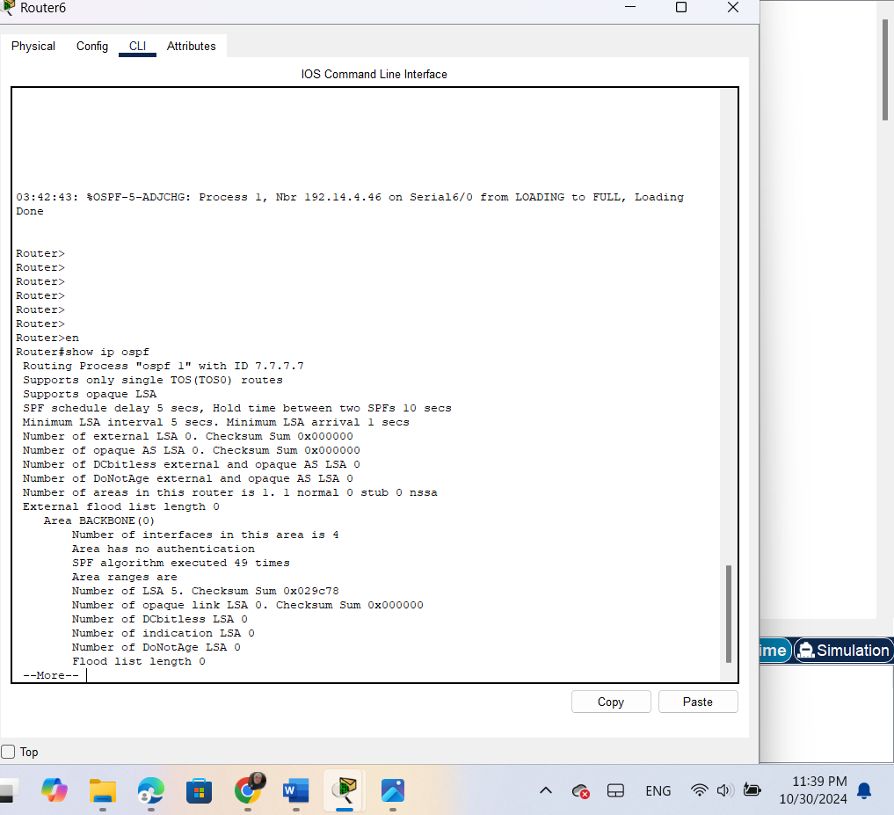
Q7) router-id for Router 0, and Router 6
Figure 27:4.2 id for router 6

Figure 27:4.2 id for router 6

5.Conclusion

The outcomes of the previous procedures were successful and consistent with theoretical expectations. This experience demonstrated that Cisco Packet Tracer is an effective platform for constructing and advertising our network topologies, increasing our proficiency with the software. We gained an understanding of the meaning behind each element of an IP address. Additionally, we examined a dynamic routing protocol that identifies the shortest path based on associated costs, affirming OSPF as a robust choice for routing within our network design. It was also noted that each router participating in the OSPF process is assigned a unique Router ID, which can be established through three methods: manual configuration, selecting the highest IP address on a loopback interface, or using the highest IP address on a non-loopback interface.

6. References

https://www.geeksforgeeks.org/difference-between-static-and-dynamic-routing/[1]
Accessed on 28 october

https://www.educative.io/answers/what-is-dynamic-routing [2]
Accessed on 28 october
https://www.techtarget.com/searchnetworking/definition/OSPF-Open-Shortest-Path-First#:~:text=Open%20Shortest%20Path%20First%20(OSPF)%20is%20an%20IP%20routing%20protocol,direct%20traffic%20on%20IP%20networks.[3]
Accessed on 29 october

ENCS4130 Course Slides and Lab Manual.[4]

