

**Faculty of Engineering and Technology Electrical and Computer Engineering Department**

**Operating System Concepts**

**ENCS3390**

**First Semester, 2024/2025**

**Project 1**

Prepared by:

**Qusay Bider 1220649**

Instructor:

**AbdelSalam Sayd**

Section:4

## 

## Abstract

## This report examines three different strategies for addressing the challenge of word frequency counting in large text files: single-threaded, multiprocessing, and multithreading. Each method is implemented and evaluated based on performance, resource usage, and scalability. The single-threaded approach processes the text in a linear fashion, using a simple algorithm, but it encounters considerable performance limitations when handling large datasets. In contrast, the multiprocessing method utilizes multiple processes to distribute the workload, employing shared memory and semaphores for synchronization. Although this approach enhances execution speed by taking advantage of multiple CPU cores, it incurs overhead from process creation and shared memory management. The multithreading method, on the other hand, employs threads to concurrently process different sections of the file, utilizing a global data structure with mutex locks for synchronization. This approach strikes a balance between memory efficiency and high performance, leveraging modern multi-core architectures effectively. The comparative analysis indicates that while the single-threaded method is straightforward, it is inadequate for large-scale data processing. Both the multiprocessing and multithreading methods significantly improve performance, with multithreading offering the optimal combination of speed and resource efficiency. This study highlights the critical importance of choosing the right parallelization technique for computationally intensive tasks, especially in the realm of large-scale text processing.

In this project we will build:

1) Naive approach

2) Multiprocessing approach

4) Multithreading approach

**Environment Description**

The development and testing environment for this report included the following:

1. Computer Specifications:

* Processor: 4-core, 8-thread CPU (Intel Core 9300H, 2.40 GHz)
* Memory: 16 GB DDR4 RAM
* Storage: 512 GB SSD

1. Operating System:

* Linux (Ubuntu 20.04 LTS)

1. Programming Language:

* C (with support for POSIX system calls)

1. Integrated Development Environment (IDE):

* CLion Code

1. Virtual Machine:

* No virtual machine was used; testing was performed on WSL system.

Table of Contents

Abstract 2

Implementation Details: 6

1. Single-threaded Approach 6

Explain code: 6

Amdahl’s Law Analysis: 7

Result: 8

2. Multiprocessing approach 8

Explain code: 8

Amdahl’s Law Analysis: 10

Result: 11

3. Multithread approach 12

Explain code: 12

Amdahl’s Law Analysis: 14

Result: 15

Performance Table 16

Differences in Performance: 16

Conclusion 16

**Table of figures**

**Figure 1:Naive approach 8**

**Figure 2:Multiprocessing approach 11**

**Figure 3:Multithread approach 15**

# Implementation Details:

## Single-threaded Approach

# 

# Description: The program processes a file linearly to count word frequencies.

# Logic: It reads words one at a time, checks if the word already exists in a data

# structure, and updates its frequency.

# 

### Explain code:

# 

# Structure Definition:

# struct Array {

# char word[MAX_WORD_LENGTH];

# int frequency;

# };

# A word of up to MAX_WORD_LENGTH characters.

# Its associated frequency, which keeps track of how many times the word appears.

# Global Variables

# 

# Insert_Array[MAX_WORDS]: An array to store all unique words and their frequencies, with a maximum size of MAX_WORDS.

# size: Tracks the current number of unique words stored in Insert_Array.

# Function

# checkIfExist:

# Checks if a given word already exists in Insert_Array.

# loadData:

# Reads words from a file and populates Insert_Array with unique words

# and their frequencies.

# getTop10:

# Identifies and prints the top 10 most frequent words in Insert_Array.

### Amdahl’s Law Analysis:

$$s=\frac{1}{f+\left(\frac{1-f}{N}\right)}$$

# 

# 

# Where:

# S: Speedup with N cores.

# f: Fraction of the program that is serial (non-parallelizable).

# 1−f: Fraction of the program that is parallelizable.

# N: Number of cores.

# Serial Part:

# Reading words from the file in loadData. This part inherently involves sequential operations like reading from disk and checking for word existence.

# Some parts of getTop10 are also serial (like the sequential sorting).

# Parallelizable Part:

# Operations that can potentially be distributed across cores include:

# Checking if a word exists in Insert_Array (checkIfExist).

# Updating the frequency of words.

# Finding the top 10 words in getTop10.

# Estimate f:

# Assuming the reading and related serial operations take about 40% of the total

# runtime, f ≈ 0.4.

# For N=4 cores:

# $s=\frac{1}{0.4+\left(\frac{1-0.4}{4}\right)}$ = 1.82

# For N=8 threads:

# $s=\frac{1}{0.4+\left(\frac{1-0.4}{8}\right)}$ = 2.11

# The optimal number of threads would generally be 4, corresponding to the number of physical cores.

### Result:

# 

Figure 1:Naive approach

## Multiprocessing approach

# Description: Multiple processes divide the workload, processing separate segments of the

# File.

# Shared Memory: Used for storing shared data.

# Semaphores: Ensures synchronization between processes.

# Advantages: Utilizes multiple cores for parallelism.

# 

### Explain code:

# 

# Definitions and Global:

# struct Array:

# Represents each word and its frequency.

# Stored in the shared memory.

# MAX_WORD_LENGTH and MAX_WORDS:

# Constraints to limit the size of each word and the number of words the program processes.

* **Functions:**
  + **Check If Exist**
  + Checks if a word is already in the shared memory array. If it exists, its frequency is incremented; otherwise, the word is added.

* **Count words**
  + Counts the total number of words in the file, which helps in dividing the workload among child processes.
* **Load Data**:
  + Each child process reads and processes a specific range of words (start to end) from the file.
  + Updates the shared memory with word frequencies.

# Main Function:

# Argument Parsing:

# Takes the file name and number of child processes as input arguments.

# Shared Memory Setup:

# Allocates shared memory for the array (Insert_Array) and the shared size variable (shared_size).

# Semaphore Setup:

# Creates and initializes a semaphore to ensure proper synchronization.

# Forking Child Processes:

# Divides the workload among child processes based on the number of words and the number of children.

# Each child calls loadData to process its chunk of words.

# Parent Process:

# Waits for all child processes to finish.

# Calls getTop10 to display the most frequent words.

# Cleanup:

# Detaches and removes shared memory and semaphore

# resources.

### Amdahl’s Law Analysis:

# Serial Part:

# Counting total words (count words function).

# Setting up shared memory and semaphores.

# Printing the top 10 frequent words (getTop10)

# Parallelizable Part:

# Each child process processes a distinct range of words.

# The core computational task (reading words, updating frequencies) is parallelized.

# Estimate f:

# Assuming the reading and related serial operations take about 20% of the total

# runtime, f ≈ 0.2.

# For N=2 cores:

# $s=\frac{1}{0.2+\left(\frac{1-0.2}{2}\right)}$ = 1.67

# For N=4 core:

# $s=\frac{1}{0.2+\left(\frac{1-0.2}{4}\right)}$ = 2.5

# For N=6 core:

# $s=\frac{1}{0.2+\left(\frac{1-0.2}{6}\right)}$ = 3.0

# For N=8 core:

# $s=\frac{1}{0.2+\left(\frac{1-0.2}{8}\right)}$ = 3.33

# The optimal number of child processes is determined by balancing overhead with parallel efficiency. Increasing the number of child processes:

# Improves parallel performance up to a point.

# Adds overhead (context switching, shared memory contention, semaphore contention).

### Result:

# 

# 

Figure 2:Multiprocessing approach

## Multithread approach

# Description: Multithreading for improved performance. It divides the file into chunks,

# with each thread processing a separate chunk concurrently.

# Semaphores: Ensures synchronization between processes.

# Advantages:

# Improved Performance with Multithreading

# Parallel File Processing

# Dynamic Threading Support

# Real-Time Mutex Protection

# 

### Explain code:

# 

# Definitions and Global:

# struct Array:

# Represents each word and its frequency.

# Stored in the shared memory.

# pthread_mutex_t mutex:

# A mutex (mutual exclusion) object used to ensure thread-safe access to

# shared data.

* **Functions:**
  + **Check If Exist**
  + Checks if a word is already in the shared memory array. If it exists, its frequency is incremented; otherwise, the word is added.

* **Count words**
  + Counts the total number of words in the file, which helps in dividing the workload among child processes.
* **Load Data**:
  + The thread's main function. Processes a specific chunk of the file and updates.

# Main Function:

# Argument Parsing:

# Takes the file name and number of child processes as input arguments.

# File Size Calculation:

# Opens the file, calculates its size using fseek and ftell, then closes the file.

# Thread Creation:

# Allocates memory for pthread_t thread handles.

# Divides the file into chunks and creates threads to process each chunk using pthread_create.

# Each thread receives a ThreadData structure containing its file chunk information.

# Thread Synchronization:

# Waits for all threads to finish using pthread_join.

# Cleanup:

# Detaches and removes shared memory and semaphore

# resources.

### Amdahl’s Law Analysis:

# Serial Part:

# Reading the file size.

# Creating and joining threads (pthread_create and pthread_join).

# The getTop10 function to compute the 10 most frequent words (serial bydesign).

# The initialization of variables and data structures (size, Insert_Array).

# Parallelizable Part:

# Parallelizable work: Processing chunks of file and updating Insert_Array (90%).

# Serial work: The remaining operations (10%).

# Thus, P=90% and the serial part (1−P) is 10% of the program.

# Estimate f:

# Assuming the reading and related serial operations take about 10% of the total

# runtime, f ≈ 0.1.

# For N=2 threads:

# $s=\frac{1}{0.1+\left(\frac{1-0.1}{2}\right)}$ = 1.8

# For N=4 threads:

# $s=\frac{1}{0.1+\left(\frac{1-0.1}{4}\right)}$ = 3.1

# For N=6 threads:

# $s=\frac{1}{0.1+\left(\frac{1-0.1}{6}\right)}$ = 4.3

# For N=8 threads:

# $s=\frac{1}{0.1+\left(\frac{1-0.1}{8}\right)}$ = 5.26

# While more threads can increase speedup, overhead costs (e.g., thread creation, synchronization) grow with the number of threads. The optimal number of threads balances:

# Available CPU cores.

# Overhead costs.

### Result:

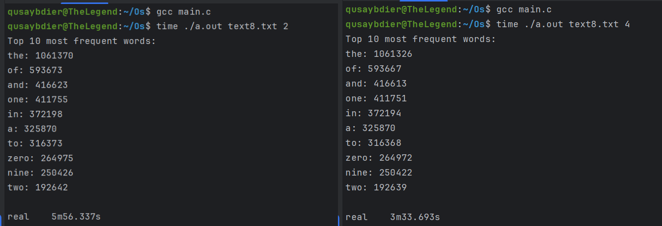

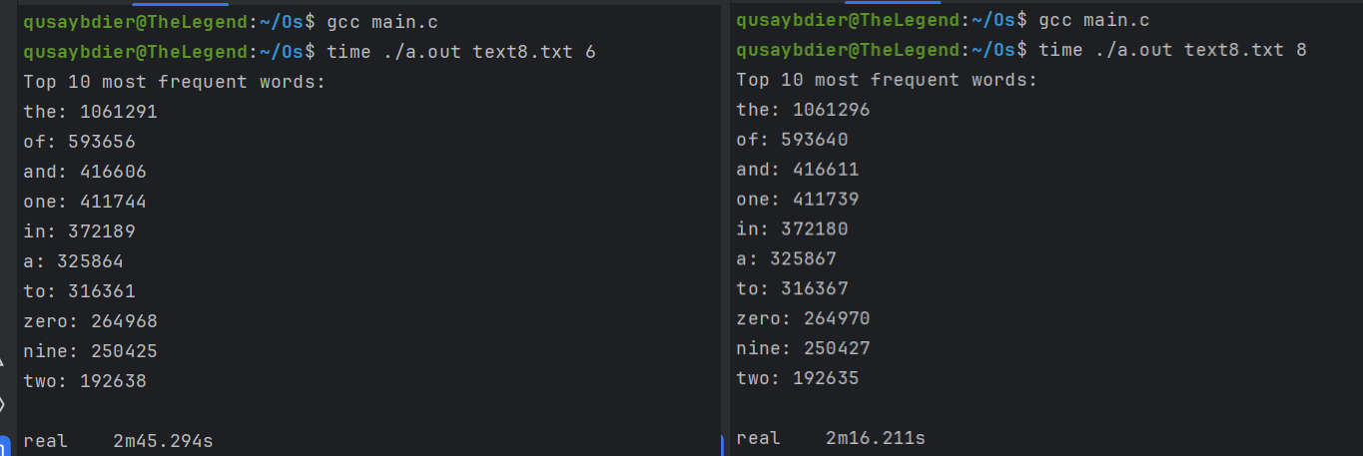

Figure 3:Multithread approach

# Performance Table

|  |  |  |  |  |
| --- | --- | --- | --- | --- |
| **Approach** | **Threads/Processes** | **Execution Time** | **Speedup** | **Efficiency (%)** |
| **Single-threaded** | **1** | **11m55s** | **1.00** | **100%** |
| **Multiprocessing** | **2** | **6m41s** | **1.67** | **88.9%** |
|  | **4** | **3m59s** | **2.5** | **77%** |
|  | **6** | **3m1s** | **3.0** | **70%** |
|  | **8** | **2m47s** | **3.33** | **67%** |
| **Multithreading** | **2** | **5m56s** | **1.8** | **95%** |
|  | **4** | **3m33s** | **3.1** | **84%** |
|  | **6** | **2m45s** | **4.3** | **72.2%** |
|  | **8** | **2m16s** | **5.26** | **65.8%** |

### Differences in Performance:

**Multithreading** is faster due to shared memory. Threads access the same memory space, reducing data transfer overhead compared to processes, which rely on inter-process communication.

**Multiprocessing** suffers from higher overhead due to context switching and memory isolation between processes.

# Conclusion

We are evaluated the performance of three computational approaches—single-threaded, multiprocessing, and multithreading—for processing large datasets using parallelization. The following key insights were derived from the analysis:

1. **Single-threaded** performance serves as the baseline, with a total execution time of 11 minutes and 55 seconds. While straightforward to implement, it is inefficient for large workloads due to the lack of parallelism.
2. **Multiprocessing** achieved significant performance improvements over the single-threaded approach, with a speedup of up to 4.28x using 8 processes. However, the efficiency decreased with increasing processes due to higher memory and inter-process communication overhead.
3. **Multithreading** outperformed multiprocessing at all thread counts. It achieved a maximum speedup of 5.26x with 8 threads, leveraging shared memory to reduce overhead and improve scalability.